Structural and Substantive Foundations of Ethnic Identity of Karakalpak Students
Zulfiya Maturazova, Elmira Maturazova, Nargiza Sagindikova ^{a)}, Aman Matjanov
Karakalpak State University named after Berdakh, Nukus, Karakalpakstan, Uzbekistan
^{a)} Corresponding author: sagindikovan@mail.ru
Abstract. This article pays special attention to the ethnic self-awareness of students, the structural content of ethnic self-awareness, the attitude towards a person’s moral and material values, and the values ​​that lead in his behavior. The generalized features of modern components of ethnic self-awareness of Karakalpak student youth are also shown.
INTRODUCTION
The analysis of scientific literature on the problem under study shows that today there are quite different positions of various scientists regarding the structural content of ethnic self-awareness of a person in general and of student youth in particular. Our conclusions are supported by G.R. Khuzeyeva's point of view, according to which the author believes that different researchers, developing the concept of ethnic self-consciousness, add more and more of new structural elements to its content. According to O.G. Lopukhova's position, there are usually three main components in the structure of ethnic self-consciousness of a modern personality:
cognitive component,
emotional component,
behavioral component.
According to E.A. Erokhina, self-consciousness is an integral component of modern man's consciousness, respectively; ethnic self-consciousness becomes an important component of national consciousness. For many scientists, the ratio of these concepts is the ratio of the whole and its part, in fact, ethnic self-consciousness is considered as a component of national consciousness. At the same time, ethnic self-consciousness is defined as self-reflection of ethnic (national) relations, finding out for oneself one's place in them, as well as realizing one's position and one's attitude to the system of interethnic relations. The central element of ethnic self-consciousness is ethnic self-identification.
In addition, as a structural component of ethnic self-consciousness also comes the self-assessment of the individual, which is understood as a person's judgment of the extent of his or her qualities, properties in correlation with certain standards, representing the system of ethnic values of the community to which the person - the subject of self-assessment refers to himself or herself and with which he or she identifies. These may be such values as typical ethnic, national character traits of the community, realization of one's own responsibility for the fate of the ethnos.
The next, quite important component of ethnic self-consciousness can be claims, which are understood as a person's instructions to choose personally significant goals determined by the system of ethnic, national values, the achievement of which (goals) can satisfy the individual's aspiration to take the desired place in the scale of such values.
Another component of ethnic self-consciousness may also include socio-psychological expectations - these are a person's perceptions of how people around him or her evaluate him or her in relation to the degree of presence of certain ethnic values, and what behavior is expected from him or her in this regard. Socio-psychological expectations also express a person's perception of how representatives of other ethnic groups evaluate his/her national characteristics.
As V.A. Avksentyev points out, a highly important component of an individual's ethnic self-consciousness is his or her conscious attitude towards the historical past, present and future ethnicity. Ethnic self-consciousness may be at a very low level due to a person's lack of interest in ethnic history, or due to extremely distorted knowledge about the past of his/her ethnic community. Such a person, as a rule, is very skeptical about his/her ethnicity and does not see the prospects of its development. Also, the author mentions in the aspect of ethnic self-consciousness a person's perception of the territorial unity of his/her ethnicity. This plays a special role in the formation of attachment to the native land, home country and directly affects the formation of patriotic feelings of the individual. Non-formed, inadequate, such perceptions often lead to distorted ethnic self-consciousness. A special place in the ethnic self-consciousness of the individual is occupied by a deeply conscious, effective attitude to the spiritual and material values of ethnicity, orientation to its leading values in his/her real behavior. This is possible when the realized values of the ethnic community become an urgent internal need of the individual [1].
EXPERIMENTAL RESEARCH
Thus, based on the above-mentioned positions of scientists, as well as the results of theoretical analysis given in the first chapter of this dissertation research, we have prepared a generalized list of features that can enter the structural components of ethnic self-awareness of modern Karakalpak student youth:
ethnic self-respect;
conscious attitude to the historical past of their ethnos;
ethnic identity;
ideas about the territorial community of their ethnos;
ethnic awareness, knowledge and perceptions;
a conscious, effective attitude to the spiritual and material values of one's ethnos;
ethnocultural competence;
emotional and valuable attitude to their ethnicity;
the significance of membership in one's ethnic community;
tolerance;
conscious attitude to the present of one's ethnic group;
conscious attitude towards the future of one's ethnos;
ethnic tolerance;
social tolerance;
tolerance as a personality trait;
image of typical traits of a member of an ethnic community (ethnic stereotype);
self-education of an individual as a member of an ethnic community;
personal maturity;
achievement motivation;
attitudes towards one's "I";
system of communication and behavior in various situations of ethno-contact;
sense of civic duty;
self-reflection of ethnic relations;
life attitude;
ability for psychological closeness with another person;
moral and ethical responsibility;
self-assessment of personality;
reflection on moral and ethical situations;
mastery of the language of one's ethnos;
intuition in the moral and ethical sphere;
existential responsibility;
altruistic emotions;
moral and ethical values [12].
Further study of socio-psychological features of harmonization of ethnic self-consciousness of Karakalpak student youth required to identify psychodiagnostic approaches to the studied attribute. For this purpose, we analyzed the available psychometric methods that could be used for psychodiagnostics of the previously identified actual structural components of ethnic self-consciousness of Karakalpak student youth. In the course of the analysis, special attention was paid to such characteristics (peculiarities) of psychometric methods as follows:
The questionnaire of ethnic identity expression by J. Finney [10;16];
Express questionnaire of tolerance index by G.U. Soldatova, O.A. Kravtsova, O.E. Khukhlaev, L.A. Shaigerova [8];
Test-questionnaire of personal maturity by Y.Z. Gilbukh [6];
I.G. Tymoshchuk's questionnaire for diagnosing the level of moral and ethical responsibility of a person [19].
The next (second) selected psychometric toolkit is the relatively popular in psychological practice Express questionnaire tolerance index by G.U. Soldatova, O.A. Kravtsova, O.E. Khukhlaev, L.A. Shaigerova. This technique is designed for psychodiagnostics of tolerance of a person's identity, which enters into the eighth selected structural component of ethnic self-consciousness of Karakalpak student youth. By analogy with the previous methodology, let us turn to the author's understanding of the diagnosed personality property. Thus, according to the developers' positions, tolerance appears to be a complex quality, covering [8]:
ethnic tolerance;
social tolerance;
tolerance as a human personality trait.
The study of the current state of development of ethnic self-consciousness of modern student youth was conducted with the help of the psychodiagnostic complex earlier selected and described in the previous paragraph, in particular:
J. Finney's questionnaire of ethnic identity expression;
Express questionnaire of tolerance index by G.U. Soldatova, O.A. Kravtsova, O.E. Khukhlaev, L.A. Shaigerova;
Test-questionnaire of personal maturity by Y.Z. Gilbukh;
I.G. Tymoshchuk's questionnaire for diagnosing the level of moral and ethical responsibility of a person.
A total of 236 people from among students studying in different higher educational institutions of the Republic of Karakalpakstan took part in the study. According to gender, out of the total number of students, 51.27% (121 people) were female and 48.73% (115 people) were male.

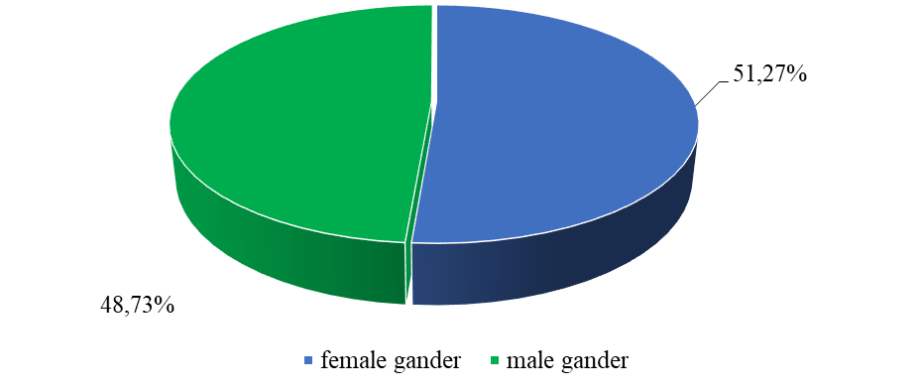
Fig. 1. Quantitative characteristic of the sample gender studies (n=236)

In terms of age, the majority of students (44.07% / 104 people) were aged 21 to 23 years. At the same time, at the age of 18 to 20 years - 35.17 % (83 people), and at the age of 24 to 26 years - 20.76 % (49 people)
The majority of students (37.29% / 88 people) were first-year students.

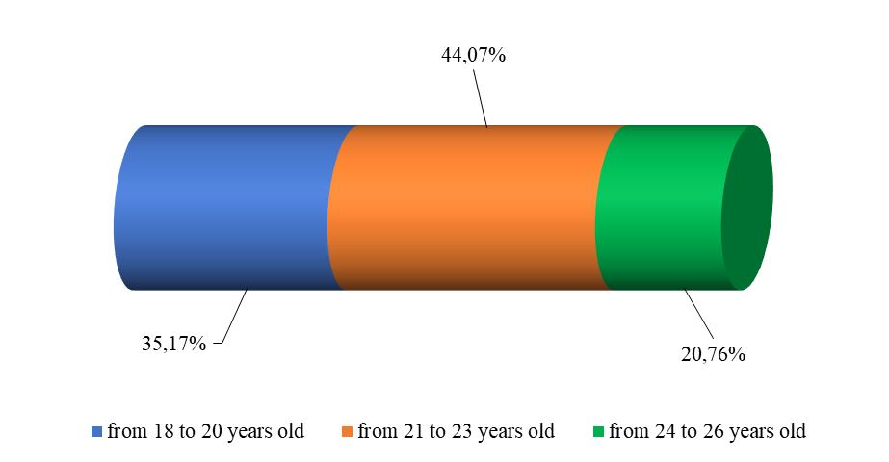
Fig. 2. Quantitative characteristic of the sample age-related studies (n=236)
Accordingly, the smallest number of students in the
sample of this study were representatives of the fourth year of study - 18.64% (44 people).

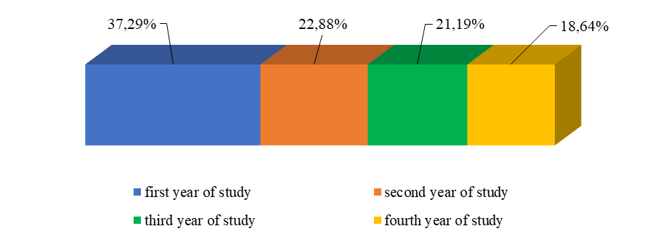
Fig. 3. Quantitative characteristic of the sample research on training courses (n=236)
RESEARCH RESULTS
Thus, the calculated indicators were distributed on the modified scale by graphical way (Fig. 4). So, the calculated arithmetic mean value (M=23.66) is located in the middle of the graphical distribution scheme and divides the second (II) interval in half. In addition, the arithmetic mean was taken as a reference point. To the right and left are measured the corresponding values equal to 0.75 (σ - sigma = 4.58) of standard deviation. As a result, to the right of the arithmetic mean, the third interval (III) is located equal from 29 points to 40 points, which corresponds to the above average level of development of ethnic self-consciousness of modern Karakalpak student youth.

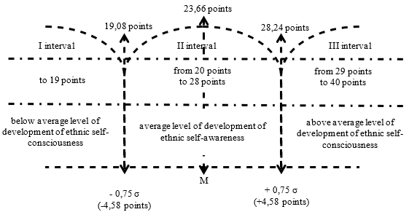
Fig. 4. Standardization of uniform indicators reflecting the level of development of ethnic self-consciousness of modern Karakalpak student youth (n=236)

In turn, the first interval (I) equal to 19 points is located to the left of the arithmetic mean, which corresponds to a below average level of development of ethnic self-awareness of modern Karakalpak student youth. Accordingly, the second interval (II) equal to 20 points up to 28 points reflects the average level of development of ethnic self-consciousness of modern Karakalpak student youth.
The conducted graphical distribution allowed us to prepare a standardized table of translation of uniform indicators into intervals that correspond to three levels of development of ethnic self-awareness of modern Karakalpak student youth (tab. 1).

Table 1. Standardized table of translation of unified indicators into walls reflecting the levels of development of ethnic self-consciousness of modern Karakalpak student youth
№ | Results of psychodiagnostic examination (four methods) on a single scale (single indicators) | Levels of ethnic self-awareness development
1 | 29 to 40 points | above average level of development of ethnic self-consciousness
2 | 20 to 28 points | average level of development of ethnic self-awareness
3 | up to 19 points | below average level of development of ethnic self-consciousness

Based on the standardization we interpreted the results of a comprehensive psychodiagnostic survey of ethnic self-awareness of modern Karakalpak student youth (tab. 2).

Table 2. The state of development of ethnic self-consciousness of modern Karakalpak student youth (n=236)
Levels of development of ethnic self-consciousness of modern Karakalpak student youth | Number of students | Percent
above average | 16 | 6,78
average level of development | 196 | 83,05
below average level of development | 24 | 10,17
Total | 236 | 100

Therefore, according to the results of the survey it was found out that the largest number of students (83.05% / 196 people) were the owners of the average level of development of ethnic self-consciousness. This category, as a rule, is more aware of belonging to its ethnic community, can realize itself as a corresponding ethnic representative and, as a consequence, its certain ethno-psychological features. Respondents of this group, as a rule, have predominant intentions to preserve cultural traditions of their ethnicity in their daily life activities. They are more oriented towards their ethnic community and consider the connection with them, their expectations, intentions, life plans. At the same time, in certain life situations the examinees may be in search of themselves as a subject of ethnic community and depending on a number of factors (their own intellectual development, social environment, education, upbringing, etc.), which have a direct influence on them as a person, different tendencies can be observed that determine their ethnic position in the future. Besides, in everyday life activity, as a rule, predominantly passive acceptance of foreign cultures is observed, which is characterized by acceptance of others at a distance, i.e. desire to perceive ethnic cultures as if isolated, in independent existence. These respondents need harmonization of their ethnic self-awareness.
Only 6.78% (16 people) of students were found at the desirable, above average level of ethnic self-awareness development. This category of respondents is aware of belonging to their ethnic community, understands the need to establish constructive interaction with other ethnic groups as a necessary determinant of enriching the culture of their own ethnic group and, thanks to this, their own culture. The surveyed see the enrichment of their inner world, their spiritual development in interaction and cooperation with other ethnic groups. As a rule, they strive to adhere to the rules, norms, and goals of their ethnic community, which is evidence of positive ethnic identity of ethno subjects. At the same time, the norms and rules of the ethnic community in most cases become their own norms and rules in various life situations, which is evidence of an above average level of reflection of their own life culture. These respondents, as a rule, have the readiness of personality to tolerant reaction to the environment in social interactions. They are characterized by tolerance to another way of life, behavior, customs, feelings, beliefs, values. As a rule, the examinees are willing and many are able to establish a constructive mutual dialog, taking into account cultural peculiarities.
10.17% (24 people) of the surveyed student youth were found to be at the undesirable, i.e. below the average level of ethnic self-awareness development. This category of the surveyed, as a rule, is not immersed in their ethnicity, they have not developed an adequate evaluation attitude towards their ethnic group, they mostly do not understand the importance of studying the historical past of the ethnic community, are not interested in its current state, etc. Respondents assimilate stereotypes of ethnic group behavior without ethnic reflection. In many life situations, the behavior of the surveyed can be characterized by impatient attitude towards representatives of a foreign ethnic community, development of negative judgments about other people's values and imposing their values on others. This category of respondents is in urgent need of harmonization of their ethnic self-awareness.
Along with the above, it is also worth noting that in the period of historical and societal changes, young people are more mentally vulnerable than other age groups of the population. This, first of all, concerns some phenomena of modernity - for example, "mass society", "mass culture" - which in the conditions of the crisis of traditional society often become factors in the worldview and values of modern youth, in particular students [5].
As it is known, in psychology student youth is considered as a separate social group (community), which can act as an independent effective social force. Modern student youth is not a closed, localized group; it is one of the channels of social movements in the structure of society as a whole. Student youth is distinguished from other groups by greater homogeneity in terms of age, unified cognitive activity, and value-orientation unity [4].
According to a number of researchers, the student age is a historical phenomenon associated with the intensive development of higher and specialized secondary education. This age period plays an important role in the social process of personality formation as the final stage of education, as the moment of a certain start in professional activity, in the assimilation of social (including ethnic and civil) functions and roles. Some of today's youth are actively looking for new values, but there are also those who nostalgically recall the lost values of their parents. The value orientations of modern student youth are often blurred. At the same time, samples of mass culture successfully penetrate into the consciousness of young people. This is due to the fact that, on the one hand, consciousness has not yet been formed in terms of life experience, worldview, self-identification of the individual, and on the other hand - mass culture is more oriented specifically to young people and their perception [21].
The modern world is no longer subject to the ways of evaluation offered by the older generation. Student youth have a need to reconsider their approach to life - this is one of the main causes of subcultural consciousness, characterized by the following signs: aggression, replaced by self-pity; distrust of accepted socio-cultural standards; refusal to evaluate the future and others. Culture is the cement of the building of social life, and values are the center of its spiritual life. Values cement social unity, integrity of the society, preventing destructive influence from the outside. The role of special ideological squeaks in the student environment is performed by social, in particular ethnic, values, which appear in the form of national-political ideals, ideas, value instructions, orientations. Performing an important role of integrating, socializing, communicative bases in the life of students and youth in general, such values ensure their spiritual and volitional unity, high level of self-consciousness and organization [18].
In conclusion of the study of the state of development of ethnic self-awareness of modern student youth, we conducted a correlation analysis of the results of psychodiagnostic examination by nonparametric Spearman's criterion (paired correlation) in SPSS. It showed that there was a very weak correlation between the indicators of the course of study of the surveyed students and their level of development of ethnic self-awareness (r=0,044 at p<0,01), as well as between the indicators of the age of student youth and their development level of ethnic self-awareness (r=0,005 at p<0,01). This may indicate the insufficient influence of the training process in higher educational institutions, as well as the natural maturation of the surveyed students on the development (harmonization) of their ethnic self-awareness.

Table 3. The results of correlation analysis of the results of psychodiagnostic study of the development of ethnic self-awareness of modern Karakalpak student youth (n=236)
№ | Names of analyzed attributes | Spearman's correlation coefficient at p<0.01
 | Course of study of student youth / Level of development of ethnic self-consciousness of student youth | 0,044
 | Age of student youth / Level of development of ethnic self-consciousness of student youth | 0,005

Thus, based on the above, it is reasonable to conclude that the results of psychodiagnostic examination (n=236) according to the selected psychometric methods, as well as the application of the developed three-stage standardized mechanism of generalization and interpretation of diagnostic data showed that the state of development of ethnic self-awareness of modern student youth needs proper targeted harmonization. This is evidenced by the fact that 10.17% (24 people) of the surveyed respondents were found to be at an undesirable (below average) level of ethnic self-awareness development. 83.05 % (196 persons) of the surveyed students had an average level of development of the studied attribute, which can be unstable, and only 6.78 % (16 persons) of the surveyed students revealed a desirable (above average) level of development of ethnic self-awareness. In addition, the conducted correlation analysis by nonparametric Spearman's criterion indicates the insufficient influence of the educational process (r=0.044 at p<0.01), as well as natural maturation (r=0.005 at p<0.01) on the proper development of ethnic self-awareness of modern student youth.
STUDY CONCLUSIONS
The conducted empirical study of structural and content bases of ethnic self-consciousness of Karakalpak student youth allows to formulate the following conclusions:
1. Based on the results of theoretical analysis of the positions of various modern scientists, a list of generalized structural components of ethnic self-awareness has been highlighted. At the same time, in order to clarify it in relation to modern Karakalpak student youth, an expert assessment (n=117) was organized and conducted using a specially developed questionnaire, which allowed, by means of calculating the average statistical indicators, fashion, and median, to identify the actual list of structural components covering at a high level of conformity ethnic identity, ethno cultural competence, ethnic tolerance, emotional and value attitude to their ethnicity, existential responsibility, moral and ethical values, reflection on moral and ethical situations, ethnic awareness, attitude to one's self, life attitudes, achievement motivation, personal maturity, moral and ethical responsibility, and other important individual-psychological features of personality.
2. The identified actual structure of ethnic self-consciousness of modern Karakalpak student youth allowed us to select a psychodiagnostic complex consisting of psychometric methods well-proven in psychological practice: the questionnaire of ethnic identity expression by J. Finney, the express questionnaire of tolerance index by G.U. Soldatova, O.A. Kravtsova, O.E. Khukhlaev, L.A. Shaigerova, the test-questionnaire of personal maturity by Y.Z. Gilbukh, the test-questionnaire of moral maturity by Y.Z. Gilbukh, the express questionnaire of tolerance index by G.U. Kravtsova, O.E. Khukhlaev, L.A. Shaigerova, Test-questionnaire of personal maturity Y.Z. Gilbukh, Questionnaire of diagnostics of the level of moral and ethical responsibility of personality I.G. Tymoshchuk. In this case, based on the conceptual approach of the authors of psychodiagnostic techniques regarding the studied properties and their structures, the classification of the selected structural components of ethnic self-consciousness of Karakalpak student youth was realized and the following four structural components were identified: ethnic identity, including ethnic awareness, knowledge and perceptions, ethno-cultural competence, emotional and value attitude to their ethnicity, the significance of membership in their ethnic community; tolerance, including ethnic tolerance, social tolerance, and tolerance as a personality trait; personal maturity, including achievement motivation, attitudes toward one's self, sense of civic duty, life attitude, and ability for psychological intimacy with another person; moral and ethical responsibility, including reflection on moral and ethical situations, intuition in the moral and ethical sphere, existential responsibility, altruistic emotions, as well as moral and ethical values.
3. The results of psychodiagnostic examination (n=236) according to the selected psychometric methods, as well as the application of the developed three-stage standardized mechanism of generalization and interpretation of diagnostic data showed that the state of development of ethnic self-awareness of modern student youth needs proper targeted harmonization. This is evidenced by the fact that 10.17% (24 people) of the surveyed respondents were found to be at an undesirable (below average) level of ethnic self-awareness development. 83.05 % (196 persons) of the surveyed students had an average level of development of the studied attribute, which can be unstable, and only 6.78 % (16 persons) of the surveyed students revealed a desirable (above average) level of development of ethnic self-awareness. In addition, the conducted correlation analysis by nonparametric Spearman's criterion indicates the insufficient influence of the educational process (r=0.044 at p<0.01), as well as natural growing up (r=0.005 at p<0.01) on the proper development of ethnic self-awareness of modern student youth.
REFERENCES
- Avksentiev V.A. Ethnopolitical identity in post-Soviet Russia as a factor of conflict. // Bulletin of the North Caucasus State Technological University. Series: Philosophy. 2004. - No. 1. - pp. 5-11.
- Agzamova E.Yu., Rakhimmirzaev S.B. Features of Adaptation of the Test-Questionnaire "Determination of the Propensity for Deviant Behavior" in the Republic of Uzbekistan. // Pedagogy and Psychology in the Activities of Law Enforcement Officers: Integration of Theory and Practice: Materials of the International Scientific and Practical Conference. St. Petersburg: St. Petersburg University of the Ministry of Internal Affairs of Russia. - 2022. - Pp. 9-20.
- Agzamova E.Yu., Rakhimmirzaev S.B. Features of the development of psychodiagnostic tools. Educational and methodological manual. - Tashkent: NUUz named after Mirzo Ulugbek, 2021. - 45 p.
- Alishev, B.S. On the Unity of the Value Foundations of Different Cultures. // Ethical Aspects of Education in the 21st Century. Materials of the International Scientific and Practical Conference. Kazan: TISBI. - 2001. - Pp. 9-13.
- Bart F. Ethnic Groups and Social Boundaries: The Social Organization of Cultural Differences. Moscow: Novoye Izdatelstvo, 2006, pp. 9-48.
- Gilbukh Yu.Z. Personal Maturity Test-Questionnaire. - Kiev: NTC Psychodiagnostics and Differentiated Education, 1994. - 24 p.
- Dvoryankina T.S. Standardization of a Technique for Diagnosing Current Personal Needs. // Bulletin of the Samara Academy of Humanities. Series: Psychology. - 2011. - No. 1. - Pp. 152-167.
- Dontsov, A.I. Psychology of Security. Textbook for Universities - M.: Yurayt Publishing House, 2023. - 269 p.
- Erokhina E.A. Ethnic self-awareness: a theoretical construct and a mental phenomenon. // New studies of Tuva. - 2017. - No. 3. – pp. 66-83.
- Idrisova Yu.A. Formation of Positive Ethnic Identity in Senior Adolescents: Abstract of Dissertation ... Candidate of Psychological Sciences. - Samara, 2007. - 25 p.
- Lopukhova O.G. Psychology of Ethnic Identity and Intercultural Communication. Textbook. - Kazan: Brig Publishing House, 2015. - Pp. 11-12.
- Maturazova Z.M. Structural and Contentual Foundations of the Ethnic Self-Awareness of Karakalpak Student Youth. // Bulletin of Integrative Psychology. – Yaroslavl, 2023. Part 1 – pp. 154-157. ISSN: 978-5-9527-02-16-5.
- Mukhamedova D.G. Socio-psychological Features of Effective Management Activities of an Education Manager. Methods and Technologies in Education - Voronezh, 2010 - No. 6. - Pp. 51-54.
- Narzikulova F.B. Model of the structure of the professional image of a modern teacher // Ilmyi tadqiqotlar axborotnomasi ilmiy-nazariy, uslubiy jurnali SDU. - Samarkand. - 2021. - No. 2 (126) - Pp. 112-118.
- Narzullayeva M.B. Socio-psychological features of constructive interaction of a manager in a conflict situation. // Abstract. diss. Doctor of Philosophy (PhD) on psych. Sciences.: 19.00.05, Tashkent, 2018. - 49 p.
- Sidorenko, E. G. Methods of Mathematical Processing in Psychology. - St. Petersburg: Rech LLC, 2002. - 350 p.
- Silivanova K.V., Vasenin G.A., et al. Diagnostics of the Ethnic Identity of Russian and Chinese Schoolchildren in the Context of the Formation of Interethnic Tolerance. // Uchenye Zapiski Universiteta Lesgafta. 2021. - No. 1 (191). - Pp. 427-436.
- Soldatova, G. U. Ethnic Self-awareness and Ethnic Identity. Ethnic Psychology: History and Methods: Anthology. St. Petersburg, Rech. - 2003. - Pp. 189-196.
- Tatarko A.N. Ethnic Identity, Group Status, and Settlement Type as Factors of Intergroup Intolerance. // Psychological Journal. - Vol. 26. - 2005. - No. 3. - Pp. 51-64.
- Timoshchuk I.G. Responsibility as a Result of Resolving a Spiritual Crisis // Journal of a Practicing Psychologist. - 2009. - No. 15. - Pp. 190-199.
- Khuseeva G.R. National Culture as a Factor in the Formation of Ethnic Identity among Adolescents from a Small Village in the Republic of Tatarstan. // Modern Social Psychology: Theoretical Approaches and Applied Research. - 2011. - No. 4. - Pp. 101-109.
- Sharapov V.V. Definition of Tolerance and Ethnic Stereotypes of the Population of Samara. // Ethnic Identity and Cross-Cultural Interaction of the Peoples of the Volga Region. - Kazan, 2003. - Pp. 172-175.

