Mathematical modeling of the capacity of space cooling systems using a solar absorption system
Anvar Anarbaev^{1,a}, Farrukh Mukhtarov^{1,2}, Abbos Kholiyorov³, Khabibulloh Norboev¹
¹ Tashkent state technical university named after Islam Karimov, Tashkent, Uzbekistan
²Tashkent Institute of Irrigation and Agricultural Mechanization Engineers, Tashkent, Uzbekistan
³ Termez state university of engineering and agrotechnologies, Termez, Uzbekistan
^{a)} Corresponding author: anizan6004@mail.ru
Abstract. The issues of use autonomous solar cooling systems based on absorption heat pumps were considered. The development of autonomous solar cooling systems based on absorption heat pumps has been demonstrated. This approach has been shown to achieve a payback on investments in solar collectors and other equipment within a few years, and also gives possibility reduce peak energy consumption by cooling units during the summer. Calculation of space cooling using the developed mathematical model takes into account the specific operating conditions of the building, such as variable air exchange, changes in internal heat gain, variable indoor air temperatures throughout the day, and hourly changes in outdoor air parameters during year.
INTRODUCTION
In Uzbekistan, economic incentives, primarily electricity and fuel tariffs, can encourage consumers to seek cost-effective solutions for energy consumption and energy sources. Therefore, it is necessary to develop technical solutions that ensure minimal average annual energy consumption, taking into account seasonal variations in system operating conditions. A cost-benefit assessment of proposed technical solutions is necessary. The primary energy efficiency criterion should be the primary energy utilization rate, taking into account the ratio of alternative energy sources. In this regard, it is necessary to consider the integrated use of refrigeration equipment and low-potential solar energy [1].
Indoor comfort depends on many factors, the most important of which are temperature and humidity. Traditionally, building cooling systems widely use compressor-type refrigeration units, in which the driving force is the mechanical energy generated by the electric motor that powers the compressor.
It's possible to harness solar energy, as on hot days when cooling is needed, solar radiation energy is at its most readily available, eliminating the need for energy storage. Rooms can be cooled by solar heat, using simple natural processes such as liquid evaporation [2].
The widespread adoption of solar cooling systems is more promising for Uzbekistan than compressor heat pump systems, because the maximum radiation falls precisely on those areas that actually need cooling, thus eliminating the problem of expensive storage.
Experience in developed countries [3,4] shows that the implementation of autonomous solar cooling systems allows for a return on investment in solar collectors and other equipment within a few years, and also helps reduce peak energy consumption by cooling units during the summer. It should be noted, however, that the inevitable rise in energy prices will alter the understanding of economical and uneconomical cooling and heating methods, leading to a shift in cost balances in favor of alternative solar energy sources for powering buildings.
In an absorption refrigeration system, the water supplied to the generator is heated by solar radiation to 80÷90°C. Typically, absorption refrigeration systems are designed for higher temperatures (120÷150°C), but technical improvements specifically designed for solar installations have made it possible to use low-grade heat [5]. A solar cooling system is based, as already mentioned, on the ability of lithium bromide to absorb water vapor and the ability of water to evaporate easily, making this system quite expensive. Water heated by solar radiation, used as a heat source, is supplied to the generator. Although there are differences in the described systems, their operating principle is identical [6].
It is necessary to develop technical solutions that ensure minimal average annual energy consumption, taking into account seasonal variations in system operating conditions, based on a cost-benefit assessment of the proposed technical solutions. The primary energy efficiency factor, taking into account the ratio of investments in alternative systems, should be the primary energy efficiency criterion. Therefore, it is necessary to consider the integrated use of refrigeration technology and low-potential solar energy.
The economic feasibility of using heat pumps is demonstrated by comparing various heating systems (Table 1). The calculation is based on space 235 m² of residential building. The required heat for heating (cooling) this building is 30 kWh.
Table 1. Technical and economic comparison of various heating systems
Heating source | Equipment type | Primary fuel efficiency | Cost per unit of fuel | The cost of 30 kWh of thermal energy
Heating with a heat pump
Electrical energy | Ground source vapor compression heat pump | COP = 3.5 | $ 0.085 / kWh | $0.729
Electrical energy | Vapor compression heat pump with heat source from outside air | COP = 2.2 | $ 0.085 / kWh | $1,159
Solar energy | Absorption heat pump, solar collectors | COP = 0.75 | $ 0.000 / kWh | $0.000
Heating with electricity
Electrical energy | Resistance heater | COP = 1.0 | $ 0.085 / kWh | $2,550
Heating with natural gas
Natural gas | Stove or boiler | 𝜂 = 80% | $0.055 / m3 | $2,074
Heating with liquid fuel
Fuel oil | Stove or boiler | 𝜂 = 80% | $0.063 / l | $2,333

As can be seen from this table, the use of an absorption heat pump with a solar thermal and electrical energy source allows for the complete elimination of carbon fuels and grid electricity. Heat and electrical energy are generated using a combined solar collector. The cost of a 30 kW absorption heat pump, including a cooling tower for cooling water, is $8,000. The cost of one combined solar collector, together with thermal and electrical energy storage, is $600-700. A heating (cooling) system with air heating (cooling) units for a house with an area of 235 m² costs equal $1,000-1,200 [8]. The use of an absorption heat pump with a solar energy source payback for itself, as shown in [9], in 4-4.5 years. The service life is 25 years. As the analysis shows, the use of energy-efficient solar cooling technology with absorption refrigeration machines in the Uzbekistan is very promising in terms of saving organic energy resources in a residential complex.
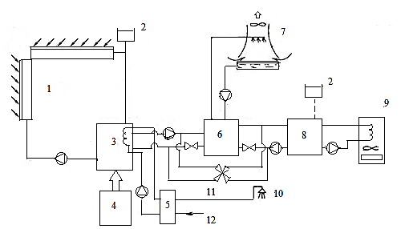
Fig. 1. Schematic diagram of a solar heating and cooling system with an absorption lithium bromide refrigeration machine: 1 - solar collector (water temperature in summer 90°C, in winter 60°C); 2 - expansion tank; 3 - first-stage thermal water accumulator with a capacity of 1 m³; 4 - electric heat generator with a power of 10 kW; 5 — heat generator for additional heating of water in the hot water supply system, 6 — absorption lithium bromide refrigeration machine (cooling water from 10 to 15°C, water flow rate of 1200 l/h, water flow rate through the cooling tower of 3820 l/h at a temperature of 35°C; water flow rate through the collector of 1850 l/h at a temperature of 85°C; 7 — fan cooling tower; 8 — second-stage heat accumulator, with a capacity of 8 m³; 9 — fan convector; 10 — hot water supply system piping network; 11 — four-way valve; 12 — tap water supply [10].
An absorption heat pump generating 100 kWh consumes no more than 1.5 kWh of electrical energy. This energy is used to drive the solution pump and two water circulation pumps.
RESEARCH METHODS
It is advisable to carry out calculations of the annual consumption of thermal energy for heating and cooling of building premises using a developed mathematical model that takes into account the features of the operating mode of the premises, such as variable air exchange, changes in internal heat input, variable indoor air temperatures during the day, as well as the features of hourly changes in outdoor air parameters during the year [11].
Considering of the possible results of applying this idea at the design stage using the example of calculating the capacity of a cooling system for an industrial building with increased requirements for the accuracy of maintaining a given indoor air temperature t_{air}.
Initial data: The room is located on the first floor of a building and has two external walls facing south and north. It is located in Tashkent. The calculated outdoor air temperature is t_{amb} = +26.4°C. The outdoor air temperature fluctuates between the maximum (t_{amb_max}) and the minimum (t_{amb_min}) with a difference of Δt_{amb} = 11.4°C.
The volume of the room is 10800 m³, internal heat input during working hours Qв = 32.4 kW, air exchange rate determined from the condition of compliance with sanitary standards n = 4, tv = +20 °C.
Wall construction: brickwork thickness δ = 0.51 m, URSA insulation, δ = 0.06 m, thermal conductivity coefficient λ = 0.042 W/(m °C).
The floor is insulated with expanded clay concrete insulation, δ = 0.06 m, λ = 0.24 W/(m °C). Double glazing (the second glass is heat-reflective), heat-transfer resistance is 0.48 (m °C)/W.
The calculations were carried out using the TRNSYS-17 program [12] based on the condition of maintaining a constant temperature t_{air} both during working and non-working hours.
In any case, the dynamics of changes in cooling costs for supply air and room cooling will differ. The model's block diagram is shown in Figure 1. It depicts a hybrid system with a primary absorption heat pump operating with solar thermal collectors to heat the generator by separating the working mixture with the refrigerant, and a backup absorption heat pump unit activated by gas combustion when solar radiation levels are insufficient. This system is based on solar radiation and outdoor air temperature data for the first week of January for Tashkent.

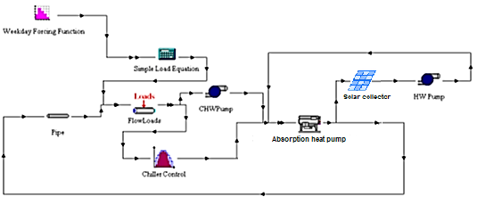
Fig. 2. Block diagram of the mathematical model of room cooling
RESEARCH RESULTS
Figure 3 presents the simulation results in the form of graphs of room temperature changes under specified external conditions and the required cooling load. The abscissa axis represents the simulation time in hours during the non-heating period. From May to September, the cooling load capacity can vary significantly, and load fluctuations can occur within a single month [13].

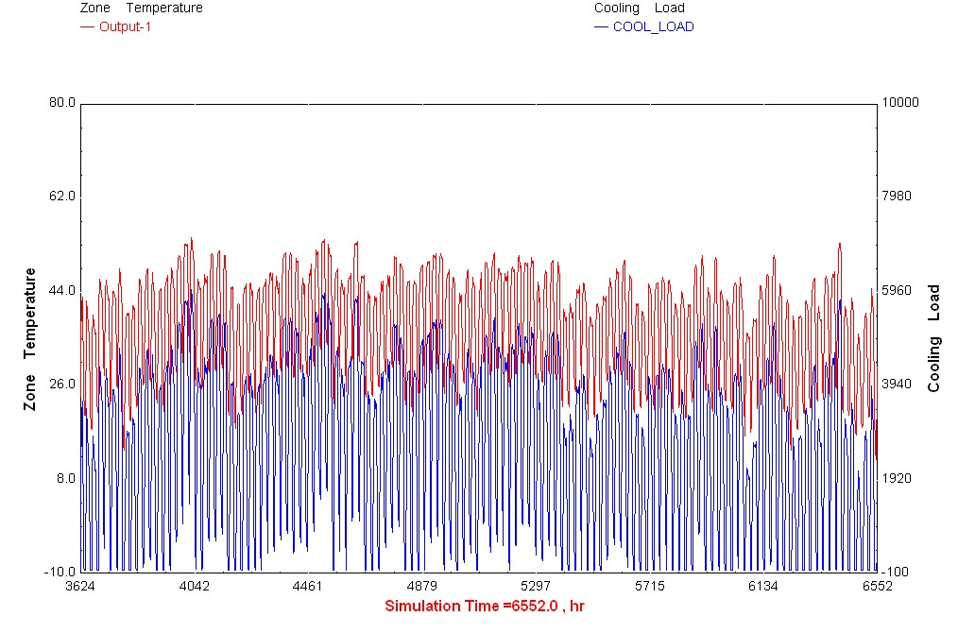
Fig. 3. Results of room cooling simulation in Tashkent for July

The share of maximum hourly inflows from solar radiation Q_{.max_s.r} in the total heat balance is 26.1%.
Fig. 3 shows the dynamics of changes in the cooling system capacity in relative values Q_{c} during the estimated day (July) for one-, two- and three-shift operation.
Q_{c} = Q_{c.min} / Q_{c.max}, (1)
where Q_{c.min}, Q_{c.max} – minimum and calculated (maximum) capacity of the cooling system.
Qx=Qxп+Qxв, (2)
where Q_{c.r}, Q_{c.a} are the cold consumption for cooling the room and the supply air, respectively.
Table 2 provides comparisons of a number of calculated indicators.
Table 2. Calculation results
Number of shifts | Q_{int} + Q_{.max_s.r} / Q_{c.h} | Q_{c.min} / Q_{c.h} | ∆Q_{c.f.}/ Q_{c.aver},% | Qxir/ Q_{c3} | Qxiр.п/ Q_{c3}
One | 2,740 | 0.112 | ±12.90 | 0.818 | 0.39
Two | 1,720 | 0.192 | ±11.14 | 0.882 | 0.69
Three | 1,152 | 0.300 | ±0.58 | 1,000 | 1.00

The following notations are used in it:
Q_{int}– internal heat gain; Q_{.max_s.r} – maximum hourly solar radiation gain; Q_{c.h} – maximum cold consumption for cooling the room, determined by this calculation; ∆Q_{c.f.} – amplitude of fluctuation of cold consumption for cooling the room from the average daily consumption Q_{c.aver}; Q_{ci} – cold consumption for one- and two-shift operation, Q_{c3} – for three-shift operation.
The data in Table 2 allow to draw the following conclusions:
1. Determining the capacity of the cooling system based on maximum heat input (Q_{air} + Q_{.max_s.r}) significantly overestimates its value (especially during one- or two-shift operation).
2. Daily fluctuations in cooling costs are determined mainly by changes in the outside air temperature [14]. The amplitude of change in the cooling requirement for a room ∆Q_{c.f.} is small, but for rooms with a greater degree of glazing and with less thermal inertia of the enclosing structures it can be significant.
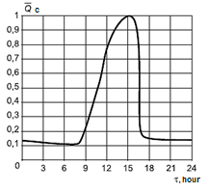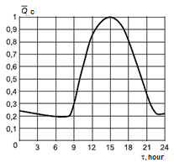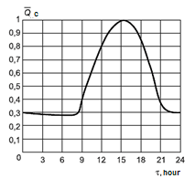
- b) c)
Fig. 4.a) Daily change in refrigeration load during single-shift operation (working period from 8:00 to 16:00); b) Daily change in refrigeration load during two-shift operation (working period from 8:00 to 00:00); c) Daily change in refrigeration load during three-shift operation

Therefore, calculations were made for two possible cases in July.
1. Minimum temperature t_{a_min} = +40°C, maximum t_{a_max}= +47.5°C. Cloudy weather.
2. t_{a_min}=+23°C, t_{a_max} =+32.9°C. Partly cloudy. With 24-hour cooling.
The calculation results show that switching the heat exchangers from heating to cooling mode and vice versa requires time, during which transient processes in the air handling system may disrupt the room's temperature regime. To eliminate this phenomenon, appropriate solutions, pre-planned in the design, are required [15]. Similar calculations conducted for single- and two-shift operation showed that, with a combined scheme, significant energy expenditure is required to heat the supply air during non-working hours (Fig. 4), and with single-shift operation, also to cool it after the end of the shift for 3–4 hours [16]. Let us now consider how the calculation results can be used to analyze design options for the cooling system.
- Separate cooling system for supply air and room air.
The temperature of the supply air is taken to be equal to the temperature of the indoor air [17].
2. Combination of cooling with supply air (combined scheme).
Therefore, the use of a combined cooling system for single- and two-shift operation is impractical. Note that, at a design temperature of tнmax = +26.4°C, the costs of heating the supply air during non-working hours are low and are partially offset by the heat accumulated by the enclosing structures. If we limit ourselves to comparing options with outdoor air parameters, the conclusions may be contradictory. The feasibility of a combined cooling system for 24-hour operation should be determined based on a technical and economic analysis [18].
With a traditional calculation, it would hardly have been possible to identify the need to heat the supply air in July, much less change the operating mode of the heat exchangers (heating - cooling - heating) during the day.
These conclusions are also true for cases where artificial air cooling is not used. An example is the data on the need to take into account hourly changes in tн when calculating ventilation systems for the assimilation of excess heat, given in work [19]. The implementation of proposals [20] will allow taking into account the specifics of buildings for various purposes, for example, entertainment and catering. In these buildings, the maximum internal heat gain occurs in the evening (from 18.00 to 22.00, and sometimes later), i.e., during the period of lower outdoor air temperatures, compared to the so-called design hour. Thus, in Tashkent this decrease is: at 18.00 - 1.2 °C; at 20.00 - 4 °C; at 22.00 - 6.8 °C. Accordingly, both energy costs for cooling the supply air and the installed refrigeration capacities will be lower. At the same time, administrative and public buildings, as a rule, do not operate at night. Therefore, there is no need for them to make the above calculations in case of low temperatures t_{a} (around +10 °C) occurring in July at night.
Thus, the number of calculated climatic points (combinations of outdoor air parameters and solar radiation intensity) depends on the specific climatic conditions, the purpose of the premises, and the requirements for the air quality. Moreover, the calculations must take into account the annual (monthly) and daily dynamics of changes in the demand for heat (cooling) in the outdoor air.

REFERENCES
1. Anisimov S., Pandelidis D. Numerical study of the cross-flow heat and mass exchanger for indirect evaporative cooling // Proceedings of the Xth international scientific conference “Indoor Air and Environment Quality”, Budapest, May 13-20. 2012. - P. 149-156
2. Anarbaev AI, Zakhidov RA Assessment of the combined use of heat pumps and solar installations for energy
supply of residential buildings // International scientific journal “Applied Solar”, 2010, No. 4. P.19-24
3. Kokorin O. Ya. Modern air conditioning systems. Moscow: Physical and Mathematical Literature Publishing House. 2003. 272 p.
4. Chandrakant Wani, Satyashree Ghodke, Chaitanya Shrivastava. A review on the potential of Maisotsenko cycle in energy saving applications using evaporative cooling // International journal of advanced research in science, engineering and technology. 2012. Vol. 1. Issue 1. R. 15-20.
5. Anarbaev A.I., Zakhidov R.A. Combined heat and cold supply scheme with a heat pump and solar collectors. // International scientific journal “Applied Solar”, No. 3 (2014). P. 59-66
6. Böbel A. Energy dach. -Fassade.- Zaun.- Stapel.Systeme, Stand und Trend der Entwiklung, Beispiele, Wirtshaftichkeitfragen. Heizung, Lüftung, Haustechnik Klimatiesirung. 1982.No.6. P. 203-209.
7. Ward DS, Lof GOG, Uesaki T. Cooling subsystems design in CSU solar house 111. Solar Energy, 1978, v. 20.
Wilbur J, Mancini TR A comparison of solar absorption air conditioning systems. Solar Energy, 1976, v. 18. P. 251-263.
8. Kassem A.-WSEnergy and water management in evaporative cooling systems in Saudi Arabia Resources. Conservation and RecyclingVolume 12, Issues 3–4 November 1994. P. 135-146.
9. Anarbaev AI, Zakhidov RA, Ivanisiva AR Research to determine optimal parameters of solar heat pump system for building heat supply. AIP Conf. Proc. 3331, 020003 (2025)https://doi.org/10.1063/5.0306118
10. Anarbaev AI, Koroli MA Autonomous hybrid solar-heat pump for system heat-cooling in buildings. IOP Conf. Ser.: Mater. Sci. Eng. 1030(2021) 012178https://doi:10.1088/1757-899X/1030/1/012178
11. Butera F., Aste N., Adhikari RS, Del Pero C., Zanelli A.Wet Curtain Wall: A Novel Passive Radiant System for Hot and Dry Climates Energy Procedia. Volume 105. May 2017. P. 953-960
12. Manolakosa D., Panagakisa P., Bartzanasa Th., Bouzianas K. Use of heat pumps in HVAC systems for precise environmental control in broiler houses: System's modeling and calculation of the basic design parameters. Computers and Electronics in Agriculture. Volume 163, August 2019, 104876
13. Stepanov O., and Tretyakova P. Centralized Heating System with Heat Pumps. TPACEE-2016. MATEC Web of Conferences, 02016 (2016)
14. Vasilyev GP Heat pump heat supply systems (HSS) for consumers of thermal energy in rural areas // Thermal power engineering. Russia 1997. No. 4. P. 24–27.50
15. Dolinsky AA Alternative heat supply based on heat pumps: evaluation criteria // Industrial heat engineering. 2007. T.29. No. 6. P. 67-71.
16. Matsevity Yu. M. On the rational use of heat pump technologies in the economy of Ukraine // Energy saving, energy, energy audit. 2007. No. 3. P. 3-11.
17. Tsatsaronis D. Interaction of thermodynamics and economics to minimize the cost of an energy-converting system. Odessa: Negotiant Studio, 2002. 152 p.
18. Agapov D.S. Structural and parametric optimization of industrial heat engineering and technological equipment systems: dis. Dr. tech. Sciences: specialty 05.14.04 / DS Agapov. St. Petersburg, 2017. 340 p.
19. Bejan A., Tsalsaronics G. Moran M. Thermal Design and Optimization. New York; J. Wiley, 1996. 530 p.
20. Anarbaev A.I, Koroli M.A, Usmanov A., Soliev K. Exergoeconomic optimization of solar heat pump systems of heat supply. E3S Web of Conferences 216 (2021) 01125https://doi.org/10.1051/e3sconf/202021601125

