The scheme of electrode motion regulation device in electric steelmaking furnaces
Ikromjon Rakhmonov ^{1,2}, Makhzuna Korjobova ^{1, a)} Kamoliddin Obidov ³, Muzaffar Kholmurodov ⁴
¹ Tashkent state technical university named after Islam Karimov, Tashkent, Uzbekistan
² Termez State University of Engineering and Agrotechnology, Termez, Uzbekistan
³ Bukhara State Technical University, Bukhara, Uzbekistan
⁴Navoi State University of Mining and Technologies, Navoiy, Uzbekistan
^{a)} Corresponding author: mahzunaqorjobova@gmail.com
Abstract. This paper presents an intelligent electrode motion regulation system for electric arc steelmaking furnaces based on fuzzy logic control. The proposed system performs real-time regulation of electrode motion using direct measurements of arc current and voltage obtained from a transreactor installed in the furnace short network. A multi-stage control algorithm ensures stable maintenance of the arc length within optimal limits under nonlinear and rapidly changing operating conditions. The developed approach improves arc stability, reduces electrode breakage, and enhances the overall energy efficiency and technological performance of the steelmaking process.
INTRODUCTION
In the global steelmaking industry, increasing the efficiency of electrical energy consumption and identifying the key factors influencing the specific energy consumption per unit of product are among the most pressing challenges. One of the most essential factors affecting energy efficiency in electric arc furnace is the effectiveness of electrode motion regulation and control, which directly determines arc stability and melting performance [1, 2].
In developed countries, the average electrical energy consumption required to melt one ton of steel typically ranges from 380 to 420 kWh. In contrast, this indicator remains substantially higher in Uzbekistan, averaging 500–550 kWh per ton, which is approximately 1,3 times greater than the global benchmark. This gap highlights the need for technological improvements and advanced control solutions in domestic steelmaking processes [3,5].
In the global practice, extensive scientific research is being conducted to enhance electrode motion regulation and control systems in electric arc steelmaking processes [6]. These studies primarily focus on increasing melting intensity by accounting for the nonlinear characteristics of the technological process, ensuring stable regulation of electric arc parameters within prescribed limits, and improving production efficiency by reducing unplanned operational interruptions.
Also, reducing the frequency of electrode breakage remains a critical issue, as it is closely associated with the energy efficiency and reliability of electrode motion regulation and control systems [7, 8, 9]. Consequently, the development of advanced electrode regulation devices, comprehensive evaluation of their impact on technological performance, and the design of intelligent control models based on fuzzy logic systems are regarded as highly relevant and promising directions of modern research. In this context, particular emphasis is placed on the implementation of resource-efficient technologies, the application of optimal control strategies, and the development of intelligent electrode motion regulation methods aimed at reducing energy losses, improving process stability, and enhancing the energy efficiency of electric arc steelmaking processes [10, 11].

EXPERIMENTAL RESEARCH
To achieve the above-mentioned results, a schematic design of an automatic electrode motion regulation device based on an intelligent control model was developed for the electric arc steelmaking process (Figure 1).
Figure 1 presents the functional schematic diagram of the automatic electrode motion regulation device. In this scheme, the electric arc current and arc voltage are considered as variable input parameters, based on which the electrode motion regulation task is performed in real time. The proposed system is designed to ensure stable control of electrode movement in accordance with variations in arc parameters.
The scheme consists of three main functional components:
- a transreactor connected in series to the short-circuited network on the low-voltage side of the special furnace transformer;
- a sensitive unit responsible for detecting changes in arc current and voltage;
- a control block incorporating a controller based on a fuzzy logic control mechanism.
This structural configuration enables effective interaction between the measured arc parameters and the control system, providing adaptive and accurate regulation of electrode motion under the nonlinear operating conditions of electric arc steelmaking furnaces.
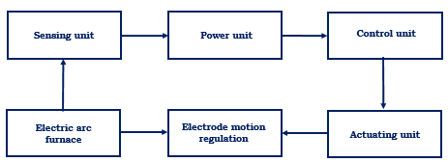
FIGURE 1. The functional schematic diagram of the electrode motion regulation system in the electric arc steelmaking process
The core principle of the proposed system is based on measuring the electric arc current in the primary winding of the transreactor, according to which the corresponding arc voltage generated in the secondary winding is automatically acquired. To implement this process, three sensing units (SU₁, SU₂, and SU₃) and three power switching units (PS₁, PS₂, and PS₃) installed in the control block are employed.
The actuating part of the system consists of the transreactor and the control block, which are connected as follows: the transreactor is connected in series with the furnace electrode circuit, while the control block is connected in parallel. This configuration ensures continuous signal exchange between the electric arc current and voltage of the electric arc furnace and the control system (see Figure 2).
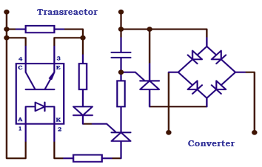
FIGURE 2. Configuration of the sensing unit in the electrode motion regulation system for electric arc steelmaking
The sensing unit operates based on an optocoupler configuration. The anode of the optocoupler light-emitting diode (LED) is connected to the first terminal of an auxiliary resistor, while its second terminal is connected to the corresponding optocoupler terminal. The auxiliary resistor and diode are connected in series. The cathode of the optocoupler LED is connected to the first plate of the capacitor through a resistor and the anode of a thyristor.
Structurally, each sensing unit consists of normally open optocoupler contacts, two thyristors, one diode, three main resistors, and one auxiliary resistor. These components enable the detection of predefined percentage variations in the arc voltage and convert them into control signals transmitted to the power switching units. The power switching units (PSUs) in the control block are composed of a thyristor, a diode bridge, and a capacitor. The anode of the thyristor is connected at a common node with the first and second diodes and is interfaced through the diode bridge. The cathode of the thyristor is also connected to a common node with the diodes. The anode of the first diode is connected to the cathode of another diode at a common node, through which the power stage is connected to the converter. The control electrode (gate) of the thyristor is connected to the first plate of the capacitor via a resistor, while the thyristor cathode is connected to the second plate of the capacitor. The remaining two power switching units are connected in an identical manner.
The operating principle of the proposed scheme can be described as follows. When the electrodes come into contact with the primary charge, an electric current flows through the short network, which induces an arc voltage in the secondary winding of the transreactor. Simultaneously, a control voltage appears at the gate terminals of the thyristors within the sensing unit, activating the optocoupler by turning on its light-emitting diode. As a result of the closure of the normally open optocoupler contacts, the auxiliary resistor is shunted, leading to a reduction in the return coefficient of the power switching units. Subsequently, the charged capacitor triggers the thyristors in the power stage. In response to the thyristor conduction, the converter becomes active and transforms the analog voltage signal into a digital representation.
The resulting digital voltage signal is then compared with a predefined reference value stored in the controller. If the measured voltage is detected to be below the specified threshold, the controller generates a corresponding control command, which is converted back into an analog signal via the driver circuit and transmitted to the electric actuators. In this manner, sufficient driving voltage is supplied to the actuators, enabling automatic regulation of electrode motion within the optimal limits of the electric arc length. Figure 3 illustrates the structural diagram of the electrode motion control system, including the conversion of signals from the power switching unit into digital form and their subsequent processing by the controller.
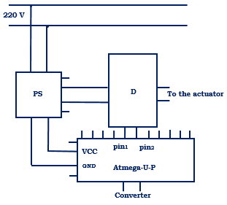
FIGURE 3. Structural diagram of the intelligent electrode motion control system in the electric arc steelmaking process
Figure 3 illustrates the schematic of the automatic intelligent control unit for electrode motion in the electric arc steelmaking process. The operation of the system begins with a 220 V mains supply, which is converted into a low-voltage power supply by the power supply unit (PSU). The stabilized low-voltage output of the PSU provides power to the controller (Arduino-U-P) through its VCC and GND terminals.
Input signals are fed to the controller via pins pin1 and pin2. These signals originate from sensors or signal converters that represent variations in the electric arc current or voltage. Based on the received input signals, the control algorithm preloaded into the controller is activated and executed. The control signal generated by the controller is then conditioned through a converter to obtain the required signal level and form, after which it is transmitted to the driver (D). The driver is responsible for controlling the electric actuators.
At the output of the driver, the generated control signal is supplied to the actuating mechanism responsible for electrode movement. As a result, the electrodes move upward or downward, maintaining the electric arc length within optimal limits. Thus, the proposed scheme enables automatic regulation of electrode motion in accordance with the electric arc state parameters, ensures arc stability, and contributes to improving the energy efficiency of the steelmaking process.
RESEARCH RESULTS
In order to evaluate the effectiveness of the proposed electrode motion regulation scheme, the operating logic and control sequence of the developed intelligent system were analyzed [12]. Based on the developed control algorithm, the electrode motion speed and direction are determined in compliance with predefined technological constraints, providing stable maintenance of the arc length within optimal limits throughout the steelmaking process. The operational sequence of the electrode motion regulation device and control system in the electric arc steelmaking process is illustrated in Figure 4. The algorithm presented in Figure 4 operates as follows.
At the initial “start” stage, the system is activated and the initial parameters are set: the reference voltage U₀=380 V, the initial electrode position l₀​, and the maximum permissible arc length l_{max}​=35±1 cm. According to the predefined condition, the arc current value in the short network is continuously monitored to determine whether it is equal to or exceeds 17 kA, while ensuring that the arc length remains within its optimal limits.
If the arc current reaches or exceeds 17 kA, a sufficient voltage level is generated in the sensing unit and transmitted to the control block of the device. Based on this signal, the electrode motion speed is regulated in three discrete stages, and the corresponding control command is sent to the driver via the controller. If the arc current is insufficient to sustain the melting of the charge, the algorithm transitions to the state K=False, and the control process is terminated. Otherwise, the electrode motion regulation process continues at 1 second intervals, maintaining the arc length within the optimal range and ensuring stable operation of the electric arc steelmaking process.

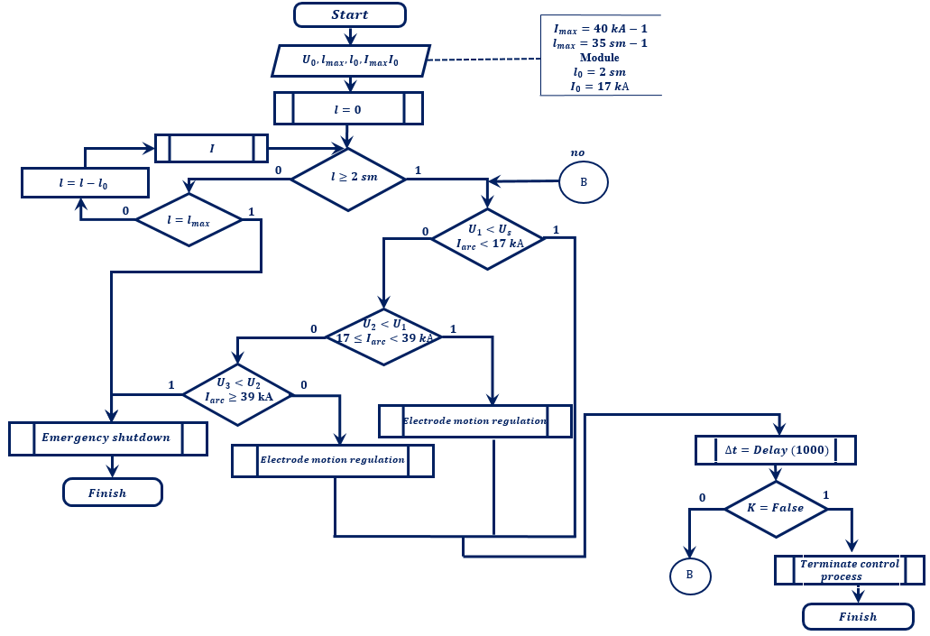
FIGURE 4. Operating algorithm of the electrode motion regulation scheme in an electric arc steelmaking process
Based on the presented algorithm, the operational logic and sequential control actions of the electrode motion regulation device in the electric arc steelmaking process were developed. The proposed control system continuously monitors the voltage of the 380 V bus bar of the special furnace transformer and the electric arc current parameters, and automatically adjusts the speed and direction of electrode motion accordingly. As a result, the arc length is stably maintained within predefined optimal limits, thereby improving the reliability, stability, and overall technological efficiency of the steelmaking process.
CONCLUSIONS
In conclusion, analysis of the operating sequence of the electrode motion regulation and control scheme shows that the proposed system enables regulation of electric arc current and voltage within narrow ranges. This approach reduces electrode breakage and ensures stable control of electrode motion, thereby enhancing the stability of the process and improving the overall intensity and efficiency of the electric arc steelmaking operation under normal operating conditions.
First of all the proposed system enables stable regulation of electric arc current and voltage within narrow operating ranges, even under conditions of rapid and nonlinear parameter fluctuations. Continuous monitoring of arc current (≥17 kA) and real-time adjustment of electrode motion ensure that the arc length is maintained within the optimal range of 35 ± 1 cm, which directly contributes to arc stability during primary charge melting.
Second, the three-stage discrete control of electrode motion speed, implemented through the transreactor–sensing unit–controller architecture, provides faster system response and improved regulation accuracy compared to traditional PLC-based or purely electromechanical solutions. This reduces delayed control actions that typically lead to arc instability and electrode–charge contact.
Third, the integration of a fuzzy logic–based controller allows the control system to adapt dynamically to changing technological conditions, resulting in reduced electrode breakage risk and improved operational reliability. By preventing excessive electrode movement and maintaining optimal arc conditions, the system minimizes unplanned process interruptions.
REFERENCES
- Ghiormez L., Prostean O., Panoiu M., Panoiu C. GUI for studying the parameters influence of the electric arc model for a three-phase electric arc furnace // IOP Conference Series: Materials Science and Engineering. – 2017. – Vol. 163. – 012026. – DOI: 10.1088/1757-899X/163/1/012026– International Conference on Applied Sciences (ICAS2016).
- Nápoles-Báez, Y., González-Yero, G., Martínez, R., Valeriano, Y., Nuñez-Álvarez, J. R., & Llosas-Albuerne, Y. Modeling and Control of the Hydraulic Actuator in an Electric Arc Furnace. SSRN Electronic Journal, January 2022. DOI: 10.2139/ssrn.4038242.
- Rakhmonov, I.U., Korjobova, M.F., Usmanov, E.G., Ushakov, V.Ya. Power regulation device for an electric arc steelmaking furnace // Patent for Invention, Federal Service for Intellectual Property (Rospatent), Russian Federation, 2025, No. 2845265.
- Rakhmonov I.U., Korjobova M.F. Analysis of Existing Methods for Regulating and Controlling Electrode Movement in the Steelmaking Process // Scientific and technical journal of Problems of Energy and Sources Saving, 2024, no. 4, pp. 17-23. https://doi.org/10.5281/zenodo.16932889
- Rakhmonov, I.U., Korjobova, M.F. Device for regulating electrode movement in electric arc steelmaking // Innovative Technologies, Scientific and Technical Journal, 2025, Vol. 58, No. 2, ISSN 2181-4732.
- Rakhmonov, I.U., Korjobova, M.F. Improving energy efficiency of electric arc steelmaking furnaces by reducing electrode breakage // In: Proceedings of the IV International Scientific and Technical Conference “Actual Problems of Power Supply Systems”, TSTU–KSU, 2024.
- Rakhmonov, I.U., Korjobova, M.F., Ushakov, V.Ya., Khoshimov, F.A. Mathematical modeling of electrode motion control in an electric arc furnace based on fuzzy logic // Bulletin of the Tomsk Polytechnic University. Geo Assets Engineering, 2025, Vol. 336, No. 9, pp. 212–226. https://doi.org/10.18799/24131830/2025/9/5150
- Rakhmonov, I.U., Korjobova, M.F. Improving the intensity of the steelmaking technological process based on fuzzy logic // Digital Technologies in Industry, 2025, Vol. 3, No. 3, DOI: 10.70769/3030-3214.SRT.3.3.2025.7
- Rakhmonov I.U., Korjobova M.F., Kholikhmatov B.B., Bazarbaeva A.X. The Mathematical Model of the Controlling Steel Smelting Process // Science and Education in Karakalpakstan. 2024 №4/1 pp. 107-112.
- Rakhmonov I.U., Korjobova M.F., Kholikhmatov B.B., Nimatov K.B./ The role of digitalization in improving energy efficiency in steel smelting in Uzbekistan // AIP Conference Proceedings. 2025. Vol. 3331. № 060009. https://doi.org/10.1063/5.0305889
- Rakhmonov I.U., Korjobova M.F., Kewnimjaeva A.Q. Analysis the Main Problems of electrodes in Electric Arc Furnaces // Science and Education in Karakalpakstan. 2023 №4/1 pp. 133-137.
- Rakhmonov I.U., Kholixmatov B.B., Korjobova M.F., Otepbergenov Sh.T. Research of the Problem of Voltage Asymmetry in the Operating Mode of an Arc Furnace // Science and Education in Karakalpakstan. 2024 №4/1 pp. 190-195.

