Control optimization methods for high-performance traction electric drives
I.K.Kolesnikov ¹, А.G.Saidkhodjaev ², Sh.N.Akbarhodjayev ³, S.H.Khakimov ¹, Saodat Alikulova ⁴
¹Tashkent State Transport University, Tashkent, Uzbekistan
²Tashkent state technical university named after Islam Karimov, Tashkent, Uzbekistan
³Renessans educational university, Tashkent, Uzbekistan
⁴ Karshi state technical university, Karshi, Uzbekistan
^{a)} Corresponding author: eldorgu777@gmail.com
Abstract. The article explores various approaches to control traction electric drives, focusing primarily on the scalar control method for induction motors. Additionally, the study delves into vector control systems for electric drives, examining both sensor-based control methods and those relying on mathematical models of electric motors. The adoption of a T-shaped substitution scheme for the induction motor serves as the basis for implementing the mathematical model. The research culminates in the development of a functional diagram for an energy-efficient direct torque control system for induction motors. The article provides insights into the efficiency-to-torque relationships within the context of energy-efficient control strategies..
INTRODUCTION
The primary approaches to optimize the control system of a traction electric drive include scalar control, frequency-current control, classical vector control, and direct torque control.
Scalar control of the induction motor involves manipulating scalar quantities, specifically the modules of frequency, voltage, currents, and magnetic fluxes. In this method, frequency serves as an independent variable, and the voltage value at a specified frequency determines the characteristics of the mechanical quantity.
For regulating asynchronous electric drives with a control range extending up to D=100:1, frequency-current control systems are employed to facilitate frequency starts, braking, and reversing. In instances where the speed control range is limited to D=10:1 with a static torque in the range of 5–10%, frequency parametric speed control is applied.
To construct high-quality closed-loop control systems for electric drives, considering the electric machine as a dynamic entity, the utilization of asynchronous electric drives with frequency-vector speed control is recommended. The objective of this scientific research is to explore vector control systems for electric drives, incorporating both direct measurement of controlled quantities through sensors and reliance on mathematical models of electric motors.
All control systems for electric drives with direct adjustments enable precise regulation of the electric drive coordinates. This precision is crucial as electric motor parameters tend to change during operation, deviating from the nominal values specified in the documentation. Such deviations can potentially introduce measurement errors.
EXPERIMENTAL RESEARCH
In the control system, the stator current serves as the factor influencing torque formation. By assessing the instantaneous values of stator current and stator voltage, the stator torque flux and the primary torque flux are determined. The functional configuration of the directly controlled drive is depicted in Figure 1.
The electric drive system with direct control does not involve multiple coordinate transformations. It comprises regulator blocks, a switching table, a phase sector computing unit, a phase voltage shaper, and an adaptive motor model. IR compensation is implemented to minimize the magnetic flux, maintaining a constant V/f ratio.
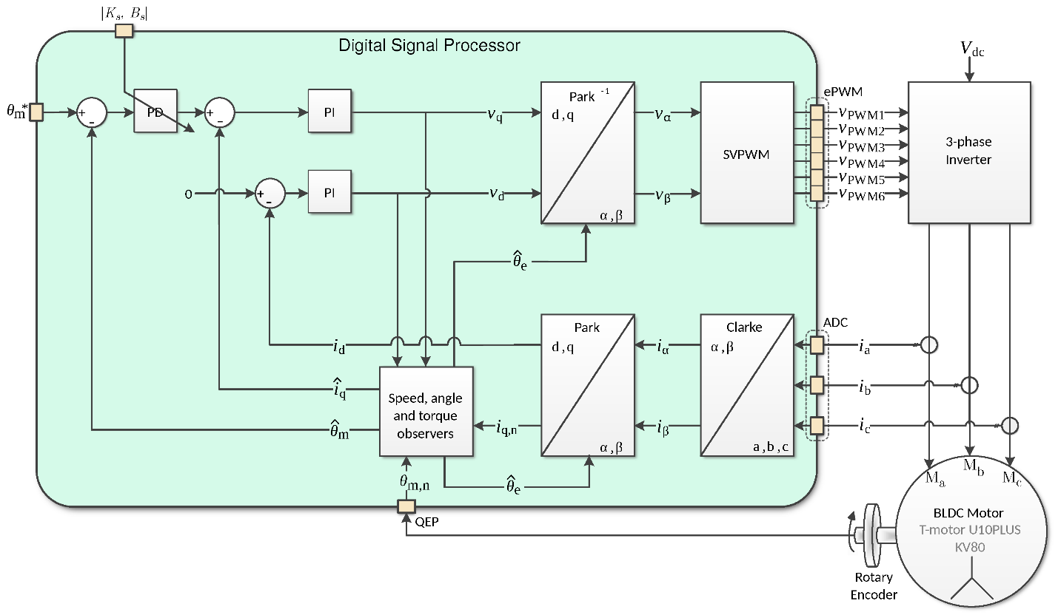
FIGURE 1. Functional diagram with direct control of the actuator

When operating at low frequencies, the effect on the change of stator winding resistance is influenced by the surface effect, which shows the impact on the operation of the electric drive.
Increasing the temperature of induction motor windings changes the electromechanical characteristics and control system parameters. Therefore, an IR compensation unit is introduced. The DTC (direct torque control) system is the optimal solution.
The power diagram of induction motor drive is shown in Fig. 2.
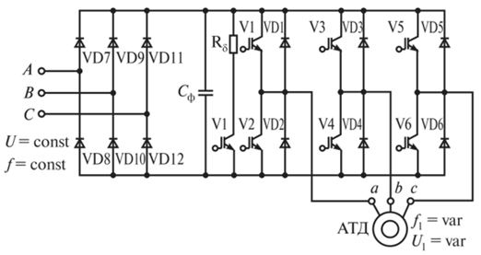
FIGURE 2. Power diagram of asynchronous electric drive

The power circuit includes a frequency converter, which includes a stand-alone inverter and an uncontrolled rectifier. The rotor flux-coupling and stator current; the main flux-coupling and stator current are taken as torque-formers.
The algorithm of minimum power consumption can be implemented in electric drives with constant load. When constructing the energy-saving algorithm, it is necessary to take into account that the critical moment:
$M_{m}=±\frac{pm_{1}U_{1}^{2}}{2ω_{1}\left[±r_{1}+\sqrt{r_{1}^{2}+{\left(x_{σ_{1}}+x_{σ_{2}}^{'}\right)}^{2}}\right]}$ (1)
U₁ - effective value of phase voltage of induction motor
ω₁=2πf₁ - phase current angular frequency
p- number of pole pairs
m₁- number of stator winding phases
r₁,r₂ ,x_{σ1} ,x_{σ2} - parameters of the T-shaped substitution diagram IM
By reducing the flux (voltage), the overload capacity of the induction motor is reduced. At the same time energy efficient control is realised. The electromagnetic torque equation of an induction motor with consideration of magnetoelectricity:
$M=\frac{3}{2}P_{n}\left|I_{S}\right|\left|Ѱ_{S}\right|\sin{θ_{S}}$ (2)
Ѳ₂- angle between stator current vectors I_{S} and stator flux-coupling vector Ѱ_{S}.
To realise the mathematical model, a T-shaped substitution diagram of an induction motor was adopted (Fig. 3).
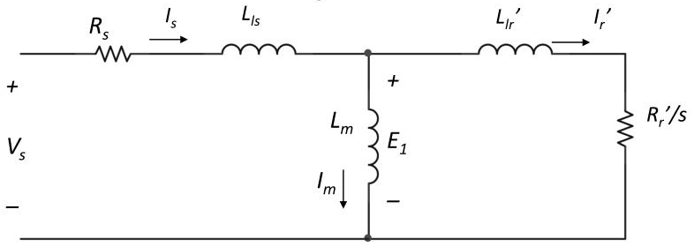
FIGURE 3. T-substitution diagram of an induction motor

Mathematical model system of induction motor:
$\left\{\begin{aligned}{\overline{U}}_{s}=R_{S}{\overline{I}}_{S}+\frac{{d\overline{Ѱ}}_{S}}{dt}+jω_{k}{\overline{Ѱ}}_{S} \\ {\overline{U}}_{R}=R_{R}^{'}{\overline{I}}_{R}^{'}+\frac{{d\overline{Ѱ}}_{R}}{dt}+j(ω_{k}-ω){\overline{Ѱ}}_{R} \\ {\overline{Ѱ}}_{S}=L_{s}{\overline{I}}_{s}+L_{m}{\overline{I}}_{R}^{'} \\ {\overline{Ѱ}}_{R}=L_{m}{\overline{I}}_{S}+L_{R}^{'}I_{R}^{'}\end{aligned}\right.$ (3)
U_{R} rotor voltage vector;
R’_{R} - reduced active resistance of the rotor
I’_{R} - reduced rotor current
Ѱ_{R} - rotor flux vector
U_{S} - stator voltage vector
R_{S} - stator resistance
I_{S} - stator current vector
Ѱ_{S} - stator flux vector
ω₁- angular frequency of the stator rotation magnetic field
ω - rotor angular speed
L_{m}- reduced mutual inductance between stator and rotor
L_{S}- stator phase inductance
L_{S}=L_{m}+L_{σS}, (4)
L_{σS} - stator dissipation inductance
L$'$_{R}- reduced inductance of the rotor phase
L$'$_{σR}- rotor dissipation inductance (reduced)
The equations in the system d - q, related to the rotor field taking into account the T-substitution scheme, take the form:
$\left\{\begin{aligned}U_{sd}=R_{S}I_{SD}+\frac{dѰ_{SD}}{dt}-jω_{k}Ѱ_{sq} \\ U_{sq}=R_{S}I_{SQ}+\frac{dѰ_{sq}}{dt}+jω_{k}Ѱ_{sd} \\ 0=R_{R}I_{Rd}+\frac{dѰ_{rd}}{dt}-\left(ω_{k}-ω\right)Ѱ_{rq} \\ 0=R_{R}I_{rq}+\frac{dѰ_{rq}}{dt}+\left(ω_{k}-ω\right)Ѱ_{Rd} \\ {\overline{I}}_{m}={\overline{I}}_{s}+{\overline{I}}_{R} \\ {\overline{Ѱ}}_{s}={\overline{Ѱ}}_{m}+{\overline{Ѱ}}_{σs} \\ {\overline{Ѱ}}_{R}={\overline{Ѱ}}_{m}+{\overline{Ѱ}}_{σR} \\ {\overline{Ѱ}}_{m}=L_{m}{\overline{I}}_{m}\end{aligned}\right.$ (5)
A functional diagram of an energy-efficient direct torque control system of an induction motor was developed (Fig. 4).
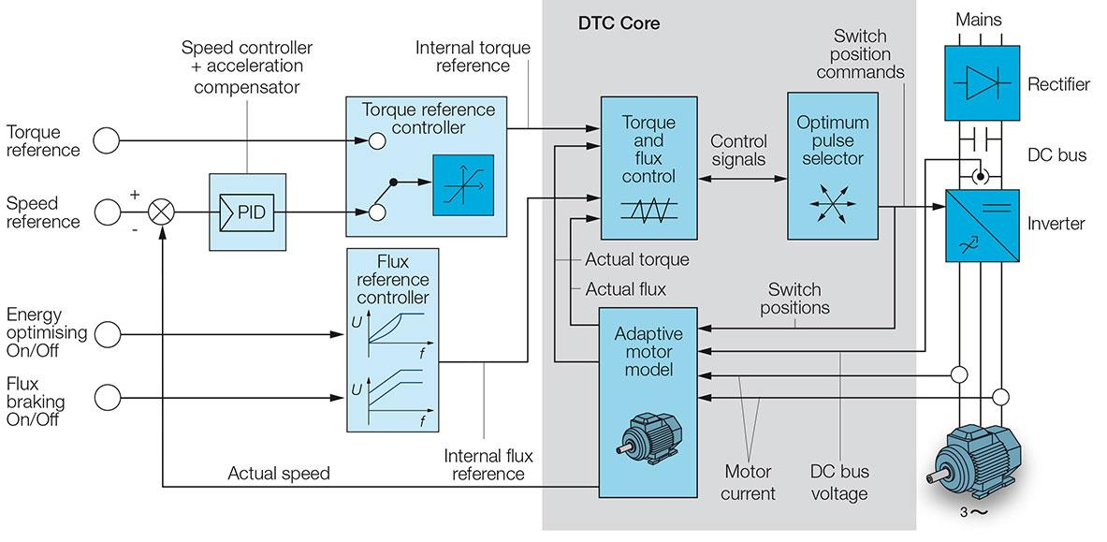
FIGURE 4. Energy efficient functional system for direct control of induction motor

The functional system consists of a speed reference ω3 (block 1), which comes from the high level system, then the speed reference from the driver controller is fed to the speed reference calculation block BVZS. This block determines the frequency limit and also sets the accelerations of wheelsets ai ora0. Accelerations are formed in the BAU adaptation block, where ai is directed to increase in the traction mode, and "a0" is directed to decrease the acceleration in the traction mode.
In traction mode
a₁=a_{l}+$∆$a_{k1}
a₀=a_{l}+$∆$a_{k2},
In braking mode
a₁=a_{l}-$∆$a_{k1}
a₀=a_{l}+$∆$a_{k2},
а_{l} - locomotive acceleration
а₁ и а₂ - wheel acceleration task
$∆$а_{k1}, $∆$а_{k2} are determined by the motion condition.
The flux-circuit setting logic unit (FSLU) allows the transition from the traditional flux-circuit change to the energy-saving law (and vice versa). The operating algorithm of the FSLU is shown in Fig. 5.
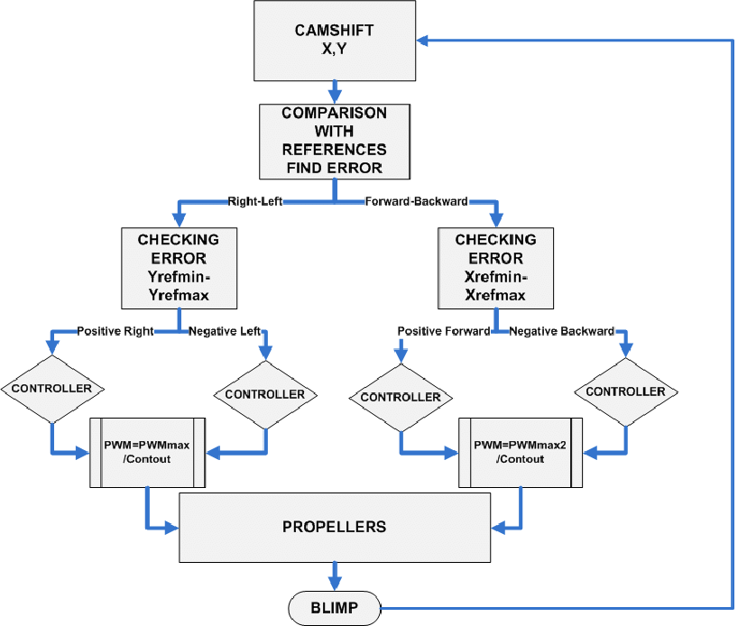
FIGURE 5. Algorithm of functioning of the logic block for setting the flux-coupling

Strategies for achieving optimal control of a traction electric drive system encompass a range of methodologies. The techniques employed to optimize the control system of a traction electric drive include:
1. Proportional-Integral-Derivative (PID) Control:
PID control is a widely adopted method that fine-tunes the system by adjusting control inputs based on proportional, integral, and derivative terms.
2. Model Predictive Control (MPC):
MPC leverages a dynamic model of the system to predict future behavior, allowing for the optimization of control inputs while considering constraints and expected trajectories.
3. Sliding Mode Control (SMC):
SMC maintains the system on a designated sliding surface, enhancing resilience against uncertainties and disturbances.
4. Fuzzy Logic Control:
Fuzzy logic control employs linguistic variables and rule-based reasoning to emulate human decision-making, particularly effective for handling system uncertainties and nonlinearities.
5. Optimal Control Techniques (LQR, LQG):
Linear Quadratic Regulator (LQR) and Linear Quadratic Gaussian (LQG) methods optimize a cost function, taking into account system dynamics and noise, and are suitable for linear systems.
6. Neural Network-Based Control:
Neural networks approximate intricate, nonlinear mappings in the control system, adapting and learning from the system's behavior.
7. Adaptive Control:
Adaptive control adjusts control parameters based on changing system dynamics, particularly beneficial when dealing with uncertain or time-varying parameters.
8. Energy-Based Control:
Energy-based control focuses on optimizing energy consumption, essential for applications where energy efficiency is a critical factor.
The selection of the optimal control method hinges on the specific requirements, characteristics, and constraints of the traction electric drive system. Frequently, a blended or integrated approach utilizing multiple methods is employed to effectively address various aspects of the control challenge.

CONCLUSIONS
1. Computer models of asynchronous traction electric drive with energy-efficient control have been developed.
2. Methods of modelling of static and dynamic modes of traction electric drive are determined.
3. The mathematical model of the traction electric drive with the use of energy-efficient direct measurement of controlled quantities is developed.
REFERENCES
- Z. Stević and M. Rajčić-Vujasinović, “Supercapacitors as a Power Source in Electrical Vehicles,” in Electric Vehicles – The Benefits and Barriers, Book 1, edited by S. Soylu (Intech, Rijeka, 2011).
- P. S. Machulin, “Modern problems of electric drive development,” Molodoi Uchenyi 10(114), 273–275 (2016) (in Russian).
- O. V. Nos, “Optimal vector control of an induction motor according to the minimum stator current criterion,” in Proceedings of the Third International Scientific and Technical Conference ‘Electrical Engineering, Electromechanics and Electrotechnology (EEE–2007)’ (Novosibirsk State Technical University, Novosibirsk, 2007), pp. 79–85 (in Russian).
- A. Akhmedov, G. Sauchuk, N. Yurkevich, S. Khudoyberganov, M. Bazarov, and K. Karshiev, “The influence of production conditions on the electrophysical parameters of piezoceramics for different applications,” E3S Web of Conferences 264, 04020 (2021).
- S. Kh. Khakimov, “Evaluation of the efficiency of an induction motor based on energy supplied from the source,” in Proceedings of the 66th International Scientific Conference of Astrakhan State Technical University (Astrakhan, 2022), pp. 684–686 (in Russian).
- I. K. Kolesnikov, A. P. Akhmedov, and S. H. Hakimov, “Electric drive efficiency criterion for specific energy consumption,” BNTU, Minsk (2023).
- I. K. Kolesnikov, G. S. Abidova, and S. H. Khakimov, “The choice of a generalized criterion for the efficiency of an automated electric drive of a railway rolling stock,” in Intelligent Systems for Industrial Automation (WCIS 2022), Lecture Notes in Networks and Systems, Vol. 912 (Springer, Cham, 2024), Article 34. https://doi.org/10.1007/978-3-031-53488-1_34
- U. T. Berdiev, I. K. Kolesnikov, M. N. Tuychieva, F. F. Khasanov, and U. B. Sulaymonov, “Methods of new technological developments of electric motors based on soft magnetic materials,” E3S Web of Conferences 401, 03038 (2023). https://doi.org/10.1051/e3sconf/202340103038

