Simulation Modeling and Analysis of Electrical Distribution Networks
Eldar Usmanov¹, Bakhtiyor Khusanov^{1, a)}, Farxod Shakarov ¹, Munisa Sobirova ²
¹ Tashkent state technical university named after Islam Karimov, Tashkent, Uzbekistan
² Karshi state technical university, Karshi, Uzbekistan
^{a)} Corresponding author: husanovbaxtiyor7@gmail.com
Abstract. In this article, a simulation model of a low-voltage electrical distribution network is developed using MATLAB Sim Power Systems. The study analyzes the effects of uneven single-phase loads on voltage unbalance, neutral conductor current, and power losses. The results show that increasing load power leads to voltage asymmetry and additional losses, highlighting the usefulness of simulation methods for improving power quality and reducing energy losses.
INTRODUCTION
Electric distribution networks supply electrical energy to industrial, non-industrial, agricultural, and residential consumers. A characteristic feature of the operation of the electric distribution network complex within the power system is that the total length of distribution lines is significantly greater than that of transmission lines of higher voltage classes. The reliability of power supply and the quality of electrical energy delivered to consumers depend on the proper selection of distribution network configurations and parameters, as well as on the effectiveness of operating mode control [1].
For the analysis and standardization of losses, it is recommended to use an extended structure of electrical energy losses, in which losses are classified into components according to their physical nature and the specific features of the methods used to determine their quantitative values.

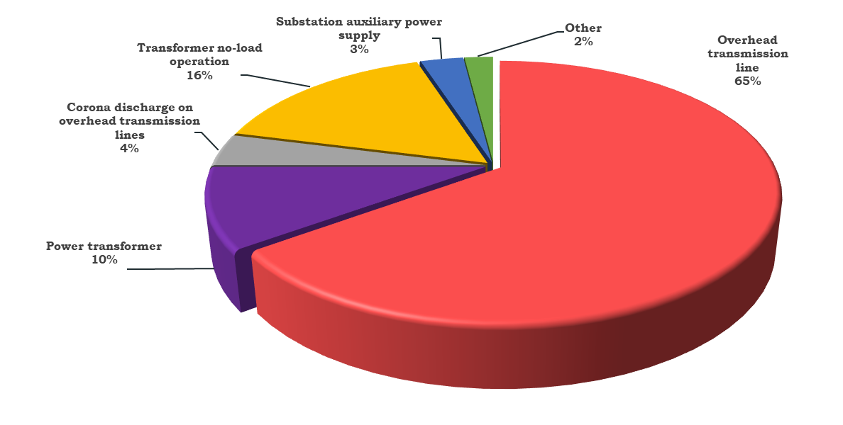
FIGURE 1. Cartogram of the shares of components of technical electrical energy losses

Figure 1 presents a cartogram illustrating the percentage distribution of the components of technical electrical energy losses. The analysis shows that losses caused by load effects in electric transmission lines constitute a relatively large share of the total losses. This indicates that, for the given facility, conducting research aimed at reducing electrical energy losses can be considered technically justified and practically effective [1-5].
Simulation models of low-voltage distribution networks make it possible to carry out theoretical studies that are close to real operating experiments. Such studies include the stages of experiment planning, implementation of simulation experiments, and analysis of the obtained results followed by drawing conclusions. The main features of these theoretical investigations are as follows:
-the use of virtual measuring devices to obtain information on the instantaneous parameters of circuit elements;
- presentation of simulation results in the form of oscillograms and time-domain characteristics, which improves the convenience of analysis;
-determination of electrical circuit parameters that are difficult to measure under actual operating conditions;
-investigation of rapid variations in load and other dynamic processes that are difficult to reproduce in practice (for example, the response of electric motors); and the possibility of conducting studies under the influence of various interference factors [5].

EXPERIMENTAL RESEARCH
At the present stage, computer technologies, mathematical software tools, and digital solutions that enable the execution of complex calculations and simulation processes are widely used for the analysis and modeling of distribution power networks operating under various load conditions [2,14,16,33].
In the development of simulation models for low-voltage distribution networks, the MATLAB software environment and its SimPowerSystems computational package, which are widely applied in the field of electric power engineering, are utilized. This software environment provides the capability to model distribution networks with different types of loads. The block diagrams of distribution networks, transformers, and loads available in the SimPowerSystems library make it possible to solve complex differential equations and to analyze the dynamic processes occurring within the network.
When modeling an electrical network using the standard blocks of MATLAB, it is necessary to input parameter values calculated on the basis of the initial data of low-voltage network elements. Table 1 presents the parameters of the TM-630/10 transformer determined from its initial data in accordance with the calculation expressions given in the appendices. Similarly, the calculated parameters of overhead power transmission lines, obtained using the corresponding expressions provided in the appendices, are summarized in Table 2 [3,25,27].

TABLE 1. Parameters of the TM-630/10 transformer
Rated apparent power, kVA | Catalog data |  |  |  |  |  | Calculated data
Rated apparent power, kVA | Rated voltage, kV |  | U_{k}, % | ΔР_{kt}, кW | Р_{s}, кW | I_{s}, % | R_{Т1},  Ω | R_{Т2},  Ω | Х_{Т1},  Ω | Х_{Т2},  Ω | L₁,  H | L₂,  H | R_{µ},  Ω | L_{µ},  H
Rated apparent power, kVA | HV | LV
630 | 10 | 0,4 | 5,50 | 7,10 | 1,47 | 2,00 | 1,79 | 0,.003 | 8,73 | 0,014 | 0,028 | 0,00004 | 68,03 | 0,025

TABLE 2. Estimated value of air line parameters of brand A25
 | Catalog data |  |  |  | Calculated data
Line type | $r_{o}$, Ω /km, | $x_{o}$, Ω /km, | I_{p}, А | length of the line section, m | R, Ω | Х, Ω | L, H
А 25 | 1,28 | 0,363 | 135 | 30 | 0,0384 | 0,01 | 0,0000347

A study based on a rural electric distribution network is considered, and its simulation model developed in MATLAB SimPowerSystems is presented in Figure 2. The simulation modeling of the electrical distribution network was carried out for an overhead power transmission line (OHL) with a total length of 2,2 km and an A-25 conductor type.
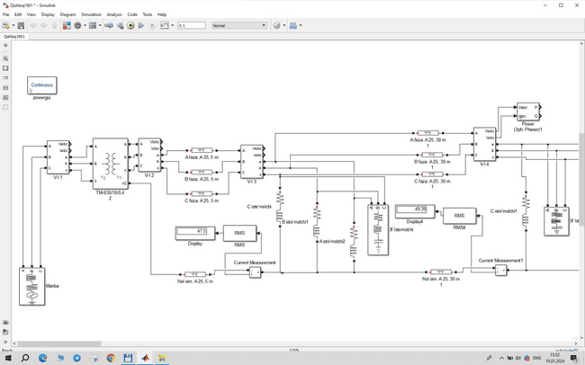
FIGURE 2. Simulation model of a low-voltage electrical distribution network with a TM-630/10 kV transformer

Figure 2 shows a simulation model of the electrical networks supplied from the transformer substation. A distinctive feature of these networks is the presence of various types of single-phase residential loads distributed along long line sections. This operating condition leads to load unbalance and voltage deviation, which consequently results in additional power losses.
RESEARCH RESULTS
Based on the voltage values measured at the poles of Feeder 1 of Substation No. 443 obtained using the Powergui block (Figure 3), the voltage unbalance factors were determined, and the corresponding calculation results are presented in Figure 4.
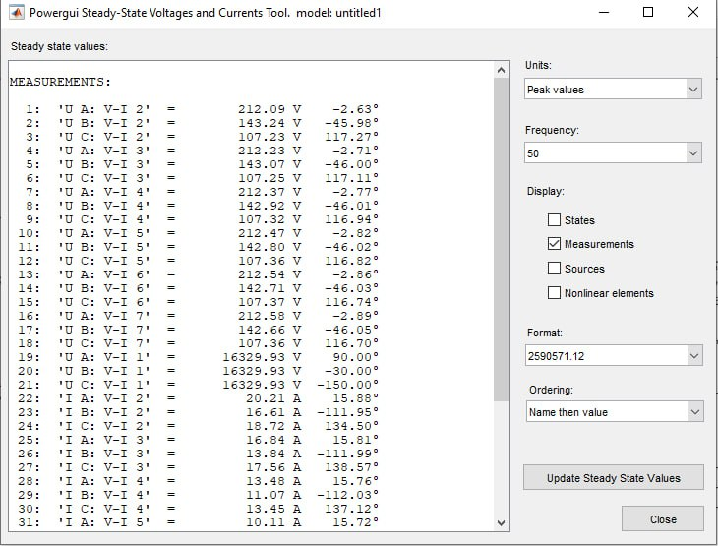
FIGURE 3. Results of network state calculation using the Powergui block
The analysis of the graph constructed based on the post-processing of the simulation modeling results indicates that, in certain sections of the network, the values of the unbalance coefficients exceed the permissible regulatory limits. Figure 4 illustrates the variation of voltage unbalance factors along the overhead line. It can be observed that both negative-sequence and zero-sequence components increase gradually with the distance from the substation and reach their maximum values in the middle sections of the feeder. In the downstream sections, a partial reduction of the unbalance factors is noted; however, their values remain relatively elevated. This behavior indicates a non-uniform distribution of single-phase loads along the line and confirms the presence of voltage asymmetry in the network.
а)
b)
FIGURE 4. Variation of the voltage unbalance factor of (a) negative-sequence and (b) zero-sequence components in the electrical network
CONCLUSIONS
The data obtained from simulation studies conducted on a low-voltage electrical distribution network indicate that, in a 0.4 kV network, when the maximum power of single-phase loads is increased up to 7.1 kW, the current in the neutral conductor varies within the range from 0,4 A to 8,15 A. In addition, the voltage unbalance factor of the zero-sequence component (Figure 4) was found to vary in the range of 2–6% [13-20, 7, 1].
1 Simulation modeling of the low-voltage electrical distribution network has shown that the uneven distribution of single-phase loads along long feeder sections leads to significant voltage unbalance and increased neutral conductor current.
2.The obtained results indicate that, in certain sections of the network, the negative-sequence and zero-sequence voltage unbalance factors exceed permissible limits, which results in additional power losses and deterioration of power quality.
3.The study confirms that the use of MATLAB SimPowerSystems is an effective tool for analyzing operating conditions of low-voltage distribution networks and for substantiating technical measures aimed at reducing electrical energy losses and improving voltage quality.
REFERENCES
- Bessonov L.A. Teoreticheskie osnovy elektrotekhniei, M., Garlariki, 2002.-638p.
- M.S.Levin, A.Ye.Muradyan “Quality of electricity in the rural network", Moscow, “Энергия”-1975 y., 224 P.
- Usmanov E.G., Khusanov B.M. E3S Web of Conferences. 216 (2020) 01161. https://doi.org/10.1051/e3sconf/202021601161.
- Erejepov, M., Novikov, A.N., Khusanov, B.M., Seytmuratov, B., Sayimbetov, Z. E3S Web of Conferences, 2021, 289, 07018. https://doi.org/10.1051/e3sconf/202128907018
- Niyozov N.N., Rikhsitillaev B.Kh., Jalilova D.A., Kuatbaev P.M. Forecasting of electricity consumption by industrial enterprises with a continuous nature of production based on the principal component method (PCA) // E3S Web of Conferences 384. 2023. РР, 01031, 1-5. https://doi.org/10.1051/e3sconf/202338401031.
- Usmanov E.G. Regulation system by voltage booster transformer // E3S Web of Conferences 384. 2023. РР, 01034, 1-4. https://doi.org/10.1051/e3sconf/202338401034.
- Rasulov A.N., Paxratdinov A.Dj. Modes and technological features of electrolysis consumers of electricity // E3S Web of Conferences 384. 2023. РР, 01035, 1-4. https://doi.org/10.1051/e3sconf/202338401035.
- Taslimov A.D. Impact of climate change on electrical energy losses in electrical networks // E3S Web of Conferences 384. 2023. РР, 01036, 1-4. https://doi.org/10.1051/e3sconf/202338401036.
- Taslimov A.D., Rakhimov F., Rakhimov Feruz. Economic interval analysis of loads for selection of crosssection surfaces of electrical transmission lines // E3S Web of Conferences 384. 2023. РР, 01037, 1-4. https://doi.org/10.1051/e3sconf/202338401037.
- Fayziyev M., Tuychiev F., Mustayev R., Ochilov Y. Development and research of non-contact starting devices for electric consumers and motors // E3S Web of Conferences 384. 2023. РР, 01038, 1-4. https://doi.org/10.1051/e3sconf/202338401038.
- Saidkhodjaev A.G., Bobojonov Y.M. Reactive power compensation for sustainable development of power grids in cities of Uzbekistan // E3S Web of Conferences 384. 2023. РР, 01040, 1-4. https://doi.org/10.1051/e3sconf/202338401040.
- Bobojanov M., Mahmutkhonov S. Influence of the consumer to power quality at the point of connection // E3S Web of Conferences 384. 2023. РР, 01041, 1-5. https://doi.org/10.1051/e3sconf/202338401041.
- Rasulov A.N., Ruzinazarov M.R. Electrical load graphs and indicators // E3S Web of Conferences 384. 2023. РР, 01042, 1-4. https://doi.org/10.1051/e3sconf/202338401042.
- Rashidov N., Rozmetov Kh., Rismukhamedov S., Peysenov M. Design of a pole changing winding for asynchronous machines drived on conveyors using the ANSYS Maxwell // E3S Web of Conferences 384. 2023. РР, 01043, 1-4. https://doi.org/10.1051/e3sconf/202338401043.
- Tuychiev F, Haqberdiev A. Development of two-speed asynchronous electric motors for the undercarriage of mine self-propelled cars // E3S Web of Conferences 384. 2023. РР, 01044, 1-5. https://doi.org/10.1051/e3sconf/202338401044.
- Bobojanov M., Torayev S. Saving electrical energy by using induction motors with pole changing windings in the water supply system // E3S Web of Conferences 384. 2023. РР, 01045, 1-4. https://doi.org/10.1051/e3sconf/202338401045.
- Reymov K.M., Esemuratova Sh.M., Khusanov B.M., Mytnikov A.V. A study of a hybrid type stand-alone 3 kW photovoltaic system of Karakalpak state university // E3S Web of Conferences 384. 2023. РР, 01047, 1-4. https://doi.org/10.1051/e3sconf/202338401047.
- Kholikhmatov B.B., Samiev Sh.S., Erejepov M.T., Nematov L.A. Modelling of laboratory work in the science "Fundamentals of power supply" using an educational simulator based on a programmed logic controller // E3S Web of Conferences 384. 2023. РР, 01032, 1-3. https://doi.org/10.1051/e3sconf/202338401032.
- Melikuziev M.V. Determination of the service area and location of transformer substations in the city power supply system // E3S Web of Conferences 384. 2023. РР, 01033, 1-5. https://doi.org/10.1051/e3sconf/202338401033.
- Bobojonov Y.M., Saidkhodjaev A.G. Critical evaluation of energy use in industrial enterprises // E3S Web of Conferences 384. 2023. РР, 01048, 1-5. https://doi.org/10.1051/e3sconf/202338401048.
- Hoshimov, F.A., Najimova A.M., Rafikova G.R., Bakhadirov I.I. Optimization of electricity generation mode, energy-intensive units, operating and various regimes production // E3S Web of Conferences 384. 2023. РР, 01049, 1-5. https://doi.org/10.1051/e3sconf/202338401049.
- Ruzinazarov M.R. Current source converter into stabilized voltage source based on electromagnetic ferromagnetic circuit // E3S Web of Conferences 384. 2023. РР, 01050, 1-5. https://doi.org/10.1051/e3sconf/202338401050.
- Bobojanov M.K., Rismukhamedov D.A., Tuychiev F.N., Shamsutdinov Kh.F. Development of new pole-changing winding for lifting and transport mechanisms // E3S Web of Conferences 365. 2023. РР, 04024, 1-10. https://doi.org/10.1051/e3sconf/202336504024.
- Khojayorov F., Saidkhodjaev A. To evaluate the operational status of the transformer load using a feed-forward neural network for analysis // E3S Web of Conferences 461. 2023. РР, 01085, 1-5. https://doi.org/10.1051/e3sconf/2023461010585
- Saidkhodjaev A., Khojayorov F. Development of the theory of complexly closed city electrical networks // E3S Web of Conferences 461. 2023. РР, 01086, 1-4. https://doi.org/10.1051/e3sconf/202346101086
- Niyozov N., Saburov S., Ganiyev Sh., Olimov Sh. AI-Powered Learning: Revolutionizing Technical Higher Education Institutions through Advanced Power Supply Fundamentals // E3S Web of Conferences 461. 2023. РР, 01092, 1-4. https://doi.org/10.1051/e3sconf/202346101092
- Niyozov N., Bijanov A., Ganiyev Sh., Kurbonova R. The Pedagogical Principles and Effectiveness of Utilizing ChatGPT for Language Learning // E3S Web of Conferences 461. 2023. РР, 01093, 1-4. https://doi.org/10.1051/e3sconf/202346101093
- Omonov F., Kurbonov N., Obidov K., Koptleulov T. Improving the method for selecting elements of an automated electrical device // E3S Web of Conferences 461. 2023. РР, 01094, 1-4. https://doi.org/10.1051/e3sconf/202346101094
- Jalilova D., Najimova A., Khalikova Kh., Akbarova Sh. Energy efficiency of energy-intensive productions and technologies // E3S Web of Conferences 461. 2023. РР, 01095, 1-4. https://doi.org/10.1051/e3sconf/202346101095
- Jalilova D., Kurbonova R., Erejepov M., Nematov L. Development and Analysis of Logical Scenario Design in Virtual Reality Laboratories for Higher Education Institutions // E3S Web of Conferences 461. 2023. РР, 01097, 1-5. https://doi.org/10.1051/e3sconf/202346101097
- Kurbonov N., Sattarov Kh., Latipov S., Sayfiev S. Developing Logical Steps to Integrate Technical University Students into the Virtual Reality Laboratory Learning Environment // E3S Web of Conferences 461. 2023. РР, 01098, 1-4. https://doi.org/10.1051/e3sconf/202346101098
- Mamarasulova F., Bobojonov Y., Djurayev Sh., Karimova N. Stimulating environmental protection activities in the energy sector // E3S Web of Conferences 461. 2023. РР, 01099, 1-4. https://doi.org/10.1051/e3sconf/202346101099
- Rafikova G., Mustaev R., Pirimov R., Zokirova F. Increasing the environmental cleanness of industrial enterprises // E3S Web of Conferences 461. 2023. РР, 01100, 1-5. https://doi.org/10.1051/e3sconf/202346101100

