Determination of the optimal battery capacity for standalone solar power systems
Olimjon Toirov¹, Shokhrukh Azimov^{1,a)}, Ogabek Kholjayev¹, Bekzodbek Pulatov¹, Nilufar Esanaliyeva², Islomjon Toshpulatov³
¹ Tashkent state technical university named after Islam Karimov, Tashkent, Uzbekistan
²Fergana state technical university, Fergana, Uzbekistan
³Kokand state university, Fergana, Uzbekistan
^{a)} Corresponding author: azimovshohruh@mail.ru
Abstract. This article is devoted to the problem of determining the optimal battery capacity in standalone photovoltaic (PV–battery) systems in order to ensure their reliable operation. In the study, a 24-hour load profile for residential consumers was developed, and the daily electrical energy consumption was calculated. In addition, based on solar radiation and ambient temperature data corresponding to local climatic conditions, the real power output of photovoltaic modules was mathematically modeled while taking into account temperature effects. For the battery system, the energy balance and state-of-charge (SOC) dynamics were formulated considering charging and discharging efficiencies. The calculations were performed in the form of a 168-hour (one-week) simulation by repeating the 24-hour profile seven times, during which the battery capacity was varied in the range of $5-80 kWh$ and thoroughly analyzed. The results show that as the battery capacity increases, the energy deficit decreases significantly, and a minimum optimal battery capacity is identified at which no power supply interruptions occur for the selected load and climatic conditions. This solution enables effective coverage of evening peak loads and efficient storage of surplus solar energy generated during daytime hours. The proposed mathematical model has practical significance for the design of standalone PV–battery systems under the conditions of Uzbekistan and provides a solid foundation for further comprehensive optimization incorporating economic performance indicators.
INTRODUCTION
Today, the use of renewable energy sources is developing rapidly on a global scale (Figure 1). China is the world leader in solar energy, ranking first in both photovoltaic production and installed capacity [1]. In 2024 alone, China successfully connected 329 GW of new installed capacity to the electricity supply system. According to Solar Power Europe, this country accounted for 55% of the total installed capacity of solar power plants worldwide [2]. According to Carbon Brief, in 2024, China installed more domestic solar capacity than it exported. The total installed capacity of solar energy in the world in 2024 reached 597 GW, with new capacity additions of 148 GW [3]. Autonomous solar photovoltaic (PV) plants are widely used as an important energy source, especially in areas that are not connected to central power grids or where connection is economically inefficient. Such systems play an important role in meeting the need for electricity in settlements, farms, greenhouses, and remote areas. Although the main advantage of autonomous PV systems is their environmental friendliness and the fact that they are based on a renewable source, their stable and reliable operation depends on many technical factors [4]. In an autonomous solar power supply system, energy production directly depends on solar radiation and is unevenly distributed throughout the day and by season. Therefore, the task of covering the consumer load during periods of lack of sunlight or low radiation falls on the battery. The battery system is one of the most important and expensive elements of an autonomous PV plant, and the correct selection of its capacity determines the technical reliability and economic efficiency of the system. Insufficient battery capacity leads to power outages, incomplete load coverage, and inconvenience to the consumer. Conversely, if an excessively large capacity is selected, initial capital costs increase sharply, the payback period of the investment is extended, and the overall economic efficiency of the system decreases [5]. Therefore, the optimal determination of battery capacity is one of the most urgent scientific and practical issues in the design of autonomous PV systems. In practice, in many projects, battery capacity is selected based on simplified rules or ready-made software tools. However, such approaches often do not sufficiently take into account the local load profile, climatic conditions, and reliability requirements. Despite the high solar resources in Uzbekistan, there is a need for open and understandable mathematical models based on realistic load regimes and climatic parameters [6]. Therefore, this article develops a mathematical model aimed at optimally determining the battery capacity for autonomous solar photovoltaic power plants based on the load profile and climatic parameters. The study uses the Loss of Power Supply Probability (LPSP) indicator as a criterion for energy balance, state of charge (SOC), and system reliability, and conducts simulations based on real data. The results obtained allow for the scientific design of autonomous PV-battery systems and ensuring the continuity of energy supply [7-8].
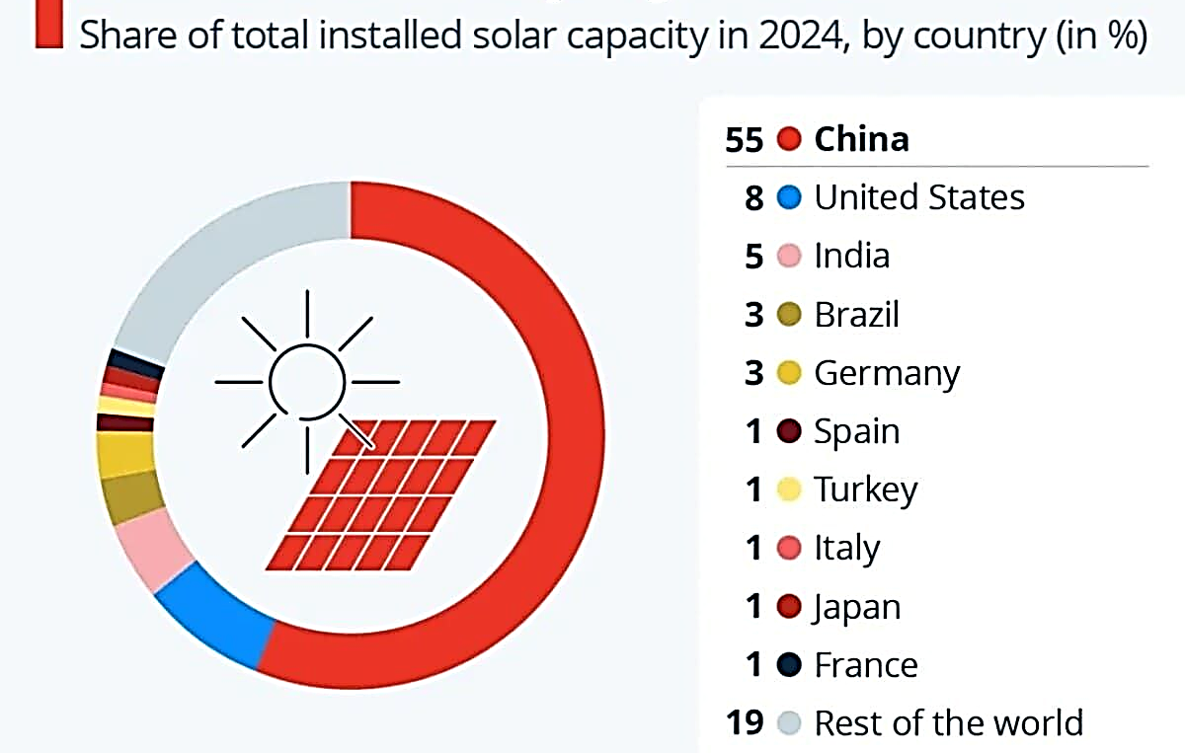
FIGURE 1. Leading countries in the installation of solar panels (as a percentage of the world capacity)
EXPERIMENTAL RESEARCH
In this study, experimental calculations and simulation studies were conducted based on real load and climate data to assess the practical effectiveness of the mathematical model developed for an autonomous PV-battery system [9-10]. A typical autonomous household suitable for the conditions of Uzbekistan was selected as the experimental object, and the consumer's demand for electricity was formulated in the form of a 24-hour load profile.

Consumer list |  | Number [pcs] | P_{nom} [kW] | Daily energy consumption [kWh] | Working hours per day  [h] | Cyclic mode coefficient  k_{i} | Operating mode and operating times
1. | Refrigerator | 2 | 0.150 | 3.24 | 24 | 0.45 | Constant, compressor cyclical
2. | Condenser | 2 | 1.20 | 10.92 | 7 | 0.65 | 12:00–17:00 and 21:00–23:00
3. | Television | 3 | 0.100 | 1.2 | 4 | 1 | 19:00–23:00
4. | Washer | 1 | 0.500 | 0.5 | 1 | 1 | 3 times a week (average 0.4 h/day)
5. | Electric oven | 2 | 2.00 | 8 | 2 | 1 | Evening 17:00–19:00
6. | Lamps (LED) | 30 | 0.020 | 3.6 | 6 | 1 | 18:00-24:00
7. | Computer/laptop | 3 | 0.070 | 1.05 | 5 | 1 | 09:00–12:00, 20:00–22:00
8. | Phone/tablet | 5 | 0.015 | 0.15 | 2 | 1 | Various times
9. | Boiler water heater | 1 | 2.00 | 3.3 | 3 | 0.55 | 06:00–08:00 and 20:00–21:00
10. | Microwave oven | 1 | 1.00 | 1 | 1 | 1 | 08:00–08:30 and 18:00–18:30
11. | Water pump | 1 | 0.750 | 1.0125 | 3 | 0.45 | 06:00–08:00 and 20:00–21:00
12. | Fan | 2 | 0.075 | 1.5 | 10 | 1 | Summer 12:00–22:00
TABLE 1. Parameters of household appliance loads for autonomous household supply

The daily energy consumption of each device, calculated using this formula, is given in Table 1:
$E_{i}=N_{i}∙P_{nom, i}∙h_{i}∙k_{i } [kWh/day]$ (1)

In the first stage of the experimental study, an hourly load graph was drawn up based on the nominal capacities, operating times and cycle coefficients of household electrical appliances (refrigerator, air conditioner, lighting, water pump, electric oven, etc.) [11-12]. As a result, the total daily electricity consumption was determined to be $35.47 kWh/day$. The highest load values ​​mainly fell on the period from 17:00 to 22:00, and this period served as a decisive factor in choosing the battery capacity. In the second stage, the production capacity of solar photovoltaic modules was determined based on real climate data. Hourly values ​​of solar radiation $G(t)$ and ambient temperature $T_{amb}$(t) were adopted, and the module surface temperature was calculated using the Nominal Operating Cell Temperature (NOCT) model [13-14]. The $PV$ system output was determined as a function $P_{pv}$(t) taking into account the temperature coefficient, inverter and cable losses, and it was observed that it could partially or fully cover the load during the daytime hours, and the output approached zero during the evening and night hours [15]. In the third stage, the operation of the battery system was modeled. The battery state of charge $SOC(t)$ was updated hourly based on the charging and discharging efficiencies ($η_{ch}(t) =$ $η_{dis}$($t) = 0.95$) and the constraints ${SOC}_{min}= 20\%,$ ${SOC}_{max}= 80\%$.

TABLE 2. 24-hour climate, production, and load parameters for an autonomous PV–battery system
t/r | Time | G(t) [W/m²] | T_amb(t) [°C] | T_cell(t) [°C] | P_{pv}(t) [kW] | P_{yuk}(t) [kW] | P_{net}(t) [kW]
1. | 00:00-01:00 | 0 | 18 | 18 | 0 | 0.135 | -0.135
2. | 01:00-02:00 | 0 | 17 | 17 | 0 | 0.135 | -0.135
3. | 02:00-03:00 | 0 | 16 | 16 | 0 | 0.135 | -0.135
4. | 03:00-04:00 | 0 | 15 | 15 | 0 | 0.135 | -0.135
5. | 04:00-05:00 | 0 | 15 | 15 | 0 | 0.135 | -0.135
6. | 05:00-06:00 | 0 | 16 | 16 | 0 | 0.21 | -0.210
7. | 06:00-07:00 | 80 | 18 | 20.5 | 0.054 | 1.5724 | -1.518
8. | 07:00-08:00 | 150 | 22 | 26.687 | 0.099 | 2.5724 | -2.473
9. | 08:00-09:00 | 300 | 26 | 35.375 | 0.192 | 0.635 | -0.442
10. | 09:00-10:00 | 450 | 29 | 43.062 | 0.280 | 0.345 | -0.064
11. | 10:00-11:00 | 600 | 31 | 49.750 | 0.364 | 0.345 | 0.019
12. | 11:00-12:00 | 800 | 33 | 58 | 0.470 | 0.345 | 0.125
13. | 12:00-13:00 | 950 | 40 | 69.687 | 0.532 | 1.845 | -1.312
15. | 13:00-14:00 | 900 | 35 | 63.125 | 0.518 | 1.845 | -1.326
16. | 14:00-15:00 | 750 | 33 | 56.437 | 0.443 | 1.845 | -1.401
17. | 15:00-16:00 | 550 | 30 | 47.187 | 0.337 | 1.845 | -1.507
18. | 16:00-17:00 | 350 | 28 | 38.937 | 0.221 | 1.845 | -1.623
19. | 17:00-18:00 | 250 | 25 | 32.812 | 0.161 | 4.285 | -4.123
20. | 18:00-19:00 | 0 | 23 | 26.125 | 0.066 | 4.885 | -4.818
21. | 19:00-20:00 | 0 | 22 | 22 | 0 | 1.26 | -1.260
22. | 20:00-21:00 | 0 | 21 | 21 | 0 | 2.8324 | -2.832
23. | 21:00-22:00 | 0 | 20 | 20 | 0 | 2.955 | -2.955
24. | 22:00-23:00 | 0 | 19 | 19 | 0 | 2.595 | -2.595
25. | 23:00-00:00 | 0 | 18 | 18 | 0 | 0.735 | -0.735

The 24-hour profile was repeated 7 times, and a 168-hour (1-week) simulation was performed. In the experimental study, the battery capacity was changed stepwise from $5 kWh$ to $80 kWh$, and the system reliability for each case was evaluated using the Loss of Power Supply Probability (LPSP) criterion. The results showed that at small capacities the evening load is not fully covered and LPSP has large values. With increasing capacity, $LPSP$ decreases sharply, and $LPSP = 0$ is observed around $C_{batt}$ $≈ 35 kWh.$ The experimental results obtained confirm the practical applicability of the developed mathematical model and allow for a scientific selection of battery capacity in autonomous PV–battery systems [16-18].
RESEARCH RESULTS
In an off-grid solar power system, the battery plays an important role as an energy storage device [19-22]. Solar energy production is uneven throughout the day, and at night and during periods of low solar radiation, the battery covers the consumer load [23-26]. Therefore, the correct selection of the battery capacity ensures uninterrupted operation of the system and has a significant impact on the overall economic efficiency. The battery model is developed based on the following basic principles. Energy balance between PV production and load.
$P_{net}(t)=P_{pv}(t)-P_{yuk}(t) kW$ (2)
If $P_{net}(t)>0$ the excess $PV$ power will charge the battery. $P_{net}\left(t\right)<0$ the battery will be discharged. All values ​​of $P_{net}(t)$ are given in Table 2 above. In this section, practical calculations were performed based on a mathematical model of photovoltaic (PV) system generation and battery energy exchange [27-32]. The following technical and operational parameters were adopted for the calculations.
Number of PV panels: $N = 16$
Power of one panel according to STC: $P= 0.665 kW,$ System efficiency (inverter + losses): $η_{sys}= 0.92$
Temperature coefficient: γ = −0.0035 1/°C Charge efficiency: $η_{char}= 0.95$ Discharge efficiency: $η_{dis}= 0.95$
In order to extend the battery life and prevent deep discharge, the following limits for $SOC$ were adopted:
Minimum permissible level: ${SOC}_{min}= 20 \%$ Maximum permissible level: ${SOC}_{max}= 80 \%$

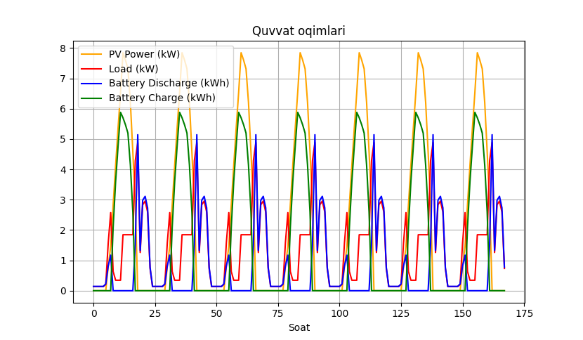
FIGURE 2. Dynamics of PV power, load and battery status in an autonomous solar system

The nominal power of each panel is $665 W$, and the number and total nominal power we need are determined as follows:
$N_{pv}=\frac{E_{day}}{P_{STC }*PSH*η_{sys}}=\frac{35.47}{0.665*6.23*0.92}=9.306≈10$ (3)
Here, we actually need 10 PV modules, but we have assumed 16 to account for cloudy days and smaller battery capacity.
$PSH=\frac{1}{1000}\sum_{t=1}^{24}{G(t)}=\frac{6230}{1000}=6.23$ (4)
$P_{pv,nom}=N_{pv}*P_{STC }=16*0.665=10.64 kW$ (5)
We have determined the temperature of the panel surface for each hour based on formula (10) above, as well as the real-time production capacity of the PV modules based on this temperature, and these values ​​are listed in Table 2.
Determination of the optimal battery capacity based on the LPSP criterion. To evaluate system reliability, the LPSP criterion – also referred to as the loss of power supply probability (or the cumulative energy deficit) – was applied:
$LPSP=\frac{\sum{P_{def}(t)*∆t}}{\sum{P_{yuk}(t)*∆t}}$ (6)
Simulation results. The Cbatt capacity was changed from $5 kWh to 80 kWh$, and a 168-hour model was run for each capacity. The results showed the following. In the range of 20–28 kWh, the LPSP is too large → the evening load is not covered. Around 30–35 kWh, the LPSP decreases sharply. At 35 kWh and above, LPSP = 0 - no energy deficit is observed at any hour during the week. The graph below shows how the LPSP decreases as the capacity increases.

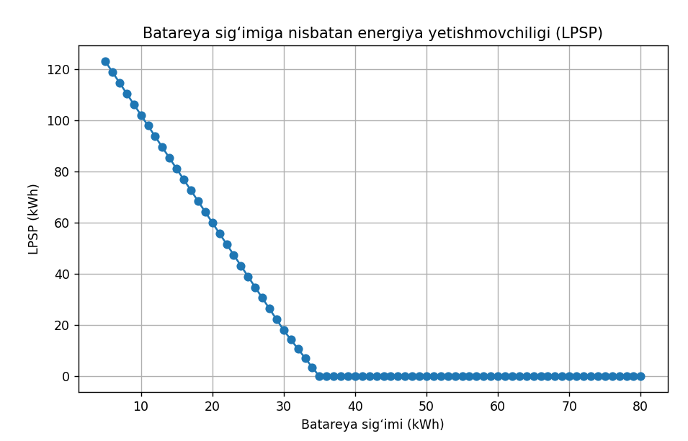
FIGURE 3. Insufficient energy compared to battery capacity
CONCLUSIONS
1. This article scientifically studies the issue of optimal battery capacity determination in terms of ensuring the reliability of energy supply in autonomous solar photovoltaic power plants and increasing the overall economic efficiency of the system. During the study, the energy balance and state of charge (SOC) for the “PV–battery” system were studied, taking into account the real load profile, solar radiation and climatic parameters such as ambient temperature. The hourly operation of the system and the battery charge and discharge modes were analyzed in depth. The results showed that it is not enough to select the battery capacity based on daily energy consumption alone, but the time distribution of the load and the unevenness of solar energy production are also decisive factors. It was found that ensuring energy continuity in conditions where PV production is zero in the evening and night hours is completely dependent on the battery system.
2. The LPSP (Loss of Power Supply Probability) criterion was used to assess the system reliability, and 168-hour (one-week) simulations were conducted for different battery capacities. The calculation results showed that energy deficits occur in batteries with small capacities, a certain part of the load is not supplied, and the LPSP value is high. It was observed that with increasing battery capacity, LPSP decreases sharply and becomes zero after a certain limit. According to the results of the study, a battery with a capacity of about 35 kWh was evaluated as the optimal solution for the selected load and climatic conditions, since in this case the system operated continuously for a week and the SOC never fell below the minimum permissible limit.
At the same time, it was found that increasing the capacity further would lead to an increase in capital costs without significantly improving energy reliability. In conclusion, the proposed mathematical model and LPSP-based evaluation method are effective tools for scientifically selecting battery capacity in autonomous PV systems, which will provide a solid foundation for further optimization studies integrated with economic indicators in the future.
REFERENCE
- K. Allaev, J. Toshov, Modern state of the energy sector of Uzbekistan and issues of their development, E3S Web of Conferences 401, 05090 (2023). https://doi.org/10.1051/e3sconf/202340105090
- O. Toirov, Sh. Azimov, Z. Toirov. Improving the cooling system of reactive power compensation devices used in railway power supply // AIP Conference Proceedings, 3331, 1, 050030, (2025). https://doi.org/10.1063/5.0305670
- D. Jumaeva, O. Toirov, B. Numonov, N. Raxmatullaeva, M. Shamuratova. Obtaining of highly energy-efficient activated carbons based on wood, // E3S Web of Conferences 410, 01018, (2023). https://doi.org/10.1051/e3sconf/202341001018
- O. Toirov, Sh. Azimov, Z. Najmitdinov, M. Sharipov, Z. Toirov. Improvement of the cooling system of reactive power compensating devices used in railway power supply // E3S Web of Conferences, 497, 01015, (2024). https://doi.org/10.1051/e3sconf/202449701015
- D. Jumaeva, U. Raximov, O. Ergashev, A. Abdyrakhimov. Basic thermodynamic description of adsorption of polar and nonpolar molecules on AOGW, // E3S Web of Conferences 425, 04003 (2023) https://doi.org/10.1051/e3sconf/202343401020
- O. Toirov, M. Taniev, M. Hamdamov, A. Sotiboldiev, Power Losses Of Asynchronous Generators Based On Renewable Energy Sources E3S Web of Conferences, 434, 01020, (2023) https://doi.org/10.1051/e3sconf/202343401020
- S. Khalikov, Sodikjon Khalikov, F. Sharopov, Studies of reliability indicators of pumping units of machine irrigation on the example of the “Namangan” pumping station, // E3S Web of Conferences 410, 05015, (2023). https://doi.org/10.1051/e3sconf/202341005015
- D. Bystrov, S. Giyasov, M. Taniev, S. Urokov. Role of Reengineering in Training of Specialists // ACM International Conference Proceeding Series (2020) https://doi.org/10.1145/3386723.3387868
- O. Toirov, V. Ivanova, V. Tsypkina, D. Jumaeva, D. Abdullaeva, Improvement of the multifilament wire lager for cable production, // E3S Web of Conferences 411, 01041 (2023), https://doi.org/10.1051/e3sconf/202341101041
- Kh. Isaxodjayev, I. Toshpulatov, G. Mamajonov, I. Azamov, D. Burxonov Analysis of thermal and overall efficiency of evaporation plants based on multi-stage evaporation plants // AIP Conf. Proc. 3152, 030015 (2024) https://doi.org/10.1063/5.0218829
- T. Kamalov, U. Mirkhonov, S. Urokov, D. Jumaeva, The mathematical model and a block diagram of a synchronous motor compressor unit with a system of automatic control of the excitation // E3S Web of Conferences, 288, 01083, (2021), https://doi.org/10.1051/e3sconf/202128801083
- O. Toirov, S. Urokov, U. Mirkhonov, H. Afrisal, D. Jumaeva, Experimental study of the control of operating modes of a plate feeder based on a frequency-controlled electric drive, // E3S Web of Conferences, SUSE-2021, 288, 01086 (2021). https://doi.org/10.1051/e3sconf/202128801086
- S. Khalikov, Diagnostics of pumping units of pumping station of machine water lifting, // E3S Web of Conferences 365, 04013, (2023). https://doi.org/10.1051/e3sconf/202336504013
- Bystrov, M. Gulzoda, Y. Dilfuza, Fuzzy Systems for Computational Linguistics and Natural Language (2020) // ACM International Conference Proceeding Series, https://doi.org/10.1145/3386723.3387873
- O. Toirov, I. Khujaev, J. Jumayev, M. Hamdamov, Modeling of vertical axis wind turbine using Ansys Fluent package program, // E3S Web of Conferences 401, 04040 (2023). https://doi.org/10.1051/e3sconf/202340104040
- O. Toirov, S. Abdi Yonis, Z. Yusupov, A. Habbal, Control Approach Of A Grid Connected Dfig Based Wind Turbine Using Mppt And Pi Controller, // Advances in Electrical and Electronic Engineering, 21, 3, (2023). https://doi.org/10.15598/aeee.v21i3.5149
- D. Jumaeva, A. Abdurakhimov, Kh. Abdurakhimov, N. Rakhmatullaeva, O. Toirov, Energy of adsorption of an adsorbent in solving environmental problems, // E3S Web of Conferences, SUSE-2021, 288, 01082 (2021). https://doi.org/10.1051/e3sconf/202128801082
- Y. Chen, M. Chen, Y. Chen, H. Guan, H. Dong. Impedance Modeling and Harmonic Stability Analysis of Electrical Railways Integrated with Energy Storage. 1-6. (2025) https://doi.org/10.1109/ECCE-Europe62795.2025.11238635 .
- M. Chen, Y. Chen, M. Wei. Modeling and Control of a Novel Hybrid Power Quality Compensation System for 25-kV Electrified Railway. // Energies. 12, 3303, (2019). https://doi.org/10.3390/en12173303
- O. Toirov, M. Khalikova, D. Jumaeva, S. Kakharov, (2023) Development of a mathematical model of a frequency-controlled electromagnetic vibration motor taking into account the nonlinear dependences of the characteristics of the elements, // E3S Web of Conferences 401, 05089, (2023). https://doi.org/10.1051/e3sconf/202340105089
- S. Khalikov. Analysis of the safety of pumping units of pumping stations of machine water lifting in the function of reliability indicators, // E3S Web of Conferences 365, 04010 (2023), https://doi.org/10.1051/e3sconf/202336504010
- О. Toirov, D. Jumaeva, U. Mirkhonov, S. Urokov, S. Ergashev, Frequency-controlled asynchronous electric drives and their energy parameters, // AIP Conference Proceedings 2552, 040021, (2022). https://doi.org/10.1063/5.0218808
- T. Sadullaev, D. Abdullaev, D. Jumaeva, Sh. Ergashev, I.B. Sapaev, Development of contactless switching devices for asynchronous machines in order to save energy and resources, // E3S Web of Conferences 383, 01029, (2023). https://doi.org/10.1051/e3sconf/202338301029
- Y. Chen, M. Chen, L. Xu, Z. Liang, Chance-Constrained Optimization of Storage and PFC Capacity for Railway Electrical Smart Grids Considering Uncertain Traction Load. // IEEE Transactions on Smart Grid. 1-13. (2023). https://doi.org/10.1109/TSG.2023.3276198
- O. Toirov, S. Khalikov, Algorithm and Software Implementation of the Diagnostic System for the Technical Condition of Powerful Units, // E3S Web of Conferences 377, 01004, (2023). https://doi.org/10.1051/e3sconf/202337701004
- D. Jumaeva, Z. Okhunjanov, U. Raximov, R. Akhrorova. Investigation of the adsorption of nonpolar adsorbate molecules on the illite surface, // Journal of Chemical Technology and Metallurgy, 58, 2, (2023). https://doi.org/10.59957/jctm.v58i2.61
- B. Li, M. Chen, G. Yu, Y. Chen K. Li, Robust real-time energy management of flexible traction substation with energy storage and PV for heavy-haul railways. // Control Engineering Practice. 165, 106558, (2025). https://doi.org/10.1016/j.conengprac.2025.106558
- O. Toirov, K. Alimkhodjaev, A. Pardaboev, Analysis and ways of reducing electricity losses in the electric power systems of industrial enterprises, // E3S Web of Conferences, SUSE-2021, 288, 01085 (2021). https://doi.org/10.1051/e3sconf/202128801085
- M. Chen, H. Deng, Y. Chen & G. Peng, Z. Liang, Stochastic Energy Scheduling for Urban Railway Smart Grids Considering Distributed EVs Charging and PV Output Uncertainty. // IEEE Transactions on Intelligent Transportation Systems. PP. 1-11. (2025). https://doi.org/10.1109/TITS.2025.3558735
- Kh. Isakhodjayev, F. Mukhtarov, D. Kodirov, I. Toshpulatov. Development of a laboratory nozzle chamber Installation for the humidification of buildings” // IOP Conf. Series: Earth and Environmental Science 939, 012025, (2021). https://doi.org/10.1088/1755-1315/939/1/012025

