Development of comprehensive diagnostics for a pump unit of a machine irrigation pumping station
Olimjon Toirov¹, Salikhjan Khalikov¹, Fozil Sharopov²^{, a)}, Shokhrukh Azimov¹ Jasurbek Nizamov³
¹ Tashkent State Technical University named after I. Karimov, Tashkent, Uzbekistan
² Institute of Energy Problems of the Academy of Sciences of the Republic of Uzbekistan, Tashkent, Uzbekistan
³ Andijan state technical institute, Andijan, Uzbekistan
^{а)} Corresponding author: sharopovfozilqobilovich@gmail.com
Abstract. The article is devoted to the development of a comprehensive diagnostic system for a pump unit of a machine irrigation pumping station. The system consists of a microprocessor-based device, analog modules, a computer, and the following condition assessment algorithms: evaluation of the electric motor thrust bearing based on temperature; assessment of the upper motor crosshead based on low-frequency radial vibration; assessment of the upper motor crosshead based on low-frequency vertical vibration (1–25 Hz); assessment of the upper motor crosshead based on high-frequency vertical vibration; assessment of the stator winding and core of the electric motor based on temperature; and assessment of the upper and lower guide bearings of the electric motor based on temperature.
INTRODUCTION
At present, special attention in the Republic is being paid to the issues of comprehensive diagnostics of the condition of electrotechnical equipment at large pumping stations (PS). Successful solutions to these issues lead to a reduction in the number of severe equipment failures and provide station personnel with retrospective technological information for the analysis and planning of equipment operation, maintenance, as well as for improving reliability and economic efficiency [1–6]. Currently, comprehensive diagnostics of the technical condition of pumping station equipment is one of the most relevant tasks for increasing the reliability of their operation, as well as for the monitoring and control of pumping stations [7–10].
EXPERIMENTAL RESSEARCH
. 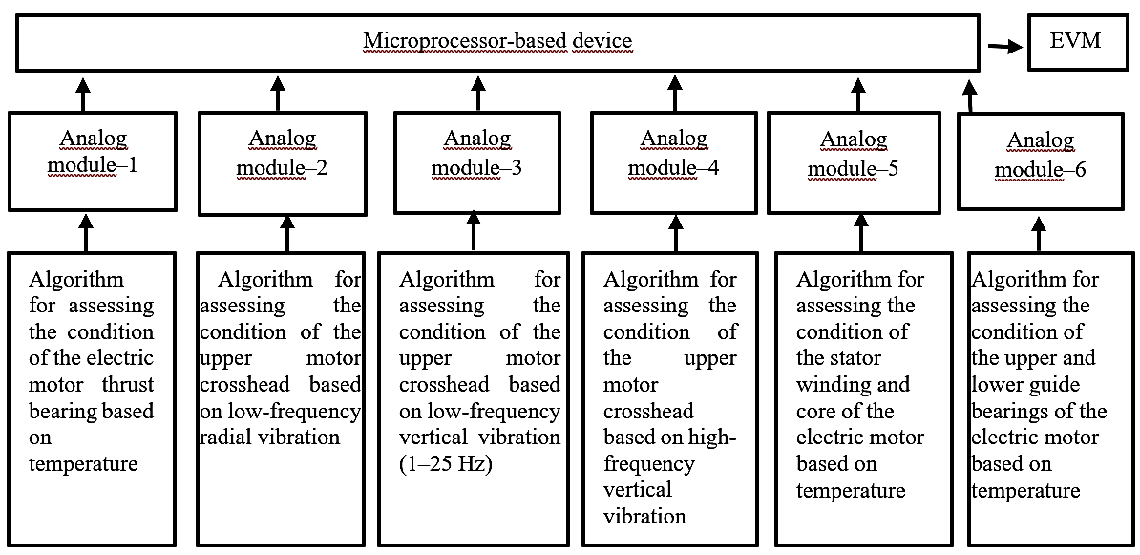
FIGURE 1. Diagram of comprehensive diagnostics of a pump unit in a machine irrigation pumping station
Taking this into account, a comprehensive diagnostic scheme for a pump unit of a machine irrigation pumping station has been developed. The scheme includes a microprocessor-based unit, a computer, analog modules, and algorithms for assessing the condition of the pump unit components (Figure 1). To perform comprehensive diagnostics, analog temperature and vibration signals obtained from sensors are fed to the analog modules, which convert them into digital form for processing by the microprocessor-based unit. The microprocessor unit compares the current parameter values with their nominal values; when deviations from the nominal values exceed permissible limits, the differences are transmitted to the computer, and a corresponding message is displayed on the operator’s screen. In addition, control commands for eliminating the detected faults are generated according to the algorithms presented in [10–11].
Let us consider the algorithms for assessing the condition of the pump unit components shown in Figures 2–4.

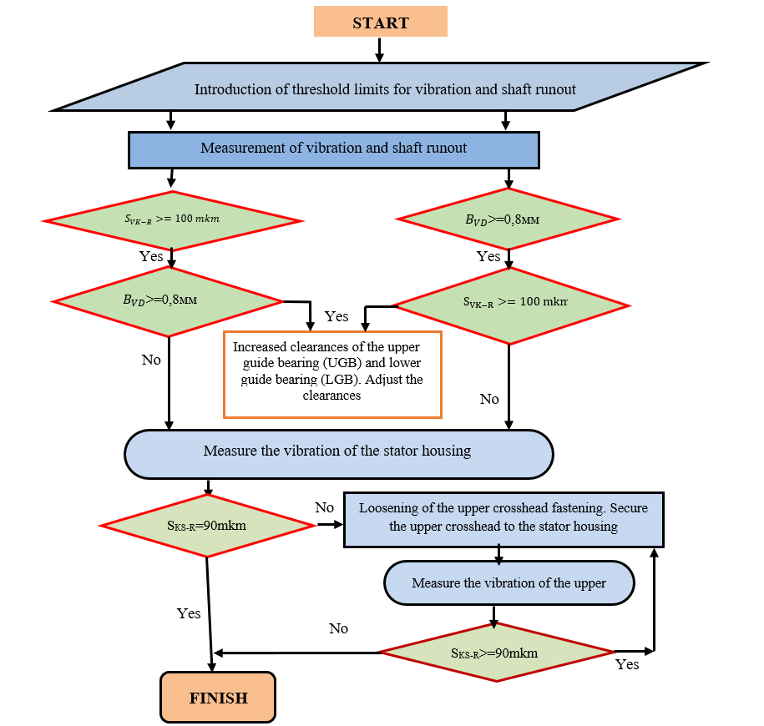
FIGURE 2. Algorithm scheme for assessing the condition of the upper crosshead of the electric motor based on radial low-frequency vibration.

1. Algorithm for Assessing the Condition of the Upper Crosshead of the Electric Motor Based on Radial Low-Frequency Vibration [12-15]. The operation of the diagnostic algorithm for radial low-frequency (rotational) vibration begins with the input of initial data: shaft runout in the region of the upper guide bearing (UGB) and radial low-frequency vibration of the upper crosshead [16-19]. The occurrence of faults is determined by exceeding the permissible threshold values of radial low-frequency vibration. An increased vibration level may be caused by the faults shown in Figure 2.
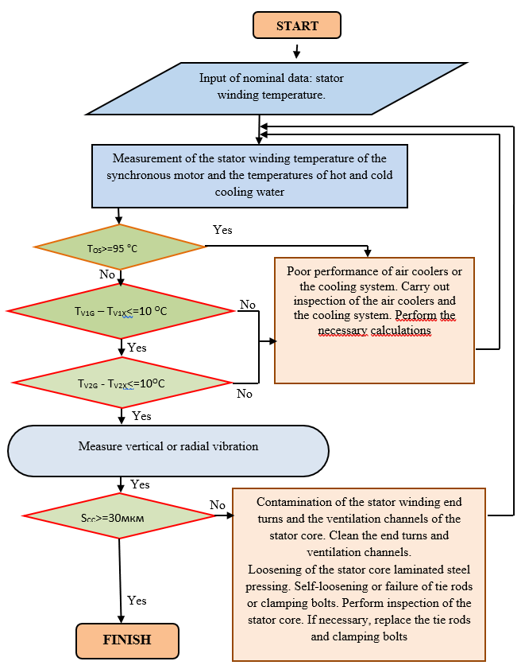
FIGURE 3. Algorithm scheme for assessing the condition of the stator winding and core of the electric motor based on temperature.

2. Algorithm for Assessing the Condition of the Stator Winding and Core of the Electric Motor Based on Temperature [20-24]. The operation of the diagnostic algorithm for the temperature of the stator winding and core begins with the input of initial data: stator winding temperature. The occurrence of faults is identified when the temperature of the stator winding exceeds the permissible values [25-29]. Possible causes of faults are shown in Figure 3.
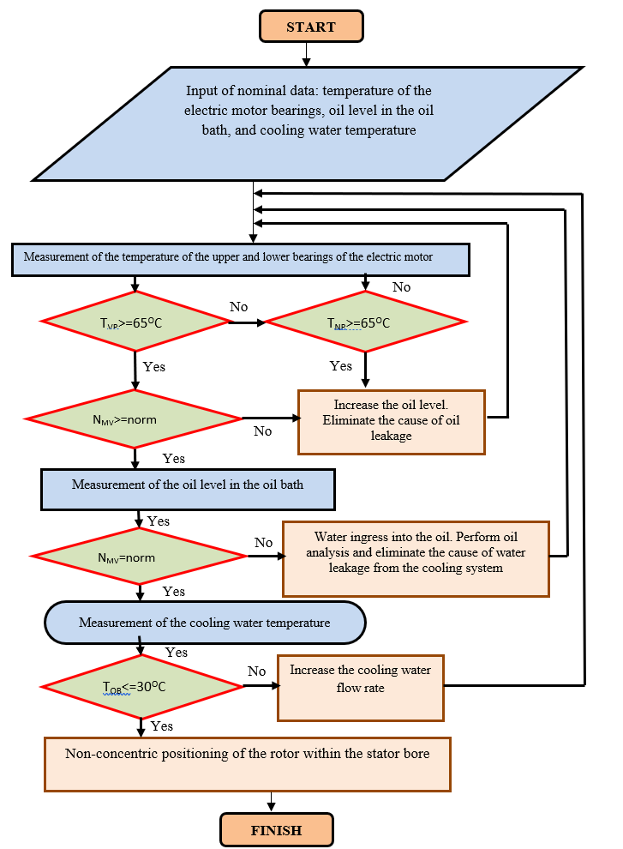
FIGURE 4. Algorithm scheme for assessing the condition of the upper and lower guide bearings of the electric motor based on temperature.

3. Algorithm for Assessing the Condition of the Upper and Lower Guide Bearings of the Electric Motor Based on Temperature [30-34]. The operation of the diagnostic algorithm for the temperature of the upper and lower guide bearings of the electric motor begins with the input of initial data. The occurrence of faults is determined by exceeding the permissible temperature limits of the guide bearings in Figure 4.
CONCLUSIONS
- The developed comprehensive diagnostic system for the condition of electrotechnical equipment at large pumping stations enables a significant reduction in the number of severe equipment failures and provides station personnel with retrospective technological information for analyzing and planning equipment operation, maintenance, and for improving reliability and economic efficiency.
- The developed comprehensive diagnostics of the technical condition of pumping station equipment represents one of the most relevant tasks for enhancing the reliability of their operation, as well as for effective monitoring and control of pumping stations.
REFERENCES
- V.Andreikov. Quantitative determination of reliability of electric units. M.: VNIIEM, 1966. 85 p.
- O. Toirov, K. Allaev, J. Toshov, Modern state of the energy sector of Uzbekistan and issues of their development, E3S Web of Conferences 401, 05090 (2023). https://doi.org/10.1051/e3sconf/202340105090
- O. Toirov, Sh. Azimov, Z. Toirov. Improving the cooling system of reactive power compensation devices used in railway power supply // AIP Conference Proceedings, 3331, 1, 050030, (2025). https://doi.org/10.1063/5.0305670
- D. Jumaeva, U. Raximov, O. Ergashev, A. Abdyrakhimov. Basic thermodynamic description of adsorption of polar and nonpolar molecules on AOGW, // E3S Web of Conferences 425, 04003 (2023) https://doi.org/10.1051/e3sconf/202343401020
- O. Toirov, Sh. Azimov, Z. Najmitdinov, M. Sharipov, Z. Toirov. Improvement of the cooling system of reactive power compensating devices used in railway power supply // E3S Web of Conferences, 497, 01015, (2024). https://doi.org/10.1051/e3sconf/202449701015
- D. Jumaeva, B. Numonov, N. Raxmatullaeva, M. Shamuratova. Obtaining of highly energy-efficient activated carbons based on wood, // E3S Web of Conferences 410, 01018, (2023). https://doi.org/10.1051/e3sconf/202341001018
- O. Toirov, M. Taniev, M. Hamdamov, A. Sotiboldiev, Power Losses Of Asynchronous Generators Based On Renewable Energy Sources E3S Web of Conferences, 434, 01020, (2023) https://doi.org/10.1051/e3sconf/202343401020
- O. Toirov, S. Khalikov, Sodikjon Khalikov, F. Sharopov, Studies of reliability indicators of pumping units of machine irrigation on the example of the “Namangan” pumping station, // E3S Web of Conferences 410, 05015, (2023). https://doi.org/10.1051/e3sconf/202341005015
- D. Bystrov, S. Giyasov, M. Taniev, S. Urokov. Role of Reengineering in Training of Specialists // ACM International Conference Proceeding Series (2020) https://doi.org/10.1145/3386723.3387868
- O. Toirov, V. Ivanova, V. Tsypkina, D. Jumaeva, D. Abdullaeva, Improvement of the multifilament wire lager for cable production, // E3S Web of Conferences 411, 01041 (2023), https://doi.org/10.1051/e3sconf/202341101041
- O. Toirov, T. Kamalov, U. Mirkhonov, S. Urokov, D. Jumaeva, The mathematical model and a block diagram of a synchronous motor compressor unit with a system of automatic control of the excitation // E3S Web of Conferences, 288, 01083, (2021), https://doi.org/10.1051/e3sconf/202128801083
- O. Toirov, S. Urokov, U. Mirkhonov, H. Afrisal, D. Jumaeva, Experimental study of the control of operating modes of a plate feeder based on a frequency-controlled electric drive, // E3S Web of Conferences, SUSE-2021, 288, 01086 (2021). https://doi.org/10.1051/e3sconf/202128801086
- O. Toirov, S. Khalikov, Diagnostics of pumping units of pumping station of machine water lifting, // E3S Web of Conferences 365, 04013, (2023). https://doi.org/10.1051/e3sconf/202336504013
- D. Bystrov, M. Gulzoda, Y. Dilfuza, Fuzzy Systems for Computational Linguistics and Natural Language (2020) // ACM International Conference Proceeding Series, https://doi.org/10.1145/3386723.3387873
- O. Toirov, I. Khujaev, J. Jumayev, M. Hamdamov, Modeling of vertical axis wind turbine using Ansys Fluent package program, // E3S Web of Conferences 401, 04040 (2023). https://doi.org/10.1051/e3sconf/202340104040
- D. Jumaeva, A. Abdurakhimov, Kh. Abdurakhimov, N. Rakhmatullaeva, Energy of adsorption of an adsorbent in solving environmental problems, // E3S Web of Conferences, SUSE-2021, 288, 01082 (2021). https://doi.org/10.1051/e3sconf/202128801082
- O. Toirov, M. Khalikova, D. Jumaeva, S. Kakharov, (2023) Development of a mathematical model of a frequency-controlled electromagnetic vibration motor taking into account the nonlinear dependences of the characteristics of the elements, // E3S Web of Conferences 401, 05089, (2023). https://doi.org/10.1051/e3sconf/202340105089
- O. Toirov, S. Khalikov. Analysis of the safety of pumping units of pumping stations of machine water lifting in the function of reliability indicators, // E3S Web of Conferences 365, 04010 (2023), https://doi.org/10.1051/e3sconf/202336504010
- О. Toirov, D. Jumaeva, U. Mirkhonov, S. Urokov, S. Ergashev, Frequency-controlled asynchronous electric drives and their energy parameters, // AIP Conference Proceedings 2552, 040021, (2022). https://doi.org/10.1063/5.0218808
- O. Toirov, T. Sadullaev, D. Abdullaev, D. Jumaeva, Sh. Ergashev, I.B. Sapaev, Development of contactless switching devices for asynchronous machines in order to save energy and resources, // E3S Web of Conferences 383, 01029, (2023). https://doi.org/10.1051/e3sconf/202338301029
- O. Toirov, S. Khalikov, Algorithm and Software Implementation of the Diagnostic System for the Technical Condition of Powerful Units, // E3S Web of Conferences 377, 01004, (2023). https://doi.org/10.1051/e3sconf/202337701004
- O. Toirov, D. Jumaeva, Z. Okhunjanov, U. Raximov, R. Akhrorova. Investigation of the adsorption of nonpolar adsorbate molecules on the illite surface, // Journal of Chemical Technology and Metallurgy, 58, 2, (2023). https://doi.org/10.59957/jctm.v58i2.61
- O. Toirov, K. Alimkhodjaev, A. Pardaboev, Analysis and ways of reducing electricity losses in the electric power systems of industrial enterprises, // E3S Web of Conferences, SUSE-2021, 288, 01085 (2021). https://doi.org/10.1051/e3sconf/202128801085
- N. Pirmatov, A. Bekishev, N. Kurbanov, O. Zaynieva, U. Norkulov. Calculation of U-shaped characteristics and reactive power of synchronous compensator with longitudinal-transverse excitation, AIP Conference Proceedings 2552, 040020 (2023); https://doi.org/10.1063/5.0115727
- А. Isakov, А. Shavazov, A. Elmuratova. Management efficiency of pumping aggregates through frequency converter. // IOP Conference Series: Earth and Environmental Science, 2022, 1076(1),
- I. Abdullabekov, Kh. Sapaev. An Energy Efficient Control System for Water Lifting Units of the Ramadan Pumping Station Based on Frequency Controlled Electric Drives. // AIP Conference Proceedings 2552, 040023, (2023). https://doi.org/10.1063/5.0130676
- Kh. Sapaev, Sh. Umarov, I. Abdullabekov, N. Khamudkhanova and M. Nazarov. Scheme of effective regulation of pumping station productivity. // AIP Conference Proceedings 2402, 060016 (2021).
- Kh. Sapaev, Sh. Umarov, I. Abdullabekov. Research energy and resource saving operating modes of the pump unit. E3S Web of Conferences 216, 01150, (2020). https://doi.org/10.1051/e3sconf/202021601150
- Kh. Sapaev, Sh. Umarov, I. Abdullabekov. Critical frequency of autonomous current inverter when operating on active-inductive load. E3S Web of Conferences 216, 01153 (2020). https://doi.org/10.1051/e3sconf/202021601153
- Kamalov T., Isakov A., Shavazov A., Tukhtamishev B., Elmuratova A. Calculation of specific rates of the electric energy consumption at frequency regulation of electric drives: A case study of pumping stations. IOP Conference Series: Earth and Environmental Sciencethis, 2021, 939(1), 012001.
- Muzafarov Sh., Isakov A., Choriev R., Ismailova Z., Mustafoyeva D. Optimization of the power consumption mode of pumping stations of “suv Okova” by reactive power. E3S Web of Conferences, 2021, 264, 04089.
- Ishnazarov O., Isakov A.m, Islomov U., Xoliyorov U., Ochilov D. Wear issues of pumping units. E3S Web of Conferences, 2021, 264, 04081.
- O. Toirov, K. Alimkhodjaev, A. Pardaboev, Analysis and ways of reducing electricity losses in the electric power systems of industrial enterprises, E3S Web of Conferences, SUSE-2021, 288, 01085 (2021).
- Adel Aljwary, Ziyodulla Yusupov, Rustam Shokirov, Mitigation of load side harmonic distortion in standalone photovoltaic based microgrid, E3S Web of Conferences, 304, 01010, (2021), ICECAE 2021, https://doi.org/10.1051/e3sconf/202130401010

