Analysis of Characteristics of the Frequency-Controlled Asynchronous Feeder Drive in the Mining Industry Based with IR-Compensation
Olimjon Toirov¹, Tuymurod Sadullaev¹, Sardor Urokov^{1,a)}, Huseyngulu Guliyev², Dilnoza Jumaeva³
¹Tashkent State Technical University named after Islam Karimov, Tashkent, Uzbekistan
²Azerbaijan Technical University, Baku, Azerbaijan
³Institute of General and Inorganic Chemistry of the Academy of Sciences of Uzbekistan, Tashkent, Uzbekistan
^{a)} Corresponding author: sardor.orakov@tdtu.uz
Abstract. This article presents an analysis of the static and dynamic characteristics of a frequency-controlled asynchronous feeder drive in the mining industry, based on the scalar control method with IR-compensation. It provides essential information on the laws and methods of frequency control for the asynchronous feeder drive. Various operating modes and severe working conditions of the frequency-controlled feeder drive have been investigated, and its main electromechanical parameters have been determined. Furthermore, using frequency-controlled drives, the static and dynamic characteristics of the feeder drive under low-frequency operation with the application of the scalar IR-compensation method have been developed with the MATLAB Script program.
INTRODUCTION
In the world, the processes of extraction of mineral resources, rational use of fuel and energy resources, and further modernization of economic sectors are becoming increasingly important for the development of countries [1]. Also, due to the ongoing global financial crisis, the demand for fuel and energy resources in various sectors of the economy is increasing daily [2-3]. This leads to an increase in demand for the further development of the mining industry and the optimization of production processes, which plays an important role in the development of countries [4]. However, the mining industry is not only a source of raw materials, but also one of the most energy- and resource-intensive industries in the process of extracting mineral resources [5-6].It is known that the processes of extracting mineral resources, grinding raw materials, and transportation of raw materials all require high electricity consumption in this industry [7]. In particular, when processing or transporting raw materials from mines and quarries to reserve points, the role of load-carrying devices, including feeding devices, is considered high [8].Feeding devices in the mining industry play an important role in crushing extracted heavy raw materials, sorting mineral resources, or accurate delivery of cargo to conveyor systems continuously and at specified time intervals [9]. Since these devices are mainly powered by electric drives and require continuous operation, these devices consume high amounts of electrical energy [10]. Also, maintaining a constant rotational speed of the electric drives of the feeder devices practically leads to inefficient consumption of electricity [11].As a result of many years of scientific research, it has been established that by smoothly starting the electric drives of feeder devices in the mining industry, taking into account various technological processes, and fully controlling the dynamic processes of these devices, as well as automatically controlling the speed of electric drives depending on the amount of transported load, it is possible to significantly increase energy efficiency in this process [12]. However, in the process of applying frequency-controlled electric drives to feeder devices in the mining industry, excessive electricity losses are also observed in these devices.
The main reason for this is the sharp increase in mechanical loads on frequency-controlled electric drives, which leads to an increase in electric current and a sharp decrease in the voltage of electric drives. Taking into account these technological processes, the analysis of the static and dynamic characteristics of the frequency-controlled asynchronous electric drive of the feeder device in the mining industry based on the scalar IR-compensation method is the main goal and objective of this scientific article.
EXPERIMENTAL RESEARCH
In the mining and metallurgical industry of our country, asynchronous electric drives of various types of feeder devices are used, among which the most common is an asynchronous electric drive with an active power of $Pn=55$ kW, the mains voltage of this asynchronous motor is $Un=220 V$, the power factor of the asynchronous motor is $cosφ=0.85$, the rotational speed is $n=1000 (980)$ rpm, the efficiency is $η=0.9$, the relative resistance of the stator coil is $Rs=0.05$ Ohm, the maximum torque is $M_{max}=1072 [N·m].$However, the maximum torque of the asynchronous motor of the feeder device should not exceed $M_{max}=1072 [N·m]$, and the installed network frequency fk=25-30 Hz should not be less than the established value. Otherwise, the asynchronous motor of the feeder device will quickly stop moving and fail. Based on the above data, we determine the nominal current of an asynchronous electric motor.
A; (1)

We determine the IR-compensation voltage:
(2)
Let's determine the proportionality of the feeder device:
(3)
The relative (range) frequency of the network voltage is determined by the following formula:
if f₁=50 Hz; ; (4)
if f₂=25 Hz; ; (5)
if f₃=10 Hz; ; (6)
if f₄=5 Hz; ; (7)
where fd3 is the relative (range) frequency of the network voltage during the IR-compensation process of the frequency-regulated electric drive of the feeder device. The main reason for this is that the relative (range) frequency of the network voltage should be in the ratio of 1÷5, according to M.P. Kostenko, ${fd}_{3}$=0.2, as well as 15-20% of electricity losses in the IR-compensation process, taking into account various operating modes of the feeder device.
The phase voltage in the stator coil of an asynchronous electric motor is expressed by the following formula:
V (8)
V (9)
V (10)
V (11)
where Un3 is the network voltage during the IR-compensation process of the frequency-regulated electric drive of the feeder device. Also, in the process of calculating the phase voltage in the stator coil of an asynchronous electric motor, it can be seen that a decrease in the network frequency leads to a proportional decrease in the voltage of the electric drive. Also, as a result of the determined values, it is possible to determine the angular velocity of an asynchronous motor in an ideal idle state. There are two options for technical solutions to stabilize the frequency of the output voltage. The first option is a direct mechanical effect on the rotation speed of the wind wheel, which is technically possible, for example, it is necessary to change the angle of the blades. The second option is to convert non-standard energy into standard electricity.
We determine the exponential coefficients of the frequency-controlled asynchronous electric drive of the feeder device:
(12)
(13)
(14)
(15)
where $U_{n1}$=200 V, $U_{n2}$=141.4 V, $U_{n3}$=89.44 V, $U_{n4}$=63.24 V - network voltage according to the exponential law of frequency-controlled asynchronous electric drive of the feeder device. Network frequency in the exponential law of frequency-controlled asynchronous electric drive of the feeder device

$$f_{n1}=50 Hz f_{n2}=25 Hz f_{n3}=10 Hz f_{n4}=5 Hz$$

It is known that the electric drives of feeder devices in the mining industry are mainly controlled based on a linear law γ=Un/fn, the main reason for which is the interaction of kinetic (tractive electromechanical forces) and potential forces (descending electromechanical forces) in the feeder devices [10-12]. Accordingly, taking into account the selected network frequency of 10 Hz during the IR-compensation process of the frequency-controlled electric drive γ=4.4ga, we determine the base and compensation voltages of the feeder device:
Basic voltage in the IR-compensation process of the frequency-controlled electric drive of the feeder device:
V (16)
Compensating voltage in the IR-compensation process of the frequency-controlled electric drive of the feeder device:
(17)
In the process of IR-compensation of the frequency-controlled asynchronous electric drive of the feeder device, it was determined that the scalar control of this electric drive by the γ=Un/fn method, the regulation of the ratio of network voltages to frequencies based on the law of proportionality, as well as in the process of IR-compensation of this asynchronous electric drive, as a result of increasing the network frequency by 10 Hz, the compensating voltage in this drive will increase by 53.47 V. Also, based on the determined electromechanical values, we achieve complete control of various operating modes, mainly dynamic operating processes, of the frequency-controlled asynchronous electric drive of the feeder device [13-15].
RESEARCH RESULTS
Based on the above calculated data, we use the modern "Matlab" program to reduce electricity losses in dynamic operating modes of the frequency-controlled asynchronous electric drive of the feeder device and reduce them by changing voltage and frequency [16-19]. Also, using the "Matlab" program, we construct the electromechanical characteristics of the frequency-controlled asynchronous electric drive of the feeder device, presented in Table 1, based on the electromechanical parameters necessary for the scalar-controlled IR-compensation process. The data presented in Table 1 are data obtained from scientific research and various reliable sources [16-19]. Figure 1 below shows the mechanical characteristics of the AIR250M6 series asynchronous electric motor according to the control law U1/f1=const.

TABLE 1. Necessary electromechanical parameters for the scalor-controlled IR-compensation process of a frequency-controlled asynchronous electric drive of a feeder device
f_{н} (Hz) | k_{f} | n_{f} (rpm) | ω (rad/s) | M (N·m) | U_{н} (V) | I_{н} (А) | ω  (rad/s с)
50 | 1 | 1000 | 104.72 | 525 | 220 | 170 | 104.72
45 | 0.9 | 900 | 94.25 | 583 | 198 | 189 | 94.25
40 | 0.8 | 800 | 83.78 | 656 | 176 | 213 | 83.78
35 | 0.7 | 700 | 73.30 | 750 | 154 | 242 | 73.30
30 | 0.6 | 600 | 62.83 | 875 | 132 | 284 | 62.83
25 | 0.5 | 500 | 52.36 | 1051 | 110 | 340 | 52.36
20 | 0.4 | 400 | 41.89 | 1312 | 88 | 425 | 41.89
15 | 0.3 | 300 | 31.42 | 1750 | 66 | 567 | 31.42
10 | 0.2 | 200 | 20.94 | 2625 | 44 | 850 | 20.94
5 | 0.1 | 100 | 10.47 | 5250 | 22 | 1700 | 10.47

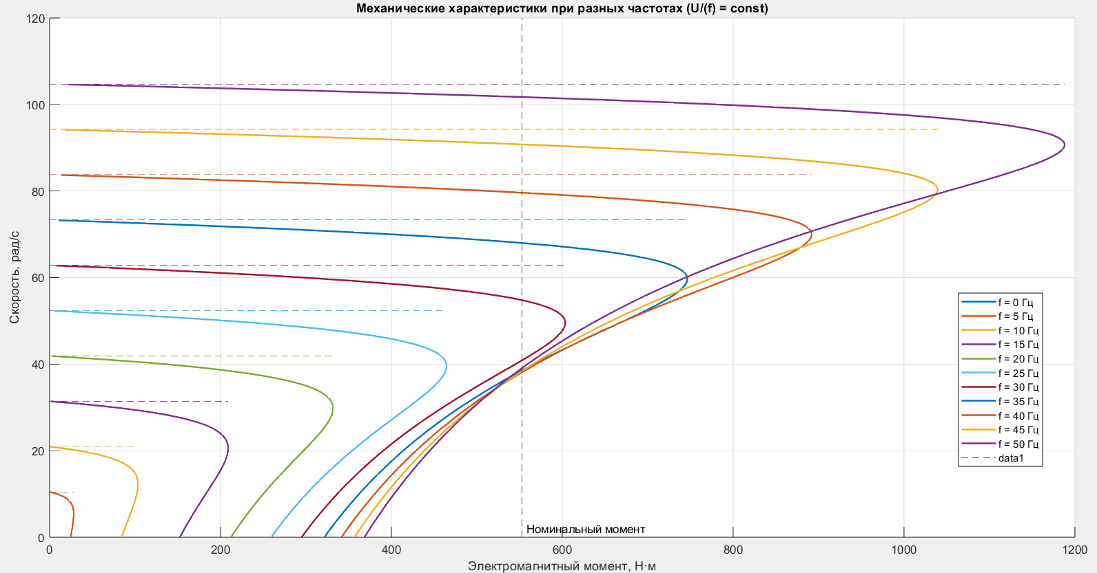
FIGURE 1. Mechanical characteristics of the AIR250M6 series asynchronous electric motor according to the control law U1/f1=const

Fig. 1 shows the mechanical characteristics of the AIR250M6 series asynchronous electric motor with speed regulation by varying frequencies according to the control law U1/f1=const [20-23]. As can be seen from this mechanical characteristic, an increase in the frequency supplied to the electric drive leads to a proportional increase in the voltage of this drive.
The following Figure 2 shows the mechanical characteristics of the AIR250M6 series asynchronous electric motor according to the control law U1/√ (f_1) =const.

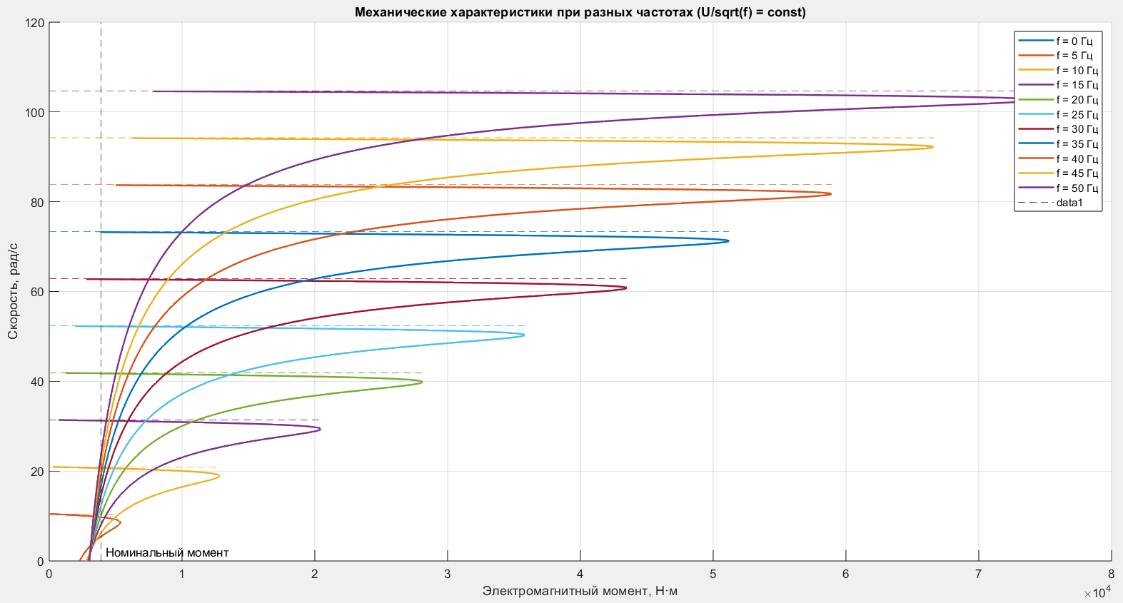
FIGURE 2. Mechanical characteristics of the AIR250M6 series asynchronous electric motor according to the control law U1/√ (f_1) =const
Fig. 3.a.b.c below shows the scalar IR-compensation graphs based on the electromechanical parameters of the frequency-controlled asynchronous electric drive of the feeder device according to the control law U1/f1=const.

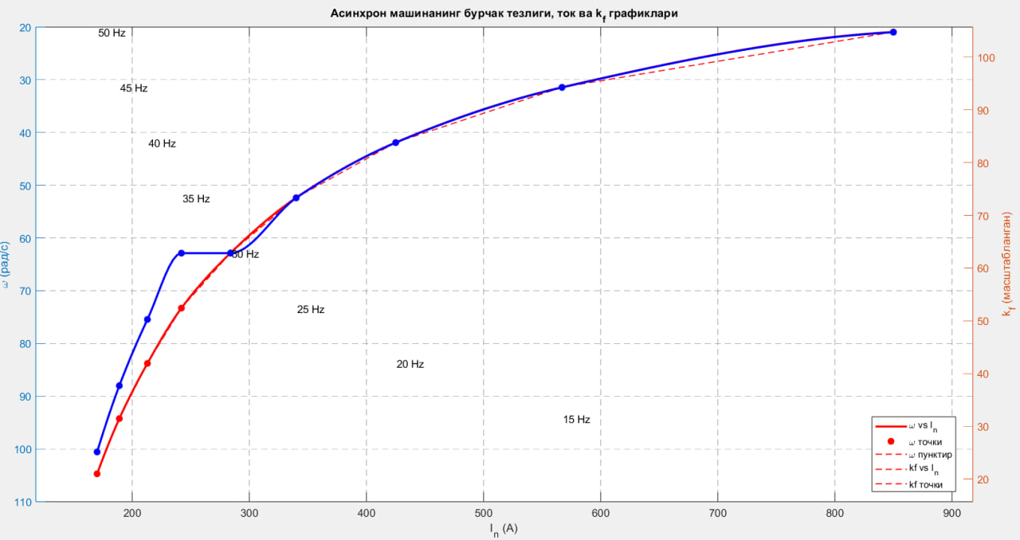
FIGURE 3.a. Scalar IR-compensation graph based on the electromechanical parameters of the frequency-controlled asynchronous electric drive of the feeder device according to the control law U1/f1=const

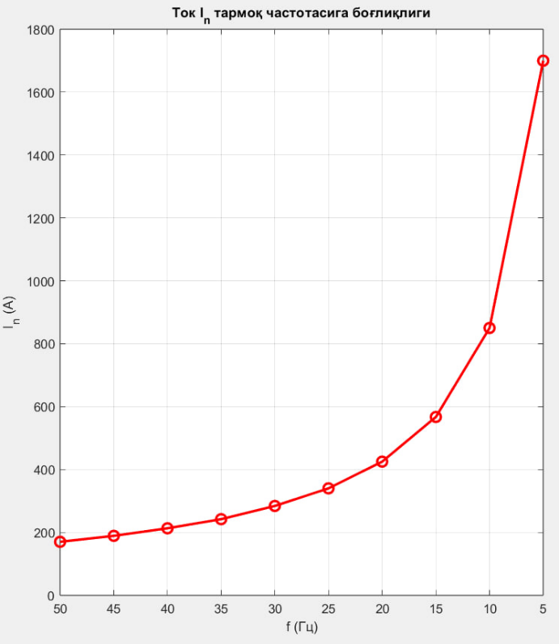 | 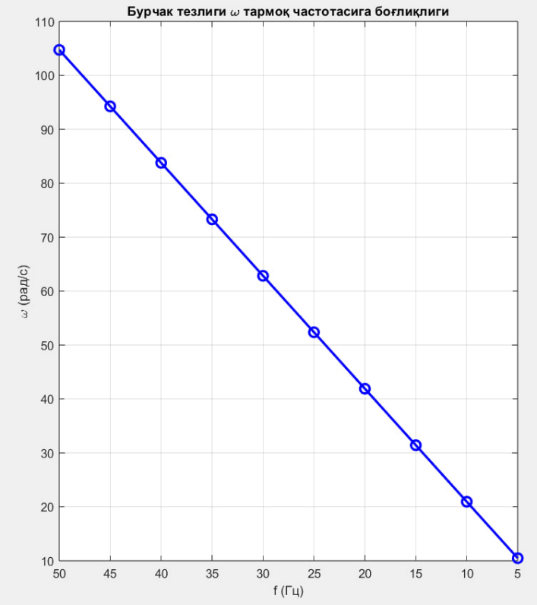
FIGURE 3.b. Graph of the dependence of electric currents on frequencies of the frequency-controlled asynchronous electric drive of the feeder device according to the control law U1/f1=const | FIGURE 3.c. Graph of the dependence of the angular velocities of the frequency-controlled asynchronous electric drive of the feeder device on the network frequencies according to the control law U1/f1=const
Figure 3.a shows a scalar IR-compensation graph based on the electromechanical parameters of the frequency-controlled (AIR250M6 series) asynchronous electric drive of the feeder device according to the control law $U1/f1=const$. In this electromechanical characteristic, a graph of the dependence of the angular velocities of the asynchronous electric drive, nominal electric currents, and IR-compensation currents based on the compensation coefficient of the electric drive - kf - on network frequencies was constructed based on the Matlab program [24-25]. As can be seen from Fig. 3.a, when operating on a frequency-controlled asynchronous electric drive based on the law $U/f = const$, at low frequencies, the magnetic flux and velocity decrease due to losses $I·Rs$ in the stator. Figure 3.b. The graph of the dependence of the electric currents of the frequency-controlled asynchronous electric drive of the feeder device according to the control law $U_{1}$/$f_{1}=const$is presented, and this graph shows how the network current In of the asynchronous electric drive changes with a decrease in frequency. The graph presented in Fig. 3.c shows the dependence of the angular velocity ω of an asynchronous electric drive on the network frequency f, and the graph clearly shows that there is an almost linear, i.e., proportional relationship between the angular velocity and frequency f of the electric drive. Also, in this graph, the angular velocity of the electric drive is $104.72 rad/s$, and the frequency of the drive is 50 Hz. However, if the drive frequency decreases by 5 Hz, the angular velocity of the drive decreases to $10 rad/s$, which fully depends on the network frequency and clearly indicates whether it operates at low or high frequencies.
CONCLUSIONS
- Scientific research shows that when starting a frequency-controlled asynchronous electric drive of a feeder device, it reduces the starting current of the drive by increasing the voltage by a specified amount and further improves the dynamic operating modes of the electric drive, which ensures long-term operation of the device under heavy loads and various operating conditions in the mining industry.
- Also, the scalar IR-compensation method of a frequency-controlled asynchronous electric drive of a feeder device in the mining industry allows controlling the drive at low rotational speeds, taking into account various operating modes and mechanical loads, and based on this process, increasing the stability and energy efficiency of the asynchronous drive. The scalar IR-compensation method of a frequency-controlled asynchronous electric drive of a feeder device in the mining industry is a convenient method both scientifically and practically, and is an important basis for the development of automated and frequency-controlled electric drives in the mining industry.
REFERENCES
- O. Toirov, S. Atoev, T. Sadullaev, D. Jumaeva. Energy-saving operating modes and functional diagrams of a cotton-cleaning device based on frequency-controlled electric drives. // In American Institute of Physics Conference Series 3152, 1, 030016, (2024). https://doi.org/10.1063/5.0218797
- Kh. Isakhodjayev, F. Mukhtarov, D. Kodirov, I. Toshpulatov. Development of a laboratory nozzle chamber Installation for the humidification of buildings” // IOP Conf. Series: Earth and Environmental Science 939, 012025, (2021). https://doi.org/10.1088/1755-1315/939/1/012025
3. Kh. Isaxodjayev, I. Toshpulatov, G. Mamajonov, I. Azamov, D. Burxonov Analysis of thermal and overall efficiency of evaporation plants based on multi-stage evaporation plants // AIP Conf. Proc. 3152, 030015 (2024) https://doi.org/10.1063/5.0218829
4. O. Toirov, T. Sadullaev, D. Abdullaev, D. Jumaeva, Sh. Ergashev, I. Sapaev Development of contactless switching devices for asynchronous machines in order to save energy and resources, // E3S Web of Conferences 383, 01029. 2023 https://doi.org/10.1051/e3sconf/202338301029
5. O. Toirov, K. Alimkhodjaev, A. Pardaboev, Analysis and ways of reducing electricity losses in the electric power systems of industrial enterprises, // E3S Web of Conferences, SUSE-2021, 288, 01085 (2021). https://doi.org/10.1051/e3sconf/202128801085
6. Allaev K., Toshov J., Toirov O. 2023 Modern state of the energy sector of Uzbekistan and issues of their development, E3S Web of Conferences 401, 05090. DOI: 10.1051/e3sconf/202340105090
7. Aljwary A., Yusupov Z. 2021. Mitigation of load side harmonic distortion in standalone photovoltaic based microgrid, E3S Web of Conferences, 304, 01010.
8. Khujaev I., Toirov O., Jumayev J., & Hamdamov M. 2023. Modeling of vertical axis wind turbine using Ansys Fluent package program. In E3S Web of Conferences (Vol. 401, p. 04040). DOI: 10.1051/e3sconf/202340104040
9. Toirov O., Khalikov S. 2023. Algorithm and Software Implementation of the Diagnostic System for the Technical Condition of Powerful Units, E3S Web of Conferences 377, 01004. DOI: 10.1051/e3sconf/202337701004
10. O. Toirov, Sh. Azimov, Z. Toirov. Improving the cooling system of reactive power compensation devices used in railway power supply // AIP Conference Proceedings, 3331, 1, 050030, (2025). https://doi.org/10.1063/5.0305670
11. D. Jumaeva, U. Mirkhonov, S. Urokov, S. Ergashev. Frequency-controlled asynchronous electric drives and their energy parameters, AIP Conference Proceedings 2552, 040021, 2022. https://doi.org/10.1063/5.0111331
12. M. Taniev, M. Hamdamov, A. Sotiboldiev, Power Losses Of Asynchronous Generators Based On Renewable Energy Sources E3S Web of Conferences, 434, 01020, (2023) https://doi.org/10.1051/e3sconf/202343401020
13. D. Jumaeva, U. Raximov, O. Ergashev, A. Abdyrakhimov. Basic thermodynamic description of adsorption of polar and nonpolar molecules on AOGW, // E3S Web of Conferences 425, 04003 (2023)
https://doi.org/10.1051/e3sconf/202343401020
14. O. Toirov, Sh. Azimov, Z. Najmitdinov, M. Sharipov, Z. Toirov. Improvement of the cooling system of reactive power compensating devices used in railway power supply // E3S Web of Conferences, 497, 01015, (2024). https://doi.org/10.1051/e3sconf/202449701015
15. D. Jumaeva, B. Numonov, N. Raxmatullaeva, M. Shamuratova. Obtaining of highly energy-efficient activated carbons based on wood, // E3S Web of Conferences 410, 01018, (2023). https://doi.org/10.1051/e3sconf/202341001018
16. O. Toirov, K. Alimkhodjaev, A. Pardaboev, Analysis and ways of reducing electricity losses in the electric power systems of industrial enterprises, // E3S Web of Conferences, SUSE-2021, 288, 01085 (2021). https://doi.org/10.1051/e3sconf/202128801085
17. O. Toirov, S. Khalikov, Diagnostics of pumping units of pumping station of machine water lifting, // E3S Web of Conferences 365, 04013, (2023). https://doi.org/10.1051/e3sconf/202336504013
- D. Bystrov, M. Gulzoda, Y. Dilfuza, Fuzzy Systems for Computational Linguistics and Natural Language (2020) // ACM International Conference Proceeding Series, https://doi.org/10.1145/3386723.3387873
- O. Toirov, I. Khujaev, J. Jumayev, M. Hamdamov, Modeling of vertical axis wind turbine using Ansys Fluent package program, // E3S Web of Conferences 401, 04040 (2023). https://doi.org/10.1051/e3sconf/202340104040
- D. Jumaeva, A. Abdurakhimov, Kh. Abdurakhimov, N. Rakhmatullaeva, Energy of adsorption of an adsorbent in solving environmental problems, // E3S Web of Conferences, SUSE-2021, 288, 01082 (2021). https://doi.org/10.1051/e3sconf/202128801082
- O. Toirov, M. Khalikova, D. Jumaeva, S. Kakharov, (2023) Development of a mathematical model of a frequency-controlled electromagnetic vibration motor taking into account the nonlinear dependences of the characteristics of the elements, // E3S Web of Conferences 401, 05089, (2023). https://doi.org/10.1051/e3sconf/202340105089
- O. Toirov, S. Khalikov. Analysis of the safety of pumping units of pumping stations of machine water lifting in the function of reliability indicators, // E3S Web of Conferences 365, 04010 (2023), https://doi.org/10.1051/e3sconf/202336504010
- О. Toirov, D. Jumaeva, U. Mirkhonov, S. Urokov, S. Ergashev, Frequency-controlled asynchronous electric drives and their energy parameters, // AIP Conference Proceedings 2552, 040021, (2022). https://doi.org/10.1063/5.0218808
- O. Toirov, T. Sadullaev, D. Abdullaev, D. Jumaeva, Sh. Ergashev, I.B. Sapaev, Development of contactless switching devices for asynchronous machines in order to save energy and resources, // E3S Web of Conferences 383, 01029, (2023). https://doi.org/10.1051/e3sconf/202338301029
- O. Toirov, D. Jumaeva, Z. Okhunjanov, U. Raximov, R. Akhrorova. Investigation of the adsorption of nonpolar adsorbate molecules on the illite surface, // Journal of Chemical Technology and Metallurgy, 58, 2, (2023). https://doi.org/10.59957/jctm.v58i2.61

