Features of Economics and Mathematics Analysis of the Use of Imitative Innovations in Small Businesses and Forecasting the Indicators of Innovative Products
Barno Tillaeva ^{1,a)}, Rano Akramova ², Jamshid Tukhtabaev ³, Nigina Sayfutdinova ¹
¹ Tashkent state technical university named after Islam Karimov, Tashkent, Uzbekistan
²Tashkent Institute of Chemical Technology (TICT), Tashkent, Uzbekistan
³Graduate School of Business and Entrepreneurship under the Cabinet of Ministers of the Republic of Uzbekistan, Tashkent, Uzbekistan
^{a)} Corresponding author: barnotillayeva78@gmail.com
Abstract. The article discusses the production of innovative products in small business enterprises, the criteria for identifying innovations, the strategy of imitative innovation, the concept of imitative innovation for small businesses, decision-making in imitative innovation strategies, and the use of imitative innovation in the production of innovative products. The general and projected indicators of innovative product production in small business and entrepreneurial entities are analyzed. According to the analysis, the production of innovative products in small business and entrepreneurial entities is more effective compared to large business entities.

Introduction
At present, the production and presentation of new innovative types of products and services, the development and implementation of new technologies, and innovative management processes in small businesses remain the most important factors in the sustainable development of small businesses. Innovative production activities are associated with improving the quality and competitiveness of products, saving material and labor resources, increasing labor productivity, organizing small businesses and entrepreneurial activities, and improving management efficiency.
The concept of "innovation" (in English - novelty) is considered the final result of innovative activity, expressed in a new or improved product sold on the market or as a new or improved technological process used in practice [1].
The concept of "innovation" differs from the concepts of "invention" and "discovery". Innovation is used in practice, discovery refers to a new scientific product that was not previously known, while invention includes new equipment, mechanisms, instruments, technology, equipment, etc., which may or may not be used in practice. According to Schumpeter, these can be included in innovation if they are implemented in business practice [2].
The concept of "innovation" was proposed and systematized by the Austrian economist Jozef Schumpeter, and it is widely used in modern economics [3]. It is organized as follows:
1. Using new types of machines and technologies in the production process and providing the market with a new or improved product.
2. Mastering the production of goods with new features.
3. Using new types of raw materials in economic activities.
4. Mastering new forms of production organization and management.
5. Formation of new goods, services and markets.
The main criteria for determining innovation are as follows: scientific novelty, practical importance, feasibility, and commercialization. "Innovation" means the processes of creating new or improved equipment, technology, goods, services, management methods and other innovations by small business entities, which, in turn, improve the quality and efficiency of production, management, commercial and other processes. It is understood that it will increase the competitiveness of its subjects, export potential and profits.
Innovative activity - activities related to the creation, acquisition, distribution and use of innovations [4].
Innovative activity is a unique productive force that leads to the integration of science and technology, material production and business.
The purpose of this research is to prove that the use of imitative innovations in the production of innovative products in small business enterprises is an effective strategy, according to the experience of foreign countries and to justify, using forecasting models that the production of innovative products in small businesses is more effective compared to large businesses.

research Methodology
In the conditions of a market economy, any innovative activity should be profitable from a commercial point of view. A small business will benefit from innovation if the use of the innovation reduces costs and maximize profits or if it is a new product that is in demand and profitable in the market.
Using the method of correlation-regression analysis and trend models, the amount of innovative products produced by small businesses on the national scale was forecast based on the cost factor involved in producing innovative products. The obtained results were then analyzed using statistical methods.

Analysis of literature
In the works of A.V. Shavel [2] and G. Fedyasheva [5], the meanings of the concepts "Innovation", "Innovative activity" and "Innovative potential" and their roles in the innovative development of the economy are explored. Specific features of the development of innovative entrepreneurship in Russia, methods of researching innovative development, assessment of innovative potential, strategic development, and state support are discussed in the works of E.V. Bulanova, N.S. Somenkova, G.B. Yagunova and Bakalagin [6]. The works of A.A. Chesnakov [7] cover methodological bases and methods of forecasting, bases of regression analysis, forecasting of socio-economic processes, and issues of forecasting and planning in small business. In the work of A.A. Kasimov [8], attention is paid to the issues of modeling and forecasting of the processes of increasing the efficiency of the regional industrial network.
Among local scientists, M. Burkhanov [9] studied the issues of evaluating the impact of innovative development on the competitiveness of enterprises, and U.V. Gafurov [10] studied the innovative potential of industrial enterprises and its indicators in increasing the activity of small businesses to implement innovations.
In the researches of foreign scientists, Xu Huixuan [11] and Yan Dondong [12] highlighted the advantages of imitative innovation and the development of small and medium businesses based on imitative innovation in the People's Republic of China.

ANALYSIS and results
According to statistics, the probability of their success is 5% [13].
When viewed in terms of applied research, 50% provides technical success, 30% commercial success, and only 12% results in profit [14].
It is known that many enterprises in developed countries use secondary innovation, focusing on modernizing existing innovative technology and equipment.
Compared to original innovation, imitative innovation is less complex but more competitive in the market. In imitative innovation, a suitable technology for the market is selected, and the innovation enterprise conducts its own research. This research is less risky and error-prone. Imitative innovation uses ready-made technology and does not require extensive r research and development.
Imitative innovation does not require large funds, reduces the cost of the product, and leads to quicker adaptation of the product to market demand and satisfaction of consumer needs. Firms can achieve independent innovation through imitative innovation. Examples include Japan, China and South Korea, where they purchased the technologies of the USA and European countries, implemented innovative processes from the idea of improving the new technology to the production of new improved technology and products, and created their own competitive products. China has developed its own 5G mobile network based on 4G mobile network and is a leader in this regard.
Compared to large enterprises, the management system in small business is more compact and ensures efficient and flexible use of investment resources. In large enterprises, the hierarchy structure is large, and decision-making and adaptation to changes are slower.
Small businesses adapt quickly to the market and direct their investment resources to promising goods and technologies. These characteristics ensure the successful implementation of imitative innovations in small businesses [15].
We see that imitative innovation has several advantages over independent innovation. In the conditions of Uzbekistan, the use of imitative innovations can be considered an effective approach for small businesses due to:low investment volume and less stringent technological requirements. High technological requirements are placed on original innovations and large investments have to be attracted. Small businesses don't have that option. Imitative innovation costs less than independent innovation. According to the Bank of Japan's long-term lending research, between 1955 and 1970, Japan spent $3 billion on acquiring technology, conducting research, and implementing the result, while the country selling its technology spent $100 billion just on initial development, research, and testing alone. spent US dollars [16].
In an imitative innovation strategy, the first promising technology is selected. Here the market demand is studied with the help of experts,the company's capacity to improve this technology is evaluated, and the raw material base is analyzed. After this, the process of imitation technology begins (Fig. 1).

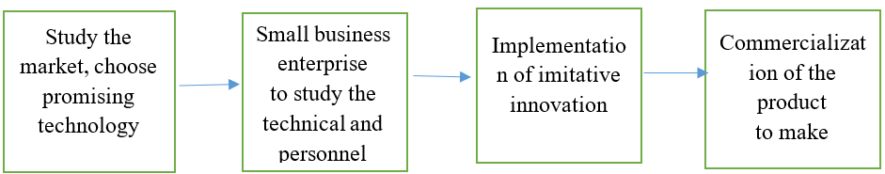
FIGURE 1. Imitative innovation strategy

When studying the scientific and technical potential of a small business enterprise in the conditions of Uzbekistan, its connection with scientific research institutes, universities and other scientific centers is taken into account. Another important issue is the issue of supplying the product with raw materials. It should be clear where, from which company it will be purchased and in which market the product will be sold. When choosing a promising technology, the study of the patent market will not be without a purpose. When using imitative innovation, a number of advantages are achieved.
Typically, imitative innovation is used in existing technologies. Here, it is possible to avoid the risks and reduce the costs incurred in the previous stages.
Imitation innovations stimulate the modernization of production in small business enterprises, increase the competitiveness of the product and the export potential of the enterprise. Therefore, imitative innovation not only improves the economic indicators of small business enterprises, but also leads to a positive change in its composition.
Small business imitative innovation enterprises improve advanced technologies and products with the help of imitative innovations, and gradually raise their economic, technical and management system to a new high level, and can become an advanced enterprise and become an enterprise that competes with its products in international markets.
The ultimate goal of small business enterprises is not to improve advanced technologies through imitative innovation, to increase the quality of the product, to get additional profit, but to achieve their own original innovations later. In the use of imitation innovations, the experience of small business enterprises in the production of innovative products and the qualification of personnel will increase, the fund will increase, and their cooperation with scientific research institutes, universities and other scientific centers and international scientific organizations will be strengthened.
The period of imitative innovation continues in China (the creation of 5G communication and becoming a world leader in this regard), South Korea (the development of the electronic network) and other countries [17]. The country of Uzbekistan can also be included in this. In our country, automobile, textile, metallurgical industry (Tashkent metallurgical plant was built on the basis of advanced Italian technology) and other industrial sectors operate on the basis of the technologies of leading companies in developed foreign countries. At the same time, the period of using imitative innovations in enterprises of these industries began.
It is known from the world experience that if any product is not modernized for 2-5 years, the competitiveness of the product will decrease and the demand for it will decrease. During the former USSR, in the 1960s, a modern car factory was built in Togliatti with the Italian company "Fiat", but the demand for Zhiguli cars fell behind modern modernization, and the factory went bankrupt.
At present, modern drip irrigation, hydroponic greenhouses from advanced foreign technology are used in the agriculture of our country. These new technologies must also be updated and changed. This renewal and change is done using imitative innovation. The problem is that the lack of qualified specialists makes it difficult to use imitative innovations in these areas.
The concept of imitative innovation (type of imitative innovation) for small business is based on the five main types of innovation of the economist Jozef Schumpeter (Fig.2).
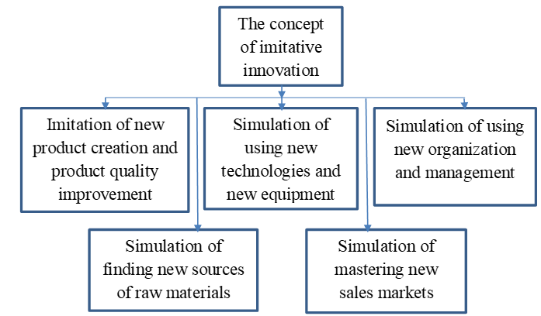
FIGURE 2. Concept of imitative innovation for small business

1. Imitation of creating a new product or improving product quality. Typically, the value of a product in primary innovation is high. In secondary innovation, by addressing its shortcomings or making modifications, the product can be positioned effectively in the market by satisfying consumer demand.
2. Simulating the use of new technology and new equipment: In this case, the shortcomings of existing technology and equipment are addressed, or they are modernized. Solving such issues requires funds and highly qualified specialist personnel. For example, a large company produces hand- washing soap, but some of the soap packages do not contain soap. The technological line is not working well. The company spends a lot of money to eliminate this shortcoming. Another small business faced the same problem but lacked funds. The head of the company assigned the mechanic to fix this problem, he installed several coolers on the tape and solved the problem.
3. Imitation of entering and mastering new markets: if the company's funds are insufficient, problem can be addressed by adopting the marketing strategies of modern, advanced companies. This involves modifying these strategies and adapting them to fit the company’s own needs.
4. Imitation of of finding a new source of raw materials: This affects the quality and cost of raw materials.
5. Imitation of using new organizational methods:The enterprise uses the experience of effectively operating enterprises, implements and improves it.
In the conditions of Uzbekistan, the introduction of patented advanced foreign technologies into production and th improving them through imitative innovations would help accelerate the innovative development of small business enterprises. But here it is appropriate to establish a policy of covering the costs of small business enterprises to a certain extent.
The stages of using imitative innovations are presented in Fig.3.
1. Assessment of the internal capabilities of the enterprise and the external environment. When assessing internal capabilities, first of all, one should have the ability to master and learn the technology and update it. One of the main conditions is to be able to organize the production process of a new product at the level of demand and to be able to start selling it. Therefore, before implementing the imitative innovation strategy, the enterprise should objectively assess its capabilities.
It is important for the company to have a clear idea of its strengths and weaknesses. Here it is appropriate to use the SWOT method.
2. When external factors are analyzed, the situation in the market, in which phase of the product's life cycle, assessment of growth, stable, decline phases (in the decline phase, imitation products are not expected to be released to the market), innovative activities of the state, policy of supporting KB, future partners, competitors, raw material supplier the issue of studying enterprises is important for the enterprise. Such studies prevent ineffective technology and product selection.
Property rights should also be considered when implementing imitative innovations. An imitation product is often associated with a patented technology.
FIGURE 3. Decision making in imitative innovation strategy

Being the owner of the trademark and intellectual property of the company that produced the primary product. Here, it is important not to violate the framework of the legislation in action and to implement the imitation within the framework allowed by the legislation. But imitation production also needs protection.
It should be noted that the imitation product is different from the original product, the imitation product is inferior to the original product in terms of its technical indicators, which is related to the technological potential of the enterprise. For example, Apple released its mobile phones and dramatically increased the market demand. Mobile phone manufacturers saw this and started selling a copy of the mobile phone. Despite the fact that the manufactured mobile phone was inferior to Apple phones in terms of quality, it started to make a profit. These mobile phones meet the fashion requirements of the appearance and the low price made them find their place in the market (China, South Korea).
The analysis of the activity of the innovative technology park "Yashnobad" in our country shows that the majority of the products developed in it are based on the use of imitation innovations. For example: production of 3D objects using plastic and photopolymers, production of SIM cards and various other cards, production of drones, production of interactive robots, etc. These products already have existing production technologies, but the characteristics of these products are being improved through imitative innovation.
In general, the success of an imitation product depends on its marketability. If the innovative product brings profit and leads to the development of the enterprise, it is considered a successful innovation.
Thus, the quality and technical performance of the imitative product ensure product competitiveness, increase subsequent orders, and at the same time guarantee the success of the imitative innovation strategy.
Table 1 shows the dynamics of information on the total innovative product produced by all enterprises in our country and the amount of innovative product produced by small business enterprises on their own and the costs of their production.

Table 1. Information on the total and only the innovative products produced by small business enterprises and the costs of their production (billion soums)
Years | Total volume of produced innovative products and services (Y) | Expenditure on total produced innovative products and services (X) | Produced by small businesses volume of innovative products and services (Y') | Produced by small businesses expenditure on innovative products and services (X')
2010 | 1849.0 | 264.4 | 113.2 | 40.6
2011 | 1348.7 | 372.6 | 116.1 | 32.3
2012 | 3635.9 | 311.9 | 265.4 | 47.3
2013 | 4614.7 | 4634.2 | 409.8 | 181.2
2014 | 7043.0 | 3757.4 | 1160.7 | 351.4
2015 | 8023.6 | 5528.3 | 1681.8 | 354.8
2016 | 10688.2 | 2571.4 | 1671.9 | 211.4
2017 | 18543.3 | 4162.3 | 2324.3 | 715.3
2018 | 28871.5 | 4707.2 | 7196.3 | 1156.8
2019 | 26811.4 | 6603.5 | 8455.4 | 1939.9
2020 | 31142.8 | 6830.0 | 14129.1 | 1041.6

Volume of innovative products and services produced in total (Y), expenditure on innovative products and services produced in total (X), volume of innovative products and services produced by small business enterprises (Y') and innovative products and services produced by small business enterprises Based on linear trend regression (1), (2), (3), (4) models for expenditure (X') indicators, forecast values for 2021-2024 were developed, Table 2.

The trend model of the volume (Y) of the total produced innovative products and services:
$y=\text{3232,1 t- 6431,}\text{4}$ $(R=\text{0,0834)}$ (1)
The trend model of expenditure (X) on total manufactured innovative products and services:
$x=\text{625,52}\text{t- }\text{140}\text{,}\text{09}$ $(R=\text{0,7268)}$ (2)
The trend model of expenditure (X) on total manufactured innovative products and services:
$y'=\text{1168,8}\text{t- }\text{3601}\text{,}\text{6}$ $(R=\text{0,7241)}$ (3)
The trend model of expenditure (X) on total manufactured innovative products and services:
$x'=\text{153,56t- 369,35}$ $(R=\text{0,7054)}$ (4)

Table 2. Forecast indicators of the volume of innovative products and services produced by total and small business enterprises (billion soums)
Years | Total volume of produced innovative products and services (Y) | Expenditure on total produced innovative products and services (X) | Volume of innovative products and services produced by small business enterprises (Y') | Expenditure on innovative products and services produced by small business enterprises (X')
2021 | 32353.8 | 7366.2 | 10424.0 | 1473.4
2022 | 35585.9 | 7991.7 | 11592.8 | 1626.9
2023 | 38818.0 | 8617.2 | 12761.6 | 1780.5
2024 | 42050.1 | 9242.7 | 13930.4 | 1934.1

Figure 4 shows the graphs of forecast indicators. It can be seen from the graph that the forecast indicators of the volume of innovative products and services produced in total have an upward trend. By 2024, this indicator will be 10.9 trillion compared to 2020. increases to soums and 42.1 trillion. amounts to soums, in terms of percentage, this indicator increases by 35.0%.

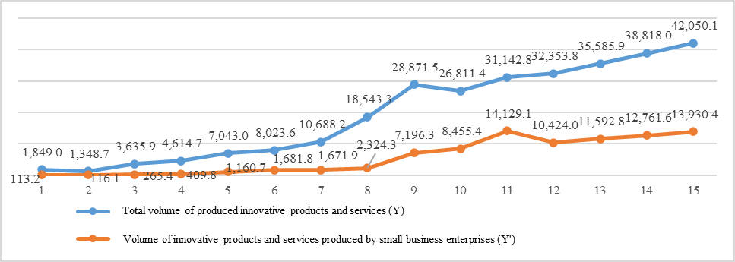
FIGURE 4. Graph of forecast indicators of the volume of innovative products and services produced by total and small business enterprises (billion soums)

Forecast indicators of the volume of innovative products and services produced by small business enterprises also have a tendency to increase during the forecast period. However, by 2024, this indicator will decrease by 198.7 billion soums compared to 2020, and by 13.9 trillion. amounts to soums, this indicator is 99.0 percent.
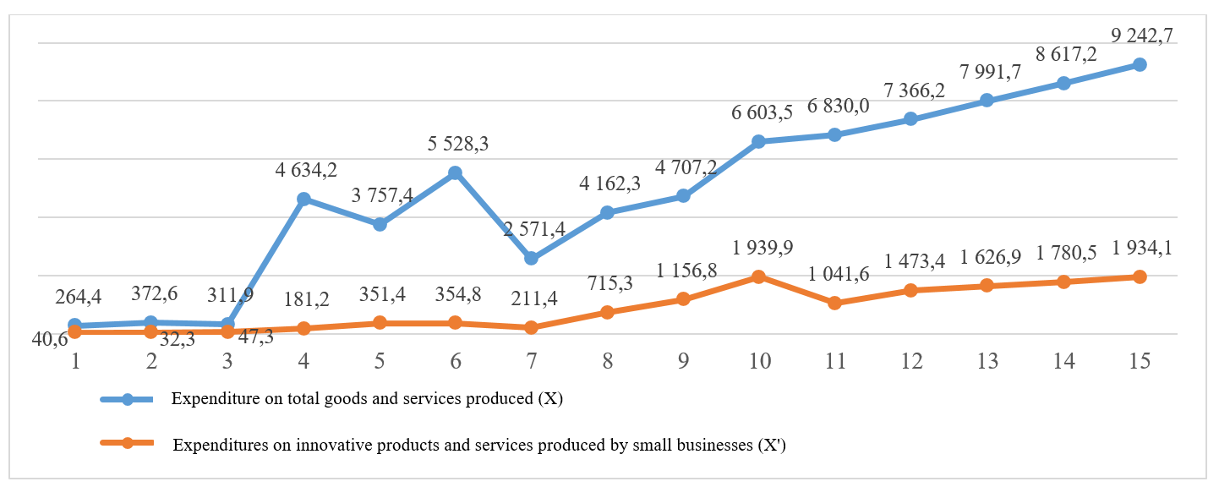
FIGURE 5. Graph of total production and expenditure on innovative products and services produced by small business enterprises (billion soums)

If we analyze the graph of total production and expenditure on innovative products and services produced by small business enterprises (Fig.5), we see that expenditure increases during the forecast period. Spending on total manufactured innovative products and services increased by 35.3% in 2024 compared to 2020. The growth in spending over the forecast period (35.3%) is slightly higher than the growth rate of innovative products and services (35.0). Spending on innovative products and services produced by small businesses also increased during this forecast period, amounting to 185.7%, while the increase in the volume of innovative products and services was equal to 99% during this period. We see that the production of innovative products and services is associated with high costs.
When we look at the volume of innovative products and services produced by small business enterprises (Fig.3), this indicator was higher than the total innovative product produced in 7 out of 10 years considered by small businesses. This advantage in small business is maintained during the forecast period. In 2020, this difference is at the maximum level and it is 13.57-4.56=9.1 billion. amounted to 7.20-4.55=2.65 billion soums by 2024. In the production of total innovative products and services, the cost per unit of innovative product is higher than that of small businesses.
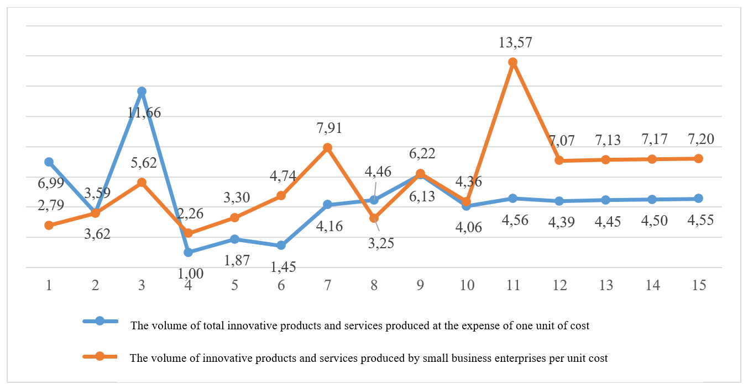
FIGURE 6. Total volume of innovative products and services produced by small business enterprises (billion soums) per unit cost (1 billion soums)

Thus, to conclude, we can see that the innovative output per unit cost in small business enterprises is higher than the total innovative output per unit cost, which can be considered as a motivating factor for small businesses to engage in innovative activities.

Conclusions and suggestions
Successive use of imitative innovations in small business enterprises leads to a strong change in the composition of enterprises. The economic, technical and organizational changes taking place in the enterprise raise it to a higher stage of development. The enterprise can start producing its original innovations after passing through the stage of imitative innovation.
Small business enterprises purchase advanced foreign technology and use imitative innovation to further improve the characteristics of this technology. This leads to savings on development costs and market research costs, reducing investment risks.
Foreign drip irrigation technologies, hydroponics, and other greenhouses, which are effectively used in agriculture, require improvement over time with the help of imitative innovations based on scientific and technical achievements, such as "SMART AGRICULTURE". The transition of small business enterprises from imitative innovations to their own innovations at the next stage can be considered the main production factor that ensures the innovative development of our country.
It can be seen from the graphs above that the volume of innovative products and services produced in total and produced by small business enterprises has a tendency to increase during the forecast period, but at the same time, we see that the growth rate of innovative products over the years is higher than the growth rate of costs, especially in small businesses.
In the forecast period, it can be observed that the volume of innovative products and services produced at the expense of one unit cost (1 billion soums) is much higher in small business enterprises than the total produced innovative product, which means that small business has an advantage over large business in creating innovative products, and innovative development in small business through imitative development with the help of innovations can be considered an effective way.

References
- S.D. Ilyenkova; et al. Innovative management. Textbook. - M., 2024. - p. 343.
- A.V. Shavel. Sustainability of the concept of "innovation" as an economic category. www.uecs.ruRogers, Everett M. Diffusion of innovations. Rev. ed. of: Communication of innovations. 5th ed. 1971. - pp. 40-46.
- B. Salimov; et al. Strategies for Integrating Digitalization in Leveraging Regional Economic and Scientific Expertise for the Innovative Growth of Small and Medium Enterprises, ICFNDS'2023: Proceedings of the 7th International Conference on Future Networks and Distributed Systems, - pp. 483–490. https://doi.org/10.1145/3644713.3644784
- D.F. Mirzaxmedova; et al. Econometric modeling and forecasting of the increase in the export potential of small businesses and private enterprises in the Republic of Uzbekistan, ICFNDS'2022: Proceedings of the 6th International Conference on Future Networks & Distributed Systems, - pp. 298-310. https://doi.org/10.1145/3584202.3584246
- G. Fedyasheva. Development of innovative potential of Uzbekistan in the conditions of economic modernization. Market money and credit, No. 2, 2011. - p. 146.
- G.E. Ershova and O.V. Iovleva. Product and technological innovations and innovations: integration and the market. Proceedings of USUE, 2012. No. 5. - pp. 5-11.
- A.A. Chesnakov. Elements of forecasting and planning in small enterprises as a factor in their development, Current issues of law, economics and governance: III Global scientific and practical conference. Cheboksary, 2021. - p. 710.
- M. Burkhanov. Forms and methods of innovative development and assessment of their impact on the growth of competitiveness of enterprises in Uzbekistan. Economy and finance. - Tashkent, 2012. - No. 11. - pp. 8-15.
- U.V. Gafurov. Activation of small business participation in the implementation of innovative ideas. Economy and finance. - Tashkent, 2012. - No. 2, - p. 17-23.
- S. Huizhuang. Analysis of the benefits of imitation innovation. Humanities and social sciences. 2012. No. 7.
- Y. Dondong and Y. Xiaoqing. Rational thinking, imitative innovation, and medium-sized business. Technological enterprise, 2011. No. 12. - p. 78.
- M. Ermatova; et al. Econometric analysis of evaluation of investment projects implemented in the Northern Regions of Uzbekistan, ICFNDS'2022: Proceedings of the 6th International Conference on Future Networks & Distributed Systems. https://doi.org/10.1145/3584202.3584311
- S. Yekimov; et al. The use of machine-building clusters to increase the efficiency of the machine-building sector of the economy, AIP Conference Proceedings 2526, 020029. 2022. https://doi.org/10.1063/5.0115672
- G.T. Samiyeva; et al. Econometric Assessment of the Dynamics of Development of the Export Potential of Small Businesses and Private Entrepreneurship Subjects in the Conditions of the Digital Economy. Internet of Things, Smart Spaces, and Next Generation Networks and Systems. NEW2AN 2022. Lecture Notes in Computer Science, vol 13772. Springer, Cham. https://doi.org/10.1007/978-3-031-30258-9_39
- N.H. Bekmurodov; et al. Analysis of investments in fixed capital in the context of the development of digital economy in the Republic of Uzbekistan, ICFNDS'2022: Proceedings of the 6th International Conference on Future Networks & Distributed Systems. https://doi.org/10.1145/3584202.3584267
- F. Khamidova; et al. Analyzing the Auto Industry: Benchmarking for Competitive Market Assessment, ICFNDS'2023: Proceedings of the 7th International Conference on Future Networks and Distributed Systems, - pp. 432-437. https://doi.org/10.1145/3644713.3644775
- B.R. Tillaeva; et al. Econometric Evaluation of Influential Factors to Increasing Labor Efficiency in Textile Enterprises. Webology, Volume 18, Special Issue on Information Retrieval and Web Search, 2021. https://www.webology.org/datacms/articles/20210129114502amWEB18024.pdf.
- Gulchekhra Allaeva, Gulchekhra Yusupkhodjaeva, Kamola Mukhitdinova, Methodology for calculating sustainable development of fec enterprises based on consolidated integral indices. AIP Conf. Proc. 3331, 030006 (2025) https://doi.org/10.1063/5.0308133
- Gulchekhra Yusupkhodjaeva, Gulchekhra Allaeva, Kamola Mukhitdinova, Sustainable development of transport enterprises in the context of the formation of the digital economy. AIP Conf. Proc. 3331, 030087 (2025) https://doi.org/10.1063/5.0306872
- Kamala Mukhitdinova, Gulchekhra Yusupkhodjaeva, Gulchekhra Allaeva, Econometric modeling of investment potential of industrial enterprisess. AIP Conf. Proc. 3331, 050026 (2025) https://doi.org/10.1063/5.0308123
- Gulchekhra Allaeva, Main directions of sustainable development of fuel and energy enterprises. AIP Conf. Proc. 3152, 050012 (2024) https://doi.org/10.1063/5.0220851
- Gulchekhra Allaeva, The role of energy security in forming the foundations for sustainable development of fuel and energy complex enterprises. In E3S Web of Conferences 461, 01061 (2023), https://doi.org/10.1051/e3sconf/202346101061
- Gulchekhra Allaeva, Sustainable development methodology of fuel-energy complex of the republic of Uzbekistan. In E3S Web of Conferences 289, 07033 (2021) https://doi.org/10.1051/e3sconf/202128907033
- Gulchekhra Allaeva, Fiscal instruments of taxation improvement as a factor of sustainable development of enterprises of the fuel and energy sector. In E3S Web of Conferences 216, 01173 (2020) https://doi.org/10.1051/e3sconf/202021601173
- Gulchekhra Allaeva, Priority directions of development “Uzbekneftegas” jsc in the conditions of globalization of the world economy. In E3S Web of Conferences 139, 01008 (2019) https://doi.org/10.1051/e3sconf/201913901008
- Saodat Ibragimova, Khilola Bakhodirova, Formation of investment activities of energy enterprises. E3S Web of Conferences 461, 01074 (2023) https://doi.org/10.1051/e3sconf/202346101074
- Ravshan Xusainov, Otabek Begmullaev, Problems of ensuring the electricity supply system in Uzbekistan. In AIP Conference Proceedings. 3331, 030002 (2025) https://doi.org/10.1063/5.0305927
- Ravshan Xusainov, Barno Tillayeva, Nigina Sayfutdinova, Development of ecology and energy in Uzbekistan. AIP Conf. Proc. 3331, 030010 (2025) https://doi.org/10.1063/5.0306384
- Gulchekhra Yusupkhodjaeva, Development of a unified digital transport and logistics intelligent platform based on the National Operator. E3S Web of Conferences 461, 01055 (2023) https://doi.org/10.1051/e3sconf/202346101055
- Kamola Mukhitdinova, Gulmira Tarakhtieva, Ensuring sustainable future: The interconnectedness of food safety and environmental health. E3S Web of Conferences 497, 03037 (2024) https://doi.org/10.1051/e3sconf/202449703037
- Hashimova, S., Yakubova, D., Tursunova, N. (2024). Possibilities of Expanding the Mineral Resource as a Base of Ferrous Metallurgy. In Lecture Notes in Networks and Systems, vol 733. Springer, Cham. https://doi.org/10.1007/978-3-031-37978-9_70
- Sarvinoz Salomova, Matlyuba Saidkarimova, Latofat Karieva, Kamola Ibragimova, Gulnora Saidova, Ravshan Khikmatov, Improving the efficiency of energy enterprises AIP Conf. Proc. 3331, 040076 (2025) https://doi.org/10.1063/5.0305987
- Otabek Begmullaev, Saidaxon Nabieva, Shakhnoza Mirsaidova, Classification of energy efficiency policies and their implementation Available to Purchase. In AIP Conference Proceedings. 3331, 030053 (2025) https://doi.org/10.1063/5.0305929
- Otabek, A., Otabek, B. Alternative energy and its place in ensuring the energy balance of the Republic of Uzbekistan. In AIP Conference Proceedings, 2023, 2552, 050030 https://doi.org/10.1063/5.0117633
- Akhmedov, O., Begmullaev, O. The ways ensuring energy balance in Uzbekistan. In E3S Web of Conferences 216, 01137 (2020), https://doi.org/10.1051/e3sconf/202021601137
- Saidakhon Nabieva, Shakhnoza Atakhanova, Modern methods of investment activity in the development of industrial enterprises. AIP Conf. Proc. 3331, 050010 (2025) https://doi.org/10.1063/5.0308119
- Sarvinoz Salomova, Increasing the efficiency of oil and gas industry enterprises in Uzbekistan. AIP Conf. Proc. 3331, 040075 (2025) https://doi.org/10.1063/5.0305986
- Mukhitdinova, K.A, Vildanova, L.A Transport improvement of the method of assessing the attractiveness of investment in automotive enterprises. Published 2020 Engineering, Business, Economics, 171 Corpus ID: 218792573, https://DOI:10.31838/jcr.07.05.

