Integration of asynchronous generators of microhydroelectric power plants and wind power plants with the power supply system
Olimjon Toirov¹, Mirzokhid Taniev^{1,a)}, Huseyngulu Guliyev², Agabek Ashirov¹, Madina Mannabova¹, Shahlo Khodjaeva¹
¹Tashkent State Technical University named after Islam Karimov, Tashkent, Uzbekistan
²Azerbaijan Technical University, Baku, Azerbaijan
^{a)} Corresponding author: tanievmirzohid@gmail.com
Abstract. This article examines the potential for integrating asynchronous generators in microhydroelectric power plants and wind turbines with the power grid, specifically the parallel operation of wound-rotor asynchronous generators with the existing grid under varying wind and water speeds. Extensive research is currently underway in developed countries on the use of asynchronous generators in renewable energy sources and the automatic control of electromechanical systems. The advantages of wound-rotor asynchronous generators are also discussed. Low harmonic distortion, which characterizes the quantitative presence of higher harmonics in the generator output voltage, is discussed, as well as how higher harmonics lead to uneven rotation and excessive heating of electrical machines. It is noted that in synchronous generators, these harmonic distortions are observed up to 15%, while in asynchronous generators, they do not exceed 2%. Experimental studies were conducted on the integration of an asynchronous generator with a phased rotor of the type 4МТН 012-6 У1, into the power supply system of microhydroelectric power plants and wind power plants with a voltage of 144 V, a current of 11,5 A, a power factor of 0,76 with a “delta/star” stator winding, a three-phase, a frequency of 50 Hz, an active power of 2,2 kW, an IP 54 protection rating, a rated rotation speed of 908 rpm, a voltage of 220/380 V, a stator current of 10,6/6,1 A, and a “star” rotor winding connection, and the obtained results were analyzed. An analysis of the mechanical characteristics of an asynchronous generator with a phased rotor of the type 4МТН 012-6 У1 was also carried out when additional resistances of various ratings were connected to the rotor winding using the MATLAB program.
INTRODUCTION
Over the last decade, electricity generation from wind farms has gained enormous importance worldwide and has In the world, special attention is paid to the rational use of existing natural energy resources, increasing the energy efficiency of generators at power plants through renewable energy sources, and creating energy-efficient operating modes of electromechanical systems at hydroelectric power plants. Currently, large-scale research is being conducted in developed countries on the use of asynchronous generators from renewable energy sources and automatic control of electromechanical systems. The installed capacity of wind power plants worldwide is increasing by 93,6 GW per year, and the total installed capacity has reached 950 GW[1-3]. Also, the installed capacity of small hydroelectric power plants up to 10 MW worldwide has reached 79 GW. In this regard, special attention is paid to improving generators at wind and hydroelectric power plants, improving their energy performance, and increasing the energy efficiency of the electromechanical system. The rotor of a phase rotor asynchronous generator (FRAG) is rotated in the same direction as the magnetic field by the speed of the wind or water flow. In this case, the rotor slip is negative, and a braking torque appears on the rotor of the asynchronous machine. The generator transmits energy to the network. The driving force in the output windings of the generator is created due to the residual magnetic field. Capacitors are used for this. Asynchronous generators are not sensitive to short circuits. The FRAG has a simpler structure and operating process than a synchronous generator. Synchronous generators have inductors in the rotor, which provide a constant current to the excitation system and create a magnetic field[4-8].
FRAG has the following advantages. The output voltage of the generator includes small harmonic distortions, which characterize the quantitative presence of higher harmonics. Higher harmonics lead to uneven rotation and excessive heating of electrical machines. In synchronous generators, harmonic distortions of up to 15% are observed, while in asynchronous generators they do not exceed 2%. Thus, asynchronous generators practically produce only useful energy. Phase rotor asynchronous generators have an alternating current of 220 / 380 V at the generator output, which can be connected directly to the consumer, as well as for parallel operation with the existing network. In addition, FRAG does not require the use of various converters for parallel operation with the existing network. Another advantage of using phase rotor asynchronous generators in wind power plants and microhydroelectric power plants is that they allow maintaining the power and voltage values at the generator output unchanged by controlling the resistances in the rotor circuit at different speeds of wind and water flow[9-12]. AGs are distinguished by their simplicity and convenience in operation and maintenance, and their integration into the power supply system is relatively easy. The mass of an AG with a capacity of 5-100 kW is approximately 1,2-1,3 times less than the mass of a SG with the same capacity. Unlike SGs, asynchronous generators do not face the risk of losing synchronism. At the same time, the main advantage of AGs over SGs is that their output voltage has a constant frequency when the rotor speed changes within certain limits, and in addition, it is characterized by stability in its integration with the network. It is precisely because of this last advantage that the use of AGs in wind power plants is increasingly developing[13].
The map is based on data from an altitude of 84 meters above the ground. According to the data on this map, areas with wind speeds of 5,0 m/s to 6,5 m/s and above occupy 70-75 percent of the total area of our country, areas with wind speeds of 3,0 m/s to 5,0 m/s occupy 20-25 percent, and areas with wind speeds of less than 2,5 m/s occupy about 5 percent. These figures indicate that wind energy can be used in 95 percent of the territory of the republic [14-17].
EXPERIMENTAL RESEARCH
According to experts, the potential of renewable energy sources in Uzbekistan is equal to 51 billion tons of oil equivalent, and the technical capabilities are 182,32 million tons of oil equivalent. This figure is three times higher than the current volume of primary energy reserves extracted annually in the country [18-21].
If we look at world experience in this regard, we see the creation of a separate International Renewable Energy Agency (IRENA) and the adoption of special laws or national goals aimed at developing this type of energy in 164 countries around the world today, and the strategies of these countries include the task of increasing the share of renewable energy sources to 50% by 2030 [22].
When using a phase rotor asynchronous generator instead of a synchronous generator of micro hydropower plants and CHPs, the following advantages of the asynchronous generator are clearly visible:
1. Due to the simple structure of the asynchronous generator, its weight and dimensions are small, and its price is 1,5 ÷ 2,0 times cheaper.
2. Due to the simplicity of connecting the asynchronous generator to the network, it is possible to operate the solar power plant and microhydroelectric power plant simultaneously, both in autonomous and parallel operation modes. It is necessary to connect a capacitor compensator (CC) parallel to the stator winding. When connecting such a power plant to the network, the CC ensures that the power factor of the generator is close to unity (cosφ ≈ 1,0) and that power losses in the power transmission line are minimal[23].
Among the types of electric machines, induction machines are the most common, the simplest in design, and the cheapest in price. The biggest and unique advantage of an induction machine operating in generator mode is its technical simplicity, technological simplicity, and convenience in parallel connection with the network. The slip of asynchronous generators in nominal mode is s_{N} = 3 ÷ 6%, in some cases 10% [24].
Figure 1 shows the mechanical characteristics of the 4MTN 012-6 U1 type, three-phase, frequency 50 Hz, active power 2,2 kW, IP 54, nominal speed 908 rpm, with a delta/star stator winding, voltage 220/380 V, stator current 10,6/6.1 A, and a star rotor winding, voltage 144 V, current 11,5 A, and power factor 0,76, i.e., the graph of the generator torque versus speed, using the MATLAB program. The graph of the torque change for the additional resistance R_{add} = 0; 0,9; 2,2; 4,7; 7,5 Ohms to the rotor winding of the 4MTN 012-6 U1 is presented. As can be seen from the figure, it can be seen that the range of torque control is extended by adding additional resistance to the rotor circuit [25].
Figure 1 shows the graph of the generator power versus speed of a 4MTN 012-6 U1 type, three-phase, frequency 50 Hz, active power 2,2 kW, IP 54, nominal speed 908 rpm, with a delta/star stator winding, voltage 220/380 V, stator current 10,6/6,1 A, and a star rotor winding, voltage 144 V, current 11.5 A, and power factor 0,76, calculated using the MATLAB program [26].

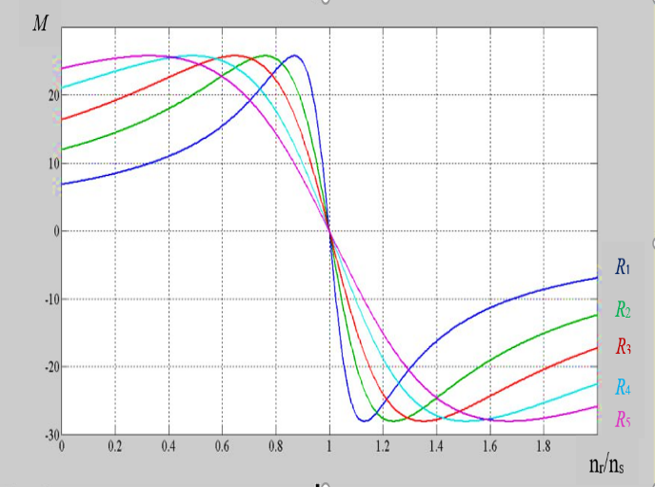 | 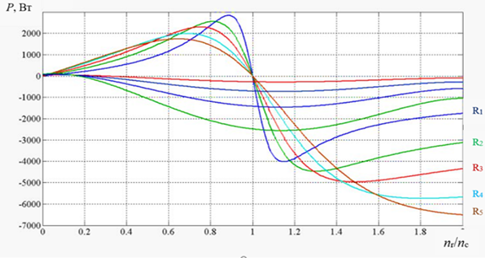
FIGURE 1. Torque vs. speed graph for additional resistance R in the rotor winding of a FRAG from 0 to 7,5 Ohm | FIGURE 2. Power versus speed graph for values of additional resistance R'_{e} introduced into the rotor circuit of the FRAG

The graph of the generator power change for the additional resistance R_{add} = 0; 0,9; 2,2; 4,7; 7,5 Ohms to the rotor winding of the FRAG is presented.
At the same time, a graph of the dependence of the power output from the generator on the rotor and wind speed for varying the additional resistance of the FRAG to the rotor circuit from 0 to 7,5 Ohms and for different wind speeds is presented [27-30]. From this relationship, it can be seen that with increasing rotor and wind speed, the active power output from the generator increases.
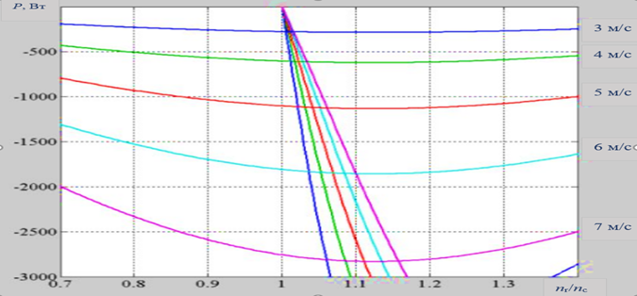
FIGURE 3. Torque vs. speed graph for additional resistance and maximum power output limits for different wind speeds.

Figure 3 shows the power versus speed graph for the additional resistance R_{add} = 0; 0,9; 2,2; 4,7; 7,5 Ohms added to the rotor winding of the FRAG using the MATLAB program and for the values of the maximum power output limits for different wind speeds. This graph makes it possible to determine the maximum power output points.
RESEARCH RESULTS
The graphs of the output voltage, stator current, active, reactive, and apparent power, power factor, rotor current, generator rotor speed, and rotor voltage of an asynchronous generator with a phase rotor when the active resistance of the rotor circuit is changed from 0 to 7,4 Ohm are presented in Table 1.
TABLE 1. Changes in the parameters of a phase rotor asynchronous generator by changing the resistances in the rotor circuit
R, Om | U, V | I, A | P, W | Q, VAr | S, VA | cosf | I_{r}, A | n, rpm | f, Hz | U_{r} | I_{d}, А
0 | 402 | 3,4 | 2298 | 909 | 2535 | 0,95 | 8,57 | 1092 | 21,96 | 0 | 19,1
0,9 | 402 | 2,9 | 2210 | -755 | 2410 | 0,94 | 7,8 | 1144 | 21,96 | 16 | 15,2
2,2 | 402 | 2,1 | 2100 | -545 | 2260 | 0,93 | 6,6 | 1195 | 21,96 | 28 | 11,5
4,7 | 402 | 1,2 | 1875 | -321 | 2048 | 0,9 | 4,28 | 1245 | 21,96 | 36 | 7,8
7,5 | 402 | 0,88 | 1680 | -132 | 1780 | 0,78 | 3,14 | 1264 | 21,96 | 40 | 6,5

Figure 4(a) shows the graph of the generator rotor speed as the additional active resistances in the rotor circuit are changed from 0 to 7,4 Ohms. As the value of the resistances connected to the rotor circuit increases, the generator rotor speed increases [31-35]. Figure 4(b) shows the graph of the generator output voltage as the additional active resistances in the rotor circuit are changed from 0 to 7,4 Ohms. As the value of the resistances connected to the rotor circuit increases, the generator output voltage remains unchanged.

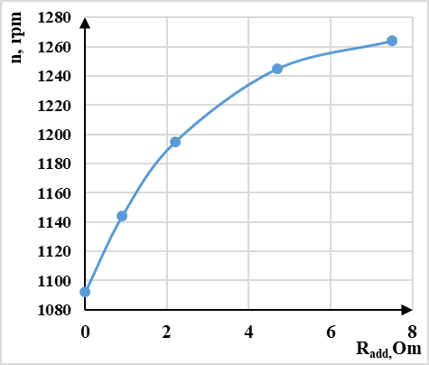 | 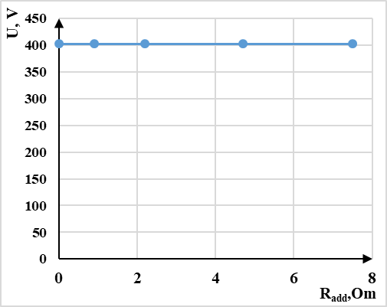
a) | b)
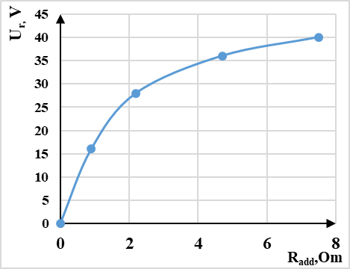 | 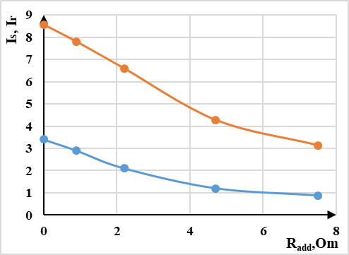
с) | d)
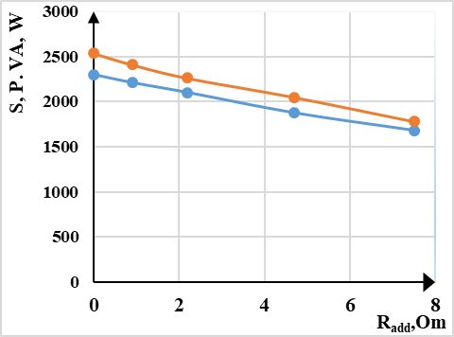 | 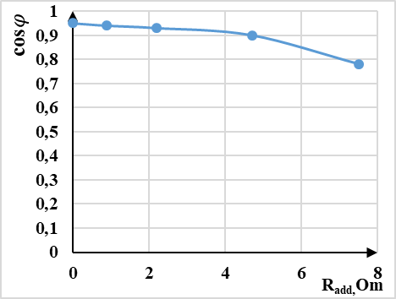
e) | f)
FIGURE 4. Variation of generator output parameters at different resistance values.
a) Variation of generator rotor speed $n$as a function of $R_{add}$; b) Dependence of generator output voltage $U$on $R_{add}$;
c) Dependence of generator rotor voltage $U_{r}$on $R_{add}$; d) Variation of generator stator current $I_{s}$and rotor current $I_{r}$as functions of $R_{add}$; e) Dependence of apparent power $S$and active power $P$of the generator on $R_{add}$; f) Dependence of generator power factor $\cos{φ}$on $R_{add}$.

Figure 4(c) shows the graph of the generator rotor voltage as the additional active resistances to the rotor circuit are changed from 0 to 7,4 Ohm. As the value of the resistances connected to the rotor circuit increases, the generator rotor voltage increases from 0 V to 40 V. Figure 4(d) shows the graph of the generator stator and rotor currents as the additional active resistances to the rotor circuit are changed from 0 to 7,4 Ohm. As the value of the resistances connected to the rotor circuit increases, the generator stator current decreases from 3,4 A to 0,88 A, and the rotor current decreases from 8,57 A to 3,14 A. Figure 4(e) shows the graph of the generator's apparent and active power as the additional active resistances to the rotor circuit are changed from 0 to 7,4 ohms. As the value of the resistances connected to the rotor circuit increased, the generator apparent power decreased from 2535 VA to 1780 VA, and the active power decreased from 2298 W to 1680 W. Figure 4(f) shows the graph of the generator power factor when the additional active resistances to the rotor circuit were changed from 0 to 7,4 Ohm. As the value of the resistances connected to the rotor circuit increased, the generator power factor decreased from 0,95 to 0,78.
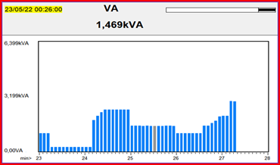 | 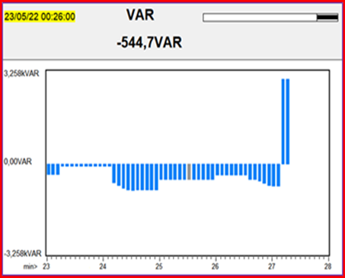
FIGURE 5. Variation of the full output power of the FRAG | FIGURE 6. Variation of reactive power at the output of the FRAG
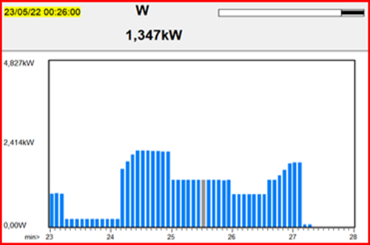 | 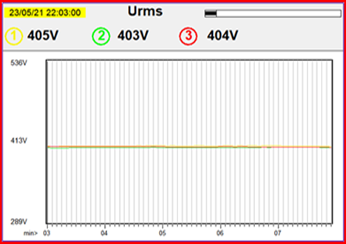
FIGURE 7. Variation of active power at the output  of the FRAG | FIGURE 8. Variation of output power of FRAG
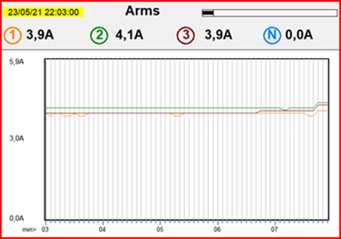 | 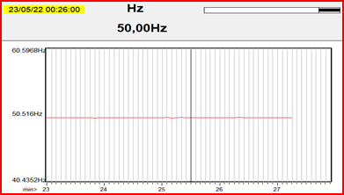
FIGURE 9. Variation of stator phase currents of the FRAG | FIGURE 10. Variation of the output current frequency of the FRAG
It is shown that when operating in parallel with the network, AGs require fewer conditions than SGs. AGs do not have problems with synchronization with the network and desynchronization. They also do not require protection against short circuits, since in this case the AG loses excitation. In addition, when operating in parallel with the network, there is no need for a self-excitation and voltage regulation system, and the quality of the generator output voltage, when compared with AGs, provides the required values. The power factor of the rotor of an asynchronous generator does not depend on the load but depends on the slip coefficient and other parameters. The square components of the primary current (relative to the voltage) at the output terminals are almost unchanged for all voltages and frequencies specified. Thus, the reactive power obtained by this scheme is supplied from an external source through a synchronous generator, capacitor banks, or power compensators, through which the reactive power compensation of the electrical network is carried out.
CONCLUSIONS
The power generated in the rotor at negative slip, or the mechanical power converted into electrical power, is the difference between the power passing through the air gap and the power dissipated in the rotor. It follows that the smaller the load inductance L, the less significant the effect on C_{ef}. However, for large values of the load inductance L, this inductance becomes significant for the output voltage. Since the slope of the capacitive reactance straight line is almost close to the straight part of the excitation curve (the air gap line). It significantly reduces the voltage drop at the output terminals of the generator. The advantage of this system is that if the load resistance is very small, the self-excited capacitor discharges very quickly, which provides natural protection against high currents and short circuits. On the other hand, high values of the self-excited capacity of the capacitor are limited by the saturation of the magnetic core.
REFERENCES
- R. Schurhuber, B. R. Oswald, L. Fickert, J. Fortmann. Verhalten von Windkraftanlagen mit doppelt speisenden Asynchrongeneratoren (DFIG) bei Kurzschlüssen und anderen Netzfehlern. Elektrotechnik, Informationstechnik (2020) 137/8: 415–424. https://doi.org/10.1007/s00502-020-00829-2
- K. Allaev, J. Toshov, Modern state of the energy sector of Uzbekistan and issues of their development, E3S Web of Conferences 401, 05090 (2023). https://doi.org/10.1051/e3sconf/202340105090
- N.Rashidov, Kh.Rozmetov, S. Rismukhamedov, M.Peysenov Design of a pole changing winding for asynchronous machines drived on conveyors using the ANSYS Maxwell // E3S Web of Conferences 384. 2023. РР, 01043, 1-4. https://doi.org/10.1051/e3sconf/202338401043.
- O. Toirov, Sh. Azimov, Z. Toirov. Improving the cooling system of reactive power compensation devices used in railway power supply // AIP Conference Proceedings, 3331, 1, 050030, (2025). https://doi.org/10.1063/5.0305670
- Sh. Azimov, Z. Najmitdinov, M. Sharipov, Z. Toirov. Improvement of the cooling system of reactive power compensating devices used in railway power supply // E3S Web of Conferences, 497, 01015, (2024). https://doi.org/10.1051/e3sconf/202449701015
- D. Jumaeva, O. Toirov, B. Numonov, N. Raxmatullaeva, M. Shamuratova. Obtaining of highly energy-efficient activated carbons based on wood, // E3S Web of Conferences 410, 01018, (2023). https://doi.org/10.1051/e3sconf/202341001018
- O. Toirov, M. Taniev, M. Hamdamov, A. Sotiboldiev, Power Losses Of Asynchronous Generators Based On Renewable Energy Sources E3S Web of Conferences, 434, 01020, (2023) https://doi.org/10.1051/e3sconf/202343401020
- D. Jumaeva, O. Toirov, U. Raximov, O. Ergashev, A. Abdyrakhimov. Basic thermodynamic description of adsorption of polar and nonpolar molecules on AOGW, // E3S Web of Conferences 425, 04003 (2023) https://doi.org/10.1051/e3sconf/202343401020
- O. Toirov, S. Khalikov, Sodikjon Khalikov, F. Sharopov, Studies of reliability indicators of pumping units of machine irrigation on the example of the “Namangan” pumping station, // E3S Web of Conferences 410, 05015, (2023). https://doi.org/10.1051/e3sconf/202341005015
- D. Bystrov, S. Giyasov, M. Taniev, S. Urokov. Role of Reengineering in Training of Specialists // ACM International Conference Proceeding Series (2020) https://doi.org/10.1145/3386723.3387868
- O. Toirov, V. Ivanova, V. Tsypkina, D. Jumaeva, D. Abdullaeva, Improvement of the multifilament wire lager for cable production, // E3S Web of Conferences 411, 01041 (2023), https://doi.org/10.1051/e3sconf/202341101041
- T. Kamalov, U. Mirkhonov, S. Urokov, D. Jumaeva, The mathematical model and a block diagram of a synchronous motor compressor unit with a system of automatic control of the excitation // E3S Web of Conferences, 288, 01083, (2021), https://doi.org/10.1051/e3sconf/202128801083
- Tuychiev F, Haqberdiev A. Development of two-speed asynchronous electric motors for the undercarriage of mine self-propelled cars // E3S Web of Conferences 384. 2023. РР, 01044, 1-5. https://doi.org/10.1051/e3sconf/202338401044.
- O. Toirov, S. Urokov, U. Mirkhonov, H. Afrisal, D. Jumaeva, Experimental study of the control of operating modes of a plate feeder based on a frequency-controlled electric drive, // E3S Web of Conferences, SUSE-2021, 288, 01086 (2021). https://doi.org/10.1051/e3sconf/202128801086
- S. Khalikov, Diagnostics of pumping units of pumping station of machine water lifting, // E3S Web of Conferences 365, 04013, (2023). https://doi.org/10.1051/e3sconf/202336504013
- D. Bystrov, M. Gulzoda, Y. Dilfuza, Fuzzy Systems for Computational Linguistics and Natural Language (2020) // ACM International Conference Proceeding Series, https://doi.org/10.1145/3386723.3387873
- O. Toirov, I. Khujaev, J. Jumayev, M. Hamdamov, Modeling of vertical axis wind turbine using Ansys Fluent package program, // E3S Web of Conferences 401, 04040 (2023). https://doi.org/10.1051/e3sconf/202340104040
- Bobojanov M., Torayev S. Saving electrical energy by using induction motors with pole changing windings in the water supply system // E3S Web of Conferences 384. 2023. РР, 01045, 1-4. https://doi.org/10.1051/e3sconf/202338401045.
- O. Toirov, S. Abdi Yonis, Z. Yusupov, A. Habbal, Control Approach Of A Grid Connected Dfig Based Wind Turbine Using Mppt And Pi Controller, // Advances in Electrical and Electronic Engineering, 21, 3, (2023). https://doi.org/10.15598/aeee.v21i3.5149
- D. Jumaeva, A. Abdurakhimov, Kh. Abdurakhimov, N. Rakhmatullaeva, O. Toirov, Energy of adsorption of an adsorbent in solving environmental problems, // E3S Web of Conferences, SUSE-2021, 288, 01082 (2021). https://doi.org/10.1051/e3sconf/202128801082
- O. Toirov, M. Khalikova, D. Jumaeva, S. Kakharov, (2023) Development of a mathematical model of a frequency-controlled electromagnetic vibration motor taking into account the nonlinear dependences of the characteristics of the elements, // E3S Web of Conferences 401, 05089, (2023). https://doi.org/10.1051/e3sconf/202340105089
- Reymov K.M., Esemuratova Sh.M., Khusanov B.M., Mytnikov A.V. A study of a hybrid type stand-alone 3 kW photovoltaic system of Karakalpak state university // E3S Web of Conferences 384. 2023. РР, 01047, 1-4. https://doi.org/10.1051/e3sconf/202338401047
- O. Toirov, S. Khalikov. Analysis of the safety of pumping units of pumping stations of machine water lifting in the function of reliability indicators, // E3S Web of Conferences 365, 04010 (2023), https://doi.org/10.1051/e3sconf/202336504010
- О. Toirov, D. Jumaeva, U. Mirkhonov, S. Urokov, S. Ergashev, Frequency-controlled asynchronous electric drives and their energy parameters, // AIP Conference Proceedings 2552, 040021, (2022). https://doi.org/10.1063/5.0218808
- T. Sadullaev, D. Abdullaev, D. Jumaeva, Sh. Ergashev, I.B. Sapaev, Development of contactless switching devices for asynchronous machines in order to save energy and resources, // E3S Web of Conferences 383, 01029, (2023). https://doi.org/10.1051/e3sconf/202338301029
- O. Toirov, S. Khalikov, Algorithm and Software Implementation of the Diagnostic System for the Technical Condition of Powerful Units, // E3S Web of Conferences 377, 01004, (2023). https://doi.org/10.1051/e3sconf/202337701004
- D. Jumaeva, Z. Okhunjanov, U. Raximov, R. Akhrorova. Investigation of the adsorption of nonpolar adsorbate molecules on the illite surface, // Journal of Chemical Technology and Metallurgy, 58, 2, (2023). https://doi.org/10.59957/jctm.v58i2.61
- M.Melikuziev. Determination of the service area and location of transformer substations in the city power supply system // E3S Web of Conferences 384. 2023. РР, 01033, 1-5. https://doi.org/10.1051/e3sconf/202338401033.
- Bobojonov Y.M., Saidkhodjaev A.G. Critical evaluation of energy use in industrial enterprises // E3S Web of Conferences 384. 2023. РР, 01048, 1-5. https://doi.org/10.1051/e3sconf/202338401048.
- O. Toirov, K. Alimkhodjaev, A. Pardaboev, Analysis and ways of reducing electricity losses in the electric power systems of industrial enterprises, // E3S Web of Conferences, SUSE-2021, 288, 01085 (2021). https://doi.org/10.1051/e3sconf/202128801085
- Ruzinazarov M.R. Current source converter into stabilized voltage source based on electromagnetic ferromagnetic circuit // E3S Web of Conferences 384. 2023. РР, 01050, 1-5. https://doi.org/10.1051/e3sconf/202338401050.
- O. Toirov, V. Tsypkina, V. Ivanova, D. Isamukhamedov, M. Kozlitin, Z. Toirov. Overview of Modern Materials Used for the Production of Optical Fiber for Fiber Optic Cables AIP Conference Proceedings, 3331 (1), 050029 (2025). https://doi.org/10.1063/5.0305669
- O. Toirov, T. Sadullaev, U. Hoshimov, S. Urokov, A. Naimov, J. Khudoyorov, Z. Toirov. Development of an integrated method for rating electrical energy consumption during the drilling process, // AIP Conference Proceedings, 3331 (1), 050028, (2025). https://doi.org/10.1063/5.0305668
- N. Avezova, O. Toirov, A. Usmanov. Review of Modern Approaches in the Development of Hybrid Biogas Systems // Applied Solar Energy, 60 (6), (2024) https://doi.org/10.3103/S0003701X25600845
- O. Filina, A. Khusnutdinov, O. Toirov, Kh. Vakhitov, A. Abdyllina, Investigation the conditions of existence and disturbances of brush-collector contact // E3S Web Conf. 563, 01009, (2024). https://doi.org/10.1051/e3sconf/202456301009

