Improvement of the algorithm of the conveyor-type dynamic weighing system to increase energy performance
Olimjon Toirov^{1,4}, Dilshod Mirzoev^{2,a)}, Shukhrat Abdullaev³
¹Tashkent State Technical University named after Islam Karimov, Tashkent, Uzbekistan
² Bukhara State Technical University, Bukhara, Uzbekistan
³LUKOIL Uzbekistan Operating Company LLC, Tashkent, Uzbekistan
⁴Termez State University of Engineering and Agrotechnology, Termez, Uzbekistan
^{a)} Corresponding author: dilshodmirzoyev85@gmail.com
Abstract. This article illustrates the algorithm of operation of a dynamic conveyor-type weighing system. This type of device is used in the production of building materials, pharmaceutical and food industries. A dynamic conveyor-type weighing system is called a checkweigher for short. Modern checkweighers utilize a hardware and software package with an automatic control system. This equipment rises production productivity, increases the quantity and quality of output products, reduces the cost of production, and increases the energy efficiency of the enterprise. When using modern frequency converters to control asynchronous motors, flexible control of the latter becomes possible. The possibility of soft control of the start-stop mode of asynchronous electric motors allows to increase the service life of mechanical rotating units, reducing mechanical wear of equipment. The checkweigher is controlled through a dispatching program. The main controlled parameters are configured at an automated production workplace. The entire control process is controlled by an industrial controller. This control method increases the flexible controllability of the technological process. Also, on the basis of an industrial controller, it is possible to account for passing products. This data can be transferred to an automated production workplace. This information is intended for data analysis during production, which allows you to take certain actions to increase energy efficiency and increase the quantity of finished products. The algorithms are compiled using modern scientific achievements and have a positive effect on business processes in production.
INTRODUCTION
The use of modern technologies for process control in production is becoming more efficient and flexible. By efficiency, we mean timely control of the implementation of production plans, maintenance and efficient production with rapid response to technological process deviations, by flexibility we mean the possibility of using different products in production, changing production volumes, and sequencing technological processes [1-3]. In modern continuous production, all costs are taken into account when calculating the cost of production, in modern realities this applies especially to energy indicators. Since energy indicators are essential for production, their improvement is one of the main areas of research in existing production facilities [4-6]. The proposed control model of a conveyor dynamic weighing system is designed for continuous production applications. The model consists of a hardware and software package [7-8].

METHODOLOGY
The algorithm of the device works according to the following principle:
The device (hereinafter referred to as the checkweigheris a mechanical unit with an automatic control system. The automatic control system consists of hardware and software parts. The hardware includes all electronic devices used to operate the checkweigher, such as a control controller, a weighing module, frequency converters, strain gauges, optical sensors, contactless magnetic sensors, a control cabinet, and a computer with a monitor. The Simatic Manadjer program and a special frequency converter program are part of the software. The Simatic Manadjer program is installed on a standard computer running the Windows operating system. The Scada program is used to visualize technological processes. Based on this program, a workplace for a production management operator has been created, abbreviated as APM (automated workplace). All production processes are displayed on this program [9-11].
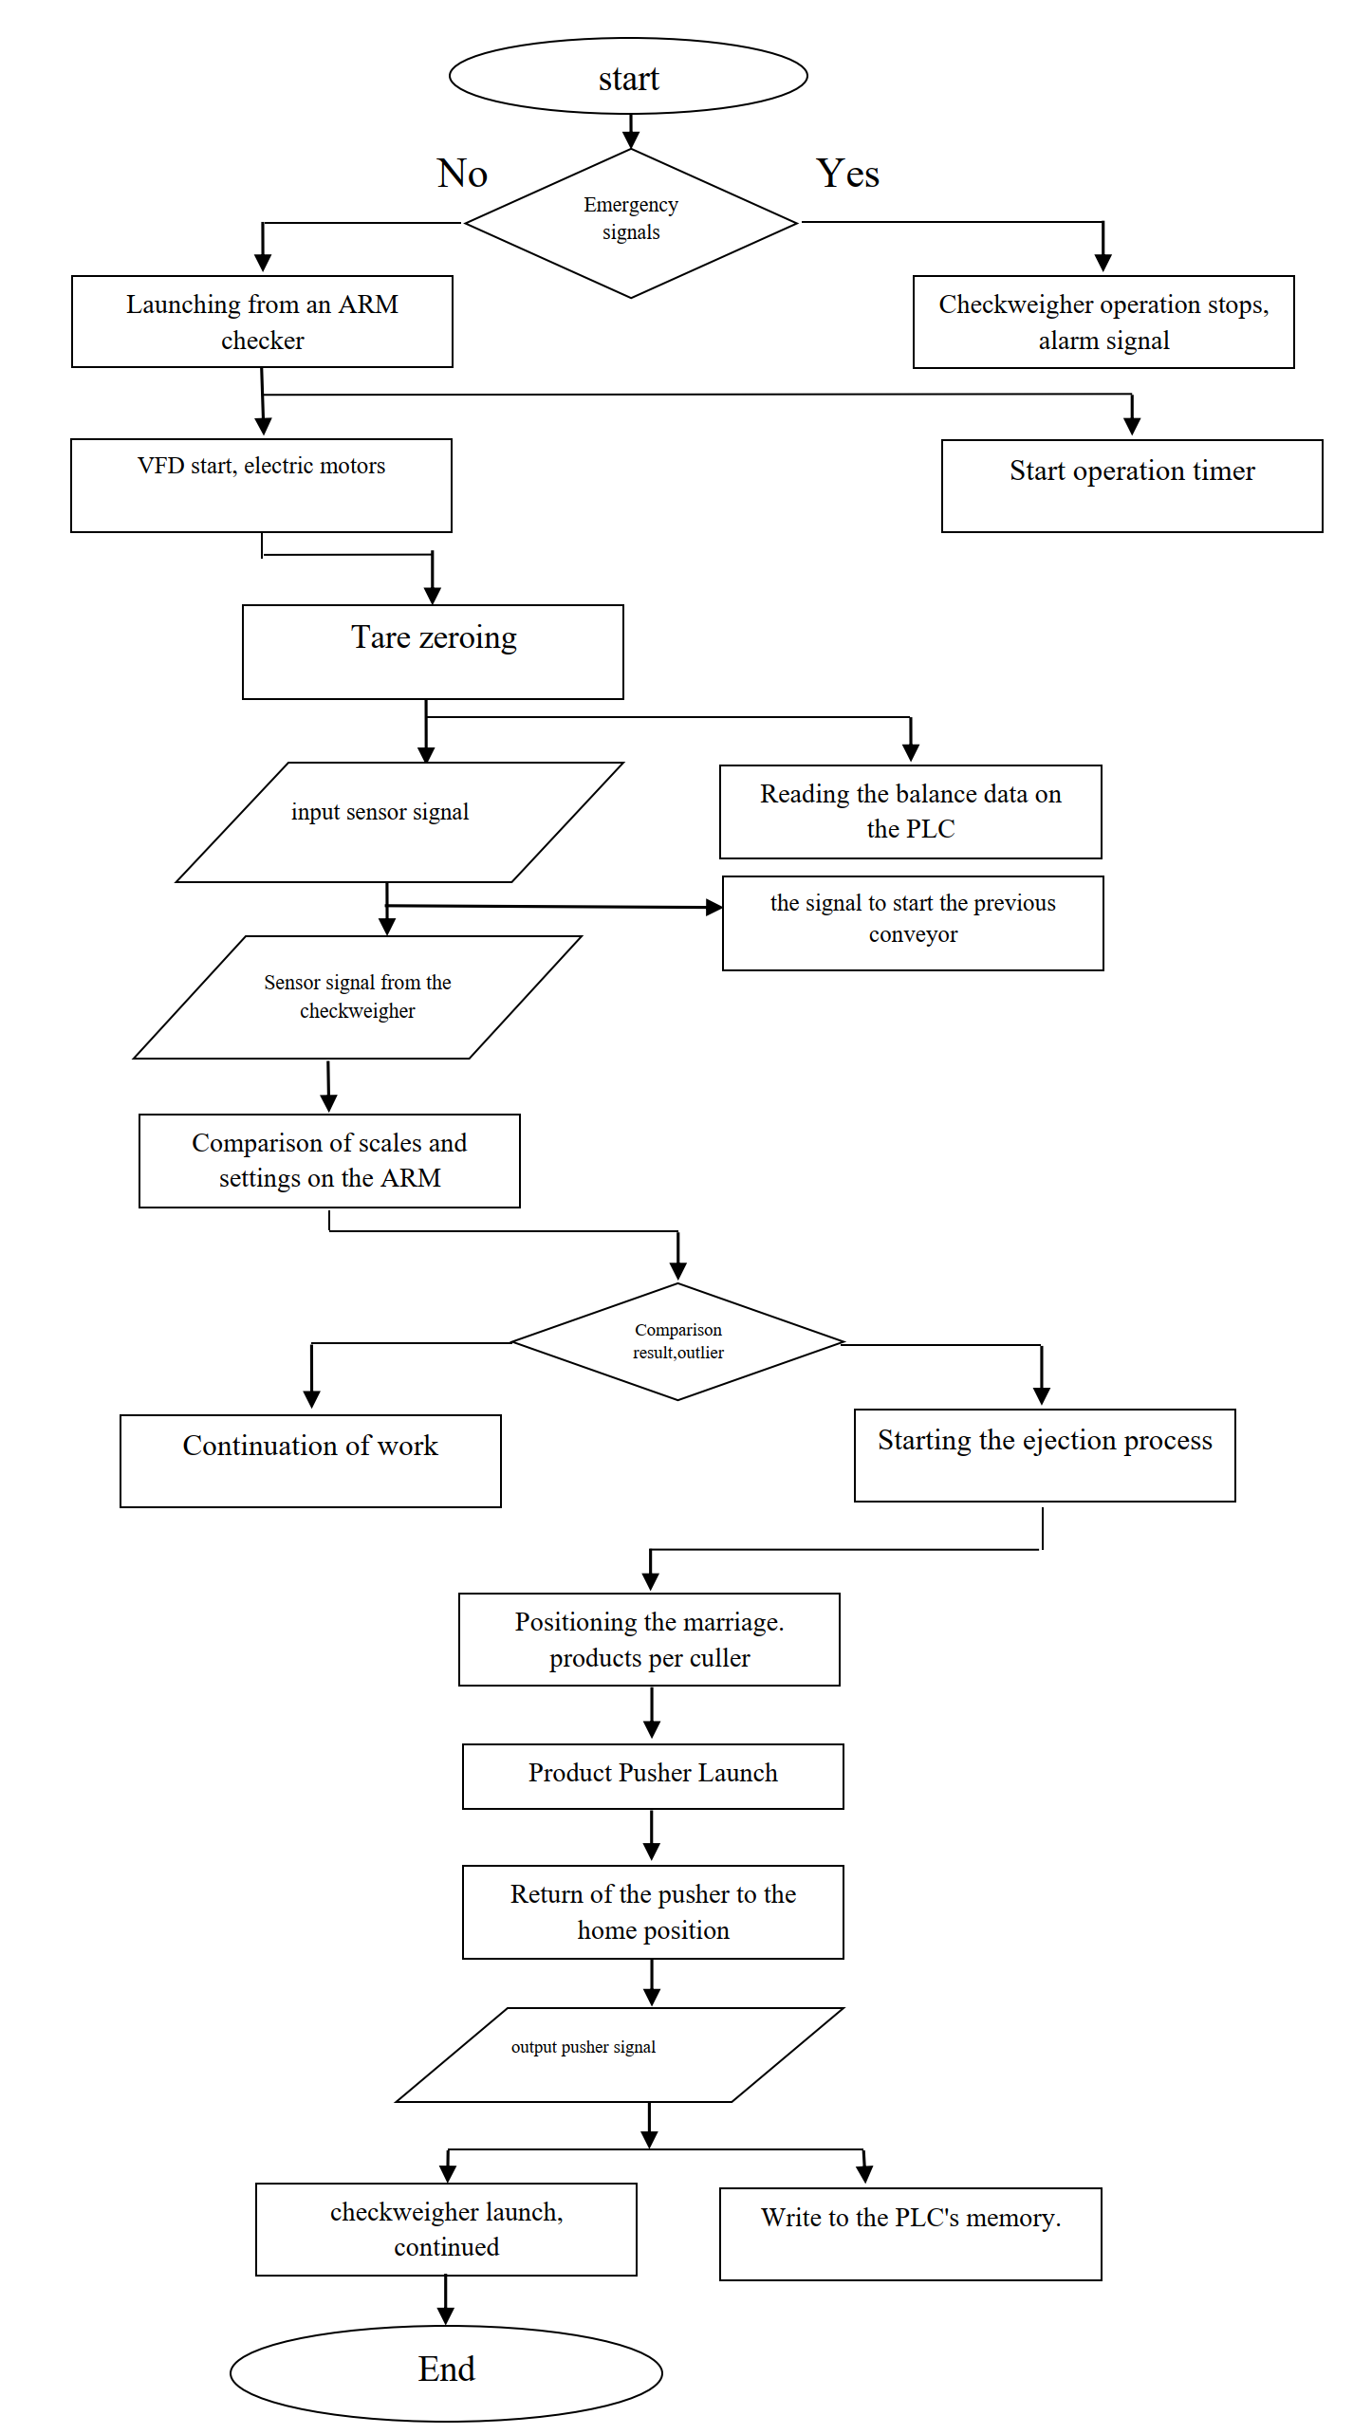
FIGURE 1. The checkweigher algorithm

EXPERIMENTAL RESEARCH
The software part is designed in such a way that, at the primary stage, the control controller checks for alarms before operation. The "alarms" algorithm is designed to ensure that the checkweigher is ready to start. If there are such signals, it activates an emergency light and sound signal, thus notifying about the presence of problems to start the checkweigher. This signal is also displayed on the computer monitor of the ARM, indicating exactly which sensor or device, such as a frequency converter, has a problem [12-16].
Next, the production management operator launches a product transportation line on the ARM, which includes a checkweigher, while the "Launch from ARM Checkweigher" algorithm is performed. After the start of the transportation line, products are supplied to the checkweigher, and to fully control the normal operation of the checkweigher, the production controller starts the "Operation Timer Start" algorithm, each time the products pass through the checkweigher, this timer is restarted [17-20]. After the "Start from ARM Checkweigher" algorithm command, the production controller starts the frequency converters, the frequency converters supply voltage to the electric motors of the checkweigher. In this case, the "Emergency start, electric motors" algorithm is performed, frequency converters start electric motors with a preset frequency and smooth start. This launch method has several advantages over the standard launch on electromagnetic starters.:
1. The equipment should be started without sudden mechanical shocks and vibrations, which has a positive effect on the service life of mechanical parts.
2. When starting electric motors using frequency converters, the inrush current decreases, thus, the current consumption of the checkweigher decreases, and the heating of electric motors decreases [21-22].
After the rotation of the electric motors, the controller can reset the electronic scales, which corresponds to the algorithm "Reset the scale container", this step is necessary for accurate measurement of the electronic scales. This algorithm is triggered in one cycle of the controller program, which does not affect other processes of the controller program algorithm. Immediately after this process, the production controller reads the signal from the input optical sensor, which corresponds to the "input sensor signal" algorithm. This algorithm is designed to detect products at the checkweigher's entrance. At the same time, the production controller reads data from the electronic scales, executing the algorithm "Reading the scale data on the PLC", to track and control the weight of products for compliance with the permissible norm. This standard is set at the ARMa by the production management operator before launching the product transportation line. After these algorithms, the production controller will start the conveyor to the checkweigher, while the "signal to start the previous conveyor" algorithm is executed so that the products are transported to the checkweigher. When the products pass through and are on the checkweigher, the controller compares the data of the scales installed on the ARM and read from the electronic scales. In this case, the algorithm "Comparing weights and settings on the ARM" is performed. The process of comparing weights takes 10 minutes..30 ms, as a result of the shutdown of the pipelines is not required. Next, the controller runs the "Comparison result, outlier" algorithm. Depending on the result of the comparison, the controller runs the required algorithm of the software part. If the entire product does not meet the permissible limit, then the "Product release process start" algorithm will be launched. The identified nonconforming products pass to the rejection conveyor, which is the second conveyor as part of the checkweigher. When defective products pass through this conveyor, the "Positioning defective products on the cull" algorithm is activated, the controller gives the stop command to the frequency converter of the cull conveyor. The electric motor stops slowing down. The time to a complete stop after receiving the stop command from the controller is preset on the frequency converter. This makes it possible to positionally stop the defective product in front of the pusher.
After the rejection conveyor is completely stopped, the controller starts the "Product Pusher Start" algorithm. The pusher is a pneumatic cylinder with a long rod. The controller switches the pneumatic cylinder to the active state, and the process of discarding defective products occurs. A metal plate is mounted on the rod, which pushes out the defective product. After testing the piston rod of the pneumatic cylinder for ejection, the controller removes the activate command from the pusher, while the piston rod returns to its original position.
This corresponds to the "Return the pusher to the home position" algorithm. When the pusher is tested in this way, the signal from the sensor mounted on the pneumatic cylinder disappears and appears. This activates the "product pusher signal" algorithm. This algorithm is designed to control the operation of a pneumatic cylinder. If this signal does not appear within a certain time, the controller activates an alarm and stops the operation of the transportation line.
After cleaning the rejection conveyor from defective products, the "checkweigher start, continue" algorithm is activated, and the checkweigher will continue to work. The controller program has added the function of reading the amount of work of the pneumatic cylinder, and the number of products that have passed is also recorded.
This corresponds to the algorithm "Write a fault in the memory of the PLC (programmable logic controller)". This information is reflected on the production ARM and is used to write to the database on a separate computer.

CONCLUSIONS
The control algorithm proposed above makes it possible to increase the energy efficiency of production and reduce the cost of production. This control algorithm increases the service life of mechanical components, reducing the number of consumables for maintenance. The smooth start of the electric motors reduces the mechanical vibrations of the installation, thereby increasing the service life of strain gauges that are sensitive to mechanical vibrations. The use of frequency converters reduces inrush currents, while adjusting the frequency of the IF to (ARM), you can control the energy parameters of the consumed current of the checkweigher. Electricity consumption is expected to decrease by up to 15-20% per transportation line.
REFERENCES
- K.R. Allaev Energy efficiency and renewable energy sources // Problems of energy and resource saving. Tashkent, 2011. Special Issue. pp. 15-25.
- O. Toirov, Sh. Azimov, Z. Toirov. Improving the cooling system of reactive power compensation devices used in railway power supply // AIP Conference Proceedings, 3331, 1, 050030, (2025). https://doi.org/10.1063/5.0305670
- D. Jumaeva, B. Numonov, N. Raxmatullaeva, M. Shamuratova. Obtaining of highly energy-efficient activated carbons based on wood, // E3S Web of Conferences 410, 01018, (2023). https://doi.org/10.1051/e3sconf/202341001018
- K. Allaev, J. Toshov, Modern state of the energy sector of Uzbekistan and issues of their development, E3S Web of Conferences 401, 05090 (2023). https://doi.org/10.1051/e3sconf/202340105090
- D. Jumaeva, U. Raximov, O. Ergashev, A. Abdyrakhimov, Basic thermodynamic description of adsorption of polar and nonpolar molecules on AOGW, // E3S Web of Conferences 425, 04003 (2023) https://doi.org/10.1051/e3sconf/202343401020
- O. Toirov, S. Khalikov, Sodikjon Khalikov, F. Sharopov, Studies of reliability indicators of pumping units of machine irrigation on the example of the “Namangan” pumping station, // E3S Web of Conferences 410, 05015, (2023). https://doi.org/10.1051/e3sconf/202341005015
- D. Bystrov, S. Giyasov, M. Taniev, S. Urokov, Role of Reengineering in Training of Specialists // ACM International Conference Proceeding Series (2020) https://doi.org/10.1145/3386723.3387868
- Sh. Azimov, Z. Najmitdinov, M. Sharipov, Z. Toirov. Improvement of the cooling system of reactive power compensating devices used in railway power supply // E3S Web of Conferences, 497, 01015, (2024). https://doi.org/10.1051/e3sconf/202449701015
- O. Toirov, V. Ivanova, V. Tsypkina, D. Jumaeva, D. Abdullaeva, Improvement of the multifilament wire lager for cable production, // E3S Web of Conferences 411, 01041 (2023), https://doi.org/10.1051/e3sconf/202341101041
- T. Kamalov, U. Mirkhonov, S. Urokov, D. Jumaeva, The mathematical model and a block diagram of a synchronous motor compressor unit with a system of automatic control of the excitation // E3S Web of Conferences, 288, 01083, (2021), https://doi.org/10.1051/e3sconf/202128801083
- O. Toirov, S. Urokov, U. Mirkhonov, H. Afrisal, D. Jumaeva, Experimental study of the control of operating modes of a plate feeder based on a frequency-controlled electric drive, // E3S Web of Conferences, SUSE-2021, 288, 01086 (2021). https://doi.org/10.1051/e3sconf/202128801086
- S. Khalikov, Diagnostics of pumping units of pumping station of machine water lifting, // E3S Web of Conferences 365, 04013, (2023). https://doi.org/10.1051/e3sconf/202336504013
- D. Bystrov, M. Gulzoda, Y. Dilfuza, Fuzzy Systems for Computational Linguistics and Natural Language (2020) // ACM International Conference Proceeding Series, https://doi.org/10.1145/3386723.3387873
- O. Toirov, I. Khujaev, J. Jumayev, M. Hamdamov, Modeling of vertical axis wind turbine using Ansys Fluent package program, // E3S Web of Conferences 401, 04040 (2023). https://doi.org/10.1051/e3sconf/202340104040
- D. Jumaeva, A. Abdurakhimov, Kh. Abdurakhimov, N. Rakhmatullaeva, O. Toirov, Energy of adsorption of an adsorbent in solving environmental problems, // E3S Web of Conferences, SUSE-2021, 288, 01082 (2021). https://doi.org/10.1051/e3sconf/202128801082
- O. Toirov, M. Khalikova, D. Jumaeva, S. Kakharov, (2023) Development of a mathematical model of a frequency-controlled electromagnetic vibration motor taking into account the nonlinear dependences of the characteristics of the elements, // E3S Web of Conferences 401, 05089, (2023). https://doi.org/10.1051/e3sconf/202340105089
- S. Khalikov, Diagnostics of pumping units of pumping station of machine water lifting, // E3S Web of Conferences 365, 04013, (2023). https://doi.org/10.1051/e3sconf/202336504013
- О. Toirov, D. Jumaeva, U. Mirkhonov, S. Urokov, S. Ergashev, Frequency-controlled asynchronous electric drives and their energy parameters, // AIP Conference Proceedings 2552, 040021, (2022). https://doi.org/10.1063/5.0218808
- T. Sadullaev, D. Abdullaev, D. Jumaeva, Sh. Ergashev, I.B. Sapaev, Development of contactless switching devices for asynchronous machines in order to save energy and resources, // E3S Web of Conferences 383, 01029, (2023). https://doi.org/10.1051/e3sconf/202338301029
- O. Toirov, S. Khalikov, Algorithm and Software Implementation of the Diagnostic System for the Technical Condition of Powerful Units, // E3S Web of Conferences 377, 01004, (2023). https://doi.org/10.1051/e3sconf/202337701004
- D. Jumaeva, Z. Okhunjanov, U. Raximov, R. Akhrorova. Investigation of the adsorption of nonpolar adsorbate molecules on the illite surface, // Journal of Chemical Technology and Metallurgy, 58, 2, (2023). https://doi.org/10.59957/jctm.v58i2.61
- O. Toirov, K. Alimkhodjaev, A. Pardaboev, Analysis and ways of reducing electricity losses in the electric power systems of industrial enterprises, // E3S Web of Conferences, SUSE-2021, 288, 01085 (2021). https://doi.org/10.1051/e3sconf/202128801085

