Improvement of vertical filling machines based on modern automation programs
Olimjon Toirov^{1,4}, Dilshod Mirzoev^{2,a)}, Shuxrat Abdullaev³
¹Tashkent State Technical University named after Islam Karimov, Tashkent, Uzbekistan
² Bukhara State Technical University, Bukhara, Uzbekistan
³LUKOIL Uzbekistan Operating Company LLC, Tashkent, Uzbekistan
⁴Termez State University of Engineering and Agrotechnology, Termez, Uzbekistan
^{a)} Corresponding author: dilshodmirzoyev85@gmail.com

Abstract. In the modern production of building materials, improvement of production indicators is constantly required. Energy performance is one of the main components that affects the cost of production. Reducing the cost of production is a key indicator when there is high competition in the business world. In the production of building materials, filling machines are used for packaging materials. These materials include cement, gypsum and other mixtures based on them. The modernization of filling machines with modern scientific developments affects the quality of finished products, increases the energy efficiency of production, and reduces mechanical wear on rotating units. At the same time, the number of products produced will increase. The use of frequency converters for asynchronous electric motors, modern programmable controllers, electronic scales with a data exchange interface with a production controller, and a dispatching program on a computer running the Windows operating system can improve the parameters of filling machines. It becomes possible to receive information about the number of products produced and then transfer it to the database.
INTRODUCTION
With the development of science and industry, packaging technology has also improved. In 1850, the price of paper on the world market plummeted, as a result of which food products began to be packaged in paper. In 1861, the world's first packaging equipment factory opened in Germany, and in 1911, a packaging machine was created [1-2]. In general, a modern packaging machine is a machine mechanism consisting of a hardware and software complex designed for individual or group packaging of various products. There are several types of packaging machines. Depending on the type of movement, such machines are divided into horizontal, vertical and combined, and depending on the level of automation – into automatic and semi-automatic. Horizontal packaging machines are widely used, mainly for packaging solid materials such as confectionery, household appliances, etc. Vertical packaging machines are used for packaging powdered and liquid products, such as gypsum, cement, sugar, flour, oils, beverages, etc [3-5].
METHODOLOGY
Vertical packaging machines take up less space than horizontal packaging machines. As a result, the production area of the enterprise becomes more compact, and additional equipment can be placed in the vacant space. In our country, enterprises producing construction materials use packaging machines at the final stage of production.space. In our country, enterprises producing construction materials use packaging machines at the final stage of production [6-8].
EXPERIMENTAL RESEARCH
The proposed improved algorithm of the vertical filling machine is shown in Fig-1. The filling machine consists of hardware and software modules. After the power is turned on to the control cabinet of the filling machine, the hardware and software modules are initialized.
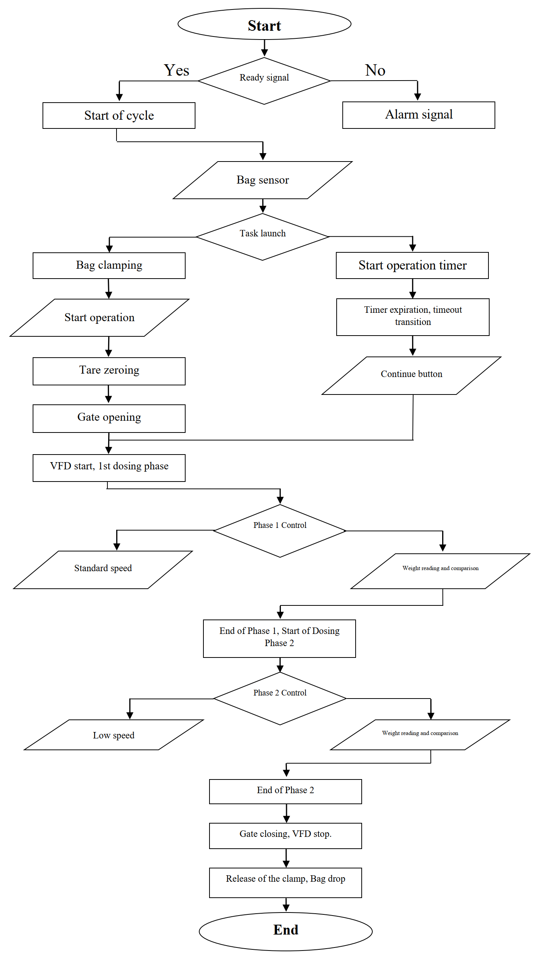
FIGURE 1. The algorithm of the filling machine.
The start of work begins when the equipment is ready for launch. This corresponds to the "Ready signal" algorithm, if there is no ready signal, then the "Alarm Signal" algorithm will take effect. This algorithm checks for alarms, activates a light and sound signal when they are present. Also, at the same time, the filling machine switches to the stop mode. To eliminate the cause of the accident, certain actions of the process control operator are required, involving the appropriate services for this. After eliminating the cause of the accident, a ready-to-work signal appears [9-11]. This process is controlled by the production controller. If there are no alarms, then the controller switches to the "Start cycle" algorithm.
The controller is waiting for a signal from the bag sensor. When the filling machine operator sets the bag to fill, the bag sensor is triggered, changing the discrete output signal. This change is recorded by the production controller, and the Bag Sensor algorithm is triggered. This algorithm is necessary for the controller to monitor the bag's cash on the spot. After that, the controller will start the "Task Start" algorithms, this task simultaneously starts two algorithms "Bag Press" and "Work timer start". The "Bag clamp" algorithm is needed to fix the bag on the filling machine. Fixing the bag allows you to confidently fill the bag with bulk material. When the bag clamp is triggered at the output pin of the magnetic clamp sensor, the discrete signal changes [12-14]. This corresponds to the "Sensor clamp" algorithm. This change is recorded by the production controller. After the pressure signal appears, the controller starts the bag filling algorithm. First, the electronic scales are reset at the command of the controller, which corresponds to the algorithm of "Zeroing the scale container". After zeroing, the controller activates the command to open the gate, in accordance with the "Gate Opening" algorithm. Immediately after that, the controller starts the frequency converter according to the "Emergency start, phase 1 dispenser" algorithm. The controller is connected to a frequency converter via an industrial interface for speed control.The frequency converter is started at a certain frequency corresponding to the first phase of dosing. This corresponds to the algorithm "Standard. speed." In the first phase of dosing, the electric motor starts up with a smooth start of the revolutions. In this case, the material enters the bag with rapid filling. The entire filled bag is controlled by the controller, reading the weight value from strain gauges connected to the weighing module and comparing this value with the setpoint entered on the ARM [15-18]. When these values are equal, the controller starts the algorithm "End of phase 1, start of phase 2 dosing", when activating the second phase of dosing, the controller reduces the frequency of the frequency converter. This decrease corresponds to the "Low Speed" algorithm. The second phase of dosing is called refilling. When the speed of the electric motor decreases, the mechanical vibrations of the entire equipment decrease dramatically, resulting in increased accuracy of weighing measurement. When switching to the second phase of dosing, bag weight control continues, which corresponds to the "Weight reading and comparison" algorithm[19-21]. When the weight of the bag becomes equal to the value set on the AWP, the bag filling process stops. Which corresponds to the "End of Phase 2" algorithm. After that, the controller closes the gate and stops the operation of the electric motor. These correspond to the algorithm "Closing the gate, stopping the emergency.". After stopping the electric motor, the controller removes the command from the clamp, according to the algorithm "Pressing release, bag drop". After releasing the clamp, the bag falls under its weight onto the transportation line. The transportation line transports the finished product to the production outlet [22].

RESEARCH RESULTS
Also, to control the time when the bag is filled with bulk material, the controller starts a timer. The filling must end before the end of this timer. If the timer is triggered on time and the bag is not full, the controller switches to the "Timer expiration, timeout transition" algorithm. When this algorithm is triggered, a time control timer termination signal is displayed on the mnemonic circuit of the automated workplace. In this case, the production controller switches the filling machine to standby mode. In standby mode, the rotation of the electric motor stops, but the bag clamp remains in the operating position. This algorithm is also necessary for cases when the packaged material has run out. After the material appears, the installation operator resumes work by clicking the "Continue" button. This mode corresponds to the "Continue button" algorithm. Upon resumption, the filling machine will continue to operate according to the algorithm of the controller program.

CONCLUSIONS
A vertical type filling machine for bulk materials operates according to this algorithm. At the same time, the energy efficiency of the installation increases, since each time the bags are filled, the electric motor starts without sudden current surges. Reducing the speed of the electric motor additionally reduces the current it consumes. Also, when working at low speeds, wear of rotating mechanical components is reduced. The use of frequency converters in the dosing process on filling machines will allow flexible control of the entire operation process. At the same time, the controller writes the quantity of the product produced to the program's memory. This data can be transferred to a database server for analyzing the production plan at the factory.
REFERENCES
- K.R. Allaev Energy efficiency and renewable energy sources // Problems of energy and resource saving. Tashkent, 2011. Special Issue. pp. 15-25.
- O. Toirov, Sh. Azimov, Z. Toirov. Improving the cooling system of reactive power compensation devices used in railway power supply // AIP Conference Proceedings, 3331, 1, 050030, (2025). https://doi.org/10.1063/5.0305670
- D. Jumaeva, B. Numonov, N. Raxmatullaeva, M. Shamuratova. Obtaining of highly energy-efficient activated carbons based on wood, // E3S Web of Conferences 410, 01018, (2023). https://doi.org/10.1051/e3sconf/202341001018
- K. Allaev, J. Toshov, Modern state of the energy sector of Uzbekistan and issues of their development, E3S Web of Conferences 401, 05090 (2023). https://doi.org/10.1051/e3sconf/202340105090
- D. Jumaeva, U. Raximov, O. Ergashev, A. Abdyrakhimov, Basic thermodynamic description of adsorption of polar and nonpolar molecules on AOGW, // E3S Web of Conferences 425, 04003 (2023) https://doi.org/10.1051/e3sconf/202343401020
- O. Toirov, S. Khalikov, Sodikjon Khalikov, F. Sharopov, Studies of reliability indicators of pumping units of machine irrigation on the example of the “Namangan” pumping station, // E3S Web of Conferences 410, 05015, (2023). https://doi.org/10.1051/e3sconf/202341005015
- D. Bystrov, S. Giyasov, M. Taniev, S. Urokov, Role of Reengineering in Training of Specialists // ACM International Conference Proceeding Series (2020) https://doi.org/10.1145/3386723.3387868
- Sh. Azimov, Z. Najmitdinov, M. Sharipov, Z. Toirov. Improvement of the cooling system of reactive power compensating devices used in railway power supply // E3S Web of Conferences, 497, 01015, (2024). https://doi.org/10.1051/e3sconf/202449701015
- O. Toirov, V. Ivanova, V. Tsypkina, D. Jumaeva, D. Abdullaeva, Improvement of the multifilament wire lager for cable production, // E3S Web of Conferences 411, 01041 (2023), https://doi.org/10.1051/e3sconf/202341101041
- T. Kamalov, U. Mirkhonov, S. Urokov, D. Jumaeva, The mathematical model and a block diagram of a synchronous motor compressor unit with a system of automatic control of the excitation // E3S Web of Conferences, 288, 01083, (2021), https://doi.org/10.1051/e3sconf/202128801083
- O. Toirov, S. Urokov, U. Mirkhonov, H. Afrisal, D. Jumaeva, Experimental study of the control of operating modes of a plate feeder based on a frequency-controlled electric drive, // E3S Web of Conferences, SUSE-2021, 288, 01086 (2021). https://doi.org/10.1051/e3sconf/202128801086
- S. Khalikov, Diagnostics of pumping units of pumping station of machine water lifting, // E3S Web of Conferences 365, 04013, (2023). https://doi.org/10.1051/e3sconf/202336504013
- D. Bystrov, M. Gulzoda, Y. Dilfuza, Fuzzy Systems for Computational Linguistics and Natural Language (2020) // ACM International Conference Proceeding Series, https://doi.org/10.1145/3386723.3387873
- O. Toirov, I. Khujaev, J. Jumayev, M. Hamdamov, Modeling of vertical axis wind turbine using Ansys Fluent package program, // E3S Web of Conferences 401, 04040 (2023). https://doi.org/10.1051/e3sconf/202340104040
- D. Jumaeva, A. Abdurakhimov, Kh. Abdurakhimov, N. Rakhmatullaeva, O. Toirov, Energy of adsorption of an adsorbent in solving environmental problems, // E3S Web of Conferences, SUSE-2021, 288, 01082 (2021). https://doi.org/10.1051/e3sconf/202128801082
- O. Toirov, M. Khalikova, D. Jumaeva, S. Kakharov, (2023) Development of a mathematical model of a frequency-controlled electromagnetic vibration motor taking into account the nonlinear dependences of the characteristics of the elements, // E3S Web of Conferences 401, 05089, (2023). https://doi.org/10.1051/e3sconf/202340105089
- S. Khalikov, Diagnostics of pumping units of pumping station of machine water lifting, // E3S Web of Conferences 365, 04013, (2023). https://doi.org/10.1051/e3sconf/202336504013
- О. Toirov, D. Jumaeva, U. Mirkhonov, S. Urokov, S. Ergashev, Frequency-controlled asynchronous electric drives and their energy parameters, // AIP Conference Proceedings 2552, 040021, (2022). https://doi.org/10.1063/5.0218808
- T. Sadullaev, D. Abdullaev, D. Jumaeva, Sh. Ergashev, I.B. Sapaev, Development of contactless switching devices for asynchronous machines in order to save energy and resources, // E3S Web of Conferences 383, 01029, (2023). https://doi.org/10.1051/e3sconf/202338301029
- O. Toirov, S. Khalikov, Algorithm and Software Implementation of the Diagnostic System for the Technical Condition of Powerful Units, // E3S Web of Conferences 377, 01004, (2023). https://doi.org/10.1051/e3sconf/202337701004
- D. Jumaeva, Z. Okhunjanov, U. Raximov, R. Akhrorova. Investigation of the adsorption of nonpolar adsorbate molecules on the illite surface, // Journal of Chemical Technology and Metallurgy, 58, 2, (2023). https://doi.org/10.59957/jctm.v58i2.61
- O. Toirov, K. Alimkhodjaev, A. Pardaboev, Analysis and ways of reducing electricity losses in the electric power systems of industrial enterprises, // E3S Web of Conferences, SUSE-2021, 288, 01085 (2021). https://doi.org/10.1051/e3sconf/202128801085

