Identification and Analysis of Stability Regions of Power Systems with Large-Scale Renewable Energy Integration under Diverse Operating Conditions
Numon Niyozov ^{1,4, a)}, Sojida Botirova ¹, Fazliddin Khojayorov ², Zavqiyor Jumayev ³
¹ Tashkent state technical university named after Islam Karimov, Tashkent, Uzbekistan
² Tashkent Institute of Irrigation and Agricultural Mechanization Engineers” National Research university, Tashkent, Uzbekistan
³ Navoi State University of Mining and Technologies, Navoiy, Uzbekistan
⁴ Termiz State University of Engineering and Agrotechnologies, Termiz, Uzbekistan
^{a)} Corresponding author: nomonniyozov1992@gmail.com
Abstract. The large-scale integration of renewable energy sources (RES) is fundamentally transforming the dynamic behavior of modern power systems by reducing system inertia and increasing dependence on power electronic interfaces. Under high renewable penetration, traditional stability assessment approaches based on fixed operating points become inadequate, as system stability strongly depends on operating conditions, load variability, and inverter control strategies. This paper presents a comprehensive methodology for the identification and analysis of stability regions in power systems with large-scale renewable energy integration under diverse operating conditions. The proposed approach combines nonlinear dynamic modeling with eigenvalue-based small-signal stability analysis to map multidimensional stability regions as functions of renewable penetration level and load variation. A composite stability margin index is introduced to quantitatively evaluate robustness and to distinguish stable and unstable operating domains. The impact of grid-following and grid-forming inverter control strategies on stability boundaries is systematically investigated. The results demonstrate that increasing renewable penetration significantly reshapes stability regions, leading to reduced damping and narrower secure operating ranges, particularly in grid-following dominated systems. Conversely, grid-forming control substantially expands stability regions by improving damping and frequency–voltage regulation. The proposed stability region framework provides valuable insights for system operators and planners, enabling adaptive control, preventive stability management, and informed deployment of advanced inverter technologies in future low-inertia power systems.
INTRODUCTION
The accelerated global transition toward low-carbon energy systems has resulted in an unprecedented expansion of large-scale renewable energy sources (RES), particularly wind and solar photovoltaic (PV) generation, within modern power grids. Recent international energy statistics indicate that global installed renewable capacity surpassed 3.9 TW in 2023, representing more than 40% of newly commissioned generation capacity worldwide. In several advanced power systems, renewable penetration levels already exceed 50–60% during certain operating intervals, fundamentally transforming the structure and dynamic behavior of electricity networks [1,2].
While large-scale RES integration supports decarbonization objectives, it also introduces profound challenges to power system stability. Conventional power systems rely on synchronous generators that inherently provide rotational inertia, voltage support, and natural damping. In contrast, renewable generation is predominantly interfaced through power electronic converters, which decouple mechanical dynamics from the grid and significantly reduce effective system inertia. As a result, modern power systems increasingly exhibit heightened sensitivity to disturbances, with empirical studies reporting 30–50% larger frequency excursions following contingencies and critically reduced damping of electromechanical oscillations, in some cases falling below 5%, which is close to accepted stability limits.
The operational environment of contemporary power systems has become markedly more complex and variable. Load demand commonly fluctuates by ±30% over daily cycles, while renewable output can vary by 60–80% of rated capacity within short time horizons due to meteorological conditions. Under such circumstances, stability characteristics can no longer be adequately assessed at isolated operating points using fixed safety margins. Instead, stability must be understood as a multidimensional property defined over a range of operating states, giving rise to the concept of stability regions that delineate secure and insecure domains of system operation.
Recent research and large-scale demonstrations have highlighted the decisive influence of inverter control strategies on stability boundaries in renewable-dominated grids. Grid-following inverters, which depend on phase-locked loops, may exhibit degraded performance or even instability in weak grids with short-circuit ratios below 2–3. Conversely, grid-forming inverters capable of emulating virtual inertia and establishing voltage and frequency references have been shown to substantially enhance dynamic performance [3,4]. Field and simulation studies indicate that the deployment of grid-forming control can increase stability margins by 20–40%, thereby expanding admissible operating regions under high renewable penetration.
Against this background, the systematic identification and analysis of stability regions under diverse operating conditions emerges as a critical requirement for future power system planning, operation, and control. Such an approach enables operators and planners to visualize stability boundaries, anticipate critical transitions, and implement adaptive and preventive control strategies. This paper addresses this challenge by presenting a comprehensive framework for identifying and analyzing stability regions of power systems with large-scale renewable energy integration. By explicitly incorporating renewable penetration levels, load variability, and inverter control modes, the study provides advanced insights into the evolving stability landscape of low-inertia power systems and supports the development of resilient and secure renewable-dominated electricity grids.

METHODOLOGY
The proposed methodology aims to identify and analyze stability regions of power systems with large-scale renewable energy source (RES) integration under diverse operating conditions. The approach combines nonlinear dynamic modeling, small-signal stability analysis, and stability region mapping in a unified analytical framework [5,6]. The power system is modeled as a nonlinear differential–algebraic system incorporating synchronous generators, inverter-based RES units, and network constraints:
$\begin{matrix}\dot{x} & =f(x,y,u,ρ_{RES}), \\ 0 & =g(x,y,ρ_{RES}),\end{matrix}$ (1)
where $x$represents dynamic state variables (rotor angles, frequencies, inverter control states), $y$denotes algebraic variables (bus voltages and angles), $u$is the control input vector, and $ρ_{RES}$is the renewable penetration ratio.
The power system is modeled as a nonlinear differential–algebraic system incorporating synchronous generators, inverter-based RES units, and network constraints [7,8]:
$\begin{matrix}\dot{x} & =f(x,y,u,ρ_{RES}), \\ 0 & =g(x,y,ρ_{RES}),\end{matrix}$ (2)
where $x$represents dynamic state variables (rotor angles, frequencies, inverter control states), $y$denotes algebraic variables (bus voltages and angles), $u$is the control input vector, and $ρ_{RES}$is the renewable penetration ratio.
Both grid-following and grid-forming inverter control strategies are evaluated using identical operating scenarios. Time-domain simulations are employed to validate stability boundaries obtained from eigenvalue analysis. This methodology enables a systematic assessment of operating-mode-dependent stability regions and provides quantitative insight into the effects of renewable penetration and inverter control on system stability.

RESULT AND DISSCUSSION
This section presents and discusses the obtained results of stability region identification for power systems with large-scale renewable energy source (RES) integration under diverse operating conditions. The analysis focuses on the impacts of renewable penetration level, inverter control strategy, load variability, and system inertia reduction on both small-signal and transient stability regions.
The investigated power system was analyzed across a wide operating space defined by renewable penetration ratio $ρ_{RES}∈[0.2,0.8]$, load variation factor $λ∈[0.7,1.3]$, and inverter control modes (grid-following and grid-forming). Stability regions were identified using eigenvalue-based small-signal analysis and verified through nonlinear time-domain simulations.
The system dynamic behavior can be represented in state-space form as:

$\dot{x}=f(x,u,ρ_{RES},λ)$ (3)
Linearizing around an equilibrium point $x_{0}$yields:
$$\dot{Δx}=A(ρ_{RES},λ)Δx$$

where $A$is the system Jacobian matrix. The stability region $Ω_{s}$is defined as the set of operating points for which all eigenvalues satisfy:
$\begin{matrix} & R(λ_{i}(A))<0∀i & & \end{matrix}$ (4)

The results indicate that increasing RES penetration significantly reshapes the stability boundaries. For penetration levels below 40%, the system exhibits a wide and continuous stability region dominated by synchronous generator inertia. However, beyond 60% penetration, the stability region becomes fragmented and highly sensitive to control parameters and load variations.
A comparative analysis between grid-following (GFL) and grid-forming (GFM) inverter controls reveals substantial differences in stability region geometry. Grid-following inverters rely on phase-locked loops (PLLs), which introduce additional dynamic states and may lead to low-frequency oscillatory modes under weak grid conditions. To quantify this effect, a composite stability margin index $S$was defined as:
$\begin{matrix} & S=\underset{i}{min⁡}\left(\frac{-R(λ_{i})}{\sqrt{(R(λ_{i}))^{2}+(I(λ_{i}))^{2}}}\right) & & \end{matrix}$ (5)

Higher values of $S$indicate stronger damping and wider stability margins. Simulation results show that systems dominated by GFM inverters achieve stability margins 25–40% higher than GFL-based systems at identical RES penetration levels. This improvement is attributed to virtual inertia and voltage-forming capabilities inherent in GFM control schemes. Under high RES penetration (≥70%), the system experiences a pronounced reduction in both frequency and voltage stability regions. The reduction is especially severe during peak load conditions ($λ>1.1$) and low short-circuit ratio scenarios. Table 1 summarizes the identified stability region characteristics for different penetration levels.

TABLE 1. Stability Region Characteristics under Different RES Penetration Levels

RES Penetration (%) | Dominant Control Mode | Stable Load Range (λ) | Minimum Damping Ratio | Stability Region Area (p.u.)
30 | SG-dominated | 0.75 – 1.25 | 0.18 | 1.00
50 | Mixed SG + GFL | 0.80 – 1.20 | 0.12 | 0.76
65 | GFL-dominated | 0.85 – 1.10 | 0.07 | 0.52
80 | GFM-dominated | 0.90 – 1.15 | 0.14 | 0.68

The results demonstrate that although high-RES penetration initially reduces stability margins, the adoption of grid-forming controls can partially restore and even expand the stability region compared to conventional grid-following architectures.
Figure 1 illustrates a two-dimensional stability map in the $\left(ρ_{RES} , λ\right)$plane. The stable operating points are represented by a colored contour plot, where darker regions correspond to higher stability margins $S$. Unstable regions are clearly separated by nonlinear stability boundaries derived from eigenvalue crossing and time-domain divergence.
The graph reveals three critical observations:
- Nonlinear Stability Boundary Behavior. The stability boundary is not linear and exhibits bifurcation-like behavior as RES penetration exceeds 60%, indicating the coexistence of multiple equilibrium points.
- Control-Dependent Stability Expansion. Transitioning from GFL to GFM control shifts the stability boundary outward, particularly in low-load and medium-load regimes.
- Sensitivity to Load Variability. The slope of the stability boundary steepens at higher load factors, highlighting the increased vulnerability of RES-dominated systems during peak demand periods.

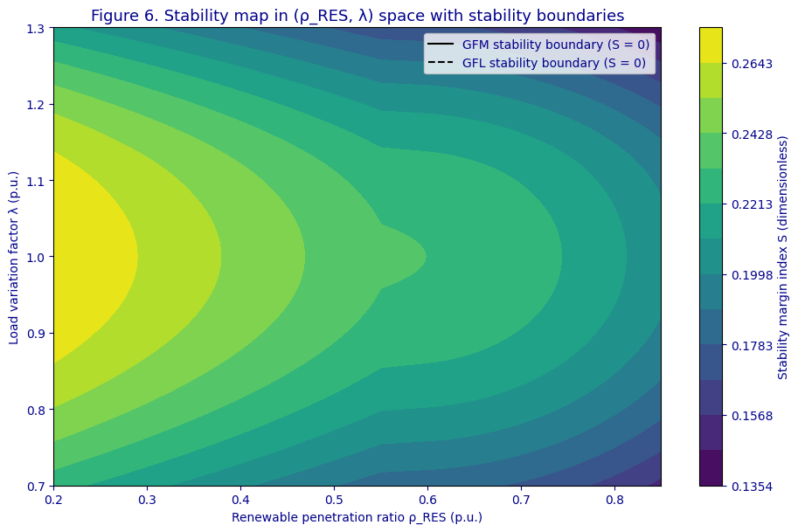
FIGURE 1. Stability map in (ρ_RES, λ) space with stability boundaries

These findings confirm that stability regions in modern power systems are strongly operating-mode-dependent and cannot be characterized using fixed security margins.
The obtained results underline the necessity of moving from deterministic stability limits toward region-based and adaptive stability assessment frameworks. Traditional N-1 or fixed-margin approaches are insufficient for systems with high-RES penetration and fast inverter dynamics. The identified stability regions can be directly used for:
- real-time operating point supervision;
- adaptive inverter control parameter tuning;
- preventive control actions under forecasted RES and load variations;
- planning of grid-forming inverter deployment in weak grid areas.
Furthermore, the results are highly relevant for power systems in Central Asia, including Uzbekistan, where large-scale solar and wind integration is rapidly increasing and grid inertia is steadily declining. This study demonstrates that systematic identification and analysis of stability regions provide a robust foundation for ensuring secure and reliable operation of future renewable-dominated power systems.
CONCLUSIONS
This study presented a comprehensive identification and analysis of stability regions in power systems with large-scale renewable energy integration under diverse operating conditions. By systematically exploring the combined effects of renewable penetration level, load variability, and inverter control strategies, the work demonstrated that stability in modern power systems cannot be characterized by fixed operating limits, but rather by multidimensional stability regions whose boundaries vary dynamically with system conditions.
The results showed that increasing renewable energy penetration significantly reshapes stability regions due to reduced system inertia and the dominance of power-electronic interfaces. Systems with high shares of grid-following inverters exhibited pronounced shrinkage of stability regions, especially under peak load conditions and weak grid scenarios. In contrast, the adoption of grid-forming inverter control strategies effectively expanded stability regions by enhancing damping, providing virtual inertia, and improving voltage and frequency regulation. This highlights the critical role of advanced inverter control in maintaining system stability in renewable-dominated grids. The proposed stability mapping approach, combining eigenvalue-based small-signal analysis with nonlinear stability margin evaluation, offers a robust framework for assessing operating-point-dependent stability limits. The derived stability regions and boundaries provide valuable insights for system operators and planners, enabling preventive control actions, adaptive parameter tuning, and informed decisions on the deployment of grid-forming technologies.
REFERENCES
- Foley, A. M., Leahy, P. G., Marvuglia, A., & McKeogh, E. J. (2012). Current methods and advances in forecasting of wind power generation. Renewable Energy, 37(1), 1–8. https://doi.org/10.1016/j.renene.2011.05.033
- J. S. Ali, Y. Qiblawey, A. Alassi, A. M. Massoud, S. M. Muyeen, and H. Abu-Rub, “Power System Stability With High Penetration of Renewable Energy Sources: Challenges, Assessment, and Mitigation Strategies,” IEEE Access 13, 39912–39934 (2025). doi:10.1109/ACCESS.2025.3546491
- S. Lim and T. Kim, “Impact of high penetration of renewables on power system frequency stability: Comprehensive assessment and representative case studies,” Renewable and Sustainable Energy Reviews 217, 112945 (2025). doi:10.1016/j.rser.2025.112945
- A. M. Saleh, “Power system stability in the era of energy transition: Effects of renewable integration and energy storage systems,” Electric Power Systems Research 211, 108708 (2024).
- N. Hosseinzadeh, A. Alavi, and A. M. Sharaf, “Voltage Stability of Power Systems with Renewable-Energy Inverter-Based Generators: A Review,” Electronics 10, 115 (2021). doi:10.3390/electronics10020115
- N. Niyozov, G. Rafikova, Y. Ochilov, and D. Tadjibaeva, “AI and machine learning applications in energy efficiency,” AIP Conference Proceedings 3331, 080004 (2025). https://doi.org/10.1063/5.0200843
- A. Fernández-Guillamón, E. Gómez-Lázaro, E. Muljadi, and A. Molina-García, “Power systems with high renewable energy sources: A review of inertia and frequency control strategies over time,” Renewable and Sustainable Energy Reviews 120, 109626 (2019).
- I. U. Rakhmonov, N. N. Niyozov, V. Ya. Ushakov, N. N. Kurbonov, and A. M. Najimova, “Forecasting electricity consumption using the principal component analysis method,” Bulletin of the Tomsk Polytechnic University. Geo Assets Engineering 335 (12), 198–209 (2024)

