Application of the Phase-shifting Properties of Electro-ferromagnetic Circuits with Power Thyristors
Ikromjon Rahmonov, Abdulhay Rasulov, Mirjalol Ruzinazarov ^{a)}, Gulrukh Sultanova
Tashkent state technical university named after Islam Karimov, Tashkent, Uzbekistan
^{a)} Corresponding author: ruzinzarov88@bk.ru
Abstract. The article examines issues related to the application of electro-ferromagnetic oscillatory circuits for controlling the state of triode thyristors in alternating current systems, where synchronization of the control signal with the mains frequency is required. The control signal is taken from the ferromagnetic element by means of an additional control winding. By varying the turn-on moment of the triode thyristor, it is possible to regulate the average value of the load current over a period from zero to its maximum. Based on a two-core electro-ferromagnetic circuit, it makes it possible to create a phase-shifting device for phase control of thyristors.
INTRODUCTION
Application of electro-ferromagnetic oscillatory circuits for controlling the state of triode thyristors in alternating current circuits where synchronization of the control signal with the mains frequency is required. The control signal is taken from the ferromagnetic element by means of an additional control winding. By varying the turn-on moment of the triode thyristor, it is possible to regulate the average value of the load current over a period from zero to the maximum. The combined use of electro-ferromagnetic circuits and thyristors makes it possible to create sensitive contactless AC relays, various frequency converters, and regulating and stabilizing devices, which are characterized by high reliability, simple design, reduced size and weight, noiseless operation, high gain, fast response, ease of maintenance, and increased efficiency. At the same time, for phase control of thyristors, it is proposed to use electro-ferromagnetic circuits that have a wide negative region in their amplitude and phase characteristics [1-15].
The quality and reliability of thyristor devices largely depend on the rational choice of the control circuit. One of the important components of the control system for triode thyristors is the phase-shifting device. It is proposed to use a two-core electroferromagnetic circuit as such an element, which can simultaneously serve as an input device.
The phase converter circuit consists of two identical three-winding transformers (Fig.1).
FIGURE 1. Two-core electroferromagnetic circuit

The windings $W_{1}=W_{2}=W$ are connected in series-according to and powered by the sinusoidal source $u_{1}=U_{1m}sinωt$. Windings $W_{3}=W_{4}=W$, connected in series-opposition, are powered by another sinusoidal source $u_{2}=U_{2m}sin⁡(ωt+ψ_{2})$. With this type of connection, there is no mutual connection between the primary and secondary circuits. We study the nature of the voltage phase change at the terminals of windings $W_{5}=W_{6}=W$ depending on the ratio of the amplitudes $U_{1m}$ and $U_{2m}$ and the value of the phase $ψ_{2}$. Neglecting losses in the ferromagnetic elements and disregarding the nonlinearity of the magnetization curve, we have the following circuit equations:
$u_{1}=W\frac{dФ_{1}}{dt}+W\frac{dФ_{2}}{dt}$ (1)
$u_{2}=W\frac{dФ_{1}}{dt}+W\frac{dФ_{2}}{dt}$ (2)
or $2W\frac{dФ_{1}}{dt}=u_{1}+u_{2}$; $2W\frac{dФ_{2}}{dt}=u_{1}-u_{2}$.
Considering that we have $W\frac{dФ_{1}}{dt}=u_{3}$ and $W\frac{dФ_{2}}{dt}=u_{4}$.
$u_{3}=\frac{1}{2}\left(u_{1}+u_{2}\right)$ (3)
$u_{4}=\frac{1}{2}\left(u_{1}-u_{2}\right)$ (4)
Knowing the law of variation of the source voltages, we obtain:
$U_{3m}sin\left(ωt+ψ_{3}\right)=\frac{1}{2}\left[U_{1m}sinωt+U_{2m}sin\left(ωt+ψ_{2}\right)\right]$ (5)
$U_{4m}sin\left(ωt+ψ_{u}\right)=\frac{1}{2}\left[U_{1m}sinωt-U_{2m}sin\left(ωt+ψ_{2}\right)\right]$ (6)
Here, $ψ_{3}$ and $ψ_{4}$ are the initial voltage phases on the output windings. From (5) and (6), after introducing dimensionless quantities and some transformations, we have:
${2X}_{3m}cosψ_{3}={jX}_{1m}+X_{2m}cosψ_{2}$ (7)
${2X}_{2m}cosψ_{3}=X_{2m}cosψ_{2}$ (8)
or $tgψ_{3}=\frac{X_{2m}sinψ_{2}}{X_{1m}+X_{2m}cosψ_{2}}$ (9)
$X_{3m}=\frac{1}{2}\sqrt{X_{1m}^{2}+X_{2m}^{2}+{2X}_{1m}X_{2m}cosψ_{2}}$ (10)
Likewise
$tgψ_{4}=\frac{X_{2m}sinψ_{2}}{X_{1m}-X_{2m}cosψ_{2}}$ (11)
$X_{4m}=\frac{1}{2}\sqrt{X_{1m}^{2}+X_{2m}^{2}+{2X}_{1m}X_{2m}cosψ_{2}}$ (12)
Where $X_{1m}=\frac{U_{1m}}{U_{δ}}$; $X_{2m}=\frac{U_{2m}}{U_{δ}}$.
For the case when $ψ_{2}=\frac{π}{2}$, we have.
$tgψ_{3}=\frac{X_{2m}}{X_{1m}}$; $tgψ_{4}=\frac{X_{2m}}{X_{1m}}$; (13)
$X_{4m}=\frac{1}{2}\sqrt{X_{1m}^{2}+X_{2m}^{2}}$ (14)
Based on the latest expressions, we will construct the dependencies $ψ_{3}=f\left(X_{2m}\right)$, $ψ_{4}=f\left(X_{2m}\right)$, $X_{3m}=f\left(X_{2m}\right)$, when $X_{1m}=I$ (Fig.2).
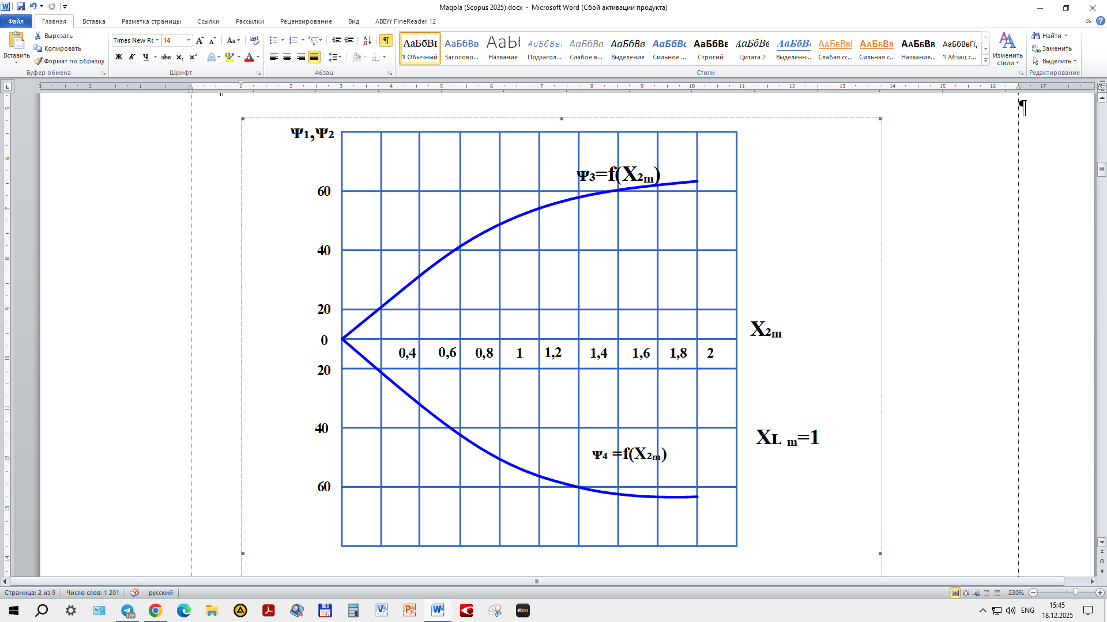 | 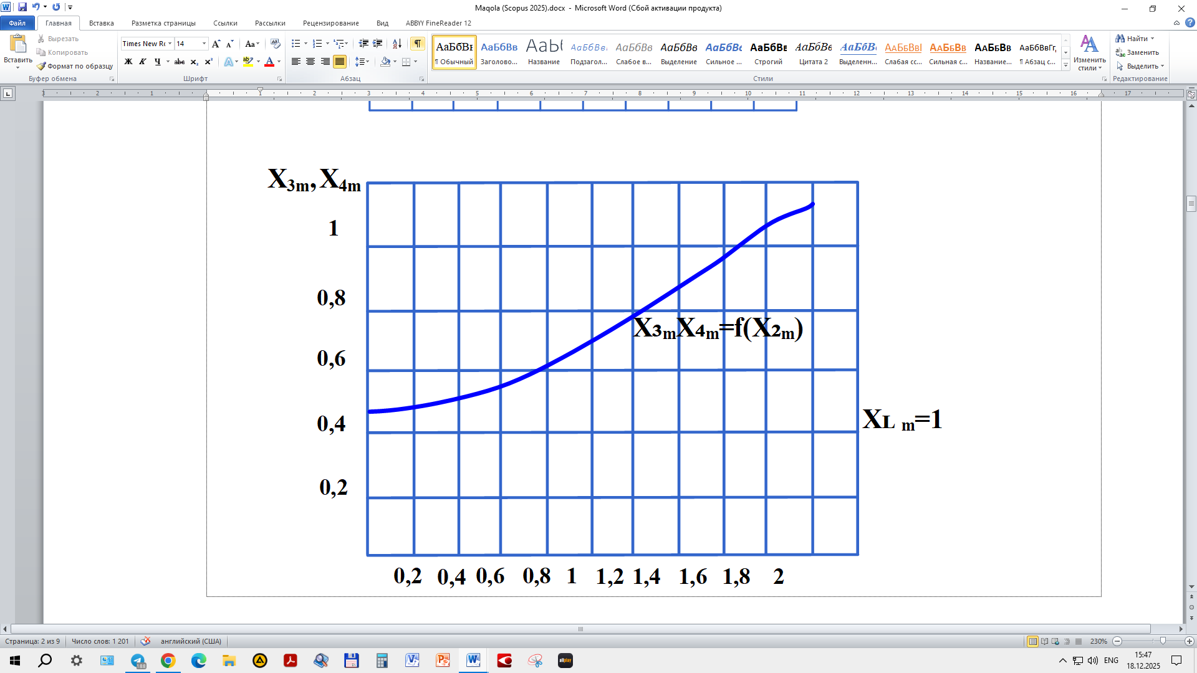
a) | b)
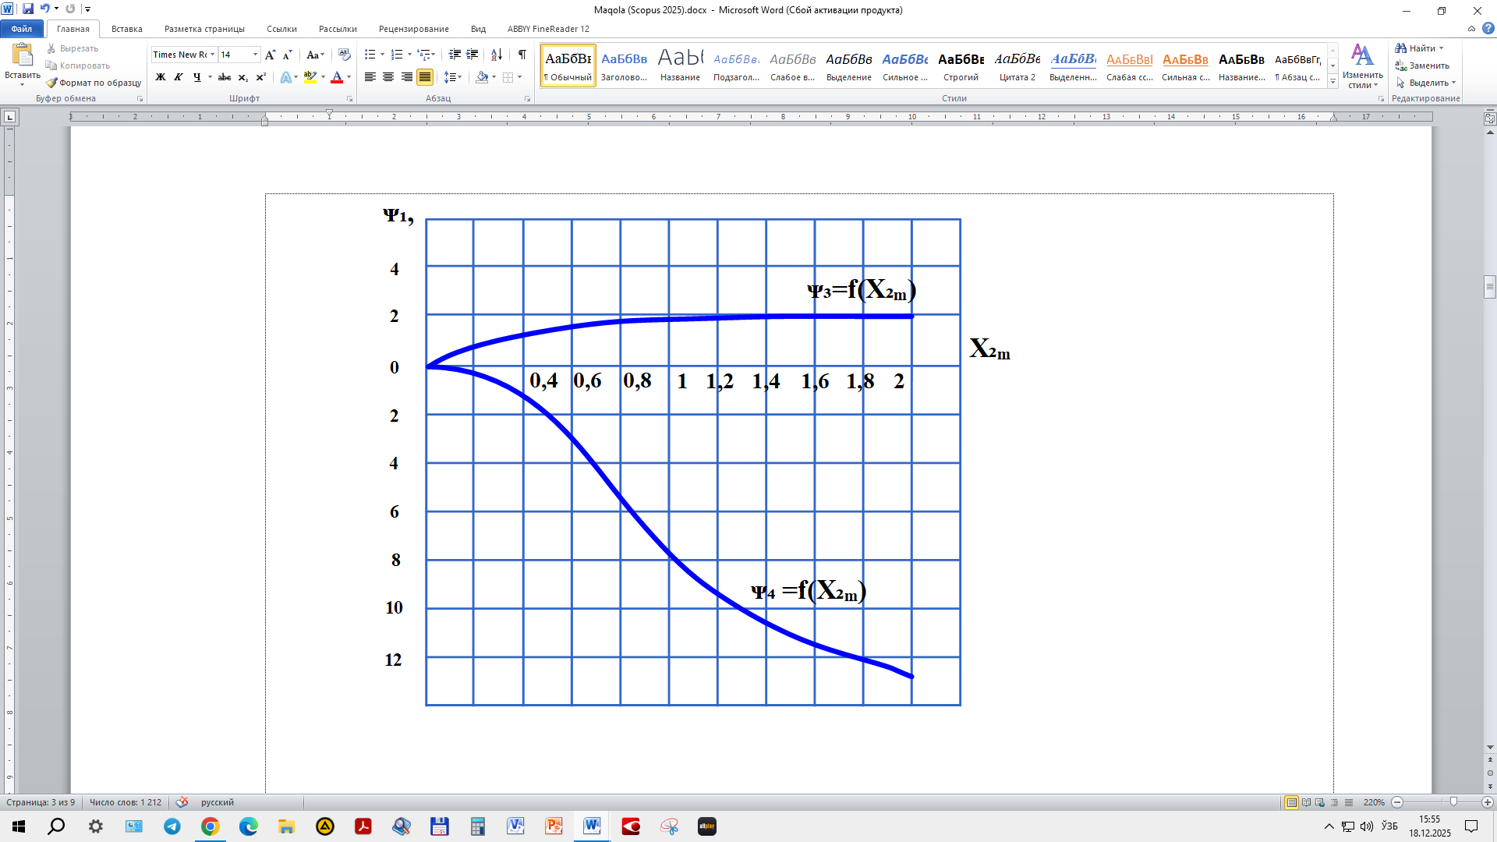 | 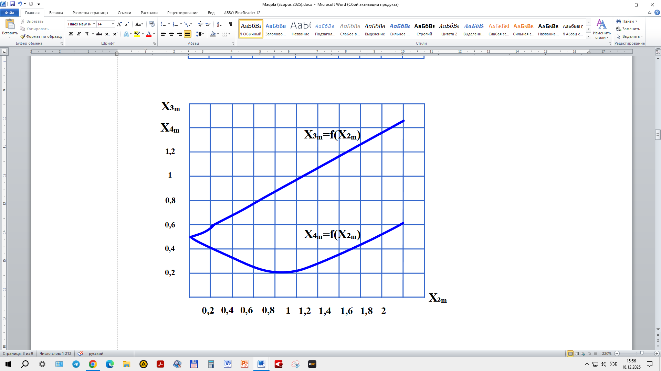
c) | d)
FIGURE 2. Dependencies $a)ψ_{3}=f\left(X_{2m}\right)$, ${c)ψ}_{4}=f\left(X_{2m}\right)$, $b)X_{3m}=f\left(X_{2m}\right)$, $d)X_{1m}=I$

As can be seen from the figures, the values of $ψ_{3}$ and $ψ_{4}$ vary from zero to 63⁰, while $X_{2m}$ deviates from zero to 2. If $ψ_{2}=\frac{π}{6}$, that:
$tgψ_{3}=\frac{0,5X_{2m}}{X_{1m}+0,866X_{2m}}$ (15)
$tgψ_{4}=\frac{0,5X_{2m}}{X_{1m}+0,866X_{2m}}$ (16)
$X_{3m}=\frac{1}{2}\sqrt{X_{1m}^{2}+X_{2m}^{2}+{2X}_{1m}X_{2m}∙1,73}$ (17)
$X_{4m}=\frac{1}{2}\sqrt{X_{1m}^{2}+X_{2m}^{2}+{2X}_{1m}X_{2m}∙1,73}$ (18)
As can be seen from Fig. 2, in this case a wider range of phase $ψ_{4}$ variation is observed. Here we considered the phase relationships for a fixed value of $ψ_{2}$, obtained when the primary and secondary windings are powered from different phases of a three-phase voltage system.
Thus, the considered circuit can serve as a phase-shifting device, distinguished from known ones by the absence of a resistive element, the relative simplicity of the electrical circuit, the sinusoidal nature of the output voltage, and the lack of moving parts.
Phase shifting can be achieved using a two-core electroferromagnetic circuit when the oppositely connected secondary windings are short-circuited through a capacitor. At the same time, there is no need for a reference voltage, which was provided for in the circuit considered in the previous paragraph. In addition, the possibility arises to change the voltage phase on ferromagnetic elements over a wide range of applied voltage magnitudes. This property of the circuit is currently used to create single-phase to three-phase and single-phase to two-phase phase converters.
As shown by the studies of several authors, when creating various thyristor stabilizing devices, a certain law for changing the phase of the control signal is required, depending on the variation of the load resistance and the magnitude of the input voltage. These requirements can be met by the nature of the voltage phase change at the terminals of the ferromagnetic element of a two-core electro-ferromagnetic resonant circuit, constructed with a coupling reactive element between the primary and secondary circuits. Figure 3 shows a diagram of a two-core electroferromagnetic circuit with capacitive coupling between the primary and secondary circuits. Here, R is a constant active resistance that accounts for losses in the electro-ferromagnetic circuit.
FIGURE 3. Two-core electro-ferromagnetic oscillatory circuits with capacitive coupling between the primary and secondary circuits | FIGURE 4. Asymmetrical circuit of two-core electro-ferromagnetic resonant circuits

The equation of the oscillatory circuit, consisting of a capacitance and the secondary windings of ferromagnetic elements, has the following form:
$W\frac{d^{2}Ф_{1}}{{dt}^{2}}-W\frac{d^{2}Ф_{2}}{{dt}^{2}}-\frac{i_{c}}{C}=0$ (19)
When formulating the equilibrium equation, the identity of the ferromagnetic elements was taken into account. By approximating the magnetization curve of the cores with a power function, we obtain:
$i_{1}W+i_{2}W=KФ_{1}^{n}$ (20)
$i_{1}W+i_{2}W=KФ_{2}^{n}$ (21)
$$i_{cb}=i_{1}+i_{2}+i_{c}$$
$i_{r}=\frac{Wd}{Rdt}=\left(Ф_{1}Ф_{2}\right)$ (22)
$$W\frac{d^{2}Ф_{1}}{{dt}^{2}}+W\frac{d^{2}Ф_{2}}{{dt}^{2}}=\frac{i_{cb}}{C_{cb}}+\frac{i_{c}}{C}$$
$i_{c}=\frac{C}{C+C_{cb}}\left[C_{cb}W\frac{d^{2}Ф_{1}}{{dt}^{2}}+C_{cb}W\frac{d^{2}Ф_{2}}{{dt}^{2}}-\frac{Wd}{Rdt}\left(Ф_{1}Ф_{2}\right)-\frac{K}{2W}\left(Ф_{1}^{n}Ф_{2}^{n}\right)\right]$ (23)
From (19) and taking into account (23), we obtain.
$\frac{d^{2}Ф_{1}}{{dt}^{2}}-γ\frac{d^{2}Ф_{2}}{{dt}^{2}}+\frac{K}{2W^{2}C}\left(Ф_{1}^{n}{-Ф}_{2}^{n}\right)+\frac{1}{RC}\frac{d}{dt}\left(Ф_{1}{-Ф}_{2}\right)=0$ (24)
where
$γ=\frac{C+2C_{cb}}{C}$ (25)
We introduce the following dimensionless parameters:
$x_{1}=\frac{Ф_{1}}{Ф_{δ}};$ $x_{2}=\frac{Ф_{2}}{Ф_{δ}};$ $τ=ωt;$ (26)
$δ=\frac{1}{RωC};$ $Ф_{δ}=\sqrt[n-1]{\frac{2ω^{2}WC}{AK}}$
From (24), we obtain:
$\frac{d^{2}x_{1}}{{dt}^{2}}-γ\frac{d^{2}x_{2}}{{dt}^{2}}+\frac{1}{A}\left(x_{1}^{n}{-x}_{2}^{n}\right)+δ\frac{d}{dt}\left(x_{1}{-x}_{2}\right)=0$ (27)
To solve equation (27), we use the method of accounting for the fundamental harmonic. We assume that:
$X_{1}=X_{1m}sinτ$; $x=X_{2m}sin⁡(τ+φ)$ (28)
Then
$x^{n}=X_{1m}^{n}\left(Asinτ-\dot{A}sin3τ+Bsin5τ-Csin7τ+…\right)$ (29)
$x_{2}^{n}=X_{2m}^{n}\left[Asin\left(τ+φ\right)-\dot{A}sin\left(3τ+3φ\right)-Bsin\left(5τ+5φ\right)+…\right]$ (30)
Substituting (28), (29), and (30) into (27) for the fundamental harmonic of the magnetic flux, we obtain:
$$-X_{1m}sinτ+{γX}_{2m}sin\left(τ+φ\right)+X_{1m}^{n}sinτ-X_{2m}^{n}\left(τ+φ\right)+δX_{1m}$$
$$cosτ-δX_{2m}cosτ-δX_{2m}\cos\left(τ+φ\right)=0$$
After separating the sine and cosine components, we obtain:
$$a=bcosφ+X_{2m}sinφ$$
$X_{1m}={-bsinφ+X}_{2m}cos⁡φ$ (31)
where
$a=\frac{1}{δ}\left(X_{1m}-X_{1m}^{n}\right)$ (32)
$b=\frac{1}{δ}\left(γX_{2m}-X_{2m}^{n}\right)$ (33)

From the system of equations, we have:
$a^{2}+X_{1m}^{2}=b^{2}+X_{2m}^{2}$ (34)
$tgφ=\frac{aX_{2m}-bX_{1m}}{X_{1m}X_{2m}+ab}$ (35)
Considering that
$$u=W\frac{dФ_{1}}{dt}+W\frac{dФ_{2}}{dt}$$
We can write
$$y=\frac{dx_{1}}{dτ}+\frac{dx_{2}}{dt}$$
where
$y=\frac{u}{u_{δ}}$; $u=Wωф_{δ}$ (36)
By substituting (28) into (36) and assuming $y=Y_{m}\sin\left(τ+ψ\right),$ after some transformations, we obtain:
$$Y_{m}=\sqrt{{\left(X_{1m}+X_{2m}cosφ\right)}^{2}+X_{2m}^{2}\sin^{2}φ}$$
$tgφ=\frac{X_{2m}sinφ}{X_{1m}+X_{2m}cosφ}$ (37)
$$b=f(X_{2m})$$
To solve the system of equations (31), the previously proposed graphical method can be used. We plot the dependencies $a=f(X_{1m})$ and $b=f(X_{2m})$ (Fig.5), using the values of $X_{1m}$ and $X_{2m}$. The value of angle $φ$ is determined by the angle between two rays drawn through the points of intersection of the circle with curves $a=f(X_{1m})$ and $b=f(X_{2m})$. Based on the graphical construction, the values of the other desired quantities $U_{m}$, $ψ_{1}$ and $ψ_{2}$ can be determined, which respectively characterize the applied voltage, the phase of the first ferromagnetic element, and the phase of the second ferromagnetic element.
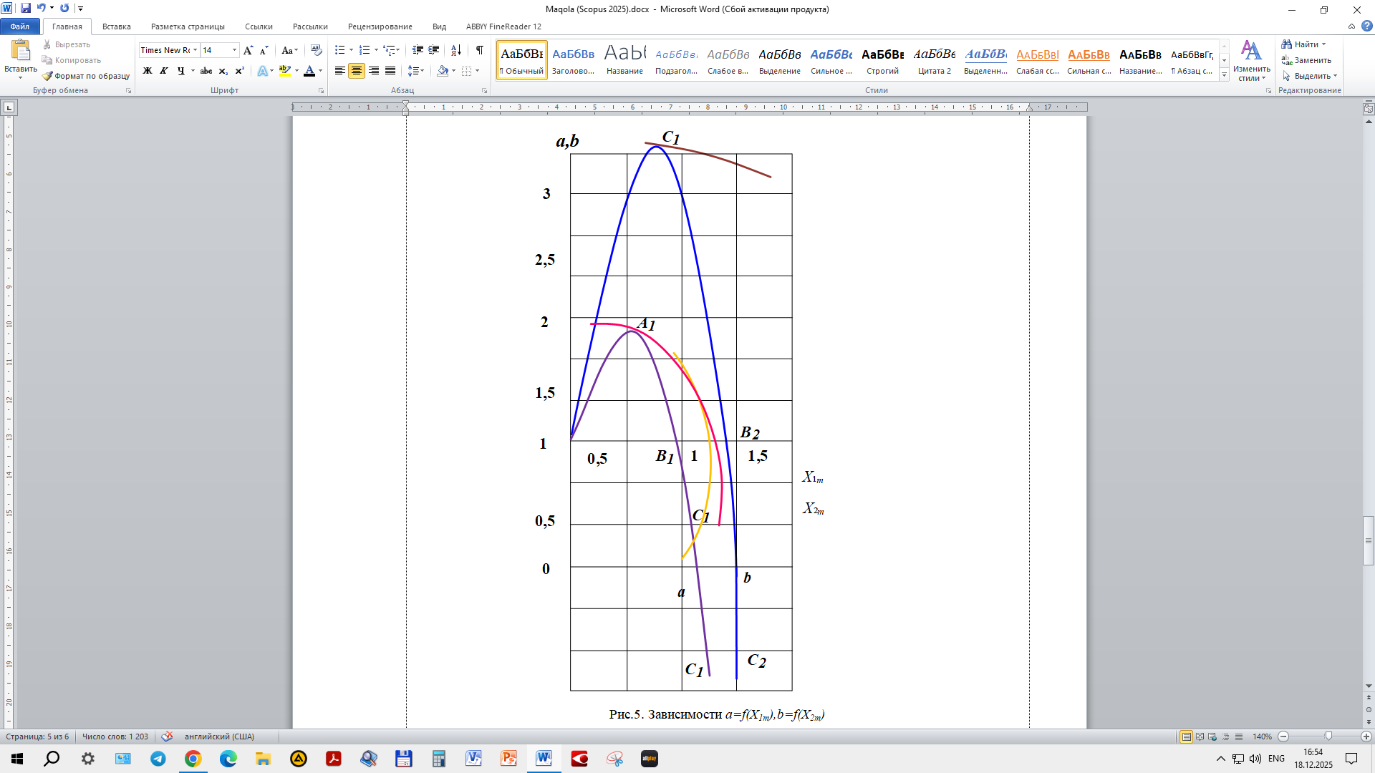
FIGURE 5. Dependencies $a=f(X_{1m})$ and $b=f(X_{2m})$

Figures 6 and 7 show the nature of the changes in the magnetic fluxes of the ferromagnetic elements depending on the applied voltage. The initial parts of the characteristics correspond to the combination of points of segments $OA_{1}$, $OA_{2}$ of curves $a=f(X_{1m})$ and $b=f(X_{2m})$ in Fig.5. On the characteristics $X_{1m}=f(Y_{m})$ and $X_{2m}=f(Y_{m})$, the segment 1-2 corresponds to the combination of points from the segments $OA_{1}$ and $OA_{2}$; the segment 2-3 corresponds to the combination of points from the segments $OA_{1}$ and $B_{1}C_{1}$; the segment 4-5 corresponds to the combination of points from the segments $C_{1}C_{1}^{1}$ and $A_{2}^{1}B_{2}$; and the segment 5-6 corresponds to the combination of points from the segments $C_{1}C_{1}^{1}$ and $B_{2}C_{2}$.
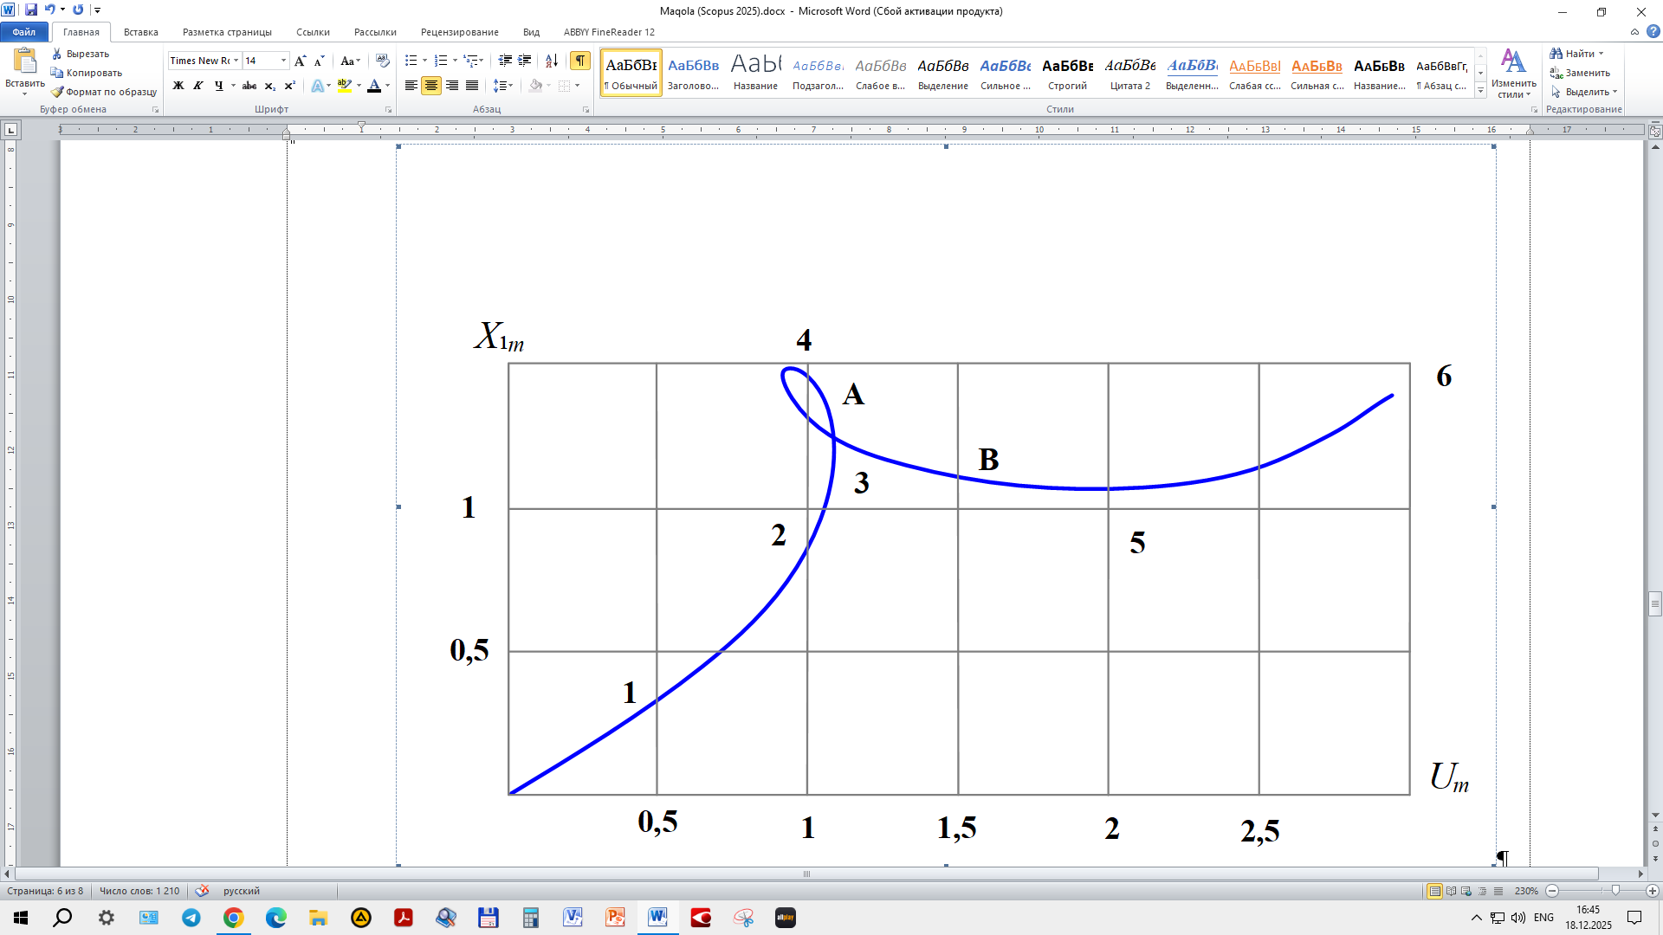 | 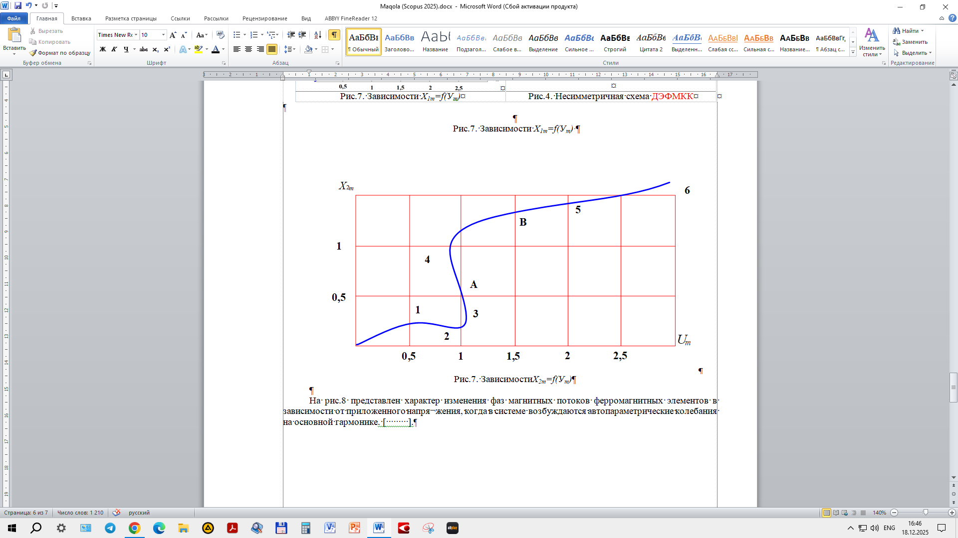
FIGURE 6. Dependencies $X_{1m}=f(Y_{m})$ | FIGURE 7. Dependencies $X_{2m}=f(Y_{m})$

Figure 8 shows the nature of the changes in the phases of the magnetic fluxes of the ferromagnetic elements depending on the applied voltage, when autoparametric oscillations at the fundamental harmonic are excited in the system.
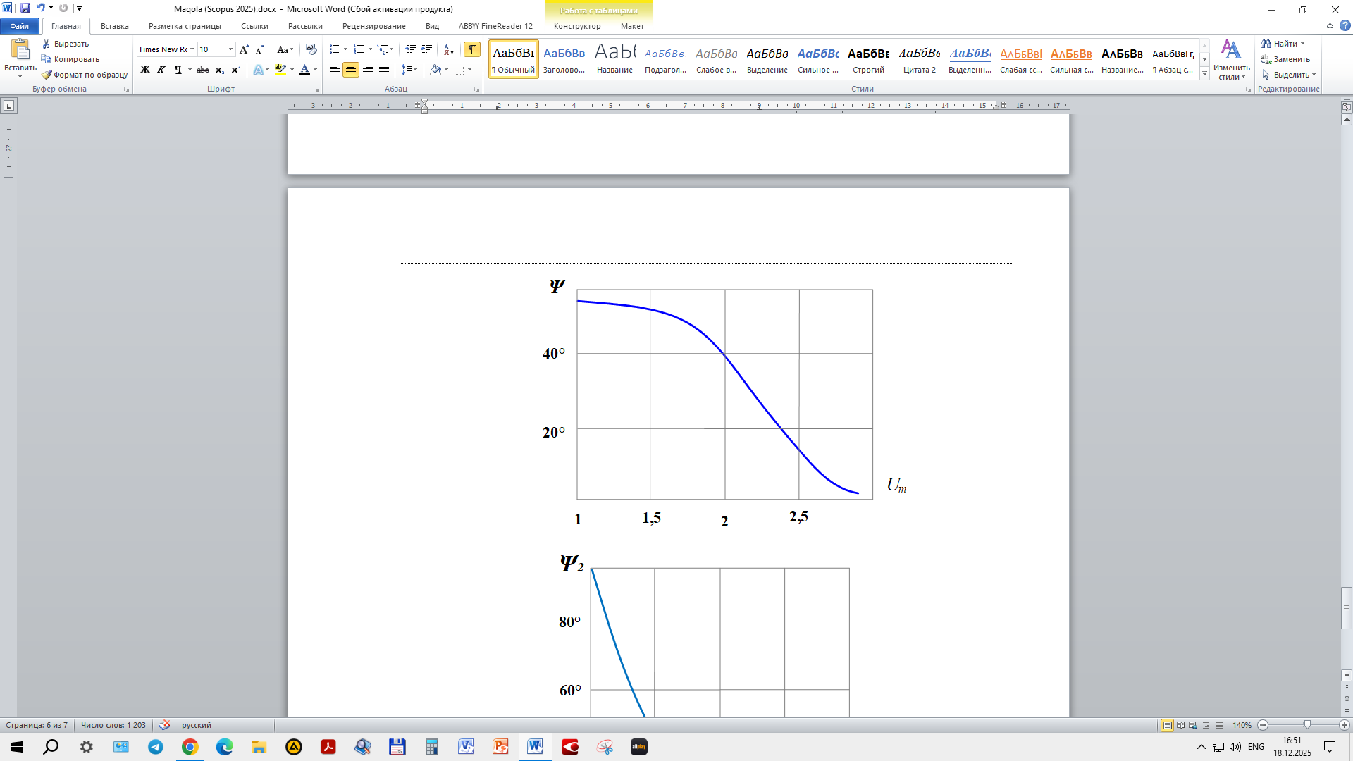 | 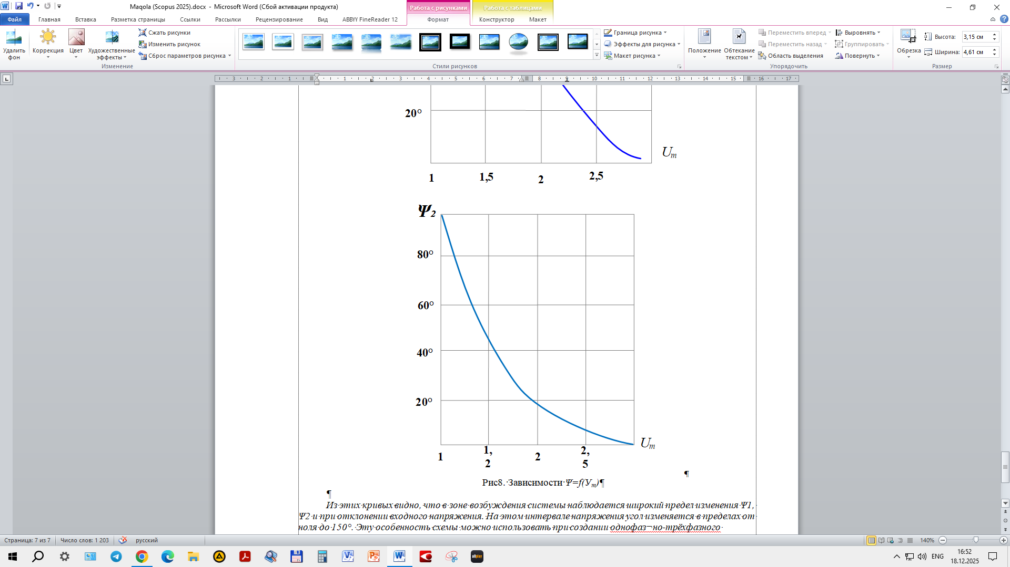
a) | b)
FIGURE 8. Dependencies a)Ψ=f(У_{m}); b)Ψ₂=f(У_{m})
CONCLUSIONS
From these curves, it can be seen that in the system excitation zone, there is a wide range of variation of Ψ₁ and Ψ₂ when the input voltage deviates. In this voltage interval, the angle changes within the range from zero to 150⁰. This feature of the circuit can be utilized in the creation of a single-phase to three-phase converter and a phase-shifting device in the control circuit of triode thyristors.
REFERENCES
1. T.M.Kadyrov. Electro-ferromagnetic circuits with a wide falling section on amplitude and phase characteristics. Izvestiya VUZov. Elektromekhanika, (1988), pp.145-149.
2. T.M.Kadyrov. Application of autoparametric circuits for thyristor control. In Electromagnetic and Semiconductor Automation Devices, Collection of Scientific Works, Tashkent, (1984), pp.9-15.
3. T.M.Kadyrov, and E.G.Usmanov. Application of autoparametric circuits for control of thyristor frequency converters. Collection of Scientific Works of TashPI, Tashkent, (1991), pp.12-17.
4. A.N.Rasulov, and T.M.Kadyrov. Electro-ferromagnetic circuits in stabilization and regulation modes, Monograph, Tashkent, (2014), p.199.
5. Ruzinazarov M.R. Current source converter into stabilized voltage source based on electromagnetic ferromagnetic circuit // E3S Web of Conferences 384. 2023. РР, 01050, 1-5. https://doi.org/10.1051/e3sconf/202338401050
6. Rasulov A.N., Ruzinazarov M.R. Electrical load graphs and indicators // E3S Web of Conferences 384. 2023. РР, 01042, 1-4. https://doi.org/10.1051/e3sconf/202338401042.
7. A.Nuraliyev, I.Jalolov, M.Peysenov, A.Adxamov, S.Rismukhamedov, R.Karimov. Improving and Increasing the Efficiency of the Industrial Gas Waste Cleaning Electrical Filter Device. AIP Conference Proceedings, 3331(1), 040040, (2025), https://doi.org/10.1063/5.0305751
8. M.Sadullaev, E.Usmanov, R.Karimov, D.Xushvaktov, N.Tairova, A.Yusubaliev. Development of Contactless Device Schemes for Automatic Control of the Power of a Capacitor Battery. AIP Conference Proceedings, 3331(1), 040042, (2025), https://doi.org/10.1063/5.0305879
9. M.Sadullaev, E.Usmanov, R.Karimov, D.Xushvaktov, N.Tairova, A.Yusubaliev. Review of Literature Sources and Internet Materials on Contactless Devices for Reactive Power Compensation. AIP Conference Proceedings, 3331(1), 040041, (2025), https://doi.org/10.1063/5.0305878
10. M.Sadullaev, M.Bobojanov, R.Karimov, D.Xushvaktov, Y.Shoyimov, H.Achilov. Experimental Studies of Contactless Devices for Controlling the Power of Capacitor Batteries. AIP Conference Proceedings, 3331(1), 040044, (2025), https://doi.org/10.1063/5.0307195
11. E.Usmanov, M.Bobojanov, R.Karimov, D.Xalmanov, N.Tairova, S.Torayev. Contactless Switching Devices Using Nonlinear Circuits. AIP Conference Proceedings, 3331(1), 040031, (2025), https://doi.org/10.1063/5.0305744
12. E.Abduraimov, M.Peysenov, N.Tairova. Development of Contactless Device for Maintaining the Rated Voltage of Power Supply Systems. AIP Conference Proceedings, 2552, 040012, (2022). https://doi.org/10.1063/5.0116235
13. E.Abduraimov. Automatic control of reactive power compensation using a solid state voltage relays. Journal of Physics Conference Series, 2373(7), 072009, (2022). DOI 10.1088/1742-6596/2373/7/072009
14. E.Abduraimov, D.Khalmanov. Invention of a contactless voltage relay with an adjustable reset ratio. Journal of Physics Conference Series, 2373(7), 072010, (2022). DOI 10.1088/1742-6596/2373/7/072010
15. E.Abduraimov, D.Khalmanov, B.Nurmatov, M.Peysenov, N.Toirova. Analysis of dynamic circuits of contactless switching devices. Journal of Physics Conference Series, 2094(2), 022072, (2021). DOI 10.1088/1742-6596/2094/2/022072

