Constructive development of impact-rotary pneumatic drilling perforators and analysis of the processes of improving their piston-impact mechanism
Bakhrom Otajonov ^{a)}, Nusrotullo Ziyadov, Jasurbek Yunusov
Tashkent state technical university named after Islam Karimov, Tashkent, Uzbekistan
^{a)} Corresponding author: Bahrom9097@yandex.ru
Abstract. This article presents a list of certain patented types of perforators designed for drilling rock using the impact-rotary method. A brief description is provided for each of the identified technical solutions, highlighting their unique features and characteristics. As a result of a critical analysis of the structural diagrams of the presented perforators, new research tasks significant for both science and practice were formulated. The implementation of these tasks will allow obtaining scientific knowledge on the application of new types of piston-impact units in impact-rotary drilling machines, as well as advancing towards the realization of the idea of reducing the negative factors affecting operators under operational conditions.

INTRODUCTION
Operations related to blasting processes, such as the exposure of mineral deposits, preparation for extraction, actual extraction, and mineral exploration, are generally based on drilling boreholes and blast holes.
The drilling process in the excavation cycle is one of the primary operations and determines the technical level of mining developments. Drilling accounts for 25–40% of the total duration and labor intensity of mining excavation operations. [5]
The search and exploration of new mineral deposits and their development require improvements in drilling operations, methods, machines, and equipment, efficient utilization of available resources, an increase in their usage efficiency, and ultimately, an enhancement in the productivity of drilling machines.
Improving the efficiency of borehole drilling using perforators in solid rock masses is possible through the enhancement of applied rock destruction methods. The impact-rotary drilling method remains a universal approach, allowing the drilling of even the hardest rocks, albeit at a relatively low drilling speed. Increasing the productivity of perforators will not only reduce the cost of drilling operations by minimizing the time required for borehole drilling but also improve the overall efficiency of mining excavation operations.
The primary requirements for modern pneumatic perforators include ensuring maximum transmission of the piston-impact energy to the drill rod, increasing the number of impacts to the maximum level within a short period, and providing structural convenience for the operator. The perforator should be lightweight, with low noise and vibration levels. To mitigate these drawbacks, methods such as equipping perforators with additional vibration-damping structures and regulating air pressure are utilized.
As research findings indicate, depending on the operating modes and conditions of perforators, the following are the main causes and sources of vibration:
- The effect of variable compressed air pressure on the machine body over time, i.e., the influence of internal disturbing forces;
- Impacts of the striker on the perforator housing (crosspiece);
- Collisions of the perforator body with the tool shoulder during seating, which usually occur during the return stroke of the impactor;
- Reverse impacts of the tool on the perforator housing;
- Vibrations of the perforator body at the moment when the impactor strikes the tool shank (rapid forward movement of the body following the penetrating tool due to applied pressing force and frictional forces in the guiding bushing). [4-7]
Almost all of these factors arise due to the interaction between the impact mechanism of the perforator, its housing, and the drilling tool. Thus, by properly selecting the shape, parameters, and materials for manufacturing the piston-impact mechanism, these factors can be partially mitigated.
The objective of this research is to identify and analyze existing technical solutions for drilling machines equipped with piston-impact mechanisms. Based on this analysis, fundamentally new scientific tasks are formulated, focusing on the justification of structural parameters for the impact assembly of drilling machines. These parameters should ensure the optimization of drilling operations under operational conditions and minimize negative factors affecting operators.

ANALYSIS
Scientific research focused on the analysis and synthesis of drilling machines equipped with piston-impact mechanisms has been conducted by various researchers in Russia and abroad.
Patent research has shown that the most active scientific studies in this field have been carried out by foreign universities and mechanical engineering enterprises. Let us take a closer look at well-known patented drilling machines with piston-impact mechanisms (Table 1), each of which can be effectively used for specific rock drilling operations.
The first-generation perforators were characterized by low productivity and a relatively short service life compared to modern perforators. One well-known perforator includes an impact mechanism and a spindle-driven rotary system. The tool rotation is achieved through a spindle kinematically connected to the rotary drive (№1, Table 1). A major drawback of this perforator is that the cross-section of the piston-impact mechanism matches that of the drill rod, and the absence of impact mechanism rotation leads to one-sided cylinder wear and jamming of the impact mechanism.
The perforator described in patent №3 addresses this drawback. To eliminate the issue, this perforator incorporates a housing-impact mechanism, spindle, and a bushing with a socket for the drill rod, using special structural solutions. The closest technical equivalent is a core perforator with a hypocycloid rotary drive, which includes an impact mechanism, a rotary system, and a spindle kinematically connected to the impactor.
Impact-rotary devices are well known, consisting of a housing with a working tool, a piston-impact mechanism installed inside the housing, an air distribution system, and a carriage rigidly connected to handles and a support mounted on the housing. The impactor moves reciprocally under the influence of compressed air, striking the tool. However, their main drawback is excessive vibration, which deteriorates working conditions.
To mitigate high vibration and noise levels in pneumatic perforators, numerous inventions and methods have been developed. One such invention (Table 1, №2) involves placing the perforator in a specialized housing. A distinctive feature of this design is that a bracket with two axes is mounted on the housing, equipped with elastic material pads to improve working conditions and enhance vibration protection efficiency. These axes hold rollers that rest on the carriage. The carriage consists of two plunger cylinders, whose plungers rest against the housing supports and provide axial movement during operation, thereby reducing vibration. [9]
Over time, methods for reducing perforator vibration have improved, culminating in the application of a specialized approach in dual-piston perforators (Table 1, №4). Unlike previous designs, the proposed pneumatic perforator uses an adjustable spool valve with a preloaded spring to regulate airflow. This ensures that air from the forward stroke chamber is not released with every stroke. As a result, the drill rod remains pressed against the rock face, reducing the likelihood of breakage. Additionally, due to the presence of an air cushion in the forward stroke chamber, the impactor does not strike the perforator housing during the return stroke, thereby reducing vibration. Consequently, the proposed perforator offers greater operational reliability compared to existing models.
One of the key factors contributing to vibration is the reverse impact of the tool on the perforator housing. To mitigate this effect, a special adjustable valve is used in perforators (Table 1, №5). The degree of spring compression in this valve ensures that air release from the forward stroke chamber does not occur with every forward stroke. This mechanism helps maintain the drill rod’s contact with the rock face while minimizing the risk of breakage during the return stroke. Thanks to the air cushion in the forward stroke chamber, the impactor does not strike the housing during its reverse movement, significantly reducing vibration.
Thus, by decreasing housing vibration and maintaining firm contact between the drill rod and the rock face, the proposed perforator demonstrates higher operational reliability compared to existing models. [9]

TABLE 1. Patented Drilling Machines with Cam Mechanisms
№ | PATENT DOCUMENT INFORMATION | MECHANISM DIAGRAM
 | SU № 870695 - Pneumatic impact machine with independent tool rotation (A.P. Mikitas, 19.09.1979) | 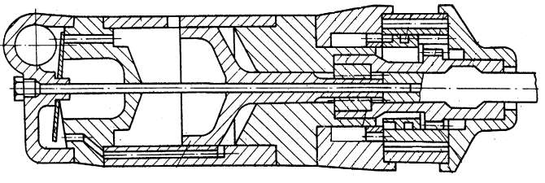
 | SU № 883387 - Pneumatic perforator (V.D. Lubenets, 23.11.1981) | 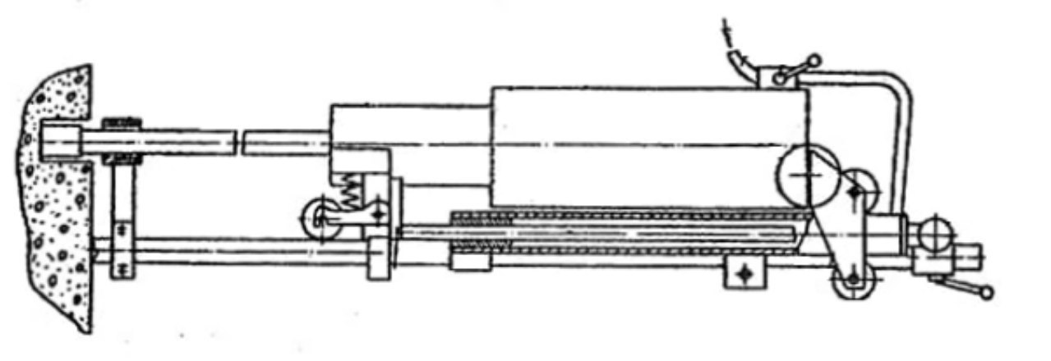
 | SU № 941565 - Perforator for drilling boreholes (B.I. Burtolik, 07.07.1982) | 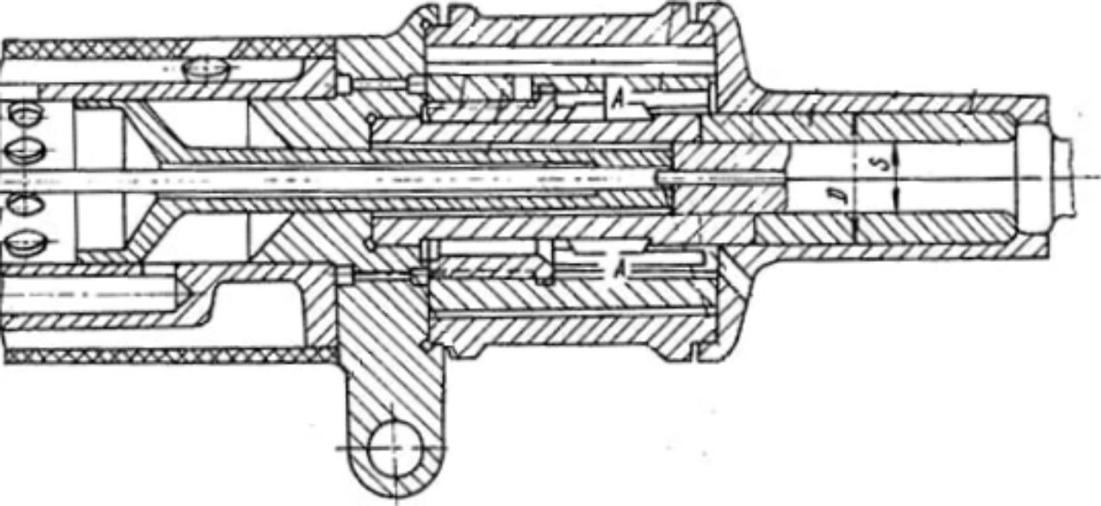
 | SU № 907230 - Pneumatic perforator (A.M. Petreev, 23.02.1982) | 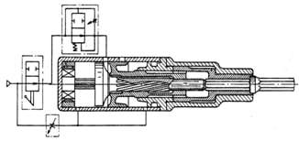
- 5 | SU № 970919 - Pneumatic perforator (B.L. Dun, 23.05.1983) | 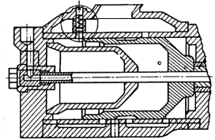
 | RU № 2035043 - Pneumatic perforator with independent tool rotation (V.Y. Svoroba, 10.01.1996) | 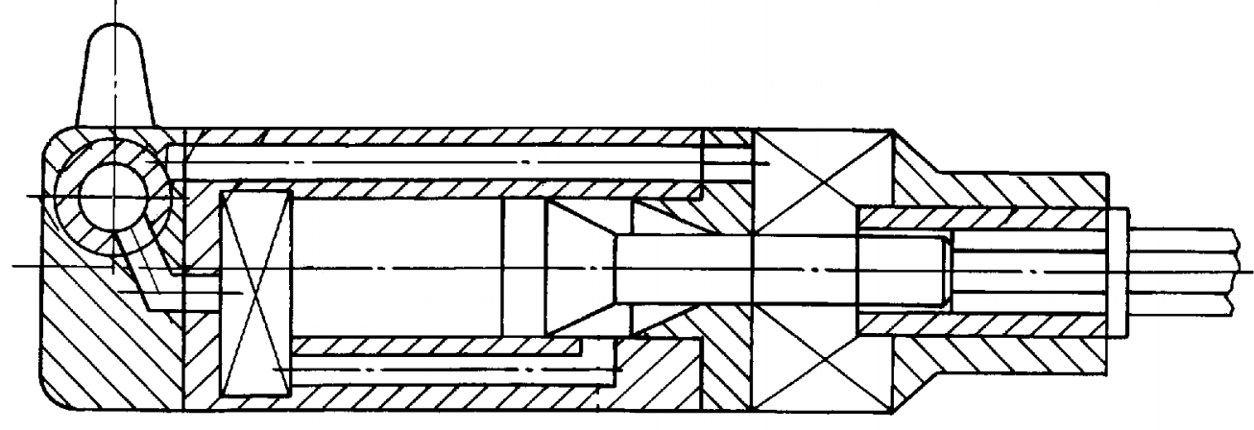
 | RU № 2121061 - Pneumatic perforator (B.I. Burtolik, 27.10.1998) | 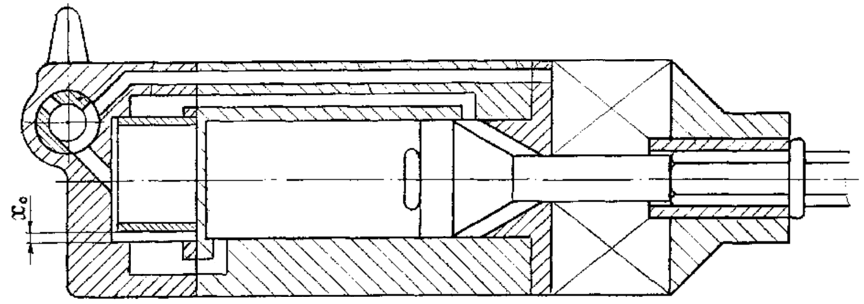
 | RU № 2241105 - Pneumatic perforator (E.A. Dronov, 27.11.2004) | 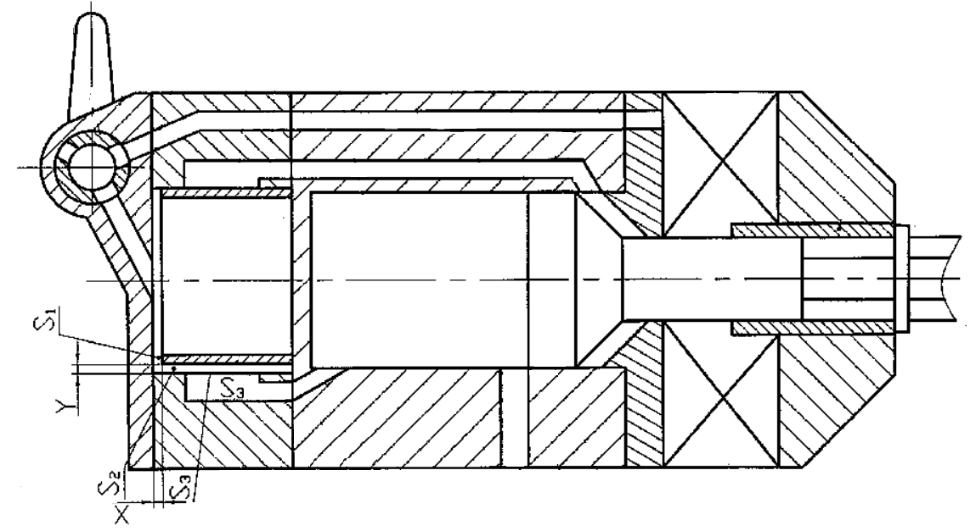

By the 1990s, the development of perforators had reached a new stage. During this period, their productivity and speed increased significantly, while energy consumption was substantially reduced. The expansion of technical capabilities made it possible to use three different drilling methods with a single perforator device. [3]
The well-known pneumatic perforators ПП54В and ПП63В consist of an impact unit with an air distribution system, a hypocycloid mechanism for drill rod rotation kinematically connected to the impactor, and a control valve unit responsible for turning the perforator on and off. In such a perforator, it is impossible to operate the impact and rotary units separately due to their kinematic connection. This limits the application scope and prevents the use of perforators, especially lightweight models like ПП36, as jackhammers for breaking oversized materials, cleaning, and soil trimming.
The closest technical equivalent in terms of functionality and achieved positive effects is a perforator with independent tool rotation, which includes a housing with a cover, impact and rotary mechanisms, and an air distribution system consisting of channels and a valve [6,7]. However, the patented perforator (Table 1, №6) is characterized by high vibration levels, which disrupt the working process, cause operator fatigue, and contribute to health issues. The proposed technical solution aims to reduce vibration by optimizing the channel sizes that connect the air distribution plug valve to the impact and rotary mechanisms. These optimizations are based on impact power and the maximum rotational torque of the working units, significantly compensating for vibration effects during both combined and separate operation.[11,12]
Moreover, the prototype does not ensure reliable independent operation of the working units, which limits the perforator’s functional capabilities. The key parameters of this type of perforator and their impact on human health, including potential negative effects, are central to modern scientific research. These studies focus on a detailed analysis of equipment characteristics and the development of solutions aimed at reducing harmful impacts. As a result of these investigations, significant improvements have been achieved.
All the perforators mentioned above employ various methods to reduce vibration levels. Among them, the inventions of V.D. Lubenets (Table 1, №2) and A.M. Petreev (Table 2, №4) are considered the most effective. However, a drawback of these inventions is the necessity of using additional equipment for pneumatic perforators.[15]

ANALYSIS RESULTS AND CONCLUSION
The analysis of the structural designs of pneumatic perforators with piston-impact mechanisms has identified key research objectives aimed at improving the efficiency of rock drilling with perforators and reducing negative factors. The implementation of these objectives contributes to enhancing the functional efficiency of piston-impact mechanisms.
The following aspects of optimizing the geometry of the piston-impact mechanism have been identified to increase the energy transfer coefficient from the impactor to the rock and to reduce the reverse impact force during operation [1-2]:
- For any piston shape, an energy transfer coefficient from the impactor to the rock can be determined.
- Increasing the cross-sectional area of the drill rods leads to an elongation of the piston.
- Excessive piston length reduces the efficiency of energy transfer to the rock.
- For drilling hard rocks, a shorter piston is required, while for softer rocks, a longer piston is more effective.
As is well known, the impact force of the piston-impact mechanism is expressed by the following formula.
$N_{у}=φ∙D^{3}∙P_{0}^{1.5}∙\sqrt{\frac{S_{g}}{m_{у}}}$ (1)
where:
- $φ$ – proportionality coefficient,
- D – impactor diameter,
- P₀ – compressed air supply pressure,
- S_{g} – structural stroke length of the impactor,
- m_{y} – impactor mass.
From this equation, it follows that the impact energy of the piston-impact mechanism is directly proportional to its diameter and length. Therefore, optimizing the geometric dimensions of the piston-impact mechanism plays a crucial role in improving the performance and impact energy of pneumatic perforators. This means that the efficiency of the perforator, expressed in terms of the number and force of impacts, directly depends on the parameters of the piston-impact mechanism. Consequently, in the design and modernization of pneumatic perforators, special attention should be given to the geometric characteristics of the piston-impact mechanism, carefully calculating its diameter and length to achieve maximum productivity and the required impact energy.
Various methods for reducing vibration levels have been applied in all the analyzed perforator designs. Currently, numerous approaches and techniques for vibration control exist, developed by both Russian and international scientists and engineers. These include modifying pressure diagram shapes, using elastic handles, damping vibrations with pneumatic shock absorbers, preventing impactor strikes on the housing, protecting the operator’s left hand from vibration exposure, and other vibration reduction methods. [8]
Solving the challenges of increasing the energy transfer coefficient from the impactor to the rock, reducing vibration levels in perforators, and improving labor productivity contributes to the development of theoretical foundations for the design of impact-rotary drilling machines. Additionally, it supports the creation of scientific and methodological principles for designing and studying impact systems intended for drilling rocks with a wide range of hardness coefficients.[10,13,14]
REFERENCES
- Technical Requirements and Test Methods for Pneumatic Perforators, State Standard of Russia. Moscow, 1999.
- Ivanov K.I., Latyshev V.A., Andreev V.D. (1987). Drilling Technology in the Development of Mineral Deposits, M.: Nedra,. 272 p.
- Gabov V.V., Lykov Yu.V. (2010). Design of Drilling Machines for Underground Works., Saint Petersburg.
- Mishchenko O.A., Tishchenko V.P. Life Safety, Pacific State University Publishing House, 2014. - 338 .
- Krupenin V.L. (2009). Impact and Vibro-Impact Machines and Devices. Bulletin of Scientific and Technical Development, No. 4 (20).
- Annakulov, T.J., Gaibnazarov, S.B., Kuvandikov, O.A., Otajonov, F.O., Otajonov, B.O. Development of a Methodology for Determining the Economic Efficiency of Cyclic-Flow Technology Schemes for Rock Mining Using Mobile Crushing and Reloading-Conveyor Complexes. AIP Conference Proceedings, 2022, Том 2432, June 2022, 030115. Tashkent 10 June 2021. Код 180176. DOI 10.1063/5.0089668 .https://www.scopus.com/record/display.uri?eid=2-s2.0-85133019709&origin=resultslist&sort=plf-f
- Baburov V.I., Gorbunov V. F. (1966). Causes of Vibration in Handheld Pneumatic Hammers and Methods of Combating It. Tomsk Polytechnic University.
- Alimov O.D., Lyapichev I. G. (1998). Study of Rotary-Impact Drilling.
- Krasovsky V.O., Maksimov G.G., L.B. (2014). Hygienic Assessment of Industrial Vibrations", Uf, 181
- Shibanov D., Agaguena A., Annakulov T. Extraction of Inclined Exit Ledges in Coal Mines in Presence of Mobile Crushing and Conveyor Complexes. (2024) International Journal of Engineering, Transactions B: Applications, 37 (8), pp. 1658 - 1666, DOI: 10.5829/ije.2024.37.08b.17. https://www.scopus.com/inward/record.uri?eid=2-s2.0-85194034364&doi=10.5829%2fije.2024.37.08b.17&partnerID=40&md5=969511836c817585c55881fe920dc868
- Tulkin, Annakulov; Ziyadov, Nusratullo; Abdikarimov, Farhod. Analysis of overburden transportation by conveyor transport as part of a cyclic-flow technology. E3S Web of Conferences.Том 414. 25 August 2023. Номер статьи 06006. 6 September 2023. Код 191994. DOI 10.1051/e3sconf/202341706006. https://www.scopus.com/record/display.uri?eid=2-s2.0-85171197765&origin=resultslist&sort=plf-f
- Annakulov, T., Gaibnazarov, S., Askarov, A., Mamadieva, L. Prospects for the use of cyclic-flow technology for the transportation of rocks at the Yoshlik-1 quarry of JSC Almalyk mining and metallurgical combine. E3S Web of Conferences, Volume 414. 25 August 2023. Article number 06007. 6 September 2023. Code 191994. DOI 10.1051/e3sconf/202341706007.
https://www.scopus.com/record/display.uri?eid=2-s2.0-85171131077&origin=resultslist&sort=plf-f
- Bulatov, G., Annakulov, T. Investigation of the width of the entry of an excavator when loading a mobile crushing plant in the conditions of the Angren coal mine of Uzbekistan. IOP Conference Series: Earth and Environmental Science, 2021, 937(4), 042088. DOI 10.1088/1755-1315/937/4/042088. https://www.scopus.com/record/display.uri?eid=2-s2.0-85122351916&origin=resultslist&sort=plf-f
- Annakulov, T. Development of technological schemes for open-pit mining of deposits using mobile crushing-reloading-conveyor complexes. E3S Web of Conferences, 2020, 201, 01010. DOI 10.1051/e3sconf/202020101010. https://www.scopus.com/record/display.uri?eid=2-s2.0-85096409332&origin=resultslist&sort=plf-f
- https://patents.su

