Increasing the energy efficiency of conductive drying of filter fabrics made of cellulose materials
Yayra Mukhiddinova, Lutfulla Eshkuvatov ^{a)}, Munira Azimova
Tashkent state technical university named after Islam Karimov, Tashkent, Uzbekistan
^{a)} Corresponding author: lutfulla-86@mail.ru
Abstract. The following studies were conducted in this work: creation of a physical model of moisture removal from cellulose materials during the drying process; study of the forms of moisture binding to the material from the point of view of choosing the most rational drying unit and revealing the mechanism of moisture removal during the drying process; study of the energy and technical-economic efficiency of the proposed drying unit for drying regenerated filter cloths made of cellulose materials; development of a waste-free process flow chart focused on the use of a conductive drying process for regenerated filter cloths aimed at minimizing solvent and DAC (Cellulose Diacetate) emissions. The object of the study is the drying process of regenerated filter cloths made of cellulose materials. The subject of the study is the issues of improving the technology and technique for drying regenerated filter cloths under conditions of conductive heat supply.
INTRODUCTION
Improvements in drying technology involve the use of effective conductive (contact) drying methods for regenerated cotton cellulose filter cloths. These methods provide superior technical and economic performance and create favorable conditions for obtaining a high-quality finished product. These methods require accurate and reliable information on the properties of the processed material and the heat and mass transfer parameters during the drying process.
The development of an effective method for drying regenerated filter cloths made of fibrous cellulose panels is driven by the growing need for filter cloth regeneration in chemical fiber production, leading to savings on expensive materials, as well as the need to improve their quality, which affects the process of converting the feedstock into synthetic fiber. This paper is devoted to a comprehensive study of the properties of cellulose materials used in the manufacture of filter cloths as objects of heat treatment (drying), and, based on this study, the selection of an effective method and type of drying system for regenerated filter cloths. This goal is achieved in this study by creating a physical model of the process of moisture removal from cellulose materials during drying, as well as by studying the forms of moisture binding to the material to inform the selection of the most efficient drying system.
Investigating the energy and technical-economic efficiency of the selected drying system for regenerated cellulose materials facilitates the development of a waste-free process flowsheet focused on the efficient use of conductive drying of regenerated cellulose materials.
In accordance with the stated objective, the following main research tasks are addressed in this work:
- Review of completed theoretical and experimental work devoted to the use of apparatus for conductive drying of cellulose materials and its instrumentation;
- Development of a method and type of drying apparatus based on thermograms and sorption-desorption curves of cellulose materials;
- Development of a mathematical model for calculating the drying process of regenerated filter cloths made of cellulose materials;
- Experimental study of the influence of operating parameters on the drying process of regenerated filter cloths in an experimental apparatus and optimization of the drying processes;
- Development of an engineering methodology for calculating the process of conductive drying of filter cloths made of cellulose materials.
A comprehensive solution to these tasks is possible through the use of waste-free heat-processing schemes utilizing energy and resource conservation principles [1-4]. The primary objective of thermal calculations for designed conductive drying systems is to determine the heat output for a given throughput, given the material being dried, and the temperature. An engineering calculation methodology has been developed that allows for determining the estimated throughput of the system for a given design and thermal conditions of the drying process.
Thermal calculations of the heat exchange intensity during filter cloth drying, based on our experimental data, show that when drying filter cloth with a heating surface temperature above 130 ⁰C, the material temperature in the first drying period is equal to the boiling point of acetone at barometric pressure and is close to 56.1 ⁰C. During the first drying period, the cloth temperature decreases by δ t_{с}= 10÷12 ⁰C due to the intensive evaporation of acetone.

EXPERIMENTAL RESEARCH
A research and development experimental laboratory rig has been designed and built, allowing testing under conditions as close as possible to production conditions (Fig. 1). An experimental setup has been created to study the process of conductive drying of spent filter materials (SFM). The setup consists of coolant preparation units [5, 6], a temperature measurement system, a condenser with a condensate drain, and the drying apparatus itself. Apparatus 1 for conductive drying is a rectangular tank measuring 0.32 x 0.32 x 0.16 m³. It has a removable lid and feed-through contacts for the input of six thermocouples. The thermocouples are attached to the surface of the material being dried using cellulose tapes. Inside the apparatus there are four flat coils, which are arranged vertically. The coils are connected to each other in series. The coil height is 0.22 m, the pitch is 0.045 m, and the distance between the coil axes is 0.008 m. The unit is made of X18H10T steel. The filter material samples used for the study were four times smaller than industrial filter elements and measured 0.22 x 0.22 x 0.15 m³. The samples were pre-washed, processed, and placed between the coil elements, three at a time.
FIGURE 1. Schematic diagram of the experimental conductive drying setup for studying the drying process of filter fabrics. 1 - evaporator; 2 - washed filter fabrics; 3 - hot coolant tube; 4 - three-way valve; 5 - condenser; 6 - measuring tank; 7 - thermocouple switch; 8 - potentiometer; 9 - Dewar flask; 10 - thermostat; 11 - copper-constant thermocouples; SGM - steam-gas mixture.

The bottom of the apparatus is inclined at a nine-degree angle toward the center, facilitating the drainage of condensed solvent into a drain hole. The top of the apparatus has a lid with a hole for purging the system with solvent vapor. A shell-and-snake condenser (5) is located beneath the main chamber and connected to it via a drain pipe. The condenser is cooled by mains water at a temperature no higher than 290 K.
A measuring vessel (6) is installed in series with the condenser to measure the amount of acetone released during the drying process. Temperature is measured by copper constant thermocouples (11), inserted into the apparatus through feedthrough contacts and connected via switch (7) to a P-330 V potentiometer (7, 8). Temperature is measured at the inlet and outlet of the coolant in the central section, as well as on the surface and interior of the filter cloths. A 10% NaCl solution is used as the coolant in the heating coil, the temperature of which is set by the I-610 thermostat. The accuracy of coolant temperature regulation is maintained up to 0.5 K.
Experiments to study the conductive drying process of filter cloths were conducted using the following method:
Washed filter cloths 2 were placed between coils 3. With three-way valve 4 closed, apparatus 1 was filled with solvent until the filters were completely submerged. After a 10-minute soak, the solvent was drained through the three-way valve. Simultaneously, condenser 5 and measuring vessel 6 were purged with solvent vapor. After the free liquid ceased draining, the required coolant temperature was set in thermostat 10, which should correspond to the surface temperature of the coil and its middle section. The temperature should be varied between 353 and 373 K in 10 K increments.
After these steps, valve 4 opens, allowing the solvent to evaporate. The evaporating solvent partially condenses on the surface of the apparatus walls, but most of the vapor is directed to condenser 5, where it is completely condensed and drained into measuring flask 6. At a given operating temperature of the installation, the temperature at the specified points and the liquid level in measuring flask 6 are measured at certain intervals (300 s).
During experiments devoted to studying the drying process, drying curves were obtained for a 0.32 x 0.32 x 0.16 m³ web; the heating agent temperature varied from 343 to 383 K in 10 K increments.
Drying rate curves and analysis of experimental results allow for the selection of rational drying process parameters [7]. In addition to drying waste filter web (SFM), the drying processes of cardboard and cotton cellulose were studied, and the obtained results were compared with drying data obtained in other devices using conductive drying.
The kinetic curves for the drying of the SFM are presented in Figure 2. As can be seen from these data, moisture (acetone) removal during drying occurs unevenly. At the beginning of the process, the wet material warms up, lasting 5-7 % of the total drying time. Then, a linear decrease in moisture content begins, reaching the first critical moisture content (the first drying period). This period is crucial and accounts for 50-60 % of the total drying time. After the first critical point and until the end of the process, the moisture content decreases according to the drying curve until moisture removal ceases completely.
Beginning at the first critical point, the material's temperature rapidly increases, then decreases, and then increases again in the second period. At this point, the drying rate sharply decreases, ushering in a second drying period, which includes a second critical point. Analysis of the drying curves and drying rate reveals the existence of two distinct, distinct regions in the second period of conductive drying.
When drying SFM, the temperature did not remain constant in the first period and immediately decreased upon reaching maximum heating (Figure 3). This temperature decrease is due to the rapid evaporation of acetone from the material (evaporation temperature is 56.1 ⁰C, and the heat of vaporization is 125 kcal/kg).
FIGURE 2. Drying curves of filter cloths in a conductive drying apparatus
It should be noted that the temperature difference, leading to intensified heat transfer, reached up to 40 ⁰C. Moreover (with the exception of contact layers), the direction of the temperature gradient coincides with the gradient of moisture content within the material; therefore, thermal-moisture conductivity gradients intensify the drying process. The drying curves show that as the coolant temperature increases from 343 to 383 K, the drying time decreases from 119 to 75 minutes.
The temperature curves (Fig. 3) indicate the emergence of a temperature gradient within the material, directed toward the heating surface. At high heating surface temperatures (above 350 K-383 K), intense vaporization occurs, significantly exceeding the rate of relaxation (absorption) of vapor within the material. As a result, a total pressure gradient arises, which is the driving force for molar vapor transfer [8] to the surface of the filter cloth. However, the increase in process temperature is limited by several technological factors. First of all, increasing the drying temperature is undesirable from the standpoint of melting the cellulose diacetate particles and ensuring explosion safety. Furthermore, increasing the temperature sharply increases the adhesion of the filter surface, where cellulose diacetate residues are present. As a result, the filter porosity decreases. Based on the above, a temperature of 373-383 K is considered a reasonable drying temperature [9-14].
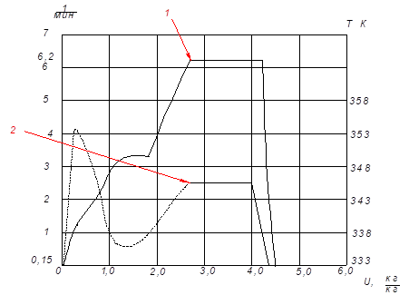
FIGURE 3. Drying rate curves (1) and heating temperature curve (2) of filter cloths at a temperature of 353K on the heating surface of the cloth

Fig. 4 shows the drying curves of cardboard in a contact drying apparatus, indicating that the required drying time for cardboard, under the same conditions, is 30–40 % less than the drying time of SFM. This is explained by the fact that the removed moisture (water) evaporates at higher drying temperatures than acetone. The internal diffusion resistance and thickness of the cardboard are much lower than those of the SFM, although the drying curves are identical.
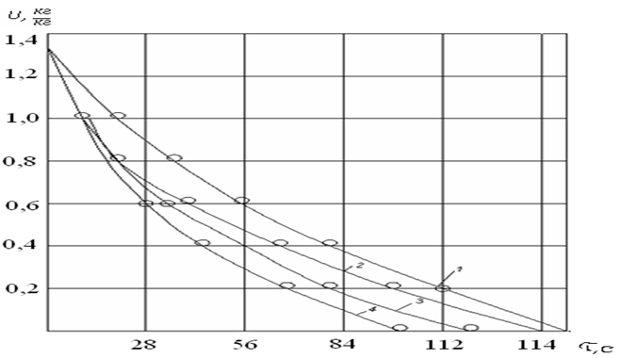
Heating surface temperature: 1-353 K; 2-363 K; 3-373 K; 4-383 K.
FIGURE 4. Drying curves for 480 g/m² cardboard in a conductive dryer.
The drying and heating curves of the cellulose web (Fig. 5), obtained in a conductive dryer, show that the drying time of cellulose under identical conditions is 3-4 times shorter than that of the SFM, and the drying rate depends primarily on the temperature of the heating surface.

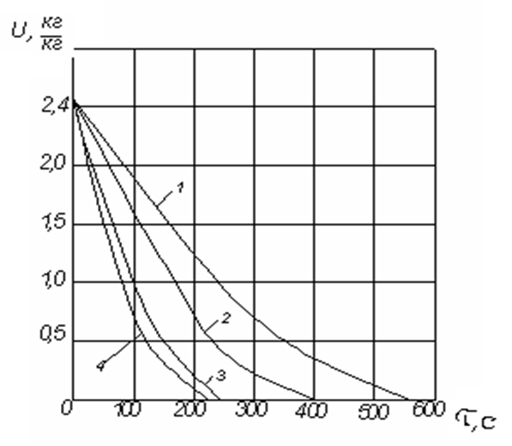
Heating surface temperature K: 1-353; 2-363; 3-373; 4-383.
FIGURE 5. Drying curves for 280 g/m² cellulose in a conductive dryer

Reducing the loss of raw materials and solvents acetone and cellulose diacetate (CDA)) plays a key role in reducing the cost of the final product. The main losses of acetone and polymer occur during the filter press refilling process. The spent filter material, along with the remaining solution, is disposed of in a landfill and incinerated.
To eliminate acetone loss, a waste-free heat and process flow diagram (Fig. 6) was developed based on acetone regeneration by absorbing the solvent from a sand and gravel mixture (SGM). The SGM, at a certain concentration, is sent from drying unit 1 to absorber 2 for regeneration. It is pre-cooled in heat exchanger 4.
The absorbent enters the absorber, purifying the SGM of acetone. The condensation of acetone in the absorber creates a vacuum, allowing for the complete extraction of acetone from the filter cloth and the surface of the apparatus walls. Water is used as the absorbent. The purified acetone is returned to storage. This creates a closed acetone vapor cycle. This eliminates solvent loss, even if the absorber does not completely absorb the solvent.
The heat transfer fluid entering drying unit 1 is heated by steam in heat exchanger 6. The acetone-water mixture formed in the absorber is sent for separation to distillation column 3.
Before entering the distillation column, the acetone-water mixture is heated in heat exchanger 5 by the heat from the column's bottoms. The acetone distilled from the acetone-water mixture is returned to production. The column's bottoms are partially cooled in heat exchanger 5 and then in cooler 7 to a temperature of 5-7 ⁰C. After cooling, the bottoms are used as an absorbent. Thus, a closed water cycle is created.
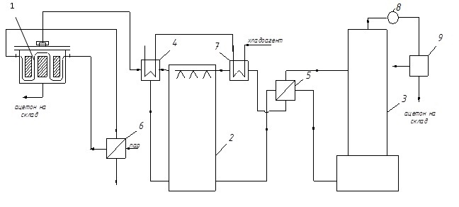
FIGURE 6. Scheme of waste-free technology for drying regenerated cellulose materials.
The diagram in Fig. 6 shows that it is free of any emissions other than leaks, which depend on the quality of installation.
The proposed diagram utilizes standard equipment: heat exchangers, a distillation and absorption column, and a drying unit. The operating parameters of the circuit elements are determined by the operating parameters of each of them in optimal mode. The heat exchangers and the distillation column [12,13] are selected from a catalog for the parameters of the selected process diagram (Fig. 6). The drying unit is designed using the calculation method for filter cloth drying units. Thus, to fully calculate the elements of a waste-free heat and process diagram, it is necessary to simulate [14,18] and calculate the acetone absorption process and select an absorption column.
RESEARCH RESULTS
The scientific and practical results of this work have been accepted for implementation at Fargonaazot OJSC and are being used in the preparation of the technical specifications for the design of drying systems for filter cloths made of cellulose materials in the acetone regeneration plant. The use and implementation of waste-free technology eliminates the energy-intensive processes of adsorption, desorption, and drying of activated carbon during filter cloth regeneration. The use of three-phase fluidized bed absorption in chemical fiber production will allow for savings of up to 20-25 % in thermal energy, up to 30 % in solvent, and up to 30 % in cellulose diacetate, while preserving the environment by preventing their release. The technology has been accepted for implementation by Uzruberoid and the State Unitary Enterprise TNIIHT, with expected thermal energy savings of 10-15 %.
TABLE 1. Results of experimental studies of the drying process of SFM at various heating surface temperatures
343 К |  |  | 353 К |  |  | 363 к |  |  | 373 к |  |  | 383 к
№ | u | τ | № | № | u | τ | u | τ | № | u | τ | № | u | τ
1 | 4,0 | 13 | 1 | 4,0 | 8 | 1 | 4,0 | 6 | 1 | 4,0 | 7 | 1 | 4,0 | 6
2 | 3,8 | 17 | 2 | 3,0 | 22 | 2 | 3,0 | 19 | 2 | 3,0 | 15 | 2 | 3,4 | 10
3 | 3,0 | 25 | 3 | 2,0 | 38 | 3 | 2,8 | 20 | 3 | 2,4 | 20 | 3 | 3,0 | 13
4 | 2,5 | 30 | 4 | 1,6 | 45 | 4 | 2,0 | 29 | 4 | 2,0 | 25 | 4 | 2,0 | 21
5 | 2,0 | 38 | 5 | 1,0 | 55 | 5 | 1,3 | 40 | 5 | 1,1 | 40 | 5 | 1,7 | 25
6 | 1,6 | 45 | 6 | 0,8 | 60 | 6 | 0,8 | 60 | 6 | 1,0 | 42 | 6 | 1,0 | 38
7 | 1,0 | 60 | 7 | 0,3 | 80 | 7 | 0,3 | 80 | 7 | 0,5 | 60 | 7 | 0,7 | 45
8 | 0,3 | 93 | 8 | 0 | 102 | 8 | 0 | 100 | 8 | 0 | 95 | 8 | 0,3 | 72
9 | 0,1 | 110 |  |  |  |  |  |  |  |  |  | 9 | 0 | 78
10 | 0 | 120
TABLE 2. Results of experimental studies of the cardboard drying process, at different heating surface temperatures
353 К |  |  | 363 К |  |  | 373 К |  |  | 383 К
№ | u | τ | № | u | τ | № | U | τ | № | U | τ
1 | 2,4 | 0 | 1 | 2,4 | 0 | 1 | 2,4 | 11 | 1 | 2,4 | 10
2 | 2,0 | 40 | 2 | 2,0 | 40 | 2 | 2,0 | 20 | 2 | 2,0 | 15
3 | 1,5 | 70 | 3 | 1,5 | 50 | 3 | 1,5 | 40 | 3 | 1,5 | 30
4 | 1,0 | 100 | 4 | 1,0 | 80 | 4 | 1,0 | 70 | 4 | 1,0 | 50
5 | 0,5 | 150 | 5 | 0,5 | 120 | 5 | 0,5 | 80 | 5 | 0,5 | 70
6 | 0 | 240 | 6 | 0 | 220 | 6 | 0 | 130 | 6 | 0 | 110

TABLE 3. Results of experimental studies of the cellulose drying process at different heating surface temperatures

353 К |  |  | 363 К |  |  | 373 К |  |  | 383 К
№ | u | τ | № | u | τ | № | u | τ | № | u | τ
1 | 2,4 | 10 | 1 | 2,4 | 0,8 | 1 | 2,4 | 0 | 1 | 2,4 | 0
2 | 2,0 | 80 | 2 | 2,0 | 60 | 2 | 2,0 | 40 | 2 | 2,0 | 40
3 | 1,5 | 170 | 3 | 1,5 | 110 | 3 | 1,5 | 70 | 3 | 1,5 | 50
4 | 1,0 | 230 | 4 | 1,0 | 170 | 4 | 1,0 | 100 | 4 | 1,0 | 80
5 | 0,5 | 350 | 5 | 0,5 | 230 | 5 | 0,5 | 150 | 5 | 0,5 | 120
6 | 0 | 550 | 6 | 0 | 390 | 6 | 0 | 240 | 6 | 0 | 220
CONCLUSIONS
A waste-free filter cloth drying technology was developed, and the absorption process in a three-phase fluidized bed was simulated. This ensures high product quality, minimal energy, raw material, and auxiliary material consumption, maximum utilization of secondary energy resources, and reduced emissions of acetone and cellulose diacetate solvents into the environment.
Research shows that the optimal drying temperature for OFP is between 373-383 K, with a temperature differential of up to 40°C, which intensifies heat and mass transfer during the drying process.
REFERENCES
1. Stig Stenström Drying of paper: A review 2000–2018 /Drying Technology (Taylor & Francis), London, UK, 2020. https://doi.org/10.1080/07373937.2019.1596949
2. Uzhov V.N., Myagkov B.I. Purification of industrial gases with filters. – Moscow: Chemistry, 1970. -319 p. https://djvu.online/file/WOfIA6zWiOAFK
3. Zhuzhikov V.A. Filtration. – Moscow: Chemistry, 1980. -398 p. https://rusneb.ru/catalog/000200_000018_rc_1063234/
4. Petryanov I.V., Kozlov V.I., Basmanov P.I. Fibrous filter materials FP. – Moscow: Knowledge, 1968. -77 p. https://rusneb.ru/catalog/000200_000018_rc_4327132/
5. Zhuchkov P.A. Thermal processes in pulp and paper production. - Moscow: "Lesnaya Promyshlennost", 1981. - 408 p. https://rusneb.ru/catalog/000199_000009_001070964/
6. Berezina Yu.I. Operation and repair of high-speed paper-making machines. - Moscow: Lesn. prom-st, 1984. - 144 p. https://search.rsl.ru/ru/record/01001218033
7. Prokhorov D.A.; Dubovy V.K. — "Study of the Effect of Drying Temperature on the Properties of Paper Made from Sulphate Bleached Softwood and Hardwood Pulp" — News of Universities. Forestry Journal, No. 3, pp. 173–184 — Arkhangelsk, 2023. https://journals.narfu.ru/index.php/fj/article/view/1487
8. Mukhiddinova Ya.D. Calculation of the absorption process in a three-phase fluidized bed. // "Bulletin of Tashkent State Technical University". - T., 2007. No. 4. - P. 28-34. https://assets.slib.uz/edition/
9. Mukhiddinov D.N. Theoretical foundations and development of effective methods for drying raw cotton and its processed products.: Abstract of a PhD thesis. - MPEI, M., 1986. - 34 p. https://e-catalog.nlb.by/Record/BY-NLB-rr16366130000
10. Mukhiddinov D.N., Babakhodzhaev R.P., Mukhiddinova Ya.D. Optimization of the drying process of filter cloths // Energy and fuel resources of Kazakhstan. Almaty, 2010. No. 10/4. - P.70-71. https://e-catalog.nlb.by/Collection/BY-NLB-br68387
11. Shchekina N.N., Subbotina T.I. New filter materials for cleaning acetate spinning solutions. Paper industry. -M., 1991. No. 5. https://rusneb.ru/catalog/000224_000128_0001330227_19870815_A1_SU/
12. Mukhiddinova Ya.D. Development of waste-free drying technology schemes for regenerated cellulose materials: // International scientific and practical conference: "Innovation-2010". - Tashkent, 2010. P. 119-120. https://www.uzinform.com/ru/news/20101020/04796.html
13. Lutfulla Eshkuvatov, Rakhimjan Babakhodjayev, Nazim Tashbayev, G’olibjon Arzikulov, Mussokhon Masumov, Abdurahmon Bafoyev Experimental investigation and processing the results of steam condensation on vertical tubes with profiled ribs of a new construction. AIR Conference Proceedings. Volume 3152, 17 June 2024 3rd International Scientific and Technical Conference on Actual Issues of Power Supply Systems, ICAIPSS 2023 Tashkent 7 September 2023, https://doi.org/10.1063/5.0218910
14. Mukhiddinov D.N., Luzhansky D.M., Alishev A.G., Babokhodzhaev R.P. Development and study of low-waste heat engineering processes in the production of diacetate fiber. – In the book: Problems of energetics of heat engineering. - M., 1983, - pp. 7-8. https://search.rsl.ru/ru/record/01001491537
15. Genis A.V., Usov V.V., Idiatulov R.K. Multilayer sorption-filtering material. Russian Federation Patent for Invention No. 2317132. Registered on February 20, 2008, published in Bulletin No. 5, February 20, 2008. https://rusneb.ru/catalog/000224_000128_2006139341_20080520_A_RU/
16. Ya. D. Mukhiddonova; K. M. Murtazaev. Modeling and experimental studies of water cooling
processes in an experimental model of a cooling towerю. AIP Conference Proceedings 2552, (2023). Pp 050016,1-9
https://doi.org/10.1063/5.0112374
17. Eshkuvatov L, Babakhodjaev R., Tashbaev N. Intensification of heat transfer during condensation of water vapor on a vertical tube. E3S Web of Conferences. Vol 43412, 4th International Conference on Energetics, Civil and Agricultural Engineering, ICECAE 2023 Tashkent 12 October 2023, https://doi.org/10.1051/e3sconf/202343401012
18. Yayra Mukhiddinova. Modeling of hydrodynamics and heat-mass transfer
processes in cooling towers. AIP Conf. Proc. 3152, 060006 (2024). Pp 060006, 1-3 https://doi.org/10.1063/5.0219390

