Monitoring and prevention of abnormal operating modes of electrical device based on data from energy meters
Dilyorbek Karimjonov^{1, a)}, Zhou Jinghua², Zhang Guichen², Nodirbek Topvoldiyev¹, Furkatbek Dumakhonov¹
¹Andijan State Technical Institute, Andijan, Uzbekistan
²North China University of Technology, Beijing, China
^{a)}Corresponding author: dilyorkarimjonov@gmail.com
Abstract. This article presents a method for monitoring electrical devices and detecting abnormal modes using digital data acquired from energy meters. In the research process, indicators such as voltage, current, active and reactive power, power factor, and frequency monitored by energy meters are gathered in real time and analyzed statistically. In this situation, the data transferred via the RS485 connector designed for data exchange in energy meters is processed by a microcontroller equipped with a Wi-Fi module. Based on the obtained data, a database is formed, relationships between parameters changing over different time intervals are determined, and an algorithm for detecting abnormal modes is developed. The monitoring system is programmed using the ARDUINO IDE. Information about abnormal modes occurring in an electrical device is sent to the responsible specialist via telegram bot. Also, this bot allows you to monitor the energy balance of the device in real time and send a warning signal before a malfunction occurs. Analysis of the results showed that using the proposed digital monitoring method, it is possible to detect abnormal modes in electrical devices at an early stage. This leads to fewer accidents, lower maintenance costs, and less energy waste.
INTRODUCTION
Today, as a result of the increase in the number of consumers in power supply systems, the complexity of operating electrical equipment grows, and the demands for energy quality rise, ensuring the continuous and stable functioning of power grids becomes an urgent issue. Real-time monitoring of the technical state of electrical devices, as well as early detection and avoidance of failures or abnormal operating modes, are crucial to increasing overall system dependability and energy efficiency.
Faults in electrical grids, load asymmetry, voltage drops or increases outside the defined standard, and reactive power changes all have a negative impact on the grid's overall efficiency. If these problems are not discovered in time, they result in the breakdown of electrical equipment, significant energy waste, and an uninterrupted supply of electricity to consumers.
Therefore, the importance of digital metering systems and automatic monitoring methods in eliminating such problems is increasing year by year. In recent years, “Smart meters” have been widely introduced. They not only calculate energy consumption, but also measure voltage, current, power factor, frequency, and other parameters in real time and transmit data to a server via the RS-485 port. Based on this data, it is possible to analyze the state of electrical devices and warn before signs of failure appear.
Early detection of abnormal conditions in electrical power distribution grids, particularly transformer stations and consumer grids, has important economic and technological implications. For example, if voltage deviations from normal values, load imbalances between phases, or excessive power consumption are detected before they lead to emergencies, they can be much easier to eliminate. Therefore, the development of a monitoring system using data analysis and abnormal condition detection algorithms based on digital data from energy meters is a relevant direction.
The purpose of this research is to develop a system for monitoring the operating status of electrical equipment in real time using a telegram bot based on measurement data from energy meters, and for early detection and prevention of abnormal modes. In the research, data received via the RS-485 port is collected, based on which the relationships between variables are determined, and deviations from the norm are automatically detected using statistical and mathematical analysis, and analytical data on the status is sent to the responsible specialist via the telegram bot. The responsible specialist monitors all parameters in real time through the telegram application on his phone or computer. The advantages of this system are fast delivery of messages, reduction of server costs, and simplification of the monitoring process.
The system works in the following stages:
The energy meter performs measurements in real time;
Data is transmitted to the microcontroller via the RS-485 port;
The device analyzes measurement data and automatically sends a warning signal to the Telegram bot in case of detected abnormal modes;
The user can monitor the status of their device via Telegram and take quick action if necessary.
A scientific and practical solution will be developed to transmit measurement data from RS-485 based energy meters via Telegram bot and automatically detect abnormal modes. This approach is a small-scale but functionally effective modification of smart energy systems, which will simplify electricity control in the conditions of Uzbekistan and expand energy saving opportunities. Therefore, many scientific studies rely on data from digital meters when monitoring electrical installations.
Mohammad Hassan Hashemi and Selim Dikmen (2023) proposed a method for real-time monitoring of power transformers via the Internet based on gas analysis. In this research, they mainly investigated the performance of transformers by analyzing the state of gases formed in the oil of the transformer. In this research, they used a gas analysis system, i.e., sensors indicating the state of the gas sent information to a microcontroller, and the transformer was monitored in real time via the Internet [1].
Tomasz Śmiałkowski and Andrzej Czyżewski (2025) proposed a method for fault detection in urban lighting systems using autoencoder and transformer algorithms. The research aims to present the effectiveness of fault detection algorithms in lighting systems based on the analysis of data obtained from energy meters. The road lighting control system operates continuously and in real time, which requires online fault detection algorithms. In this case, they monitored the system using a specially developed web application, which does not receive data from the energy meter directly using a microcontroller, but through a server [2].
Hashim Raza Khan, Majida Kazmi, et al. (2024) proposed a low-cost energy monitoring system with universal compatibility and real-time visualization for increased usability and energy savings. In their research, they collected data from energy meters, aggregated it and sent it to a server, and based on this, they monitored the electricity consumption of consumers in real time using a specially developed web application through a server, rather than directly [3].
Santosh Kumar Tripathi, Vaibhav Shukla et al. (2025) have worked on an ESP32-based energy meter with remote monitoring and security features. In their research, they developed an IoT-based remote monitoring, data analysis, and smart energy meter system using ESP-32. In this, they used voltage and current sensors to detect electrical parameters and send them to a microcontroller. Based on this, they developed a device for remote monitoring of electricity consumption [4].
Dicky Andrian Nugraha and Amirullah (2023) proposed a method for real-time monitoring of electrical appliances in homes by monitoring, controlling, and protecting the consumption of household electrical appliances through a telegram application. In this, they mainly used the PZEM-004t energy meter module, not energy meters. In the research process, the data obtained from the PZEM-004t module was processed by NodeMCU ESP8266 and sent to a telegram bot. In this way, they developed a system for real-time monitoring of electrical appliances in homes [5].

EXPERIMENTAL RESEARCH
The main cause of malfunctions in electrical devices is the deviation of its electrical parameters (voltage, current, power factor, frequency, phase asymmetry, high harmonic currents, etc.) from their standard values. These parameters are inextricably linked, and if one of them deviates from the standard, the others also change. As a result, the operating mode of the electrical device is disrupted, which leads to negative situations such as increased losses, insulation degradation, changes in magnetic flux, increased vibration and noise. An electrical device should operate in normal mode within the range of nominal values established by standards. If it deviates from these nominal values, it is considered an abnormal (pre-accident) operating mode. If an electrical device operates with electrical parameters that deviate from the standard continuously or for a short period of time, this leads to the failure of the electrical device or to its operation in a short-term abnormal mode. Below is a formula for the dependence of changes in electrical parameters affecting the operating mode of an electrical device on its operating period [1, 5].
(1)
where:
D(t) - damage level of the device
I(t) - instantaneous value of current
U(t) - instantaneous value of voltage
cosφ(t) - instantaneous value of the power factor
∆U - voltage difference
U_{th} - threshold voltage
h_{n} - influence coefficient depending on the nth harmonic
k₁, k₂, k₃, k₄, k₅, k₆ - coefficients expressing the effect of each parameter on the device
It is extremely important that these quantities are within the specified limits. Because the stability of these parameters ensures the efficient, safe and long-term operation of electrical devices. If any deviation or change is not detected in time, it can lead to device failure or a chain of failures throughout the entire electrical network. In order to prevent such problems, continuous monitoring systems are introduced in modern energy systems. Electrical parameters are monitored in real time through monitoring systems. Current and voltage transformers, hall-effect sensors, digital measuring sensors, and intelligent energy meters (Smart Energy Meters) are widely used. These devices measure the voltage, current, power and frequency of each phase in the electrical network with high accuracy and transmit the results in digital form. Thus, the stability of electrical parameters and their continuous monitoring are of decisive importance in energy saving and preventing accidents [2, 4, 8].
In this research, an effective method for monitoring the operating status of electrical equipment and early detection and elimination of abnormal modes based on real-time data from energy meters has been developed. The main focus of the research is to identify system faults by analyzing parameters such as voltage, current, active power, reactive power, and power factor, which are open data transmitted from digital energy meters. The goal is to use electricity efficiently, reduce energy waste, and ensure the safe operation of consumer devices.
Currently widely used energy meters are multifunctional and have the ability to simultaneously determine several data and analyze electricity consumption based on the determined data. This data is divided into “Open” and “Closed” types of data.
Open Data is digital information about energy consumption and network status collected by energy meters and made available to third-party systems (e.g. SCADA, IoT platforms, energy analysis software) via an open interface (API, RS-485, MODBUS, MQTT, DLMS/COSEM, etc.). That is, this data is collected within the meter, but external systems can access it via standard protocols. In this case, several quantities measured by the energy meter, such as voltage, current, power factor, frequency, active power, reactive power, incoming and outgoing active and reactive currents, fall into the category of open data.
Closed Data (Closed Data/Restricted Data) is data that is available in the energy meter, but can only be accessed with special permission (admin, operator or manufacturer software). It is not visible to a regular user or external monitoring system. The reason is that this data is related to the meter's internal algorithms, security keys or control functions. Closed data includes Technological data, cryptographic data, tariff and configuration data, diagnostic data and communication settings. This data is protected in order to maintain information security and metrological accuracy.
The RS-485 and optical port on the meter are used to obtain open and closed data from the energy meter. While open data can be directly viewed, read or obtained via the interface by the user or dispatcher, closed data can be obtained by system operators, the manufacturer or specially authorized users via a password or key [4-7].
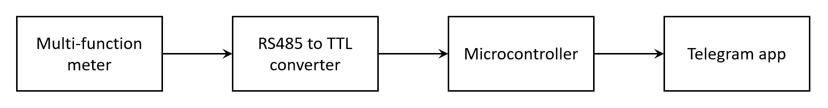
FIGURE 1. Block diagram of the monitoring system

In the first stage of the research, open data from the energy meter is received via the RS-485 communication port. This data is read via the DLMS or MODBUS RTU protocol. RS-485 is an industrial-grade communication standard designed for data transmission. It operates on the basis of a differential signal, that is, it transmits data via the voltage difference on the A and B wires. The information at the RS-485 output cannot be directly connected to microcontrollers that do not have an RS-485 port — they operate at different signal levels. Therefore, a MAX485 or RS-485 to TTL converter is used to convert the RS-485 signal into a signal that the microcontroller understands.
Two of the most important concepts when working with energy meters are the DLMS/COSEM and MODBUS protocols. They are standard protocols used for data exchange, but each has its own purpose, architecture, and application area.
DLMS/COSEM (IEC 62056 standard) is the most advanced international protocol for energy meters. It not only transmits measurement results, but also manages device configuration, time synchronization, network status, tariff modes and other complex data. It represents all meter data in the form of objects. All meter data is stored in OBIS codes, allowing you to call up data with a specific address (ID).
MODBUS is the simplest, most widely used industrial protocol. It is used to transfer data between devices over RS-485 or Ethernet. The data is stored in the form of registers.
In the research process, open data is received through the RS-485 communication port of the energy meter, processed using a microcontroller, and sent to the telegram application. In this case, after the physical connection is made, a program is written in the microcontroller in the appropriate order based on the communication protocol of the energy meter [6, 8].
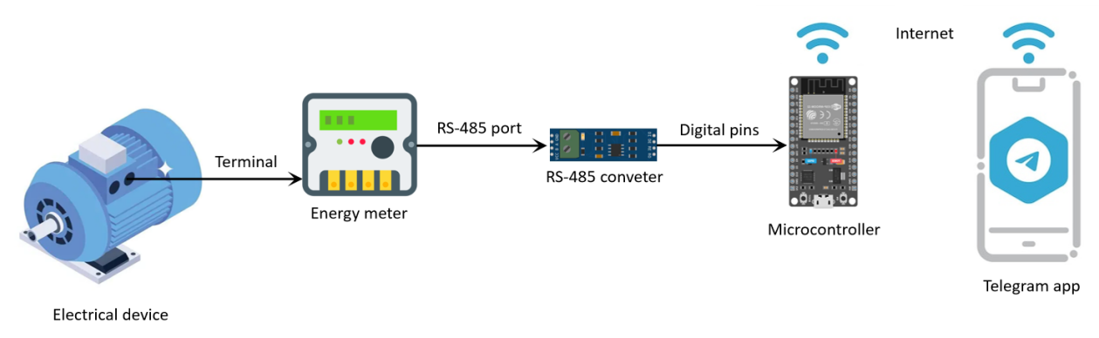
FIGURE 2. Monitoring system of electrical device via energy meter

In this case, data from the energy meter is processed by a microcontroller. That is, conditions are set such as data filtering, statistical analysis, or fault detection (for example, sudden voltage changes or a decrease in power factor). This process is automated using codes written in the Arduino, Python, or C++ programming languages.
At the next stage, the processed data is sent to the Telegram bot application via Wi-Fi. Initially, a separate bot is created in the Telegram application using the BotFather bot. Based on the specified time interval or conditions, the microcontroller sends the measurement results to the server in JSON format. The Telegram bot displays data to the user in real time. In addition, the system also uses an automatic alert function. When the energy meter detects information about negative situations that have occurred in an electrical device based on the specified conditions, the Telegram bot automatically sends a message. These are deviations from the voltage value, increases in current strength above the specified value, decreases in power factor below the specified value, increases in voltage and current asymmetry coefficients, and phase failures in three-phase systems. These values are determined based on the technical parameters of the electrical device [9-11].
RESEARCH RESULTS
The problems of collecting data from energy meters via the RS-485 connection, processing them with a microcontroller, and continuously monitoring the working mode were examined throughout the research to guarantee dependable and steady operation of the electrical equipment. The RS-485 interface used in the research is a differential signal transmission standard that is resistant to high levels of electromagnetic interference and allows data transmission over long distances. As a result, the RS-485 connection was selected as a dependable way of communication between the energy meter and the microcontroller. The microcontroller constantly analyzes the digital data received through this interface and compares it to standard values. For example, if the voltage value is 10-15% higher or lower than the nominal, the microcontroller immediately recognizes it as a “malfunction” and notifies the telegram bot of the situation.
The findings of the study revealed that such automatic monitoring systems allow for the prompt diagnosis and removal of problems in electrical infrastructure. The system operates without human intervention, which saves time, increases maintenance efficiency and improves power quality.
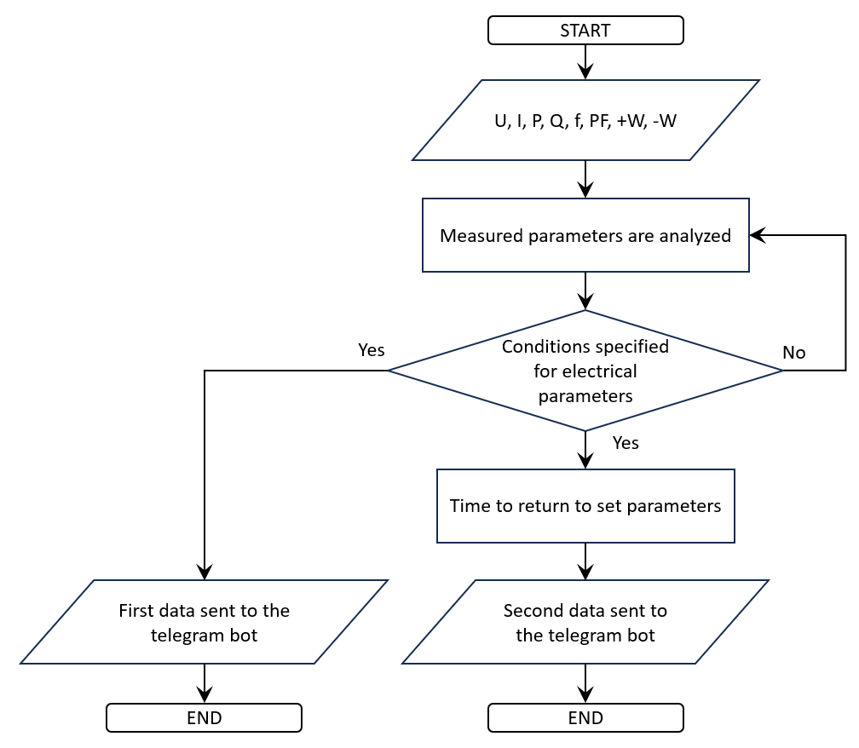
FIGURE 3. Data detection and transmission algorithm

Based on the algorithm, the data received from the energy meter - electrical quantities such as voltage, current, active and reactive power, power factor, and frequency - are transmitted to the microcontroller. The microcontroller is constantly reading this data and comparing it to predetermined standard values. If the parameters fall outside of the prescribed range, i.e., the voltage increases or lowers significantly, the current exceeds the norm, or the power factor drops sharply, the system will automatically notice a defect. As soon as this condition is detected, the microcontroller uses the real-time module to record the exact time of the fault and starts a timer. The timer serves to determine how long the fault condition has lasted. At the same time, the microcontroller sends a message to the technician's phone via the Telegram bot. The message contains information about the type of fault condition, the value of the electrical parameters, the time and place of the condition. The technician receives this alert through his Telegram application and analyzes the negative situation that has arisen and takes measures to eliminate it.
If the technician fixes the fault or the electrical parameters return to the specified standard, the microcontroller automatically detects this change. At this point, the timer is stopped and the time it has shown is saved. The microcontroller then sends a second message to the technician via the Telegram bot. This message indicates that the fault state has been resolved, the length of time the condition existed, and the time when normal operation was restored. This enables the technician to determine the duration and frequency of the problem, identify the causes, and take steps to avoid similar occurrences in the future.
This method enables the quick detection and removal of defects in electrical grids. The technology works in real time, detecting errors, measuring their length, instantly alerting the technician, and providing feedback on eliminated situations. This approach increases the reliability of electrical grids, extends the service life of electrical devices and automates maintenance processes. The data collected in this way is analyzed and serves as the main source for assessing the reliable and high-quality operation of electrical devices and energy quality, as well as improving the operational system.
In the research process, a single-phase asynchronous motor with a power of 250 W and an electric meter with a MODBUS communication protocol were used as an electrical device. In laboratory conditions, electrical quantities that negatively affect the operating mode of the asynchronous motor were generated, and based on this, fault conditions were analyzed. Below is a case where data obtained from the electric meter and analyzed using a microcontroller were sent to a telegram bot in laboratory conditions.
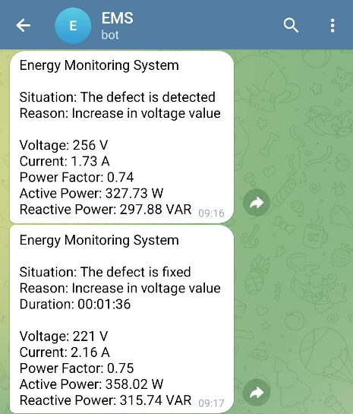  FIGURE 4. Information about the voltage value over the norm, its duration and elimination | 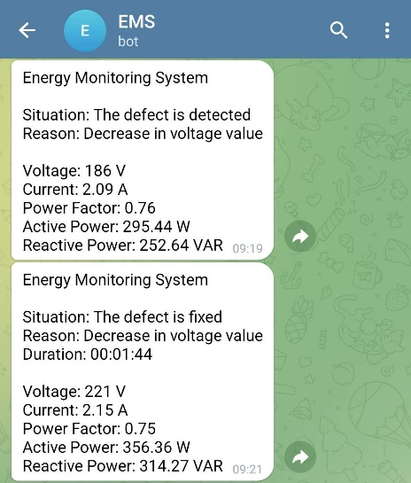  FIGURE 5. Information about the voltage value below the norm, its duration and elimination

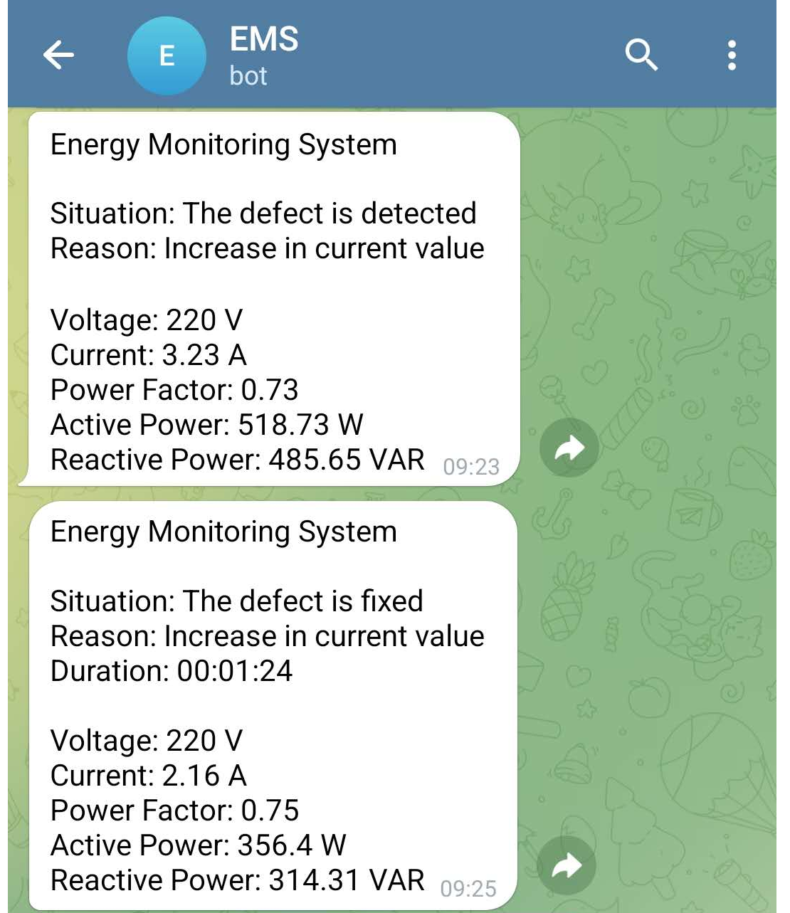  FIGURE 6. Information about the current value over the norm, its duration and elimination | 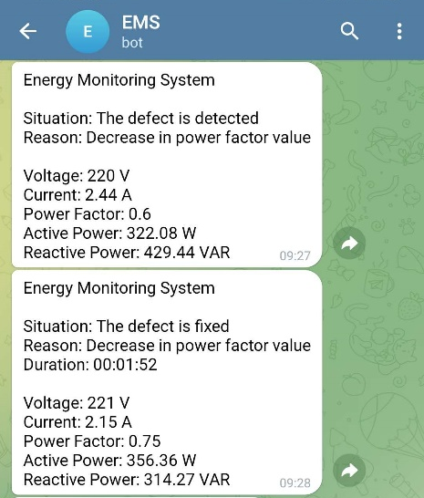  FIGURE 7. Information about the power factor value below the norm, its duration and elimination

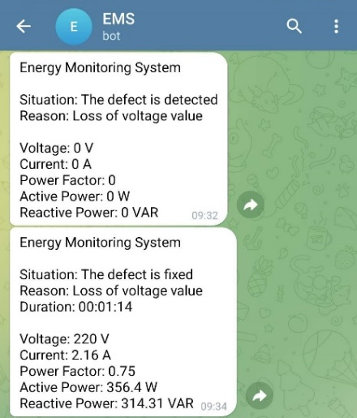  FIGURE 8. Information about the loss, its duration and elimination of the voltage | 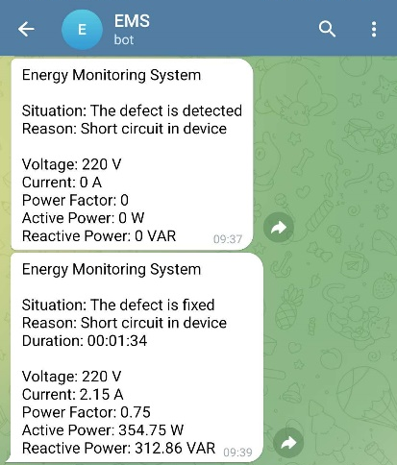  FIGURE 9. Information regarding the status, its duration and elimination of a short circuit in the device
Information indicating the state of the device is sent to the telegram bot not at a certain time, but automatically when changes occur outside the norms established in the system, based on the data from the energy meter, the permissible limit values for each parameter in the system are predetermined by the software. Any malfunctions associated with electrical quantities occurring in the power supply and electrical equipment are recorded by the telegram bot, that is, information about which electrical quantity deviated from the norm and how long this situation lasted, as well as information about the values of electrical quantities at that time. The telegram bot is the main point of contact for the user. It receives each signal from the system in real time and visually notifies the user. The message text clearly indicates the cause of the malfunction, the time the situation began, and the degree of deviation of the parameters from the norm. If the malfunction persists for a long time or several parameters simultaneously deviate from the threshold value, the system will trigger a mechanism for repeatedly sending the message. This provides the user with a real warning about the danger. When the device returns to normal, the system will also send a final signal to the Telegram bot that “it has returned to normal.” Thus, the user will be able to remotely monitor the entire operation of the electrical device, determine the cause of each change and take preventive measures.
CONCLUSIONS
The technology created in this study enables the automation of the real-time monitoring process for electrical devices. Parameters such as voltage, current, active and reactive power, power factor, and frequency obtained from the energy meter are continuously monitored by a microcontroller, and deviations from the established standards are detected. This allows not only control, but also the possibility of early detection of malfunctions, recording their time and analyzing their duration.
According to the results of laboratory tests, the system, based on data from the energy meter, considered such situations as voltage increase or decrease, current increase, power factor decreases, voltage loss, and short circuit. The microcontroller recorded the time of occurrence of these situations using the real-time module and sent a message to the technician via the Telegram bot. The message clearly indicated the type of malfunction, the time of occurrence, and the current values of the parameters. This serves to ensure that the technician makes quick decisions and eliminates dangerous situations in the system in a timely manner.
Once the fault condition was resolved, the system automatically recorded this change and used a timer to determine the duration of the fault. A second message sent to the Telegram bot informed the bot that the system had returned to normal and the duration of the fault.
The results show that the proposed monitoring system significantly increases the reliability and safety of three-phase electrical installations. Real-time data analysis detects problems that reduce the quality of electrical energy, extending the service life of electrical installations and increasing energy efficiency. In addition, the data collected by the system can be further analyzed to determine the frequency, duration, and causes of failures. Based on this information, it becomes possible to modernize power grids, create automated energy audit systems, and optimize operational processes.
Thus, the developed system not only performs monitoring and warning functions, but can also be considered as a solution of significant practical importance for improving the diagnostics and preventive maintenance system of electrical devices.
REFERENCES
- Mohammad Hassan Hashemi, Selim Dikmen. Real-Time Condition Monitoring of Power Transformers Using the Internet of Things (IoT) and Dissolved Gas Analysis // 2023 XIX International Scientific Technical Conference Alternating Current Electric Drives (ACED), Yekaterinburg, Russia, May 23-25, 2023, http://dx.doi.org/10.1109/aced57798.2023.10143439
- Śmiałkowski, T., Czyżewski, A. Anomaly detection in urban lighting systems using autoencoder and transformer algorithms // Sci Rep 15, 35972 (2025), https://doi.org/10.1038/s41598-025-19414-8
- Khan, Hashim Raza, Majida Kazmi, Lubaba, Muhammad Hashir Bin Khalid, Urooj Alam, Kamran Arshad, Khaled Assaleh, and Saad Ahmed Qazi. A Low-Cost Energy Monitoring System with Universal Compatibility and Real-Time Visualization for Enhanced Accessibility and Power Savings // Sustainability 16, no. 10: 4137, 2024, https://doi.org/10.3390/su16104137
- Santosh Kumar Tripathi, Vaibhav Shukla, Anusha Baranwal, Vindu, Anubhav Pandey. ESP32-Based Prepaid Smart Electricity Energy Meter with Remote Monitoring and Security Features // KADIM RESEARCH JOURNAL (ISSN : 2757 - 9395) VOLUME 11 ISSUE 5 2025.
- Dicky Andrian Nugraha, and Amirullah. Telegram Application for Monitoring, Controlling and Protecting the Consumption of Household Electrical Appliances // ELKHA : Jurnal Teknik Elektro, Vol. 15 No. 1, April 2023, pp. 1 - 10 ISSN: 1858-1463 (print), 2580-6807 (online), https://doi.org/10.26418/elkha.v15i1.61245
- Hala Jarallah El-Khozondar, Shady Y. Mtair, Khaled O. Qoffa, Omer I. Qasem, Ahmed H. Munyarawi, Yasser F. Nassar, Ehab HE Bayoumi, Ahmed Abd El Baset Abd El Halim. A smart energy monitoring system using ESP32 microcontroller // e-Prime - Advances in Electrical Engineering, Electronics and Energy, Volume 9, 2024, 100666, ISSN 2772-6711, https://doi.org/10.1016/j.prime.2024.100666.
- T. Karthick, SC Raja, J. Nesamalar, K. Chandrasekaran. Design of IoT based smart compact energy meter for monitoring and controlling the usage of energy and power quality issues with demand side management for a commercial building // Sustainable Energy, Grids Netw., 26 (2021), Article 100454, https://doi.org/10.1016/j.segan.2021.100454
- A. Salunkhe, Y. Kanse, P. Krishnarao, S. Suhas. Internet of Things based smart energy meter with ESP 32 real time data monitoring // 2022 International Conference on Electronics and Renewable Systems (ICEARS) (2022), pp. 446-451
- D. Hercog, T. Lerher, M. Truntič, O. Težak. Design and implementation of ESP32-based IoT devices // Sensors, 23 (2023), p. 6739, https://doi.org/10.3390/s23156739
- Mokhirbek Makhsudov , Dilyorbek Karimjonov. Research algorithm and dynamic characteristics of three-phase electromagnetic current transducers in filter-compensation devices // E3S Web of Conferences 461, 01056 (2023), https://doi.org/ 10.1051/e3sconf/202346101056
- Dilyorbek Karimjonov , Mokhirbek Makhsudov , Abdukunduz Khalimjanov , Dilshodbek Abdukhalilov , Durbek Akhmedov , Kholmirza Mamajonov. Modeling the structures of three-phase asynchronous motor reactive power variations using electromagnetic transducers // International scientific conference on modern problems of applied science and engineering: MPASE2024, https://doi.org/ 10.1063/5.0241567

