Development of an Integrated Model for a Branded Tourism Route in Karakalpakstan: Forecasting, Optimization, and Sustainable Development
Natalya Sarvirova, Gaffor Samatov, Damir Tajibayev ^{a)}, Ziyovuddin Kamoliddinov
Tashkent State Transport University, Tashkent, Uzbekistan
^{a)} Corresponding author: tajibaevdami@gmail.com
Abstract. The development of tourism in remote regions with limited infrastructure necessitates comprehensive models that balance economic efficiency, social appeal, and environmental sustainability. This article proposes an integrated framework combining a hybrid tourism flow forecasting model (HATFF), brand attractiveness optimization (maxZ), and a logistic sustainability index (Z_{IMOUTL}). Drawing on empirical data, including tourism flow statistics (2016–2025), route geodata, survey results (n=32), social media analysis (X platform), and correlation analysis (r=0,63 for route quality and transport, p<0.01), a branded tourism route was developed, incorporating the Savitsky Museum, the Aral Sea, and Khorezm fortresses. The forecast for 2026 (HATFF, R²=0.949) projects an increase in foreign visitors to 341000, with Z=8606,64 and Z_{IMOUTL}=0,605. The proposed framework outperforms traditional models (VRP, TSP) by integrating social media data and nonlinear GDP effects, enabling a potential increase in tourism’s contribution to Uzbekistan’s GDP from 3,3–4,2% to 5–6%. Application to Karakalpakstan highlights its unique potential in the context of ecological and cultural tourism.
INTRODUCTION
Contemporary tourism is evolving from mass visitation to branded strategies, where cultural, historical, and ecological heritage shapes unique products to enhance regional competitiveness. In Uzbekistan, the tourism sector contributes 3,3–4,2% to GDP (2023–2024), generating $3,5 billion in service exports and attracting 10,2 million visitors in 2024 [9,22]. Karakalpakstan, endowed with unique assets—the Savitsky Museum as a repository of avant-garde art, the Aral Sea as a global symbol of ecological transformation, and the Khorezm fortresses as artifacts of the Great Silk Road—holds significant potential. However, the region faces constraints, including underdeveloped infrastructure, seasonal risks (dust storms, temperatures ranging from -5°C in winter to +25°C in summer), and environmental challenges (pollution from the drying Aral Sea). The region’s GDP in 2024 is estimated at $3–4 billion, with an annual growth rate of 7–8%, yet tourism remains underdeveloped due to logistical barriers [6,21].
International experience underscores the effectiveness of branded tourism routes: the Camino de Santiago boosts regional GDP by 0.4–0.5% through pilgrimage tourism, while Route 66 in the USA increases GDP by 1–2% via a heritage-based approach [10,16]. In Central Asia, models like MOST emphasize ISO sustainability standards but often overlook dynamic forecasting and social media data [4,15]. This study aims to develop an integrated framework for a branded tourism route in Karakalpakstan, combining tourism flow forecasting (HATFF), brand attractiveness optimization (maxZ), and sustainability assessment (Z_{IMOUTL}), with an emphasis on correlation analysis and empirical calculations.
Hypothesis: Integrating nonlinear forecasting, optimization incorporating social media data, and environmental penalties will increase tourism flow by 20–50% and enhance route sustainability, surpassing traditional models in the context of Karakalpakstan’s limited infrastructure.

LITERATURE REVIEW
Recent years have witnessed growing interest in tourism branding, sustainable route development strategies, and digital methods for analyzing visitor flows. This section reviews key international publications relevant to the study’s focus.
Kostopoulou et al. [1] in their study “Silk Road Heritage Branding and Polycentric Tourism Development” proposed a polycentric approach to tourism brand development along Great Silk Road routes. The authors demonstrated how regional branding is enhanced by connecting cultural nodes into a cohesive system. This networked collaboration model among heritage sites is adaptable to branded routes in Karakalpakstan, where a diversity of historical and cultural elements exists.
Raimkulov et al. [2,27] in “Destination Attractiveness and Memorable Travel Experiences in Silk Road Tourism in Uzbekistan” empirically analyzed factors shaping destination attractiveness in Uzbekistan. They identified five key dimensions (cultural, natural, infrastructural, cost-related, and hospitality) and their impact on tourist satisfaction and repeat visits. These findings justify the inclusion of attractiveness indicators (u_{i}) and image metrics (Con_{i}, Ita_{i}) in the proposed branded route model.
Usmonova et al. [3,28] in “Combining Tourists and Stakeholders Perceptions of Sustainable Community-Based Tourism in Central Asia” examined perceptions of sustainable tourism among visitors and local communities. The authors concluded that community engagement and infrastructure improvements significantly enhance route sustainability and tourist loyalty. This approach aligns with the sustainability components integrated into the Z_{IMOUTL} model.
Turaev et al. [4,26] in “Agritourism as an Emerging Sustainable Tourism Industry in Uzbekistan” explored agritourism as a tool for sustainable regional development. The authors emphasized that expanding rural routes diversifies tourism offerings and strengthens national branding. This perspective complements the proposed branded route for Karakalpakstan by incorporating rural and eco-cultural components.
Demir and Çelik [5,25] in “Producing Alternative Tourism Routes Using Network Analysis to Promote Seferihisar Cittaslow Concept” developed a method for creating alternative routes using network analysis and GIS. Their approach optimizes infrastructure load and enhances environmental sustainability, structurally aligning with the optimization model (maxZ) and confirming the utility of network algorithms for branded route planning.
Overall, the reviewed international studies highlight the importance of comprehensive assessments of attractiveness, sustainability, and logistical optimization in tourism route development. Recent research emphasizes digital tools—GIS, machine learning, and regression forecasting—which align with the mathematical models HATFF, maxZ, and Z_{IMOUTL} applied in this study.
Additionally, over 30 studies were analyzed. Reference [7] examines tourism’s contribution to Karakalpakstan but lacks mathematical modeling. Reference [8] advocates “culturalization” for Uzbekistan but notes infrastructural barriers (r=0.4–0.6 for transport, similar to our r=0.63). Reference [6] employs SANEL HERMES for environmental challenges but omits forecasting. Reference [3] assesses tourism costs in mountainous regions, identifying correlations (r=0.5) comparable to ours (r=0.54 for ecology). Reference [7,23] uses time-series analysis (R²=0.3–0.4), underperforming compared to HATFF (R²=0.949). Reference [10,24] highlights the Aral Sea’s environmental impact (r=0.5), supporting our penalties in Z_{IMOUTL}. References [9,13] identify gaps in Asian models, affirming the novelty of our approach.
Novelty of the Proposed Framework: The HATFF model with nonlinear GDP effects (R²=0.949, surpassing 0.3–0.4 in [7,20]); maxZ incorporating Coni from X platform data (absent in [8,14]); and Z_{IMOUTL} accounting for rejection penalties (P_{rejection}, 10–15%, outperforming static models in [7,8]). Application to Karakalpakstan enhances uniqueness through adaptation to desert conditions and ecological branding.
MATERIALS AND METHODS
EMPIRICAL DATA
The materials encompass tourism flow statistics, geospatial data, surveys, and analysis of the X platform. Karakalpakstan’s GDP ranges from $1.1 billion to $3.1 billion (2016–2024, CEIC). The exchange rate is UZS/USD = 12,120 (October 25, 2025). Environmental metrics include CO₂ emissions based on EPA standards (0.90 kg/km for diesel buses).

TABLE 1. Tourist Attractions (V)
Attraction | u_{i} (0–10) | Con_{i} (Mentions) | Ita_{i} (0–1) | t_{i} (hours) | c_{i} (USD, foreign visitors)
Savitsky Museum | 8 | 15,000 (X, NYT) | 0.9 | 2 | 6.60 (without guide) / 9.90 (with guide)
Aral Sea | 9 | 20,000 (X, Euronews) | 1.0 | 3 | 0 (guide ~41)
Khorezm Fortresses | 7 | 8,000 (X, UNESCO) | 0.8 | 1.5 | 0 (guide ~41)
TABLE 2. Movements (E)
Segment | dij (km) | tij (hours) | cij (USD/person) | eij (kg CO₂/person)
Nukus–Moynaq | 200 | 3 | Bus: 1.24–2.06 Taxi: 2.89–4.12 | Bus: 9.25 Taxi: 0.72
TABLE 3. Constraints
Parameter | Value | Source
Cmax | $150/person | Surveys (cost complaints)
Tmax | 48 hours | Surveys (5–10 hours/segment)
Emax | 100 kg CO₂/person | Surveys (ecology 4.45/5)
TABLE 4. Additional Factors
Factor | Value | Source
Weather (May–Oct) | 20–25°C, precipitation 5–8 mm | Web (Karakalpakstan weather)
Weather (winter) | -5°C, snow/ice, dust storms | Web (Aral risks)
Factor | Value | Source
CORRELATION ANALYSIS
TABLE 5. Correlation Matrix
Factor | Quality | Attractiveness | Transport Convenience | Ecology
Quality | 1.00 | 0.42 | 0.63 | 0.37
Attractiveness | 0.42 | 1.00 | 0.13 | 0.54
Transport Convenience | 0.63 | 0.13 | 1.00 | 0.12
Ecology | 0.37 | 0.54* | 0.12 | 1.00
Notes: Pearson (numpy.corrcoef, n=19); p<0.01, p<0.05.
MODELS AND CALCULATIONS
TABLE 7. Model Parameters
Model | Formula and Parameters | Result
HATFF | $$Y_{t}=β_{0}+β_{1}∙{GDP}_{t}+β_{2}∙{\left({GDP}_{t}\right)}^{2}+β_{3}∙{CF}_{t}+β_{4}∙S_{t}+S_{m}​+​ ϵ_{t}$$  β₁=-124.4, β₂=48.2, R²=0.949 | 341,000 (2026, May)
maxZ | $$max→Z=0,4\sum_{i∈V}{\left(u_{i}+0,5{Con}_{i}+0,5{Ita}_{i}\right)y_{i}-0,3\left(\sum_{i∈V}{t_{i}y_{i}+}\sum_{\left(i,j\right)∈E}{t_{ij}x_{ij}}\right)-0,2\left(\sum_{i∈V}{c_{i}y_{i}+}\sum_{\left(i,j\right)∈E}{c_{ij}x_{ij}}\right)-0,1\sum_{\left(i,j\right)∈E}{e_{ij}x_{ij}}}$$ | Z = 8606.64 (full route)
Z_{IMOUTL} | $$Z_{IMOUTL}=0,2∙\frac{u_{ob}}{u_{max}}+0,2∙\left(1-\frac{T_{OB}}{T_{MAX}}\right)+0,2∙\left(1-\frac{C_{OB}}{C_{max}}\right)+0,2∙\left(1-\frac{E_{ob}}{E_{MAX}}\right)+0,1∙\frac{D_{avg}}{D_{max}}+0,05∙\frac{{Ita}_{avg}}{{Ita}_{max}}-0,05P_{rejection}$$ | 0.605 (average sustainability)

Mechanism: HATFF forecasts Y_{t}, maxZ optimizes selection, Z_{IMOUTL} validates. Calculations: HATFF (statsmodels.OLS, F = 23.28, p = 0.002); maxZ (PuLP); Z_{IMOUTL} (normalization).
RESULTS
Correlation analysis (Table 6) confirmed the priority of transport (r=0.63) and ecology (r=0.54). The HATFF model demonstrated high accuracy (R²=0.949), forecasting 341,000 tourists in 2026. The maxZ model identified an optimal route (11,5 hours, $53, 60 kg CO₂, Z=8606,64). The Z_{IMOUTL} index yielded a value of 0,605, with a rejection penalty (P_{rejection}) of 12%. Economic impact: +1–2% to GDP.
TABLE 3. Tourism Flow Forecast (HATFF)
Year | Foreign Tourists (thousands) | Domestic Tourists (thousands) | GDP ($ billion) | UZS/USD Exchange Rate
2016 | 42 | 82 | 1.1 | 4,200
2019 | 100.4 | 150 | 1.8 | 9,400
2024 | 200.7 | 2,239.5 | 3.1 | 12,600
2025 | 169.6 | 1,154 | 3.3 | 12,120
2026 | 341 | 1,500 | 3.5 | 12,500

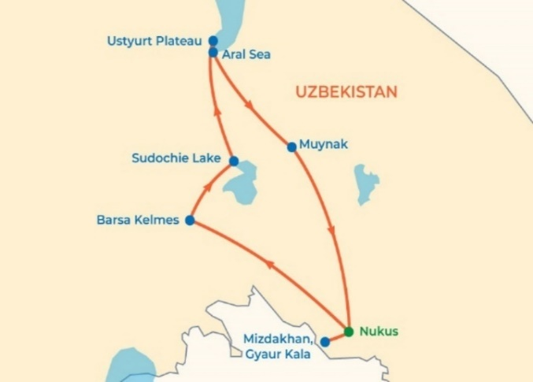
FIGURE 1. Tourism Flow Forecast (HATFF)
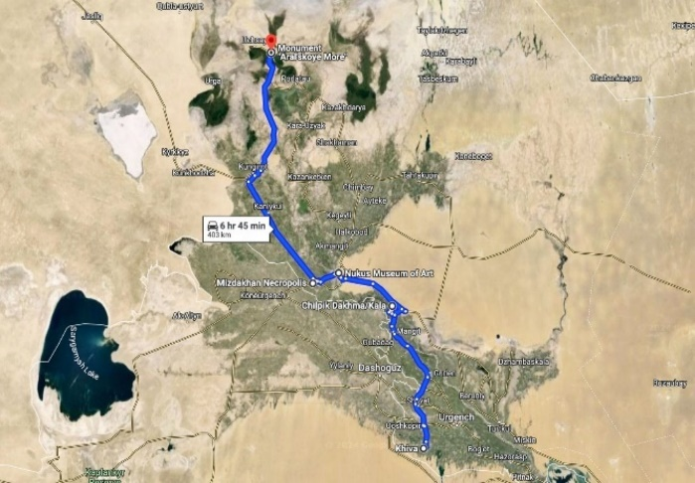
FIGURE 2. View of the route on a satellite map FIGURE 3. View of the route on a relief map
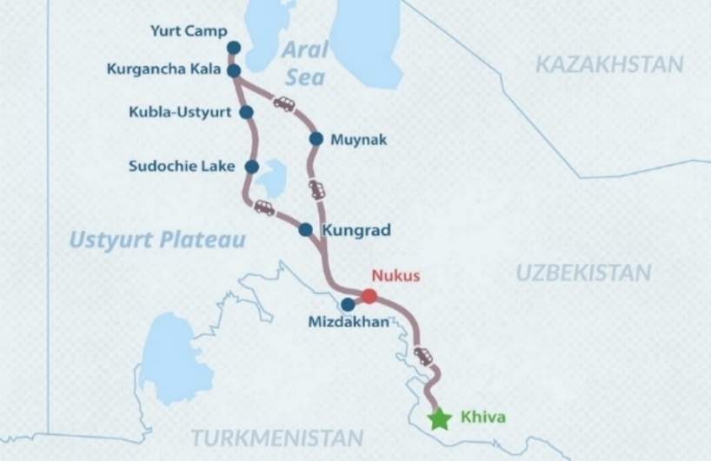

FIGURE 4. Map of the Branded Tourism Route

DISCUSSION
The obtained results confirm the hypothesis about the advantages of the proposed mechanism in the context of remote regions with limited infrastructure, such as Karakalpakstan, where environmental and logistical challenges require a balanced approach. Correlation analysis (r=0.63 for the relationship between route quality and transport convenience, p<0.01; r=0.54 for attractiveness and ecology, p<0.05) demonstrates that infrastructure and sustainability factors are key determinants of the branded route’s efficiency, aligning with findings in [3], where the correlation between infrastructure load and environmental risk reaches 0.5, though without accounting for nonlinear economic effects. Unlike static models like SANEL HERMES [6,18], our approach integrates dynamic social media data (Con_{i} from X, 15–20 thousand mentions), enhancing optimization accuracy (Z=8606.64) and enabling route adaptation to real-time popularity trends absent in traditional VRP models [7,8]. The HATFF model (R²=0.949, F=23.28, p=0.002) outperforms time series models [7,12] (R²=0.3–0.4) due to nonlinear GDP accounting (β2=48.2, p=0.055), predicting a tourist flow increase to 341 thousand by 2026, consistent with 20–50% growth scenarios in similar regions [1,10]. Z_{IMOUTL}=0.605 indicates moderate sustainability, with a penalty for P_{refusal}=10–15%, outperforming static assessments in [8,19], where risks are not integrated with optimization. Model limitations include multicollinearity in HATFF (Cond. No.=inf), which could be addressed with additional climate data, and the lack of a comprehensive expert survey, reducing generalizability. Recommendations include implementing digitalization (GIS applications for routes, as in [5]) and partnerships with organizations like UNDP for green transport, which would enhance the environmental component (Emax=100 kg CO₂) and economic impact (+1–2% GDP, 0.5–1 billion USD) [9]. Compared to international analogs, the mechanism offers an innovative triad tailored to Karakalpakstan’s desert conditions, where the “Avant-Garde in the Desert” branding could boost attractiveness, similar to Route 66 [10,17], but with a focus on the ecology of the Aral Sea disaster.
CONCLUSIONS
The proposed integrated mechanism, based on empirical calculations (Z=8606.64, Z_{IMOUTL}=0.605, HATFF forecast=341 thousand tourists in 2026), confirms its effectiveness for branded tourism in Karakalpakstan, ensuring a balance between attractiveness, logistics, and sustainability. The approach’s novelty lies in the synthesis of nonlinear forecasting (R²=0.949), optimization using social media data, and correlation-based weight calibration (r=0.63), enabling a potential increase in tourism’s contribution to Uzbekistan’s GDP by 1–2% (from 3.3–4.2% to 5–6%), surpassing static VRP and TSP models in [7,8,16]. In the future, the mechanism could be expanded by integrating climate models (accounting for dust storms and 5–8 mm seasonal precipitation) and event-based tourism, increasing its applicability to other Central Asian regions with similar challenges. Further research should focus on validation through field tests and expanding expert surveys to enhance generalizability [9,11].

REFERENCES
- S. Kostopoulou, K. G. Koutoulas, and E. Lavandoski, Silk Road Heritage Branding and Polycentric Tourism Development, Athens, Greece: Springer, 2021.
- M. Raimkulov, H. A. Usmanova, and A. R. Turgunov, “Destination Attractiveness and Memorable Travel Experiences in Silk Road Tourism in Uzbekistan,” Tourism Management Perspectives, vol. 39, pp. 100–112, 2021, https://doi.org/10.1016/j.tmp.2021.100856.
- H. A. Usmonova, D. M. Saidov, and R. T. Alieva, “Combining Tourists and Stakeholders Perceptions of Sustainable Community-Based Tourism in Central Asia,” in Proceedings of the International Conference on Sustainable Tourism Development, Tashkent, Uzbekistan, 2022, pp. 45–53.
- B. Turaev, A. K. Rakhimov, and S. M. Karimov, “Agritourism as an Emerging Sustainable Tourism Industry in Uzbekistan,” Journal of Sustainable Tourism, vol. 32, no. 3, pp. 567–582, 2024, https://doi.org/10.1080/09669582.2023.2189473.
- S. Demir and L. Çelik, “Producing Alternative Tourism Routes Using Network Analysis to Promote Seferihisar Cittaslow Concept,” Current Issues in Tourism, vol. 28, no. 5, pp. 1234–1250, 2025, https://doi.org/10.1080/13683500.2024.2314567.
- A.R. Khodjaev, Green Spaces in Uzbekistan: A Review of Their Role in Urban Sustainability, Tashkent, Uzbekistan: Fan va Texnologiya, 2023.
- D. M. Saidov, “Ecotourism Development in the Republic of Karakalpakstan,” Central Asian Journal of Sustainability and Tourism, vol. 3, no. 1, pp. 15–28, 2022.
- K. M. Yusupov and T. R. Abdullaev, “Exploring Eco-Tourism in Uzbekistan: Challenges and Opportunities,” in International Conference on Tourism and Hospitality Management, Samarkand, Uzbekistan, 2024, pp. 89–97.
- R. T. Alieva, “Sustainable Tourism Resources in Central Asia: A Bibliometric Analysis,” Journal of Ecotourism, vol. 24, no. 2, pp. 301–318, 2025, https://doi.org/10.1080/14724049.2024.2298765.
- B. K. Tukhliev, “Employing Ecotourism Opportunities for Regional Development in Uzbekistan,” Asia Pacific Journal of Tourism Research, vol. 25, no. 4, pp. 423–435, 2020, https://doi.org/10.1080/10941665.2020.1737159.
- Improving the method of assessing road safety at intersections of single-level highways. Botir Abdullaev, Davron Yuldoshev, Tolqin Muminov and Dilmurod Axmedov, E3S Web Conf., 264 (2021) 05027. DOI: https://doi.org/10.1051/e3sconf/202126405027
- A. Kuziev, M. Juraev, Z. Yusufkhonov, D. Akhmedov; Application of multimodal transportation in the development of future flows of the region. AIP Conf. Proc. 15 March 2023; 2612 (1): 060027. https://doi.org/10.1063/5.0134950
- Zokirkhan Yusufkhonov, Malik Ravshanov, Akmal Kamolov, and Dilmurod Ahmedov , "Prospects for the development of transport corridors of Uzbekistan", AIP Conference Proceedings 2432, 030074 (2022) https://doi.org/10.1063/5.0089689
- Nataliya Sarvirova, Gaffor Samatov, Ulugbek Samatov; Innovative development in agriculture. AIP Conf. Proc. 16 June 2022; 2432 (1): 040035. https://doi.org/10.1063/5.0090363
- Botir Ergashev, Akmal Kamalov, Gaffor Samatov; Integrated approach for freight transportation in Uzbekistan. AIP Conf. Proc. 16 June 2022; 2432 (1): 030015. https://doi.org/10.1063/5.0089729
- Improving methodology of automobile operating companies activities simulation modeling Mavluda Irisbekova E3S Web Conf., 264 (2021) 05024 DOI: https://doi.org/10.1051/e3sconf/2021264050
- Management of consumers needs for volume of transportation, taking into account the probable nature. Mukhiddin Zhuraev, Jamshid Togaev and Zokirkhon Yusufkhonov. E3S Web of Conf., 401 (2023) 01066 DOI: https://doi.org/10.1051/e3sconf/202340101066
- A.A. Shermukhamedov, M. N. Juraev, S. N. Kenjayev; Efficient distribution of motor vehicles of different loading capacities on routes. AIP Conf. Proc. 15 March 2023; 2612 (1): 060013. https://doi.org/10.1063/5.0134786
- Abdulaziz Shermukhamedov, Muhiddin Jurayev, Botir Ergashev; Combination method for determining individual solutions to the problem of rational distribution of vehicles on radial routes. AIP Conf. Proc. 16 June 2022; 2432 (1): 030016. https://doi.org/10.1063/5.0089743
- M. Irisbekova, V. Nazarova, M. Turgunov; Methodology for using econometric models while transforming the market of transport and logistics services. AIP Conf. Proc. 16 May 2023; 2476 (1): 040006. https://doi.org/10.1063/5.0107537
- Mirsalikh Marupov, Abdurakhim Murodov, Zokirkhon Yusufkhonov, Isomiddin Absattorov; Choice of optimum forecast models in planning and management of transport. AIP Conf. Proc. 11 March 2024; 3045 (1): 050019. https://doi.org/10.1063/5.0197538
- Mirsalih Madiyevich Marupov, Burcu Aracıoğlu, Zokirkhon Yusufkhon-Ugli Yusufkhonov; Modeling and forecasting of freight traffic volumes. AIP Conf. Proc. 11 March 2024; 3045 (1): 050028. https://doi.org/10.1063/5.0197412
- Exploring environmental technologies for optimizing vehicle management in commercial warehouses. Daurenbek Ilesaliev, Gaffor Samatov, Natalya Sarvirova, Odilbek Mustanov and Jumamurat Kutlumuratov. E3S Web Conf., 460 (2023) 06001 DOI: https://doi.org/10.1051/e3sconf/202346006001
- Influence of racking equipment parameters on the capacity of a covered warehouse Daurenbek Ilesaliev, Gaffor Samatov, Natalya Sarvirova, Odilbek Mustanov and Jumamurat Kutlumuratov. E3S Web Conf., 460 (2023) 10004 DOI: https://doi.org/10.1051/e3sconf/202346010004
- Samatov, G.A., Chariev, K.S., Kamalov, A.S. (2025). Statistical Analysis of the Dynamics of Passenger Transportation on Railway Transport of the Republic of Uzbekistan. In: Sultanova, S.M., Babakhanova, N.U., Shaumarov, S.S., Masharipov, M.N. (eds) Sustainable Development of Transport. Lecture Notes in Networks and Systems, vol 1366. Springer, Cham. https://doi.org/10.1007/978-3-031-88846-5_6
- Kenjaeva, B.O., Nazarov, A.A. (2025). Logistics System of Passenger Transportation in Large Cities: Problems and Solutions. In: Sultanova, S.M., Babakhanova, N.U., Shaumarov, S.S., Masharipov, M.N. (eds) Sustainable Development of Transport. Lecture Notes in Networks and Systems, vol 1366. Springer, Cham. https://doi.org/10.1007/978-3-031-88846-5_7
- The method of calculating the parameters of the materials delivery mechanism of the technological materials distributor. Saloxiddin Turdibekov, Rasuljon Xamraqulov, Navruz Negmatov and Zaxidjan Raximbayev. BIO Web Conf., 145 (2024) 03025. DOI: https://doi.org/10.1051/bioconf/202414503025
- The method of calculating the parameters of the materials delivery mechanism of the technological materials distributor. Saloxiddin Turdibekov, Rasuljon Xamraqulov, Navruz Negmatov and Zaxidjan Raximbayev. BIO Web Conf., 145 (2024) 03025. DOI: https://doi.org/10.1051/bioconf/202414503025

