Improving the efficiency of the power supply system of electric car charging stations
Ikromjon Rakhmonov ¹, Navruz Uzakov ^{1,4 a)}, Polatbek Kuatbaev ², Akram Tovbaev³
¹Tashkent state technical university named after Islam Karimov, Tashkent, Uzbekistan
² Karakalpak State University named after Berdakh, Nukus, Uzbekistan
³ Navoi State University of Mining and Technologies, Navoiy, Uzbekistan
⁴Termiz State University of Engineering and Agrotechnologies, Termiz, Uzbekistan
^{a)} Corresponding author: uzaqovnavruz81@gmail.com
Abstract. In this article, based on the conditions of Uzbekistan, several reasons and conveniences for switching from internal combustion engines to electric cars are given, and explanations are given through several examples of providing electric car chargers from renewable energy sources. Through the given examples, the use of alternative energy sources and their almost non-existent emissions into the environment are explained based on calculations, and when using internal combustion engine cars, various harmful gases emitted from them per km are cited.
INTRODUCTION
In recent years, it can be seen that the demand for electric cars is increasing significantly due to several conveniences (Fig. 1). As an example of the reasons, first of all, we can say that they do not emit carbon dioxide gas, which is harmful to nature and the human body, and their noise is much lower compared to cars with internal combustion engines. Secondly, we can cite as an example that the number of charging devices is increasing on a large scale throughout our country [1].

FIGURE 1. A chart of the growth of the number of electric cars in the last 7 years

If we describe the situation in the diagram, we can see a significant increase in electric vehicles in recent years, considering their several advantages over internal combustion engine vehicles. You can see that the main increase is from 2180 in 2022, and in 2024, the number of electric cars entering our country has reached 51,130 considering the current 10 months. [2].
In the picture below, you can see how the number of charging stations in our country changes over the years. Considering the low demand for electric cars in 2018 and 2019, you will see that there was no charging station in our country.

FIGURE 2. Chart of the growth of the number of charging stations over 7 years

From 2020, charging stations began to enter our country, and by now it can be seen that their total number has reached 703 in 10 months of 2024. Currently, scientists of the National Research Institute of Renewable Energy Sources under the Ministry of Energy are conducting scientific research on providing them with alternative energy sources. [3].

The most efficient of current charging stations is direct charging, which can charge electric vehicles up to 80% in 20-30 minutes. They are considered ultra-fast chargers and use a higher DC voltage than DC chargers, delivering up to 350 kW of power. However, the harmful aspects of charging the battery many times in such a short time have been identified, and these devices are currently in the process of testing [4].

EXPERIMENTAL RESEARCH
In recent years, we can see that the demand for electric cars is increasing in the world, including in Uzbekistan. In turn, the increase in demand for electric cars means that the demand for their charging stations and electricity will increase at the same time. Currently, the number of electric vehicles in our country exceeds 90 thousand and the total number of charging stations exceeds 500. Existing electric cars consume 67 thousand kW per day, 2 million kW per month, and 24 million kW per year. This indicator has a significant impact on the energy system and requires the expansion of measures aimed at the production of electricity from alternative energy sources [5].
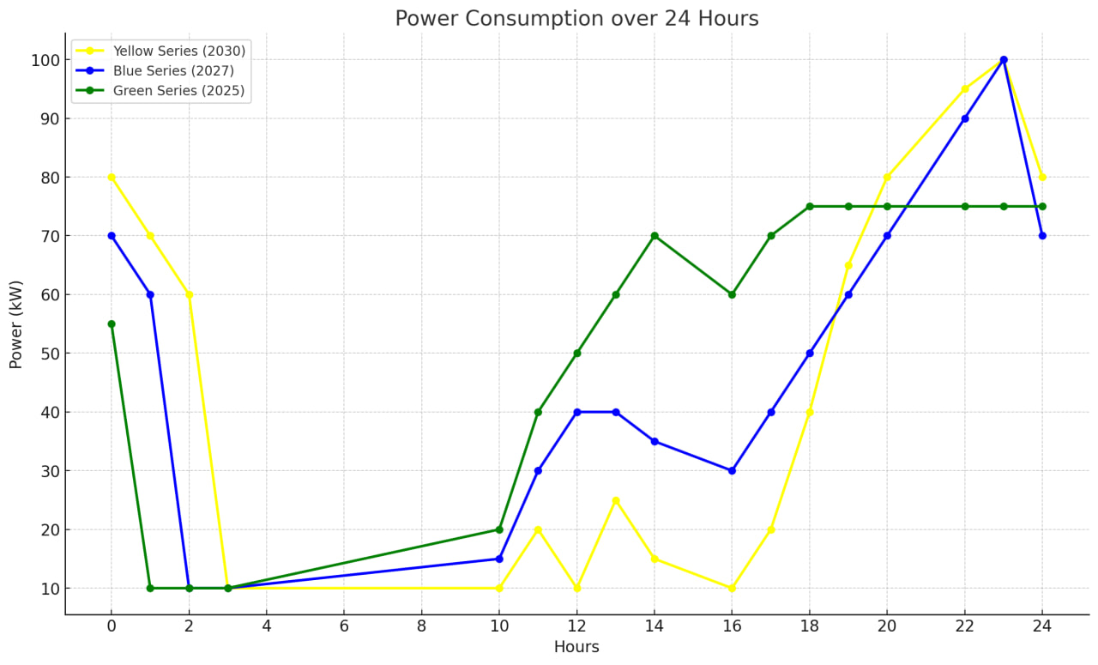
FIGURE 3. Change in loading schedule between 2025 and 2027
According to the forecasts of the Ministry of Transport, the number of electric cars in Uzbekistan will reach 350,000 by 2030, and the total number of charging stations will reach 100,000. It is said that approximately 24 million kilowatts of power per year will be needed to charge electric vehicles in these numbers, and this power will not be without its negative impact on the energy system. Relying on alternative energy sources in solving this problem has several positive results [6].
At the same time, it is purposeful to review the operating modes of electric vehicle charging stations. The conducted researches show that today's mode of operation of charging stations is variable in nature, and considering the small number of electric cars, we can see that charging occurs mostly in the evening and at night. Figure 3 shows a typical daily electricity load graph of a charging station, and the analysis of the electricity load graph shows that the peak consumption time of charging is between 2000 and 700 [7].
RESEARCH RESULTS
If we can increase the amount of electricity produced by alternative energy sources, we will save the fuel needed for electricity production and reduce carbon dioxide emissions. Taking into account the above values, relying on alternative energy sources in solving energy problems would have had a significant positive effect [8].
You can see the increase in demand for electric cars between 2024 and 2027 in the picture below.

FIGURE 4. Diagram of the growth of electricity production in the period 2024-2030

In 2024, about 80 billion kWh of electricity will be produced, of which 0.05 % will be spent on charging electric cars. Considering that the annual energy production will reach 120 billion kWh by 2030 and the increasing demand for electric cars, approximately 8 % of the electricity produced for charging them will be used for charging (Fig. 3). These values ​​have an impact on the energy system [9].
Electric cars are said to be clean for the environment, but attention is not paid to the carbon dioxide gas that is released from the fuels that are burned to drive them. It is an urgent issue to consider the issue of providing their supply source with a green energy source [10].
The analysis of the literature shows that charging electric vehicles based on the use of renewable energy sources in the power supply system of electric vehicle charging stations has been cited as meeting the criteria of full green energy, and today there are a number of works on this abroad researches are being carried out [11]. From this point of view, it is appropriate to use renewable energy sources to improve the energy efficiency of these charging stations. Below you can see the change in the charging schedule of the charging station located in the city of Tashkent (Figure 5).
FIGURE 5. Loading graph of charging stations

In the middle period, the consumption is relatively moderate, that is, more stable, and in the other parts, it corresponds to high consumption. At this point, increasing the efficiency of charging stations and using renewable energy sources in their power supply system is one of the important issues [12].
According to the scientific research of our scientists, 1 car with an internal combustion engine running on gasoline emits more than 3 tons of carbon dioxide gas, 93 kg of hydrocarbons, 500 kg of carbon dioxide, and about 30 kg of nitrogen oxide to cover a distance of 15,000 km. This indicator means that about 60% of harmful emissions on the scale of the republic are accounted for by vehicles. These indicators are even higher in cars running on diesel fuel. Currently, developed countries emphasize that the use of electric cars is the only effective way to reduce the damage caused to the environment. Supplying charging stations by renewable energy sources is 100% safe for the environment [13].
Based on the conditions of Uzbekistan, the use of photoelectric power plants is considered appropriate today. If the main effective working hours of photovoltaic plants are taken from 900 to 1600, it can be seen that 30% of the total daily electricity is consumed in these intermediate charging stations. If we analyze in terms of numbers, if one charging station currently charges 3-4 electric cars a day, it consumes approximately 240-320 kWh of electricity. If 0.107 m³ of natural gas and 0.45 kg of carbon dioxide are released for the production of 1 kW*h of electricity, on average, one charging station releases 32.1 m³ of natural gas and 135 kg of carbonization gas from burning gas per day. If the charging stations were equipped with 300 kW solar panels, they would charge 3-4 electric cars during the day and provide electricity to the grid. If each charging station was equipped with panels, 37.5 m³ of natural gas and 40.5 tons of carbon dioxide emissions would be reduced per day. If these values ​​are expressed annually, the emission of 8,236,970 m³ of natural gas and 34,640 tons of carbon dioxide gas will be saved throughout Uzbekistan. [14].
CONCLUSIONS
In conclusion, charging stations are necessary for the movement and charging of every electric vehicle. Currently, scientific research is being conducted by our scientists in order to solve this problem in our country. At the same time, measures are being taken to provide them with renewable energy sources. According to the calculations, the charging stations are provided with solar panels, and the electricity generated from them is directed to various stores, enterprises, apartments or similar buildings. If these things are carried out, that is, if we switch from traditional energy production to non-traditional energy sources, the ecology would be much cleaner in the next 3-5 years.
REFERENCES
- Plug in electric vehicle hand book for public charging stations hosts. [Online]. Available: http://www.energy.gov/
- Skundin, A.; Kulova, T.; Rudy, A.; Mironenko, A. All Solid State Thin-Film Lithium-Ion Batteries: Materials, Technology, and Diagnostics, 1st ed.; CRC Press: Boca Raton, FL, USA; Taylor & Francis Group: Boca Raton, FL, USA, 2021; 214p, ISBN 9780367086824.
- Wu, G.; Lu, R.; Zhu, C.; Chan, C.C. An Improved Ampere-Hour Method for Battery State of Charge Estimation Based on Temperature, Coulomb Efficiency Model and Capacity Loss Model. In Proceedings of the IEEE Vehicle Power and Propulsion Conference (VPPC), Lille, France, 1–3 September 2010; pp. 1–4.
- Arifjanov, A.Sh. and Ayupov, A.Sh., Forecasting and rationalization of energy consumption for megacities taking into account the factors caused by scientific and technical progress, with application of informationalanalytical technologies, Proc. Global Forum for Energy, Environment and Commercial Civilization (GFEECC), Chengdu: Sichuan Univ., Oct. 22–26, 2015.
- Arifjanov, A.Sh. and Zakhidov, R.A., An approach to the creation of the adaptive control system for integration of nonsteady power sources into a common electric power grid, Proc. 10th Int. Conf. on Management Science and Engineering (ICMSEM), Baku, Aug. 31–Sep. 2, 2016, pp. 563–574.
- Eshquvvatovich, I. S., & Abdukarimovich, U. B. (2022). INFLUENCE OF CAR ERGONOMICS ON TRAFFIC SAFETY. Journal of Academic Research and Trends in Educational Sciences, 1(5), 22-29.
- Mansurovna, M. L., & Eshquvvatovich, I. S. (2021). Study of the influence of operating factors of a vehicle on accident by the method of expert evaluation. Journal of Academic Research and Trends in Educational Sciences, 1(1), 10-17.
- Falvo, M. C., Manganelli, M., Moscatiello, C., & Vellucci, F. (2022, June). Electrical vehicles and charging stations: State of art and future perspectives. In 2022 IEEE International Conference on Environment and Electrical Engineering and 2022 IEEE Industrial and Commercial Power Systems Europe (EEEIC/I&CPS Europe) (pp. 1-7). IEEE.
- Muthukumar, M., Rengarajan, N., Velliyangiri, B., Omprakas, M. A., Rohit, C. B., & Raja, U. K. (2021). The development of fuel cell electric vehicles–A review. Materials Today: Proceedings, 45, 1181- 1187
- Galina Anatolievna Fedyaeva, D. Eng., Assistant Prof. of the Dep. “Electronic, Radio-Electronic and Electro-Technical Systems”, Bryansk State Technical University, e-mail: galina-fed@yandex.ru
- Wu, G.; Lu, R.; Zhu, C.; Chan, C.C. An Improved Ampere-Hour Method for Battery State of Charge Estimation Based on Temperature, Coulomb Efficiency Model and Capacity Loss Model. In Proceedings of the IEEE Vehicle Power and Propulsion Conference (VPPC), Lille, France, 1–3 September 2010; pp. 1–4.
- I.U.Rakhmonov, N.Ch.Uzakov. Improving the performance of charging devices // Collection of scientific works on the topic "ACTUAL PROBLEMS OF POWER SUPPLY SYSTEMS" of the IV International Scientific and Technical Conference. - Karakalpakstan, October 3-4, 2024. pp 300-302.
- https://t.me/minenergy_uz
- N.Ch.Uzakov. Prospects for the development of electric vehicles in Uzbekistan // Materials of the republican scientific and technical conference dedicated to the 75th anniversary of “Almalyk KMK” JSC on the topic “Prospects for the extraction and processing of mineral raw materials from the perspective of young people”. - Almalyk, May 15, 2024. pp. 234-236.
- I.U.Rakhmonov, N.Ch.Uzakov. Analysis of existing methods for increasing the efficiency of electric vehicles // Republican scientific and practical conference on the topic "PROBLEMS AND PROSPECTS OF Innovative development of energy industry". – Navoi: October 21-22, 2024. pp 239-241.

