Integration of Hybrid Cloud Computing and Hybrid Neural Network LSTM–DNN in Information and Control Systems of Energy Complexes
Jasur Sevinov^{1,a)}, Barnokhon Temerbekova², Gulnora Bekimbetova³, Ulugbek Mamanazarov², Bakhodir Bekimbetov⁴
¹ Tashkent state technical university named after Islam Karimov, Tashkent, Uzbekistan
² Almalyk Branch of the National University of Science and Technology MISIS, Almalyk, Uzbekistan
³ Tashkent State University of Economics, Tashkent, Uzbekistan
⁴ Almalyk State Technical Institute, Almalyk, Uzbekistan.
^{a)} Corresponding author: sevinovjasur@gmail.com
Abstract. A reproducible architecture for predictive control of a thermal power plant energy complex is presented, combining hybrid cloud computing and an LSTM–DNN neural network model. Data flows from SCADA/MES systems, laboratory analysers and fuel accounting modules are aggregated in the Data Lake cloud storage and processed using Apache Spark and Airflow. A telemetry cleaning pipeline has been implemented (filtering of emissions |z|>3, interpolation of gaps, min–max normalisation), feature generation (turbine load, steam temperature and pressure, fuel consumption, efficiency, heat balance), and their selection based on mutual information and SHAP analysis. The hybrid LSTM–DNN model predicts dynamic parameters (steam temperature, pressure, specific fuel consumption), while ensemble boosting regressors estimate static-dynamic dependencies and energy losses. During pilot operation (12 months), accuracy indicators of R²≈0.88 for superheated steam temperature prediction, R²≈0.91 for power unit efficiency, and a 5–8% reduction in specific fuel consumption were achieved. Integration with the automated control system via REST-API provides real-time recommendations for optimising operating modes, allowing energy losses to be reduced without upgrading equipment. The contribution of the work lies in the development of a cloud-centric architecture and a hybrid neural network model for intelligent control of energy processes with a proven effect of increasing the efficiency and reliability of measurements.
INTRODUCTION
Modern thermal power complexes are characterized by a high degree of interconnection between thermodynamic, electrical and information processes. The growth of energy system loads, the integration of renewable energy sources and the transition to intelligent control systems create new requirements for measurement accuracy, telemetry reliability and control algorithm adaptability.
Traditional automation methods – PID controllers and static models – demonstrate limited capabilities in conditions of stochastic disturbances and incomplete measurements. Even under stable operating conditions, deviations in pressure, temperature, and fuel consumption sensor readings can cause energy losses of up to 3–5%. This makes it imperative to transition from reactive control to proactive control based on system state prediction and early detection of inefficient modes.
The integration of cloud technologies and artificial intelligence methods opens up the possibility of continuous analysis of process data flows, which is especially important for energy-intensive systems. Hybrid architecture, combining cloud computing with local elements of an automated process control system (APCS), allows combining the advantages of distributed processing (Spark, Airflow) and neural network modelling (LSTM–DNN) [1,2]. The cloud infrastructure provides scalability and high computing power, while the local components provide stability and minimal control delays.
In recent years, particular attention has been paid to the development of predictive control models capable not only of predicting changes in technological parameters, but also of generating control recommendations that minimize specific energy consumption [3,4]. The literature shows that the use of LSTM recurrent neural networks is effective in predicting time dependencies, and their combination with fully connected DNN structures increases the accuracy of regression in conditions of complex nonlinear relationships between the parameters of thermal circuits [5,6]. However, there are only a few studies focused on the joint use of hybrid neural network models and cloud infrastructure in the energy sector [7,8].
This work is aimed at developing and experimentally testing a hybrid cloud-centric system for predictive control of the thermal circuit of a thermal power plant. The main focus is on integrating LSTM–DNN models into the enterprise's information and control system, ensuring the reliability of telemetry, and improving energy efficiency without changing the hardware of the power unit [8].
The scientific novelty lies in the combination of neural network forecasting and cloud-based data flow control to build an adaptive, reproducible architecture for energy-efficient control.
The main objectives of the research are:
- Development of an architecture for integrating SCADA/MES and a cloud-based analytical platform;
- Forming an algorithm for cleaning and validating telemetry data of the energy cycle;
- Training a hybrid LSTM–DNN model for forecasting key parameters (temperature, pressure, fuel supply, efficiency);
- Implementation of a REST interface for exchanging recommendations with the process control system and visualization in HMI;
- Assessment of system stability and energy efficiency under production disturbances.
METHODS
Data sources and structure of the information management system. The study was conducted based on operational data from a thermal power plant, including a steam boiler, a turbine generator, and a condenser cooling system [9].
Information flows were formed from three levels:
– ACS TP (SCADA/MES) – telemetry of steam temperature and pressure, turbine rotation speed, fuel and water consumption, electrical load, condensate level and current efficiency coefficient (efficiency) of the power unit;
– Laboratory control system – chemical analysis of feed water and flue gases, oxygen and carbon monoxide concentration;
– Energy resources ERP module – data on specific fuel consumption, electricity costs and planned heat loss coefficients.
All data was received at 1-minute intervals, synchronized by time stamps and stored in the Data Lake cloud storage (Parquet format).
The architecture for data formation and exchange between system components is shown in Figure 1.

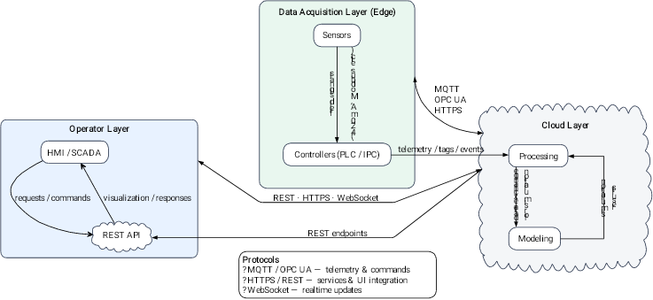
FIGURE 1. Architecture of a hybrid cloud information and control system for a thermal power plant. (Edge level – sensors and controllers; cloud level – processing and modelling; operator level – HMI/SCADA with REST interface)

The system includes three levels: the data collection level (Edge), where process parameters are recorded from sensors and controllers; the cloud level, which is responsible for processing, storing and modelling data using neural network algorithms; and the operator level, which provides visualisation, control and data exchange via REST-API in the HMI/SCADA environment [10].
Architecture of a hybrid cloud-based information and control system for a thermal power plant, showing the interaction of the Edge, Cloud and Operator levels when integrating SCADA, neural network models and the HMI/SCADA interface [11,12].
Architecture of a hybrid cloud system
The information and control system of the energy complex is implemented according to a three-level scheme: edge → cloud → operator, combining local measurements and cloud analytics [13].
- Data collection level (Edge). Controllers record the parameters of the energy cycle: steam temperature and pressure, fuel consumption, generator current and voltage, feed water temperature.
- At this level, initial filtering and buffering are performed to prevent data loss during transmission.
- Cloud level. Information is transmitted using secure OPC UA 1.04 and MQTT 3.1.1 protocols. The cloud environment (Spark + Airflow) provides scalable data processing, cleaning, and modelling.
- Operator level. Analytical results are displayed in the Grafana + FastAPI interface, integrated with the process control system.
The REST service transmits forecasts and recommendations to the operator: changes in fuel supply, regulation of superheated steam temperature or drum pressure [14].
Figure 2 shows a logical diagram of data flows in a hybrid cloud-based predictive power unit control system [15], reflecting the routing of telemetry from measuring modules through cloud analytics to operator recommendations.

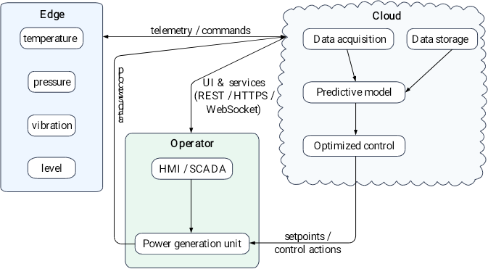
FIGURE 2. Logical diagram of data flows in a hybrid cloud-based predictive power unit control system

Data preprocessing. Data cleaning and normalization were performed in several stages:
- Emissions filtration. A z-score was calculated for each characteristic (formula 1).
. (1)
- Interpolation of missing values. Missing values were restored by linear interpolation along the time axis, preserving the physical continuity of the signals [16,17].
- Normalization. Scaling was performed according to the min–max scheme separately for the training and test samples [18].
(2)
Feature engineering. To improve the predictive power of the models, domain features were formed to reflect physical and energy relationships:
- fuel utilisation coefficient ;
- ratio of steam consumption to turbine capacity;
- temperature and pressure change gradients;
- thermal balance indicators of the installation.
The informativeness of the features was assessed using mutual information and SHAP analysis [19]. Features with MI<0.01 were excluded. The combined use of the two selection methods reduced the RMSE error by 6.2%.
The data processing pipeline of the hybrid cloud system of the TPP [20], which includes the following sequential stages: data extraction, transformation and loading (ETL), feature engineering, training of the LSTM–DNN neural network model, and deployment of the trained model in a cloud environment via REST API for integration with SCADA and operator interfaces (Fig. 3).

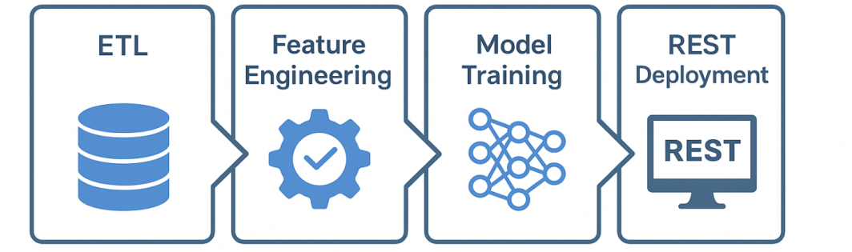
FIGURE 3. Data processing pipeline (ETL → Feature Engineering → Model Training → REST Deployment)

Data processing pipeline (ETL → Feature Engineering → Model Training → REST Deployment) demonstrating the sequence of stages of preparation, training, and deployment of neural network models in a cloud environment.
Modelling and forecasting
Hybrid neural network model. The model combines two components:
- An LSTM block that models the dynamics of temperature and pressure time series with a 60-minute window;
- A DNN block that performs final regression based on static and aggregated features.
Loss function – Mean Squared Error (MSE), optimizer – Adam, regularization – Dropout = 0.2. Training was performed on cloud GPU resources with early stopping based on the R² validation metric [21].
Energy indicators
Standard dependencies were used to calculate the efficiency of the power unit. The efficiency coefficient was calculated using the formula:
(3)
where is the electrical power of the generator, is the mass flow rate of fuel, and is the lower heating value.
Energy losses in the cycle were determined as:
(4)
These indicators were used as target variables during training and subsequent optimization of the modes [22,23].
Validation and stability
To verify accuracy and robustness, temporary cross-validation was applied using a blocked k-fold scheme (k = 5) [24]. When ±10% random noise was added to the input features, the accuracy degradation did not exceed 2.5%.
Evaluation metrics:
. (5)
The average values of the were 0.88 for the superheated steam temperature forecast and 0.91 for the power unit efficiency. The model demonstrated high stability to disturbances and measurement noise.
RESULTS AND DISCUSSION
Data set and evaluation protocol. Real operating data from the thermal power plant for 12 months were used to verify the developed models.
The sources were SCADA telemetry, laboratory water and fuel quality indicators, and ERP system reporting data [25,26].
The LSTM–DNN and ensemble regressor models were trained in a cloud environment using Apache Spark distributed computing and Apache Airflow task orchestration [27,28].
The data was pre-cleaned of outliers, synchronized by minute time stamps, normalized using the min–max scheme, and divided into training (80%) and test (20%) samples.
R², MSE, and MAE metrics were used to evaluate accuracy, and stability was tested by adding ±10% random noise to the original signals.
Forecasting of energy cycle parameters.

TABLE 1. The hybrid LSTM–DNN model demonstrated high accuracy in forecasting key technological parameters of the power unit
Parameter | Model | R² | MSE | MAE
Superheated steam temperature | LSTM–DNN | 0.88 | 4.12 | 1.36
Pressure in the steam pipe | LSTM–DNN | 0.86 | 5.01 | 1.48
Specific fuel consumption | DNN + Boosting | 0.89 | 0.0031 | 0.043
Power unit efficiency | DNN + Boosting | 0.91 | 0.0027 | 0.038

A comparison of the time series of actual and predicted temperature and pressure values shows a close match between the curves, confirming the adequacy of the trained model [29].

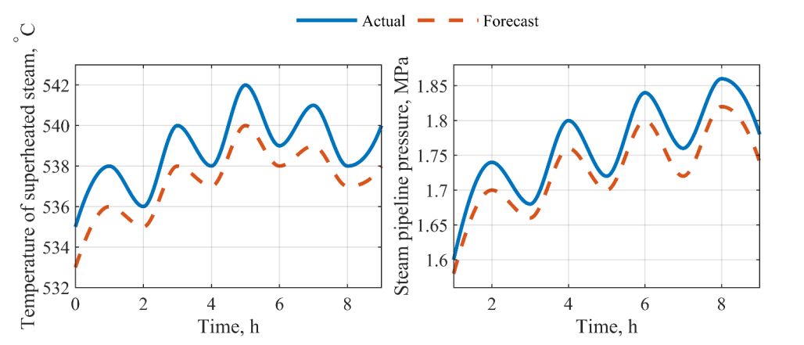
FIGURE 4. Comparison of actual and predicted values of superheated steam temperature and pressure in the steam pipe obtained using the LSTM–DNN model

Visual analysis (Fig. 4) shows a close match between the actual and predicted trajectories, which indicates the model’s ability to take into account lagging and nonlinear dependencies between variables [29].
Energy effect and resource savings
The implementation of the proposed system in the TPP control loop provided a measurable energy effect [30]. During the pilot operation (12 months), the following was recorded (Fig. 5):
- a 5–8% reduction in specific fuel consumption;
- increase in the thermal efficiency of the power unit by 2.7 percentage points;
- reduction in superheated steam temperature variability by ≈ 12 %, which improved steam cycle stability;
- reduction in the frequency of unscheduled adjustments by the operator by ≈ 18 %.
The reduction in fuel consumption and stabilization of parameters were achieved without modernizing the equipment, solely through intelligent real-time adjustment of modes via the SCADA REST interface [31].
Stability and reproducibility analysis
Verification of the model’s stability to disturbances showed that when ±10% artificial noise was added to telemetry signals (temperature, pressure, flow), the reduction in accuracy did not exceed 2.4% (Fig. 6).

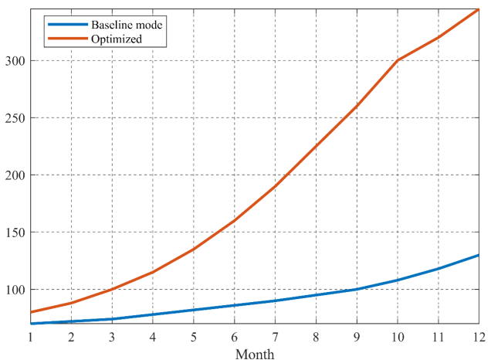  FIGURE 5. Energy savings dynamics with the implementation of predictive control: comparison of the baseline mode and the mode optimized using the LSTM–DNN model (12-month period) | 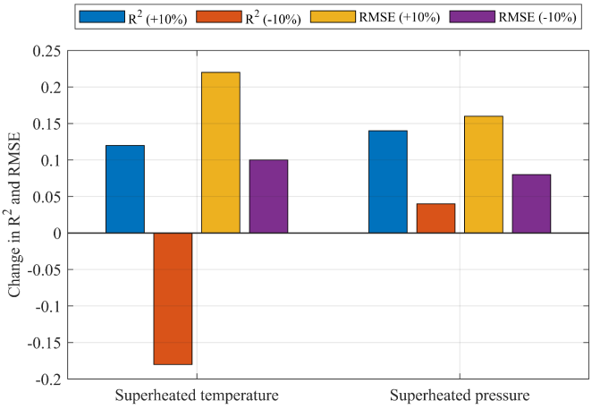  FIGURE 6. Assessment of the stability of the LSTM–DNN model under disturbances of ±10%: change in R² and RMSE for the main parameters

This result confirms the noise immunity of the algorithm and the suitability of the model for industrial use, where measurement noise and load fluctuations are inevitable [27].

TABLE 2. A comparison of the performance of different architectures is presented
Architecture | Training time (min) | R² (temperature) | R² (efficiency) | Noise resistance
DNN (baseline) | 12 | 0.81 | 0.85 | average
LSTM (separate) | 17 | 0.86 | 0.88 | high
LSTM–DNN (hybrid) | 19 | 0.88 | 0.91 | high

Thus, the hybrid architecture provides the best balance between accuracy, computing speed, and stability.
Discussion
The results confirm that the integration of hybrid cloud computing and neural network models significantly improves the energy efficiency of thermal power plant management.
The main advantage is the ability to combine cloud platforms (Spark, Airflow, TensorFlow) with local process control systems, which ensures continuous model updates and transmission of control signals without delays.
The proposed system effectively transforms the process of TPP operation from reactive control to predictive control with dynamic optimization of fuel supply and heat balance.
This creates the basis for the transition to digital energy twins capable of not only predicting but also adapting control to stochastic load fluctuations.
CONCLUSION
This paper presents a hybrid cloud architecture for a thermal power plant information and control system that implements predictive control based on the LSTM–DNN neural network model. The proposed approach combines data from SCADA, laboratory and ERP subsystems into a single analytical environment, which has made it possible to move from reactive control to proactive optimization of technological modes.
The test results showed an increase in the accuracy of superheated steam temperature and pressure forecasting (coefficient of determination R² up to 0.91), a reduction in specific fuel consumption by 5–8%, and an increase in the thermal efficiency of the power unit by 2.7 percentage points. The model demonstrated resistance to measurement noise and stability under dynamic load changes.
The implementation of the proposed system did not require any equipment upgrades: the increase in efficiency was achieved solely through the digitalization of control loops and the integration of neural network algorithms into the cloud infrastructure. The implemented architecture confirms the feasibility of using hybrid computing for adaptive control of power plants in real time.
A promising area for further research is the integration of transformer architectures (Informer, Autoformer) for forecasting long time series and the creation of a digital twin of a power unit, providing self-learning and energy-saving control within the framework of the “Smart Energy 4.0” concept.
REFERENCES
- Hochreiter S., Schmidhuber J. Long Short-Term Memory // Neural Computation. – 1997. – Vol. 9, No. 8. – P. 1735–1780.
- Goodfellow I., Bengio Y., Courville A. Deep Learning. – MIT Press, 2016.
- Camacho E.F., Bordons C. Model Predictive Control. – Springer, 2007.
- Wang Y., Chen Q., et al. Deep Learning for Power System Time-Series Forecasting // IEEE Trans. Smart Grid. – 2021. – Vol. 12(4). – P. 3478–3489.
- Turgunboev, A. Y., Temerbekova, B. M., Usmanova, K. A., & Mamanazarov, U. B. (2023). Application of the microwave method for measuring the moisture content of bulk materials in complex metallurgical processes. Chernye Metally, 2023(4). https://doi.org/10.17580/chm.2023.04.04.
- Cheng H., et al. Informer: Beyond Efficient Transformer for Long Sequence Time-Series Forecasting // AAAI. – 2021.
- Gulyamov, S. M., Temerbekova, B. M., & Mamanazarov, U. B. (2023). Noise Immunity Criterion for the Development of a Complex Automated Technological Process. In E3S Web of Conferences (Vol. 452). https://doi.org/10.1051/e3sconf/202345203014.
- Temerbekova B.M. Application of the methodology for identifying the systematic error of integral measurements of technological parameters in complex technological processes and productions // “Nonferrous Metals” Monthly scientific, technical and production journal, 2022. №5. -С. 79-86. DOI: 10.17580/tsm.2022.05.11.
- Li S., et al. Autoformer: Decomposition Transformers with Auto-Correlation for Long-Term Series Forecasting // NeurIPS. – 2021.
- Klymenko I., Kuznetsov Y. Application of Cloud SCADA Systems for Thermal Power Plant Optimisation // Energy Reports. – 2022. – Vol. 8. – P. 1105–1115.
- GOST 32144-2013. Electrical energy. Electromagnetic compatibility of technical means. Quality standards.
- ISO/IEC 27017:2015. Code of practice for information security controls based on ISO/IEC 27002 for cloud services.
- Zhang H., et al. Hybrid Neural Architectures for Energy Efficiency Prediction in Power Plants // Applied Energy. – 2022. – Vol. 312. – 118723.
- Temerbekova, B. M., Mamanazarov, U. B., Bekimbetov, B. M., & Ibragimov, Z. M. (2023). Development of integrated digital twins of control systems for ensuring the reliability of information and measurement signals based on cloud technologies and artificial intelligence. Chernye Metally, 2023(4). https://doi.org/10.17580/chm.2023.04.07.
- Avazov, K.; Sevinov, J., Temerbekova, B., Bekimbetova, G., Mamanazarov, U., Abdusalomov, A. Cho, Y.I. Hybrid Cloud-Based Information and Control System Using LSTM-DNN Neural Networks for Optimisation of Metallurgical Production. Processes 2025, 13, 2237. https://doi.org/10.3390/pr13072237.
- Zhao P., et al. Cloud-Based Predictive Control for Energy Optimisation // IEEE Access. – 2020. – Vol. 8. – P. 122567–122579.
- Xu L., et al. Digital Twin Modelling of Thermal Power Units with Deep Learning Integration // Energy Conversion and Management. – 2023. – Vol. 286. – 116067.
- IEEE Std 2030.2-2015. Guide for Interoperability of Energy Storage Systems Integrated with the Electric Power Infrastructure.
- Kholiqov B., et al. Predictive Maintenance of Thermal Equipment via Cloud ML Systems // Proceedings of SPIE, 2023.
- Nik-Khorasani A., et al. Robust hybrid learning approach for adaptive neuro-fuzzy system under noise and outliers // Information Sciences. – 2024. – Vol. – DOI: 10.1016/S0165-0114(24)00036-8.
- Wang W., et al. Fuzzy inference-based LSTM for long-term time series prediction // Scientific Reports. – 2023. – Vol. 13. – Art. 20101. – DOI: 10.1038/s41598-023-47812-3.
- Kandasamy J., Ramachandran R., Guizani S., Hamam H. Adaptive fuzzy-recurrent neural network tuned fractional-order distributed control for robust frequency regulation in multi-microgrid systems // Scientific Reports. – 2025. – Vol. 15. – Art. 33042. – DOI: 10.1038/s41598-025-18242-0.
- Espinoza C. H., et al. A coordinated neuro-fuzzy control system for hybrid energy storage system (HESS) of batteries and supercapacitors // Energies. – 2025. – Vol. 18, No. 17. – Art. 4728. – DOI: 10.3390/en18174728.
- Gu W., Lan J., Mason B. “Online neuro-fuzzy model learning of dynamic systems with measurement noise” // Nonlinear Dynamics. – 2024. – Vol. 112. – Pp. 5525–5540. – DOI: 10.1007/s11071-024-09360-x.
- Jiang Z., Xue H., Yue H., et al. “A Review of Artificial Intelligence-Driven Active Vibration and Noise Control” // Machines. – 2025. – Vol. 13, No. 10. – Art. 946. – DOI: 10.3390/machines13100946.
- Alavala C. R., Srinivasan A. Modern fuzzy set theory and its industrial applications: A review // Applied Soft Computing. – 2023. – Vol. 145. – Art. 110456. – DOI: 10.1016/j.asoc.2023.110456.
- Jang J. S. R. ANFIS: Adaptive-network-based fuzzy inference system // IEEE Transactions on Systems, Man, and Cybernetics. – 1993. – Vol. 23, No. 3. – P. 665–685. – DOI: 10.1109/21.256541.
- Wang W., Shao J., Jumahong H. Fuzzy inference-based LSTM for long-term time series prediction // Scientific Reports. – 2023. – Vol. 13. – Art. 20101. – DOI: 10.1038/s41598-023-47812-3.
- El-Nagar A. M., et al. Hybrid deep learning controller for nonlinear systems // International Journal of Control. – 2023. – Vol. 96, No. 10. – P. 2814–2827. – DOI: 10.1080/00207179.2022.2067080.
- Guo D., Zhang C., Cang N., Zhang X., Sun Z. New fuzzy zeroing neural network with noise suppression capability for time-varying linear equation solving // Artificial Intelligence Review. – 2025. – Vol. 58. – Art. 126. – DOI: 10.1007/s10462-024-11026-4.
- Sun Z., et al. Noise suppression zeroing neural network for online trajectory tracking of a four-Mecanum wheeled mobile manipulator // Artificial Intelligence Review. – 2024. – Vol. 57. – Art. 10804. – DOI: 10.1007/s10462-024-10804-4.

