Constructive optimization in the poultry farm for increasing efficiency of evaporative air-cooling conditioning system
Anvar Anarbaev ^{1, a}, Dildora Badalova ¹, Abdumalik Badalov¹, Islomjon Bokhodirov²
¹Tashkent state technical university named after Islam Karimov, Tashkent, Uzbekistan
² Fergana State Technical University, Fergana, Uzbekistan
^{a)} Corresponding author: anizan6004@mail.ru
Abstract. The article is devoted to testing efficiency of existing low-power evaporative cooling systems in poultry farms. The article presents the constructive and energetic parameters of the developed evaporative air cooling system.There are defined optimal placement of elements of this system: wet curtain wall and fans. Such it is determined design composition of the evaporative air-cooling system in such indoor areas. The proposed method of intensifying the process of heat and mass transfer between gaseous and liquid is considered. By the temperature’s parameters at which the most favorable conditions for the life of hens and their high productivity are created. There are shown energetic efficiency of the air-cooling system in poultry farm. It will develop a design for the reconstruction of systems in a poultry building housing 36,000 laying hens at the Zhumabozor poultry farm in the Tashkent region.
INTRODUCTION
At hot ambient temperature’s conditions the rising air temperatures of the hen’s body lead to overheating and reduced feed consumption, leading to a sharp reduce in its productivity [1]. Year-round operation of microclimate control systems in poultry farm areas should ensure that air conditions in the hen’s body approach or even meet the conditions for maintaining optimal its biological activity [2].
This research has shown that the Jumabozor poultry farm in Tashkent region makes extensive use of production facilities constructed from standard windowless reinforced concrete panels (Fig. 1, a). Evaporative cooling units are located near the side walls of each 6-meter building module. Columns and beams with protruding crossbars measuring 0.2-0.4 meters are used to assemble the building panels [3]. The depth of the evaporative cooling unit on base wet curtain wall is 0.2 meters as there are shown in Fig. 1, b.
The poultry building, in which are 36,000 laying hens in three-tiered cages, is 96 meters long and 18 meters wide. Sixteen six-meter panels with 0.6-meter-diameter openings at the bottom, 0.3 meters above the ground, are installed on each side of the building. Axial fans with a 0.6-meter impeller diameter and a 0.8-kW electric motor are installed in these openings. Five axial fans with a 1.0-meter impeller diameter and a 2.2-kW electric motor are located in extensions at the ends of the building, 2.8 meters above ground level on each side. A receiving chamber with a heater for heating outside air during cold periods is located on the intake side of the fan [4]s. The heaters are supplied with hot water from the poultry farm's boiler building. At outside air temperatures of +5°C or higher, heating in the heaters is stopped, and the flaps at the end of the chamber open, allowing outside air to reach the intake openings of five axial fans, ten at each end of the building. In this ventilation mode, ten supply axial fans deliver 160,000 m³/h of fresh outside air to the upper zone of the building in compact streams. Axial fans at the bottom of the side walls extract air from the lower zone of the building and exhaust it outside [5]. The total energy consumption for all fans is 49 kWh.

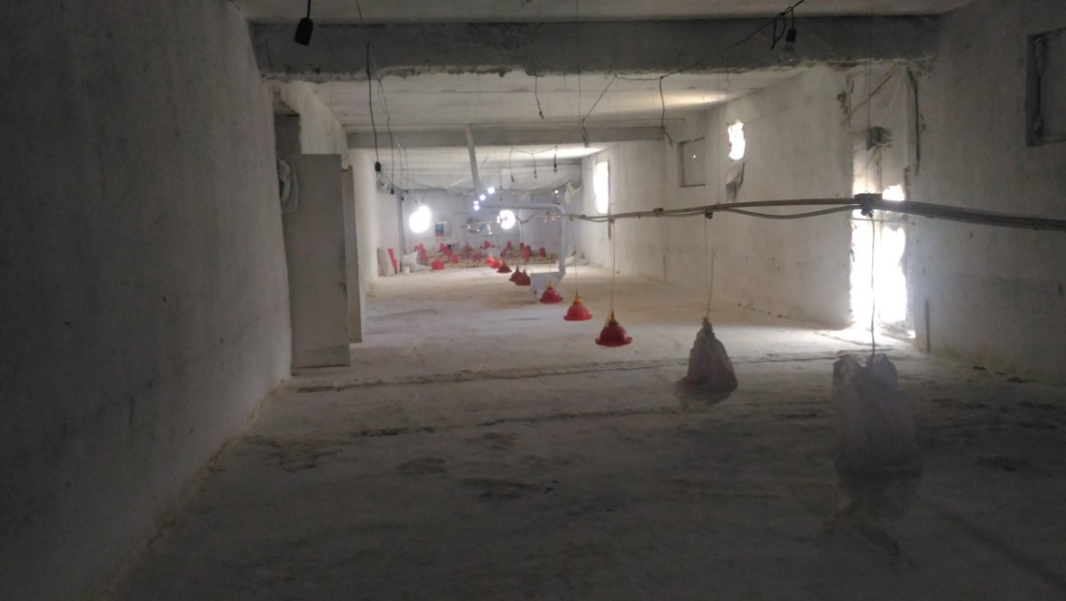
a)
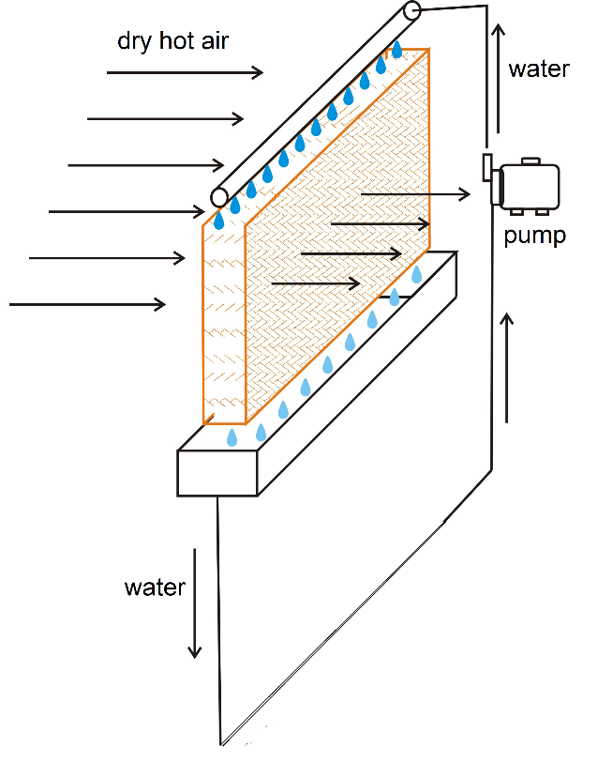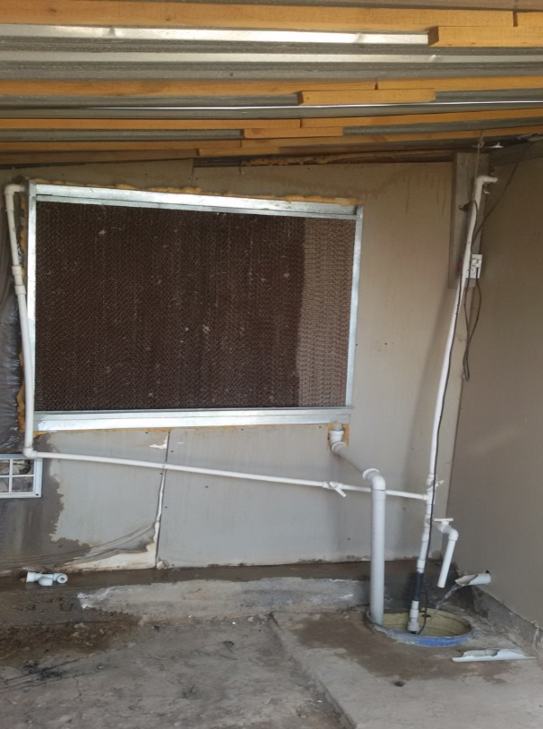
b) с)
FIGURE 1. Poultry farm "Zhumabozor" in Tashkent region (a), operating principle (b), and design of the evaporative cooling system (c)

EXPERIMENTAL RESEARCH
For the purpose increasing efficiency, the flaps at the ends of the incoming air chambers are closed, and outside air is drawn in through a duct containing heaters located in openings in the side walls of the chamber. The capacity of ten axial fans in the supply systems is reduced to 80,000 m³/h. Cold water is supplied to the air-cooling, and the incoming outside air is heated to 5°C [6], while 32 operating axial fans in the side walls of the room exhaust. Its release warm and polluted air outside. Field surveys of poultry farms have shown that during the winter, warm air discharged up to 1.5 meters from the side walls of the poultry building does not produce cold, which melts from the flow of warm exhaust air at a temperature of at least 16°C. Despite significant energy and heat consumption, traditional microclimate systems do not create and maintain optimal air conditions in the hen’s body [7]. This can be explained by the following reasons.
A jet supply of fresh air into the upper zone of the premises does not ensure uniform penetration of fresh air along the 48-meter length of the premises, which is served by a single end supply system of five axial fans. We observed attempts by poultry farm workers to install additional axial fans in the upper zone, 20 meters from the end walls, to increase the length of the supply air penetration zone [8].
1.2-meter-wide access passage is located between the hen cages and the side walls, where axial fans are installed at the bottom [9]. Between the top of the cages and the ceiling, there is a clear space at least 0.4 meters high near the access passages. The presence of clear spaces above and to the sides of the cages allows the axial fans to draw in some of the exhaust air, bypassing the volume occupied by the hen cages [10]. Measurements show that the exhaust air contains less harmful gases than the air within the hen cages.
The supply air is not humidified, which maintains elevated temperatures of up to 30°C and low relative humidity (40-46%) in the Tashkent region during the warm season [11]. We have proposed implementing an energy-saving technology for preparing the supply air in the poultry farm areas. Air is supplied by blowing air over the area where the hens are building.
To supply fresh air to the area of cages with hens, evaporative cooling devices are used, the design diagram of which is shown in Fig. 1, c.
The incoming outside air in the amount of 2500 m³/h passes through the wet material and enters the poultry building over the entire height of the cages.
It is advisable that in rooms where chickens are kept in three-tiered cages, the air inflow is carried out through evaporative cooling devices with an inlet section height of 1.6 m.
There are allow it to be installed near the side walls without blocking the technological passages in the poultry buildings [11].
Fresh air is prepared by four supply units, each located in two supply chambers at the end walls of the poultry building [12]. Construction solutions for poultry farm’s buildings include supply chambers located in the center of the building, in the form of a brick extension.
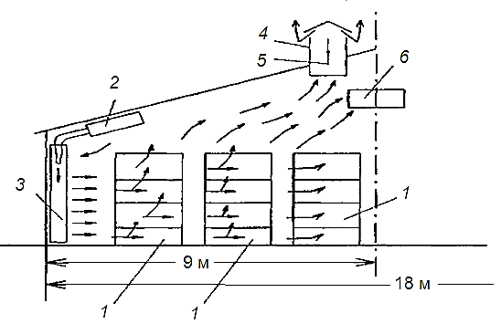
FIGURE 2. Schematic diagram of the organization of air exchange in microclimate systems using energy-saving technology in poultry farm facilities

The hens in the cages emit heat, moisture, and harmful gases, which rise to the roof and are removed through shafts in which valves 5 are open in the summer [13]. The air exchange coefficient for the diagram in Fig. 2 is K_{b} = 2.42. This allows for the calculation of exhaust air parameters.
In these cases, it is recommended to install two or four supply chambers in the extension. Each supply system delivers prepared fresh outside air to half the wall length of the floor-mounted units [14,15]. 8 evaporative cooling units. Fig. 2 shows a variant of organizing air exchange in a poultry building when keeping laying hens in three tiers [16].
Exhaust air is supplied to the evaporative cooling units (position 3) via the supply air duct 2. During the warm season, the exhaust of polluted, heated air is carried out through ventilation shafts 4 constructed in the roof of the poultry building near the roof ridge [17]. An air valve 5 is installed in the cross-section of shaft 4 and is closed in winter. During winter operation of the exhaust fan, polluted, heated air is drawn in through the duct and fed to the heat-extracting heat exchanger of the utilization unit.
Traditional microclimate systems in poultry farm facilities in the republic's climate include only means for heating the supply air in heaters fed with hot water, usually from local boiler buildings of agricultural enterprises [18,19].
During the cold season, when outside air temperatures drop below 5°C, the ventilation system is switched to heating the incoming outside air [20]. Additional use of a solar thermal system during the cold season eliminates the need for heat from a local boiler or electric heaters, thereby saving fuel.
RESEARCH RESULTS
In the heat recovery unit, the incoming outside air is heated by the extracted heat from the exhaust air. It is recommended that the heat recovery unit be designed with an intermediate coolant (antifreeze) circulation system. Typically, under design conditions for the cold season, the incoming outside air in the heat-transfer exchanger of the heat recovery unit is insufficient to supply it to the hen’s body. To increase the temperature in winter, the indoor air is heated in evaporative cooling units. In evaporative cooling units, the shut-off valve for the incoming outside air is set to close, allowing it to flow into the evaporative air-cooling unit. This ensures that the indoor air is heated through the top of the evaporative cooling unit. The resulting mixture, at a temperature of 5°C, is then supplied to the hen habitat throughout the entire height of the cages.
During the warmer months, the cassettes in the evaporative cooling units are moved toward the façade section. By reducing the aerodynamic drag of the evaporative cooling units, the supply air capacity increases while maintaining the same power consumption of the supply fan motor. During the warmer months, tap water is supplied to the evaporative air-cooling units' trays, which moistens the hygroscopic material in the facade section.

FIGURE 3. The proposed evaporative air-cooling system in a cage-type poultry building for 36 thousand laying hens at the Zhumabozor poultry farm in the Tashkent region

The designs of existing poultry farms, which use evaporative air-cooling units in the conditioning systems of the Zhumabozor farm, were examined: 36 thousand laying hens.
Building dimensions: a = 18 m, h average = 4 m, S transverse = 72 m²
The capacity of the existing units of the poultry farm of the Zhumabozor farm: 16 exhaust fans with a capacity of 400 kW each.
Let's calculate the air exchange for a floor-based broiler building.
Poultry - 36,000 heads, age 40 days, planned live weight - 2.0 kg.
C = 400,000 m³/h, i.e. - 5.7 m³/kg of live weight.
The maximum possible V = 400,000 m³/h/ 72 m²/ 3600 sec = 1.54 m/sec, that is, 1.62 times less than the required 2.5 m/sec.
In such situation, the desired speed can be achieved in two ways:
1 - Increase the hood power by 1.6 times, which is very expensive and not always technically feasible.
2 - Reduce the cross-sectional area of the poultry building by 1.6 times (due to its height). This is the simplest and most cost-effective solution.
As shown in Fig. 3, instead of 10 axial supply fans and 32 axial exhaust fans in the traditional design, consuming 48 kW·h of electricity, it is proposed to use four supply systems with a capacity of 20,000 m³ /h of air each. The electricity consumption in the four supply systems was: 4 × 4 = 16 kW·h. According to calculations, the electricity savings during the warm season will be
E= 48 - 16 = 32 kW·h. (1)
Using a waste heat recovery system during the cold season eliminates the need for heat from the local boiler or electric heaters. Operating four exhaust fans in winter, with the valves 5 in Fig. 2, in the exhaust shafts closed, consumes 4 × 3 = 12 kW h of electricity. Operating the waste heat recovery system pumps consumes 4 × 0.15 = 0.6 kW·h. The total energy consumption for the proposed microclimate system in winter will be:
N =16 + 12 + 0.6 = 28.6 kW·h, (2)

Which is almost half the energy consumption of a traditional system. The proposed microclimate system, as shown in Fig. 3, doesn’t require heating incoming outside air.

CONCLUSIONS

Instead of the 16 axial exhaust fans in the traditional design of air-cooling system, which consume 6.4 kW of electricity, it is proposed to use four supply systems with a capacity of 20,000 m³/h of air each. The power consumption of the fans in the four supply systems have only eight fans.

- 4×2×400 = 3.2 kW. (3)
Electric power during the warm season will decrease to

E= 6.4 - 3.2 = 3.2 Kw (4)
which will ensure consumption of electricity costs half that of a traditional system.
Traditional microclimate systems in poultry farm facilities in the republic's climate include only means for heating the supply air in heaters suppled with hot water, usually from local boiler buildings of poultry farm.
Additional use of a solar thermal system during the cold season eliminates the need for heat from a local boiler or electric heaters, thereby saving fuel.
REFERENCES
1. Saeed M., Abbas G., Alagawany M., Kamboh A.A., Abd El-Hack M. E., Khafaga A.F., Chao S. Heat stress management in poultry farms: A comprehensive overview. Journal of Thermal Biology. Volume 84, August 2019, P. 414-425.
2. Nacer T., Hamidat A., Nadjemi O. A comprehensive method to assess the feasibility of renewable energy on Algerian dairy farms. Journal of Cleaner Production, Volume 112, Part 520 January 2016. Pp. 3631-3642
3. Izar-Tenorioa J., Jaramilloa P., Griffina W.M., Small M. Impacts of projected climate change scenarios on heating and cooling demand for industrial broiler chicken farming in the Eastern U.S. Journal of Cleaner Production. Volume 255, 10 May 2020, 120306
4. Li B., Liang Ch., Zheng W. Dynamic simulation of thermal load and energy efficiency in poultry buildings in the cold zone of China. Computers and Electronics in Agriculture. Volume 168, January 2020, 105127
5. Nawab A., Ibtisham F., Li G., Kieser B., Wu J., Liu W., Zhao Y., Nawab Y., Li K., Xiao M., An L. Heat stress in poultry production: Mitigation strategies to overcome the future challenges facing the global poultry industry. Journal of Thermal Biology. Volume 78, December 2018, P. 131-139
6. Vitt R., Weber L., Zollitsch W., Baumgartner J., Niebuhr K., Piringer M., Anders I., Andre K., Hennig-Pauka I., Schauberger G. Modelled performance of energy saving air treatment devices to mitigate heat stress for confined poultry buildings in Central Europe. Biosystem engineering.164. 2017. P. 85-97
7. Fidaros D., Baxevanou C., Bartzanasa T., Kittas C. Numerical study of mechanically ventilated broiler house equipped with evaporative pads. Computers and Electronics in Agriculture. Volume 149, June 2018, P. 101-109
8. Kassem A.-W. S. Energy and water management in evaporative cooling systems in Saudi Arabia Resources. Conservation and Recycling Volume 12, Issues 3–4 November 1994. P. 135-146.
9. Wolfenson D., Bachrach D., Maman M., Graber Y., Rozenboim I. Evaporative Cooling of Ventral Regions of the Skin in Heat-Stressed Laying Hens. Poultry Science. Volume 80, Issue 71 July 2001. P. 958-964
10. Butera F., Aste N., Adhikari R. S., Del Pero C., Zanelli A. Wet Curtain Wall: A Novel Passive Radiant System for Hot and Dry Climates Energy Procedia. Volume 105. May 2017. P. 953-960
11. Anarbaev A.I., Zakhidov R.A., Ivanisiva A.R. Research to determine optimal parameters of solar heat pump system for building heat supply. AIP Conf. Proc. 3331, 020003 (2025) https://doi.org/10.1063/5.0306118
12. Ahmed E. M., Abaas O., Ahmed M., Ismail. M. R. Performance evaluation of three different types of local evaporative cooling pads in greenhouses in Sudan. Saudi Journal of Biological Sciences Volume 18, Issue 1January 2011. P. 45-51
13. Lieffering M., Newton Paul C. D., Vibart R., Li F.Y. Exploring climate change impacts and adaptations of extensive pastoral agriculture systems by combining biophysical simulation and farm system models. Agricultural Systems Volume 144. May 2016. P. 77-86
14. Robert W. Bottcher, Gerald R. Baughman, Joseph T. Magura. Field Measurements of Fan Speed and Power Use in Poultry Houses. Journal of Applied Poultry Research, Volume 5, Issue 11 March 1996. P. 56-62
15. Franco A., Valera D. L., Peña A., Pérez A.M.. Aerodynamic analysis and CFD simulation of several cellulose evaporative cooling pads used in Mediterranean greenhouses. Computers and Electronics in Agriculture, Volume 76, Issue 2. May 2011. P. 218-230.
16. Anarbaev A.I., Zakhidov R.A., Tursunov O., Kodirov D.B., Vakhidov U.F., Khaliknazarov U., Yusupov Z., and Kushev A. Using of evaporative cooling systems in poultry farms. IOP Conf. Series: Earth and Environmental Science 614 (2020) 012015 https://doi:10.1088/1755-1315/614/1/012015
17. Badalov А.А., Shaislamov A.Sh., Badalova D.A., Khaydarov I.B. Modeling of the drying process of dispersed materials in a weighted layer in order to increase efficiency. AIP Conf. Proc. 3152, 030011 (2024) https://doi.org/10.1063/5.0219129
18. Badalova D.A. Swirling flow for dust capture. E3S Web of Conferences 401, 03065 (2023) CONMECHYDRO – 2023 https://doi.org/10.1051/e3sconf/202340103065
19. Badalova D.A., Badalov А.А. Study on the hydrodynamic characteristics of swirl flow device. E3S Web of Conferences 434, 02018 (2023) ICECAE 2023 https://doi.org/10.1051/e3sconf/202343402018
20. Calvet S., Cambra-López M., Blanes-Vidal V., Estellés F., Torres A.G.. Ventilation rates in mechanically-ventilated commercial poultry buildings in Southern Europe: Measurement system development and uncertainty analysis. Biosystems Engineering. Volume 106, Issue 4August 2010. P. 423-432.

