Mathematical Modeling and Experimental Verification of the Stray Magnetic Field in the Stator Section of an Asynchronous Motor
Jasurbek Nizamov ^{a)}, Zailobiddin Boihanov, Shuxratbek Mannobboyev
Andijan state technical institute, Andijan, Uzbekistan
^{a)} Corresponding author: jasurnizamov92@gmail.com
Abstract. This article examines the calculation of the stray magnetic field in the stator section of the rotor winding of a squirrel-cage asynchronous motor intended for general industrial applications, as well as its analysis through a simulation model. The research object is the variability of the stray magnetic field, while the subject is its mathematical model and its comparison with experimental results. The relevance of the study is explained by the significant role of stray magnetic-field diagnostics in the early detection of faults during the operation of asynchronous motors. The main objective of the research is to determine the magnetic fields in stator sections and compare them using a highly accurate model. As a method, a mathematical model based on orthogonal coordinates (dq) developed in MATLAB Simulink, together with experimental measurements, is employed. The obtained results show that the average deviation between the amplitudes of the magnetic field in the air gap from the experimental data and the model is 4.37%, which demonstrates the adequacy of the model. The research findings can be applied in the development of diagnostic devices, particularly for the detection of bearing and phase faults. In conclusion, it is noted that the proposed device and model expand the possibilities for determining the operating condition of asynchronous motors.
INTRODUCTION
We consider the mathematical model of the electrical and mechanical quantities of asynchronous machines connected to the electromagnetic torque. Mathematical models of asynchronous machines include both distributed-parameter and lumped-parameter types. Distributed-parameter mathematical models of asynchronous machines are constructed directly based on the magnetic-field values in the structural components of the motor. The advantages of this type of mathematical model include universality for all motors and a high degree of accuracy. However, this type of mathematical model has several limitations: the calculations require significant time, making them inconvenient for application under real operating conditions; distributed-parameter mathematical models do not consider the influence of temperature changes or material-processing characteristics, which may differ from the initial state by up to 25%; individual structural details (slots, dimensions of the air gap, etc.), which significantly influence parameter estimation, are not always feasible to account for from a technological standpoint.
Lumped-parameter mathematical models are widely used in scientific literature and practice. The equations in this method are based on resistance and inductance, and are used to determine magnetic fluxes, electromagnetic torque, and other parameters. Although this model type provides internationally recognized results, local influences (such as climate) are not taken into account [1–5]. The family of lumped-parameter mathematical models includes various approaches, but two of them are particularly important: the phase-coordinate model and the orthogonal (dq) model [2; 1–6]. The first type works with the real electric machine. The equations include stator–rotor mutual inductances that vary based on rotor position among other parameters. As a result, the model is nonlinear, making the study of dynamic processes difficult [3; 6; 7]. In orthogonal (dq) models, parameters independent of the rotor position are usually used. This significantly simplifies the calculations due to the convenience of phase-vector definitions. Using classic theory of total magnetic flux, we consider a mathematical model in which voltage angular velocity is linked, while current does not participate: [2-10]. One of the most important parts of this work is the investigation of transient processes caused by voltage asymmetry. MATLAB Simulink is used as the working platform, and the variations of electrical, magnetic, and mechanical quantities during transients are obtained. Using the orthogonal dq model, the total magnetic flux of an asynchronous machine is calculated. To study the instantaneous values of the stator and rotor (full flux), the dq coordinate system is applied. If the magnetic flux variation equation is transformed from the (a, b, c) system to the (α, β, 0) pole-coordinate system, then, in order to obtain the stator and rotor equilibrium equations, the following steps are performed:

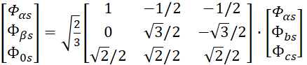 (1)
By grouping the terms of this expression, we obtain the following expression.

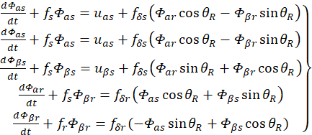 (2)
The notations used in the formula are shown in the following figure. We supplement these equations with the motion equation and the working form of the equation system (4 electrical circuits and 1 motion equation)

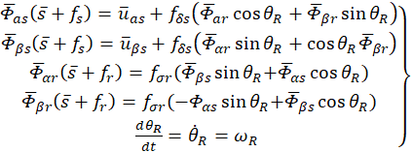 (3)
The expressions indicate that instead of studying a three-phase asynchronous machine, it is possible to analyze it as a two-phase (2-phase mathematical model) machine. In this case, the system parameters can be determined through linear variations
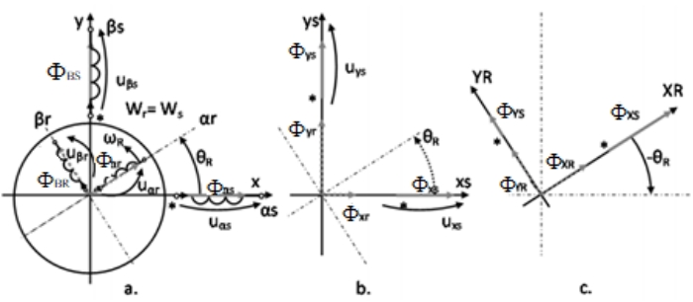
FIGURE 1. Asynchronous machine diagram:
a) Two-phase model b) Simplified representation of the stator total flux c) Simplified representation of the rotor total flux
(4)
If the value of the magnetic flux is taken in relative units (with a step of 5), the variation equation is represented in the form of the following graphs (Figures 3, 4, 5, and 6)."
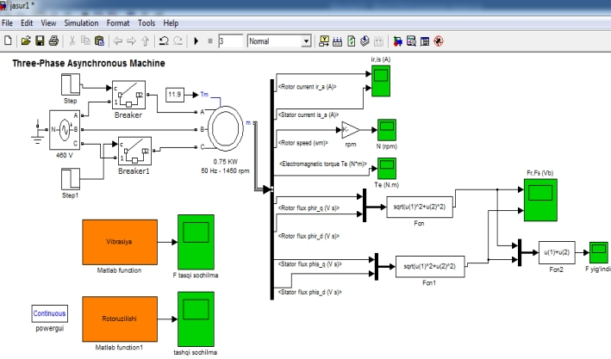FIGURE 2. MATLAB simulation model created for calculating the external magnetic field of the asynchronous motor
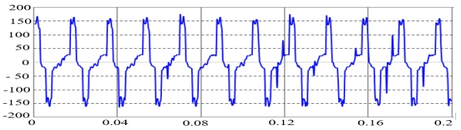
FIGURE 3. Oscillogram of the external stray magnetic field of a single rotor bar in the asynchronous motor under a broken-bar condition, obtained from the MATLAB simulation model
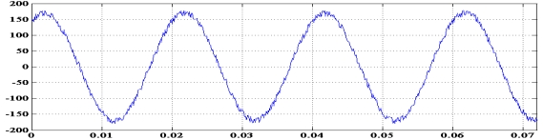
FIGURE 4. External magnetic field of the asynchronous motor under a vibration condition
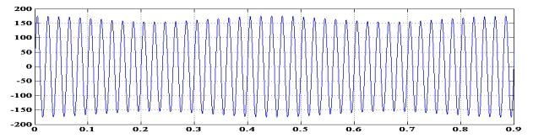
FIGURE 5. Oscillogram of the external magnetic field of the asynchronous motor under a single-phase open-circuit conditio

EXPERIMENTAL RESEARCH
A sensor is installed inside the bearing shield of the asynchronous machine, opposite the stator section of the rotor winding, with a length equal to the pole pitch and a radius corresponding to the radius of the rotor winding’s end section. When the asynchronous machine operates in parallel with the electrical network, the stray magnetic field generated in the stator section of the rotor winding induces an EMF in the sensor.
The limitation of this device is the restricted applicability of the sensor for other electrical equipment.
This article focuses on the wide-scale application of a sensor designed to measure the stray magnetic field in the stator section of the rotor winding of a squirrel-cage asynchronous motor commonly used in industry. Figure 7 shows the installation and positioning of the sensor in two projections.
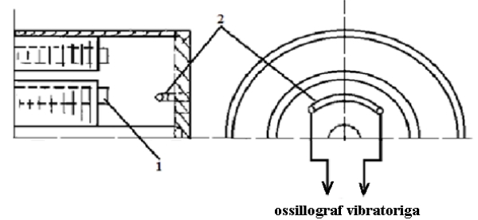
Figure 6. Installation and positioning of the sensor in two projections: 1 – squirrel-cage rotor winding; 2 -sensor

The oscillograms of the air-gap magnetic field of the asynchronous motor in the normal operating condition and under a single-phase open-circuit condition are shown in Figure 5.
a)  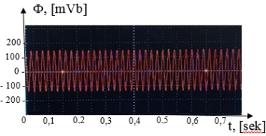 | b)  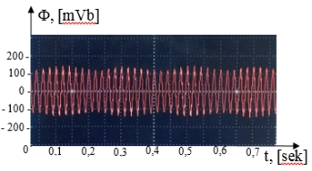
FIGURE 7. Oscillograms of the air-gap magnetic field of the asynchronous motor: (a) normal operating condition, (b) single-phase open-circuit condition

According to Figure 5b above, the amplitude of the resultant air-gap magnetic field of the asynchronous motor varies significantly. This allows for the diagnosis of a single-phase open-circuit condition in the motor. The oscillograms of the air-gap magnetic field obtained from the improved mathematical model (Figure 2.3) and from the experimental object (Figure 3) have been compared.
It is known from the course of the general theory of electric machines that the rotation speed of the generator rotor directly affects the main characteristics of electricity. Thus, rotating at different speeds, the generator generates a voltage with variable parameters in amplitude, frequency and phase. In turn, the requirements of GOST 32144-2013 set strict limits on the quality parameters of electricity. When the direction and intensity of the wind flow changes, it is necessary to convert electric energy with variable parameters into electric energy with standard parameters [2]. The problem of overcoming the instability of the wind flow is solved with the help of an orientation system for wind turbines with a horizontal axis and wind turbines with a vertical axis of rotation insensitive to the wind direction.
To simplify the process of constructing a winding circuit, a new way of presenting the current distribution in the form of a discretely specified spatial function, in short DSSF, was introduced, from which the method was named "DSSF method" [3, 11-16].
There are two options for technical solutions to stabilize the frequency of the output voltage. The first option is a direct mechanical effect on the rotation speed of the wind wheel, which is technically possible, for example, it is
According to the comparison results in Table 1, the amplitude values of the air-gap magnetic field obtained from the mathematical model and the experimental object in both the normal operating condition and the single-phase open-circuit condition differ on average by 4.37%. This confirms the adequacy of the mathematical model.
RESEARCH RESULTS
Comparison of the air-gap magnetic field oscillograms of the asynchronous motor under a single-phase open-circuit condition obtained from the mathematical model and the experimental object.
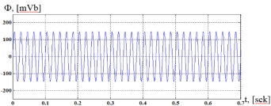 | 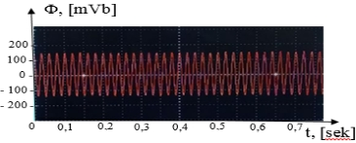
a) | b)
FIGURE 8. Air-gap magnetic field oscillograms of the asynchronous motor in normal operation: (a) obtained from the mathematical model, (b) obtained from the experimental object
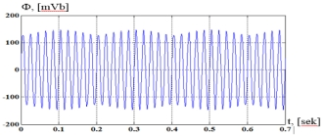 | 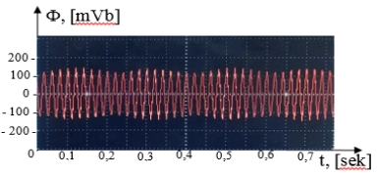
a) | b)
FIGURE 9. Air-gap magnetic field oscillograms of the asynchronous motor under a single-phase open-circuit condition: (a) obtained from the mathematical model, (b) obtained from the experimental object

Table 1. Comparison results between the mathematical model of the asynchronous motor and the air-gap magnetic field oscillograms obtained from the experimental object
Type of experiment” | Amplitude value of the air-gap magnetic field | Difference between the results obtained from the MATLAB model and the experimental object
Type of experiment” | mV_{b}
Amplitude value of the air-gap magnetic field obtained from the experimental object (normal operating condition). | 150 | 3,44 %
Amplitude value of the air-gap magnetic field obtained from the MATLAB Simulink model (normal operating condition). | 145 | 3,44 %
Amplitude value of the air-gap magnetic field obtained from the experimental object (under single-phase open-circuit condition). | 150 | 5,3 %
Amplitude value of the air-gap magnetic field obtained from the MATLAB Simulink model (under single-phase open-circuit condition). | 158 | 5,3 %

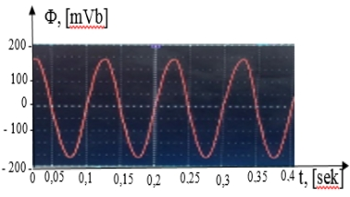 | 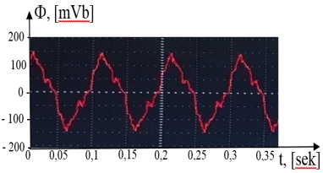
a) | b)
Figure 10. Air-gap magnetic field oscillograms of the 0,75kW asynchronous motor bearing: (a) normal condition, (b) faulty condition

The graphs in Figure 7 indicate that when a bearing fault occurs, the air gap of the machine exhibits both static and dynamic eccentricity. This eccentricity generates higher harmonics, altering the shape of the magnetic field. Consequently, based on the pattern of the air-gap magnetic field obtained using the proposed device, it is possible to diagnose the presence of a bearing fault. The results of the conducted research, as well as the oscillograms in Figures 4 and 5b, highlight that in motors with a faulty bearing, distortions appear near the zero point of the sinusoidal waveform. By analyzing these oscillograms, we can conclude the occurrence of a bearing failure.

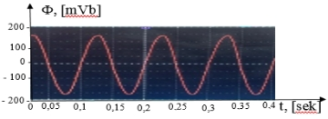 | 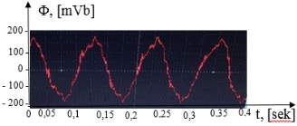
a) | b)
FIGURE 11. Air-gap magnetic field oscillograms of the asynchronous motor: (a) normal condition, (b) condition with vibration

Based on the conducted research and the oscillogram results obtained from the air gap in Figure 9, it is evident that in all motors operating under heavy load conditions, deviations on both sides of the sinusoidal waveform are clearly noticeable. The proposed diagnostic method, which utilizes a device for measuring the air-gap magnetic field of asynchronous motors, is significant due to its affordability and reliability compared to existing diagnostic devices and methods. The electromagnetic field of an electric machine is generated by the magnetomotive forces of the stator and rotor windings, located in the slots of the magnetic core or salient-pole core. Uneven distribution of conductors throughout the machine, nonlinear magnetic properties, the complex configuration of magnetic cores, and the presence of an air gap between the stator and rotor make precise calculation of the magnetic field very difficult. Even with modern computational tools, accurate calculation is almost impossible, necessitating a series of simplifying assumptions during machine design.In a machine, the magnetic field is divided into the main field and the stray (leakage) field. The main field is associated with flux lines linked to both the primary and secondary windings. The stray field, on the other hand, is associated with flux lines linked to either the stator or rotor winding (respectively referred to as stator leakage field and rotor leakage field).Thus, in addition to the main flux Φ\PhiΦ linked with the stator and rotor windings, asynchronous machines have two additional fluxes called leakage fluxes: stator leakage flux Φs1\Phi_{s1}Φs1​ and rotor leakage flux Φs2\Phi_{s2}Φs2. Each leakage flux interacts only with its respective winding, producing the corresponding leakage electromotive forces, i.e., Es1E_{s1}Es1​ in the stator winding and Es2E_{s2}Es2​ in the rotor winding. The stray magnetic field in the stator part due to the rotor winding of an electric machine has a complex form influenced by multiple factors, including the type of winding used, the structure and spatial distribution of the stator parts, the angular displacement of the stator sections relative to the machine axis, and the presence of surfaces with varying magnetic and electrical conductivity. Knowing the field distribution is necessary for determining electrodynamic forces acting on stator windings, calculating inductive reactances, and evaluating losses in both the stator core and the massive elements of the stator windings.Air-gap magnetic fields of synchronous machines have been studied in the literature [1–5]. Modeling the magnetic field in the stator part of synchronous machine windings is described in [6]. According to [6], modeling the magnetic field of the stator section in a synchronous machine is performed in two stages. First, the magnetic field of a single stator coil section and a rotor coil turn carrying a current
CONCLUSIONS
The study addressed the measurement and analysis of the leakage magnetic flux in the stator of a squirrel-cage rotor asynchronous motor. For this purpose, a novel sensor system was developed to accurately detect the leakage flux in the air gap between the rotor and stator.A mathematical model was implemented in the orthogonal (dq) coordinate system using MATLAB Simulink. Comparison with experimental results showed an average deviation of 4.37% in the amplitude of the air-gap magnetic flux, confirming the high accuracy of the model. This validates the capability of the sensor and model to reliably analyze the leakage magnetic flux in the rotor-stator system.The results indicate that rotor and stator geometry, winding type, air-gap characteristics, and magnetic material properties significantly influence the magnetic field distribution. Moreover, the proposed device allows for the detection of bearing faults, single-phase interruptions, and eccentricity in the motor. The method offers advantages such as high diagnostic accuracy, practical applicability in industrial settings, and adaptability to various types of asynchronous motors.Consequently, the study provides an effective tool for computing and monitoring the leakage magnetic flux in the stator of a squirrel-cage rotor asynchronous motor, contributing to enhanced operational efficiency and optimized maintenance of electrical machines.clinical trials or any research involving human subjects.
REFERENCES
1. J Nizamov, Sh Ergashov, DI Kurbanbaeva Phase angle measurement device between the resultable electric drive force and the electric drive force of the main harmonic magnetic field in the air gap of the industrial …AIP Conference ProceedingsAIP Conf. Proc. 3152, 040021 (2024) https://doi.org/10.1063/5.0218808
2. Siddikov, I. K., Malikov, A., Makhsudov, M. T., Boikhanov, Z. U., & Uzaqov, R. (2022, June). Study of the static characteristics of the secondary stator voltage converter of the currents of an induction motor. In American Institute of Physics Conference Series (Vol. 2432, No. 1, p. 020003). https://ui.adsabs.harvard.edu/abs/2022AIPC.2432b0003S/abstract
3. Z. G. Chen, T. Lei, Z. J. Hua, B. Z. Urazali Ugli and A. R. Yigitali Ugli, "Short-term photovoltaic power generation prediction based on VMD-IGWO-LSTM," 2024 IEEE 4th International Conference on Digital Twins and Parallel Intelligence (DTPI), Wuhan, China, 2024, pp. 682-686, doi: 4.1109/DTPI61353.2024.10778814. keywords: Short-term photovoltaic power generation prediction based on VMD-IGWO-LSTM | IEEE Conference Publication | IEEE Xplore.
5. Siddikov I.X., Karimjonov D.D., Aʼzamov S.S. Uzakov R.Study on determination of an asynchronous motorʼs reactive power by the current-to-voltage converter//IOP Conference Series: Earth and Environmental Science, ICECAE-2022, doi:10.1088/1755-1315/1142/1/012023 Study on determination of an asynchronous motorʼs reactive power by the current-to-voltage converter — IOPscience
6. O. Ishnazarov, X. Xaydarov, “Mathematical Analysis of the Impact of External Factors on the Operating Modes of Pump Installations in the Technological Process,”, Journal of Academia Open, vol. 10, no. 1, 2025, https://doi.org/10.21070/acopen.10.2025.10507 .
7. N. Pirmatov, X. Xaydarov, “Investigating the issues of energy saving by means of a mathematical model of transient processes of asynchronous engines in pump units,” (in Uzbek), Journal of Science and innovative development, vol. 6, no. 5, pp. 63-71, https://dx.doi.org/10.36522/2181-9637-2023-5-7
8. N. Pirmatov, S. Mahamadjonov, M. Matqosimov and H. Haydarov, “Characteristics of the static and dynamic operating modes of the asynchronous generator in renewable energy sources and the production of electric energy control through a frequency converter,” in 2024 II International Scientific and Practical Conference “Energy, Ecology and Technology in Agriculture”, E3S Web Conf. vol. 480, no. 01007, https://doi.org/10.1051/e3sconf/202448001007
9. N. Pirmatov, X. Xaydarov, S. Abduraxmonov and Sh. Sayitov, “Energy saving using a frequency converter in asynchronous motor operating modes,” in 2023 International Conference on Green Energy: Intelligent Transport Systems - Clean Energy Transitions (GreenEnergy 2023), E3S Web of Conf. vol. 508, no. 08011, https://doi.org/10.1051/e3sconf/202450808011
10 X. Xaydarov, K. Qarshiyev, U. Berdiyorov, “Energy saving using a frequency converter in asynchronous motor operating modes,” in 2024 AIP Conf. Proc, vol. 3152, no. 030008, https://doi.org/10.1063/5.0219049
11.J Nizamov, SO Ergashov, ON Berdiyorov, UN Berdiyorov Device for measuring the resulting magnetic field of the stator winding of asynchronous motor for general industrial application AIP Conference Proceedings AIP Conf. Proc. 3152, 050013 (2024) https://doi.org/10.1063/5.0218809 June 2024
12. M Taniev, U Mirkhonov, M Rakhmatova, F Isakov, S Ergashov, J Nizamov Study of the substitution scheme of the parameters of a phase-rotor induction generator AIP Conference Proceedings Proc. 2552, 060010 (2023). https://doi.org/10.1063/5.0130746 January 2023
13.NB Pirmatov, AM Egamov, CM Giyasov, J Nizamov NA Mamarasulov, UN Berdiyorov, Some aspects of comparing the operational properties of synchronous machines with a conventional and two mutually shifted excitation windings E3S Web of Conferences 10.1051/e3sconf/202340103056 EID: 2-s2.0-85169675134Part of ISSN: 22671242 25550403
14.K Alimkhodjaev, M Mirsaidov, M Khalikova, J Nizamov Transient processes of vibration machines with inertial electric drives E3S Web of Conferences 2020 | Conference paperDOI: 10.1051/e3sconf/202021601121EID: 2-s2.0-85098463210 Part of ISSN: 22671242 25550403
15. G Mustafakulova, A Egamov, U Mirkhonov, J Nizamov Calculation and study of the magnetic field of the stator winding of a turbine generatorE3S Web of Conferences 2020 | Conference paper DOI: 10.1051/e3sconf/202021601118 EID: 2-s2.0-85098455421Part of ISSN: 22671242 25550403
16. Boihanov Z.U. (2023). Modeling of asynchronous motor reactive power consumption on the basis of current transdusers. https://doi.org/10.5281/zenodo.10073963

