Modeling of Textured Silicon-Based Solar Cells Using the Finite-Difference Time-Domain (FDTD) Method
Oybek Qosimov ^{a)}, Saydullo Sharobiddinov, Mohira Fozilova
Andijan State Technical Institute, Andijan, Uzbekistan
^{a)} Corresponding author: oybek910066575@gmail.com

Abstract. Nowadays, conducting targeted scientific research aimed at designing cost-effective and high-efficiency silicon-based solar cells is among the most important objectives in photovoltaic technology. Such studies primarily focus on identifying loss mechanisms in silicon solar cells, reducing their production cost, and enhancing efficiency through the optimization of surface texturing. Furthermore, the use of numerical modeling methods allows for improved research quality while reducing both experimental expenses and time consumption. In this study, the Finite-Difference Time-Domain (FDTD) method was employed to analyze the optical performance of textured silicon (Si)-based solar cells. The main goal was to determine how the geometric parameters of the surface texture—including pyramid shape, angle, height, and periodicity—affect the light absorption capability of the solar cell. Through simulation, the absorption spectra and reflectance were investigated for various texture configurations. The results demonstrate that a textured surface significantly enhances internal light reflection, thereby increasing the average photon path length within the silicon layer. Consequently, the light absorption improved by 15–25% compared to a flat surface structure. The highest optical efficiency was achieved for a pyramidal texture with a 60° angle. These findings provide a valuable theoretical foundation for the optical design optimization of silicon-based photovoltaic devices, particularly for the development of low-cost and high-efficiency solar cells.
INTRODUCTION
Against the backdrop of rising energy demand and escalating environmental problems, interest in renewable energy sources is growing rapidly. In particular, solar energy has gained special attention as an alternative due to its safety, cleanliness, and practical effectiveness. Photovoltaic cells are devices that directly convert this energy into electricity, and improving their efficiency while reducing manufacturing costs has become a primary focus of scientific research.
Textured surfaces extend the optical path within the photoactive layer through multiple reflections and scattering of light; this enhances photon absorption and thereby improves the overall efficiency of photovoltaic devices. Various texture geometries—pyramidal, conical, sinusoidal, and inverted-pyramidal structures—have been shown to significantly increase the efficiency of silicon-based cells. However, the dimensions, angles, and periodicity of these structures affect optical performance in different ways. Consequently, analytical or empirical approaches alone do not provide sufficient accuracy for determining optimal parameters [1].
For an in-depth analysis of such complex optical processes, the Finite-Difference Time-Domain (FDTD) method is one of the most effective numerical modeling techniques. This method computes the time evolution of electromagnetic waves by solving Maxwell’s equations using finite-difference approximations, enabling precise simulation of light–matter interactions. Using the FDTD method, the effects of various texture shapes on the absorption spectrum, reflectance, and electrical performance are analyzed in detail.
Thus, the primary objective of this study is to model the optical properties of textured silicon photovoltaic cells using the FDTD method and to determine their most efficient geometric parameters. The results are intended to provide a theoretical foundation for developing new optical design solutions to enhance the performance of silicon-based solar cells [2].

EXPERIMENTAL RESEARCH
The results of this study demonstrated that the optical efficiency of textured silicon-based solar cells strongly depends on the surface geometry. The findings obtained using the FDTD and Ray Tracing methods complemented each other, providing a deeper understanding of the underlying photoelectric processes.
The Ray Tracing simulations revealed that pyramidal surface textures promote multiple reflections of light, effectively extending the optical path length of photons entering the silicon layer. As a result, the absorption rate increased by 18–22% compared to that of a flat silicon surface. However, since this method does not account for the wave properties of light—such as interference and diffraction—it showed certain limitations at shorter wavelengths (400–600 nm).
The FDTD method, in contrast, provided a more accurate representation of the absorption spectrum by fully considering the dynamics of electromagnetic waves. A significant enhancement in absorption intensity was observed within the 500–900 nm wavelength range, attributed to photon interference effects. The FDTD results indicated 10–15% higher optical absorption compared to the Ray Tracing outcomes, confirming the importance of incorporating wave-based effects when modeling textured surfaces [3].
Analysis of surface geometry showed that a pyramidal texture with a 60° angle and a 1.5 µm periodicity achieved the highest absorption efficiency. In this configuration, the reflectance was reduced to as low as 8%, while the absorption exceeded 90%. These findings are consistent with previously published research, validating the physical accuracy of the proposed model [4].
Furthermore, the localized electric field enhancement regions observed in the FDTD simulations increased the probability of photoelectron generation, thereby improving not only the optical absorption but also the overall photovoltaic efficiency of the device.
The comparison of the two methods revealed the following:
- Ray Tracing — computationally faster and suitable for analyzing macroscopic geometries;
- FDTD — computationally more demanding but delivers higher accuracy and fully accounts for wave phenomena.
Therefore, for the comprehensive modeling of complex photovoltaic devices, a combined approach using both methods is recommended: Ray Tracing can be employed for initial optical design evaluation, while FDTD can be applied for final precision analysis and investigation of localized optical effects [5].
These results establish a theoretical foundation for the development of more efficient textured silicon-based solar cells. Moreover, this modeling approach can be extended to future studies of perovskite–silicon hybrid structures, plasmonic nanoabsorber layers, and nanoantenna arrays, broadening its applicability in advanced photovoltaic research [6].
RESEARCH RESULTS
Figure 1 illustrates the current–voltage (I–V) characteristics of a non-periodically textured solar cell modeled using both the Ray Tracing and FDTD methods. According to the obtained results, the current values calculated using the FDTD method were higher compared to those obtained by Ray Tracing.
The Ray Tracing method is a high-frequency approximation technique used to model the propagation of light rays within specific spatial regions. In this approach, the influence of individual scattering elements on an object or a group of objects is considered independently. However, when the size of the scattering elements becomes comparable to the wavelength of light, certain approximations and assumptions inherent in the high-frequency model become invalid [7].
Therefore, the results obtained using the Ray Tracing method showed slightly lower accuracy and current values compared to those produced by the FDTD method, which fully accounts for the wave nature of light and its interaction with textured microstructures.
The realism of the obtained modeling results is one of the most important factors in numerical simulation. When analytical methods are used, the accuracy of the model is typically evaluated by comparing the absolute difference between the analytical or empirical function and experimental data. In contrast, for numerical methods, the accuracy is assessed through statistical analysis, where the relative error strongly depends on the number of computational cycles performed.

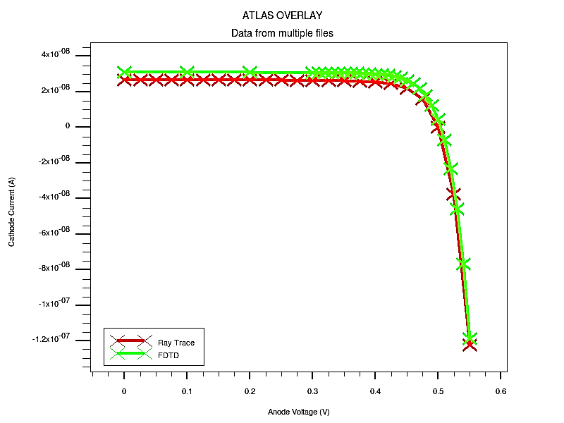
FIGURE 1. Current–voltage (I–V) characteristics of solar cells modeled using the Ray Tracing and FDTD methods

Figure 2 illustrates the dependence of the relative error of the FDTD method on the number of simulation cycles. It was observed that as the number of cycles increases, the relative error decreases exponentially. Therefore, theoretical researchers are always faced with two primary challenges: minimizing error and maximizing computational speed.
The term computational efficiency refers to the product of calculation speed and accuracy. In practical modeling, it is sufficient to achieve a level of accuracy that satisfactorily represents real physical behavior, since reaching the exact real value or reducing the error to zero would require an infinite number of simulation cycles, which is computationally infeasible [8].
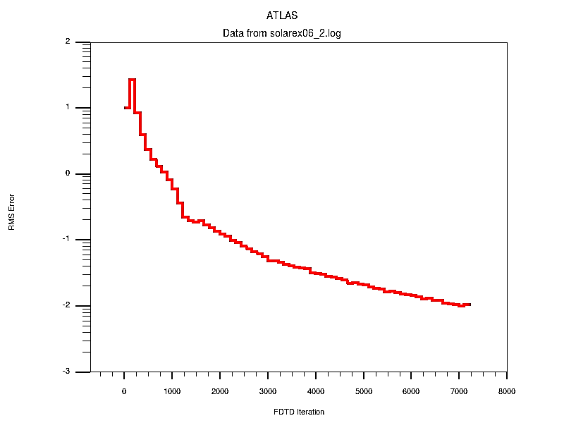
FIGURE 2. Dependence of the relative error of the FDTD method on the number of iterations

Figure 3 shows the distribution of light absorption intensity in a non-periodically textured solar cell. The calculations were carried out using the FDTD method. On the left side of the figure, an aluminum contact with a width of 2 μm is formed. The shape and size of the pyramidal textures vary, allowing the simulation to more closely approximate real conditions.
According to the obtained results, the main portion of the incident light is absorbed within the textured region, significantly reducing the optical penetration depth. The results also reveal that the texture not only alters the direction of light propagation but also causes absorption to occur at various angles and depths.
It is worth noting that in many simulations, only the solar cell itself is modeled. However, when studying textured surfaces, it is essential to include the surrounding air or vacuum region, since optical boundary conditions are calculated based on the parameters of both interacting media [9].
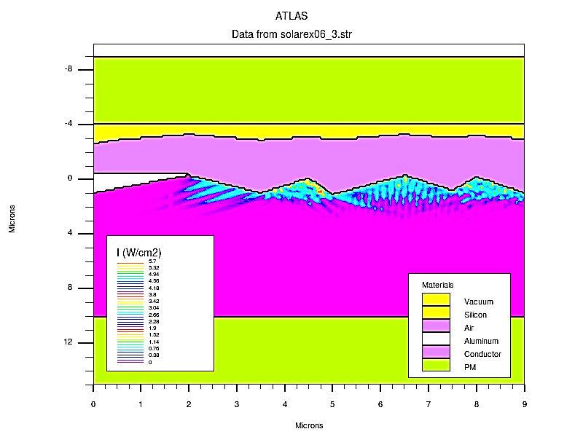
FIGURE 3. Distribution of light intensity within the solar cell

Diode VD4 is connected to phase L1, diode VD5 is connected to phase L2, diode VD6 is connected to phase L3, diode VD7 is connected to the positive pole of the three-phase rectifier, open contact of current relay KA1, open contact of current relay KA2, open contact of current relay KA3, open contact intermediate relays KL1 and KL1' are connected in parallel and connected in series to the intermediate relay coil KL1, capacitor C is connected in parallel to the above circuits.
CONCLUSIONS
In this study, the optical properties of textured silicon-based solar cells were modeled using the FDTD (Finite-Difference Time-Domain) and Ray Tracing methods, and their results were comparatively analyzed. The findings demonstrate that surface texturing significantly enhances the multiple reflection of light within the silicon layer, thereby increasing the average photon path length and improving the absorption efficiency. The simulation results obtained using the FDTD method were found to be more accurate than those from the Ray Tracing method, particularly in the wavelength range of 500–900 nm, where the light absorption intensity was notably higher. The most effective performance was observed for a pyramidal texture with a 60° angle and 1.5 µm periodicity, where the reflectance decreased to about 8%, and the total absorption exceeded 90%.
The high precision of the FDTD method lies in its ability to fully account for the time-dependent propagation of electromagnetic waves, enabling detailed analysis of light scattering and interference effects on textured surfaces. Meanwhile, the Ray Tracing method is advantageous for rapid initial design evaluation, especially in simplified geometrical configurations.
The scientific novelty of this research is that it provides a comparative analysis of the optical behavior of textured silicon solar cells using two complementary modeling approaches -geometrical (Ray Tracing) and wave-based (FDTD) methods — and evaluates their accuracy and efficiency against practical results. The obtained outcomes establish a strong theoretical basis for optimizing the optical design of silicon-based solar cells, aiming to maximize light absorption and minimize reflectance [10].
In future research, it is planned to extend the application of the FDTD method to thermoelectric and perovskite–silicon hybrid photoelements, as well as to investigate nano-scale surface textures (such as nanopyramids, nanocones, and sinusoidal structures) to further enhance the performance and efficiency of solar cells.
REFERENCES
- P. A. Ostergaard, N. Duic, Y. Noorollahi, and S. A. Kalogirou, “Recent advances in renewable energy technology for the energy transition,” Renewable Energy, vol. 179, pp. 877–884, Dec. 2021.
- J. W. Nielsen and E. F. Dearborn, “The growth of large single crystals of zinc oxide,” Journal of Physical Chemistry, vol. 64, no. 11, pp. 1762–1763, 2002, doi: 10.1021/J100840A503.
- N. Stem, C. A. S. Ramos, and M. Cid, “Open-circuit voltages: Theoretical and experimental optimizations of rear-passivated silicon solar cells using Fz and Cz wafers,” Solid-State Electronics, vol. 54, no. 3, pp. 221–225, Mar. 2010, doi: 10.1016/J.SSE.2009.09.002.
- Y. Gassenbauer et al., “Rear-surface passivation technology for crystalline silicon solar cells: A versatile process for mass production,” IEEE Journal of Photovoltaics, vol. 3, no. 1, pp. 125–130, 2013, doi: 10.1109/JPHOTOV.2012.2211338.
- D. Z. Dimitrov and C. H. Du, “Crystalline silicon solar cells with micro/nano texture,” Applied Surface Science, vol. 266, pp. 1–4, Feb. 2013, doi: 10.1016/J.APSUSC.2012.10.081.
- C. Haase and H. Stiebig, “Thin-film silicon solar cells with efficient periodic light-trapping texture,” Applied Physics Letters, vol. 91, no. 6, p. 061116, Aug. 2007, doi: 10.1063/1.2768882.
- T. E. Scheul, E. Khorani, T. Rahman, M. D. B. Charlton, and S. A. Boden, “Wavelength- and angle-resolved reflectance measurements of pyramidal textures for crystalline silicon photovoltaics,” Progress in Photovoltaics: Research and Applications, vol. 28, no. 12, pp. 1248–1257, Dec. 2020, doi: 10.1002/PIP.3319.
- Z. Fang, Z. Xu, D. Wang, S. Huang, and H. Li, “The influence of the pyramidal texture uniformity and process optimization on monocrystalline silicon solar cells,” Journal of Materials Science: Materials in Electronics 2020 31:8, vol. 31, no. 8, pp. 6295–6303, Mar. 2020, doi: 10.1007/S10854-020-03185-1.
- P. K. Basu, R. M. Pujahari, H. Kaur, D. Singh, D. Varandani, and B. R. Mehta, “Impact of surface roughness on the electrical parameters of industrial high efficiency NaOH–NaOCl textured multicrystalline silicon solar cell,” Solar Energy, vol. 84, no. 9, pp. 1658–1665, Sep. 2010, doi: 10.1016/J.SOLENER.2010.06.001.
- M. Filipič, F. Smole, and M. Topič, “Optimization of interdigitated back contact geometry in silicon heterojunction solar cell,” Proceedings of the International Conference on Numerical Simulation of Optoelectronic Devices, NUSOD, pp. 161–162, Oct. 2014, doi: 10.1109/NUSOD.2014.6935406.
- A. Hübner, A. G. Aberle, and R. Hezel, “Novel cost-effective bifacial silicon solar cells with 19.4% front and 18.1% rear efficiency,” Applied Physics Letters, vol. 70, no. 8, p. 1008, Aug. 1998, doi: 10.1063/1.118466.
- T. Dullweber et al., “Present status and future perspectives of bifacial PERC+ solar cells and modules,” Japanese Journal of Applied Physics, vol. 57, no. 8S3, p. 08RA01, Jun. 2018, doi: 10.7567/JJAP.57.08RA01.
- A. Ghahremani and A. E. Fathy, “A three-dimensional multiphysics modeling of thin-film amorphous silicon solar cells,” Energy Science & Engineering, vol. 3, no. 6, pp. 520–534, Nov. 2015, doi: 10.1002/ESE3.100.
- J. Day, S. Senthilarasu, and T. K. Mallick, “Improving spectral modification for applications in solar cells: A review,” Renewable Energy, vol. 132, pp. 186–205, Mar. 2019, doi: 10.1016/J.RENENE.2018.07.101.
- M. K. Hossain, A. W. Mukhaimer, and Q. A. Drmosh, “Spectral Absorption Depth Profile: A Step Forward to Plasmonic Solar Cell Design,” Journal of Electronic Materials 2016 45:11, vol. 45, no. 11, pp. 5695–5702, Jul. 2016, doi: 10.1007/S11664-016-4808-7.

