Study of the processing depth and stable movement of a machine unit that performs volumetric treatment of cotton bushes
Iqboljon Ikromov ^{a)}, Khaydarali Fayzullayev, Nodirjon Otaboev, Valikhon Oribjonov
Fergana State Technical University, Fergana, Uzbekistan
^{a)} Corresponding author: Iqbol1978@mail.ru
Abstract. This article presents the results of theoretical and experimental studies on the processing depth and stable movement of a machine unit designed for volumetric cultivation of cotton ridges. Theoretical studies showed that the processing depth and stable operation of the machine unit performing volumetric cultivation of cotton ridges are mainly ensured by the constant contact of its supporting wheels with the field surface. As a result, the working bodies penetrate to the specified depth and maintain it through proper adjustment. To verify the obtained results, it was established that for the working bodies of the machine to penetrate to the specified depth and move uniformly at that depth, the condition N_{z}>0 must be satisfied (where N_{z} is the vertical reaction force exerted by the soil on the supporting wheels of the machine). Only under this condition do the supporting wheels remain in continuous contact with the field surface, ensuring that the working bodies operate at the specified depth without changing the cultivation depth. Experimental studies revealed that when the vertical distance was 45–50 cm, the working bodies penetrated to the desired depth and operated stably while supported by the wheels. Based on the research results, it was determined that for the machine to maintain stable operation at the specified depth—without altering the processing depth—the vertical distance between the support plane and the lower suspension points must be at least 45 cm. However, an excessive increase in this distance Н₁ leads to greater pressure exerted by the supporting wheels on the soil, thereby increasing rolling resistance. Therefore, it is recommended to set Н₁ = 50 cm.
INTRODUCTION
Under certain soil and climatic conditions, sowing seeds on ridges is more effective than sowing on a flat surface. This method promotes earlier germination of seeds, better plant development, and higher yields.
After autumn plowing and subsequent soil treatment during ridge formation, an increase in the thickness of the fertile soil layer was observed, while the soil density in the plowed areas remained within the required range. The soil temperature in the 0–5 cm layer increased by an average of 2.2°C. As a result, microbial activity and plant nutrition improved. Due to temperature fluctuations and precipitation during the autumn-winter season, soil clods on the ridges disintegrated, forming a fine-grained surface layer.
Experimental studies showed that the yield of cotton sown on ridges exceeded that of cotton sown on flat fields by an average of 4.5 centners per hectare. Similar results were obtained under other soil conditions as well [1].
As a result, agrotechnical requirements for soil-cultivating machines and implements were developed. New working bodies, machine components, and design schemes were identified and recommended to design bureaus for the creation of new machinery. Among these developments are the new GH-4 ridge former and a device designed for ridge preparation equipped with special profiled attachments. The introduction of such equipment into agricultural practice improved the quality of soil cultivation during ridge planting, reduced agrotechnical timeframes, and laid the foundation for achieving higher crop yields [2].
Taking the above into account, scientists from the Research Institute of Agricultural Mechanization developed a device for ridge cultivation, consisting of working bodies designed to treat the furrows, slopes, and tops of ridges [3; 4]. During operation, the tine-type looseners cultivate the furrows, rotary looseners treat the slopes, and toothed looseners process the tops of the ridges. As a result, weeds growing on the tops, slopes, and furrows are completely destroyed, and a fine-grained soil layer that helps retain moisture throughout the ridge profile is formed [5].
The design of this device was developed, and studies were conducted to substantiate its parameters [5].
This article presents the results of research on the processing depth and stable movement of a machine designed for volumetric cultivation of ridges.

EXPERIMENTAL RESEARCH
Results and Discussion. For the working bodies of the ridge-cultivating machine to penetrate to the specified processing depth and move uniformly at that depth, the condition N_{z}>0 must be satisfied, where N_{z} is the vertical reaction force exerted by the soil on the supporting wheels of the machine.
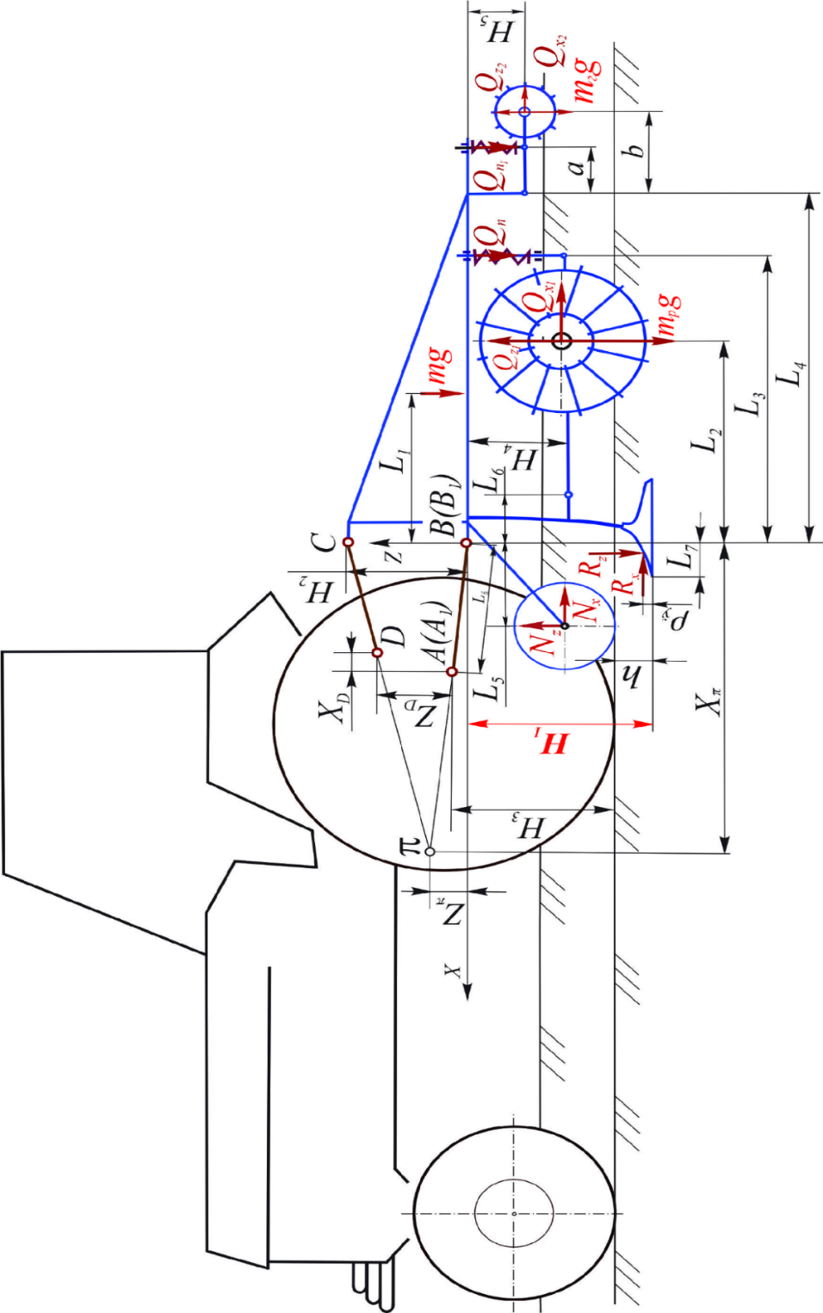

FIGURE 1. Forces acting on the machine for volumetric processing of cotton ridges
Only under this condition do the supporting wheels remain in continuous contact with the field surface, ensuring that the working bodies penetrate to the designated depth and maintain a constant cultivation depth [6; 7].
Otherwise, when N_{z} < 0, the supporting wheels lift off the field surface, causing the working bodies to operate at a shallower depth than specified. In such cases, variations in the physical and mechanical properties of the soil, the aggregate’s travel speed, and other external factors lead to fluctuations in the working depth of the tools, resulting in uneven soil cultivation.
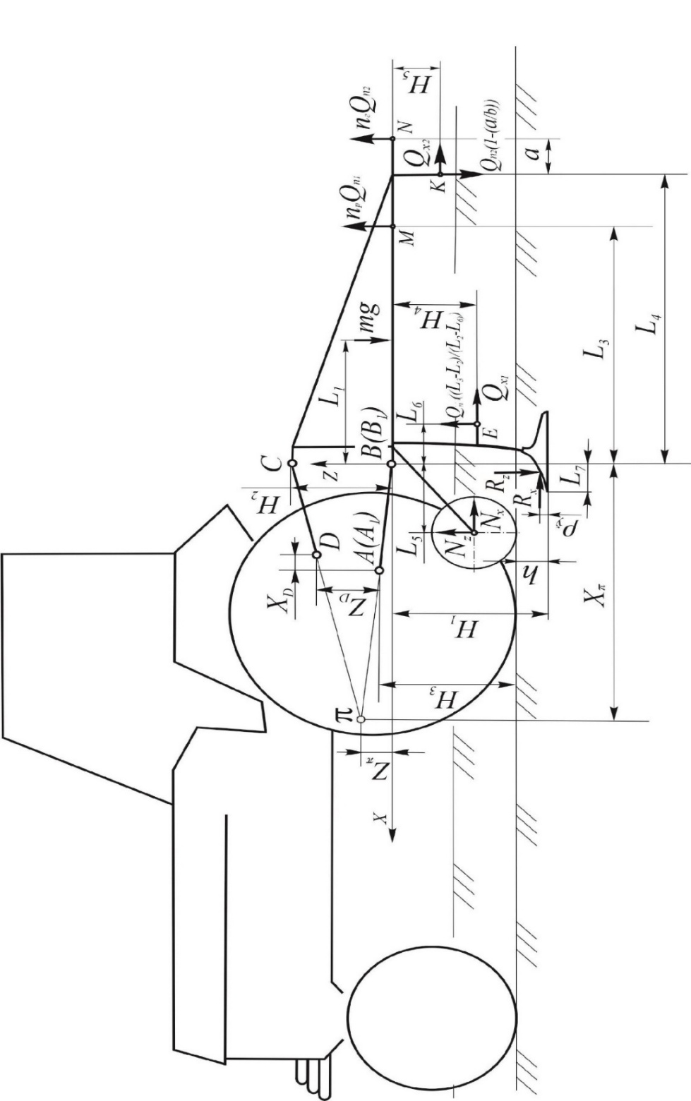

FIGURE 2. Diagram for determining the force 𝑁_{z}

Based on the above, we will investigate the factors that ensure the fulfillment of the condition N_{z} >0.
To solve this problem, we first consider the forces acting on the working bodies of the machine during operation.
According to the schematic diagram shown in Figure 1, the following forces act on the system:
mg – the weight of the machine frame and the working parts rigidly attached to it; Р – the traction force applied by the tractor; N_{x}, N_{z} – the horizontal and vertical components of the soil reaction forces acting on the supporting wheels of the machine; R_{x}, R_{z} – the horizontal and vertical components of resistance acting on the chisel-like plowshare; m_{р}g – the weight of the rotary loosener; m_{г}g – the weight of the slatted roller; Q_{x1}, Q_{x2} – the horizontal components of the reaction forces acting on the rotary loosener and the slatted roller, respectively; Q_{z1}, Q_{z2} – the vertical components of the reaction forces acting on the rotary loosener and the slatted roller, respectively; Q_{n1}, Q_{n2} – the compression forces of the springs of the rotary loosener and the slatted roller; m, m_{р}, m_{г} – the masses of the machine frame, rotary loosener, and slatted roller, respectively; g – acceleration due to gravity.
To determine the force N_{z}, the forces acting on the rotary loosener and the slatted roller are transferred to the hinges E and K, as well as to points M and N, where their springs are connected to the frame (see Figure 2).
At points M and N, the spring pressure forces acting on the rotary loosener and slatted roller are directed upward, while at hinges E and K, opposite reaction forces arise during operation of the device.
Using the schematic shown in Figure 2, we formulate the equilibrium equation of all forces acting on the machine with respect to its longitudinal-vertical axis of rotation passing through the instantaneous center of rotation π:
$$ΣM_{π}=mg\left(X_{π}+L_{1}\right)-n_{p}Q_{n1}\left[\left(\frac{L_{3}}{L_{2}}-1\right)\left(L_{6}+X_{π}\right)+\left(L_{3}+X_{π}\right)\right]-$$
$$-n_{z}Q_{n2}\left[L_{4}+a+X_{π}-\left(1-\frac{a}{b}\right)\left(L_{4}+X_{π}\right)\right]-n_{p}Q_{x1}\left(H_{4}+Z_{π}\right)-$$
$-N_{x}\left(H_{1}-h-0,5d_{Т}+Z_{π}\right)-N_{z}\left(X_{π}-L_{5}\right)=0,$ (1)
where: X_{π} – longitudinal distance from the machine’s lower contact points В(В₁) to its instantaneous center of rotation; Z_{π} – vertical distance from the machine’s lower contact points В(В₁) to its instantaneous center of rotation; L₁ – longitudinal distance from the machine’s lower contact points В(В₁) to its center of gravity;
n_{p}, n_{г} – number of rotational loosening tools and slatted rollers installed on the machine; L₂ – longitudinal distance from the lower contact points to the rotation axis of the rotational loosener; L₄ – longitudinal distance from the lower contact points to the hinges connecting the slatted rollers; а – longitudinal distance from the hinges of the slatted rollers to the points of application of spring forces; b – longitudinal distance from the hinges of the slatted rollers to their rotation center; L₅ – longitudinal distance from the axes of the machine’s support wheels to its lower contact points; Н₁ – vertical distance from the machine’s support plane, i.e., from the tip of the knife-labbed tool, to its lower contact points; Н₃ – vertical distance from the tractor’s support plane to the lower fixed hinges of the lifting mechanism А(А₁); Н₅ – vertical distance from the machine’s lower contact points to the rotation center of the slatted roller; h – working depth of the machine’s knife-labbed tool; ​ L₆ – longitudinal distance from the lower contact points to hinge E, to which the rotational loosener is attached; L₇ – longitudinal distance from the tip of the knife-labbed tool to its lower contact point; ρ_{ў} – vertical distance from the tip of the knife-labbed tool to the force R_{x} , m; d_{т} – diameter of the support wheels.
N_{x}=μN_{z} Taking into account that 𝜇 - is the rolling coefficient of the machine’s support wheel [8], the force N_{z} was determined from equation (1):
$$N_{z}=\left\{mg\left(X_{π}+L_{1}\right)-n_{p}Q_{n1}\left[\left(\frac{L_{3}}{L_{2}}-1\right)\left(L_{6}+X_{π}\right)+\left(L_{3}+X_{π}\right)\right]\right.-$$
$$-n_{г}Q_{n2}\left[L_{4}+a+X_{π}-\left(1-\frac{a}{b}\right)\left(L_{4}+X_{π}\right)\right]-n_{p}Q_{x1}(H_{4}+Z_{π})-$$
$:\left[μ\left(H_{1}-h-0,5d_{Т}+Z_{π}\right)+\left(X_{π}-L_{5}\right)\right].$ (2)
This expression can be rewritten in the following form:$N_{z}=\left\{mgL_{1}-n_{p}\left[Q_{n1}\left(\left(\frac{L_{3}}{L_{2}}-1\right)L_{6}+L_{3}\right)+Q_{х1}Н_{4}\right]\right.-$
$-n_{г}\left[Q_{n2}\left(L_{4}\frac{a}{b}+a\right)-Q_{x2}H_{5}\right]-n_{ў}\left[R_{x}\left(H_{1}-ρ_{ў}\right)+R_{z}\left(L_{7}-ρ_{ў}ctgα_{ў}\right)\right]+$$:\left[μ\left(H_{1}-h-0,5d_{Т}+Z_{π}\right)+\left(X_{π}-L_{5}\right)\right].$ (3)

In this expression, the distances X_{π} ​ and Z_{π} are expressed through the dimensions and parameters of the tractor lifting mechanism and the machine lifting device [6]:

$X_{π}=\frac{H_{2}\sqrt{L_{б}^{2}-{\left(H_{3}+h-H_{1}\right)}^{2}}{\left[\sqrt{L_{б}^{2}-{\left(H_{3}+h-H_{1}\right)}^{2}}-Х_{D}\right]}_{}}{\left(H_{2}-Z_{D}\right)\sqrt{L_{б}^{2}-{\left(H_{3}+h-H_{1}\right)}^{2}}-\left(H_{3}+h-H_{1}\right)Х_{D}}$ (4)
ва
$Z_{π}=\frac{H_{2}\left(H_{3}+h-H_{1}\right){\left[\sqrt{L_{б}^{2}-{\left(H_{3}+h-H_{1}\right)}^{2}}-Х_{D}\right]}_{}}{\left(H_{2}-Z_{D}\right)\sqrt{L_{б}^{2}-{\left(H_{3}+h-H_{1}\right)}^{2}}-\left(H_{3}+h-H_{1}\right)Х_{D}},$ (5)
Here, H₂ denotes the distance between the lower and upper hitch points of the machine; Xᴅ and Zᴅ represent the longitudinal and vertical distances between the fixed joints A (A₁) and D of the lower and central links of the tractor hitch mechanism; Lᵦ is the length of the lower links of the tractor hitch mechanism.
The values of Xπ and Zπ, determined according to equations (4) and (5), are substituted into expression (3):
Where Н₂ – is the distance between the lower and upper suspension points of the machine; X_{D}, Z_{D} – are the longitudinal and vertical distances between the fixed hinges А(А₁) and D of the tractor lifting mechanism; L_{б} – is the length of the lower links of the tractor lifting mechanism.
We substitute the values of X_{π} and Z_{π} from (4) and (5) into expression (3):
$$N_{z}=\left\{mgL_{1}-n_{p}\left[Q_{n1}\left(\left(\frac{L_{3}}{L_{2}}-1\right)L_{6}+L_{3}\right)+Q_{х1}Н_{4}\right]\overset{\underset{}{}}{\overset{\underset{}{}}{\overset{\underset{}{}}{-}}}\right.$$
$$-n_{г}\left[Q_{n2}\left(L_{4}\frac{a}{b}+a\right)-Q_{x2}H_{5}\right]-n_{ў}\left[R_{x}\left(H_{1}-ρ_{ў}\right)+R_{z}\left(L_{7}-ρ_{ў}ctgα_{ў}\right)\right]+$$
$$×\frac{H_{2}\sqrt{L_{б}^{2}-{\left(H_{3}+h-H_{1}\right)}^{2}}{\left[\sqrt{L_{б}^{2}-{\left(H_{3}+h-H_{1}\right)}^{2}}-Х_{D}\right]}_{}}{\left(H_{2}-Z_{D}\right)\sqrt{L_{б}^{2}-{\left(H_{3}+h-H_{1}\right)}^{2}}-\left(H_{3}+h-H_{1}\right)Х_{D}}-$$
$$-\left(n_{р}Q_{x1}+n_{г}Q_{x2}+n_{ў}R_{x}\right)×$$
$$\left.×\frac{H_{2}\left(H_{3}+h-H_{1}\right){\left[\sqrt{L_{б}^{2}-{\left(H_{3}+h-H_{1}\right)}^{2}}-Х_{D}\right]}_{}}{\left(H_{2}-Z_{D}\right)\sqrt{L_{б}^{2}-{\left(H_{3}+h-H_{1}\right)}^{2}}-\left(H_{3}+h-H_{1}\right)Х_{D}}\right\}:$$
$$:\left[μ\left(H_{1}-h-0,5d_{Т}+\overset{\underset{}{}}{\overset{\underset{}{}}{\overset{\underset{}{}}{\overset{\underset{}{}}{}}}}\right.\right.$$
$$\left.+\frac{H_{2}\left(H_{3}+h-H_{1}\right){\left[\sqrt{L_{б}^{2}-{\left(H_{3}+h-H_{1}\right)}^{2}}-Х_{D}\right]}_{}}{\left(H_{2}-Z_{D}\right)\sqrt{L_{б}^{2}-{\left(H_{3}+h-H_{1}\right)}^{2}}-\left(H_{3}+h-H_{1}\right)Х_{D}}\right)+$$
$+\left.\frac{H_{2}\sqrt{L_{б}^{2}-{\left(H_{3}+h-H_{1}\right)}^{2}}{\left[\sqrt{L_{б}^{2}-{\left(H_{3}+h-H_{1}\right)}^{2}}-Х_{D}\right]}_{}}{\left(H_{2}-Z_{D}\right)\sqrt{L_{б}^{2}-{\left(H_{3}+h-H_{1}\right)}^{2}}-\left(H_{3}+h-H_{1}\right)Х_{D}}-L_{5}\right]$. (6)
From this expression, it can be seen that the vertical reaction force N_{z} exerted by the soil on the machine's support wheels depends on their position relative to the suspension points (L₅), the diameter (dт), the weight of the machine (mg), the point of application of this weight (L1), the forces acting on the machine's working components (R_{x}, R_{z}, Q_{n1}, Q_{n2}, Q_{x1}, Q_{x2}), their directions and points of application, the machine's parameters (L₂, L₃, L₄, L₆, L₇), the dimensions and parameters of the machine’s suspension device and the tractor’s lifting mechanism (H₁, H₂, H₃, L_{б}, X_{D}, Z_{D}), as well as the working depth (h).
However, since the dimensions of the tractor’s lifting mechanism and the vertical distance between the machine’s lower and upper suspension points (H₂) are standardized [9] and known for a specific tractor, and the machine’s parameters and weight are chosen to ensure reliable and quality execution of the technological process with minimal energy and material consumption, the condition N_{z}>0, and therefore the operation of the machine’s working components at the designated depth and their uniform movement at this depth, is primarily ensured by adjusting the vertical distance H₁ from the support frame to the lower suspension points.
RESEARCH RESULTS
TABLE 1. Effect of the vertical distance from the support plane of the ridge-forming volumetric processing machine to the lowest suspension points on its performance indicators
Vertical distance from the machine’s support plane to the lowest suspension points, cm | Processing depths of the machine’s working elements (cm) and their root mean square deviation (±cm) |  |  |  |  |  | Draft resistance, kN
 | In ridge furrows |  | On the slopes of ridges |  | On the top of the ridge |  | Draft resistance, kN
 | h_{ўр} | ±σ | h_{ўр} | ±σ | h_{ўр} | ±σ | Draft resistance, kN
Movement speed of the unit 5,6 km/h
40 | 7,5 | 0,98 | 3,6 | 0,63 | 3,4 | 0,69 | 9,14
45 | 9,8 | 0,89 | 5,5 | 0,59 | 5,2 | 0,57 | 10,93
50 | 10,3 | 0,87 | 5,8 | 0,54 | 5,4 | 0,56 | 11,70
Travel speed of the unit 9.1 km/h
40 | 7,1 | 0,94 | 3,3 | 0,61 | 3,1 | 0,64 | 10,73
45 | 9,5 | 0,93 | 5,4 | 0,58 | 5,0 | 0,61 | 12,35
50 | 10,1 | 0,92 | 5,6 | 0,56 | 5,2 | 0,60 | 13,21

Based on the analysis of the conducted theoretical and experimental studies, the penetration of the working components of the machine for volumetric bed cultivation to the specified working depth and ensuring their uniform motion at the required level is primarily achieved by adjusting the vertical distance from the support frame to the lower suspension points.

For a machine designed for bed cultivation and aggregated with a class 1.4 tractor, the vertical distance from the support frame to the lower suspension points must be at least 47.3 cm to ensure that the working components penetrate to the specified depth and move stably at that depth.

FIGURE 3. Graph of NZ variation depending on H₁
The results of the experiments are presented in Table 1. Their analysis shows that as the vertical distance from the machine’s support plane to the lowest suspension points increases, the processing depth increases, while its root mean square deviation decreases, meaning that the stability of the processing depth improves. When this distance increased from 40 cm to 45 cm, the processing depth at speeds of 5.6 and 9.1 km/h, respectively, increased as follows: in furrows – from 8.4 cm to 9.8 cm and from 8.1 cm to 9.5 cm; on slopes – from 4.8 cm to 5.5 cm and from 4.5 cm to 5.4 cm; on ridges – from 4.5 cm to 5.2 cm and from 4.3 cm to 5.0 cm. The root mean square deviation, in turn, decreased: in furrows – from ±0.94 cm to ±0.89 cm and from ±0.98 cm to ±0.93 cm; on slopes – from ±0.61 cm to ±0.59 cm and from ±0.63 cm to ±0.58 cm; on ridges – from ±0.63 cm to ±0.57 cm and from ±0.69 cm to ±0.61 cm.
When the vertical distance from the machine’s support plane to the lowest suspension points is less than 45 cm, the machine’s working elements do not reach the designated depth. When the distance is 45 cm or greater, the machine’s working elements reach the designated depth and operate with support on the supporting wheel.
Therefore, for the working elements of the ridge-forming volumetric processing machine to reach the designated depth and operate stably at that depth, the vertical distance from the support plane to the lowest suspension points must be at least 45 cm.
CONCLUSION
Based on the analysis of the above theoretical and experimental studies, for the working elements of the ridge-forming volumetric processing machine to reach the designated depth and operate stably, i.e., without changing the processing depth, the vertical distance from the support plane to the lowest suspension points must be at least 45 cm.
However, an excessively large H₁ distance leads to an increase in the pressure of the supporting wheels on the soil and, consequently, to higher rolling resistance. Therefore, it is advisable to set the H₁ distance to 50 cm.
REFERENCES
1. Umarov M.U., Ikramov J. Study and Creation of Optimal Physical Properties of Soil. – Tashkent, Fan, 1979. – 84 p.
2. Cotton (Intensive Technology): Practical Guide. – Moscow: Agropromizdat, 1988. – 64 p.
3. Abdulkhayev Kh.G. Device for Processing Ridges // Problems of Implementing Innovative Projects in Production: Proceedings of the III Republican Scientific and Technical Conference. – Jizzakh: JizzPI, 2011. – pp. 34-35.
4. Tuxtakuziev A., Abdulkhayev Kh. Results of Tests of a Pre-Sowing Ridge Processing Device // Searching for Innovative Ways to Develop Agriculture under Modern Conditions: Proceedings of the International Scientific and Practical Conference. Volgograd: FSBEI Volgograd State Agrarian University, 2014. – pp. 405-407.
5. Abdusalim Tokhtaquziev¹, Iqboljon Ikromov²*, Nuriddin Obidov², Pulat Fayziev² and Makhmudjon Turdiev² In E3S Web of Conferences (Vol. 623, p. 02009). EDP Sciences. https://www.e3s-conferences.org/articles/e3sconf/abs/2025/23/e3sconf_aees2025_02009/e3sconf_aees2025_02009.html
6. Tuxtakuziev A., Mansurov M., Rasuljonov A., Karimova D. Scientific Foundations for Ensuring Stability of Working Depth of Soil-Processing Machines. Tashkent: TURON-IQBOL, 2020. – 168 p.
7. Yeon-Soo Kim, Wan-Soo Kim, Seung-Yun Baek, Seung-Min Baek, Young-Joo Kim, Sang-Dae Lee, and Yong-Joo Kim. Analysis of Tillage Depth and Gear Selection for Mechanical Load and Fuel Efficiency of an Agricultural Tractor Using an Agricultural Field Measuring System. Sensors 2020, 20, 2450; http://doi:10.3390/s20092450
8. Vygodskiy M.Ya. Handbook of Higher Mathematics. – Moscow: Nauka, 1972. – 872 p.
9. GOST 10677-2001 “Rear Mounted Device of Agricultural Tractors, Classes 0.6-8. Types, Main Parameters and Dimensions”. – Minsk, 2001. – 11 p. https://files.stroyinf.ru/Index2/1/4294815/4294815796.htm

