A review of the problems of using thermal energy recoverees for growing agricultural poultry
Zohid Hasanov¹, Abbos Hazratov^{1, a)}, Nizomjon Usmonov²
¹ Tashkent state technical university named after Islam Karimov, Tashkent, Uzbekistan
²Tashkent international university of financial management and technologies, Tashkent, Uzbekistan
^{a)} Corresponding author: abboshazratov1601@gmail.com
Abstract. In this article poultry is one of the energy-intensive industries that consumes a large amount of energy to ensure a comfortable microclimate and the health and productivity of birds. High investment costs in poultry enterprises lead to the need to reduce costs. Due to the rising cost of fuel, traditional heating systems are not cost-effective at most poultry farms. One of the research approaches in this direction is the use of heat recovery plants to save energy. Thermal energy recovery is a process of partial return of energy for reuse. Recuperates (heat recovery units) are surface-type heat exchangers that use the energy of exhaust gases. The use of recuperative thermal energy systems in poultry houses can significantly affect the savings in energy resources when keeping poultry. However, there is currently insufficient research in this direction. In the future, developing and applying new heat supply technologies are important research areas in the poultry industry. The system's design and technical specifications meet the developed technical requirements, reducing energy consumption by up to 50% compared to traditional livestock systems. It has been established that heat recovery from exhaust air significantly reduces energy costs for maintaining an optimal microclimate, thereby increasing animal and poultry productivity. Directions for further development of microclimate systems based on the latest information technologies and energy conservation have been identified.
INTRODUCTION
The productivity of poultry in agriculture largely depends on environmental conditions; changes in temperature within the poultry house can trigger cold or heat stress. Chickens are homeothermic, which means they maintain an almost constant internal body temperature regardless of environmental conditions. In cases where a bird's organism converts the majority of nutrients from feed into heat, productivity decreases. Table 2 presents the optimal environmental parameters for the interior of a poultry house. The temperature on the first day of chicks' lives should be maintained between 30 and 32 °C. After this, the temperature should be gradually reduced by 2-3 °C each week, until it reaches 21-23 °C when the chicks are 7 weeks old. The desired range of relative humidity (RH) is between 50% and 70%. If the RH level exceeds 70%, it will lead to significant moistening of the litter, spread of pathogens, contamination of eggs, and increased ammonia emissions. If the relative humidity level falls below 50%, bird droppings may dry out, causing dust problems. Generally, ammonia concentrations above 25 ppm are undesirable. High levels of ammonia can damage birds' respiratory systems [1÷5].
Heat is generated by metabolic processes in the body, which include growth, egg production, and meat production. Heat production is influenced by species, body mass, feed quality, and feed consumption level [6, 7]. Excess body heat in birds is dissipated through radiation, convection, evaporative cooling, and conduction, which are referred to as sensible heat losses. The impact of the microclimate on animals is a complex combination of factors, but temperature, humidity, air velocity, concentration of harmful gases, lighting, and industrial noise are of particular importance from a zoohygienic perspective. Air temperature significantly influences the level of animal heat production and the body's heat exchange with the environment (air and surrounding surfaces). Different groups of animals have their own zone of thermal neutrality (thermal indifference), within which metabolism remains constant. Depending on the age, breed, adaptation of the animals, feeding intensity, and other conditions, this zone ranges from +4 to +20ºC for cattle. The economic efficiency of intensive livestock farming depends on rational animal management, which is largely determined by the presence of an optimal microclimate in the facilities. Regardless of the high breeding and pedigree qualities of the animals, without the necessary microclimate conditions, they are unable to maintain health and realize their hereditary productive potential [8, 9].

MODELING
The indoor microclimate is formed under the influence of the external environment and the factors of the technological process within the building. The interaction of the building with the external environment manifests itself in the flows of heat, moisture, and air. The direction and intensity of heat and moisture transfer through external enclosures are determined by the potential difference between the components of heat, moisture, and air transfer. The determining factors are the external environmental parameters: air temperature tн, ground temperature, wind speed and direction, intensity of direct and diffuse solar radiation, and partial pressure of water vapor in the air. Heat transfer through external enclosures is determined by the temperature difference between the external and internal environments. Due to changes in external parameters over time, heat transfer through external enclosures is non-stationary. Heat flow through windows is not distorted in magnitude or time due to the low thermal inertia of window openings. Massive enclosures—walls and ceilings—transmit transformed heat flow. One of the energy-saving approaches is the use of recuperates (heat recovery units), i.e., surface-type heat exchangers for utilizing the energy of exhaust gases, in which heat exchange between heat transfer fluids occurs continuously through a separating wall [10, 11]. The effectiveness of a recuperative heat exchanger is determined by its temperature efficiency [12] and thermal efficiency. The temperature efficiency is calculated using the following formula [13]:
$Φ_{t}=\frac{t_{22}-t_{21}}{t_{11}-t_{12}}$ (1)
where $Φ_{t}$ is the temperature efficiency, $t_{11}$- temperature of the exhaust air $(°C)$, $t_{12}$ - outgoing air temperature $(°C)$, $t_{21}$ - outdoor air temperature $(°C)$, $t_{22}$ - supply air temperature $(°C)$.
The heat output of a recuperative heat exchanger (Q) is calculated using the following equation [13]:
$Q=\frac{{m∙c}_{pl}-(t_{22}-t_{21})}{1000} \left(kWt\right)$ (2)
where Q is the heating output $(kWt)$, $m$ - mass flow rate of air $(kg/h)$, $c_{pl}$- specific heat capacity of air in relation to dry air $(\frac{Wt}{kg∙K})$.
TABLE 1. Effects of heat stress on physiological and performance parameters in poultry

Indicators | Changes in the indicator under heat stress | Indicators | Changes in the indicator under heat stress
Feed intake | $$↓^{*}$$ | Mortality | $$↑^{**}$$
Egg production | $$↓$$ | Cannibalism | $$↑$$
Egg weight | $$↓$$ | Immunosuppression | $$↑$$
Eggshell quality | $$↓$$ | Deducibility | $$↓$$
Squirrel height | $$↓$$ | Height | $$↓$$
$↓^{*}$- decreases, $↑^{**}$- increases.

TABLE 2. Optimal parameters for the internal environment of a poultry house
№ | Parameters | Optimal levels
1 | Overall air temperature | 22–28 °C
2 | Air temperature during the first week of life | 30–32 °C
3 | Air temperature from 1 to 7 weeks of life | 20–32 °C
4 | Air temperature after 7 weeks of life | 10–27 °C
5 | Relative humidity (RH) | 50–70 %
6 | Ammonia | <25 ppm
According to research [12], the temperature efficiency of heat recuperates depends on the temperature of the exhaust and outdoor air, as well as the mass air flow rate: with an increase in air flow rate, the temperature efficiency rapidly decreases (while the system resistance increases) [13, 14]. Research has shown that the implementation of heat recovery technology is relevant not only for residential and industrial buildings [3, 15, 16] but also for energy conservation in agricultural complexes. However, research concerning the use of recuperative heat exchangers in livestock and poultry enterprises is currently limited. The first scientific studies on the application of a recuperative heat exchanger in animal husbandry were described in the context of fattening pigs in East Germany [1, 2, 3]. A heat recovery unit of this design was tested in one poultry house at this farm, where the unit demonstrated high efficiency: at an outside air temperature of -15°C, air flowing at 0°C was supplied to the after heating heater. Furthermore, the construction of this unique heat recovery unit paid for itself in just one heating season. This allowed the farm, using only funds allocated for equipment depreciation, to reconstruct the ventilation and heating system for a heat recovery unit within a few years and recover heat in 81% of the poultry houses. This large-scale conversion enabled the farm to reduce its annual heat consumption by a third, compared to broiler farms of comparable capacity located in a similar climate zone. Based on the scale of broiler production alone, Uzbekistan's annual reduction in heat emissions (Kyoto Protocol) will amount to 8.6 million Gcal, and gas consumption will decrease by 1.075 billion m³ [1÷3].
EXPERIMENTAL RESEARCH
Following this, studies of these installations at pig farms in 2010 and 2012 were published [15, 16]. On average, the performance of heat exchangers studied in piglet rearing was 18.7 ± 8.3 $kWt$ per year (at an airflow rate of 11,471 ± 3,041 $m^{3}/h$). A study by the German Agricultural Society, dedicated to testing a heat energy recuperator used for fattening pigs in winter conditions, recorded a heat output of 26.0 $kWt$ at an airflow rate of 11,465 $m^{3}/h$ [8]. The heat output of the Earny heat exchanger used for broiler fattening was 23.8 $kWt$ in winter conditions at an airflow rate of 5,008 $m^{3}/h$ [11]. An important factor influencing the effectiveness of recuperates is their size, design, material, and material thickness (especially the heat transfer coefficient) [15]. At present, recuperates in use are classified according to the scheme of relative movement of heat transfer fluids into counter flow, parallel flow, and others; by design - into tubular, plate, and finned types; and by material - into metal, membrane, and plastic [2]. Overall, according to literature data [12, 18], the application of thermal energy recuperates makes it possible to save 50 to 60% of fuel resources for maintaining optimal microclimate parameters.
As noted by authors undefined, Domestic scientists [1÷3] have developed a plate recuperator that works reliably with high dust concentrations in poultry house air. The recovered section is shown in Figure 1.
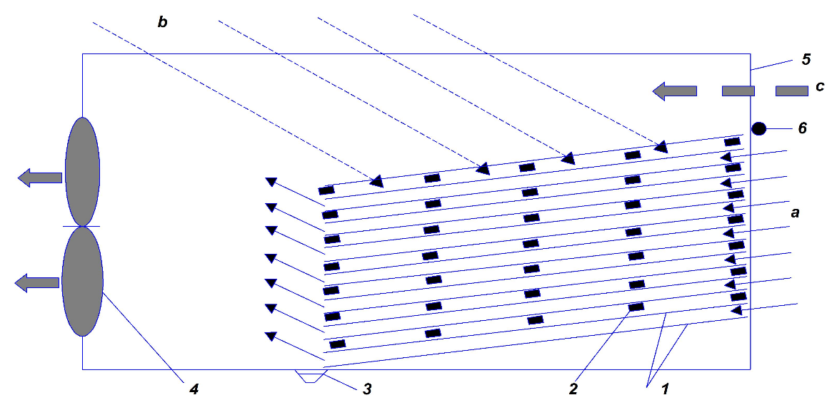
FIGURE1. Cross-section of a heat recuperator (cited from: Gusev et al., 2012)
1 - galvanized steel sheets; 2 - wooden beam or nipple drinker pipe; 3 - groove for condensate and water drainage during irrigation and washing; 4 - exhaust fan (VO-12); 5 - bypass channel door; 6 - curtain. a - direction of air movement from the poultry house; b - direction of cold air movement into the poultry house; c - direction of air movement through the bypass channel from the poultry house.

Rising energy prices are forcing the search for new ways to reduce poultry house heating costs. An analysis of heat gains and loss patterns in caged poultry houses revealed that 75-82% of heat energy is emitted into the atmosphere along with the exhausted, warm, polluted air. The remaining 18-25% of heat loss is due to losses through the roof, walls, floor, doors, and moisture evaporation (1). The most effective technical solution for reducing poultry house heating energy costs is to use the biological heat generated by the birds to heat the incoming air (2). Commercially available heat recovery units are not suitable for use in poultry houses, as they are primarily designed for air with dust concentrations of up to 0.5 mg/m³, while the dust concentration in poultry house air ranges from 4 to 10 mg/m³. Dust in poultry houses tends to clump, making it very difficult to regenerate filters. The use of filters significantly increases airflow resistance and, consequently, increases energy costs, reducing the efficiency of the recuperate.
The microclimate in animal facilities depends on a number of factors: the local climate, the thermal and humidity conditions of the building's enclosing structures, the level of air exchange or ventilation, heating, sewerage, and lighting, as well as the animals' heat production, their housing density, housing technology, daily routine, and so on. An analysis of the energy consumption structure on livestock farms shows that the cost of creating and maintaining an optimal microclimate in the facilities accounts for 40 to 90% of total energy consumption. The main ways to reduce energy costs are by reducing heat loss through the building's enclosing structures and through ventilation air. Of the above methods, the most interesting is the development and use of technical means to recover the heat from exhaust air and use it to partially or completely cover the building's heat deficit [17÷19]. Recently, heat-exchange ventilation, which utilizes the biological heat generated by animals and then uses it to heat the supply air, has become increasingly common. This reduces the heat required to heat the supply air. Various heat exchanger designs have been proposed, but most have significant drawbacks.
Author [12] also noted that dust accumulation on the heat exchanger surface on the exhaust air side not only impairs heat transfer but also leads to increased pressure resistance as dust deposition grows. To prevent this, the authors recommended a water-based cleaning system.

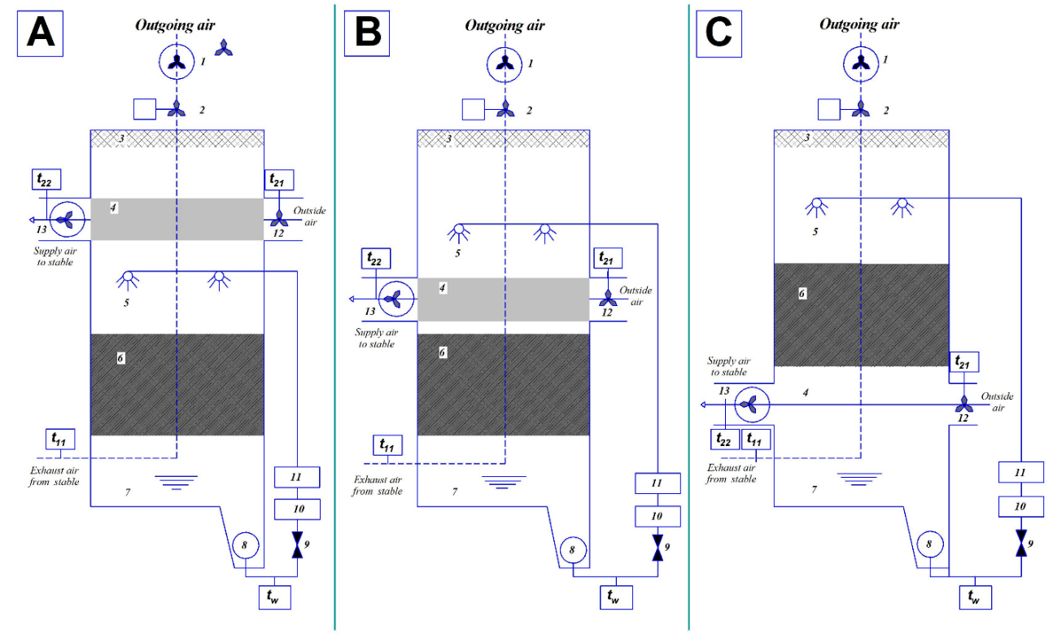
FIGURE 2. Diagram of an exchange unit for mechanically ventilated livestock facilities, capable of simultaneously cleaning exhaust air and recovering heat.
A, B, C - investigated assembly variants of the heat exchanger unit. A -Heat exchanger above, not sprayed. B - Heat exchanger above, sprayed. C - Heat exchanger below, sprayed. 1-exhaust air fan, 2-exhaust air measuring fan, 3-mist eliminator, 4-heat exchanger (cross-current), 5-spray nozzles, 6-packing material, 7-scrubbing water basin, 8-recircutation pump, 9-ball valve, 10-flow indicator (water meter), 11-bourdon-tube gauge, 12-supply air measuring fan, 13- supply air fan.

Pollutants generated by intensive livestock and poultry farming include particulate matter, ammonia $({NH}_{3})$, and greenhouse gases such as methane $({CH}_{4})$ and nitrous oxide $(N_{2}O)$. Several studies have demonstrated that exhaust air purification systems in pig farms and poultry facilities can reduce emissions of particulate matter and ${NH}_{3}$ [20]. Interestingly, author published a study [21] reporting on a scientific approach to developing a multi-stage air purification system with an integrated heat exchanger for broiler chicken farming [21]. The first purification stage employs vertically installed pipes that spray a liquid with a pH of 3.5 to reduce ${NH}_{3}$ emissions; the second stage involves spraying a liquid wit a pH of 6.8 to reduce odor. Since ${NH}_{3}$ emissions during the first few days of broiler rearing are very low (due to the small live weight of broilers and low airflow), only the second stage of processing is required to purify the exhaust air at this phase. However, at this time, the broilers' need for heat is very high (the initial room temperature is approximately 32-34 $°C$), which results in very high exhaust air temperatures. Therefore, during the first few days of broiler rearing, the first stage is used for heat recovery without liquid spraying. Author [22, 23] have also developed a new installation technology for mechanically ventilated livestock buildings. This technology is capable of simultaneously purifying exhaust air and performing heat recovery (Figure 2).
RESEARCH RESULTS
Modern poultry farming emits significant amounts of heat into the atmosphere, and according to the Kyoto Protocol [1÷5], energy is a significant component of the cost of eggs, poultry meat, and all food products made from them. Unique designs of recuperative heat recovery units are proposed that minimize aerodynamic drag, allowing exhaust air to be removed by axial fans. In this case, radial fans are necessary for the inlet, given the use of a heater. In addition to heat recovery, this ventilation system also offers the advantage of being able to operate under both negative and positive pressure conditions in the poultry house, for example, during the start-up period for broilers. The proposed heat recovery unit was tested in a pilot poultry house, where the installation demonstrated high efficiency and a one-third reduction in annual heat consumption compared to other poultry farms located in a similar climate zone. Tests of a ventilation and heating system with a heat recovery unit have shown that by preheating the supply air with heat from the exhaust air, heat consumption during the cold season can be reduced by 30-35%, with an average outdoor temperature of -7.2°C over five winter months. Since the cost of a home-made heat recovery unit is relatively low, the payback period is no more than one year. During the first period of broiler rearing (from one day old to 14-20 days old), the heat recovery unit can be used during the warm and transitional periods of the year. During the hot season, the heat recovery units' plates can be sprayed with water, reducing the supply air temperature.
Furthermore, the heat recovery unit's temperature efficiency coefficient of 0.5 allows for savings of up to 80% of heat energy during the heating season. The unit is designed for large pig fattening facilities, which, under normal occupancy, have sufficient heat surplus to effectively recover heat from the exhaust air. Taking into account scientific advances in production organization and the use of the latest digital technologies for regulating technological processes based on energy efficiency, it is possible to increase animal productivity, reduce animal diseases, and decrease energy consumption by 40-50%. The optimal distribution pattern of temperature and velocity fields in a microclimate control unit distributing air through a perforated variable-section duct has been identified. During the cold season, the average temperature of 22.6–22.8 °C is formed within the velocity field range of 0.24–0.28 m/s. The maximum temperature and velocity values are 21.6–23.1 °C and 0.13–0.41 m/s. During the transition period, the temperature of 22.9–23.1 °C is formed within the velocity field range of 0.35–0.39 m/s. The maximum temperature and velocity values are 22.4–24.0 °C and 0.25–0.53 m/s.
CONCLUSIONS
Thus, it is evident that today there is a need to implement innovative, environmentally friendly, cost-effective, and energy-saving strategies to reduce energy consumption. One such approach is the use of recuperators (heat recovery units), i.e., surface-type heat exchangers, to utilize the energy from exhaust gases. The use of recuperative heat energy systems in poultry houses can significantly impact the conservation of energy resources in poultry management. However, to date, there is insufficient research in this area. In the future, the development and application of new heat supply technologies remain important and complex fields of research in poultry farming. As practice has shown, rapid microclimate calculations based on "average" parameters lead to excessive energy expenditure and are one of the reasons why poultry fails to reach their productivity potential. Only the use of optimized microclimate control algorithms can solve these problems. By taking into account scientific advances in production management and the use of the latest digital technologies for regulating technological processes based on energy efficiency, it is possible to increase animal productivity, reduce animal diseases, and reduce energy consumption by 40-50%.

REFERENCES
1. Cuce P. M. A comprehensive review of heat recovery systems for building applications / P. M. Cuce, S. Rifat // Renew. Sustain. Energy Rev. 2015. Vol. 47. P. 665–682. https://doi.org/10.1016/j.rser.2015.03.087
2. Ivanova-Peneva S. G. Ammonia emissions from organic housing systems with fattening pigs / S. G. Ivanova-Peneva, A. J. A. Aarnink, M. W. A. Ver-stegen // Biosyst. Eng. 2008. Vol. 99. P. 412–422. https://doi.org/10.1016/j.biosystemseng.2007.11.006
3. Krommweh M. S. Heating performance of a laboratory pilot-plant combining heat exchanger and air scrubber for animal houses / M. S. Krommweh, W. Büscher // Scientific reports. 2021. Vol. 11(1). P. 6872. https://doi.org/10.1038/s41598-021-86159-5
4. Mardiana A. Review on physical and performance parameters of heat recovery systems for building applications / A. Mardiana, S. B. Rifat // Renew. Sustain. Energy Rev. 2013. Vol. 28. P. 174–190. https://doi.org/10.1016/j.rser.2013.07.016
5. Mardiana-Idayu A. Review on heat recovery technologies for building applications / A. Mardiana- Idayu, S. B. Rifat // Renew. Sustain. Energy Rev. 2012. Vol. 16. P. 1241–1255. https://doi.org/10.1016/j.rser.2011.09.026
6. Vitt R. Modelled performance of energy saving air treatment devices to mitigate heat stress for confined livestock buildings in Central Europe / R. Vitt, L. Weber, W. Zollitsch et al. // Biosyst Eng. 2017. Vol. 164. P. 85–97. https://doi.org/10.1016/j.biosystemseng.2017.09.013
7. Winkel A. Emissions of particulate matter from animal houses in the Netherlands / A. Winkel, J. Mosquera, P. W. G. Groot Koerkamp et al. // Atmos. Environ. 2015. Vol. 111. P. 202–212. https://doi.org/10.1016/j.atmosenv.2015.03.047
8. Yuanlong C. A comprehensive review on renewable and sustainable heating systems for poultry farming / C. Yuanlong, T. Elmer, G. Tugba et al. // International Journal of Low-Carbon Technologies. 2020. Vol. 15(1). P. 121–142. https://doi.org/10.1093/ijlct/ctz048
9. Siroj Yarashev., Gulnoza Azizova., Nizomjon Usmonov. Study of energy regularities of direct evaporative air-cooling modes. E3S Web of Conferences 563, 01012 (2024) https://doi.org/10.1051/e3sconf/202456301012
10. B.B. Shodiyev. A review of heat recovery technology for passive ventilation applications. E3S Web of Conferences 434, 01034 (2023) https://doi.org/10.1051/e3sconf/202343401034
11. J.Y. Usmonov. Research of aerodynamic resistance in the channels of heat exchange nozzles for poultry. E3S Web of Conferences 563, 01013 (2024) https://doi.org/10.1051/e3sconf/202456301013
12. A.G. Hazratov. Selection of optimal design of heat exchanger for regenerative indirect evaporative cooling. E3S Web of Conferences 563, 01014 (2024) https://doi.org/10.1051/e3sconf/202456301014
13. N.O. Usmonov. Calculation of evaporative-radiant cooling of recycled water in summer air-conditioning systems. E3S Web of Conferences 401, 05052 (2023) https://doi.org/10.1051/e3sconf/202340105052
14. N.O. Usmonov. About possibility of using natural sources of cold in air conditioning system. E3S Web of Conferences 401, 04059 (2023) https://doi.org/10.1051/e3sconf/202340104059
15. F.X. Mukhtarov. Study on the cost effectiveness of a combined evaporation unit. E3S Web of Conferences 434, 01023 (2023) https://doi.org/10.1051/e3sconf/202343401023
16. Kh. Norboyev. Study of the influence of cooling water quality and inhibitors on the corrosion rate of brass in cooling water. E3S Web of Conferences 434, 01029 (2023) https://doi.org/10.1051/e3sconf/202343401029
17. Kh. Norboyev et. Development of a mathematical model of a recycling cooling system of a thermal power plant. E3S Web of Conferences 434, 01030 (2023) https://doi.org/10.1051/e3sconf/202343401029
18. Farrukh. Mukhtarov., Siroj Yarashev. Development of circuit solutions for a wind turbine on the basis of integrated membrane technologies for steam-gas thermal power plants. E3S Web of Conferences 434, 01022 (2023) https://doi.org/10.1051/e3sconf/202343401022
19. Chunmei Guo, Yu Li, Xianli Li, Ruxue Bai, Chuans’huai Dong. Design Selection Method of Yexhaust Air Heat Recovery Type Indirect Yevaporative Cooler // Sustainability 2023, 15, 7371. https://doi.org/10.3390/su15097371
20. Tuncay Yilmaz, Orhan Büyükalaca. (2003) Design of Regenerative Heat Yexchangers // Heat Transfer Yengineering, 24:4, 32-38, https://doi.org/10.1080/01457630304034
21. Orhan Büyükalaca, Tuncay Yilmaz. Influence of rotational speed on yeffectiveness of rotary-type heat yexchanger // Heat and mass transfer 38 (2002) 441-447. https://doi.org/10.1007/s002310100277
22. Yewa Zender–Swiercz. A Review of Heat Recovery in Ventilation // Yenergies 2021, 14, 1759. https://doi.org/10.3390/en14061759

