Mathematical and Computational Simulation of Heat and Mass Transfer During Air Ventilation in Poultry Facilities
Saodat Axmatova¹, Jamshid Usmonov^{1,a)}, Nizomjon Usmonov²
¹Tashkent state technical university named after Islam Karimov, Tashkent, Uzbekistan
²Tashkent international university of financial management and technologies, Tashkent, Uzbekistan
^{a)} Corresponding author: usmonovjamshid819@gmail.com
Abstract. In this article during the hot season, poultry houses experience significant internal heat gains (temperatures exceeding the maximum permissible temperature by 10°C or more). Ventilation systems are unable to neutralize this heat, as their capacity can only be increased to a maximum. This limit is determined by the maximum permissible air velocity in the poultry area. Therefore, research aimed at improving temperature and humidity parameters in poultry houses is relevant and has significant economic significance. Mathematical modeling of heat and mass transfer processes during air ventilation in poultry housing has been conducted. To cool the incoming air, new designs of heat exchangers are proposed, which utilize underground well water as a coolant. As a result of numerical modeling using the ANSYS Fluent 14.0 CAD software, velocity, temperature, and pressure fields in the poultry house were obtained. Recommendations are provided for selecting the design of ventilation systems in poultry houses. A new method for cooling poultry houses during the summer season has been proposed, utilizing heat exchangers-recuperates that use underground well water as a coolant. This approach enables lowering the air temperature in the poultry house to 20 °C without increasing its relative humidity.
INTRODUCTION
The physiological state of birds and the productivity of poultry farms depend on the microclimate maintained in poultry houses. When the main microclimate parameters do not correspond to optimal zoohygienic standards, the weight gain of broiler chickens decreases by 20-30%, egg production of birds decreases by 30%, and losses of young birds reach 30%, leading to significant economic overruns in product manufacturing. The thermal and humidity regime of the poultry house is established as a result of heat and mass transfer processes occurring both inside the facility and through its external enclosure. This regime is formed under the influence of the heating and ventilation system, depending on the meteorological parameters of the outside air and the thermal engineering characteristics of the building structures. The impact of temperature on poultry health is explained by the fact that poultry have an underdeveloped thermoregulatory system, lacking sweat glands and relying primarily on water evaporation during respiration. Excessive humidity in the poultry house will also inhibit this process, potentially leading to heatstroke. Zootechnical requirements for air pollution and air velocity in poultry houses are based on the fact that birds do not tolerate drafts or prolonged exposure to polluted air. During their life cycle, adult poultry emit significantly more heat than other animals. In densely confined cages, a flock emits 200 kJ/h of free heat per cubic meter of space. At the same time, due to moisture evaporation during respiration, up to 60–70 liters of liquid are released in the room in the same hour. All this has an extremely negative impact on the indoor air quality and, consequently, on the physical condition and health of the birds [1÷5].
The essence of the work lies in conducting theoretical studies related to the regulation of heat exchange processes in poultry houses, occurring both inside the premises and through their external enclosures, depending on the meteorological parameters of the outside air and the thermal characteristics of the building structures. The obtained calculation data enable the proper selection of such structures and ventilation systems for poultry houses. The objective of this research is to conduct numerical mathematical modeling of heat and mass transfer processes and calculate local hydrodynamic and thermal characteristics of incoming air in poultry housing facilities during the summer period using the ANSYS Fluent 14.0 CAD package. Additionally, the study aims to develop a new method for cooling poultry houses using a heat exchanger-recuperator that utilizes underground well water as a coolant [6, 7].

MATERIALS AND RESEARCH METHODS
Tunnel ventilation in poultry housing is predominantly used during the summer period (at temperatures above 26 $°C$), which allows for the removal of excess heat generated by the birds. It should be noted that at high ambient temperatures and high air humidity, a specialized system of devices is necessary to cool the air and create an optimal microclimate in the poultry house. In ventilation systems, cooling systems of various types are often used to reduce the temperature of supply air during summer months, predominantly through water spraying methods. This paper proposes a new approach to cooling outdoor air using a recuperative heat exchanger, where water from underground wells serves as the cold heat transfer medium. This method allows for the reduction of outdoor air temperature without increasing air humidity, which is characteristic of, for example, water spray cooling systems [7÷11].
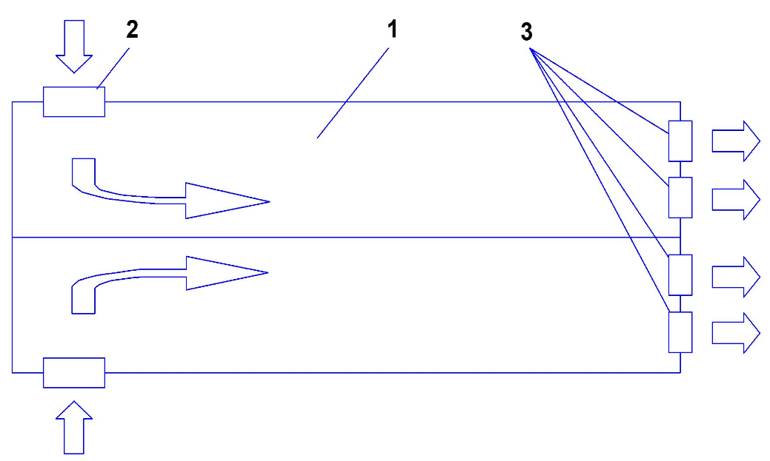
FIGURE 1. Schematic of air circulation in a poultry house (top view): 1 - poultry house premises; 2 - heat exchanger; 3 - ventilation units

Figure 1. schematically illustrates the direction of air movement in the poultry house. The proposed method for cooling the incoming air operates as follows. Warm air from the external environment enters poultry house 1 through heat exchanger recuperators 2 (S₁...S₁₀), which are installed in the ventilation windows. After passing through all sections of the heat exchanger 2, cooled air enters the poultry housing facility 1. The removal of exhaust air from the service area is carried out by individual ventilation units 3 (φ₁...φ₇). The air movement in facility 1 is achieved due to the difference in atmospheric pressure at the inlet of heat exchanger 2 and the outlet of the ventilation unit 3.
Computer mathematical modeling of transport processes in poultry housing. Numerical mathematical modeling of hydrodynamic processes and heat transfer processes in a poultry house has been conducted. For this purpose, the computer modeling method based on the ANSYS Fluent 14.0 software package was utilized. The mathematical model is founded on the Navier-Stokes equations [8] and energy transfer equations for convective flows. The Spalart-Allmaras turbulence model [6, 7] was applied in the calculations. The computations were carried out both with and without the use of a cooling recuperative heat exchanger.
Navier-Stokes equation
$$ρ\left(\frac{∂u}{∂t}+u\frac{∂u}{∂x}+v\frac{∂u}{∂y}+w\frac{∂u}{∂z}\right)=-\frac{∂p}{∂x}+μ\left(\frac{∂^{2}u}{∂x^{2}}+\frac{∂^{2}u}{∂y^{2}}+\frac{∂^{2}u}{∂z^{2}}\right),$$
$ρ\left(\frac{∂u}{∂t}+u\frac{∂u}{∂x}+v\frac{∂u}{∂y}+w\frac{∂u}{∂z}\right)=-\frac{∂p}{∂y}+μ\left(\frac{∂^{2}u}{∂x^{2}}+\frac{∂^{2}u}{∂y^{2}}+\frac{∂^{2}u}{∂z^{2}}\right),$ (1)
$$ρ\left(\frac{∂u}{∂t}+u\frac{∂u}{∂x}+v\frac{∂u}{∂y}+w\frac{∂u}{∂z}\right)=-\frac{∂p}{∂z}+μ\left(\frac{∂^{2}u}{∂x^{2}}+\frac{∂^{2}u}{∂y^{2}}+\frac{∂^{2}u}{∂z^{2}}\right),$$
where $ρ$ is the density of the medium, $kg/m^{3}$; $μ$ is the dynamic viscosity of the medium, $Pa·s$; p is the pressure, Pa; u, v, we are components of the velocity vector field; t is time, s.
Continuity equation (2)
$\frac{∂u}{∂x}+\frac{∂u}{∂y}+\frac{∂u}{∂z}=0$ (2)
Energy conservation equation (3)
$ρC_{p}\left(V_{x}\frac{∂T}{∂x}+V_{y}\frac{∂T}{∂y}+V_{z}\frac{∂T}{∂z}\right)= \frac{∂}{∂x}\left(λ\frac{∂T}{∂x}\right)+\frac{∂}{∂y}\left(λ\frac{∂T}{∂y}\right)+\frac{∂}{∂z}\left(λ\frac{∂T}{∂z}\right)$ (3)
where $T$ is the temperature at a given point, $K$; λ is the thermal conductivity coefficient of the medium, $W/m·K$; $c_{p}$ is the specific heat capacity of the medium, $J/kg·K.$
Boundary conditions. We set the boundary conditions (see Figure. 1.) at the inlet ventilation openings of the front end wall:
$$y^{'}Si≤y≤y^{"}Si; z^{'}Si≤z≤z^{"}Si;$$
$i=1,2…6; S_{i}\left(y=±\frac{M}{2},x,z\right);$ (4)
$$W=W_{in}; T=T_{s;}$$
on the inlet ventilation openings of the side walls:
$$x^{'}Si≤x≤x^{"}Si; z^{'}Si≤z≤z^{"}Si;$$
$i=7,8…10; S_{i}\left(y=±\frac{M}{2},x,z\right);$ (5)
$$W=W_{in}; T=T_{s;}$$
on the exhaust ventilation openings, where the fans are located on the rear end wall:
$$y_{φi}^{'}(z)≤y≤y_{φi}^{"}(z); z_{φi}^{'}(y)≤z≤z_{φi}^{"}(y);$$
$i=1,2…7; φ_{i}\left(x=L,y,z\right);$ (6)
$$W=W_{in}; \frac{∂T}{∂x}=0 ;$$
adhesion conditions of the air heat transfer fluid on the front end wall:
$$-\frac{M}{2}≤y≤\frac{M}{2}; 0≤z≤H+h\left(y\right);$$
$0≤h\left(y\right)≤h_{high};$ (7)
$y∉S_{i}\left(x=0,y,z\right); i=1,2…6; W=0 ; T=T_{wall}$;
Adhesion conditions on the rear end wall:
$$-\frac{M}{2}≤y≤\frac{M}{2}; 0≤z≤H+h\left(y\right);$$
$0≤h\left(y\right)≤h_{high};$ (8)
$y∉S_{i}\left(x=L,y,z\right); i=1,2…7; W=0 ; T=T_{wall}$;
Adhesion conditions on the side walls and ceiling:
$$y=±\frac{M}{2};0≤x≤L; 0≤z≤H+h\left(y\right);$$
$y∉S_{i}\left(y=±M/2,x,z\right);$ (9)
$$z∉S_{i}\left(y=±M/2,x,z\right); i=7,8…10;$$
$W=0 ; T=T_{wall}$;
where $S_{i}(x≤0,y,z)$ is a function that describes the boundaries of the inlet ventilation opeings; $φ_{i}(x=L,y,z)$ is a function that describes the boundaries of the outlet ventilation openings; $L$ - length of the side walls of the poultry house, m; $M$ - width of the front and rear end walls, m; $H$ - height of the poultry house, m; $h (y)$ - function of the roof height in the $0y$cross-section, m; $T_{wall}$ - wall temperature, $°C$; $W_{in}$ - inlet air velocity into the poultry house, $m/s$; $W_{out}$ - outlet air velocity from the poultry house, $m/s$.
Turbulence model (Spalarta-Allmarasa)

$\frac{∂}{∂t}\left(ρv\right)+\frac{∂}{{∂x}_{i}}\left(ρvu_{i}\right)=G_{ω}+\frac{1}{σv}\left[\frac{∂}{∂x_{i}}\left\{\left(μ+ρv\right)\frac{∂v}{∂x_{i}}\right\}+C_{b2ρ}{(\frac{∂v}{∂x_{i}})}^{2}\right]-Y_{v}+S_{v}$ (10)

where $G_{ω}$ is the production of turbulent viscosity; $Y_{v}$is the destruction of turbulent viscosity, which occurs in the near-wall region due to wall effects, blocking, and viscous damping; $v$ and $C_{b2ρ}$are constants, and $ω$ is the molecular kinematic viscosity; $S_{v}$ is the source term, defined by the user.
All calculations were performed at an air mass flow rate of 170 $kg/s.$ The outdoor air temperature is assumed to be 40 $°C$. The walls and floor are made of expanded clay concrete with a thickness of 200 mm. The calculation was carried out twice, without and with the use of a heat exchanger-recuperator. Outdoor air with an inlet temperature of 40 $°C$ was chosen as the heat transfer medium in the heat exchanger-recuperator. This, in turn, will result in a 20 $°C$ output to water coming from underground wells at a temperature of 10 $°C$. In the poultry houses, birds are kept on the floor, which serves as a source of heat generation [10÷15].
RESEARCH RESULTS
The calculation results for the poultry housing are presented in Figures 2-5. Figures 2. and 3 show the temperature distributions in the service area. When using a heat exchanger recuperate, the inlet temperature in the housing is 20 $°C$. The outlet temperature of the cooled air is about 27 $°C$ due to heat released by the birds. Thus, the birds are surrounded by warm air within the acceptable range, which prevents them from experiencing heat stress. The temperature field in the poultry house is also non-uniform, ranging from 20 to 40 $°C$. Near the walls, the temperature is higher due to the elevated temperature of the outside air.
Tests of a ventilation and heating system with a heat recovery unit have shown that by preheating the supply air with heat from the exhaust air, heat consumption during the cold season can be reduced by 30-35%, with an average outdoor temperature of - 7.2℃ over five winter months. Since the cost of a homemade heat recovery unit is relatively low, the payback period is no more than one year. During the initial period of broiler rearing, the heat recovery unit can be used during the warm and transitional periods of the year. During the hot season, the heat recovery units' plates can be sprayed with water, reducing the supply air temperature [15, 16].

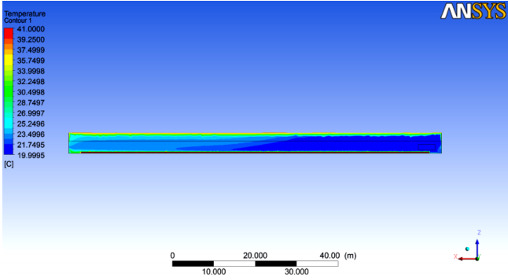
FIGURE 2. Changes in temperature fields along the longitudinal section of the building at the center line, 6 m from the wall

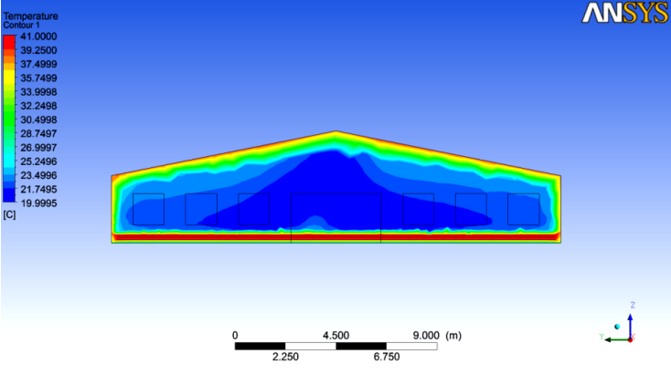

FIGURE 3. Temperature distribution in the poultry house in the building's cross-section along the 0y axis at a distance of 30 m from the entrance

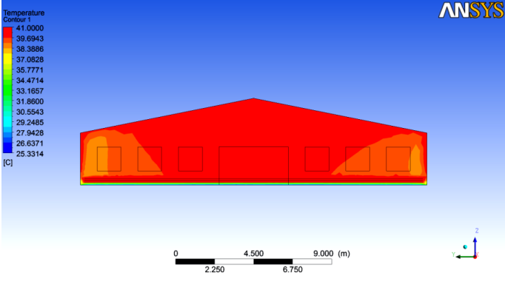
FIGURE 4. Temperature distribution in the poultry house in the building's cross-section along the 0y axis at a distance of 30 m from the entrance

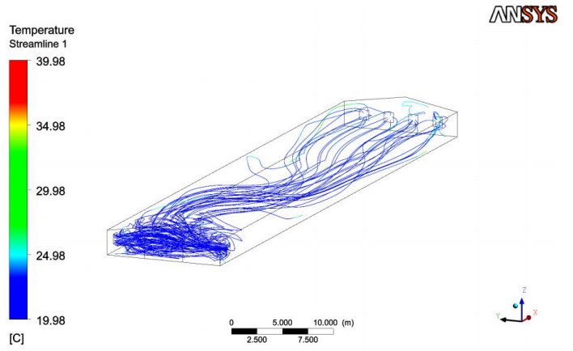
FIGURE 5. Air current patterns in the poultry house
Figure 4. illustrates the temperature distribution with an inlet temperature of outdoor air at 40$°C$, without the use of a heat exchanger-recuperator. The hottest zones are located precisely in the areas where the birds are placed. For two different models, the average air velocity reaches 1.95 $m/s$, which fully complies with the technical design standards for poultry enterprises [17÷20]. Figure.5. depicts the air flow streamlines within the room.
The microclimate determines 20-30% of poultry productivity. Creating and maintaining optimal air conditions in poultry houses is also essential due to the bird's underdeveloped thermoregulatory system. Heat loss occurs primarily through water evaporation during respiration. Adult birds generate significantly more heat during their life cycle than other farm animals generate per kg of live weight. In high concentrations of birds housed in cages, over 200 kJ/h of free heat is released per cubic meter of space [21÷23]. As a result of numerical computer modeling of heat and mass transfer processes in ventilation air, an analysis of temperature, pressure, and velocity distributions of incoming air in a poultry house with a tunnel ventilation system during the summer period was conducted. To normalize temperature parameters in poultry houses during this time of year, it is proposed to use heat exchanger-recuperates, which are integrated into exhaust ventilation units and provide cooling of the incoming air using well water. Thus, the use of this cooling method allows for a reduction in the temperature of the incoming air in the poultry house to 20 $°C$ without increasing the relative humidity of the air. The optimal distribution pattern of temperature and velocity fields in a microclimate control unit distributing air through a perforated variable-section duct has been identified. During the cold season, the average temperature of 22.6–22.8 °C is formed within the velocity field range of 0.24–0.28 m/s. The maximum temperature and velocity values are 21.6–23.1 °C and 0.13–0.41 m/s. During the transition period, the temperature of 22.9–23.1 °C is formed within the velocity field range of 0.35–0.39 m/s. The maximum temperature and velocity values are 22.4–24.0 °C and 0.25–0.53 m/s.
CONCLUSIONS
ANSYS CFX software, which utilizes the finite volume method for calculations, was used for the modeling. The study was conducted for steady-state heat and mass transfer. The modeling results were evaluated using temperature and humidity contours in the most characteristic intersecting planes. Due to the inability to directly determine air humidity using the software, a method for determining humidity using an empirical equation was described. Numerical mathematical modeling of heat and mass transfer processes of ventilation air in poultry housing facilities was conducted, both with and without the use of heat exchangers as cooling devices for incoming air. Using ANSYS Fluent 14.0 CAD software, velocity, temperature, and pressure fields in the poultry house were obtained. Optimal ventilation regimes for poultry facilities have been determined. A new method for cooling poultry houses during the summer season has been proposed, utilizing heat exchangers-recuperators that use underground well water as a coolant. This approach enables lowering the air temperature in the poultry house to 20 °C without increasing its relative humidity.
REFERENCES
1. Bardina J.E., Huang P.G., Coakley T.J. Turbulence Modeling Validation, Testing and Development // NASA reports. April 1997.
2. P. Spalart and S. Allmaras. A one-equation turbulence model for aerodynamic flows. Technical Report AIAA-92-0439. American Institute of Aeronautics and Astronautics. 1992. https://doi.org/10.2514/6.1992-439
3. Spalart, P. R., and Allmaras S. R. A One-Equation Turbulence Model for Aerodynamic Flows, La Recherche Aerospatiale. No. 1. 1994. Pp. 5-21. https://doi.org/10.2514/6.1992-439
4. Cuce P. M. A comprehensive review of heat recovery systems for building applications / P. M. Cuce, S. Rifat // Renew. Sustain. Energy Rev. 2015. Vol. 47. P. 665–682. https://doi.org/10.1016/j.rser.2015.03.087
5. Ivanova-Peneva S. G. Ammonia emissions from organic housing systems with fattening pigs / S. G. Ivanova-Peneva, A. J. A. Aarnink, M. W. A. Ver-stegen // Biosyst. Eng. 2008. Vol. 99. P. 412–422. https://doi.org/10.1016/j.biosystemseng.2007.11.006
6. Krommweh M. S. Heating performance of a laboratory pilot-plant combining heat exchanger and air scrubber for animal houses / M. S. Krommweh, W. Büscher // Scientific reports. 2021. Vol. 11(1). P. 6872. https://doi.org/10.1038/s41598-021-86159-5
7. Mardiana A. Review on physical and performance parameters of heat recovery systems for building applications / A. Mardiana, S. B. Rifat // Renew. Sustain. Energy Rev. 2013. Vol. 28. P. 174–190. https://doi.org/10.1016/j.rser.2013.07.016
8. Mardiana-Idayu A. Review on heat recovery technologies for building applications / A. Mardiana- Idayu, S. B. Rifat // Renew. Sustain. Energy Rev. 2012. Vol. 16. P. 1241–1255. https://doi.org/10.1016/j.rser.2011.09.026
9. Vitt R. Modelled performance of energy saving air treatment devices to mitigate heat stress for confined livestock buildings in Central Europe / R. Vitt, L. Weber, W. Zollitsch et al. // Biosyst Eng. 2017. Vol. 164. P. 85–97. https://doi.org/10.1016/j.biosystemseng.2017.09.013
10. Winkel A. Emissions of particulate matter from animal houses in the Netherlands / A. Winkel, J. Mosquera, P. W. G. Groot Koerkamp et al. // Atmos. Environ. 2015. Vol. 111. P. 202–212. https://doi.org/10.1016/j.atmosenv.2015.03.047
11. Yuanlong C. A comprehensive review on renewable and sustainable heating systems for poultry farming / C. Yuanlong, T. Elmer, G. Tugba et al. // International Journal of Low-Carbon Technologies. 2020. Vol. 15(1). P. 121–142. https://doi.org/10.1093/ijlct/ctz048
12 Siroj Yarashev., Gulnoza Azizova., Nizomjon Usmonov. Study of energy regularities of direct evaporative air-cooling modes. E3S Web of Conferences 563, 01012 (2024) https://doi.org/10.1051/e3sconf/202456301012
13. B.B. Shodiyev. A review of heat recovery technology for passive ventilation applications. E3S Web of Conferences 434, 01034 (2023) https://doi.org/10.1051/e3sconf/202343401034
14. . J.Y. Usmonov. Research of aerodynamic resistance in the channels of heat exchange nozzles for poultry. E3S Web of Conferences 563, 01013 (2024) https://doi.org/10.1051/e3sconf/202456301013
15. A.G. Hazratov. Selection of optimal design of heat exchanger for regenerative indirect evaporative cooling. E3S Web of Conferences 563, 01014 (2024) https://doi.org/10.1051/e3sconf/202456301014
16. N.O. Usmonov. Calculation of evaporative-radiant cooling of recycled water in summer air-conditioning systems. E3S Web of Conferences 401, 05052 (2023) https://doi.org/10.1051/e3sconf/202340105052
17. N.O. Usmonov. About possibility of using natural sources of cold in air conditioning system. E3S Web of Conferences 401, 04059 (2023) https://doi.org/10.1051/e3sconf/202340104059
18. F.X. Mukhtarov. Study on the cost effectiveness of a combined evaporation unit. E3S Web of Conferences 434, 01023 (2023) https://doi.org/10.1051/e3sconf/202343401023
19. Kh. Norboyev. Study of the influence of cooling water quality and inhibitors on the corrosion rate of brass in cooling water. E3S Web of Conferences 434, 01029 (2023) https://doi.org/10.1051/e3sconf/202343401029
20. Kh. Norboyev et. Development of a mathematical model of a recycling cooling system of a thermal power plant. E3S Web of Conferences 434, 01030 (2023) https://doi.org/10.1051/e3sconf/202343401029
21. Farrukh. Mukhtarov., Siroj Yarashev. Development of circuit solutions for a wind turbine on the basis of integrated membrane technologies for steam-gas thermal power plants. E3S Web of Conferences 434, 01022 (2023) https://doi.org/10.1051/e3sconf/202343401022
22. I. P. Salaev, N. A. Koroleva, V. A. Ofitserov, A. V. Ivanov, A. P. Bakharev Microclimate, ventilation and gas co
mposition of air in poultry houses (review) // Poultry Farming. 2016. - No. 6.- P. 44-49. https://doi.org/10.15688/jvolsu11.2018.2.3
23. Ovsyannikov, A. P. Microclimate indicators in the poultry house for laying hens / A. P. Ovsyannikov, S. M. Domolazov // Scientific Notes of the Kazan State Academy of Veterinary Medicine named after N.E. Bauman. - 2015.Vol. 221. - No. 1. - pp. 160-161.

