Mathematical modeling of an indirect-evaporative regenerative heat and mass transfer apparatus
Siroj Yarashov^{1,a)}, Farrukh Mukhtarov¹, Nizomjon Usmonov²
¹Tashkent state technical university named after Islam Karimov, Tashkent, Uzbekistan
²Tashkent international university of financial management and technologies, Tashkent, Uzbekistan
^{a)} Corresponding author: sirojyarashov@gmail.com
Abstract. This work analyzes an indirect-evaporative regenerative heat and mass transfer apparatus. To analyze the working processes occurring in this apparatus, it is first necessary to develop a suitable mathematical model that would allow for a sufficiently accurate assessment of the distribution of all key operating parameters of the flows within the apparatus. To address this, an analysis of contemporary works by various foreign authors was conducted, in which mathematical models of indirect evaporative cooling devices were studied in different forms. However, the number of domestic publications that have performed mathematical modeling of indirect evaporative devices is small. The fact that this area attracts interest from many foreign researchers indicates the necessity to develop this topic, including in our country. This study presents a comprehensive mathematical model of an indirect-evaporative regenerative heat and mass transfer apparatus, designed for efficient cooling applications. The apparatus leverages the principles of heat exchange and evaporative cooling to achieve energy-efficient performance, with two separate air streams: a primary air stream cooled for delivery and a secondary air stream facilitating evaporative heat rejection. The model incorporates coupled heat and mass transfer equations, energy balances, and mass transfer mechanisms for dry and wet channels.
INTRODUCTION
The widespread use of existing refrigeration units in air conditioning systems using traditional energy sources is associated with significant energy costs and poses a significant environmental hazard as an additional source of thermal and chemical pollution. Therefore, reducing the energy intensity of modern manufacturers by partially replacing refrigeration units with units that utilize the thermodynamic nonequilibrium of atmospheric air as a renewable energy source is a pressing issue. Systems that utilize this energy to generate cold include direct and indirect evaporative air cooling units. Low cost and energy consumption, ease of maintenance and reliability, and high environmental performance are the main advantages of evaporative air cooling units. Therefore, much attention has recently been paid to the development of low-energy evaporative cooling units for air conditioning systems and establishing conditions for their efficient implementation of heat and mass transfer processes [1÷8].
Evaporative cooling is an energy-efficient and cost-effective method of air conditioning. Evaporative cooling is classified into two main categories: direct evaporative cooling and indirect evaporative cooling. In systems with direct evaporative cooling (Fig. 1, a), air is in direct contact with water. Heat and mass transfer processes between air and water reduce the dry-bulb temperature of the air and increase its humidity. As a result, warm dry air becomes cool and moist, but its enthalpy remains constant. Existing direct evaporative cooling systems are 75-90% effective in terms of the wet-bulb temperature of the incoming air and are suitable only for use in dry, hot climates, or in spaces requiring both cooling and humidification [6÷11]. Systems with indirect evaporative cooling (Fig. 1, b) can lower air temperature without adding moisture. The wet side absorbs heat from the dry side through water evaporation, thereby cooling the dry side, while the latent heat of water evaporation is transferred to the air in the moist channels. The minimum temperature achievable through both direct and indirect evaporative cooling is limited by the wet-bulb temperature of the ambient air. To cool the product air stream to a temperature below the wet-bulb temperature of the outdoor air, the working air must first be pre-cooled indirectly before being fed into the wet channels. Temperatures below the wet-bulb temperature can be achieved through regenerative indirect evaporative cooling (Fig. 2), as the working airflow at the entrance to the wet channels has a lower wet-bulb temperature compared to the ambient air. Henceforth, we will use the abbreviated designation regenerative heat and mass transfer apparatus (RHMA) for this regenerative heat and mass transfer apparatus.
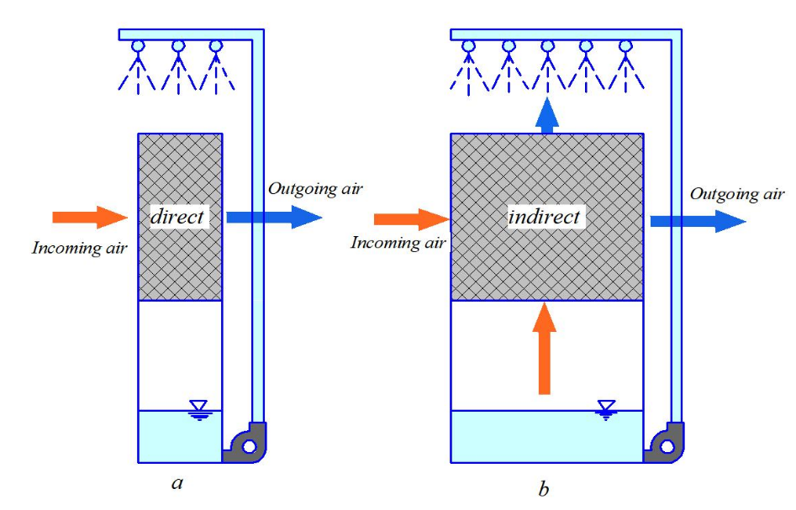
FIGURE 1. Types of air evaporative cooling
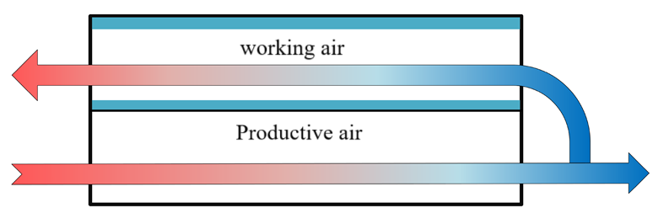
FIGURE 2. Regenerative indirect evaporative cooling

MATHEMATICAL MODELING
According to the classification of regenerative heat exchanger designs given in [2] and some other sources mentioned in [1], the apparatus in question is classified as a cross-flow design with two immiscible flows, where both working fluid flows change their parameters along both coordinates. For this case, the mathematical description of heat exchange is considered within the framework of the Newton-Reichmann model, where we are interested in the distribution of the medium's parameters in space along the heat exchange surface and, as a result, their values at the apparatus outlet. This can be accomplished in the following form.
When discussing the performance analysis of RHMA, it can be stated that for its evaluation, it is advisable to use wet-bulb efficiency, dew point efficiency, cooling capacity, as well as “room cooling capacity” [8÷10]. Wet-bulb effectiveness is defined as the ratio of the difference between the incoming and outgoing air temperatures to the difference between the incoming air temperature and its wet-bulb temperature. This can be expressed as:

$ε_{w.t}=\frac{t_{in}-t_{out}}{t_{in}-t_{in}^{w.t}}$ (1)
Accordingly, the dew point efficiency can be defined as the ratio of the difference between the incoming and outgoing air temperatures to the difference between the incoming air temperature and its dew point temperature. This can be expressed as follows:
$ε_{w.t}=\frac{t_{in}-t_{out}}{t_{in}-t_{in}^{D.t}}$ (2)
As indicated in the work [1], these criteria for evaluating the performance of RHMA are insufficient. For example, an RHMA may have high wet-bulb efficiency, but if the air flow entering it is small, it cannot effectively meet the room’s cooling needs. On the other hand, if the RHMA has a high cooling capacity, but the supplied air temperature is higher than or equal to the comfort temperature, this will also be unacceptable. Therefore, according to the author of article [1, 2], a more objective criterion for evaluating the performance of RHMA is the so-called “room cooling capacity” (RCC), which is the product of the mass flow rate of air supplied to the room, the specific heat capacity of the supplied air, and the difference between the temperature of the supplied air and the comfort temperature. The comfort temperature is assumed to be 25°C [11, 12]. Thus, this expression can be written as:
$CC=M_{sa}c_{p}(t_{sa}-t_{comf})$ (3)
To obtain values of temperature, moisture content, and enthalpy distribution throughout the RHMA, it is necessary to develop a heat and mass transfer model. There are several approaches to developing a mathematical model for RHMA [13÷15]. In the first case, the apparatus is divided into a certain number of computational elements, and calculations are carried out on each of these elements using iterative methods [2, 4, 10]. In the second case, the entire apparatus is considered as a single element, and the ε-NTU method is employed for solving [7, 16, 17]. This paper proposes the use of the first method.
The schematic diagram of the RHMA and the computational element used for numerical analysis are shown in Figure 3 and Figure 4, respectively.

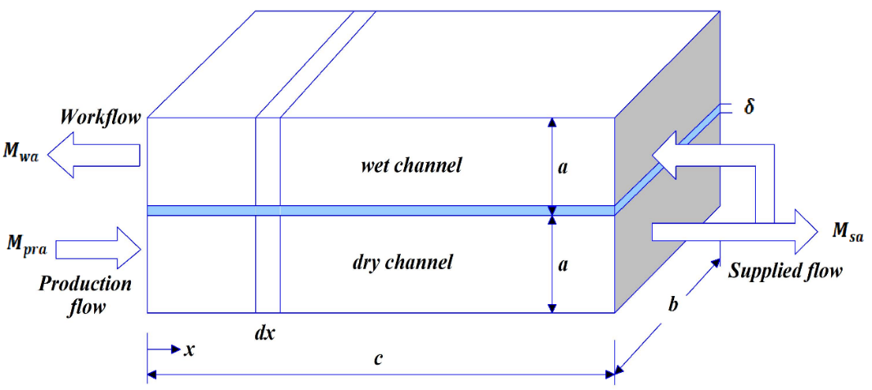
FIGURE 3. The scheme of the regenerative heat and mass transfer apparatus

To simplify the mathematical model, the following assumptions were made [11]: the flow is incompressible and uniform; longitudinal thermal conductivity and mass transfer are negligible, as the Peclet number (Pe) is greater than 100; heat is not transferred to the surrounding environment; the height of the channel is small compared to its width, thus the model can be considered one-dimensional; the small channel size and low air velocity result in low Reynolds numbers (100<Re<400) under optimal operating conditions; consequently, the flow along the channel is assumed to be fully developed and laminar; due to the low transfer velocities, the Reynolds analogy can be applied, and the Lewis number is assumed to be unity; the temperature of the air-water interface is considered equal to the temperature of the water film due to the negligible thermal resistance of the water film.
At the same time, in the mathematical models described in works [18÷21], the specific heat capacities and heat and mass transfer coefficients are considered constant. In the proposed model, however, these parameters are treated as variables and are recalculated taking into account the changes in flow temperatures within the apparatus. The author of work [18] demonstrated that by applying the principles of heat and mass conservation to the computational element and considering the aforementioned assumptions, the following set of fundamental equations can be derived:
Analysis of the first law of thermodynamics for the production air flow in a dry channel yields:

$M_{pra}=c_{p.ha}\left(t_{pra}^{n.in}-t_{pra}^{n.out}\right)=k\left(t_{pra}^{n}-t_{wf}^{n}\right)dS$ (4)

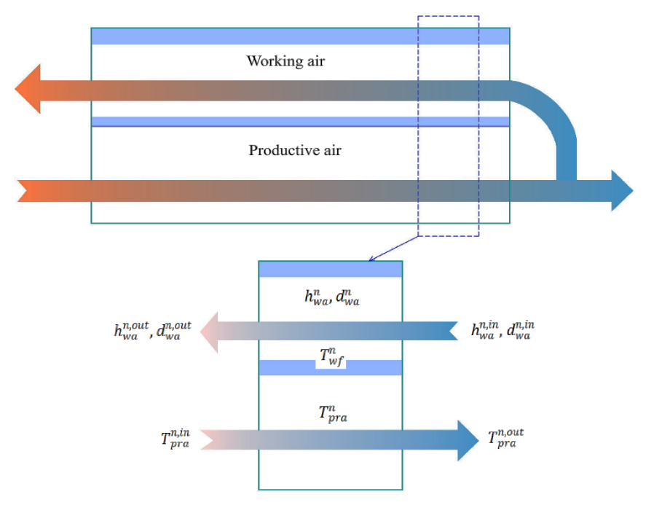
FIGURE 4. Schematic of the computational element

TABLE 1. Decoding symbols in expressions
Designation | Transcription | Unit of measurement
M | mass flow rate | $$\frac{kg}{s}$$
$$c_{p.ha}$$ | the specific heat capacity of humid air | $$\frac{J}{kg∙K}$$
t | temperature | $$℃$$
k | overall heat transfer coefficient | $$\frac{Vt}{m^{2}∙K}$$
S | heat transfer area | $$m^{2}$$
$$β$$ | convective mass transfer coefficient | $$\frac{kg}{m^{2}∙s}$$
h | wet air enthalpy | $$\frac{J}{kg}$$
d | moisture content | $$\frac{{kg}_{humid}}{{kg}_{dry.air}}$$
CC | room cooling capacity | Vt
$$λ_{air}$$ | thermal conductivity of air | $$\frac{Vt}{m∙K}$$
$$λ_{wall}$$ | thermal conductivity of the wall | $$\frac{Vt}{m∙K}$$
$$ϑ$$ | air speed | $$\frac{m}{s}$$
$$μ$$ | dynamic viscosity | $$Pa∙s$$
$$ρ$$ | density | $$\frac{kg}{m^{3}}$$
$d_{h}$, $δ_{wall}$, l, a, b | hydraulic diameter, wall thickness and channel length, height, width | $$m$$
Expression (4) indicates that the change in the enthalpy of the production air flow is equal to the total heat transfer between it and the water film. The law of conservation of energy for the working airflow in a humid channel states:
$M_{wa}\left(h_{wa}^{n.out}-t_{wa}^{n.in}\right)=β\left(h_{sat}^{n}-h_{wa}^{n}\right)dS$ (5)
The term on the left side of expression (5) determines the change in enthalpy of the working air flow, while the term on the right side represents the total energy transfer through convective heat and mass transfer between the working air flow and the water film. The general law of conservation of energy for a differential element can be expressed as:
$M_{pra}∙c_{p.ha}\left(t_{pra}^{n.in}-t_{pra}^{n.out}\right)=M_{wa}∙\left(h_{wa}^{n.out}-t_{wa}^{n.in}\right)$ (6)
Expression (6) signifies that the change in enthalpy of the production air flow is equal to the change in enthalpy of the working airflow. Finally, the law of conservation of mass of water vapor in the humid channel gives:
$M_{wa}\left(d_{wa}^{n.out}-d_{wa}^{n.in}\right)=β\left(d_{sat}^{n}-d_{wa}^{n}\right)dS$ (7)
The term on the left side of expression (7) represents the change in moisture content of the working air flow, while the term on the right side characterizes the convective mass transfer between the working air flow and the water film.
Tables 1 and 2 provide explanations of the notations used in the expressions, as well as the subscript and superscript indices employed in the current and subsequent chapters. The psychrometric properties of humid air, along with the heat and mass transfer coefficients in the aforementioned expressions, can be determined using the mathematical relationships presented in Table 3.
TABLE 2. Decoding subscript and superscript indices
Index | Transcription
n | nodal point
in | incoming
out | outgoing
wf | water film
pra | production air
sat | state of saturation
wa | working air
sa | supplied air

TABLE 3. Mathematical expressions for psychometric properties and heat and mass transfer coefficients
Property | Expression
Saturated vapor pressure | $$P_{sat}=6.1121∙exp\left[\left(18.678-\frac{t}{234.5}\right)∙\left(\frac{t}{257.14+t}\right)\right]∙100$$
The moisture content of saturated air | $$d_{sat}=0.62189\frac{P_{sat}}{P-P_{sat}} , P=101325 Pa$$
Enthalpy of moist air | $$h=1.006t+d(2501+1.86t)$$
Convective heat transfer coefficient | $$α=Nu\frac{λ_{air}}{d_{h}} , Nu=8.235$$
Convective mass transfer coefficient | $$β=\frac{α}{c_{p.ha}} {Le}^{-\frac{2}{3}} , Le=1$$
Overall heat transfer coefficient | $$k={\left(\frac{1}{α}+\frac{δ}{λ_{wall}}\right)}^{-1}, δ=0.0015 m , λ_{wall}=0.6 \frac{Vt}{m∙K}$$

To solve the system of equations (3) - (7) using a numerical method, the heat and mass transfer apparatus is divided into a series of sections (200), and the system of equations is solved sequentially for each section. Additionally, the following boundary conditions are set for the extreme sections of the apparatus: the temperature of the production air at the inlet (first calculation layer) is known and equals 30 °C; the moisture content of the inlet production air is known and equals 0.009 kg/kg; the temperature and moisture content of the working air at the entrance to the humid channels (the last calculated layer) are taken to be equal to the temperature and moisture content of the production flow at the exit. The moisture content at the entrance to the humid channels is equal to 0.009.

RESEARCH RESULTS
Thus, the system of equations (3) - (7) is solved taking into account the aforementioned boundary conditions, and as a result, unknown quantities are determined for all calculated sections, specifically: temperature of the production air stream; enthalpy of the working airflow; moisture content of the working airflow; temperature of the water film. Mathematical modeling was carried out using the Mathcad software package, which enables the comprehensive implementation of calculations for all the aforementioned mathematical expressions. The mathematical model was verified by comparing the obtained results with the data presented by the author of the article [6]. Similar values for all parameters involved in the calculations were adopted.

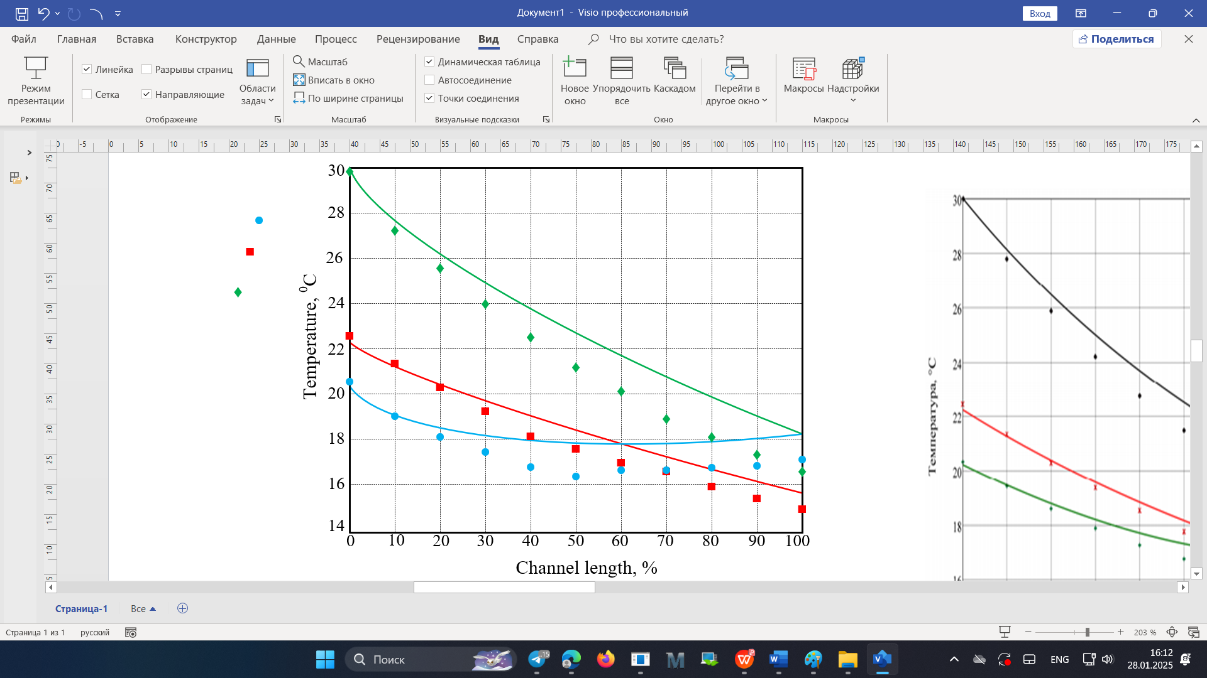
FIGURE 5. Results of calculations using the mathematical model and their comparison with data from

Figure 5 shows a comparison of airflow and water film temperatures based on the mathematical model calculations with the data from [7]. As can be observed, the greatest discrepancy in values occurs at the apparatus outlet, where it amounts to 6% for the temperature of the production and working flows, and 3% for the temperature of the water film. The efficiency indicators of this apparatus can also be calculated, specifically: the wet-bulb efficiency and dew point efficiency:

$$ε_{w.t}=\frac{t_{in}-t_{out}}{t_{in}-t_{in}^{w.t}}=\frac{30-18.22}{30-18.7}=1.042 (8)$$
$$ε_{w.t}=\frac{t_{in}-t_{out}}{t_{in}-t_{in}^{D.t}}=\frac{30-18.22}{30-12.5}=0.67 (9)$$

In the case of direct evaporative cooling, the wet-bulb effectiveness according to ranges from 0.7 to 0.95. In indirect evaporative coolers that do not utilize the principle of regenerative heat and mass transfer, the wet-bulb effectiveness according to data from ranges from 0.4 to 0.6 [9]. In indirect evaporative coolers that do not use the principle of regenerative heat and mass transfer, the efficiency of the wet thermometer according to the data is $ε_{w.b.}=0,4÷0,6$. Thus, the wet-bulb efficiency value obtained in this calculation, $ε_{w.b.}=1,042$ indicates that this apparatus has a significant advantage over the aforementioned ones.

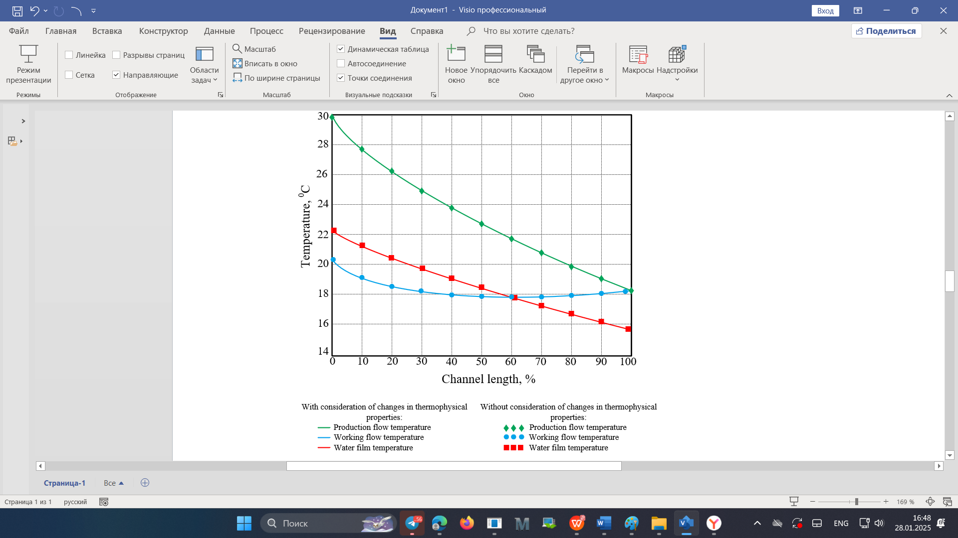
FIGURE 6. Comparison of calculation results considering the variation in thermophysical properties and their constancy

As mentioned earlier, in this model, the specific heat capacity and heat and mass transfer coefficients are considered variable and are calculated considering the change in flow temperatures in the apparatus. Given this circumstance, it is possible to compare the results of calculations using a mathematical model, considering the variability of these parameters and their constancy [12]. This comparison is presented in Figure 6, which shows the values of the flow temperatures in the apparatus, calculated taking into account the variability of the aforementioned parameters and their constant values. The calculation results show that accounting for the properties had a negligible effect on the obtained flow temperature values, with the greatest discrepancy occurring at the apparatus outlet. For the output temperature values of the production and working flows, this discrepancy amounted to 0.6%, while for the output temperature value of the film, it was 0.3%.
CONCLUSIONS
A mathematical model of heat transfers in the "dry" chamber of an air cooler was developed and implemented. Analytical relationships were derived for calculating the temperature of the main air flow at the device outlet. Particle "drying" in the "wet" chamber of the air cooler was determined. An experimental setup was assembled, and laboratory studies of the air cooler's hydrodynamics and heat and mass transfer were conducted.
In this work, an analysis of the working processes occurring in an indirect-evaporative regenerative heat and mass transfer apparatus was conducted using numerical mathematical modeling methods. A mathematical model was proposed that accounts for the variation in specific heat capacity and heat and mass transfer coefficients along the length of the channels as a function of temperature. The distributions of key flow parameters along the length of the apparatus were obtained, and efficiency indicators were calculated under specified conditions. In addition, the dependence of the outgoing flow parameters on the conditions of the air entering the apparatus was investigated, specifically its temperature and moisture content. It was concluded that as the temperature and moisture content of the incoming air increase, the temperature of the supplied air decreases. Subsequently, the impact of the production flow rate and the ratio between working and production flows on the apparatus's efficiency was analyzed. The calculation results indicate that the room's cooling capacity reaches its maximum value when the production flow rate is within the range of 0.0017 - 0.0027 kg/s and the ratio of working to production flows is between 0.3 and 0.4.

REFERENCES
1. Fakhrabadi F., Kowsary F. Optimal design of a regenerative heat and mass exchanger for indirect evaporative cooling // Applied Thermal Engineering. 2016. Т. 102. P. 1384-1394. https://doi.org/10.1016/j.applthermaleng.2016.03.115
2. Hasan A. Indirect evaporative cooling of air to a sub-wet bulb temperature // Applied Thermal Engineering. 2010. Т. 30. №. 16. P. 2460-2468. https://doi.org/10.1016/j.applthermaleng.2010.06.017
3. Moshari S., Heidarinejad G. Numerical study of regenerative evaporative coolers for subwet bulb cooling with cross-and counter-flow configuration // Applied Thermal Engineering. 2015. Т. 89. P. 669-683. https://doi.org/10.1016/j.applthermaleng.2015.06.046
4. Heidarinejad G., Moshari S. Novel modeling of an indirect evaporative cooling system with cross-flow configuration // Energy and Buildings. 2015. Т. 92. P. 351-362. https://doi.org/10.1016/j.enbuild.2015.01.034
5. Riangvilaikul B., Kumar S. Numerical study of a novel dew point evaporative cooling system // Energy and Buildings. 2010. Т. 42. №. 11. P. 2241-2250. https://doi.org/10.1016/j.enbuild.2010.07.020
6. Hsu S. T., Lavan Z., Worek W. M. Optimization of wet-surface heat exchangers // Energy. 1989. Т. 14. №. 11. P. 757-770. https://doi.org/10.1016/0360-5442(89)90009-1
7. Hasan A. Going below the wet-bulb temperature by indirect evaporative cooling: analysis using a modified ε-NTU method // Applied energy. 2012. Т. 89. №. 1. P. 237-245. https://doi.org/10.1016/j.apenergy.2011.07.005
8. Zhao X., Li J. M., Riffat S. B. Numerical study of a novel counter-flow heat and mass exchanger for dew point evaporative cooling // Applied Thermal Engineering. 2008. Т. 28. №. 14. P. 1942-1951. https://doi.org/10.1016/j.applthermaleng.2007.12.006
9. Siroj Yarashev., Gulnoza Azizova., Nizomjon Usmonov. Study of energy regularities of direct evaporative air-cooling modes. E3S Web of Conferences 563, 01012 (2024) https://doi.org/10.1051/e3sconf/202456301012
10. B.B. Shodiyev. A review of heat recovery technology for passive ventilation applications. E3S Web of Conferences 434, 01034 (2023) https://doi.org/10.1051/e3sconf/202343401034
11. J.Y. Usmonov. Research of aerodynamic resistance in the channels of heat exchange nozzles for poultry. E3S Web of Conferences 563, 01013 (2024) https://doi.org/10.1051/e3sconf/202456301013
12. A.G. Hazratov. Selection of optimal design of heat exchanger for regenerative indirect evaporative cooling. E3S Web of Conferences 563, 01014 (2024) https://doi.org/10.1051/e3sconf/202456301014
13. N.O. Usmonov. Calculation of evaporative-radiant cooling of recycled water in summer air-conditioning systems. E3S Web of Conferences 401, 05052 (2023) https://doi.org/10.1051/e3sconf/202340105052
14. N.O. Usmonov. About possibility of using natural sources of cold in air conditioning system. E3S Web of Conferences 401, 04059 (2023) https://doi.org/10.1051/e3sconf/202340104059
15. F.X. Mukhtarov. Study on the cost effectiveness of a combined evaporation unit. E3S Web of Conferences 434, 01023 (2023) https://doi.org/10.1051/e3sconf/202343401023
16. Kh. Norboyev. Study of the influence of cooling water quality and inhibitors on the corrosion rate of brass in cooling water. E3S Web of Conferences 434, 01029 (2023) https://doi.org/10.1051/e3sconf/202343401029
17. Kh. Norboyev et. Development of a mathematical model of a recycling cooling system of a thermal power plant. E3S Web of Conferences 434, 01030 (2023) https://doi.org/10.1051/e3sconf/202343401029
18. Farrukh. Mukhtarov., Siroj Yarashev. Development of circuit solutions for a wind turbine on the basis of integrated membrane technologies for steam-gas thermal power plants. E3S Web of Conferences 434, 01022 (2023) https://doi.org/10.1051/e3sconf/202343401022
19. Wang L., Zhan C., Zhang J. The energy and exergy analysis on the performance of counter-flow heat and mass exchanger for M-cycle indirect evaporative cooling. Therm Sci 2019; 23: 613–623. https://doi.org/10.2298/TSCI171221153W
20. Zhu G.Т., Chow T.А., Lee C.K. Performance analysis of counterflow regenerative heat and mass exchanger for indirect evaporative cooling based on data-driven model. Energy Build (2017) 155:503-512.
21. Fakhrabadi F.А., Kowsary F.Р. Optimal design of a regenerative heat and mass exchanger for indirect evaporative cooling. Appl Therm Eng (2016) 102:1384-1394. https://doi.org/10.1016/j.applthermaleng.2016.03.115

