Methods of analysis and improvement of modern gas engines
Zakirjan Musabekov ^{a)}, Rustam Tillahodjaev, Jamshid Xakimov, Firuza Rakhmatova
Tashkent state technical university named after Islam Karimov, Tashkent, Uzbekistan
a) Corresponding author: zokirmusabekov@gmail.com
Abstract. This article presents the technical characteristics of modern gas engines developed by Cummins, MAN, and Volvo, their analysis in terms of power, torque, fuel consumption, and improvement methods. As a result of the study, it was possible to increase fuel efficiency in gas engines. The Miller cycle, the introduction of gas distribution phase control, and automatic diagnostic systems are considered as the most promising directions, and the Miller cycle used in engines is shown to increase fuel economy and their resource.
INTRODUCTION
The development of environmentally friendly gas engines is rapidly progressing worldwide. Companies such as Cummins, MAN, and Volvo have begun mass production of natural gas engines. Gas engines allow for reduced emissions, lower fuel costs, and improved environmental friendliness. However, their thermodynamic efficiency is still 10–15% lower than that of diesel engines [2,5].
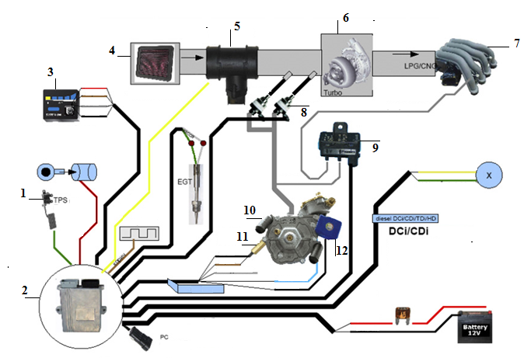
FIGURE 1. Scheme of diesel gas. 1-Throttle pedal, 2- Electronic control unit, 3-Gas system indicator, 4-air filter, 5-air consumable propulsion probe, 6-turbocompressor, 7-Input Collector, 8- Electromagnetic Nozzles, 9-circuit regulator, 10-gas gearbox, 11-temperature sensor, 12-Electromagnetic valve.

TABLE 1. The main technical characteristics of gas engines for motor vehicles
№ | Engine name | Volume.l | Max. torque,  Nm/min-1 | Max. power,  kW/min-1 | Compression ratio | Liter capacity,  kWh/l
- 11 | Cummins CG -- 250 | 8,3 | 1017/1400 | 186 | 11,2 | 22,41
- 22 | MAN E2876 | 12,5 | 1360/1500 | 210 | 11,4 | 16,80
- 4 | "Mercedes" - M447hG | 11,97 | 880/1320 | 175/2200 | 12,5 | 14,62
- 5 | Renault GDR062045 | 9,84 | 1020/1300 | 185/2100 | 12,5 | 18,80
- 6 | "Cummins – Sao Paulo | 8,3 | 894/1200 | 205/2400 | 12,0 | 24,70
- 7 | Skania SGI - 12 | 12,0 | 905/1200 | 192/2200 | 11,0 | 16,00
- 8 | Caterpillar G326 | 6,6 | 900/1250 | 186/2200 | 11,0 | 28,18
- 9 | YC4G180N-30 | 5,25 | 650/1400 | 132/2300 | 11,0 | 25,14
- 1 | Iveco C13 ENT C | 12,9 | 1350/1200 | 297 /1900 | 10,9 | 23,02
- 1 | Iveco 8149.03 | 2.8 | 220 / 2200 | 78 /3800 | 10,9 | 27,86
- 1 | 1ueso N60 ENT G | 5.9 | 650 /1250 | 147/ 2700 | 10,9 | 24,92
- 1 | Iveco C78 ENT G | 7.8 | 1100 / 1650 | 200/ 2000 | 10,9 | 25,64

Gas cars and buses are produced by Volvo, Scania, MAN, Iveco, Mercedes, Kenworth, several factories in China, and IKD (Iran). From the data presented in Table 1, it follows that the maximum torque of modern gas engines for ATVs is 650 ... It is in the range of 1360 Nm, and maximum power is 78,200 kW, and power per liter is in the range of 14.26 kW/l.
Today, almost all engine factories in the world have gas modifications of diesel engine-based engines [1,5,8].

EXPERIMENTAL RESEARCH
In this work, the method of increasing the volume of the combustion chamber and subsequently closing the intake valve was used to convert diesel engines to a gas fuel system. Looking at mass-produced gas engines and diesel engines, we see those various options for changing the engine design were used during the modification.

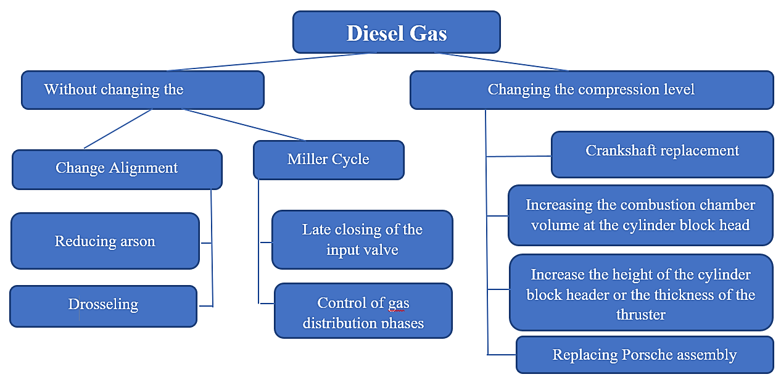
FIGURE 2. Methods for converting a diesel engine to a gas engine.

When converting a diesel engine to a gas engine, there are several options for modifying the engine design shown in Figure 2.
TABLE 2. Main technical indicators of modern gas engines
Engine name | Cylinder capacity | Max. torque (Nm) Max. | Power (kW) | Compression | Ratio Efficiency (%)
Cummins ISL G | 8.9 | 1150 | 239 | 11.2 | 38
MAN, E0836 LOH | 6.9 | 1100 | 206 | 11.4 | 37
Volvo GH10 | 9.6 | 1150 | 184 | 11.5 | 36

The thermodynamic principle of the Miller cycle, its advantages in gas engines, the difference in efficiency compared to the Otto cycle, and its practical application are analyzed. The Miller cycle optimizes the compression process by changing the intake valve closing time in the engine, which ultimately increases thermal efficiency.
The essence of the Miller cycle was developed to improve the combustion process in internal combustion engines, reduce heat losses, and increase fuel efficiency. In this cycle, the intake valve closes earlier or later, which reduces the actual compression ratio but lengthens the expansion phase.

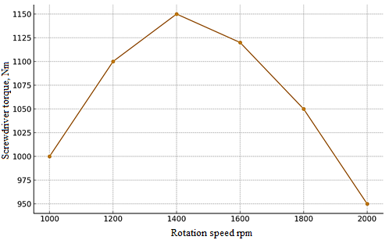
FIGURE 3. Cummins ISL G engine torque graph.

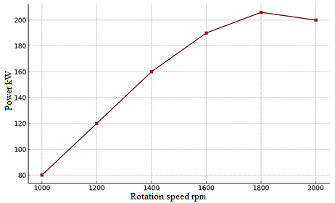
FIGURE 4. MAN, E0836 LOH engine power graph.
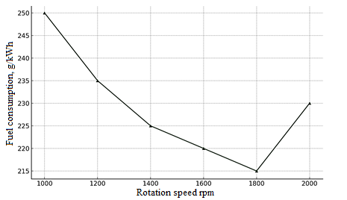
FIGURE 5. Fuel consumption graph of the Volvo GH10 engine.

The P–V diagram compares the pressure-volume changes of the Otto and Miller cycles (Figure 6). As can be seen, in the Miller cycle, the start of compression stops earlier, but the expansion occurs deeper, which increases thermal efficiency.
The experimental, comparative analysis table compares the efficiency, torque, and exhaust gas performance of gas engines operating on the Otto and Miller cycles (Table 3).

TABLE 3. Comparison of the performance of gas engines operating on the Otto and Miller cycles
Engines | Thermal efficiency (%) | Max. moment (Nm) | NOx emissions (%)
Cummins ISL G (Otto) | 35.0 | 1150 | 100
Cummins ISL G (Miller) | 38.8 | 1100 | 70
MAN, E0836 LOH (Miller) | 37.5 | 1080 | 65
Volvo GH10 (Miller) | 36.9 | 1120 | 68

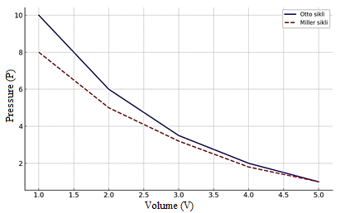
FIGURE 6. Pressure–volume (P–V) diagram of the Miller and Otto cycles.

The advantages of the Miller cycle are an increase in thermal efficiency of 5–15%, a decrease in NOx emissions by 30–40%, and a decrease in the risk of detonation.
Disadvantages: a decrease in torque at full load, a complex valve timing control system is required, and integration with turbo and EGR systems is necessary.
Diagnostics and control of the gas distribution system. The reliability of these gas engines depends on the precise operation of the gas distribution system; the mechanism controlling the opening and closing phases of the valves is automatically adjusted by means of hydraulic compensators. Noise analysis, analysis of metal particles in the oil, infrared, and ferrographic methods are used for technical diagnostics.
Technological trends such as the introduction of automatic control systems for gas distribution phases, optimization of compression pressure through the implementation of the Miller cycle, the use of adaptive algorithms in electronic control units, online analysis of crankcase oil and early detection of malfunctions, and the use of modern catalysts to reduce NOx and CO in exhaust gases are of great importance to increase the efficiency of engines.
CONCLUSIONS
The results of the analysis show that, although modern gas engines are more environmentally friendly than diesel counterparts, complex design and control system improvements are required to increase their power performance. The Miller cycle in gas engines smooths the combustion process, increases thermal efficiency, and reduces exhaust gases. The Miller cycle, used in Cummins, MAN, and Volvo engines, allows for an increase in fuel economy by 10–15% and an engine resource of up to 30%.
REFERENCES
- Zakirjon Musabekov, Rustam Tillahodjaev, Abdulla Mirzayev, Avaz Yangibayev, Hilola Uralova. "Increasing energy efficiency as a result of the influence on the operation of a Sano automobile engine with the addition of hydrogen as an additive to primary fuel doi":10.1088/1755-1315/1284/1/012038
- Rustam Tillahodjaev, Abdulla Mirzayev "Improving the quality of fuel with the use of a zeolite filter in the supply system of engines running on compressed and liquefied gas". Conference: Problems and prospects of innovative techniques and technology in the agri-food chain. Proceedings scientific papers of the III-International Conference. -Tashkent, 2023.At: Tashkent
- Rustam Tillahodjaev, Abdulla Mirzayev "The influence of the correct selection of engine oil on the economic and environmental performance of internal combustion engines with gas-balloon equipment". Academic Leadership 2:11-15 DOI: 10.5281/zenodo.6563097 June 2022
- Rustam Tillahodjaev "Natural compressed and liquefied gases as an alternative to improving the environmental and economic performance of cars". Conference: Problems and prospects of innovative techniques and technology in the agri-food chain. Proceedings scientific papers of the II-International Conference. -Tashkent, 2022.At: Tashkent
- Tulaev BR, Musabekov ZE, Daminov OO. "Application of supercharging to internal combustion engines and increasing efficiency in achieving high environmental standards." AIP Conference Proceedings 2432, 030012 (2022). DOI: 10.1063/5.0090304
- Rustam Tillakhodjaev "Improving the environmental properties and economic performance of gas engines". Conference: Actual problems and techniques of teaching engineering disciplines At: November 2022, Termez
- Musabekov ZE, Khakimov JO, Ergashev B. Differential equations for calculating gas exchange in an internal combustion engine. E3S Web of Conferences 264, 01003 (2021). The International Scientific Conference "Construction Mechanics, Hydraulics and Water Resources Engineering (CONMECHYDRO 2021)". 1-3 April 2021. Published online: 02 June 2021. DOI: 10.1051/e3sconf/202126401003
- Musabekov Z., Khakimov J., Yangiboev A., Tairova N., Usmonov J., Petruchenko A. Flow stabilization and pulsation in external channels in fuel engines. (2023) IOP Conference Series: Earth and Environmental Science, 1142 (1), article no. 012022. DOI: 10.1088/1755-1315/1142/1/012022

