Scientific foundations for the development of highly efficient and innovative technologies for acid gas removal
Ozoda Axmedova ^{a)}, Nazirila Maxmudov, Abdurasul Qayumov, Ra’no Asadova, Suhrob Ergashev, Abror Axmedov
Tashkent state technical university named after Islam Karimov, Tashkent, Uzbekistan
^{a)} Corresponding author: zodamedova@gmail.com
Abstract: This article presents research on the preparation and application of compositions containing the required concentration of activators and corrosion-reducing inhibitors in the absorbent to enhance the complete absorption of acidic components from gases. According to the studies, activation of absorbents with activators allows for more complete absorption of acidic components from gases and reduces the formation of heat-resistant salts, thereby reducing corrosion observed in devices and preventing excessive accumulation in the absorber. It has been established that by varying the operating parameters of the expander device, it is possible to reduce the amount of acidic components in the gas sent for flaring. By adding expander gases to the main raw gas during the material balance, an increase in the volume of purified gas to 0,044% is achieved. Furthermore, the second proposed technological improvement – the use of expander gases as fuel for the plant's pyrolysis furnaces and boilers – allows for savings on raw materials used for the furnaces and boilers' internal needs and reduces operating costs.
INTRODUCTION
Since natural gas significantly exceeds other resources in terms of available reserves, a number of countries purposefully use it as fuel and in chemical synthesis processes. Countries such as the United States, Saudi Arabia, Iran, Qatar, Russia, and others have the largest gas reserves. In Uzbekistan, this raw material is also used in the fuel and energy industry, for the production of synthetic fuels and in the manufacture of polymer products [1].
For such manufacturing enterprises, it is crucial that the hydrocarbon gases used as feedstock are thoroughly purified. Hydrocarbon gases contain compounds with heteroatoms such as sulfur (S), nitrogen (N), and oxygen (O) – that is, acidic components – along with water vapor, mechanical particles, salts, and in small amounts, oil and gas condensate. This means that such gas does not meet the requirements for transportation, corrosion resistance, technical specifications for commercial products, or environmental standards. To remove these additional components, the absorption process is widely used.
To date, the most widely used absorbent for absorption processes worldwide is diethanolamine (DEA). DEA is particularly effective at absorbing H₂S. However, due to the slow rate of bicarbonate formation, the absorption of carbon dioxide (CO₂) is relatively lower. Many hydrocarbon gases (natural gas, biogas, and others) may also contain impurities such as carbonyl sulfide (COS), carbon disulfide (CS₂), mercaptans (RSH), thiophenes, and other compounds. Catalytic technologies for processing hydrocarbon gases require deep removal of acidic components. In this context, and given certain challenges encountered in such enterprises, the development of an improved absorbent composition becomes highly relevant. For designing the most efficient composite absorbent, a key task is selecting the optimal composition and determining the concentrations of the added activators [2–4].
EXPERIMENTAL RESEARCH
To improve the technical and economic performance of hydrocarbon gas purification processes and reduce operational costs, a modified version of the absorption process using diethanolamine (DEA) was developed. Based on the industrially used absorbent – diethanolamine (DEA) – a composite absorbent was synthesized by introducing activators (hexamine and carbogydrazide).
DEA – technical – grade diethanolamine, produced by Sintez OKA Limited Liability Company. The mass fraction of diethanolamine is 85,9% (analysis method according to TU 2423-003-7822668-200010, clause 4.3).
Hexamine – an activator that increases the CO₂ absorption rate, reduces the energy required for desorption, and decreases the formation of thermally stable salts resulting from chemical reactions of the absorbent.
Carbogydrazide – an inhibitor that prevents corrosion.
Water – solvent.
RESEARCH RESULTS
The conducted studies showed that activation of absorbents using activators promotes more complete extraction of acidic components from the gas mixture, reduces the formation of thermally stable salts, which in turn decreases equipment corrosion and prevents excessive foaming in the absorber. Furthermore, experiments demonstrated that when the absorbent concentration was reduced, losses of the absorbent were minimal due to the use of activators [5,6].
To improve the technical and economic performance of the absorption process, alongside the use of the activated absorbent composition, modern approaches were developed within the technological system. These approaches aim to enhance process efficiency, reduce losses of products and reagents, ensure rational utilization of off-gases, and extend the service life of equipment under operational conditions [7,8].
At the Shurtan Gas Chemical Complex, the feedstock consists of a mixture of natural gases from fields in the Shurtan region delivered through three parallel pipeline lines via a main pipeline system at a pressure of 4–5,5 MPa and a temperature not exceeding 75 °C. In the amine-based natural gas purification unit, the gas pressure is maintained in the range of 3,765–4 MPa using control valves installed on the three parallel pipelines. To protect the control valves from contamination by mechanical impurities, mesh filters are installed on the natural gas supply lines upstream of the valves. Two filters operate continuously, while one remains in reserve.
The humidity of the natural gas does not exceed 25–30 g/m³. The natural gas (I) is then directed through separate parallel pipelines to gas coolers (1). At the outlet of the coolers, the gas streams are combined into a single pipeline and fed into a gas separator (2) with a flow rate not exceeding 400 t/h. The natural gas flow is automatically regulated, taking into account corrections for temperature, pressure, and molecular weight. The current flow rate and the volume of gas over a given period are measured in tonnes, while commercial gas accounting is maintained in standard cubic meters (m³).
В In the natural gas coolers, circulating water is used to cool the gas through heat exchange. Safety valves are installed in the system to maintain a set pressure of 4,37 MPa. The feedstock passing through the coolers is directed to a separator where components in the liquid phase (gas condensate and water) and mechanical particles are removed. The flow of the feedstock leaving the separator is regulated to ensure that the natural gas temperature does not exceed 45 °C using a flow meter. The gas pressure in the separator is monitored with a manometer. At the top of the separator, at the gas outlet, a demister is installed to ensure complete separation of the gas from water droplets and gas condensate. For laboratory analysis, a sampling device (C-1701 sampler) is installed. The cooled feedstock from the separator, at approximately 45 °C, is introduced into the lower part of the absorber for the removal of carbon dioxide, hydrogen sulfide, and sulfur-containing compounds – acidic components of the hydrocarbon gas.
The absorber is an internal-circulation device resembling a vertical column. The internal section of the unit is designed for the absorption process – separating gases from acidic components – while the upper section is intended for washing the purified feed gas with warm water. The absorption section consists of two layers of FLEXIMAX 400 packing, two distributor trays, and a drainage device. The upper section of the unit contains four washing trays for cleaning the purified feed gas with warm and hot water, three of which are cap trays and one is a closed tray supporting the lower tray. At the very top of the absorber, a droplet retention device is installed at the outlet of the purified feed gas.
The treated feed gas enters the bottom section of the absorber and moves upward through two layers of packing, where it comes into contact with a highly efficient alkanolamine-based absorbent composition solution supplied from the top downward. The acidic components are absorbed by the absorbent. In the opposite direction of the feed gas flow, that is, in countercurrent mode, hot-water washing is carried out below the outlet of the absorber. The absorbent composition solution, distributed by the distribution device, is continuously supplied in an amount of up to 560 m³/h at a temperature of 55–62 °C in solution form.
On the surface of the packing, as a result of the chemical interaction of the acidic components of the raw hydrocarbon gas with the diethanolamine (DEA) composition solution, unstable, water-soluble complex compounds are formed. The gas purified from acidic components passes through the absorber’s demister, where entrained absorbent droplets carried into the gas stream are removed. The purified gas then enters the upper section of the absorber for hot-water washing at 54–62 °C, where it undergoes washing. The purpose of washing with hot steam condensate is to reduce losses of the absorbent composition solution entrained by the purified gas. The hot steam condensate is fed to the top tray of the absorber and flows downward countercurrent to the upward flow of purified gas. The flow rate of condensate supplied to the absorber is regulated within the range of 2,0–3,9 m³/h. The wash water, together with the gas stream, is captured by the lower closed demister tray and discharged from the absorber. The spent wash water is directed to the desorber – into the “wetting” liquid feed line of the amine regeneration column. The purified gas, washed with hot water at a temperature not exceeding 62 °C, passes through a demister where residual traces of the DEA solution are captured, after which it is sent to the gas fractionation unit (GFU).
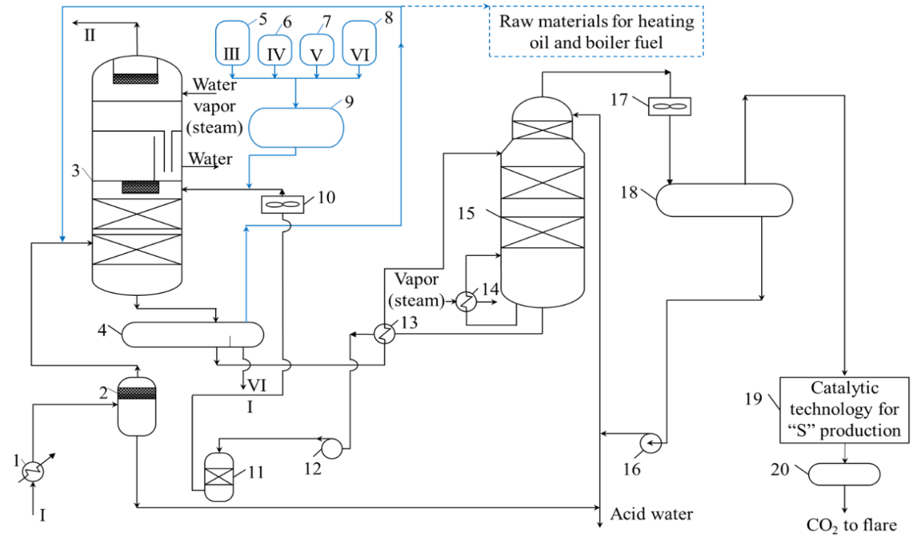
FIGURE 1 Improved gas absorption technology scheme: 1, 13 – heat exchangers; 2, 18 – separators; 3 – absorber; 4 – expansion unit; 5 – water tank; 6 – activator tank; 7 – inhibitor tank; 8 – fresh DEA; 9 – chemical reagent tank; 10, 17 – air coolers; 11 – filtration system; 12, 16 – pumps; 14 – steam heat exchanger; 15 – desorber; 19 – sulfur production unit; 20 – gas flare system.
A gas analyzer is installed at the outlet of the absorber to determine the residual carbon dioxide content in the purified hydrocarbon gas. For laboratory analysis of the natural gas composition, samples are taken using the S-1701 device and a special gas sampler. To prevent overpressure and pressure buildup in the absorber unit and pipelines, five safety valves are installed. The operating pressure in the absorber is 4370 kPa. During operation, the DEA composition solution becomes saturated with the acidic components of the feed gas and is withdrawn to the lower part of the unit. The level of the saturated DEA solution in the lower section of the absorber is maintained within 10–85% using a level gauge. For laboratory control of the solution composition, sampling from the saturated DEA solution pipeline at the outlet of the absorber is provided through the S-1705 device. The saturated DEA solution from the absorber enters an expansion vessel – the expander (4), where dissolved gases (hydrocarbon gases, H₂S, CO₂, R–SH, COS) are released from the amine solution.
It was proposed to implement technological modernization specifically in the expander unit. According to the regulations, the gas released from the expander is directed to the flare system, where it is burned together with the acid gas. However, about 90% of the released gas has a hydrocarbon composition, which makes it significant, as it is close in composition to the feed gas. Its quantity is 176 kg/h, which is equivalent to 0,044% of the total feed. The operating pressure of the expander is 400 kPa, while the amount of released gas is 176 kg/h. When the pressure is increased to 750 kPa, the amount of released gas can be reduced to 135 kg/h, and it is also possible to decrease the content of carbon dioxide and sulfur compounds in its composition. Taking into account that the expander unit is designed for pressures up to 900 kPa, setting the operating pressure at 750 kPa allows for reducing the content of acidic components in the expander gas.
Chromatographic comparative analyses of the composition of untreated feed gas and expander gas were carried out (Figs. 2, 3) [9].
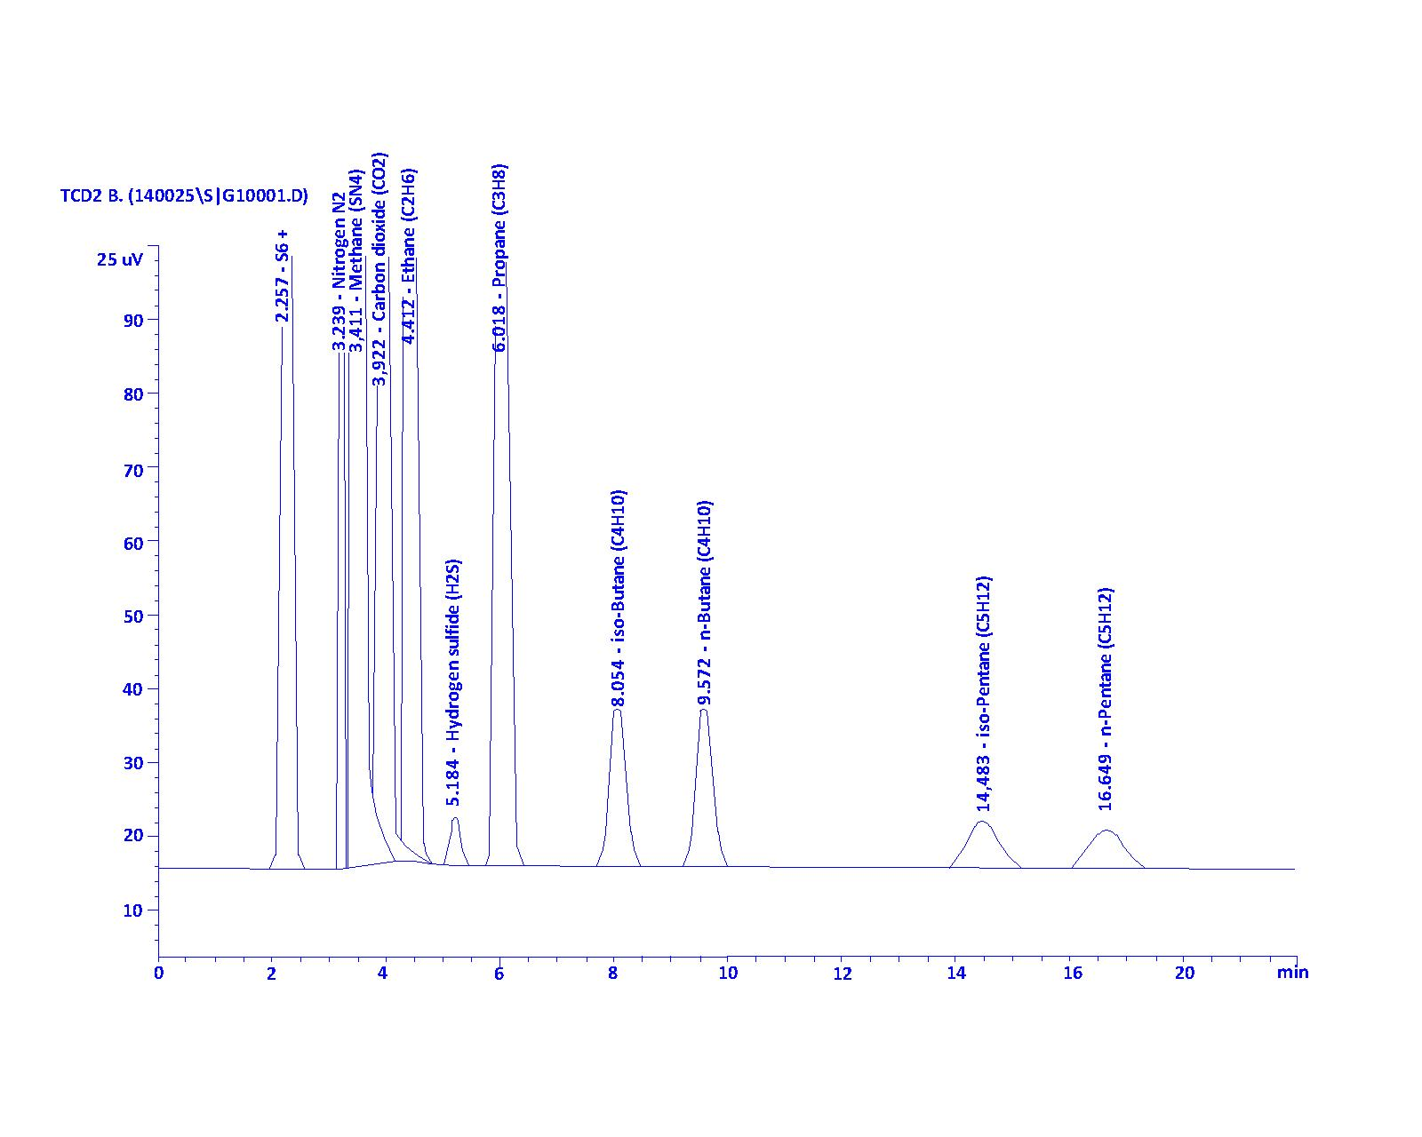
FIGURE 2. Gas chromatographic spectrum of the untreated (feed) gas of the plant 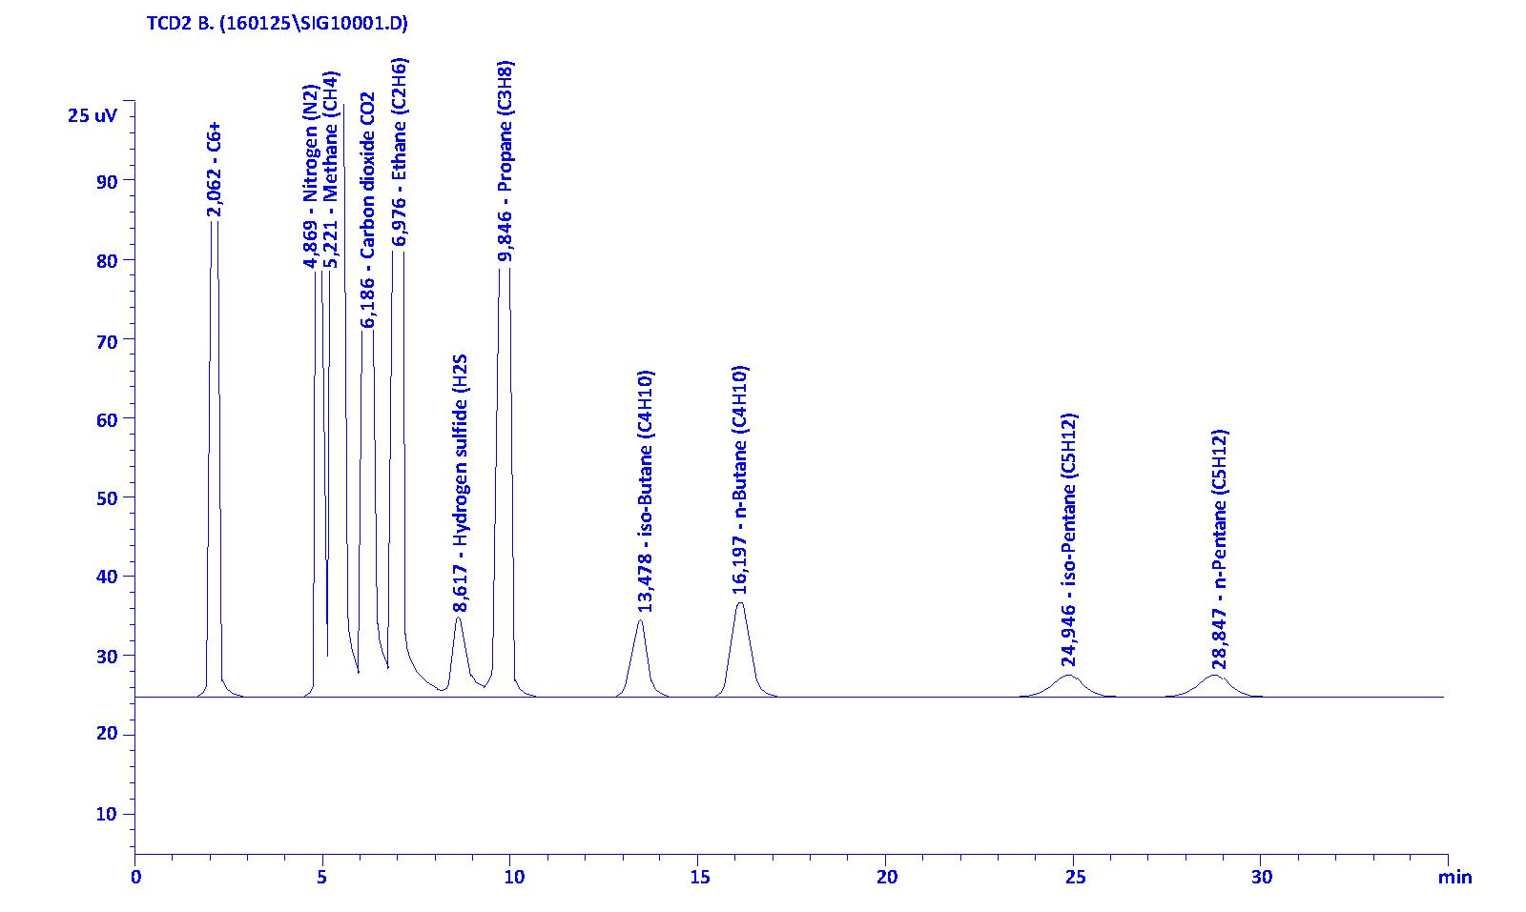
FIGURE 3. Gas chromatographic analysis of the gas after the expansion unit

Table 1. Comparative composition of the analyses of the gas after the expansion unit and the untreated feed gas

№ | Component composition | Unit of measurement | Expander gas composition | Composition of the gas supplied from the Shurtan field group
1 | CH₄ | mole % | 89,219 | 89,83
2 | C₂H₆ | mole % | 4,483 | 4,08
3 | C₃H₈ | mole % | 0,879 | 0,93
4 | n-C₄H₁₀ | mole % | 0,172 | 0.24
5 | i-C₄H₁₀ | mole % | 0,126 | 0.22
6 | C₅H₁₂ | mole % | 0,118 | 0,18
7 | C₆⁺ | mole % | 0,391 | 0,31
8 | CO₂ | mole % | 2,696 | 3,36
9 | H₂S | mole % | 0,092 | 0,093
10 | N₂ | mole % | 0,819 | 0,757
11 | Total: | % | 100 | 100
In conclusion, it can be stated that the first proposed technological improvement involves directing the gas after the expander into the main stream of untreated feed gas. Material balance calculations show that the amount of purified gas increases by 0,044%. The second proposed technological improvement is the use of the gas after the expander as fuel for the plant’s pyrolysis furnaces and boilers. This makes it possible to save the feedstock consumed for the internal needs of the furnaces and boilers and to reduce overall economic costs.
The saturated amine solution (13) that has passed through the expander is heated in heat exchangers through heat transfer with the stream of desorbed (regenerated) amine solution through the tube walls and, at a temperature of 68–98 °C, is fed into the lower part of the desorber column (15) due to the pressure difference. The saturated diethanolamine (DEA) composition solution, which has absorbed acidic gases, undergoes desorption (regeneration) in the desorber.
The circulation of the DEA solution is carried out continuously, sequentially through the processes of absorption and desorption in the following order:
the lower part of the absorber column → the shell side of the heaters → pumps → filters → regenerated amine coolers → the acid gas absorber → the expansion vessel (expander) → the tube side of the heaters → the absorber column.
The regenerated DEA composition leaving the lower part of the desorber is cooled in heat exchangers through heat transfer with the saturated DEA solution supplied from the expander vessel (13). The heat exchanger is installed on the bypass (bypass line) of the regenerated amine circulation path between the shell sides. Heating and cooling of the DEA solutions occur due to the temperature difference between the streams. The heat exchanger is installed in parallel with the sequentially arranged heat exchangers. Maintaining a constant temperature of the saturated DEA solution fed into the desorber is achieved by adjusting the amount of regenerated DEA solution supplied to the heat exchanger. The regenerated DEA solution flows from the saturated amine heaters into the suction pipeline of the circulation pumps (12). During scheduled maintenance, connection points were prepared and shut-off equipment was installed for the installation of an additional circulation pump in parallel with the suction and discharge lines of the regenerated amine solution. To increase the volume of the circulating solution to the allowable maximum value, the installation of an additional circulation pump is planned.
To verify that the regenerated DEA solution is completely free from absorbed acidic components, samples are taken using the C-1706 device on the pipeline of regenerated DEA coming from the pumps. After the pump, the desorbed DEA solution (in an amount of 10–15% of the total flow) is directed to the filtration unit (11). The DEA solution filtration network consists of mechanical filters for primary purification and a fine filter. Mechanical filters are installed at the inlet and outlet of the amine solution filtration network. Their purpose is to remove corrosion products – rust, iron sulfide, and a small amount of activated carbon – from the desorbed DEA solution. The carbon filter removes amine decomposition products, corrosion products, thermally stable salts, and polymers.
The flow of amine passing through the filtration network (up to 10–15% of the total flow) is controlled by the FI-17007 instrument installed on-site. After the filtration section, sampling for laboratory control of the DEA composition is carried out using the C-1708 device, located after the mechanical filter on the regenerated DEA pipeline. The flow of desorbed DEA solution is automatically regulated by a controller and maintained at 30 m³/h. The purified DEA solution is combined with the main flow supplied from the pumps and directed to the regenerated amine coolers. Cooling of the DEA solution is carried out by supplying air from fans (10)—two fans per device.
The temperature of the DEA solution fed into the absorber is regulated by a controller and maintained in the range of 55–60 °C. Fresh absorbent composition is periodically added to the regenerated absorbent after it has passed through the air cooler.
The absorbent composition is prepared as follows: in tank 5 – distilled water (III), in tank 6 – hexamine activator (IV), in tank 7 – corrosion inhibitor – carbodihydrazide (V), and in tank 8 – fresh DEA (VI) at the required concentration. The required amounts of components are supplied by dosing devices (plunger pumps). In tank 9, the mixture is collected and serves to replenish losses. The regenerated DEA solution, to which the new absorbent has been added, is fed into the absorber (3). The regenerated DEA solution enters the lower part of the desorber, from where it is returned to the circulation loop. Absorption was carried out using a composite absorbent containing the following mixture: diethanolamine – 32 %, hexamine – 2 %, carbodihydrazide – 0,025 %. Using the method described above, the most effective composite absorbent was selected, and the purified gas mixture after the absorption process was also checked using gas chromatography (Figure 4) [10,11,12].
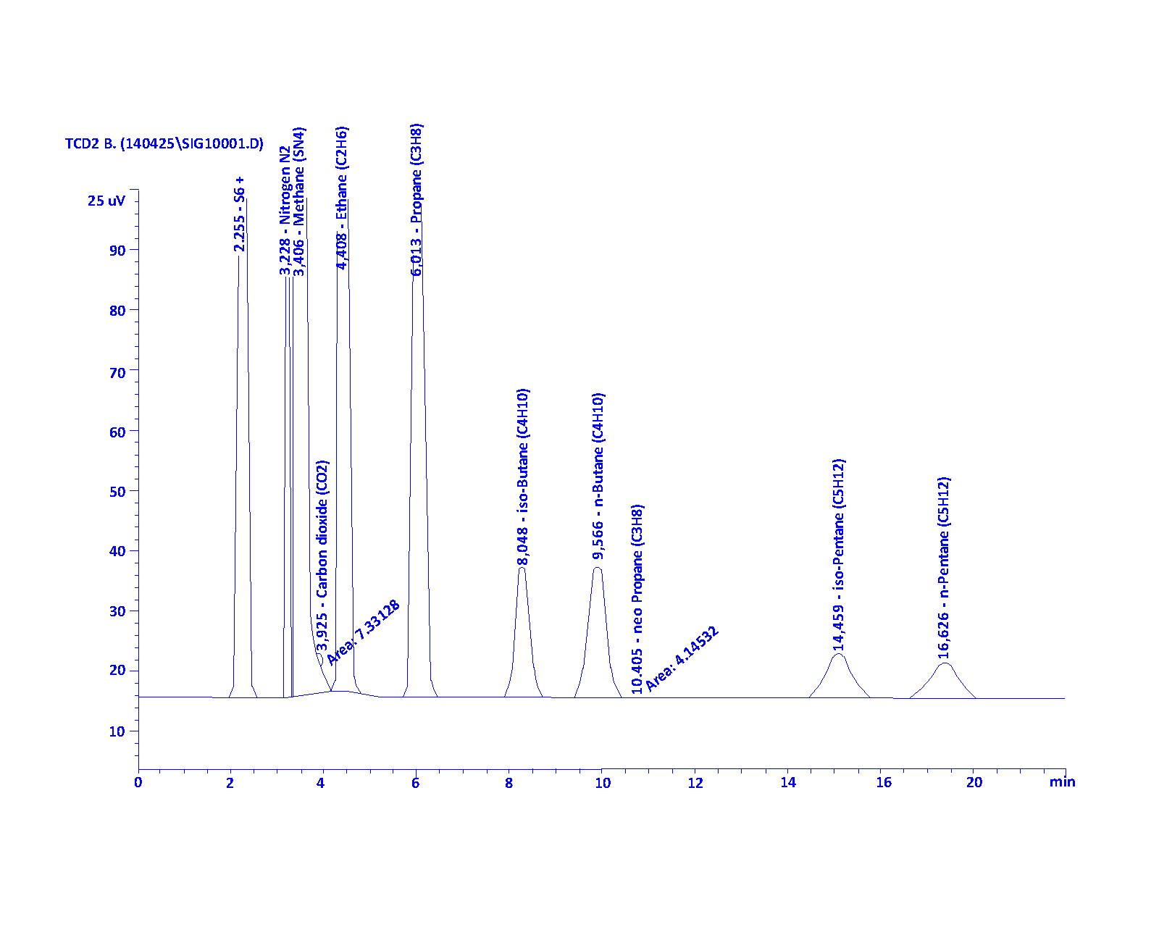
FIGURE 4. Gas chromatographic spectrum of the gas composition purified using the composite absorbent
Table 2. Results of the gas chromatographic analysis of the purified gas composition
No | Substance name | Retention time | Peak region | %, mole
1 | Methane (CH₄) | 3,406 | 8,178564 | 92,483560
2 | Ethane (C₂H₆) | 4,408 | 5777,86768 | 4,297052
3 | Propane (C₃H₈) | 6,013 | 1913,02246 | 1,151073
4 | n-Butane (C₄H₁₀) | 9,566 | 492,89981 | 0,257529
5 | iso-Butane (C₄H₁₀) | 8,048 | 457,72412 | 0,244604
6 | n-Pentane (C₅H₁₂) | 16,626 | 219,15773 | 0,010134
7 | izo-Pentane (C₅H₁₂) | 14,459 | 260,69608 | 0,125495
8 | C₆+ | 2,255 | 1242,39587 | 0,492785
9 | Carbon dioxide (CO₂) | 3,925 | 7,33128 | 0,005739
10 | Hydrogen sulfide (H₂S) | 5,187 | - | -
11 | Nitrogen (N₂) | 3,228 | 954,62738 | 0,836577
12 | neo-Pentane (C₅H₁₂) | 10,405 | 4,14532 | 0,002065
Total: |  |  |  | 100,0000
The analysis of the purified gas mixture by gas chromatography established that its composition contains: methane – up to 92,483 %, ethane – up to 4,297 %, propane – up to 1,151 %, a mixture of n-butane and iso-butane – up to 0,501 %, a mixture of n-pentane, iso-pentane, and neo-pentane – up to 0,137 %, and hydrocarbons heavier than hexane – up to 0,493 %. The analysis results showed that the content of the acidic component – carbon dioxide – is up to 0,0057 %. Hydrogen sulfide (H₂S) could not be detected, as its quantity was too low to be registered by the gas chromatograph.
For comparison, a sample of natural gas purified using the absorbent employed at the plant was taken with the S-1701 sampling device, and its composition was analyzed in the laboratory.
For comparison, it was established that the composition of the purified natural gas obtained using the absorbent employed at the plant contains: methane – up to 92,548 %, ethane – up to 4,258 %, propane – up to 1,0571 %, a mixture of n-butane and iso-butane – up to 0,511 %, a mixture of n-pentane and iso-pentane – up to 0,258 %, and hydrocarbons heavier than hexane – up to 0,512 %. The analysis results showed that the content of the acidic component – carbon dioxide – is up to 0,0101 %.

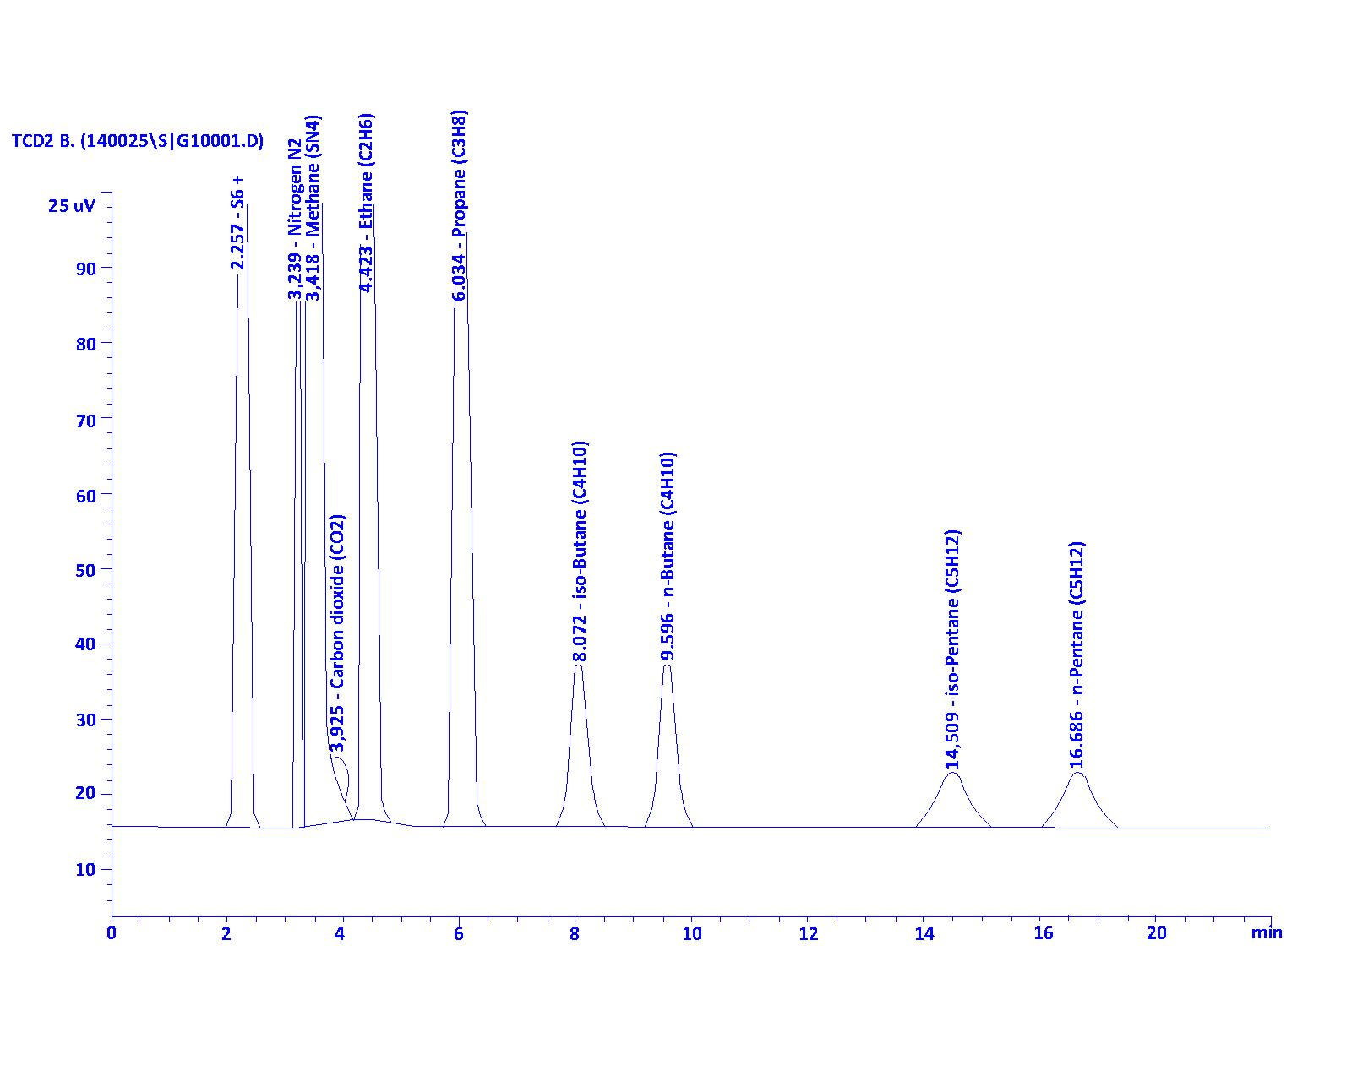
FIGURE 4. Gas chromatographic spectrum of the gas composition purified using the absorbent employed at the plant, for comparison

Table 3. Results of the gas chromatographic analysis of the gas composition purified using the absorbent employed at the plant
№ | Substance name | Retention time | Peak region | %, mole
1 | Methane (CH₄) | 3,418 | 8,178564 | 92,548140
2 | Ethane (C₂H₆) | 4,423 | 5785,00684 | 4,258207
3 | Propane (C₃H₈) | 6,034 | 1781,83997 | 1,057069
4 | n-Butane (C₄H₁₀) | 9,596 | 532,95605 | 0,272238
5 | iso-Butanе (C₄H₁₀) | 8,072 | 451,41434 | 0,236912
6 | n-Pentanе (C₅H₁₂) | 16,686 | 287,21921 | 0,130925
7 | iso-Pentanе (C₅H₁₂) | 14,509 | 269,90692 | 0,127161
8 | C₆+ | 2,257 | 1375,51514 | 0,512006
9 | Carbon dioxide (CO₂) | 3,925 | 13,06693 | 0,010134
10 | Hydrogen sulfide (H₂S) | 5,187 | - | -
11 | Nitrogen N₂ | 3,239 | 971,05933 | 0,847208
Total: |  |  |  | 100,0000
The quality of the feedstock and products supplied to the Shurtan Gas Chemical Complex is presented below. During the purification of natural gas using amine, comparative analyses were carried out of the results after absorption using the standard DEA absorbent employed at the plant and the composite absorbent (Table 4).

Table 4. Comparative analysis of the gas chromatographic results of natural gases
No | Substance name | Concentration in untreated gas, % (mol) | Concentration in plant-purified gas, % (mol) | Concentration in gas purified with sample №. 4, % (mol)
1 | Methane (CH₄) | 89,83 | 92,548140 | 92,483560
2 | Ethane (C₂H₆) | 4,08 | 4,258207 | 4,297052
3 | Propane (C₃H₈) | 0,93 | 1,057069 | 1,151073
4 | n-Butane (C₄H₁₀) | 0,24 | 0,272238 | 0,257529
5 | iso-Butane (C₄H₁₀) | 0,22 | 0,236912 | 0,244604
6 | n-Pentane (C₅H₁₂) | 0,13 | 0,130925 | 0,010134
7 | iso-Pentane (C₅H₁₂) | 0,05 | 0,127161 | 0,127495
8 | C₆+ | 0,31 | 0,512006 | 0,492785
9 | Carbon dioxide CO₂ | 3,36 | 0,010134 | 0,005739
10 | Hydrogen sulfide H₂S | 0,093 | - | -
11 | Nitrogen N₂ | 0,757 | 0,847208 | 0,836577
 | Total: | 100,0000 | 100,0000 | 100,0000
The research results showed that the use of absorbent compositions in the absorption process allows reducing the corrosion rate of equipment and lowering the energy costs for amine regeneration.
As a conclusion, it can be noted that the industrial-scale tests demonstrated positive results for sample 4. It was established that the amount of acidic components was reduced by half compared to the absorbent used at the plant.
The content of very small amounts of sulfur compounds in the purified gas was determined using a spectrophotometric method. However, due to the extremely low concentration of hydrogen sulfide (H₂S) in the mixture of purified gases, quantitative determination was challenging. Nevertheless, trace amounts of H₂S (in ppm) were determined according to GOST 22387.2–2021 using the special “Lambda 20” spectrometer under laboratory conditions.

Table 5. Results of the analysis of trace amounts of sulfur compounds in the purified gas
Description | Designation in the formula | Unit of measurement | Indicator
Mass of mercaptan sulfur in the analyzed volume of the absorption solution, determined from the calibration results | m | mkg | 15,5
Volume of gas measured by the gas meter for the test | V | dm³ | 6
Correction factor for converting the volume of the analyzed gas to standard conditions (temperature 20 °C, pressure 101,325 kPa) | K | - | 0,92
Conversion factor from micrograms to grams | 100 | - | 100
Concentration of all sulfur-containing compounds in the gas (H₂S, R-SH, COS) | X | g/m³ | 0,0028

The analysis results showed that the content of sulfur compounds in the purified gas, according to the spectrophotometric method, is 0,0028 g/m³. Comparison of this value with the gas purified using the absorbent employed at the plant (0,0057 g/m³ of sulfur compounds) showed that their amount was reduced by a factor of 2. The use of such an absorption composition ensures the absence of undesirable chemical reactions in subsequent stages of hydrocarbon gas processing in technological units.
CONCLUSIONS
As a result of applying the new composite absorbent and improving the technology by modifying the operating parameters of the expander unit, the following positive changes were observed:
1. Due to the activator introduced into the absorbent composition, the absorption rate and degree of carbon dioxide capture are increased. It was established that during natural gas purification with amines, the CO₂ content in gas purified on the original plant equipment using DEA ranges from 0,0101–0,2% (mol.). After absorption with the selected composite absorbent, according to gas chromatographic analysis, the CO₂ content decreases to 0,0057% (mol.), indicating a twofold reduction.
2. According to the analysis of purified gas by the spectrophotometric method, the sulfur compound content using the selected composite absorbent is 0,0028 g/m³, whereas purification with the standard absorbent yields 0,0057 g/m³. Thus, the sulfur content is also reduced by a factor of 2.
3. It was established that modifying the operating parameters of the expander unit allows a reduction in the content of acidic components in the gas directed to flare combustion.
4. Material balance calculations showed that recirculation of expander gases into the stream of untreated raw gas allows an increase in the volume of purified gas by up to 0,044%.
5. The second proposed technological solution is the use of expander gases as fuel feedstock for pyrolysis furnaces and boiler equipment, which ensures fuel savings for the internal needs of the furnaces and boilers and leads to a reduction in operational costs.
REFERENCES
1. Tilloyev, L., Dostov, H., Ataullayev, S., & Kurbanova, M. (2025, July). Research of the process of extraction of hydrocarbon components from waste “Yellow oil”. In AIP Conference Proceedings (Vol. 3304, No. 1, p. 040097). AIP Publishing LLC.
2. Tilloev, L., Murodov, M., Ataullaev, S., Turakulova, M., & Savriev, M. (2024). Extraction of hydrocarbons from “yellow oil” with liquefied gas residue. In E3S Web of Conferences (Vol. 486, p. 04023). EDP Sciences.
3. Akhmedova, O. B., & Boboqulov, F. B. (2021). Analysis of the effectiveness of methyldiethanolamine absorbent in the purification of gases. In International scientific-practical online conference" Innovative solutions to current problems in the field of organometallic high-molecular compounds." Tashkent May (Vol. 28, pp. 211-213). https://scholar.google.com/scholar?oi=bibs&cluster=15585973214132099655&btnI=1&hl=ru.
4. A.Chakma, A.Meisen // Improved Kent-Eisenberg model for predicting CO₂ solubilities in aqueous diethanolamine (DEA) solutions. Gas Sep. Purif. 2001. 4 (1), 37–40 p. https://scholar.google.com/citations?user=Wx1SRSAAAAAJ&hl=ru
5. Sh.U.Axmedova Axmedova O.B. Analysis of modern technologies of absorption treatment of hydrocarbon gases from acidic components in the world. international conference on higher education teaching. Hosted from Hamburg, Germany. Vol.3 No. 2 (2025) 96 -98 p.
6. Sh.U.Axmedova Axmedova O.B. Physicochemical parameters of saturated and desorbed absorbent compositions. nnovative research in modern education. Hosted from Toronto, Canada Vol.3 No. 2 (2025) 64 – 69 p.
7Sh. U. Akhmedova, O. B. Akhmedova. Production of Amine Absorbents Based on Local Raw Materials. Universum: Technical Sciences, electronic scientific journal, Moscow, pp. 53–58.
8. O. B. Akhmedova, Sh. U. Akhmedova. Creation of an effective absorbent composition for absorption gas purification // Universum: Technical sciences: electronic scientific journal. - 2024. - No. 11. - P. 67-71.
9. O. B. Akhmedova, Sh. U. Akhmedova, Kh. S. Fozilov. Improving the technology of gas purification from acidic components using an absorbent composition based on DEA // O‘zbekiston “Neft va gaz” ilmiy-texnika jurnali.
10. AF, PhD Khuzhakulov, and PhD Akhmedova OB. "TECHNOLOGY of an Environmentally Safe Gas Chemical Complex for Utilization of Sulfur-containing and Flare Gases Discharged From Technological Installations." American Journal of Pedagogical and Educational Research 11 (2023): 159-163.
11. OB Axmedova, SA G’Aybullayev. Gazlarni glikolli quritish jarayonining ishchi parametrlari, Central Asian Research Journal for Interdisciplinary Studies (CARJIS) 2 (5), 543-552, 2022.
12. O.B. Akhmedova, Sh.U. Akhmedova, S.A. Gaybullayev. Gas chromatography analysis of an absorbent composition containing DEA, hexamine, and carbohydrazide in the purification of gases from acidic components // Fergana State Technical University Journal 2025. T.29, No.4.110-114 p.

