Modern digital interpretation of granitoid massifs

Otabek Zokirov¹^{,a)}, Nargiza Tulyaganova², Nilufar Khamidova², Dilfuza Makhamadsabirova², Gulnara Arslonkhonova²

¹Tashkent state transport university, Tashkent, Uzbekistan
²Tashkent state technical university named after Islam Karimov, Tashkent, Uzbekistan
^{a)} Corresponding author: zokirov-otabek@mail.ru
Abstract. The article presents materials on granitoid massifs obtained from Landsat satellite images, their distance indicators and characteristics, a comparison of their location on a geological map, as well as their interpretation features and analysis results.

INTRODUCTION
Remote sensing is the study of the Earth’s surface using various types of imagery in different ranges of the electromagnetic spectrum acquired from aerospace vehicles. A detector installed on artificial satellites, interplanetary automatic stations, and other carriers transmits information to Earth in digital form. It should be emphasized that in remote sensing, due to the imaging of the Earth’s surface in different ranges of the electromagnetic spectrum, various geological formations appear in satellite images against backgrounds of different types. As a result, it becomes possible to delineate their distribution boundaries and to refine existing geological maps. For example, information on the geological and remote-sensing criteria obtained from cosmogeological studies of the Karnab, Akmazar, Guzhak, Maizak, Koshkuduk, and Chaydaroz granitoid massifs in the Ziyovutdin Mountains can serve as such an example [1,7,8].

EXPERIMENTAL RESEARCH
The use of digital satellite images in geological studies makes it possible to delineate geological bodies, to detail the structural characteristics of tectonic deformations, and to update the level of geoinformation on existing maps by identifying structures, photo-anomalies, and other objects of various configurations that were previously overlooked or difficult to detect during earlier geological surveys [8]. In the analysis of satellite images, stereoscopes and interpretoscopes were used, and both direct indicators (distinct boundaries, specific image appearance, color, size, geometric shape or configuration, tone, shadow, texture, structure, etc.) and indirect indicators (soils, vegetation, etc.) were applied. Experimental results showed that there are considerable differences between geological data on granitoid massifs—including their contours and distribution areas—and the analytical information obtained from digital satellite images (Figure 1). This demonstrates the advisability of a broader use of modern methods in scientific and applied research.
RESEARCH RESULTS
A complex analysis of granitoid massifs based on geological data and digital satellite imagery produced new findings: the remote-sensing criteria for the Karnab, Akmazar, Guzhak, Maizak, Koshkuduk, and Chaydaroz massifs were established, and previously unknown subsurface and surface boundaries and shapes were identified (Figure 2). Satellite images were processed using the well-known “Erdas Imagine” and “Multispec” software packages from the USA and Europe. This in turn made a significant contribution to improving the quality and efficiency of the research results. Below we provide brief descriptions of the remote-sensing criteria and their comparison with geological information [1–10].

Karnab Intrusive Body. The Karnab intrusion is situated at the eastern termination of the Ziyaetdin Mountains, within the core of an anticlinal structure. It contacts marbleized limestones in the south and Upper Silurian limestones and shales in the north. The intrusion represents a relatively small (approximately 21 km²), steeply dipping stock. It is predominantly composed of coarse-grained biotite granites, commonly containing porphyritic microcline phenocrysts.

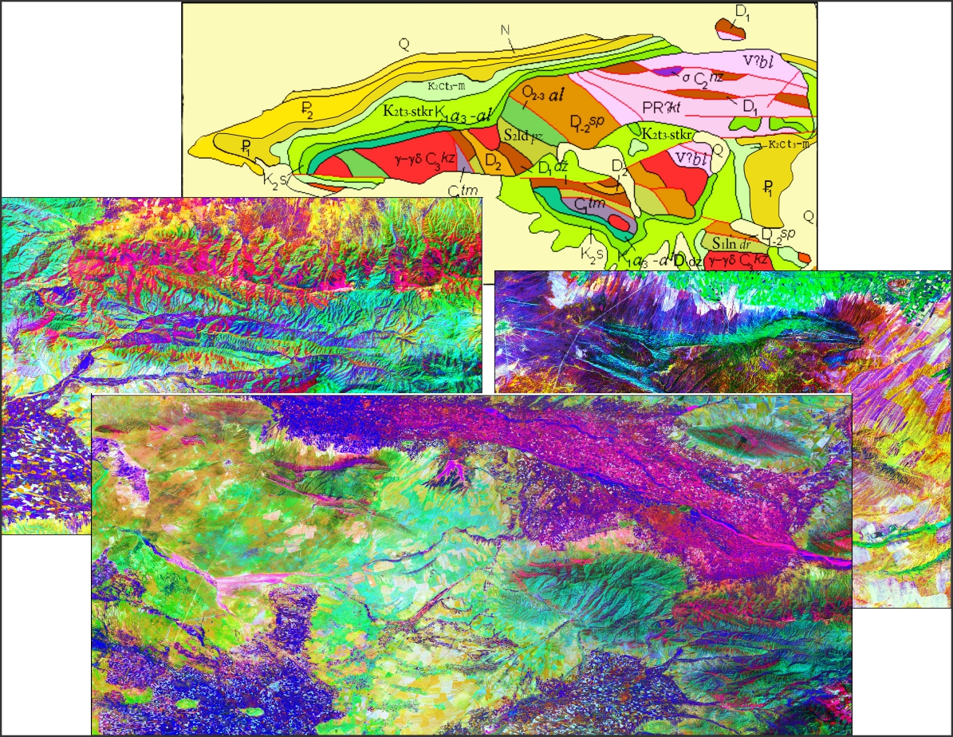

FIGURE 1. Geological and digital space image processing and complex deciphering process

(Based on the data of O.Zokirov, V.Mikhailov and others).

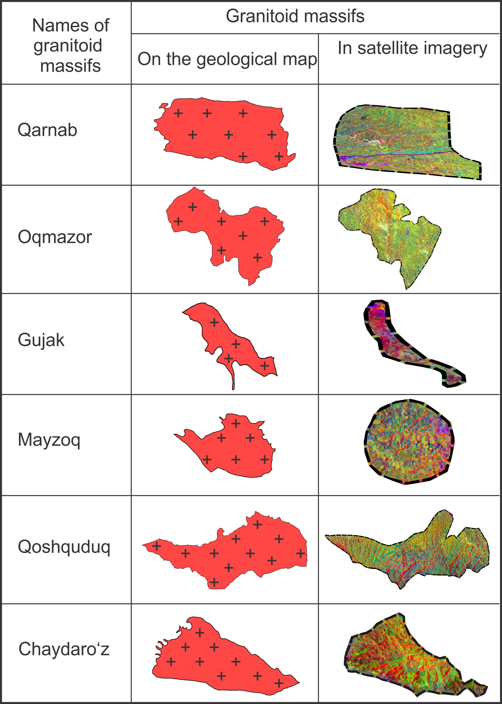

FIGURE 2. Interpretation of Granitoid Massifs Using Traditional and Non-Traditional Materials
(Based on the data of O.Zokirov and others).

Remote-sensing criteria. The intrusion is characterized by a yellow–green background with numerous small red points forming a speckled pattern. The photo-boundaries and tones of the sub-latitudinal carbonate strata north and south of the intrusion are clearly defined. Areas with greater rock exposure show numerous red points interspersed with small yellow spots. Mesozoic–Cenozoic deposits between the carbonate and shale units on the northern and eastern margins are easily recognized by yellow and yellow-light-violet tonalities. A fault, 2–3 mm thick on 1:50,000-scale imagery, appears as a burgundy line trending from northeast to west for several tens of kilometers.

Akmazar Intrusive Body. The Akmazar intrusion is located 8 km northwest of the Karnab massif. It intrudes Silurian shales and is overlain by Cretaceous deposits to the southeast and northwest. The body occupies the core of an anticline and is elongated northwestward. Its exposed area in the present erosional level is 22 km². It consists of biotite granites, including porphyritic and leucocratic varieties.
Remote-sensing criteria. The massif exhibits a yellow-green tone with numerous fine light-red points. In zones of newly identified small-scale faults, the concentration of red points forms thin strokes, lines, and narrow bands. The western part shows a reddish background, whereas the eastern part exhibits a yellow-green tone, producing an overall mottled image. Multispectral remote-sensing analysis identified diagnostic criteria, revealed new ring structures, and allowed refinement of earlier interpretations. These results confirm the high scientific value of digital satellite data for studying intrusive bodies and justify its use in petrographic and mineralogical–geochemical investigations.

Gujak Intrusive Body. The Gujak intrusion lies 15 km west of the Karnab massif. It contacts shale formations to the north and northwest, while its southwestern portion is overlain by Mesozoic–Cenozoic deposits. The intrusion is associated with an anticlinal fold and has a present-day exposed area of 5 km². It consists of porphyritic biotite granites that gradually transition into granodiorites, adamellites, and alaskites in endocontact zones.
Remote-sensing criteria. On geometrically corrected satellite images at 1:50,000 scale, the porphyritic biotite granites exhibit dark-red and light-green color tones.

Maizak Intrusive Body. The Maizak intrusion is situated in the central part of the Ziyaetdin Mountains, northeast of the Koshkuduk massif, and represents one of the domal structures of the Ziyaetdin pluton. It contacts marbleized Lower Silurian limestones in the southeast and is overlain by Cretaceous deposits in the northwest. The visible outcrop area is 6 km². The massif consists of porphyritic biotite granites and alaskites.
Remote-sensing criteria. A distinctive mottled tonal pattern and speckled photo-texture clearly differentiate the intrusion from its surroundings. Diagnostic characteristics include its oval shape, sharp photo-boundaries, relatively depressed photo-relief, and lineaments trending north and east. Ring structures are identified through rounded shapes and yellowish internal coloration. Biotite granite exposures exhibit dark-violet tones due to numerous colored points, whereas granodiorite exposures show yellow–red–green tones with fewer dark points. Principal Component Analysis (PCA) products are recommended as primary remote-sensing materials, enabling detailed mapping of lithological varieties irrespective of composition, age, or elevation. They allow confident identification of contact zones and intraformational alteration areas. Importantly, PCA revealed a new photo-interpretation criterion for single- and multi-zonal ring structures: phototonal zoning, where each zone is marked by distinctive color patterns likely reflecting mineralogical or structural-textural variations.

Koshkuduk Intrusive Body. The Koshkuduk intrusion lies between the Maizak and Chaydaroz massifs. It contacts marbleized limestones in the east and Lower Paleozoic shales in the west, and is overlain by Cretaceous deposits in the southwest and northwest. Its area is 34 km², elongated west–east. It comprises porphyritic granites, leucocratic granites, granite-aplites, pegmatites, and pegmatite-like lithologies.
Remote-sensing criteria. The massif displays a highly distinctive linear-ribbed pattern and variegated tonal contrast, setting it apart from both the sedimentary–metamorphic country rocks and adjacent granitoid massifs. The pattern corresponds to narrow ridges and relief contrasts, appearing as straight reddish lines 1–7 cm long and up to 3–4 mm wide on imagery, separated by yellow–green–violet bands up to 1 cm wide. In the southeastern portion, the lineaments trend northeast, northwest, north, and north-northeast. The western half shows a yellow–green background, whereas the eastern half displays violet-greenish tones with yellowish hues toward the southeast. Phototonal zones form circular shapes in the center and semicircular shapes along the margins. Concentric anomalies—clearly multi-zonal—together with tonal variations indicate localized compositional changes, likely formed during different stages of geological evolution.

Chaydaroz Intrusive Body. The Chaydaroz intrusion forms the western extension of the Ziyaetdin Mountains and represents the northwestern continuation of the Koshkuduk massif, being one of the exposures of the Ziyaetdin pluton. It contacts shales in the east and is overlain by Cretaceous deposits in the west and southwest. Its exposed area is 12 km², and it is composed of biotite granites and alaskites.
Remote-sensing criteria. The intrusion is strongly distinguished on imagery by its linear-ribbed pattern. The western half and southern portion, dominated by coarse-grained granites, exhibit yellow–red–rusty tones, whereas the eastern part, containing fine- and medium-grained granites and alaskites, shows yellow-rusty tones. The massif is defined by alternating dark and light narrow bands trending northeast, and less frequently north–south and northwest. In the field these correspond to sinuous short displacements, faults, and fractures with widths of 2–4 mm.
CONCLUSIONS
Thus, it can be concluded that rock formations are expressed vividly and with strong contrast in digital satellite imagery, regardless of their hypsometric position, age, or lithological composition. Contact zones and photo-boundaries of their distribution are confidently identified. The informativeness and quality of interpreting geological, material, and structural features always depend on the method applied for processing remote-sensing data.
REFERENCES
- Ergashev, Sh.E., & Zokirov, O.T. Modern Methods for Prospecting Ore Mineralization in Low-Mountain Conditions. Tashkent: State Enterprise “Research Institute of Mineral Resources (NIIMR)”, 2009. 115 p.
- Goipov, A.B., Akhmadov, Sh.I., & Yusupov, V.R. Characteristics of Geophysical Fields and Geophysical Signs of Mineralization in the Bo‘kantov Mountains in the Southern Tien Shan. ANAS Transactions, Earth Sciences, No. 2, 2024, pp. 77–91.
- Goipov, A.B., Akhmadov, Sh.I., Tevelev, A.V., Musakhonov, Z.M., & Mirsayapov, R.I. Application of Innovative Methods of Spectral and Structural Interpretation to Solving Geological Problems and Searching for Deposits (Based on the Example of the Auminzatau–Beltau Ore District of the Republic of Uzbekistan). Moscow University Geology Bulletin, 2024, Vol. 79, No. 6, pp. 798–809. ISSN 0145-8752.
- Goipov, A.B., Ashurov, A.U., & Atabaev, D.Kh. Interpretation of Airborne Electrical Exploration Data in the Search for Gold-Ore Objects and Geodynamic Zoning of the Bukan-Tau Mountains (Southern Tien Shan). Journal of Geophysical Research, 2025, No. 1, pp. 79–97.
- Khamidova, N., Dadasheva, A., & Ashurova, Sh. Workforce Reskilling and Economic Shifts in Automation with Eco-Skills Monitoring. International Conference on Civil, Environmental, and Applied Sciences (ICCEAS 2025), pp. 85–91.
- Urinov, U., Hamidova, N., & Mirzakulov, I. Chemical Technology of Oligomers Production from Homopolymer Based on Epichlorohydrin and Morpholine. E3S Web of Conferences, 497, 03030 (ICECAE 2024), pp. 1–6.
- Zokirov, O.T. Cosmo-Structural Model of the Ziaetdin Mountains and Its Significance in Studying the Patterns of Gold Mineralization Distribution (Based on Digital Space Remote Sensing Data), PhD Dissertation. Tashkent, 2012. 118 p.
- Zokirov, O.T. Cosmo-Structural Objects of Central Asia and Their Importance in the Localization of Mineral Deposits, DSc Dissertation. Tashkent, 2019. 198 p.
- Raximov Z, Zokirov O. Digital space imagery, space infrastructure and metasomatic changes/4th International Conference Series on Science, Engineering, and Technology (ICSSET) 2024, Indonesian, pp.171-178
- Zokirov O.T. Raximov Z.Z. Methods of interpreting digital space images/4th International Conference Series on Science, Engineering, and Technology (ICSSET) 2024, Indonesian, pp.103-109
- Janibekov, B., Turapov, M., Tulyaganova, N., Zokirov, O., Abdurasulov, D. Study on Interplay of tension, deformation, and ore formation. E3s Web of Conferences Open-source preview, 2023, 434, 02028
- Turapov, M.K., Akbarov, H.A., Tulyaganova, N.S., Ummatov, N., Raxmatullayeva. S.D. Role of regional faults in the formation and placement of gold ore objects in western Uzbekistan. E3s Web of Conferences Open source preview, 2023, 371, 01022

