Methods of Starting Asynchronous Motors Using Non-Contact Devices
Makhsud Bobojanov¹, Sardorbek Matkarimov ², Ruslan Mustayev^{3, a)}
¹ Tashkent state technical university named after Islam Karimov, Tashkent, Uzbekistan
² Urganch State University, Urganch, Uzbekistan
³ Karshi state technical university, Karshi, Uzbekistan
^{a)} Corresponding author: ruslanmustayev89@gmail.com
Abstract. This article discusses the issues of energy saving and ensuring power supply. It is important to automate the management of one of the relevant issues to this regulation. Many functions by disconnecting power consumers from the network with contactless starting devices, improving the connection structure does not become relevant. From this, asynchronous high-power motors from the “star” network start by dragging into the "triangle" the possibility of contactless operation of the discharge device circuit design was extracted and analyzed. According to the contactless launcher, the structural elements and the principle of operation are described in detail.
INTRODUCTION
The growing demand for electrical energy and the diversity of consumers with different operating modes increase the need for effective switching devices. For voltages below 1000 V, magnetic starters and contactors are commonly used, allowing up to 600–1500 switching operations per hour. However, their use in fire-hazardous areas can cause dangerous consequences:
- Sparks between contacts can lead to fire;
- Noise during operation and switching;
- Contacts may weld due to overheating;
- Mechanical wear;
- Contact oxidation and burning;
- Slow switching speed;
- Large size and weight;
- Low reliability and high maintenance needs;
- The need for arc extinguishing systems at high current levels.
To eliminate these drawbacks, there is a need for devices that can perform frequent and rapid switching without mechanical contact. Non-contact devices enable silent and rapid connection/disconnection of consumers, particularly effective in fire-hazardous industrial environments [1-10].
When starting large-capacity asynchronous motors, high inrush currents cause sparking between contacts. Various starting methods are used, one of the most common being the “star–delta” switching method. Here, the motor initially starts in a star connection to the network and after a certain time, switches to delta connection. This reduces the starting current threefold. Another known method is step-by-step starting, where a two-speed motor starts at low speed and then switches to a higher speed [1-6].

EXPERIMENTAL RESEARCH
Considering the above, the use of a contactless starter for high-power motors is appropriate. Based on the “star–delta” principle, a non-contact starter circuit was developed [3-5]. The circuit allows automatic transition from star to delta connection. Depending on the purpose, a corresponding control program is written into the microcontroller, while the circuit hardware remains unchanged [8-12].
The device has 18 input-output terminals, and the consumer is connected according to the selected scheme. Control is achieved via a microcontroller, receiving input signals from control buttons or an automated system. If used for a “star–delta” start, the buttons perform star start, delta switch, and stop operations. Automatic switching can also be implemented by programming the transition time from star to delta [6-8]. The schematic diagram is shown in Figure 1.

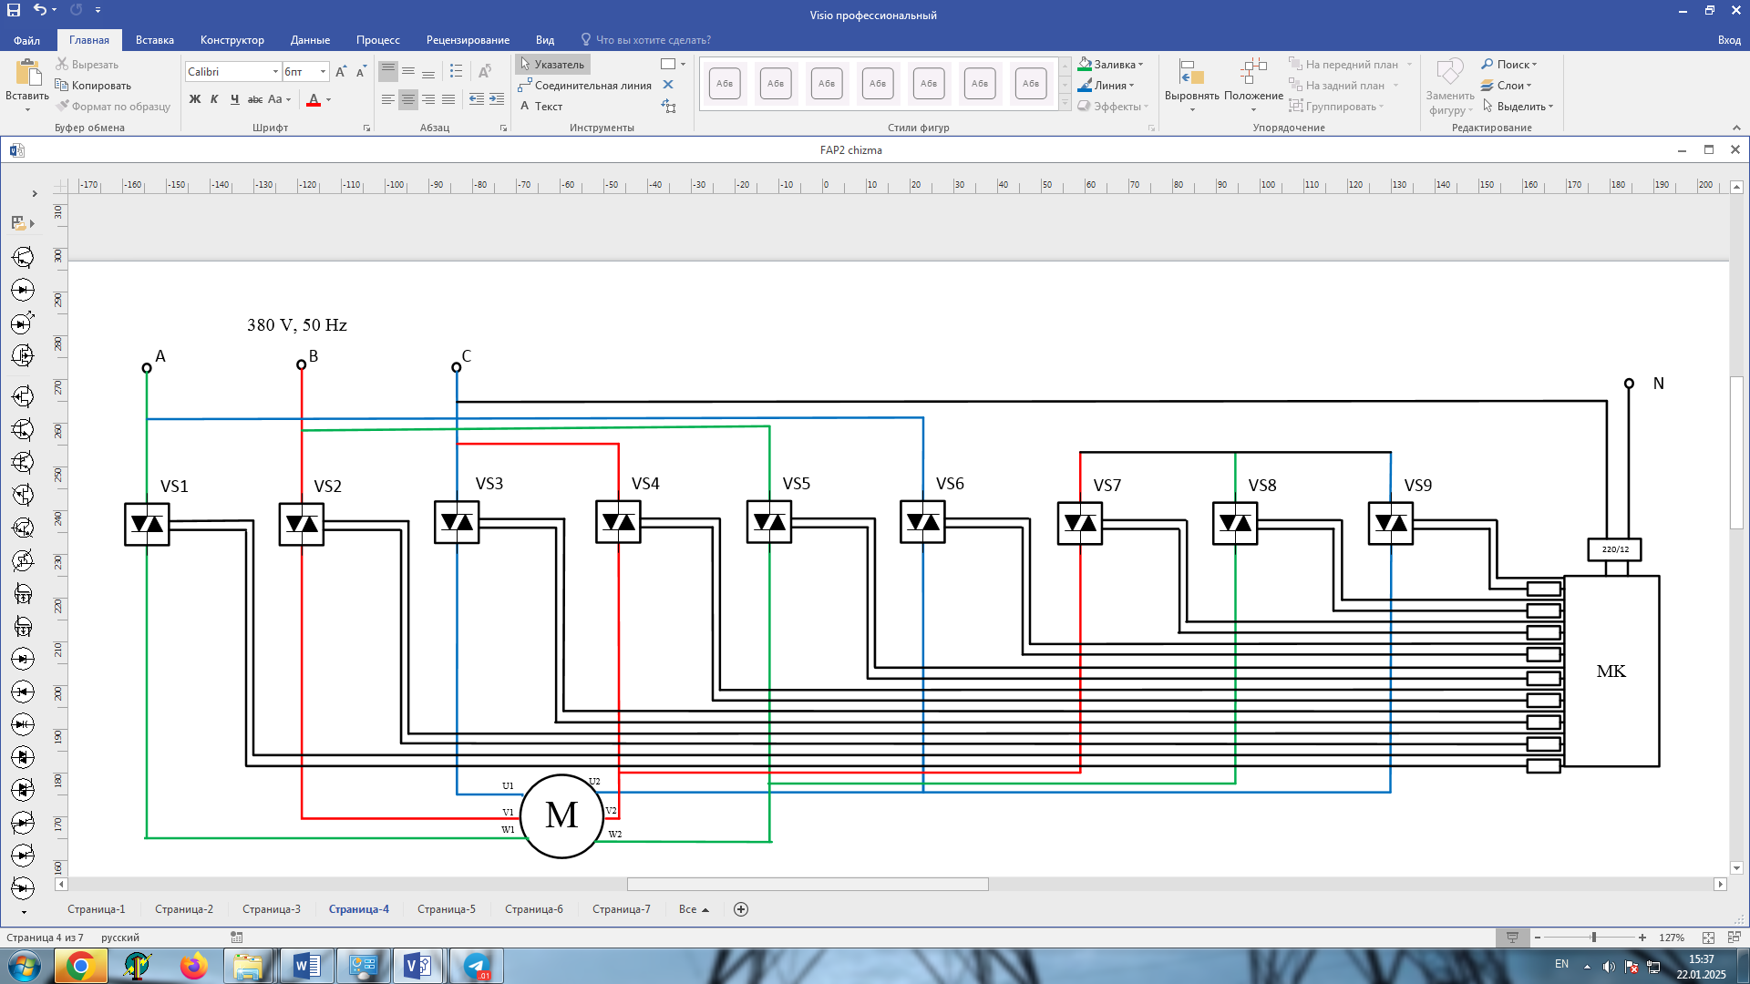
FIGURE 1. Circuit diagram for starting a three-phase motor using a contactless “star–delta” device

For smooth and efficient starting of three-phase induction motors, contactless control circuits are widely applied. One such circuit automatically switches the connection from star to delta using thyristor (or triac) blocks. In this scheme, nine thyristor blocks (VS1–VS9) are used, each responsible for switching the motor phases. Initially (star connection), control signals are sent to VS1, VS2, VS3, VS7, VS8, and VS9. These open the corresponding thyristors, connecting the windings in a star configuration and enabling smooth acceleration. After a delay (typically 3–5 seconds), the control system disconnects VS7–VS9 and activates VS4–VS6, forming a delta connection. The motor then operates at rated voltage and full power. The key advantage of this system is the absence of mechanical contacts, eliminating sparks and contact wear, ensuring higher reliability and reduced maintenance needs. The switching process is electronic, improving speed and operational safety. Additionally, the contactless “star–delta” method ensures soft starting, reduces voltage drops, and eliminates mechanical shocks — making it suitable for modern automated drives [8-15].
RESEARCH RESULTS
We will develop the mathematical model of the considered scheme in the MATLAB system. One of the most remarkable features of MATLAB is the availability of an efficient tool for simulating program models — the Simulink visual programming package.
A mathematical model of the studied circuit was built in MATLAB/Simulink, which allows dynamic simulation of linear and nonlinear systems. The simulation model (S-model) is assembled visually using blocks from the Simulink library [12-15].
The model includes a three-phase AC source, thyristors, a squirrel-cage induction motor, current and voltage measurement blocks, oscilloscopes, and switches. Each thyristor pair forms a simistor block connected in anti-parallel. The simulation circuit for an asynchronous motor with the developed device is shown in Figure 2.
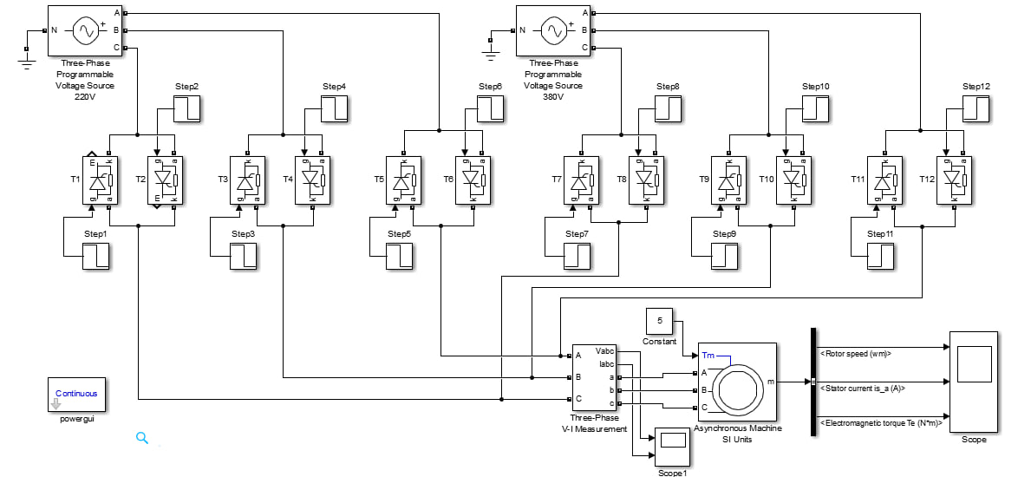
FIGURE 2. MATLAB simulation model of the contactless “star–delta” starting system

The selected motor parameters are shown in Figure 3. Signals from the motor are monitored using Scope and Bus Selector blocks to analyze current, speed, and electromagnetic torque (Figure 4).

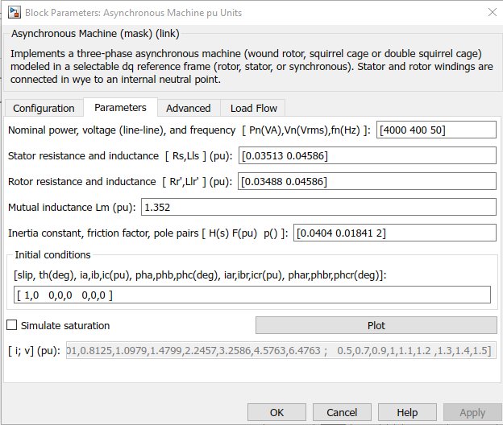
FIGURE 3. Parameters of the three-phase squirrel-cage induction motor
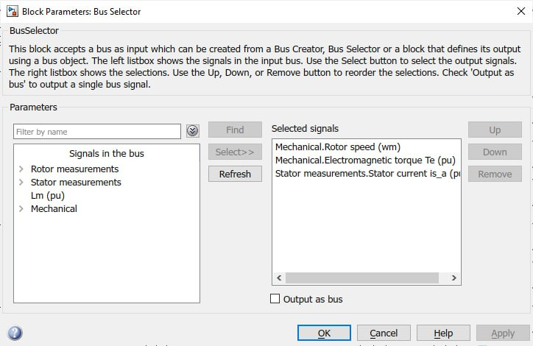

FIGURE 4. Bus Selector configuration window

The three-phase AC source (Figure 5) is configured to match the motor parameters. Current and voltage are measured using three Current Measurement blocks connected to an oscilloscope. Eighteen thyristors (forming nine simistor pairs) simulate contactless switching. The control pulses are generated by Pulse Generators.
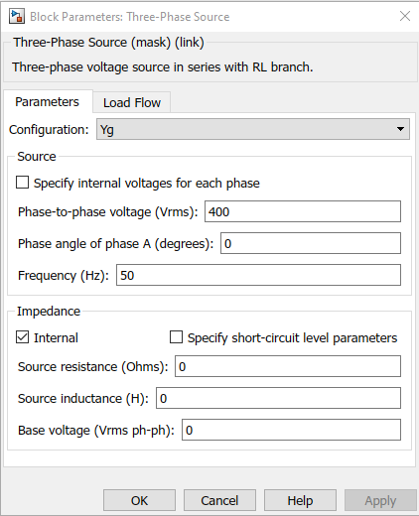
FIGURE 5. Parameters of the three-phase voltage source

The motor initially operates in star connection. After 3 seconds, the first three-phase switch opens, and the second closes — switching to delta (Figure 6). Thus, the thyristors reconfigure the connection accordingly.
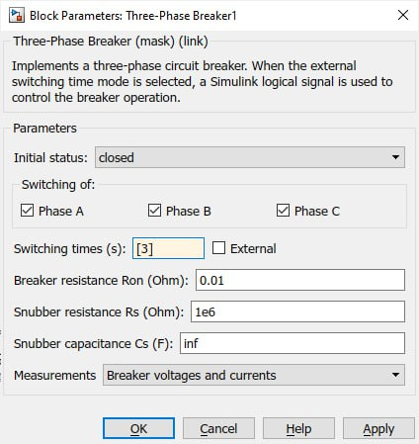
FIGURE 6. Parameters of the three-phase switch

The Pulse Generator parameters are based on a sinusoidal current of 5 V amplitude and 50 Hz frequency (period = 0.02 s). Pulse width = 50% (0.01 s), phase delay = 0 s for positive half-cycle, and 0.01 s for the negative one (Figure 7).

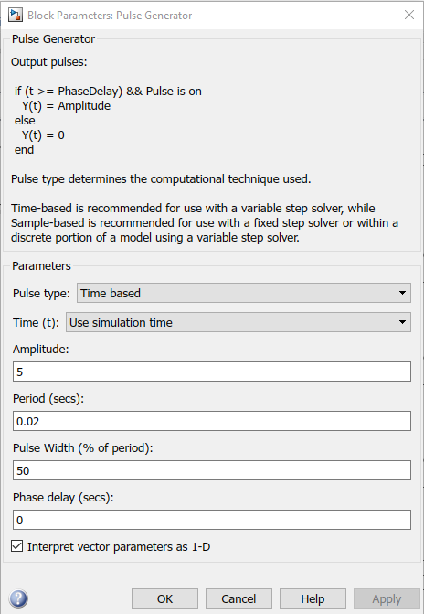 | 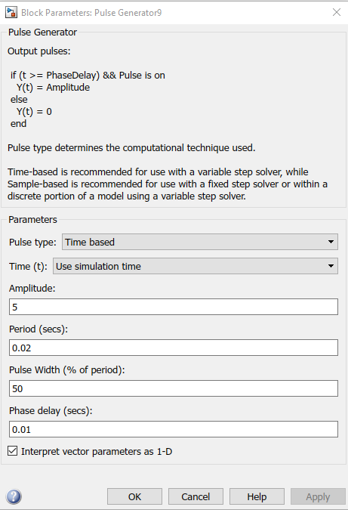
FIGURE 7. Pulse Generator parameters

When the simulation runs, the generator sends control signals to the thyristors, applying 380 V to the motor terminals. The Scope shows the three-phase voltage and current curves (Figure 8), and Scope1 displays the motor’s speed, torque, and stator current (Figure 9).

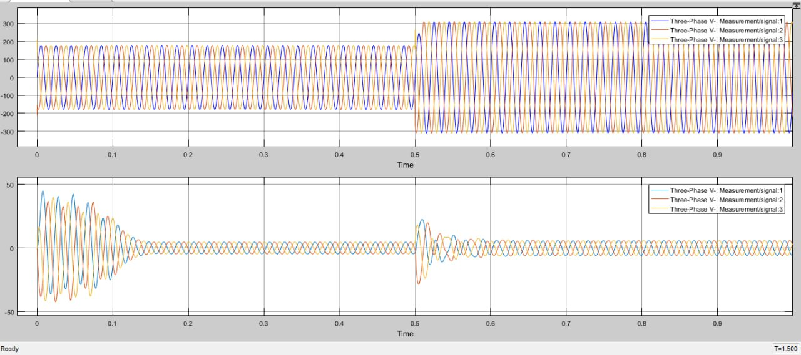
FIGURE 8. Three-phase voltage and current waveforms during contactless start

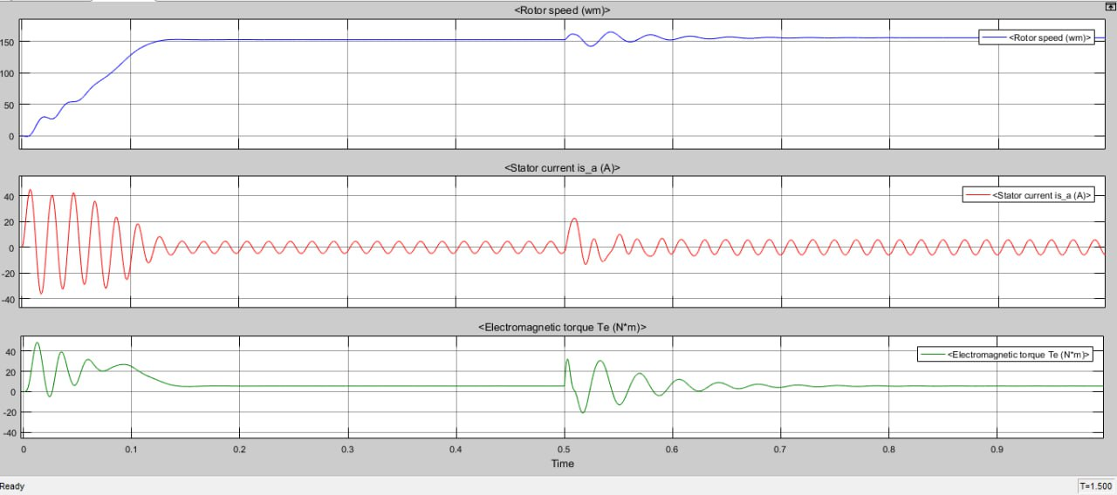
FIGURE 9. Performance characteristics during contactless start
CONCLUSIONS
Using contactless control systems for large asynchronous motors operating in intensive modes is one of the most effective modern electrotechnical solutions. The contactless “star–delta” method provides smooth, reliable, and safe motor startup. It reduces the starting current by a factor of three, prevents voltage drops, decreases thermal load, and eliminates mechanical shock — thereby extending system lifespan.
Such systems, based on semiconductors (thyristors, triacs, etc.), operate silently, without sparks or arcs, offering high reliability and low maintenance. Their fast and precise control simplifies integration into automated systems. These advantages make them suitable for industrial plants, pump and fan systems, compressors, and conveyor lines, where high performance and reliability are required.
Overall, the contactless “star–delta” starting method ensures efficient, safe, and economical operation of electric motors. MATLAB Simulink enables both theoretical and practical analysis of these processes, making this method an essential part of modern energy-efficient drive systems.
REFERENCES
- Mukhanova P. P. Research of low-voltage switching devices for electrical complexes of the oil and gas industry. Actual questions of practical physics and energy SUMGAIT, November 12-13, 2020.108-133 p. https://kgeu.ru/studportfolio/GetDoc/50910?idFizLico=124832
- Usmanov E.G. Departments and E. Faculty, “The noncontact switch for switching of the big capacities” European research № 4 (27), 2017 11-13 p. https://internationalconference.ru/images/PDF/2017/27/EUROPEAN-RESEARCH-4-27.pdf
- Klevtsov A.V. Contactless devices for starting and braking electric motors. Tutorial M: Infra-Engineering, 2018 -188 p https://radiohata.ru/other/3114-beskontaktnye-ustrojstva-puska-i-tormozhenija-jelektrodvigatelej.html
- V.T. Devices and A. Motors, "Contactless forcing circuits in braking devices of induction motors," pp. 31-36. https://rep.bntu.by/bitstream/handle/data/2638/31-36.pdf?sequence=1
- M.K. Bobajanov, M.M. Fayziev, R.A. Mustaev, Babayev.O.E. et al. Applying the non-contact devices for starting a single-phase asynchronous electric motor // Bulletin of science and education. 2021. no. 11-2 (114).
- M.Bobojanov, F.Tuychiev, N.Rashidov, A.Haqberdiyev. The possibility of using hybrid winding in doubly fed induction generator. AIP Conference Proceedings, 3152(1), 020005, (2024). https://doi.org/10.1063/5.0219623
- M.K.Bobojanov, D.A.Rismukhamedov, Kh.F.Shamsutdinov, M.B.Peysenov, S.D.Rismukhamedov. Development of a pole-changing winding for close pole ratio. AIP Conference Proceedings, 3152(1), 040034, (2024). https://doi.org/10.1063/5.0219624
- M.Bobojanov, T.Furkat, N.Hamid, A.Husen, H.Javahir. Determining the optimal steps of the number of fields with variable windings. E3S Web of Conferences, 497, 01014, (2024). https://doi.org/10.1051/e3sconf/202449701014
- M.Bobojanov. Induction machine with pole-changing winding. Archives of Electrical Engineering, 72(2), PP.415-428, (2023). DOI:10.24425/aee.2023.145417
- Bobojanov M.K., Fayziev M.M., Mustaev R.A. Three-Phase Contactless Switching Device Development And Research// International Journal of Advanced Research in Science, Engineering and Technology Vol. 10, Issue-10, Oktober 2023 pp. 21109-21113.
- M.K.Bobojanov, S.K.Matkarimov. Analysis of non-contact starting devices for one- and three-phase consumers// International scientific and technical conference on the topic "Actual problems of the power supply system" Tashkent-Karakalpakistan. October 21-22, 2024. 197-200 р.
- Fayziyev, M., Tuychiev, F., Mustayev, R., & Ochilov, Y. (2023). Development and research of non-contact starting devices for electric consumers and motors. In E3S Web of Conferences (Vol. 384). EDP Sciences.
- Fayziyev, M., Ochilov, Y., Nimatov, K., & Mustayev, R. (2023). Analysis of payment priority for electricity consumed in industrial enterprises on the base of classified tariffs. In E3S Web of Conferences (Vol. 384). EDP Sciences.
- Rafikova, G., Mustaev, R., Pirimov, R., & Zokirova, F. (2023). Increasing the environmental cleanness of industrial enterprises. In E3S Web of Conferences (Vol. 461, p. 01100). EDP Sciences.
- Kholikhmatov, B., Djumabekova, A., Ismailova, Z., & Mustaev, R. (2024, June). Design and evaluation of a logical framework for an instructional simulator in basic power supply principles. In AIP Conference Proceedings (Vol. 3152, No. 1, p. 050031). AIP Publishing LLC.

