Application of Evolutionary Optimization Methods for Reactive Power Control in Electric Arc Furnaces
Ikromjon Rakhmonov^{1,3}, Bakhriddin Kholikhmatov ^{1, a)}, Nodira Inatova¹, Khasan Murodov²
¹ Tashkent state technical university named after Islam Karimov, Tashkent, Uzbekistan
² Navoi State University of Mining and Technologies, Navoiy, Uzbekistan
³ Termez State University of Engineering and Agrotechnology, Termez, Uzbekistan
^{a)} Corresponding author: xolixmatov.b22@mail.ru
Abstract. This paper presents an improved approach to reducing the voltage asymmetry factor that occurs during the operation of electric arc furnaces by applying a genetic algorithm within a thyristor-based reactive power compensation system (TRPCS). The proposed method is based on the real-time optimization of thyristor firing angles, which enables adaptive redistribution of reactive power among the phases according to the current operating conditions of the arc furnace. The use of an evolutionary algorithm allows for effective compensation of dynamically changing and stochastic distortions characteristic of the arc discharge, thereby reducing the voltage asymmetry factor to a normatively acceptable level. Implementation of the method enhances the electromagnetic compatibility of equipment, improves power quality indicators, and increases the stability of the 35 kV electrical network under energy-intensive metallurgical loads.
INTRODUCTION
Modern metallurgical enterprises widely use electric arc furnaces (EAFs) because they offer high productivity and flexible control. However, the operation of EAFs poses significant challenges for the power system. Due to the pulsed and uneven nature of the load, phase voltage asymmetry and reactive power fluctuations occur in the network.
Such distortions degrade power quality, cause additional energy losses, accelerate equipment wear, and reduce system stability. Even the use of transformers with a delta connection does not completely eliminate negative-sequence components, especially in medium-voltage networks [1].
Various reactive power compensation devices are employed to mitigate these negative effects, but traditional systems are often limited by inertia and inflexible control mechanisms. Therefore, the use of intelligent optimization methods, which allow adaptive regulation of power supply parameters under rapidly changing load conditions, is becoming increasingly relevant.
The need for this research is driven by several factors. First, the growing adoption of electric arc furnaces increases the demand for stable and high-quality power supply. Second, traditional methods of reactive power compensation often fail to respond adequately to the rapid and chaotic load variations characteristic of EAF operation. Hence, there is a demand for flexible methods capable of real-time adaptation. The genetic algorithm, as a tool for global optimization, performs well in nonlinear and multiparametric systems. Its application to the control of thyristor firing angles enables automatic adaptive compensation of voltage asymmetry.
The most common approaches include PID controllers, fuzzy logic, and evolutionary optimization methods. PID controllers are simple but insufficiently effective under rapidly changing nonlinear loads. Fuzzy logic is less sensitive to noise but requires careful rule tuning. Genetic algorithms (GAs), in turn, make it possible to search for optimal parameters in complex multidimensional systems.

EXPERIMENTAL RESEARCH
In this study, the genetic algorithm (GA) was selected as the primary control method for optimizing the operation of a thyristor-based reactive power compensation system (TRPCS). Unlike traditional offline optimization approaches, the proposed implementation operates in real time, continuously adjusting the control parameters in response to the rapidly changing conditions of the EAF. The decision to employ the GA is driven by its strong capability to address multi-objective optimization problems such as minimizing voltage asymmetry, stabilizing voltage magnitude, and regulating reactive power flow, without requiring an explicit or highly accurate mathematical model of the complex “furnace–network–compensation device” system [2–4].
One of the key advantages of the GA lies in its global search ability. Unlike deterministic control methods, which may converge prematurely to local minima, the GA uses stochastic operators such as selection, crossover, and mutation to explore a broad search space and identify globally optimal solutions. This property is particularly valuable for power systems with highly nonlinear and time-varying characteristics, such as those found in EAF applications, where the load can fluctuate abruptly and unpredictably.
To enable real-time operation, an accelerated version of the genetic algorithm is implemented in this work. The algorithm’s structure is optimized by reducing the number of individuals and generations per iteration while maintaining a sufficient level of genetic diversity. Additionally, the fitness evaluation and selection processes are simplified to allow rapid computation and immediate response to variations in system parameters. The optimization loop continuously updates the thyristor firing angles in accordance with the measured voltage and reactive power on the 35 kV side of the system. This ensures that compensation is not only accurate but also adaptive, allowing near-continuous balancing of phase voltages under dynamic operating conditions.
Electric arc furnaces represent one of the most complex and disruptive industrial electrical loads (Fig. 1). Their inherently nonlinear behavior, driven by the intermittent nature of the arc discharge, results in rapid current fluctuations and irregular power consumption patterns. These phenomena lead to voltage flicker, phase unbalance, and reactive power instability across the supply network. The impact is most pronounced on the 35 kV distribution side, where the furnace transformer interfaces with the main grid. Excessive voltage asymmetry and reactive power oscillations can deteriorate power quality, reduce equipment lifespan, and increase transmission losses.
To mitigate these adverse effects, thyristor-controlled capacitor banks (TCCBs) are employed to dynamically regulate reactive power flow. By continuously adjusting the firing angles of the thyristors, the compensation system can maintain voltage symmetry and improve power factor even during abrupt load changes. However, conventional control strategies often struggle to adapt quickly enough to the fast and chaotic dynamics of the EAF process. In contrast, the proposed GA-based approach introduces an intelligent, self-optimizing mechanism capable of learning and adapting in real time. This enables the TRPCS to respond efficiently to disturbances, stabilize voltage conditions, and significantly reduce the voltage asymmetry factor.
In summary, the integration of the genetic algorithm into the control system represents a notable advancement in the field of reactive power management for metallurgical applications. The proposed approach combines the strengths of evolutionary computation with modern power electronics, offering a flexible and robust solution to the challenges posed by nonlinear and rapidly varying industrial loads.

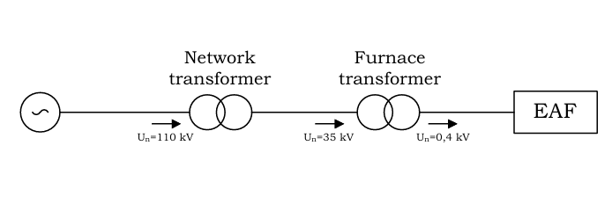
Fig. 1. Electrical supply diagram for electric arc furnaces
The objective of this study is to improve power quality and enhance the energy efficiency of the system by reducing voltage asymmetry in the power supply of electric arc furnaces (EAFs). To achieve this, capacitors are connected to each phase, and their switching is controlled by thyristors. The optimal selection of thyristor firing angles is determined using a genetic algorithm [5–7].
Electric arc furnaces are an integral part of modern metallurgical production and represent a powerful, dynamic, three-phase load. Their operation is accompanied by uneven distribution of currents and voltages among the phases, leading to voltage asymmetry in the supply network (1).

$k_{U2}=\frac{U_{2}}{U_{1}}∙100\%$ и $k_{U0}=\frac{U_{0}}{U_{1}}∙100\%$ (1)

For the successful operation of the genetic algorithm (GA), it is crucial to select an appropriate fitness function that defines the optimization criteria:
$\text{J}\left({\text{α}}_{\text{A}}\text{,}{\text{α}}_{\text{B}}\text{,}{\text{α}}_{\text{C}}\right)\text{=}{\text{ω}}_{\text{u}}\text{∙}{\text{K}}_{\text{u2}}^{\text{2}}\text{+}{\text{ω}}_{\text{q}}\text{∙}\sum_{\text{i=A,B,C}}{{\left(\frac{{\text{Q}}_{\text{i}}\left({\text{α}}_{\text{i}}\right)\text{-}{\text{Q}}_{\text{m}}}{{\text{Q}}_{\text{m}}}\text{∙100\%}\right)}^{\text{2}}}$ (2)
The following flowchart illustrates the sequence of stages in the operation of the genetic algorithm:
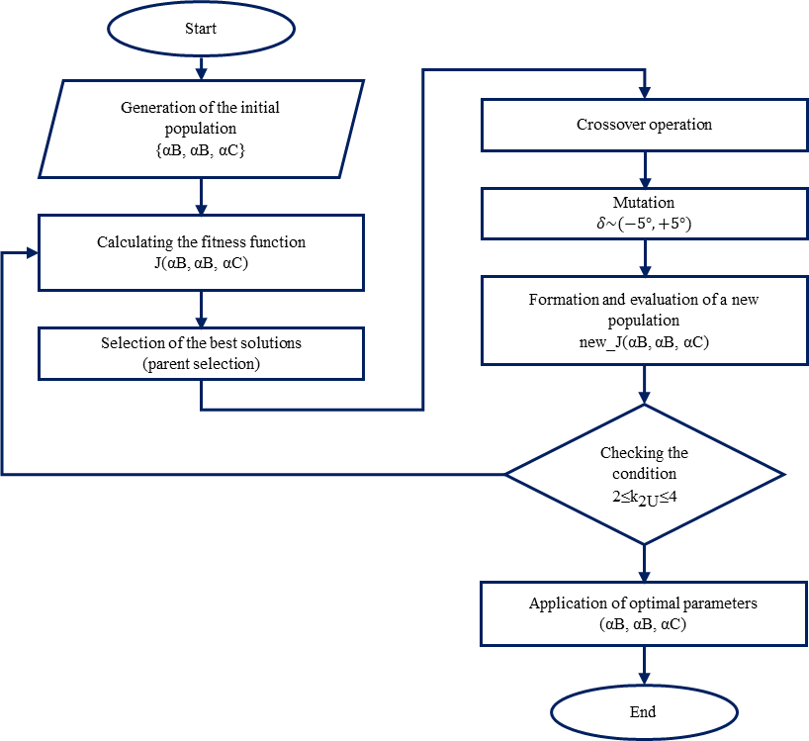
Fig. 2. Flowchart of the genetic algorithm operation for optimizing thyristor firing angles

The overall workflow of the proposed GA is illustrated in Fig. 2. The diagram outlines the logical structure and sequence of computational stages that enable adaptive optimization of thyristor firing angles within the compensation system. At the initial stage, the algorithm defines the control parameters, the limits of their variation, and the optimization criterion based on the voltage asymmetry factor K_{U2}​. These preliminary settings establish the search boundaries and ensure that all generated solutions remain within the physical constraints of the 35 kV network and the thyristor switching reliability requirements.
After initialization, the GA enters the iterative optimization cycle. In each iteration, the algorithm evaluates all candidate solutions according to the fitness function J(α_{A}, α_{B}, α_{C}), which reflects the degree of voltage asymmetry and overall system deviation from the optimal balance point. The most promising solutions are preferentially selected for further processing, while less effective ones are discarded.
The evolutionary process proceeds through selection, crossover and mutation, as shown in the flowchart. These mechanisms collectively ensure that the algorithm explores the solution space efficiently, combining exploitation of known good regions with exploration of new potential areas. The diversity of the population is preserved throughout the process, preventing premature convergence and maintaining adaptability to changing load conditions.
The optimization cycle continues until the stopping criterion – a voltage asymmetry factor within the acceptable standard range – is reached. When convergence is achieved, the GA produces the optimal set of thyristor firing angles that can be directly implemented in the reactive power compensation system.
This structural organization, summarized in Fig. 2, demonstrates how the GA transforms real-time voltage and reactive power data into adaptive control signals. The result is a self-correcting mechanism capable of maintaining network stability and power quality without the need for a detailed mathematical model of the “furnace–network–compensation device” system.
RESEARCH RESULTS
In this study, the genetic algorithm is applied as an optimization tool for determining the thyristor firing angles in the thyristor reactive power compensation system, enabling effective reduction of voltage asymmetry under the unstable operating conditions of electric arc furnaces. The optimization process is based on the evolutionary improvement of a set of potential solutions – chromosomes containing the parameters α_{A}, α_{B} and α_{C}, which define the reactive power level in each phase.
The operation of an electric arc furnace is accompanied by sharp and chaotic current fluctuations, leading to dynamic voltage imbalances and the generation of significant negative- and zero-sequence components. Traditional compensation methods based on fixed settings are unable to respond effectively to the rapidly changing conditions of the arc discharge. In this regard, the genetic algorithm – with its stochastic search nature and ability to adaptively converge toward the optimum – is the most suitable tool for real-time control of the firing angles.
At the first stage of the study, an initial population of chromosomes is formed. Each chromosome includes three control angle values, α, varying within the range of 50–80°, determined by the physical constraints of the TRPCS and the requirements for minimum commutation reliability of the thyristors. The calculation of the fitness function J for these initial solutions yielded high values ranging from 9267 to 16228,22. At the same time, the measured voltage asymmetry factor K_{U2} ranged from 6,87% to 7,06%. These results confirm that the initial thyristor firing angles are insufficient to ensure acceptable voltage quality and require further optimization.
To ensure consistent improvement of the initial parameters, a tournament selection mechanism is applied, allowing only the most successful chromosomes to be selected from the population based on the minimization criterion of the fitness function J. The selection of the three best solutions forms the foundation for generating a new population. Subsequently, a single-point crossover is performed, which enables the exchange of chromosome segments and the creation of new, previously non-existent combinations of firing angles. This approach increases the probability of finding a more optimal configuration of phase control angles.
The mutation stage serves to prevent premature convergence of the algorithm and stagnation in one of the suboptimal solutions. Mutations of approximately ±5° were chosen based on the system’s sensitivity analysis: variations of firing angles within this range do not cause abrupt changes in reactive power but still provide sufficient diversity to expand the search space toward the global optimum. From the standpoint of evolutionary algorithm theory, this mutation magnitude is balanced – it preserves the general search direction while avoiding “stagnation” in local minima.
Reevaluation of the updated population showed a significant improvement in performance indicators. Among the generated offspring, a chromosome with parameters α_{A} = 58°, α_{B} = 71°, and α_{C} = 58° stood out. For this configuration, the voltage asymmetry factor decreased to 4,52%, and the fitness function value dropped to J = 1842,3, indicating that the system was approaching an efficient operating mode. This also demonstrates that the GA successfully identified the asymmetric reactive power demands across the phases and redistributed the control angles accordingly.
Further evolution produced even more notable results. Since the stopping criterion of the algorithm was the reduction of the voltage asymmetry factor to a normative level, the optimization process continued until K_{U2} decreased to 3,8%. This value meets the established power quality standards for 35 kV networks, confirming the validity of the chosen optimization criterion and the effectiveness of the developed control method for phase angles.
The completion of the optimization process at a K_{U2} level of 3,8% indicates that the algorithm found a stable and practical solution capable of ensuring reliable TRPCS operation even under sharp and chaotic load fluctuations characteristic of electric arc furnace processes. This demonstrates the ability of the genetic algorithm to function as an adaptive regulator that adjusts in real time to the current characteristics of the technological process and reduces stress on the electrical network.
Thus, the conducted research has shown that the application of a genetic algorithm provides dynamically optimal control of thyristor firing angles, significantly reduces voltage asymmetry, and enhances the stability of the 35 kV power network. The obtained results confirm the potential of evolutionary optimization methods in reactive power compensation systems for metallurgical loads.
CONCLUSIONS
In the course of this research, a control system for a TRPCS was developed and tested. The system is based on a GA designed to reduce the voltage asymmetry factor in a 35 kV power network during the operation of an EAF. The conducted optimization of thyristor firing angles demonstrated that the algorithm is capable of effectively selecting control parameters under conditions of rapidly changing and nonlinear loads, which are typical of EAF processes.
The implementation of the GA resulted in a reduction of the voltage asymmetry factor to 3,8%, which falls within the permissible limits defined by power quality standards. This achievement fulfills the main objective of the study – to provide automatic, adaptive compensation of voltage asymmetry in real time. The adaptive nature of the algorithm ensures that the control system continuously responds to fluctuations in furnace load, dynamically redistributing reactive power among the phases to maintain network stability.
The obtained results confirm that the proposed method can be successfully implemented in industrial reactive power compensation systems. It has the potential to enhance power network stability, reduce negative-sequence voltage components, and improve the overall quality and reliability of power supply in metallurgical applications utilizing electric arc furnaces. Furthermore, the demonstrated adaptability and robustness of the GA-based control system highlight its suitability for integration into modern intelligent power management solutions aimed at optimizing the operation of energy-intensive industrial facilities.
REFERENCES
- Olczykowski, Z. Electric Arc Furnaces as a Cause of Current and Voltage Asymmetry. Energies 2021, 14, 5058. https://doi.org/10.3390/en14165058
- M.Y.Naqash and Z. Rashid, “PI Controller Based Automatic Power Factor Correction (APFC) Using Capacitor Bank”, ECCE, vol. 19, no. 1, pp. 40–48, Jun. 2023.
- Dixon, J.; Moran, L.; Rodriguez, J.; Domke, R. Reactive power compensation technologies: State-of-the-art review. Proc. IEEE 2005, 93, 2144–2164.
- O. Igodo and F. U. Ilo, “Improving the quality of power supply in distribution network using Genetic-based SVC,” Int. J. Res. Trends Adv. Comput. Syst., 2023.
- Rakhmonov I.U., Kholikhmatov B.B., Ilyasov A.P. Genetic algorithms as a method of global optimization: possibilities and limitations // Universum: Technical Sciences: Electronic Scientific Journal. 2024. 11(128).
- Rakhmonov I.U., Kholikhmatov B.B., Saidkhodzhaev A.G. International Scientific Journal “Internauka” No. 43 (360), November 2024.
- Usmanov Eldor, Kholikhmatov Bakhriddin, Rikhsitillaev Bakhodir, Nimatov, Kamoliddin. Device for reducing asymmetry // E3S Web of Conferences 461. 2023, PP, 01052, 1-5. https://doi.org/10.1051/e3sconf/202346101052

