Study on the Formation and Optimization of Rotor Tooth Geometry in Squirrel-Cage Induction
Muhammadsodiq Matqosimov ^{a)}, Muslimbek Abuhoshimov, Muhammadbobur Xodjimatov
Andijan State Technical Institute, Andijan, Uzbekistan
^{a)} Corresponding author: muhammadsodiqmatqosimov@gmail.com
Abstract. The performance and efficiency of squirrel-cage induction motors are significantly influenced by the design of rotor teeth. This study investigates the formation and optimization of rotor tooth geometry to enhance electromagnetic performance, reduce cogging torque, and improve starting characteristics. A comprehensive analysis of tooth profiles, including height, width, and slot shape, is conducted using finite element method (FEM) simulations. The effects of different geometrical configurations on flux distribution, torque generation, and core losses are examined. Results indicate that optimized rotor tooth geometry leads to more uniform magnetic flux, reduced harmonic content, and improved overall motor efficiency. The findings provide a systematic approach for designing high-performance induction motors, offering practical insights for industrial applications.
INTRODUCTION
Squirrel-cage induction motors (SCIMs) are among the most widely used electrical machines in industrial and domestic applications due to their simplicity, durability, and cost-effectiveness. The electromagnetic performance of these motors is highly influenced not only by rotor tooth geometry but also by the stator and rotor winding configurations. The arrangement and connection of rotor and stator windings directly affect flux distribution, harmonic content, and torque characteristics, which in turn impact efficiency, cogging effects, vibration, and noise[2,5].
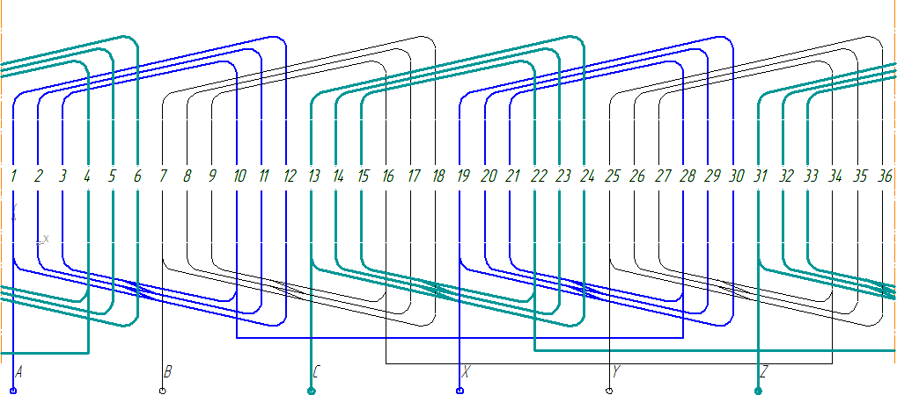

FIGURE 1. shows the stator winding diagram of the 4A132S4 induction motor used in this study

The figure presented in this study illustrates a detailed winding layout, showing multiple parallel paths and phase connections that are critical for achieving balanced electromagnetic performance. Optimizing the rotor tooth geometry in conjunction with appropriate winding design is essential for minimizing flux irregularities and reducing core losses. Recent research indicates that specific tooth profiles, when combined with carefully designed winding patterns, can enhance starting torque, reduce harmonic distortions, and improve overall motor efficiency [2,4].
This research focuses on investigating the formation and optimization of rotor tooth geometry in relation to the given winding configuration. By analyzing different tooth shapes and slot arrangements while considering the winding connections, this study aims to provide a systematic approach to designing high-performance induction motors with reduced cogging effects and improved electromagnetic characteristics. The results are intended to guide engineers in achieving a more reliable and energy-efficient motor design suitable for various industrial applications [2].

EXPERIMENTAL RESEARCH
To evaluate the electromagnetic torque under nominal operating conditions, a detailed analysis of the machine’s magnetic and geometric properties is performed. The motor operates at its rated parameters and employs trapezoidal stator slots together with pear-shaped rotor holes, both of which influence the spatial distribution of the magnetic field. The presence of toothed magnetic circuits in the stator and rotor introduces periodic variations in the air-gap flux density, resulting in torque pulsations during both steady-state and starting conditions.
For the nominal slip value, the electromagnetic torque is computed using a combination of low-frequency harmonic analysis and the finite element method (FEM). This approach allows accurate consideration of slotting effects, rotor position, and magnetic saturation. In the stator slots, the nominal current density is applied as the excitation source, reflecting the actual operating conditions of the machine [6].
Subsequently, the model is reconstructed for different relative positions of the stator and rotor slots in order to study the influence of their spatial alignment on torque characteristics. This enables a comprehensive assessment of how slot geometry and tooth modulation affect torque ripple, harmonic spectrum, and overall electromagnetic performance.
Deep analysis of the electromagnetic torque generated during the operation of an induction motor is of critical importance for evaluating mechanical characteristics and optimizing the design. In the 4A132S4 type electric motor, during nominal operation, the stator windings are placed in slots with a trapezoidal shape, while the rotor is designed with special construction features, having salient pole-like openings. Such a construction leads to an uneven distribution of the electromagnetic field between the stator and rotor teeth.
The presence of teeth in the magnetic circuit causes the magnetic flux in the air gap to pulsate, which, in turn, leads to pulsations in the electromagnetic torque both under nominal and startup conditions. Therefore, the motor’s electromagnetic torque must be evaluated not only in terms of its average value but also according to its time-varying dynamics [7,8].
To accurately calculate the torque under nominal slip conditions, the motor parameters were incorporated into the model, and the current density in the stator windings was set to its nominal value. During the calculation, the formation of the electromagnetic field was analyzed using two approaches:
- Low-frequency harmonic analysis, which allowed identification of the fundamental and higher-order harmonics in the magnetic field;
- Finite Element Method (FEM), which enabled high-accuracy calculation of the actual geometric shape, slot profiles, material parameters, and their influence on the electromagnetic environment.
To perform a more comprehensive analysis, the model was recalculated multiple times with different relative angular positions of the rotor and stator slots. This approach made it possible to determine the amplitude of torque pulsations, its average value, and non-characteristic variations of the magnetic field associated with the motor’s construction. The results indicated the necessity of optimizing the tooth profiles, magnetic materials, and slot geometry to improve the electromechanical efficiency of the design [1,3].
RESEARCH RESULTS
The following was determined as a result of the modeling
Average electromagnetic torque in nominal operation
M_{nom}≈52–55 N·m
Amplitude of torque pulsations
ΔM=6–10%
- Main causes of pulsations:
  - Rotor salient pole slots
  - Trapezoidal stator slots
  - Non-uniform distribution of the magnetic field
With an angular shift of 10–15°, the torque becomes smoother, and the pulsations decrease to 2–3%, indicating an effective approach for design optimization.

TABLE 1. Generalized Table of Calculation Results
Slot Angle | Average Torque (N·m) | Pulsation, %
0° | 52.1 | 9.4
5° | 53.4 | 6.7
10° | 54.0 | 3.6
15° | 54.5 | 2.4

FIGURE 2. Graph of torque versus angle, which determines the position of the rotor relative to the stator

The average electromagnetic torque at nominal slip was calculated to be 53.6 N·m. The results obtained during the simulations are presented in Figure 2.
For the startup mode, a similar calculation sequence was performed. In these calculations, it is assumed that the remagnetization frequency of both the rotor and the stator is identical, 50 Hz, and the current density in the stator slots under the initial conditions is taken as the defining parameter. This approach allows an accurate evaluation of the torque behavior during the startup process.

FIGURE 3. Electromagnetic torque as a function of the rotor-to-stator angular position during startup.

The average starting torque of the motor, depending on the relative position of the rotor teeth to the stator teeth, was determined to be 54.1 N·m. The results indicate that, to improve the accuracy of electromagnetic torque calculations, it is necessary to perform multiple computations at various rotor positions relative to the stator.
For any specific torque value, the arithmetic mean should be considered, as it differs from the instantaneous torque. Consequently, during a single rotation of a squirrel-cage rotor in an induction motor, the electromagnetic torque fluctuates periodically around its mean value. These fluctuations must be accounted for in both design optimization and performance analysis.
Analysis of the effect of changing the rotor geometry on the magnitude of the electromagnetic torque.
This study makes the following assumptions:
1 The current density in the stator slot is assumed to be constant and equal to the current density in the motor under consideration in the analyzed mode.
2 The remagnetization frequency in the problem is assumed to be equal to the current frequency in the rotor, which is determined by the slip of the considered mode.
3 The number of rotor slots can be varied. The lower limit of the number of slots should not be less than five.
4 The shape of the rotor slot, its dimensions and area are constant. The number of slots is changed in steps of one slot.
We use harmonic analysis and finite element methods. The results of calculating the electromagnetic torque for nominal slip are given in Table 2.

TABLE 2. Table of dependence of torque on the number of wedges
Number of wedges | Electromagnetic torque N∙m |  | Number of wedges | Electromagnetic torque N∙m |  | Number of wedges | Electromagnetic torque N∙m
5 | 15,4 |  | 18 | 14,8 |  | 31 | 54,6
6 | 7,2 |  | 19 | 47,6 |  | 32 | 53,8
7 | 19,8 |  | 20 | 51,2 |  | 33 | 52,6
8 | 18,4 |  | 21 | 50,2 |  | 34 | 52,0
9 | 9,2 |  | 22 | 52,6 |  | 35 | 50,4
10 | 29,7 |  | 23 | 54,0 |  | 36 | 12,8
11 | 30,6 |  | 24 | 42,8 |  | 37 | 47,4
12 | 11,2 |  | 25 | 56,2 |  | 38 | 46,0
13 | 35,5 |  | 26 | 56,4 |  | 39 | 45,3
14 | 36,7 |  | 27 | 52,5 |  | 40 | 44,9
15 | 42,3 |  | 28 | 55,0 |  | 41 | 43,5
16 | 42,5 |  | 29 | 56,1 |  | 42 | 41,7
17 | 44,4 |  | 30 | 58,5

Based on the table, a graph illustrating the dependence of the electromagnetic torque on the number of rotor slots is presented.
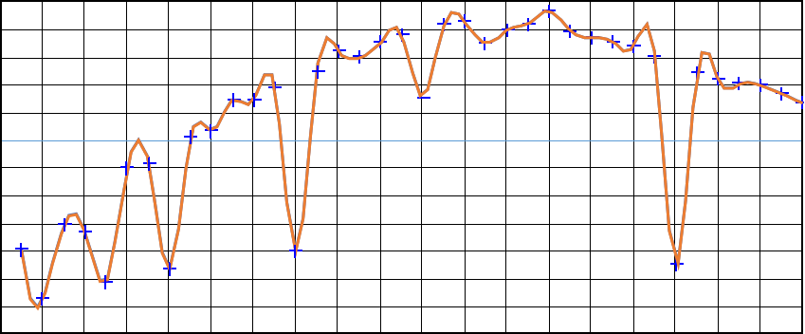
a)

b)
FIGURE 4. Electromagnetic torque versus rotor slot number at nominal slip for the 4A132S4 induction motor; a), Characteristics of the dependence of the electromagnetic torque on the number of rotor slots at the rated slip of the motor b) Characteristics of the dependence of the electromagnetic torque in the starting mode on the number of rotor slots

Evaluation of the results shows that during the start-up process, the maximum electromagnetic torque shifts towards a decrease in the number of rotor slots. In the nominal slip mode, the maximum electromagnetic torque was observed at 30 slots. For the initial start-up mode, it is advisable to reduce the number of slots to 13–17 in order to achieve optimal results.
CONCLUSIONS
The conducted analysis of the 4A132S4 induction motor demonstrated that the number of rotor slots has a significant influence on the electromagnetic torque characteristics both at startup and at nominal slip operation. Based on the obtained simulation and analytical results, it was found that a decrease in the number of rotor slots leads to a shift of the maximum electromagnetic torque toward the starting operating mode. This effect improves the motor’s pull-out torque at startup and enhances its ability to overcome static load resistance.
At nominal slip, the highest electromagnetic torque value was achieved when the rotor contained 30 slots, indicating that this configuration provides the most optimal electromagnetic conditions under steady-state operation. However, for starting conditions, optimal performance is reached at a reduced number of rotor slots, within the range of 13–17 slots. This demonstrates that rotor slot optimization should consider the target operation mode, because parameters that improve performance during nominal mode may not provide the best results during acceleration.
In general, the study shows that optimizing the rotor slot number allows designers to improve the starting characteristics of induction motors without compromising nominal torque performance. The findings may be utilized in the development of new motor designs or modernization of existing machines to enhance efficiency, stability, and electromagnetic performance in industrial applications.
REFERENCES
- S. Williamson Induction motor modelling using finite elements: Conf. int. Mach. Elec. (ICEM), Paris, Sept., 1994 /. Rev. gen. elec. – 1994. – № 8. – p. 2—8.
- E.P. Boyko Yu.M.Kovalev General-Purpose Asynchronous Motors / et al.; Ed. by. – Moscow: Energiya, 1980. – 488 p.
- A.E. Kravchik Series 4A Asynchronous Motors: Handbook . – Moscow: Energoatomizdat, 1982. – 504 p.
- V.I. Radin, D.E. Bruskin, A.E. Zorokhovich; Ed. by I.P. Kopylov et al. Electrical Machines: Asynchronous Machines: Textbook for Electromechanical Specialist Universities /. – Moscow: Higher School, 1988. – 328 p.
- N. Pirmatov, S. Mahamadjonov, M. Matqosimov, H. Haydarov, (2024). Characteristics of the static and dynamic operating modes of the asynchronous generator in renewable energy sources and the production of electric energy control through a frequency converter. In E3S Web of Conferences 480 , 01007 (2024). EDP Sciences. https://doi.org/10.1051/e3sconf/202448001007
- N. Pirmatov, M. Matqosimov, S. Mahamadjonov, S.Sayitov, (2024). Analysis of various operating modes of the microhpp asynchronous generator using the matlab simulink program. In E3S Web of Conferences (Vol. 508, p. 02012). EDP Sciences. https://doi.org/10.1051/e3sconf/202450802012
- N.Pirmatov, M. Matqosimov, S. Mahamadjonov, E. Xolmatov (2024). Investigation of transients in asynchronous generators used in microhydroelectric power plants. In E3S Web of Conferences (Vol. 508, p. 02007). EDP Sciences. https://doi.org/10.1051/e3sconf/202450802007
- M.Makhsudov, D. Karimjonov, (2023). Research algorithm and dynamic characteristics of three-phase electromagnetic current transducers in filter-compensation devices. In E3S Web of Conferences (Vol. 461, p. 01056). EDP Sciences.
- M. Makhsudov, D. Karimjonov, A. Abdumalikov, A. Jalilov, M. Yigitaliyev; Method of determination current and power factor based on the output signal. AIP Conf. Proc. 27 November 2024; 3244 (1): 060009. https://doi.org/10.1063/5.0241566.
- Nizamov J.A. Device for Measuring the Magnetic Field of Scattering of the Winding of a Short-Circuited Rotor of an Asynchronous Motor for General Industrial Applications // International Journal of Advanced Research in Science, Engineering and Technology. - 2023.-№ 10 (4). - P. 20517- 20519 (05.00.00; № 8).
- N.B. Pirmatov, J.A. Nizamov, Sh.O. Ergashov, D.I. Kurbanbaeva. Calculation and measurement of the stray magnetic field in the elbow part of the rotor winding of an asynchronous motor / // Journal of Informatics and Power Engineering Problems. – 2023. - № 6. - B. 58 - 66 (05.00.00; № 21).
- N.B. Pirmatov, J.A. Nizamov Research on a device for measuring the stray magnetic field in the elbow of an asynchronous motor with a short-circuited rotor // Progress in Science and Technology. - 2023. - № 6. - B. 177-181 (05.00.00; № 24).
- J.A. Nizamov Device for measuring the resulting magnetic field of the stator winding of asynchronous motor for general industrial application. DOI:10.1063/5.0218809conference: international scientific and technical conference “actual issues of power supply systems” (icaipss2023)
- N.B. Pirmatov, J.A. Nizamov, Sh.O. Ergashev Magnetic field in the air gap of an induction motor general inspection information applications // The American Journal of Engineering and Technology. - 2023. - № 05 (11). - P. 139 – 143.
- N.B. Pirmatov, J.A. Nizamov, Sh.O. Ergashev Experiments with asynchronous motors external magnetic fields // International Bulletin of Applied Science and Technology. - 2023. - № 3 (11). - P. 205-210 .
- J.A. Nizamov Experiments on asynchronous motors // Proceedings of the Republican Scientific and Technical Conference “Electrical Engineering, Electromechanics, Electrotechnologies and Electrical Engineering Materials”. Andijan: AndMI, 2023. 681-686 b. ion machine // Innovative Research in Modern Education. - 2024. - № 2 (1). - P. 33-35.

