Assessment of the impact of municipal and household consumers on voltage and current sinusoidality
Abduraxim Taslimov^{1а)}, Matkarim Ibragimov², Vaxobiddin, Moʻminov ³, Xamza Aminov⁴
¹Tashkent State Technical University named after Islam Karimov, Tashkent, Uzbekistan
²Tashkent Institute of Irrigation and Agricultural Mechanization Engineers" National Research University, Tashkent, Uzbekistan
³Almalyk state technical institute, Almalyk, Uzbekistan
⁴Urganch State Universitu, Urganch, Uzbekistan
^{a)} Corresponding author: ataslimov@mail.ru
Abstract. This article investigates the emergence of numerous electrical appliances with nonlinear current and voltage characteristics in residential buildings, as well as the influence of high-order harmonic currents on the power grid. It is shown that large amplitudes of these harmonics lead to a deterioration of the voltage waveform. The study establishes that the power consumption of nonlinear household electrical devices constitutes a significant share of the total electrical load in residential buildings, with their share reaching 66.5% according to the presented list of household appliances. It is substantiated that high-order harmonic currents generated by communal and domestic loads cause additional power losses in transformers of up to 15.3%, and that the losses in the neutral conductor caused by high-frequency currents emitted by three-phase residential nonlinear loads exceed the fundamental-frequency losses by an average factor of 2.6 over a 24-hour period.
INTRODUCTION
In recent years, considerable attention has been given to improving energy efficiency, enhancing power supply reliability, and ensuring the quality of electrical energy in rural electrification systems. The introduction and widespread deployment of modern multifunctional measuring instruments in the Republic have enabled deeper analysis and consideration of electrical regime parameters and additional factors that were previously difficult to assess using electronic computing devices. Among these additional and insufficiently studied factors is the low quality of electrical energy—particularly voltage and current waveform distortion (nonsinusoidality). In rural power supply systems, this issue is primarily associated with the increasing number and installed capacity of household devices exhibiting nonlinear load characteristics. From this perspective, research on the influence of modern electrical appliances on power networks, the characteristics of the municipal–household sector, power quality issues, and the application of new technologies to reduce power losses is of particular importance [1].
Modern residential buildings are equipped with a wide variety of electrical appliances. According to the data presented in [2], the number of long-term household electrical devices currently in use in residential buildings is summarized in Table 1.

Table 1. Number of long-term household electrical appliances per 100 households in the Republic.
Electrical Appliances | Number per 100 households
Television sets | 131
Video equipment (video recorders and digital playback units) | 63
Audio tape recorders | 54
Personal computers and associated peripheral devices | 22
Home audio systems (integrated music centers) | 29
Refrigerators | 114
Washing machines | 99
Vacuum cleaners | 83
Sewing machines | 67

Lighting of residential buildings is carried out using general-purpose household luminaires. Typically, residential premises are illuminated by incandescent lamps or energy-saving lamps with a rated power of 20–120 W.
Household electrical appliances can be conventionally classified into the following groups:
– domestic utility appliances (washing machines, electric irons, vacuum cleaners, etc.);
– food processing and storage appliances (refrigerators, multifunctional kitchen machines, mixers, etc.);
– heating appliances used for food preparation (electric cookers, electric kettles, microwave ovens, etc.);
– cultural and household appliances (television sets, personal computers, audio systems, DVD players, etc.);
– sanitary and hygiene appliances (ventilation units, hair dryers, curling irons, etc.);
– appliances for space conditioning and heating (climate control systems, electric radiators, etc.) [3].
A large portion of electrical appliances used in residential buildings are equipped with switched-mode power supplies or are capable of electronic control of their operating modes. Such appliances exhibit nonlinear volt–ampere characteristics and are therefore referred to as nonlinear electrical loads.
The main types of nonlinear electrical appliances found in 0.38-kV municipal and household distribution networks include: personal computers, uninterruptible power supplies, energy-saving lamps, electric motors with variable-frequency drives, air conditioners, televisions, video recorders, microwave ovens, and others.
The power consumption of nonlinear electrical appliances constitutes a significant share of the total electrical load of a residential building. According to expression (1), and based on the list of household appliances provided in [4], the share of electrical consumption attributable to nonlinear electrical devices amounts to 66.5% of the total electrical energy demand of residential buildings.
$K_{n.e}$=$\frac{{\sum{P}}_{n.eq}}{\sum{Р_{n.eq}}+\sum{Р_{l.eq}}}∙100\%,$ (1)
Here, K_{n.e} – the share of electrical energy consumption attributable to nonlinear electrical appliances;
$\sum{P_{l.eq.}}$ – the total installed power of linear electrical appliances;
$\sum{P_{n.eq}}$.​ – the total installed power of nonlinear electrical appliances.
It is important to note that devices operating for extended periods are typically nonlinear electrical appliances (television sets, personal computers, audio systems, etc.). When lighting is provided by fluorescent or energy-saving lamps, the lighting load also becomes nonlinear.
Experimental investigations were carried out using an ASK-4166 digital oscilloscope and an application software package connected at the input of a residential building according to the schematic diagram shown in Figure 1. These measurements made it possible to obtain the amplitude–frequency characteristics of major nonlinear electrical appliances operating at a nominal voltage of 0.38 kV.
By sequentially connecting electrical appliances to the network and recording oscillograms, the instantaneous variations of the consumed current and voltage were obtained. These waveforms are presented in Figure 2.
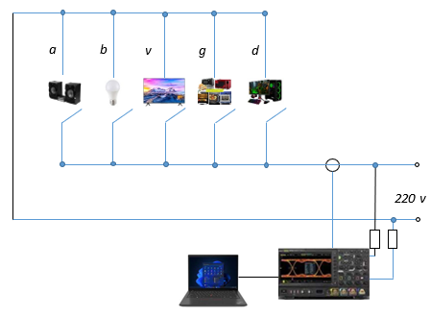
FIGURE 1. Experimental setup diagram:
a – music center;b – energy-saving lamp;c – television set;d – microwave oven;e – personal computer;f – oscilloscope connected to a personal computer.
RESEARCH RESULTS
According to GOST 13109-97 [5], the distortion of voltage and current waveforms from an ideal sinusoidal form is characterized by two indicators: the voltage waveform distortion factor and the current waveform distortion factor.

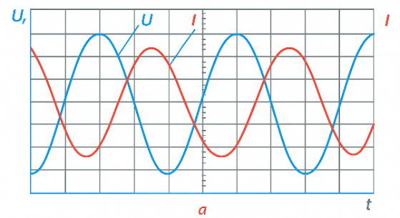 | 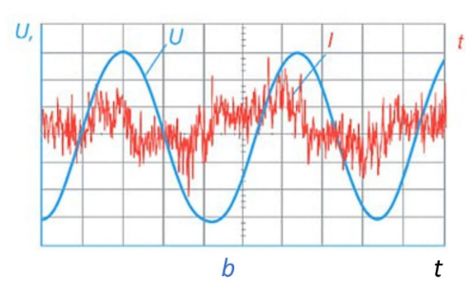

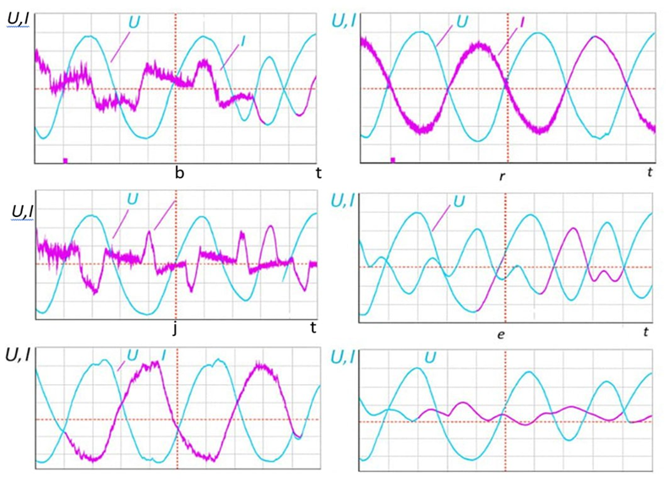

FIGURE 2. Oscillograms of current and voltage waveforms:
a – incandescent lamps; b – energy-saving lamp; c – television set; d – refrigerator; e – personal computer (CPU and monitor); f – microwave oven; g – climate control systems; h – personal computer.

$K_{U}=\frac{\sqrt{\sum_{n=2}^{40}{U_{\left(n\right)}^{2}}}}{U_{nom}}∙100\%;$ K_{i}=$\frac{\sqrt{\sum_{n=2}^{40}{I_{\left(n\right)}}}}{I_{\left(1\right)}}∙100\%,$ (2)
Here, I₍₁₎ – the root-mean-square (RMS) value of the fundamental-frequency current;
U_{nom} – the nominal voltage of the power supply network;
U_{(n)}, I_{(n)} – the RMS values of the n-th harmonic components of voltage and current, respectively;
the coefficient of the n-th harmonic component of voltage and current.
$K_{U\left(n\right)}=\frac{U_{\left(n\right)}}{U_{\left(1\right)}}∙100;$ $K_{i\left(n\right)}=\frac{I_{\left(n\right)}}{I_{\left(1\right)}}∙100,$ (3)
Here,U₍₁₎, I₍₁₎ – the root-mean-square (RMS) values of the fundamental-frequency voltage and current;U_{(n)}, I_{(n)} – the RMS values of the n-th harmonic components of voltage and current.
Studies carried out using a KE analyzer of the type ERIS-KE 02 at the three-phase input of a residential building have demonstrated that the nonlinear load of an individual residential facility contributes significantly to the distortion of the current waveform. The spectral composition of the currents in the phase and neutral conductors is shown in Figure 3.
According to [6], the harmonics generated by nonlinear electrical appliances are combined in different ways depending on their order: harmonics of order 3, 5, and 7 are combined arithmetically; harmonics of order 11 and 13 are combined using the power method; and higher-order harmonics above the 4th are combined according to the square-law method. It is also known that harmonics that are multiples of three accumulate along the neutral-phase conductor loop.
Therefore, as can be observed from Figure 4, the highest amplitudes of higher-order harmonic currents occur in the neutral conductor. The total harmonic distortion (THD) of the current in the neutral conductor reaches 436.99%.
The presented graph indicates that the peak of high-frequency harmonic current emission coincides with the peak of the average load curve for gas-stove residential buildings (Figure 5) [7].
Although the highest values of the current waveform distortion factor are likely associated with the switching of electrical equipment, the levels of high-frequency currents remain significant. Experimental investigations showed that, during certain half-hour intervals of the measurement day, the amplitude of high-frequency currents in the neutral and phase conductors exceeded the values of the fundamental-frequency current.
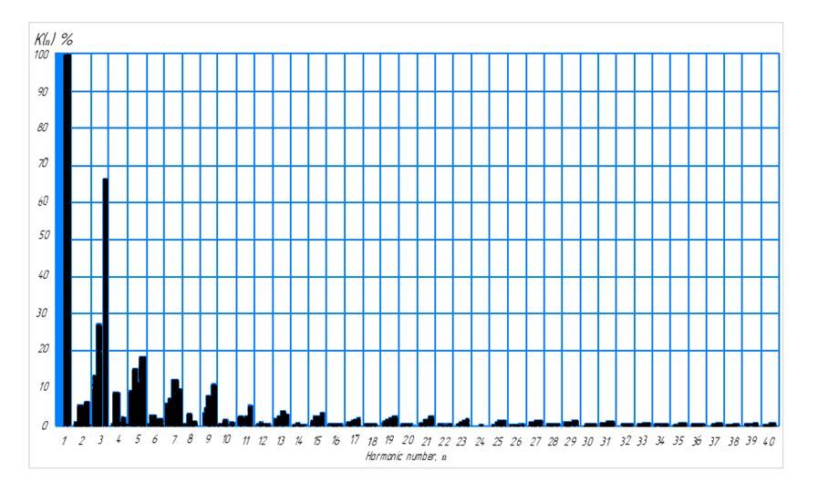
FIGURE 3. Spectral composition of currents at the three-phase input of a residential building based on average 24-hour measurements
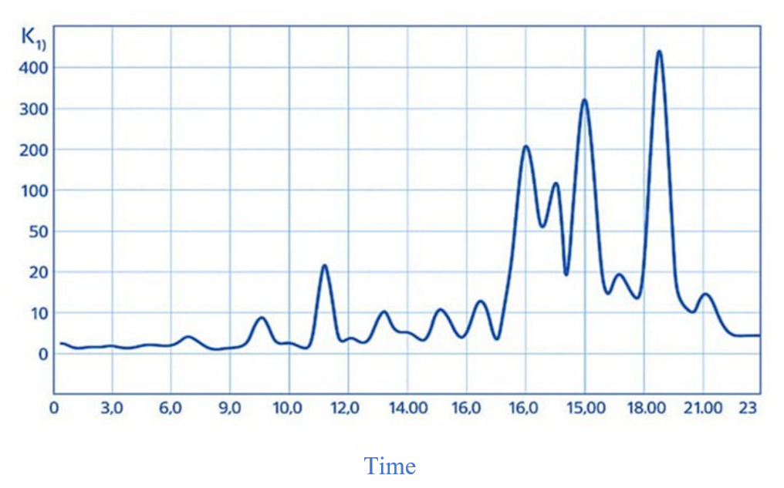
FIGURE 4. Variation of the total harmonic distortion (THD) of the current waveform in the neutral conductor over a 24-hour period

An individually located residential building consumes a current of 10–12 A at the fundamental frequency during peak load periods. High-frequency currents generated by the nonlinear electrical appliances of an individual residential building do not cause significant voltage drops in the elements of the power supply network and, consequently, do not lead to a substantial distortion of the voltage waveform. At the same time, a single rural transformer substation may supply electricity to multiple residential buildings[8,9,10].
Monitoring of power quality in 0.38 kV municipal networks of Tashkent region has shown that, according to the harmonic coefficient (KE), the voltage of the n-th harmonic component does not meet GOST requirements in all three transformer substations.

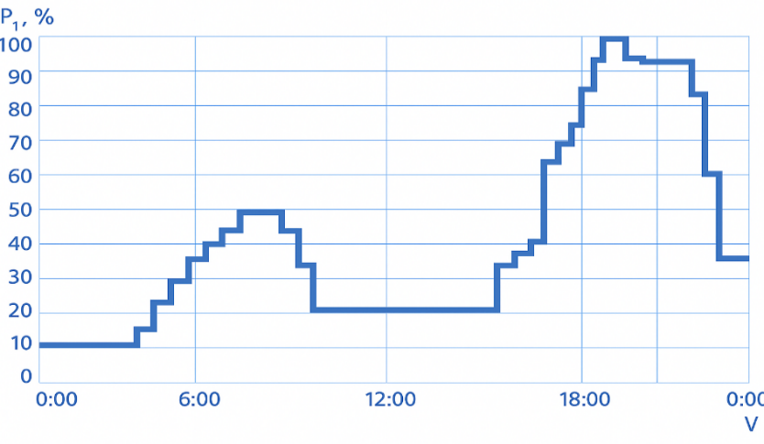
FIGURE 5. Average daily load curve of a residential building equipped with a gas stove

The presence of high-frequency harmonic currents not only deteriorates the electromagnetic condition of the power network but also reduces the reliability and durability of the main electrical equipment.
Studies conducted in the networks of Tashkent region have demonstrated that, when a large share of the total load is represented by municipal and household loads, the power losses caused by high-order harmonic currents may constitute a significant portion of the total losses.
Thus, active power losses from the fundamental-frequency current in power transmission lines and transformer windings are as follows [11,12]:
$∆P=3I_{\left(1\right)}^{2}r,$ (4)
Ower Losses Resulting from the Presence of High-Order Harmonic Currents [9,10]:
$∆P_{ВГС}=3\sum_{n=2}^{40}{I_{n}^{2}r\sqrt{n} }$, (5)
Therefore, the relative share of the losses can be calculated:
$K_{∆P}=\frac{\sum_{n=2}^{40}{I_{\left(n\right)}^{2}\sqrt{n}}}{I_{\left(1\right)}^{2}},$ (6)
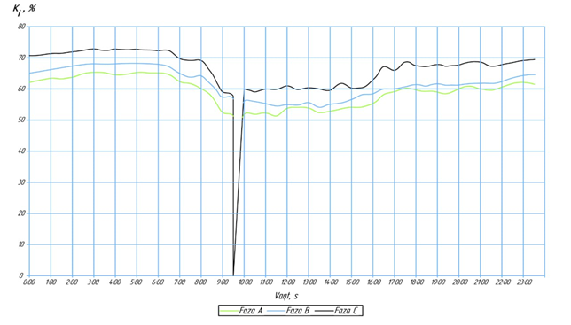
FIGURE 6. Variation of the current waveform distortion coefficient at a substation supplying municipal and household loads (office center)

Here, I₍₁₎ – fundamental-frequency current; $\sum_{n=2}^{40}{I_{n}}$​ – the sum of high-frequency harmonic currents; $K_{∆P}$– the coefficient representing the ratio of energy losses caused by high-frequency currents to the losses caused by the fundamental-frequency current; n – harmonic order.
The ratio of power losses in the neutral conductor caused by the emission of high-frequency currents from nonlinear electrical appliances in a residential building to the losses at the fundamental frequency was calculated. The results indicate that, on average over a 24-hour measurement period, the losses caused by high-frequency currents are 2.64 times greater than those at the fundamental frequency. The coefficient of the loss ratio varies widely throughout the day, with its variation pattern corresponding to the average daily load curve of a residential building equipped with a gas stove.
Additional losses in transformers supplying municipal and household loads range from 5% to 15%. Furthermore, high-frequency currents not accounted for during the design stage may create the risk of overloading the transformer [13,14].
Measurement results at a substation supplying public municipal and household loads (office center) are presented in Figure 6.
The graph indicates that the daily load regime at the substation supplying municipal and household loads is generally stable, with phase-specific distortion coefficient values varying in the range of 60–70%. Phase asymmetry is observed, with Phase A experiencing a higher load compared to the other phases. This indicates either excessive current loading on this phase or an uneven distribution of consumers. At certain times (around 09:00), sharp drops in loads across all phases may occur, resulting from voltage dips, short-term disturbances in the load, activation of high-power equipment, or temporary fault conditions. To improve the efficiency of power supply, it is necessary to balance the phase loads, identify the causes of observed anomalies, and take corrective measures.
CONCLUSIONS
1. Statistical data processing indicates that in modern residential buildings, the installed power share of nonlinear electrical appliances may reach 66.5% of the total installed capacity.
2. Additional power losses in transformers caused by high-order harmonic currents generated by municipal and household loads may reach 15.3%.
3. High-frequency currents emitted by nonlinear electrical appliances in three-phase residential building cause losses in the neutral conductor over an average 24-hour period that are 2.6 times greater than the losses at the fundamental frequency.
4. A significant portion of power losses in transmission lines and transformers can be considered as a distinct component of technological losses, and the possibility of overloading electrical equipment should be taken into account during the design stage.
REFERENCES
1. A.D. Taslimov, V.U. Mo‘minov.On the Influence of Low-Voltage Electrical Consumers on the Sinusoidality of Current and Voltage. // Problems of Energy and Resource Saving. – Tashkent, 2024. No. 4. – pp. 1–10.
2. Agency of Statistics under the President of the Republic of Uzbekistan. https://stat.uz/ru/
3. Taslimov A.D., Mo‘minov V.U. Assessment of the Influence of Voltage and Current Non-Sinusoidality on the Quality of Operation of Electrical Networks. International Scientific and Technical Conference Actual Problems of Power Supply Systems // Proceedings. – Nukus, Berdakh Karakalpak State University, 2024, pp. 144–148.
4Kharchenko, V.N. Electrical Installations of Individual Residential Buildings: Handbook. / V.N. Kharchenko. — Moscow: JSC “Energoservis”, 2004. — 496 p.
5. GOST 13109-97. Electrical Energy. Electromagnetic Compatibility of Technical Equipment. Power Quality Standards in General-Purpose Power Supply Systems.
6. Deokar, Sanjay A., Waghmare, Laxman M. Analysis of Distribution Transformer Performance under Non-Linear Balanced Load Conditions and Its Remedial Measures. International Journal of Technology and Advanced Engineering, Vol. 1, Issue 2, December 2011, pp. 152–161.
7. Filatov D.A., Terentyev P.V. Electric Power Quality and Electromagnetic Compatibility in Agricultural Power Engineering: (Textbook).Nizhny Novgorod State Agricultural Academy, 2017. — 116 p..
8. Kartashev, I.I. Electric Power Quality in Municipal Networks of the Moscow Region. / I.I. Kartashev, I.S. Ponomarenko et al. // Industrial Power Engineering. — 2003. — No. 5. — pp. 43–45..
9. Raximov, F., Taslimov, A., Majidov, A., & Norqulov, A. (2024). Optimization of losses by switching to higher voltage in distribution networks. In E3S Web of Conferences (Vol. 525, p. 03009). EDP Sciences. https://doi.org/10.1051/e3sconf/202452503009
10. Yezhelenko, I.V. Higher Harmonics in Power Supply Systems of Industrial Enterprises. /I.V. Yezhelenko. — Moscow: Energoatomizdat, 2000. — 331 p.
11. Taslimov A., Rakhimov F., Rakhimov F. Economic interval analysis of loads for selection of cross-section surfaces of electrical transmission lines //E3S Web of Conferences. – EDP Sciences, 2023. – T. 384. – S. 01037. https://doi.org/10.1051/e3sconf/202338401037 12.
12. A.D. Taslimov. Impact of climate change on electrical energy losses in electrical networks. E3S Web of Conf. Volume 384, 2023 https://doi.org/10.1051/e3sconf/202338401036.
13. Abdurakhim Taslimov, Feruz Raximov, Farrukh Rakhimov, Iles Bakhadirov // Optimal Parameters and Selection Criteria for Neutral Grounding Resistors in 20 kV Electrical Networks // V International Scientific and Technical Conference “Actual Issues of Power Supply Systems” AIP Conf. Proc. 3331, 030048-1–030048-7; https://doi.org/10.1063/5.0306108.
14. Abdurakhim Taslimov, Farrukh Rakhimov, Feruz Rakhimov, Vaxobiddin Moʻminov. Analysis of the results of sampling the surfaces of sections of rural electric networks// IV International Scientific and Technical Conference “Actual Issues of Power Supply Systems” AIP Conf. Proc. 3331, 030041-1–030041-6; https://doi.org/10.1063/5.0305783.

