Non-equidistance of initial data and its accounting method in assessing the average annual concentration and flow volume of biogenic substances in the Pskem river
Jasurjon Hamroqulov^{1, a)}, Aaed Mkhanna², Khabiba Tukhtaeva⁴, Rustam Rayimjanov³, Istat Mirzayeva⁴, Fotimabonu Xaydarova⁴, Amanova Zulfizar⁴
¹“Tashkent Institute of Irrigation and Agricultural Mechanization Engineers” National Research University. Tashkent, Uzbekistan
² Saint Petersburg State Marine Technical University. Saint Petersburg, Russia
³ National University of Uzbekistan named after Mirzo Ulugbek. Tashkent, Uzbekistan
⁴ Bukhara State Technical University, Bukhara, Uzbekistan
^{a)} Corresponding author hamroqulov1993@mail.ru
Abstract. The research studied the interdynamics of hydrochemical information, average annual concentrations, and V biogenic runoff of the Pskem River (Uzbekistan). The research aims to analyze the calculations of the numerical characteristics of the measured concentrations of nutrients in waters and consider the water content during sampling for hydrochemical analysis and the unevenness of information about hydrochemistry. We analyzed the complex processing of hydrochemical information to clarify the assessment of the average annual concentrations and volumes in the annual runoff of biogenically important substances. The biogenic runoff along the Pskem River was refined during the sampling for chemical analysis, and the unevenness of the initial series of observed phenomena. We used the method for calculating the average annual concentration to consider the unevenness of the primary series of observations. The inequality of time intervals for 365 days between sampling for hydrochemical analysis was also taken into account. Based on the obtained conclusions, an analysis of the increase in the runoff of biogens was carried out. In this work, for the first time, the features, and dynamics of changes in concentrations and the volumes of runoff of ammonium nitrogen biogens in the water of the Pskem River over a long-term period were studied with a correlation analysis between the content of the studied nitrogen compounds and physicochemical parameters: water flow, temperature and pH pollution of the Pskem river with nitrogen compounds. A scheme for analyzing the equidistance of time series of pollutant concentrations and a method for accounting for non-equidistance to estimate average annual concentrations were applied.
INTRODUCTION
Environmental pollution and depletion of water resources is the most important global problem [3].
More than 100 countries around the world are experiencing freshwater shortages, according to the UN; more than 30 countries are facing the threat of a serious water crisis [12]. For the Republic of Uzbekistan, freshwater quality issues are more relevant. In general, throughout Uzbekistan, up to 30% of water samples do not meet the requirements of the standard [2].
The determination of the anthropogenic load on water resources is based on hydrochemical observations [6]. An important characteristic of the anthropogenic load is the determination of the average annual values of concentrations and volumes of annual biogenic discharge through rivers. At the same time, well-known evaluation methods given in the works by V.A. Shelutko [5], E. V. Kolesnikova [7], E. S. Smyzhova [10], etc., do not take into account the features of the primary information included in the calculation of N indicators of pollutants. However, in the works of Nasser Othman, for the first time, a complex method was developed for simultaneously considering water content and non-equidistance when calculating the average annual concentration and annual discharge [8]. In this regard, the authors proposed techniques and methods significantly rise estimates of the average annual concentrations and volumes of biogenic discharge. This article is a logical continuation of these studies.
The reason for the intensive decline in the water quality of natural objects is the growth of anthropogenic influence and urbanization [11]. Over time, the population of cities and the area of urban communications are increasing; more water resources are used in industry, agriculture, and national needs. With the growth of industrial areas in the city, the activation of the agricultural sector of the economy, the anthropogenic impact on water resources also increases [9].
According to hydrochemical observations, the method for estimating the average annual concentrations of substances contained in the aquatic environment is based on theoretical provisions:
- Time series of pollutant concentrations at each observation point are described by the model as a series of values of a random variable;
- These series of observations are stationary, regular and homogeneous.
It has been noted that recent data collection on hydrochemical observations does not correspond to these temperatures. In this regard, the question arose about the representativeness and reliability of the collected dataset for the average annual N substances reported in river water [10].
EXPERIMENTAL RESEARCH
The research aims to analyze an integrated methodology using hydrochemical information in assessing the average annual concentrations and volumes of the annual runoff of nutrients. Refinement of the volumes of nutrient runoff along the Pskem River by taking including the water content during the period of sampling for chemical analysis and the non-equidistance of the initial series of observations.
Following tasks are solved in this research:
- Analysis of the value of the average annual concentrations of nutrients calculated by the standard method.
- Analysis of the runoff of biogens, taking into account the water content and the non-equidistance of the initial information.
The Pskem River, located in the Tashkent region of Uzbekistan, in the Syrdarya river basin, was chosen as an object. The Pskem River originates from the confluence of the Maidantal and Oygaing rivers and flows into the Charvak reservoir [8].
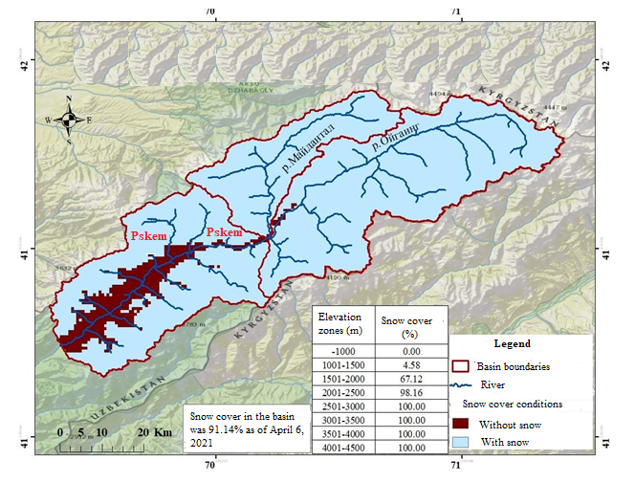
FIGURE 1. Map of the Pskem River Basin, 2021

The basin area covers 2,840 km². The river is 70 km long. Its hydrological regime is fed by snow and glaciers. The majority of the river basin is situated in the Bustanlik district, with the remaining portions extending into the territories of Kazakhstan and Kyrgyzstan. It is known that the Pskem River is one of the main tributaries of the Chirchik River. The average elevation of the Pskem Mountain Range above sea level ranges between 300 and 3,300 meters.
There is a separate method for calculating the average annual concentration to consider the unevenness of the initial series of observations. It takes into account the inequality of time intervals in a year between sampling for hydrochemical analysis.
Before calculating the annual average concentration value, it is necessary to determine the concentration values for January 1 and December 31 of each year. These values are found by interpolation between the last measured concentration value of the previous year and the first measured value in the observed year using formulas (1) and (2).

$$C_{1.01}=C_{nn}+{\left(C_{1n}-C_{nn}\right)}/{\left(d_{1n}-d_{nn}\right)×d_{nn} }$$ | (1)

where: $C_{nn}$ - the last measured concentration in the previous year; $C_{1n}$ - first measured concentration in the observed year; $d_{1n}$ - time interval from the beginning of the previous year to the last measured concentration in the observed year; $d_{nn}$- time interval from the beginning of the previous year to the first measured concentration in the observed year.

$$C_{31.12}=C_{np}+{\left(C_{np}-C_{1n}\right)}/{\left(d_{np}-d_{1n}\right)×\left({365-d}_{np}\right) }$$ | (2)

where: $C_{np}$ - the last measured concentration in the observed year; $C_{1n}$ - the first measured concentration in the next year; $d_{np}$ - the interval t о from the beginning of the studied year to the last measurement of N in it; $d_{1n}$ - the interval t from the beginning of the studied year to the first measurement of N in the next 365 days [4].
Then the calculation of the average annual N is carried out according to the formula (3), with the inequality of the intervals t between sampling.

$${\overline{C}}_{j}={\sum_{1}^{n-1}{\left({\overline{C}}_{ji}×∆t+C_{j,j-1}×∆t+C_{j,j+1}×∆t\right)}}/{t }$$ | (3)

where: ${\overline{C}}_{ji}={C_{ji}+C_{j,i+1}}/{2 }$- the average N of two adjacent measurements over 365 days; $C_{j,j-1}={C_{j,1}+C_{j-1,n}}/2$- the average N of the last measurement in the past 365 days and the first value in the current year; $C_{j,j+1}={C_{j+1,1}+C_{j,n}}/2$ - the average N of the last measurement in the year under study and the first value in the next 365 days; $∆t=t_{i+1}-t_{i}$ - the interval t of adjacent measured N; t - a number of days during the observation period; n - a number of measurements per observation period under consideration [6, 13].
To determine the errors in calculating the average annual concentrations, it is first necessary to calculate the average annual concentrations of various forms of nitrogen in the Pskem River using one of the methods listed above, after which the absolute and relative errors are calculated using formulas (4) and (5).

$$∆_{i}=S_{ai}-S_{bi}$$ | (4)

$$δ_{i}={∆_{i}}/{S_{bi}}×100\%$$ | (5)

where: $S_{ai}$ - annual average concentrations of the substance, calculated without taking into account water content; $S_{bi}$ - annual average concentrations of the substance, calculated taking into account the water content [1].
Values $∆_{i}$ and $δ_{i}$ were calculated for each i-th year for all series of observations.
At this point, a more accurate path was chosen, which consists and begins with accounting for water content, and then, based on a number of obtained values, non-equidistance was taken into account. The block diagram below shown Figure 1 calculation for joining the two algorithms.
Thus, this technique is complex and takes into account most of the features of hydrochemical information, which means that it is the most accurate of all those described above.
At the end of the block diagram, the process culminates in the integration of both algorithms, providing a comprehensive assessment of the average annual concentrations of biogenic substances. This integrated approach ensures that all relevant factors, including water content and non-equidistance, are accounted for. As a result, it leads to more precise and reliable results, ultimately improving the accuracy of hydrochemical assessments. This complex method is the most effective for addressing the inherent variability in hydrochemical data.

FIGURE 1. Block diagram of the sequence of calculations in assessing the average annual values of concentrations using a complex method for taking into account the features of hydrochemical information.

RESEARCH RESULTS
The calculation of the average annual concentration of various nitrogen compounds in the Pskem River was conducted with careful consideration of the non-equidistance of the initial observation series. Initially, the concentration values for January 1 and December 31 of each year were determined using formulas (1) and (2). Then, the average annual concentration was computed using formula (3). In addition, the errors resulting from neglecting the non-equidistance of the original data series were assessed using formulas (4) and (5). This method allowed for a more accurate estimation of the nitrogen compound concentrations, accounting for the temporal variability in the data and providing a more reliable representation of the average annual concentrations.

TABLE 1. Presents the obtained values of average annual concentrations with and without allowance for non-equidistance, as well as calculation errors for ammonium nitrogen in the Mullala gauge
Year | Average annual concentrations, mg/l |  | $$∆_{i}$$ | $δ_{i}$,%
Year | Medium arithmetic | Taking into account the non-equidistance | $$∆_{i}$$ | $δ_{i}$,%
1990 | 0.132 | 0.099 | 0.033 | 34
1991 | 0.156 | 0.119 | 0.037 | 31
1992 | 0.078 | 0.049 | 0.029 | 60
1993 | 0.062 | 0.042 | 0.020 | 48
1994 | 0.066 | 0.058 | 0.008 | 15
1995 | 0.362 | 0.277 | 0.085 | 31
1996 | 0.080 | 0.137 | -0.057 | -42
1997 | 0.082 | 0.090 | -0.008 | -9
1998 | 0.120 | 0.137 | -0.017 | -12
1999 | 0.182 | 0.134 | 0.048 | 36
2000 | 0.132 | 0.114 | 0.018 | 15
2001 | 0.056 | 0.062 | -0.006 | -10
2002 | 0.040 | 0.046 | -0.006 | -12
2003 | 0.092 | 0.069 | 0.023 | 32
2004 | 0.046 | 0.038 | 0.008 | 22
2005 | 0.014 | 0.014 | 0.000 | 0
2006 | 0.008 | 0.009 | -0.001 | -14
2007 | 0.040 | 0.029 | 0.011 | 40
2008 | 0.036 | 0.034 | 0.002 | 5
2009 | 0.014 | 0.019 | -0.005 | -26
2010 | 0.182 | 0.168 | 0.014 | 8
2011 | 0.036 | 0.135 | -0.099 | -73
2012 | 0.044 | 0.039 | 0.005 | 14
2013 | 0.062 | 0.066 | -0.004 | -6
2014 | 0.090 | 0.078 | 0.012 | 16
2015 | 0.014 | 0.015 | -0.001 | -7
2016 | 0.012 | 0.010 | 0.002 | 16
2017 | 0.010 | 0.007 | 0.003 | 36

Source: Compiled by the authors.
Table 1 shows that the errors in the values of the average annual NH₄ of ammonium nitrogen in the site of the Mullala settlement demonstrate the dynamics of values - 73%–60%. The error in absolute terms is 0.099–0.085.
Based on this analysis, Figure 3 was constructed to visually represent the average annual concentrations of ammonium nitrogen at the Mullala village site, comparing values with and without considering non-equidistance. The graph demonstrates the variations between the two calculation methods, highlighting the impact of non-equidistance on the accuracy of the estimated concentrations. This visual representation further emphasizes the importance of incorporating non-equidistance when assessing the concentrations of biogenic substances.
According to Fig. 2, the average annual N, as arithmetic mean, is often higher than when compared with non-equidistance. The same trend was recorded for nitrogen. The errors in the values of the average annual N of ammonium nitrogen at the Mullala station are 73%–60%. Error-values in absolute terms are 0.099–0.085.
Long-term average ammonium nitrogen I in the Mullala point, obtained by the proposed method, with taking into account water content and non-equidistance, was 0.072 mg/dm³.
The long-term average concentration obtained by the conventional method during this period was 0.081 mg/dm3. The difference between these two values was 12.5%.
The magnitude of the error depends on the number of concentration measurements made per year. The more samples are taken per year, the greater the error is obtained if non-equidistance is not taken into account. And vice versa, the smaller the number of measurements per year, the less the difference between the values calculated with and without non-equidistance.

FIGURE 2. Average annual NH₄ of ammonium nitrogen in the site of Mullala village with and without taking into account non-equidistance. Source: Compiled by the authors.
For a detailed analysis of the errors in the calculation of average annual concentrations, without taking into account non-equidistance, empirical curves for the probability of error values were constructed.
In Fig. 3, as an example, an empirical error assurance curve for estimating the average annual concentrations of ammonium nitrogen is presented without taking into account the non-equidistance.

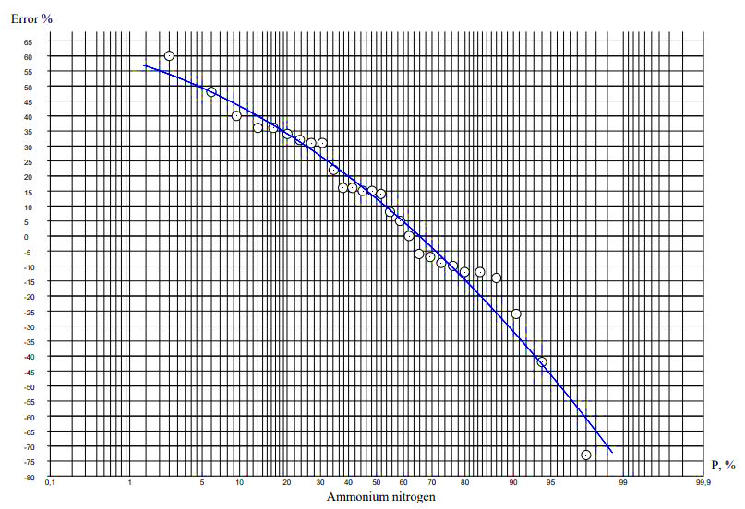
FIGURE 3. Empirical curve for the assurance of error values δi %, not taking into account the non-equidistance of the original information graphs. Source: Compiled by the authors.
As follows from the presented graphs, the errors can be positive and negative; average long-term indicators with and without considering unevenness, coincide with long series of observations.
For short series, μ differ significantly from the actual calculated values under the non-equidistance method. Larger deviations were obtained in the values of standard deviations and coefficients of variation in the series of average annual concentrations of river water.
DISCUSSION
This study confirms the findings of J. S. Hamroqulov [2]. For the first time, the characteristics and dynamics of ammonium nitrogen biogenic runoff (N, V) in the Pskem River over an extended period were analyzed through a correlation study of the nitrogen compound concentrations. Additionally, for the first time, biogenic runoff from various sections of the watershed along the Pskem River was estimated through the construction of integral concentration curves at each observation point.
A novel methodology was employed to analyze the equidistance of pollutant concentration time series, along with a technique for accounting for non-equidistance when estimating average annual concentrations. This study also explores the potential for improving the state environmental monitoring system for the Pskem River's water quality by incorporating the developed practical recommendations and pollution maps.
The integration of these methods provides a more accurate and comprehensive approach to assessing the water quality, which could significantly enhance monitoring practices and contribute to better management of the river's ecological health.
CONCLUSION
In most cases, not taking into account non-equidistance leads to an underestimation of possible extreme values. Non-equidistance of the initial data series of the concentrations of nutrients and indicators of biogenic pollution according to the developed method should be considered to eliminate the possibility of large errors.
The study allowed us to draw the following conclusions:
- When assessing the ecological state of land water bodies, the features of primary geo-ecological information are usually not taken into account;
- The errors in the calculation of average annual concentrations due to the disregard for the non-equidistance of the initial data vary from plus 115% to minus 73%;
- The long-term average concentration of ammonium nitrogen at the Mullala station, obtained by the proposed method, taking into account water content and non-equidistance, was 0.072 mg/dm3. The long-term average concentration obtained by the conventional method during this period was 0.081 mg/dm³. The difference between these two values was 12.5%;
- In many cases, the processes of changing the concentrations and volumes of runoff of the considered forms of nitrogen over time are not stationary;
- The more times a year sampling was carried out, the greater the error obtained if non-equidistance is not taken into account. And vice versa, the smaller the number of measurements per year, the less the difference between the values calculated with and without non-equidistance;
- Empirical curves are a fairly good indicator of the state of chemical pollution of rivers and, apparently, must be used in the initial analysis, especially to identify certain significant trends in change.
In further studies non-equidistance of initial data can open new possibilities to more accurate determination to estimate average multiyear concentrations and volumes of pollutant discharge, as well as will contribute to define the presence of severe observation sites, to evaluate biogenic discharge to urban and intercity areas.
REFERENCES
- Fatxulloyev, A. , Hamroqulov, J. , Gafarova, A. The discounting water influence estimation on the results of the annual concentration calculation and runoff volume of the Pskem river biogenous substances. E3s Web of ConferencesOpen source preview, 2021, 264, 03062. DOI: 10.1051/e3sconf/202126403062
- Human BL, Pierls BL, Caraco NF et al (1991) Influence on river nitrogen. Nature 350:386–389
- Kolesnikova EV (2008) Development of the theory and methods for assessing pollution of river waters. Dissertation, Russian State Hydrometeorological University
- Sabinin NV, Shelutko VA (2007) Analysis of the laws of distribution of biogen concentrations and indicators of the content of organic matter in the river runoff. In: City stud. conf.: Let's save the breath of the planet, RSHU, St. Petersburg, 20–21 November 2007
- Fatxulloyev A., Hamroqulov J., Gafarova A. Assessment of influence of groundwater dynamics on meliorative condition of irrigated territories on base of GIS (case study of Karasuv river basin) // AIP Conference Proceedings. – 2025. – DOI: 10.1063/5.0267003.
- Shelutko VA (2007) Methods of Processing and Analysis of Hydrological Information Educational-Methodical Manual. St. Petersburg State University Publishing House, Saint Petersburg
- Shelutko VA, Kolesnikova EV (2008) Analysis of errors in the calculation of average annual concentrations of pollutants in rivers due to neglect of water content. Bulletin of St. Petersburg State University 7(3):81–88
- Shelutko VA, Othman N, Urusova ES (2014) Analysis of the processes of pollution of the runoff of the river. Great various forms of nitrogen. Bulletin of St. Petersburg State University. Ser 7(3):95–103
- Hamroqulov J., Nazaraliev D., Tukhtaeva K., Nazarov I., Baxronova Z., Karimov D. Quantitative assessment of hydrological regime changes in Kuyimazar water reservoir // AIP Conference Proceedings. – 2025. – DOI: 10.1063/5.0267002.
- Smyzhova ES (2010) Evaluation of the runoff of biogenic substances, taking into account the peculiarities of hydrochemical information (on the example of the Velikaya river). Dissertation, Russian State Hydrometeorological University
- Smyzhova ES, Shelutko VA (2008) Accounting for the influence of non-equidistance of initial information on the assessment of biogenic pollution of rivers on the example of the Velikaya river. In:Intern. scientific-practical. conf.: Geographic education and science in Russia: History and current state, VVM, St. Petersburg, 3–4 December 2008
- Nazaraliev D., Hamroqulov J., Nurjanov S., Jumabayeva G., Baxronova Z., Juraqulov S. Quantitative assessment of water balance and its components of Ahangaran water reservoir // AIP Conference Proceedings. – 2025. – DOI: 10.1063/5.0267004.
- Toropova NM (2003) Comprehensive assessment of runoff pollution of the river. Neva and its tributaries with biogenic substances. Dissertation, Russian State Hydrometeorological UniversityUrusova ES, Shelutko VA (2013) Theoretical foundations and methodology for assessing the extreme level of pollution of river waters. Proceedings of the VI International Conference: Ecological and Hydrometeorological Problems of Large Cities and Industrial Zones 2:110–119.

