Research and analysis of the prospects of multi-cascade solar cells with high energy conversion efficiency
Gulmira Abidova ^{1,a)}, Islom Kurbanov ¹, Orif Mirsagdiev¹, Saulesh Minazhova ²
¹ Tashkent state transport university, Tashkent, Uzbekistan
^{2.} Associate Prof. at Power Engineering Department, Satbayev University, Almaty, Kazakhstan
^{a)} Corresponding author: abidova_g@tstu.uz
Abstract. There's a growing public belief that the energy of the future must be based on the large-scale use of solar energy, in its various forms. The sun is a vast, inexhaustible, and completely safe source of energy, equally owned and accessible to all. Relying on solar energy should be viewed not only as a win-win, but also, in the long term, as the only viable option for humanity. We will examine, both retrospectively and prospectively, the possibilities of converting solar energy into electricity using semiconductor photovoltaic cells. These devices appear today to be scientifically and technologically mature enough to be considered as the technical basis for large-scale solar power generation of the future.
INTRODUCTION
The photovoltaic effect was first observed in an electrolytic cell by Edmond Becquerel in 1839. The first experiments with selenium-based solid-state photovoltaic cells were carried out by Adams and Day in London in 1876 [1]. It took more than half a century for the first solar cells to appear with an efficiency barely exceeding 1%. They were sulfur-thallium photocells with a barrier layer developed in the 1930s at the Physico-Technical Institute [2]. The research was carried out under the guidance of the founder of the institute, academician A.F. Ioffe, who already at that time (1938) first submitted to the USSR government a program for the energy use of solar photovoltaic roofs. However, to start photovoltaic energy (even without taking into account economic considerations) significantly greater efficiency was required. Decisive for this direction was the creation of silicon photocells with a p–n junction, which had an efficiency of about 6% [3]. The first practical use of silicon solar cells for energy purposes took place not on Earth, but in near-Earth space. In 1958, artificial Earth satellites equipped with such batteries were launched - the Soviet Sputnik-3 and the American Avangard-1.
It should be noted here that the scientific basis for the creation of the first solar cells was the development of the theory and technology of semiconductor materials and device structures with p–n junctions. The main areas of application of devices based on semiconductor materials at that time were seen in the technology of converting electrical energy (converting alternating current to direct current, high-frequency generation, switching, etc.) and in electronic devices for transmitting and processing information (radio, communications, etc. ). In addition to the “classical” semiconductor materials - germanium and silicon, the synthesis of A^{III} B^{V} type materials began in 1950 [4]. In the early 1960s, the first solar cells with a p–n junction based on gallium arsenide were created. Although inferior in efficiency to silicon solar cells, gallium arsenide cells were nevertheless able to operate even with significant heating. The first practical application of advanced gallium arsenide solar cells for energy purposes was even more exotic than in the case of silicon batteries.

EXPERIMENTAL RESEARCH
Solar cells based on heterostructures. The creation of solar cells based on AlGaAs-GaAs heterostructures opened a new page in solar photoenergy [5]. Once again, the contribution of the Institute of Physics and Technology turned out to be very significant. Here, in the second half of the 1960s, pioneering work was carried out on the production and study of “ideal” heterojunctions in the AlAs–GaAs system, aimed, among other things, at improving solar cells.
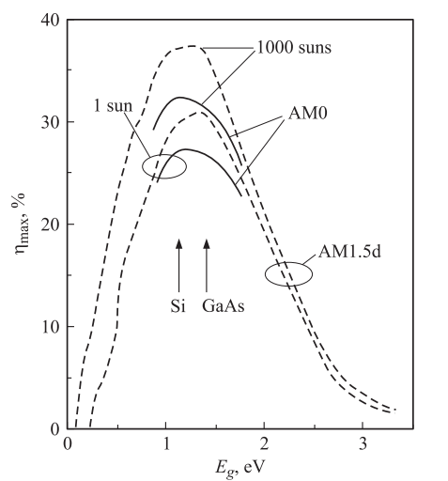 | FIGURE 1. Dependences of the maximum achievable conversion efficiency (ηmax) of a solar cell with one p−n junction on the material band gap (Eg). Solid lines are for the AM0 solar spectrum, dotted lines are for the AM1.5d spectrum (for unconcentrated solar radiation (1 sun) and for 1000-fold concentrated radiation).

One of the results of the studies of heterojunctions was the practical implementation of the idea of a wide-gap window for solar photocells. This idea was put forward earlier and was aimed at protecting the photoactive region of the photocell from the action of surface states. In heterostructures (AlGaAs (wide-gap window)) − (p−n-GaAs (photoactive region)) it was possible to form a defect-free heterointerface and provide ideal conditions for the photogeneration of electron-hole pairs and their collection by the p−n junction. Since heterophotocells with a gallium arsenide photoactive region also turned out to be more radiation-resistant, they quickly found application in space technology, despite their significantly higher cost compared to silicon photocells. An example of the large-scale energy use of solar cells based on AlGaAs/GaAs was the installation of them in 1986 at the Soviet Mir orbital station.
Silicon and gallium arsenide largely satisfy the conditions of “ideal” semiconductor materials. If we compare these materials from the point of view of their suitability for the manufacture of a solar photocell with a single p–n junction, then the maximum possible photoelectric conversion efficiencies turn out to be almost the same, and close to the absolute maximum for a single-junction photocell (Figure 1). Of course, the undoubted advantages of silicon are its high abundance in nature, non-toxicity and relative cheapness. These circumstances, as well as the widespread expansion of the industry for the production of semiconductor electronics devices, have determined the extremely important role of silicon photocells in the development of the emerging solar photoenergy industry. And although significant efforts have been spent on creating various types of thin-film solar cells, today crystalline silicon (in mono – and polycrystalline modifications) continues to make up the main share in the global production of ground-based solar cells.
Until the mid-1980s, the development of solar cells based on both silicon and gallium arsenide was carried out on the basis of relatively simple structures and simple technologies. For silicon solar cells, a planar structure with a small p–n junction, obtained by the diffusion method, was used. For solar cells based on gallium arsenide, when growing a wide-gap AlGaAs window, it was necessary to use epitaxial methods. We used a relatively simple method of liquid-phase epitaxy, developed earlier to obtain the structures of first-generation heterolasers. In the case of solar cells, it was necessary to grow only one wide-gap p-AlGaAs layer, while the p–n junction was obtained due to the diffusion of a p-type impurity from the melt into the n-GaAs base material (Figure 2a).
Since the mid – 1980s, the penetration of “high technology” into the field of semiconductor solar photovoltaics began. Sophisticated structures of silicon-based solar cells have been proposed to reduce both optical and recombination losses in them. Efforts have also been made to improve the quality of the base material itself. The implementation of such structures turned out to be possible thanks to the use of multi-stage technological techniques that had been well developed by this time in the manufacture of silicon integrated circuits. The result of these efforts was a dramatic leap in the photovoltaic conversion efficiency of silicon solar cells [6]. The efficiency demonstrated by laboratory samples came very close to the theoretical limit (Figure 1). Unfortunately, the cost of “highly efficient” silicon solar cells was many times higher than the cost of “ordinary” ones.
At the same time, progress in the field of solar photovoltaic cells based on gallium arsenide was driven by the use of new epitaxial methods for growing heterostructures – mainly the method of metal-organic vapor phase epitaxy (MOVE). This method was developed in the process of improving injection lasers and second-generation photocells based on A^{III} B^{V} compounds.
.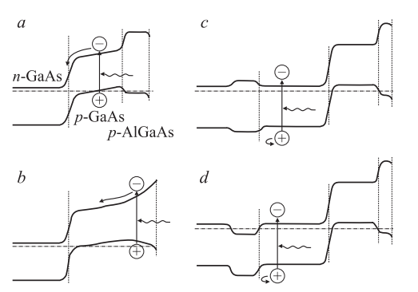
FIGURE 2. Band diagrams of p – gAlGaAs – p – n – GaAs heterojunction solar cells:
a - structure in which a p – GaAs layer with a built – in electric field is obtained by diffusion of zinc into the n - GaAs base during the growth of a wide-gap p – n AlGaAs layer; b - structure with a strong built – in electric field; c — structure with a rear wide – gap layer creating a potential barrier; d—structure with a rear potential barrier formed by a highly doped n⁺- GaAs layer.

What improvements have been made to the structure of solar heterophotocells thanks to the new technological possibilities that have opened up? First, the wide-gap AlGaAs window was optimized, the thickness of which became comparable to the thickness of nano-sized active regions in heterolasers. The AlGaAs layer also began to serve as the third component in the three-layer interference anti-reflection coating of the photocell (ARC in Figure 3, a). A narrow-gap, heavily doped contact layer began to be grown on top of the wide-gap AlGaAs layer, which was removed during post-growth processing in the spaces between the contact strips. Secondly, a rear (behind the p–n junction) wide-gap layer was introduced, which, together with the front wide-gap layer, provides two-way confinement of photogenerated carriers within the light absorption region (Figure 2c). Recombination losses of carriers before they are collected by the p–n junction were reduced. At this stage of optimization of AlGaAs/GaAs photocell heterostructures with a single p–n junction, the newly developed technological method of MOS HPE was still experiencing competition from the improved method of low-temperature liquid-phase epitaxy. Thus, for this kind of structures, the record efficiency value = 27.6% under conditions of illumination with concentrated sunlight with the AM1.5 spectrum belongs to photovoltaic cells grown by the MOS HPE method (the indicated efficiency value is an absolute record for photocells with one p–n junction [6] ), and photocells grown by liquid-phase epitaxy still have a record efficiency value of 24.6% under conditions of 100-fold concentration of solar radiation with an AM0 spectrum [7].
In the structures of AlGaAs/GaAs photocells grown by the MOCVD method, a single wide-gap AlGaAs layer forming the rear potential barrier could be replaced by a system of alternating pairs of AlAs/GaAs layers forming a Bragg mirror (Figure 3b). The maximum wavelength in the reflection spectrum of such a mirror was chosen near the absorption edge of the photoactive region, so long-wave radiation that was not absorbed in this region in one pass could be absorbed during the second pass after reflection from the mirror [8]. At the same time, the wide-gap mirror layers continued to function as a rear barrier for photogenerated carriers. Under these conditions, the thickness of the photoactive region could be reduced by a factor of 2 without loss of current compared to structures without a mirror. This significantly increased the radiation resistance of photocells, since the number of defects introduced during irradiation with high-energy particles, which affect the degradation of the diffusion lengths of carriers, decreased in proportion to the decrease in the thickness of the photoactive region [8].

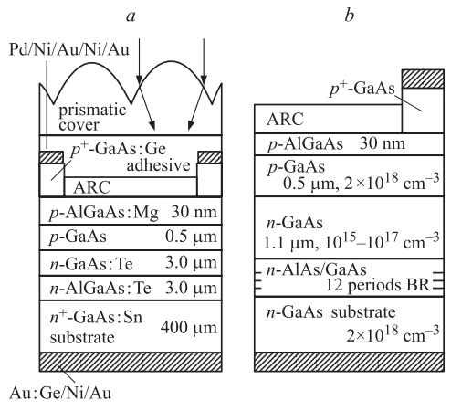 | FIGURE 3. Schematic diagrams of single-junction multilayer solar cells (SCs) based on AlGaAs/GaAs for space applications: a - SC structure with a rear potential barrier and a thin wide-gap p-AlGaAs window. Using such elements, a record conversion efficiency of 24.6% for solar cells with one transition was obtained for 100-fold concentrated “cosmic” solar radiation (AM0); b—SC structure with a built-in Bragg reflector (BR), grown by MOCVD hydride epitaxy. The BO consists of 12 pairs of layers (AlAs (72 nm)) / GaAs (59 nm), tuned to a wavelength of λ = 850 nm and has a reflectance of 96%. As a result, the effect of double transmission of long-wave radiation through the solar cell structure is achieved, which makes it possible to reduce the thickness of the n-GaAs base layer to 1–1.5 μm. With such elements, high radiation stability was achieved—a “residual power” of 84–86% after irradiation with electrons with an energy of 1 MeV (flux density 10¹⁵ sm²).

Along with the implementation in the structures of solar photocells of the scientific and technical “background” created earlier during the development of heterolaser structures, the use of new epitaxial methods made it possible to solve a number of purely “photoelectric” problems. Using the nonequilibrium conditions of epitaxy and (or) incorporating intermediate superlattices, it was possible to find conditions for the growth of perfect AlGaAs/GaAs heterostructures on a germanium substrate. From this point on, germanium heterophotocells began to be considered as the main candidates for use on most spacecraft. The decisive role here was played by the fact that germanium is mechanically stronger than gallium arsenide, previously used as substrates. Therefore, batteries composed of AlGaAs/GaAs photocells on germanium were comparable in weight and strength characteristics to silicon ones, and surpassed them in efficiency and radiation resistance. Another “photovoltaic” problem was fundamentally important for solar photovoltaics. We are talking about creating cascade photocells.
The idea of cascaded solar cells has been discussed since the early 1960s and was seen as an obvious but distant prospect for improving efficiency. The situation began to change in the late 1980s, when many research groups concentrated their efforts on developing various types of two-stage solar cells (Figures 4, 5). At the first stage, the best efficiency results were obtained in mechanically coupled photocells, although everyone understood that photocells with a monolithic structure were truly promising. Such structures were developed earlier than others by employees of NREL (USA). Using germanium substrates, they grew multilayer lattice-period-matched structures using the MOS HPE method, in which the upper photocell had a p–n junction in the In0.5Ga0.5P solid solution, and the bottom photocell in GaAs. The series connection of photocells was carried out through a tunnel p–n junction, specially formed between the cascades. Subsequently, a third cascade with a p–n junction in a germanium substrate was also connected to the photoelectric conversion process (Figure 6). Currently, three-cascade photocells (see table) are already at the stage of practical use when equipping spacecraft.
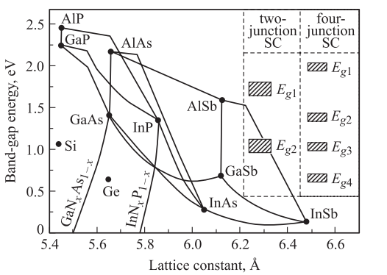 |  | FIGURE 4. Band gap Eg depending on the lattice constant for Si, Ge, III-V compounds and their solid solutions. The shaded boxes represent the Eg intervals for various materials that provide the highest efficiencies in 2- and 4-junction solar cells (SCs).
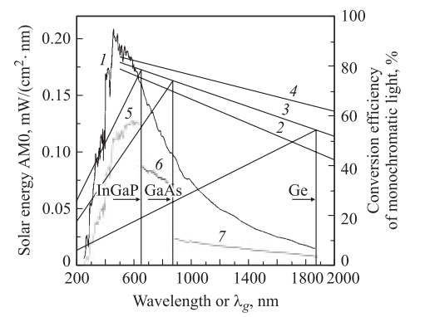 | FIGURE 5. Curve 1 - energy spectrum AM0 for unconcentrated solar radiation; straight lines 2, 3 and 4 are the maximum values of the “monochromatic” efficiency of the idealized solar cell for photocurrent densities j_{ph} = 0.1, 1.0 and 10 A/sm², respectively, which depend on the cutoff wavelength λ_{g} of the semiconductor material; slanted lines on the left - dependences of the conversion efficiency in idealized solar cells based on In_{0.5}Ga_{0.5}P, GaAs and Ge materials at j_{ph} = 1.0 A/sm²; Curves 5, 6 and 7 show the parts of solar energy converted into electricity in the corresponding cascades that make up a solar cell with 3 p–n junctions.

It may seem that we have paid too much attention to the description of very complex and expensive solar cells based on A^{III} B^{V} compounds. Being developed for a rather narrow and specific area of energy application, which is space technology, do they have prospects for use in large-scale photovoltaics of the future? In our opinion, the answer to this question is positive, and there are numerous reasons for this.
The structure of three-cascade heterophotocells is complex, and it will become even more complicated when moving, for example, to four- and five-cascade photocells. However, the epitaxial growth of such structures is a one-stage, fully automatic process, the success of which depends entirely on the degree of development of the technological base. The consumption of starting materials (gases in the MOS HPE method) here depends little on the number of cascades. Since all photoactive regions are made, as a rule, from “direct gap” materials, the total thickness of the epitaxial structure to be grown is only a few microns.
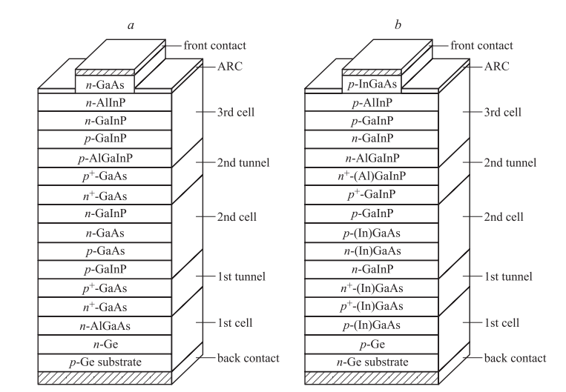 | FIGURE 6. Cross sections of solar cells with 3 p–n junctions: a – (Al)GaInP/GaAs/Ge heterostructure, in which the 2nd element, as well as the 1st and 2nd tunnel junctions are made of GaAs; b - (Al)GaInP/(In)GaAs/Ge heterostructure, in which the 1st tunnel junction is made of InGaAs, while the 2nd element and 2nd tunnel junction are made of (Al)GaInP.

One of the determining factors in the cost of an epitaxial structure is the cost of the substrate. We have already said that the use of a germanium substrate “foreign” in relation to A^{III} B^{V} materials made it possible to improve the performance parameters of space solar batteries. In fact, this led to the “rebirth” of germanium technology, which was once the first “classical” material in semiconductor technology and was then replaced by silicon. The cost of germanium as a substrate material is lower than the gallium arsenide used for this, not to mention its technological advantages (mechanical stability during post-growth processing) and the ability to be included in the photoelectric conversion process in a cascade structure. However, today, looking back at the successes achieved in nanoheterostructure technologies, we can assume that germanium, already as a substrate material, will perhaps again be replaced by silicon as even cheaper and more technologically advanced. Work in this direction is already underway. Thus, the result of using “high technology” for the production of solar photovoltaic cells based on III-V compounds can be not only a radical increase in efficiency (in multi-stage structures), but also a radical reduction in the cost of heterostructural solar cells.
Let us now consider the prospects for increasing efficiency in multi-stage photocells (see table). Today's experience in the development of three-stage photocells allows us to hope for the practical implementation of increased efficiency values in four-, five-, and perhaps even more multi-stage structures. There is no scientific and theoretical doubt that hopes will be justified if suitable materials for intermediate cascades are found and these materials are grown of proper quality. The search for such materials is ongoing, and several directions can be identified here.
The “traditional” direction is “simply” the synthesis of new materials. Among the A^{III} B^{V} materials, these are semiconductor nitrides and borides that have been little or not mastered in practice. For wide-gap nitrides, there is already a significant technological backlog (when grown using the same MOS HPE method), due to the “rosy” prospects for a revolution in lighting technology. Perhaps we will witness how, everywhere in lighting devices, hot mercury and heated tungsten will be replaced by “cold” structures based on micron-thick A^{III}N materials. However, cascade photocells require rather narrow-gap materials that are more consistent in lattice type and period with materials already operating in three-cascade structures. Such materials can be, for example, GaInNAs solid solutions (Figure 4), which are currently being intensively studied. It is interesting to note that the increasing complexity of the structure of photocells, namely, the transition to multi-stage structures, weakens the requirements for the volumetric properties of the materials used. Indeed, the more cascades, the thinner the photoactive region in each of them and the less influence on the efficiency of such a parameter as the diffusion length of minority charge carriers. The method of compensating for insufficiently good volumetric properties of materials by the technological perfection of the cascade structure is beginning to be used in the creation of new types of thin-film solar cells.
Let us now consider some other possibilities for improving cascade solar cells. In this case, we will use the previous experience in the development of semiconductor technology and, in particular, lasers based on A^{III} B^{V} compounds (Figure 7). Until now, two stages in this development could be distinguished. The first of them was associated with the creation of heterostructures, the second - with the creation of nanoheterostructures. In both cases, the main initial ideas were aimed at improving injection lasers and developing technologies for creating such lasers. In the 1970s, a tradition even developed according to which the parameters of injection heterolasers manufactured using one or another method have always served as a criterion for the perfection of the technological method itself. The definition of “laser-quality material” meant that, thanks to its high crystallographic perfection, this heterostructure is capable of operating at ultra-high pump densities necessary to realize the laser effect. Analyzing the trends currently observed in work on the creation of third-generation injection lasers, we will see that this is primarily a transition to structures with quantum dots [9].
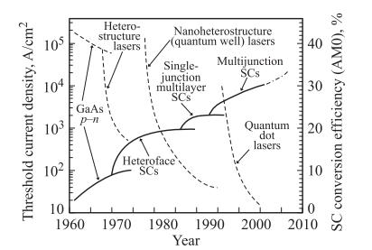 | FIGURE 7. Evolution of parameters of injection lasers and solar cells based on A^{III} B^{V}. Dashed lines (left axis) - evolution of threshold current densities for three generations of injection lasers. Solid lines (right axis) - evolution of photoelectric conversion efficiencies in solar cells based on various structures (AM0 solar spectrum, without luminous flux concentration).

As for solar photovoltaic converters, recently new approaches involving the use of materials with quantum dots have also been proposed. In particular, we are talking about creating a photoactive medium with an “intermediate zone” [12]. In the structures of multi-stage photocells, in addition to using newly created materials with a given absorption spectrum, it would probably be possible to improve the characteristics of switching tunnel diodes (increase the peak current) by introducing super lattices of vertically coupled quantum dots between the n⁺- and p⁺-layers. It should be added that there are other, including quite old, proposals for increasing the efficiency of photovoltaic converters, the implementation of which would require “newly designed” materials. These include the idea of using smooth heterostructures, in which it is necessary to obtain a very large difference in the band gap while ensuring high mobility of charge carriers. All these proposals are driven by the desire to bring (first theoretically and then practically) the efficiency of solar photovoltaic conversion closer to the thermodynamic limit of 93%, determined by the Carnot cycle.
Previous experience shows that all achievements in increasing the efficiency of solar photocells will be primarily used in space technology [10,11]. The same conclusion can be drawn by assessing the scale of the tasks facing new space technology. There is a need for a large number of powerful telecommunications satellites, the requirements for energy supply for manned orbital stations are growing, and it becomes necessary to create specialized energy satellites that could power space vehicles. In particular, on energy satellites, solar energy would be converted into electrical energy, and electrical energy into beam energy to transmit energy using a laser or microwave beam. In the longer term, energy in significant quantities could be transmitted to Earth to generate electricity. To implement the largest projects, the structures of solar photocells would have to be grown directly in orbit using the molecular beam epitaxy method in the vacuum of space. In any case, a significant expansion of the production of photocells for space will make it possible to “in passing” also create a technological base for even larger-scale production of photocells for ground use.
RESEARCH RESULTS
Photovoltaic conversion of concentrated solar radiation. Until now, we have not considered another possibility for increasing the efficiency of photoelectric conversion. We are talking about the transition to the transformation of pre-concentrated solar radiation. The maximum calculated factor of concentration of radiation at a distance from the Sun corresponding to the Earth's orbit is 46200 X. It is this factor of concentration that is usually set when assessing the thermodynamically limiting efficiencies of various types of solar photocells. In particular, for multijunction photocells consisting of several dozen cascades, the maximum efficiency is very close to the efficiency of the Carnot cycle and is almost 87%. Thus, multijunction photocells, in addition to demonstrating the highest efficiency values today and the prospect of increasing them in the near future, also have the best “fundamental” prospects.
But is it possible to talk about the prospects for large-scale use of such photovoltaic cells in terrestrial conditions, where the determining factor is the economic factor? Multijunction photocells are indeed very complex in structure. Moreover, they are perhaps the most structurally complex of all other semiconductor devices. This is where the largest changes in band gap values should be achieved for several photoactive regions with p–n junctions. The doping levels of the layers also vary quite significantly, with a sharp change in the type of conductivity during the formation of several (as the structure grows) tunnel p–n junctions that switch the cascades. The specified thicknesses of the layers of photoactive regions must be maintained with high accuracy, ensuring the calculated absorption of a certain part of the solar spectrum to generate the same photocurrent values in the cascades. The layers that form the p⁺ − n⁺ tunnel junctions must be extremely thin (in the nanometer range) to minimize light absorption, while the photoactive layers must be about 2 orders of magnitude thicker. The entire set of A^{III} B^{V} materials (in the form of solid solutions) turns out to be involved in the formation of the structure of multijunction solar cells (in the future also nitrides), grown, among other things, on a foreign substrate (Ge, and in the future - Si). However, as already noted, the economic side is not so dramatic. Growing the structure is a one-step, automated process, its entire thickness is only a few micrometers, and the non-photoactive substrate can be quite cheap. The decisive circumstance for the economically justified use of multijunction solar cells is the fact that they can operate very efficiently under highly concentrated solar irradiation.
The fact that heterojunction solar cells based on gallium arsenide can operate efficiently with a significant (hundreds and even thousands of times) concentration of light flux and compare favorably with silicon ones in this regard was noted back at the turn of the 1970s–1980s. The first experiments on the creation of concentrator photovoltaic modules with high-current heterophotocells date back to this time [13]. The generated photocurrent increased linearly with increasing luminous flux, and the output voltage, in turn, increased with increasing current according to a logarithmic law. Thus, the output power increased superlinearly as the radiation was concentrated, and the efficiency of photoelectric conversion increased. This situation could be used in practice if the larger current did not create a noticeable voltage drop across the internal resistance of the photocell. Radically reducing internal ohmic losses became a key problem in the development of concentrator photocells. The prospect of increasing efficiency when working with radiation concentrators looked very tempting. However, the main driving force in the creation of concentrator modules was the possibility of reducing the consumption of semiconductor materials to generate a given electrical power in proportion to the concentration factor of the light flux. In this case, semiconductor photocells with a relatively small area intercepted solar radiation while located in the focal plane of concentrators - focusing mirrors or lenses made of relatively cheap materials. The contribution of the cost of photocells to the cost of solar modules became insignificant, while the efficiency of the modules directly depended on the efficiency of the photocells used. Thus, the prerequisites were created for the economically justified use of the most efficient, albeit expensive, photovoltaic cells based on III-V compounds in ground-based energy [14,15].
Since the early 1990s, a new direction has emerged in the practice of creating solar concentrator systems, based on the concept of small-sized modules that have all the prerequisites for providing highly efficient and economically feasible photoelectric conversion of solar radiation [14–19]. When the linear dimensions of the concentrator are reduced and the specified ratio of the aperture size to the focal length is maintained, the value of the radiation concentration factor is also maintained. However, in this case, the building height of the module is reduced due to the shorter focal length of the lenses. The linear dimensions of photocells are reduced to 1−2 mm (Figure 8), so that their installation can be achieved using automatic equipment used for the installation of discrete devices during mass production of products in the electronics industry. With small linear dimensions of photocells, the thickness of the substrate for growing structures can be reduced, and the proportion of the useful area of the plates can be increased, which leads to additional savings (besides the fact of concentrating radiation) of the semiconductor material. Installation can be carried out without complex compensation of the coefficients of thermal expansion of the photocell materials and the metal heat-removing base. It is especially important that the thickness of the heat sink also decreases in proportion to the decrease in the linear dimensions of the concentrator in the module, which leads to a sharp decrease in metal consumption in the manufacture of such a module. Thus, in the concept of small-sized concentrator modules, the advantages of concentrator systems (increased efficiency, savings in semiconductor materials) can be realized while maintaining the generally distributed nature of solar radiation conversion and heat release (as in systems without radiation concentration).
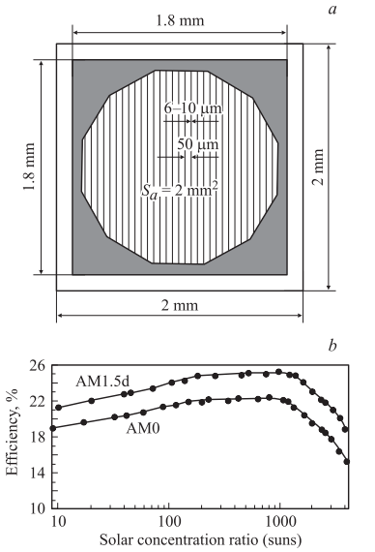 | FIGURE 8. a - schematic view of a concentrator solar cell; b - dependence of the conversion efficiency on the concentration factor of solar radiation for a single-junction solar cell based on AlGaAs/GaAs for irradiation conditions AM0 and AM1.5.

It should be noted that when considering the prospects for large-scale solar power generation, the consumption of any, even the most common, structural materials can be economically justified only with high conversion efficiency per the entire photo receiving surface. This is due to the need to cover significant areas of the earth's surface to intercept radiation when generating large powers.
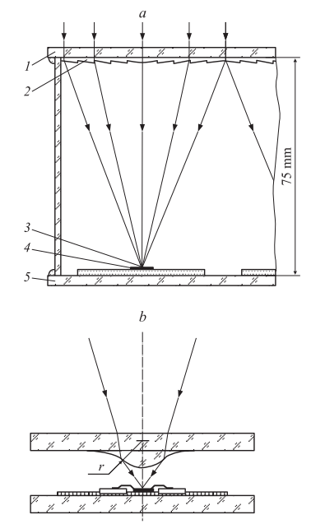 | FIGURE 9. a - cross section of the concentrator module: 1 - base of the lens panel, made of glass; 2 - microprisms of Fresnel lenses made of silicone; 3 - focused sun rays; 4 - solar cell mounted on a metal base; 5 - the base of the solar cell panel, made of glass. b - a system with secondary minilenses to increase the concentration factor of solar radiation.

Obviously, conversion devices must be protected from atmospheric influences to ensure their long-term (20-30 years) performance. In this regard, the design of “all-glass” concentrator modules (Figures 9, 10), developed in recent years at the Physico-Technical Institute named after. A.F. Ioffe in cooperation with the Fraunhofer Institute for Solar Energy Systems (Freiburg) [16,17]. Small-sized Fresnel lenses are combined into an integral panel. The panel also includes concentrator photocells mounted on thin (0.5 mm) metal heat sinks. Both of these panels are fastened with glass side walls, so that the internal volume of the module is sealed. The lens panel has a composite structure. Here, a sheet of ordinary silicate glass that protects the module from the front side serves as the basis for a thin Fresnel profile made of transparent silicone and located on the inside of the glass, which focuses sunlight. The basis for the photocell panel is also a sheet of silicate glass, through which heat is dissipated. Thus, cheap and stable glass becomes the main structural material of the concentrator module. The consumption of optical quality silicone here is reduced to the minimum required for the formation of refractive microprisms (average thickness of about 0.2 mm). To connect and seal the glass parts of the module, use ordinary construction silicone (Figure 9). Thanks to the use of the most radiation- and weather-resistant materials (glass and silicone), these concentrator modules have the best prospects for long-term operation. In experimental “all-glass” modules, the optical efficiency of Fresnel lenses reached 89%. When using two-stage InGaP/InGaAs photocells with an efficiency of 30% (AM1.5 d), the module efficiency measured under natural conditions was 24.8% based on the radiation power incident on the lens surface [17].
Further improvement of the modules of the design under consideration follows the path of increasing the concentration factor of solar radiation. In particular, with the dimensions of each single lens in a submodule being 4 × 4 sm², high optical efficiency is ensured by using photocells with a photosensitive surface diameter of 2 mm (Figure 8), which corresponds to a concentration factor of about 500×. Further reduction in the size of photocells and the transition to concentration ratios of 1000× or more are possible when using secondary minilenses with a smooth profile located in close proximity to the photocells (Figure 9). In this case, secondary lenses can also be combined into a panel (Figure 10) [18,19]. Under highly concentrated solar irradiation, the use of multijunction solar cells has additional advantages. As the number of stages increases, the output voltage increases and the photocurrent decreases. Due to this circumstance, internal ohmic losses during current collection are reduced, so that high efficiency is maintained at higher factors of radiation concentration.

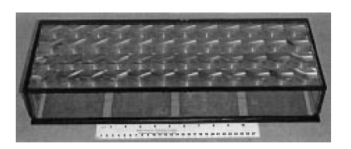

FIGURE 10. Experimental photovoltaic module for converting concentrated solar radiation with a panel of 48 Fresnel lenses.

With regard to the practical use of photoconverters of concentrated solar radiation, there may be certain concerns associated with the need to ensure tracking of concentrator modules for the Sun. Indeed, in this case, to place the modules, it is necessary to create special rotary support devices equipped with solar position sensors and electric drives. Compared to the placement of conventional modules without hubs, this leads to additional consumption of construction materials and energy consumption for tracking. But even in a conventional module, with constant tracking of the Sun, 30-40% more energy is generated during daylight hours than without tracking. Considering this increase and the fact that the concentrator modules are more efficient, we can say that this compensates for the additional costs of materials. As for the energy costs for tracking, in experimental installations they amount to only 0.2−0.3% of the energy generated by the concentrator modules located in these installations [18,19].
Conventional and concentrator modules should not be contrasted when assessing the prospects for the development of solar photovoltaics. Both should be used in future power supply systems. Apparently, conventional modules with solar cells made of crystalline silicon or thin-film structures will form the basis of a decentralized power generation system. Owned by a wide range of people, installed on the roofs and walls of houses and buildings, united in a network, they will embody the “democratic principles” of the new energy industry in comparison with the “dictatorship” of the energy giants that is currently taking place. However, to cover the energy needs of energy-intensive industries, municipal communities, etc., it will be necessary to create sufficiently large solar stations that ensure the minimum cost of generated electricity. Such stations, located in specially designated areas and maintained by special personnel, will also be part of a decentralized energy system. The use of concentrator photovoltaic modules when creating such stations looks like a completely natural solution. There are numerous economic estimates (see, for example, [20–22]), according to which concentrator photovoltaics in the next ten years can become not only the most cost-effective among other devices for photoelectric conversion, but also compete with existing traditional sources in terms of the cost of generated electricity. It is also important that it is possible to build solar power plants of significant capacity without deploying new semiconductor production in large volumes. Indeed, in this case, the main efforts will be associated with the production not of photocells, but of mechanical parts of the design of concentrator modules and supporting devices, for the production of which a production base already exists.
Meanwhile, the problem of deploying new production capacities of the semiconductor industry may become urgent in the near future due to the need to provide space technology with highly efficient photovoltaic cells based on III-V compounds. And here the concentrator approach is considered as one of the possible solutions to the problem. In space conditions, the most promising is the use of linear Fresnel lenses as radiation concentrators. This allows relatively precise solar tracking to be used around only one axis parallel to the microprisms of the lenses, while tracking around the second axis can be much coarser. The radiation concentration multiplicities in this case are usually from 6 to 10. The refractive profile in the lenses is made of transparent silicone. For space applications, lenses can have a very thin (~0.1 mm) glass base [23] or even no glass base at all [24-27]. In the first case, a sheet of glass doped with cerium dioxide serves to protect the lens from ultraviolet radiation and the action of high-energy particles. In the second case, multilayer protective coatings are applied to the front surface of the silicone lens. In both cases, photocells are better protected from adverse influences than is the case in solar batteries without concentrators. The radiation resistance of batteries also increases due to operation at a higher photocurrent density, achieved by concentrating solar radiation. Increasing the current density becomes especially important when launching space objects away from the Sun. In this case, the concentration of radiation compensates for the effect of reducing the efficiency of solar cells observed as the power density of sunlight decreases. For near-Earth space conditions, it is possible to realize a specific power per unit weight of a concentrator solar battery of ~ 180 W/kg and a specific power per unit area of ~ 300 W/m² [24]. These parameters are expected when using three-stage InGaP/GaAs/Ge solar cells and cannot be achieved in any other type of space solar cells. Developed at the Physicotechnical Institute. A.F. Ioffe space modules with short-focus (23 mm) linear Fresnel lenses allow them to be used instead of conventional flat batteries without changing the design of transport containers.
CONCLUSIONS
The development of solar photovoltaics is one of the most promising areas of modern science and technology. Over the past decades, advances have been made from the first low-efficiency silicon solar cells to complex multi-cascade structures based on A^{III} B^{V} compounds, achieving record-breaking solar radiation conversion efficiency. Continuous improvements in crystal growth technology, optimization of junction layers, and the use of new materials and nanostructures have significantly increased the stability, reliability, and performance of solar cells. At the same time, active work is underway to reduce production costs and improve the environmental friendliness of technologies, making solar energy more accessible and sustainable.
Multi-cascade solar cells based on gallium-aluminum-indium compounds have demonstrated unique capabilities in delivering high efficiency even in limited spectral ranges. Their implementation in space and terrestrial energy systems demonstrates the technology's maturity and readiness for industrial application. Overall, solar photovoltaics is gradually becoming a key element of the global energy system of the future, ensuring the transition to renewable energy sources and reducing the anthropogenic impact on the environment. Further research into new materials, nanotechnology, and hybrid systems will enable even higher efficiency and reliability of solar cells.
REFERENCES
- M. L. Katche, “A comprehensive review of maximum power point tracking (MPPT) techniques used in photovoltaic systems,” Energies 16, 2206 (2023).
- A. Bughneda, S. X., et al., “Review of multilevel inverters for PV energy systems: classifications, development and challenges,” Energies 14, 1585 (2021).
- B. Sharma, et al., “A comprehensive review of multi-level inverters: topology, modulation and control techniques for PV applications,” Scientific Reports (2025).
- IEEE Std 1547™-2018, IEEE Standard for Interconnection and Interoperability of Distributed Energy Resources with Associated Electric Power Systems Interfaces, IEEE (2018).
- E. Pohl, et al., Decision Options Matrix / Adoption guidance for IEEE 1547-2018, NREL/IREC technical notes (2022–2024).
- F. Blaabjerg, Power electronics contribution to renewable energy conversion, in Power Electronics for Green Energy Conversion (Wiley, 2022).
- S. C. Lim, et al., “Analysis of inverter efficiency using photovoltaic power equipment: methods to evaluate degradation and performance,” IEEE Access (2024).
- Y. H. Liu, et al., “Comprehensive review on fast maximum power point tracking (FMPPT) methods for PV systems,” Renewable Energy (2024).
- C. Adupa, et al., “Design and performance evaluation of multilevel inverter topologies for improved power quality and efficiency,” STET-Review (2024).
- L. A. Iturralde Carrera, M. G. Garcia-Barajas, et al., “Efficiency and sustainability in solar photovoltaic systems: review of key factors and innovative technologies,” Eng. 6, 50 (2025).
- A. Azizi, et al., “Topology and control strategies of high-power multilevel inverters — challenges and applications,” Elsevier review (2025).
- A. Umarov and O. Zaripov, “Calibration and self-calibration of fiber-optic measuring transducers (sensors) in production and operation,” *AIP Conf. Proc.* 3152, 040017 (2024). doi:10.1063/5.0212345
- Z. O. Olimovich, S. D. Usmonovna, and B. S. Gayratovich, “Adaptive position-determination and dynamic model properties synthesis of moving objects with trajectory control system (in the case of multi-link manipulators),” *Trans. Korean Inst. Electr. Eng.* 73, 3 (2024).
- A. Umarov, O. Zaripov, and R. Zakirov, “Application of fiber optic sensors in aircraft fuel management system,” *Lect. Notes Comput. Sci.* 13741, 354–360 (2023).
- R. Zakirov, O. Zaripov, and A. Umarov, “Fiber optic temperature sensors in the aircraft fuel system application,” *Proc. Int. Conf. Inf. Sci. Commun. Technol.* (ICISCT), Tashkent, Uzbekistan (2021).
- A. P. Akhmedov and S. B. Khudoyberganov, “Generation of electricity with the help of wind and solar on the route of Tashkent overground metro trains,” *Int. Conf. Therm. Eng.* 1, 1 (2024).
- A. Akhmedov and S. Khudoyberganov, “Cumulative generation of electricity from the wind of passing vehicles and natural wind in the Bukhara region of the Republic of Uzbekistan,” *E3S Web Conf.* 461, 01073 (2023). doi:10.1051/e3sconf/202346101073
- G. Abidova, “Calculation and development of measuring amplifier with automatable and digital comparator of ensuring switching of amplification coefficients,” *AIP Conf. Proc.* 3152, 050003 (2024). doi:10.1063/5.0218847
- Kolesnikov I.K, Abidova G.Sh, Khakimov S.H. "The Choice of a Generalized Criterion for the Efficiency of an Automated Electric Drive of a Railway Rolling Stock", 2024, https://www.scopus.com/ inward/record.uri?eid=2-s2.0-85187647030&doi=10. 1007%2f978-3-031-53488-134&partnerID=40&md5= e889d5 ec240c11a2d336162706deeb77
- A. Akhmedov and S. Khudoyberganov, "Cumulative generation of electricity from the wind of passing vehicles and natural wind in the Bukhara region of the Republic of Uzbekistan," E3S Web Conf. 461, 01073 (2023). https://doi.org/10.1051/e3sconf/202346101073
- A. P. Akhmedov and S. B. Khudoyberganov, "Generation of electricity with the help of wind and solar on the route of Tashkent overground metro trains," Int. Conf. Therm. Eng. 1, 1 (2024). https://www.scopus.com/inward/record.uri?eid=2-s2.0-85199166478&partnerID=40&md5=c545973449e66f14166b44089f170b20
- A. A. Khalikov and M. S. Ortiqov, “Determining the depth of a rail defect from the signals of the electromagnetic flaw detector,” AIP Conf. Proc. 2612, 060032 (2023).
- A. Khalikov, “Analysis of methods for determining the characteristics of a single spatial electromagnetic field,” E3S Web Conf. 226, 00001 (2021).
- Abidova G.Sh. Kurbanov I.B. Selection of Alternative Energy Sources for Power Supply Systems of Production Facilities. American Journal of Science and Learning for Development Volume 1, No 2| Dec – 2022
- Boltayev O.Т., Akhmedova F.A., Kurbanov I.B. Consideration of the nonlinearity of the magnetization curve in the Calculation of magnetic chains with a moving electromagnetic screen. DOI - 10.32743/UniTech.2022.95.2.13086.
- R. Mirsaatov, S. Khudoyberganov, A. Akhmedov; Uncertainty estimation in determination of Cocoons silkiness by thickness of their shell. AIP Conference Proceedings 15 March 2023; 2612 (1): 050010. https://doi.org/10.1063/5.0114683

