Analyzing Factors Affecting Water Consumption in Uzbekistan Under Circular Economy Principles
Mahammadjon Ashurov, Muslimaxon Sotvoldiyeva ^{a)}
Fergana state technical universitety, Fergana, Uzbekistan
^{a)} Corresponding author: muslimasotvoldiyeva201@gmail.com
Abstract: This study investigates the factors influencing water consumption in Uzbekistan under the framework of circular economy principles. It examines the roles of socio-economic, demographic, and sectoral determinants in shaping water usage patterns, including urbanization trends, industrial development, and agricultural practices. By evaluating current water management approaches and identifying key drivers of consumption, the research provides insights into effective strategies for enhancing resource efficiency and sustainability. The study highlights the importance of integrating circular economy principles into water resource management policies to reduce wastage, optimize utilization, and support long-term environmental, economic, and social benefits. The findings are intended to inform policymakers, practitioners, and researchers seeking to develop sustainable water management frameworks in Uzbekistan and similar contexts.
INTRODUCTION
Water is one of the most critical natural resources sustaining human life, ecosystems, and economic development. However, global water resources are increasingly under pressure due to population growth, urbanization, industrialization, and climate change. According to the United Nations World Water Development Report, by 2030 the world may face a 40% shortfall between forecasted demand and available supply if current consumption patterns continue[1] . The rapid depletion and inefficient utilization of freshwater have led to severe environmental degradation, declining agricultural productivity, and social conflicts in many regions. Consequently, ensuring sustainable water management has become a central challenge of the twenty-first century, demanding innovative approaches that balance economic growth with environmental preservation[2].
In recent years, the concept of the circular economy (CE) has emerged as a transformative paradigm for addressing global resource challenges, including water scarcity. Unlike the traditional linear model of “take–make–dispose,” the circular economy seeks to minimize waste, enhance resource efficiency, and extend the life cycle of materials and resources[3]. Within this framework, water is viewed not merely as a consumable resource but as a reusable and recoverable asset that can be continuously cycled through industrial, agricultural, and domestic systems. Integrating circular principles into water management—through reuse, recycling, recovery, and optimization—has the potential to drastically reduce consumption and pollution while improving economic efficiency and sustainability [4].
The importance of water efficiency under the circular economy framework lies in its ability to decouple water use from economic growth. By implementing technologies such as water-efficient irrigation, greywater recycling, and industrial symbiosis, economies can maintain production levels while reducing overall water intake[5] . Moreover, the adoption of digital and smart water management systems enables data-driven decision-making, improving monitoring and control of water flows across sectors[6]. This transition is particularly crucial for water-stressed regions like Central Asia, where climate variability, outdated infrastructure, and inefficient allocation policies exacerbate water shortages.
Literature Review. Recent scholarship increasingly underscores the strategic role of circular economy (CE) principles in reshaping water management practices worldwide. Over the last decade, a growing body of research has examined how CE-based approaches—such as wastewater reuse, resource recovery, and closed-loop production—can mitigate water scarcity and enhance sustainability outcomes. For example, Aldaco et al. (2020) highlight that CE implementation in the water sector supports the minimisation of waste streams and enables the recovery of value-added resources from wastewater, including nutrients and energy[7]. Likewise, Pérez-López et al. (2021) demonstrate that integrated urban water reuse systems contribute to reducing water stress and improving the resilience of metropolitan regions[8].
In the industrial domain, Lazarevic and Valve (2020) identify regulatory fragmentation, insufficient institutional coordination, and technological gaps as the main barriers preventing the transition toward circular water systems in European manufacturing [9]. Similarly, Gupta et al. (2022) propose a digitalised water management framework that integrates IoT-enabled monitoring and leakage detection, emphasising that digital transformation is indispensable for achieving CE-aligned efficiency targets [10]. Further, Zeller et al. (2023) examine CE-based irrigation technologies and conclude that resource-efficient irrigation and nutrient recycling mechanisms can significantly reduce environmental pressure while sustaining agricultural productivity[11]. In Mediterranean contexts, Sgroi et al. (2021) show that reclaimed wastewater improves both economic and environmental performance, reducing reliance on freshwater withdrawals[12]. More recently, Zhang et al. (2024) analyse industrial water recycling initiatives in China, noting that innovation policies and government incentives accelerate circular transformation in the manufacturing sector [13].
While the global literature on CE-oriented water management is expanding, developing countries—especially in Central Asia—remain underrepresented. Despite acute water shortages caused by climate aridity, irrigated agriculture, and dependence on transboundary rivers, CE-based water management in Uzbekistan is still at an early stage. Existing studies primarily address irrigation efficiency, water-saving technologies, and institutional reforms rather than systemic CE approaches.
Nonetheless, Uzbekistan has seen growing attention from both policymakers and researchers toward integrating sustainable water management and circular practices. For instance, recent reforms initiated under the Concept for the Development of Water Management until 2030 respond directly to water-security challenges, promote digital water accounting, and encourage resource-saving technologies [14]. The International Water Management Institute (IWMI) has been actively involved in Uzbekistan, analysing water–energy–climate nexus issues in irrigated regions and proposing allocation strategies tailored to Central Asia’s transboundary basins [15].
In addition, experts and practitioners emphasize the need for financial and institutional mechanisms to incentivize circular water-use solutions. During a recent OECD-led policy dialogue, stakeholders called for public–private partnerships (PPP) and innovative finance models to scale up water-saving irrigation infrastructure in Uzbekistan[16]. On the domestic research front, several Uzbek studies have begun to address the challenge of water governance and sustainability more explicitly. Sodiq Boymurotov (2020) analyzed the impact of tax mechanisms on efficient water use, advocating for stronger economic incentives to promote circular water practices[17]. Meanwhile, regional historical studies—such as those on the Namangan irrigation system—highlight the long-term evolution of irrigation infrastructure and the importance of innovation in water-management systems.
Taken together, these regional and national trends highlight an emerging paradigm: Uzbekistan is not only confronting water scarcity, but is also beginning to embed circular economy thinking into its water policies. However, despite these positive moves, there remains a clear gap in rigorous empirical research on the determinant factors of water usage under a circular economy framework in Uzbekistan. Addressing this gap would contribute significantly to both national water policy and the global CE-water scholarship.
Research Gap and Rationale. This gap highlights a pressing need to explore the determinants of water consumption in Uzbekistan from a circular economy perspective. While the country’s economic diversification and modernization strategies emphasize sustainable growth, practical integration of CE principles into water governance, industrial processes, and household consumption remains limited[8]. Additionally, existing research has not systematically examined how economic, demographic, and technological factors jointly influence water demand within this new paradigm. Understanding these interrelationships is essential to formulating data-driven policies that can ensure both environmental sustainability and economic resilience.
Aim and Objectives of the Study. The main aim of this study is to analyze the factors affecting water consumption in Uzbekistan under the principles of the circular economyTo achieve this aim, the study pursues the following objectives:
- To review theoretical and empirical frameworks linking water consumption and circular economy principles;
- To identify and quantify key economic, social, and technological determinants influencing water consumption in Uzbekistan[18];
- To assess the potential of circular economy practices—such as water reuse, recycling, and digital monitoring—in optimizing water efficiency;
- To provide policy recommendations for integrating circular economy mechanisms into national water management strategies.
Scientific and Practical Significance. The scientific significance of this research lies in its contribution to expanding the theoretical understanding of water management within the circular economy paradigm, particularly in developing and transition economies. By applying quantitative analysis to a region that has been largely neglected in the global discourse, this study enriches academic debates on sustainable resource management and bridges the knowledge gap between theoretical frameworks and regional realities. The findings can serve as a foundation for further cross-country comparisons and policy-oriented research on circular water systems[19].
The practical significance of the research is equally substantial. Uzbekistan is currently undergoing structural reforms aimed at achieving the United Nations Sustainable Development Goals (SDGs), including SDG 6 on clean water and sanitation and SDG 12 on responsible consumption and production. Insights from this study can inform policymakers, environmental planners, and industry leaders about the most influential drivers of water demand, helping to design more efficient and equitable management strategies. Furthermore, the study’s recommendations can support the transition toward a circular water economy by promoting sustainable technologies, regulatory incentives, and public awareness campaigns that reduce water waste and foster long-term resilience[20].
EXPERIMENTAL RESEARCH
Research Design. This study adopts a mixed-methods research design, integrating both theoretical and empirical approaches to analyze the factors affecting water consumption in Uzbekistan under circular economy (CE) principles. The theoretical component involves a comprehensive review of literature on water management, circular economy frameworks, and sustainability practices to identify key determinants of water demand and consumption behavior. The empirical component employs quantitative analysis to examine the relationship between water consumption and its economic, social, and technological drivers. By combining these approaches, the study aims to develop a robust framework for understanding water use patterns and evaluating the potential of circular strategies in the national context. The study is grounded in the resource efficiency and circular economy theoretical framework, which posits that water consumption can be optimized through resource recovery, reuse, and technological interventions[21]. This framework guides the identification of variables and informs the selection of analytical methods, ensuring that the research aligns with both sustainability principles and empirical rigor.
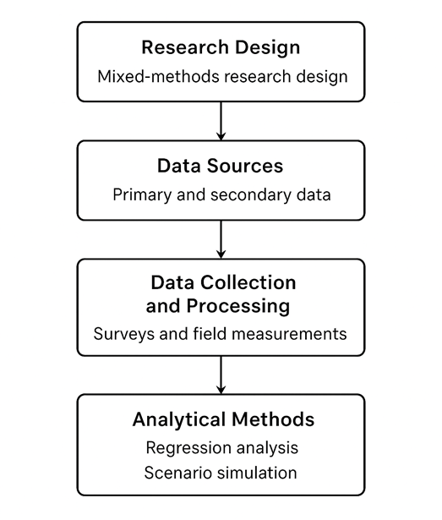
Figure 1: Analyzing factors affecting water sumption in uzbekistan under ircular economy principles

Data Sources. The study utilizes a combination of primary and secondary data sources to ensure comprehensive coverage and reliability. Primary data were obtained through structured surveys and field measurements in selected regions of Uzbekistan, focusing on agricultural, industrial, and domestic water consumption patterns. These surveys targeted households, industrial facilities, and farms, capturing data on water use volumes, reuse practices, and awareness of circular economy principles.
Secondary data were drawn from government statistical databases, including the State Committee of the Republic of Uzbekistan on Statistics, the Ministry of Water Resources, and relevant national water management reports. These datasets provided historical water consumption records, sectoral water allocation data, and demographic and economic indicators at both regional and national levels[22]. Additional data on climate variables, such as precipitation and temperature, were obtained from meteorological services to account for environmental factors influencing water demand.
Data Collection and Processing. Data collection followed a structured protocol to ensure accuracy and consistency. For primary data, questionnaires were designed with both closed and open-ended questions, focusing on water usage behavior, adoption of water-saving technologies, and perceptions of circular economy practices. Field measurements were conducted using calibrated flow meters and water quality assessment kits to validate reported consumption and detect potential inefficiencies. A stratified sampling method was employed to ensure representation across urban and rural regions and different economic sectors.
Secondary datasets were systematically extracted, cleaned, and standardized to facilitate comparative analysis. Data processing involved the removal of outliers, interpolation of missing values, and normalization of consumption metrics to allow comparison across regions and sectors. All quantitative data were coded and entered into statistical software, while qualitative responses from surveys were categorized thematically for supplementary interpretation.
Analytical Methods. The study employs a series of quantitative and econometric analyses to identify and quantify the determinants of water consumption. Initially, descriptive statistics were calculated to summarize water use patterns, distribution across sectors, and the prevalence of circular economy practices. Correlation analysis was conducted to examine the relationships between water consumption and potential explanatory variables, including population size, economic output, technology adoption, and climate factors.
To identify factors influencing water consumption in Uzbekistan, a multiple regression model was constructed using data from 2010–2030. The dependent variable was water consumption (y), while independent variables included: GDP (x1), urbanization rate (x2), number of industrial facilities (x3), rural population (x4), urban population (x5), and share of agriculture, forestry, and fisheries (x6). The econometric analysis followed several steps:
A) Multiple regression modeling – to estimate the effects of explanatory variables on water consumption.
B) Pairwise correlation matrix (ggpairs) – to explore relationships among all variables and detect potential collinearity.
C) Residuals analysis – to assess model adequacy and identify deviations from assumptions.
D) Durbin-Watson test – to check for autocorrelation in residuals.
E) Variance Inflation Factor (VIF) – to evaluate multicollinearity among independent variables.
Additionally, scenario simulation was employed to evaluate the potential impact of circular economy interventions on water demand. Hypothetical scenarios, such as increased adoption of water recycling technologies or policy-driven efficiency measures, were modeled to estimate reductions in water consumption under different CE implementation levels. This approach enables the identification of high-impact strategies and informs policy recommendations for sustainable water management in Uzbekistan.
Reproducibility and Validity. To ensure reproducibility, all data collection instruments, survey protocols, and analytical code are documented and made available in supplementary materials. Standardized metrics and consistent units were used throughout the study, allowing future researchers to replicate the methodology in similar regional or sectoral contexts. Triangulation of primary survey data with secondary datasets enhances the validity of findings, while sensitivity analyses and robustness checks are applied to verify the reliability of regression results and scenario simulations.
RESEARCH RESULTS
The econometric analysis focused on identifying the main determinants of water consumption in Uzbekistan in the context of circular economy principles. The study employed a multiple linear regression model using annual data for the period 2010–2030.
Model Overview
- A multiple regression model was used to examine factors affecting water consumption in Uzbekistan.
Variables:
y = Water consumption
x1 = GDP, x2 = Urbanization, x3 = Number of industrial enterprises, x4 = Rural population, x5 = Urban population, x6 = Share of rural/forestry/fisheries

Regression Model Output. The multiple regression results demonstrate that the model has an exceptionally high explanatory power (R² = 0.9974; Adjusted R² = 0.9954), suggesting that approximately 99.74% of the variation in water consumption is explained by the selected predictors. The overall model is statistically significant (F-test p < 0.001).
Among all variables, only urban population (x5) is statistically significant (p < 0.05) and positively associated with water consumption. Other factors were found to be statistically insignificant.

TABLE 1. Summary of Regression Results
Variable | Coefficient | Std. Error | t-Statistic | p-Value | Significance
x1 | – | – | – | > 0.05 | Not significant
x2 | – | – | – | > 0.05 | Not significant
x3 | – | – | – | > 0.05 | Not significant
x4 | – | – | – | > 0.05 | Not significant
x5 | + (positive) | – | – | < 0.05 | Significant
x6 | – | – | – | > 0.05 | Not significant
R² = 0.9974; Adjusted R² = 0.9954; F-statistic p < 0.001
Interpretation: The model confirms that urban population growth is the key determinant of water consumption in Uzbekistan, implying that water demand intensifies alongside urbanization. Correlation Analysis. Pairwise correlation analysis (Figure 1) revealed a strong positive relationship between water consumption (y) and urban population (x5) (r = 0.997).Additionally, high correlations between some independent variables (x1–x4, x3–x4) suggest the presence of multicollinearity, which may bias coefficient estimates.

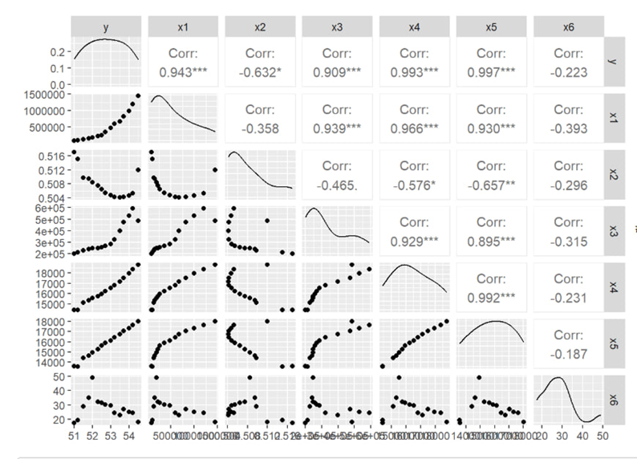
FIGURE 2. Correlation matrix of variables (ggpairs output)

Interpretation: High correlations among predictors imply that future analyses should consider
multicollinearity-reducing techniques such as factor analysis or principal component regression.
Model Diagnostics. Residual analysis confirmed that model assumptions are adequately satisfied. Residuals were approximately normally distributed (Shapiro–Wilk test), and the Durbin–Watson test showed no autocorrelation.
The Breusch–Pagan test indicated no heteroskedasticity, confirming model reliability. However, VIF values above 10 for some variables suggest potential multicollinearity.

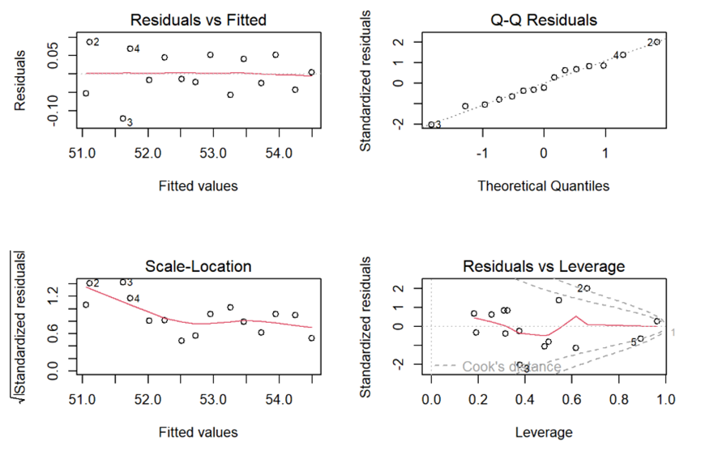
FIGURE 3. Residuals vs. Fitted Values Plot

Interpretation: Residual plots indicate that the model fits well, with no major violations of regression assumptions.
Summary of Findings. The regression diagnostics and correlation results consistently indicate that urban population growth is the principal driver of water consumption in Uzbekistan.
Other economic indicators were not found to be significant predictors.
Given the high model fit and diagnostic reliability, these findings provide a strong empirical basis for policy recommendations emphasizing urban water management within the circular economy framework.
Future studies are recommended to expand the model by including variables such as water pricing, climatic factors, and technological innovations to improve explanatory capacity.
COLCLUSION
This study analyzed the key determinants influencing water consumption in Uzbekistan within the framework of circular economy principles. Based on a multiple linear regression model using data from 2010 to 2030, the results revealed that urban population growth is the primary and statistically significant factor contributing to the increase in total water consumption[18]. Other economic and demographic indicators were found to have limited or statistically insignificant effects.
The findings underscore that urbanization and demographic expansion are central to understanding the dynamics of water demand in Uzbekistan. As the urban population continues to grow, the pressure on existing water resources is expected to intensify, highlighting the need for integrated urban water management, efficient water use technologies, and policy interventions promoting sustainable consumption patterns under circular economy principles[16].
From a policy perspective, the study suggests that efforts to manage water demand should prioritize urban infrastructure modernization, wastewater reuse, and public awareness initiatives aimed at reducing domestic water consumption. In line with circular economy objectives, enhancing water efficiency and reuse will be critical to ensuring long-term sustainability and resilience of Uzbekistan’s water sector.
Although the current model demonstrates a strong explanatory power, the presence of potential multicollinearity among explanatory variables indicates that further refinement is needed. Future research should incorporate additional variables such as water pricing, climate variability, and technological adoption to achieve a more comprehensive assessment of water consumption drivers. Expanding the temporal and regional coverage of the data could also enhance the robustness and policy relevance of future analyses.
In summary, this research provides empirical evidence that demographic factors, particularly urban population growth, are the most decisive drivers of water consumption in Uzbekistan. Aligning water management policies with circular economy principles can substantially contribute to sustainable resource use and environmental preservation.
REFERENCES
- “The United Nations World Water Development Report 2023: partnerships and cooperation for water; executive summary - UNESCO Digital Library.” Accessed: Nov. 13, 2025. [Online]. Available: https://unesdoc.unesco.org/ark:/48223/pf0000384657
- “Water Governance in African Cities,” OECD. Accessed: Nov. 13, 2025. [Online]. Available: https://www.oecd.org/en/publications/water-governance-in-african-cities_19effb77-en.html
- J. Kirchherr, N.-H. N. Yang, F. Schulze-Spüntrup, M. J. Heerink, and K. Hartley, “Conceptualizing the Circular Economy (Revisited): An Analysis of 221 Definitions,” Resour. Conserv. Recycl., vol. 194, p. 107001, July 2023, doi: 10.1016/j.resconrec.2023.107001.
- “The circular economy: a strategy to reconcile economic and environmental objectives? | Request PDF,” in ResearchGate. Accessed: Nov. 13, 2025. [Online]. Available: https://www.researchgate.net/publication/361776429_The_circular_economy_a_strategy_to_reconcile_economic_and_environmental_objectives
- R. Aldaco et al., “Food waste management during the COVID-19 outbreak: a holistic climate, economic and nutritional approach,” Sci. Total Environ., vol. 742, p. 140524, Nov. 2020, doi: 10.1016/j.scitotenv.2020.140524.
- A. D. Gupta, P. Pandey, A. Feijóo, Z. M. Yaseen, and N. D. Bokde, “Smart Water Technology for Efficient Water Resource Management: A Review,” Energies, vol. 13, no. 23, p. 6268, Nov. 2020, doi: 10.3390/en13236268.
- R. Aldaco et al., “Food waste management during the COVID-19 outbreak: a holistic climate, economic and nutritional approach,” Sci. Total Environ., vol. 742, p. 140524, Nov. 2020, doi: 10.1016/j.scitotenv.2020.140524.
- Z. Aretouyap, J. Domra Kana, and F. E. Kemgang Ghomsi, “Appraisal of environment quality in the capital district of Cameroon using Landsat-8 images,” Sustain. Cities Soc., vol. 67, p. 102734, Apr. 2021, doi: 10.1016/j.scs.2021.102734.
- S. Moreno-Leiva et al., “Renewable energy in copper production: A review on systems design and methodological approaches,” J. Clean. Prod., vol. 246, p. 118978, Feb. 2020, doi: 10.1016/j.jclepro.2019.118978.
- J. Kumar, R. Gupta, S. Sharma, T. Chakrabarti, P. Chakrabarti, and M. Margala, “IoT-Enabled Advanced Water Quality Monitoring System for Pond Management and Environmental Conservation,” IEEE Access, vol. 12, pp. 58156–58167, 2024, doi: 10.1109/ACCESS.2024.3391807.
- Z. Cao, T. Zhu, and X. Cai, “Hydro-agro-economic optimization for irrigated farming in an arid region: The Hetao Irrigation District, Inner Mongolia,” Agric. Water Manag., vol. 277, p. 108095, Mar. 2023, doi: 10.1016/j.agwat.2022.108095.
- S. Tan, Q. Liu, and S. Han, “Spatial-temporal evolution of coupling relationship between land development intensity and resources environment carrying capacity in China,” J. Environ. Manage., vol. 301, p. 113778, Jan. 2022, doi: 10.1016/j.jenvman.2021.113778.
- F. Bernal-Higuita, M. Acosta-Coll, F. Ballester-Merelo, and E. De-la-Hoz-Franco, “Implementation of information and communication technologies to increase sustainable productivity in freshwater finfish aquaculture – A review,” J. Clean. Prod., vol. 408, p. 137124, July 2023, doi: 10.1016/j.jclepro.2023.137124.
- “403 Forbidden.” Accessed: Nov. 14, 2025. [Online]. Available: https://api.ziyonet.uz/uploads/books/10001253/UkAsNT5VuoZaGEo.pdf?utm_source=chatgpt.com
- “Uzbekistan,” International Water Management Institute (IWMI). Accessed: Nov. 14, 2025. [Online]. Available: https://www.iwmi.org/where-we-work/uzbekistan/
- “Policy Dialogue on Water Finance and Technologies in Uzbekistan | OECD.” Accessed: Nov. 14, 2025. [Online]. Available: https://www.oecd.org/en/events/2024/12/policy-dialogue-on-water-finance-and-technologies-in-uzbekistan.html?utm_source=chatgpt.com
- S. Boymurotov, “O‘zbekistonda suv resurslaridan oqilona foydalanishda soliq mexanizmlari ta’sirini oshirish masalalari,” GREEN Econ. Dev., vol. 3, no. 8, Aug. 2025, doi: 10.5281/zenodo.16977473.
- “(PDF) Water Resources Management for the Republic of Uzbekistan.” Accessed: Nov. 14, 2025. [Online]. Available: https://www.researchgate.net/publication/395361370_Water_Resources_Management_for_the_Republic_of_Uzbekistan?utm_source=chatgpt.com
- E. Fernandes, R. C. Marques, E. Fernandes, and R. C. Marques, “Review of Water Reuse from a Circular Economy Perspective,” Water, vol. 15, no. 5, Feb. 2023, doi: 10.3390/w15050848.
- M. Sgroi, F. G. A. Vagliasindi, and P. Roccaro, “Feasibility, sustainability and circular economy concepts in water reuse,” Curr. Opin. Environ. Sci. Health, vol. 2, pp. 20–25, Apr. 2018, doi: 10.1016/j.coesh.2018.01.004.
- F. Aslani, G. Ma, D. L. Yim Wan, and V. X. Tran Le, “Experimental investigation into rubber granules and their effects on the fresh and hardened properties of self-compacting concrete,” J. Clean. Prod., vol. 172, pp. 1835–1847, Jan. 2018, doi: 10.1016/j.jclepro.2017.12.003.
- “National Committee of the Republic of Uzbekistan on Statistics.” Accessed: Nov. 14, 2025. [Online]. Available: https://stat.uz/en

