Migration Of Manganese Impurities in Silicon Under the Influence of an Electric Field
Bobir Isakov^{1,a)}, Khalmurat Iliev¹, Zafar Xudoynazarov¹, Kutbiddin Ayupov¹, Giyosiddin Kushiev¹, Ernazar Kosbergenov², Islambek Kazakbaev¹
¹ Tashkent state technical university named after Islam Karimov, Tashkent, Uzbekistan
² National University of Uzbekistan named after Mirzo Ulugbek, Tashkent, Uzbekistan
^{a)} Corresponding author: bobir6422isakov@gmail.com
Abstract. In this work, the diffusion coefficients of manganese in silicon were compared by doping the element manganese into silicon at 5 different temperatures (T=800, 850, 900, 950, 1000 ⁰C) using traditional diffusion and electrodiffusion methods. At temperatures between 800÷900 ⁰C, manganese atoms were observed to form positive ions by settling between the silicon nodes and diffusing towards the negative pole of the electrodiffusion device. At temperatures between 950÷1000 ⁰C, manganese atoms settle on the silicon nodes, forming negative ions, and diffusion towards the positive pole of the electrodiffusion device was observed.
INTRODUCTION
It is known that new technologies for doping impurity atoms into semiconductor materials allow improving the basic parameters of semiconductor materials. Therefore, there is a great deal of interest in new technologies for doping impurity atoms into semiconductor materials. Currently, there are several types of doping of impurity atoms into semiconductor materials. Examples of these include doping during semiconductor growth [1,2], diffusion [3-7], bombardment with high-energy ions [8-10], and doping using laser beams [11-13]. However, these methods have their advantages and disadvantages. Some doping methods, while providing high-quality and precise doping levels, require very expensive equipment and technology. While the method of bombardment with high-energy ions allows the introduction of high concentrations of impurity atoms into the surface layer of the sample, its main disadvantage is the disruption of the crystallinity of this surface layer. In the diffusion method, the solubility of impurity atoms in the semiconductor material and the presence of limiting values of the diffusion coefficient are considered [14-16]. As a solution to the disadvantages of these methods of doping impurity atoms into semiconductors, the authors propose a new method of doping (electrodiffusion) using an external electric field [17-19].
The introduction of silicon atoms into the volume of semiconductor materials under the influence of an electric field and the elucidation of the mechanism of their distribution are of great scientific and practical importance. It is known from the literature that in the traditional diffusion process, the impurity atoms move chaotically and are mainly in the form of positive ions. It is known that the diffusion parameters of the impurity atoms, for example; the diffusion coefficient, the solubility of the impurity atoms and their location in the crystal lattice, depend on the diffusion temperature and time [20-22]. Knowing the introduction of impurity atoms into silicon under the influence of an electric field and their distribution in volume allows obtaining very important scientific information. The method of doping dopant atoms into silicon in an electric field with a sufficiently high current density (J=25÷40 A/cm²) significantly accelerates the penetration of dopant atoms into the silicon volume, and leads to a decrease in the diffusion temperature of dopant atoms by T~150÷200˚C compared to the traditional diffusion temperature.

RESEARCH METHODS
For the study, monocrystalline p-Si silicon with a resistivity of ρ≈5 Ω·cm, doped with boron during growth by the Chokhral method, was selected. The sample dimensions were prepared in the form of 40×80×1 mm³. A thin layer of manganese (Mn) was formed on one side of these samples using a VUP-4 vacuum device. Two samples were glued together with the sides with the formed thin layer of manganese facing each other and placed in an electrodiffusion device (see Figure 1). When an electric current is passed through the samples, heating occurs due to resistance. The temperature values T=800, 850, 900, 950 1000 ⁰C were selected for the test. For comparison, the traditional diffusion method was also carried out at these temperatures (see Table 1).

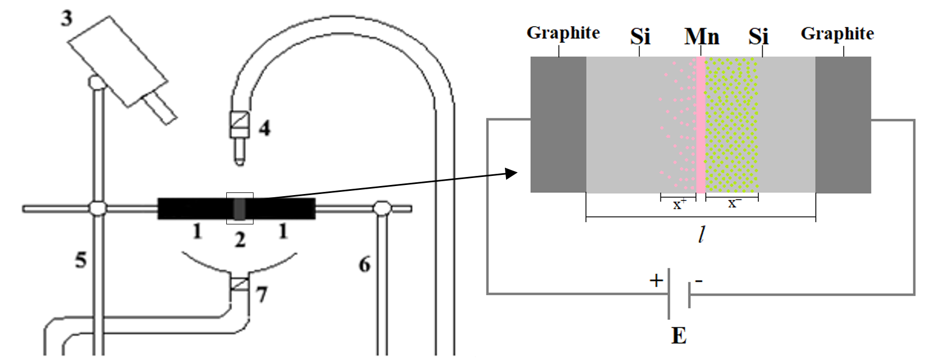
FIGURE 1. Schematic of a structure created for the diffusion of dopant atoms into silicon under the influence of an electric field: 1-Graphite; 2-sample; 3-thermocouple; 4-sample cooling unit; 5,6-electrodes; 7-cooler.

TABLE 1. Thermoelectric parameters of samples alloyed with manganese intercalated atoms.
№ | Traditional diffusion | Electrodiffusion
№ | T,°C | I, A | T,°C | U, V | l, mm (total thickness of two samples)
1 | 800 | 35 | 800 | 3 | 2
2 | 850 | 47 | 850 | 3 | 2
3 | 900 | 60 | 900 | 3 | 2
4 | 950 | 70 | 950 | 3 | 2
5 | 1000 | 80 | 1000 | 3 | 2

RESEARCH RESULTS AND DISCUSSION
The samples were quenched in a special oil after electrodiffusion and conventional diffusion processes. The process was carried out in the same way for both methods (t=15 minutes). After the alloying process, the electrophysical parameters of the samples were measured using an HMS-3000 device. All measurements were carried out at room temperature (T=300 K). The diffusion coefficient of the manganese inclusion in silicon was calculated using the measured electrophysical parameters and equations (1), (2), (3) and (4) (see Tables 2 and 3).
(1)
(2)
(3)
(4)

TABLE 2. Research results of the sample placed on the negative pole of the electrodiffusion device
T, ⁰C | Traditional diffusion |  | Only the effect of the electric field |  | Diffusion under the influence of an electric field |  |  |  |  | t, s
T, ⁰C | x, mkm | D, 10⁻⁷ cm²/s | D^{EP} (μEL), 10⁻⁷ cm²/s | μ, 10⁻⁷ cm²/(V·s) | D^{ED}, 10⁻⁷ cm²/s | x–, mkm | U, V | l, cm | E, V/cm | t, s
800 | 272 | 2.067 | 5.433 | 1.81 | 7.5 | 260 | 3 | 0.2 | 15 | 900
850 | 372.9 | 3.862 | 12.178 | 4.06 | 16.04 | 380 | 3 | 0.2 | 15 | 900
900 | 496.3 | 6.843 | 23.157 | 7.719 | 30 | 520 | 3 | 0.2 | 15 | 900
950 | 645 | 11.57 | 29.77 | 9.9 | 41.34 | 610 | 3 | 0.2 | 15 | 900
1000 | 822 | 18.77 | 23.93 | 7.97 | 42.7 | 620 | 3 | 0.2 | 15 | 900

Based on the results presented in Table 2, a temperature dependence graph was constructed for the diffusion coefficient (D) of manganese dopant atoms in silicon doped by the traditional diffusion method, the diffusion coefficient (D^{ED}) of manganese ions in silicon by the electrodiffusion method, and the diffusion coefficient (D^{EP}) of manganese ions in silicon under the influence of an electric field only.
FIGURE 2. Temperature dependence of the diffusion coefficients of manganese in silicon: 1—conventional diffusion, D=D₀·exp(-Q/(kT); 2—electric field effect only, D^{EP}=μEL; 3—electrodiffusion, D^{ED}=D+D^{EP}.

It is clearly seen from Figure 2 that the diffusion coefficient of manganese doped in silicon by electrodiffusion is larger than that of conventional diffusion. However, when the temperature exceeds 950 ⁰C, the diffusion coefficient of manganese doped in silicon by electrodiffusion remains almost unchanged (line 3 in Figure 2). In this case, only under the influence of an electric field, we can see that the diffusion coefficient of manganese in silicon (line 2 in Figure 2) decreases at a temperature of 1000 ⁰C. In conventional diffusion, the diffusion coefficient of manganese in silicon increases linearly with increasing temperature (line 1 in Figure 2).
To better understand this process, we are required to analyze the results of samples placed on the positive pole of an electrodiffusion device.

TABLE 3. Research results of the sample placed on the positive pole of the electrodiffusion device
T, ⁰C | Traditional diffusion |  | Only the effect of the electric field |  | Diffusion under the influence of an electric field |  |  |  |  | t, s
T, ⁰C | x, mkm | D, 10⁻⁷ cm²/s | D^{EP} (μEL), 10⁻⁷ cm²/s | μ, 10⁻⁷ cm²/(V·s) | D^{ED}, 10⁻⁷ cm²/s | x₊, mkm | U, V | L, cm | E, V/cm | t, s
800 | 272 | 2.067 | -1.842 | -0.614 | 0.225 | 45 | 3 | 0.2 | 15 | 900
850 | 372.87 | 3.862 | -3.115 | -1.0038 | 0.747 | 82 | 3 | 0.2 | 15 | 900
900 | 496.3 | 6.843 | -3.633 | -1.211 | 3.21 | 170 | 3 | 0.2 | 15 | 900
950 | 645 | 11.57 | -0.754 | -0.251 | 10.816 | 312 | 3 | 0.2 | 15 | 900
1000 | 822 | 18.77 | 17.33 | 5.78 | 36.1 | 570 | 3 | 0.2 | 15 | 900

The reason why the diffusion coefficient and ion mobility values in Table 3, which are only affected by the electric field, are less than zero, that is, negative, in the temperature range of 800÷950 ⁰C can be explained as follows.
It is known [23-26] that manganese atoms in a sample placed on the positive pole of an electrodiffusion device diffuse from the negative pole to the positive pole due to the concentration difference under the influence of heat. However, the manganese atoms in the sample initially settle between the nodes of the silicon crystal lattice and form positive ions. Positive manganese ions move towards the negative pole under the influence of an electric field and inhibit the manganese atoms diffusing from the negative pole to the positive pole due to the concentration difference. As a result, the diffusion coefficient of manganese in silicon seems to decrease.
Based on the results presented in Tables 2 and 3, a temperature dependence graph was constructed for the diffusion coefficient (D) of manganese impurity atoms in silicon in conventional diffusion, the diffusion coefficient (D^{EP}) of manganese ions in a silicon sample placed on the negative pole of the electrodiffusion device, and the diffusion coefficient (D^{ED}) of manganese in a silicon sample placed on the positive pole of the electrodiffusion device.
FIGURE 3. Temperature dependence of the diffusion coefficients of manganese in silicon: 1—conventional diffusion; 2—sample placed on the negative pole of the electrodiffusion device; 3—sample placed on the positive pole of the electrodiffusion device.
It is clearly seen from Figure 3 that the diffusion coefficient of manganese in silicon in the sample placed on the negative pole of the electrodiffusion device is larger than the diffusion coefficients of manganese in the sample placed on the positive pole of the electrodiffusion device by conventional diffusion and by electrodiffusion. We can see that the diffusion coefficient of manganese in the sample placed on the positive pole of the electrodiffusion device increases sharply with increasing temperature in the temperature range of 800÷1000 ⁰C. In addition, at a temperature of 950 ⁰C, it can be seen that the diffusion coefficients of manganese in the sample placed on the positive pole of the conventional diffusion [27-29] and electrodiffusion [30-32] devices become equal to each other (lines 1 and 3 in Figure 3).
CONCLUSIONS
Based on the results obtained, we will consider the diffusion mechanism of manganese in silicon by the electrodiffusion method. During the electrodiffusion process, manganese ions located in the silicon crystal lattice are simultaneously affected by the diffusion current (J_{D}) and the electric field current (J_{EP}) due to the concentration difference and temperature.
1. In this case, since in the temperature range of 800÷900 ⁰C most of the manganese atoms are mainly located between the nodes of the silicon crystal lattice and form positive ions, the directions of the diffusion current (J_{D}) and the electric field current (J_{EP}) acting on the positive ions of manganese in the sample placed on the positive pole of the electrodiffusion device are opposite to each other (see Figure 4).

J_{ED}=J_{D} – J_{EP} (5)
The directions of the diffusion current (J_{D}) and the electric field current (J_{EP}) acting on the positive ions of manganese in a sample placed on the negative pole of the electrodiffusion device are the same (see Figure 4).

J_{ED}=J_{D} + J_{EP} (6)

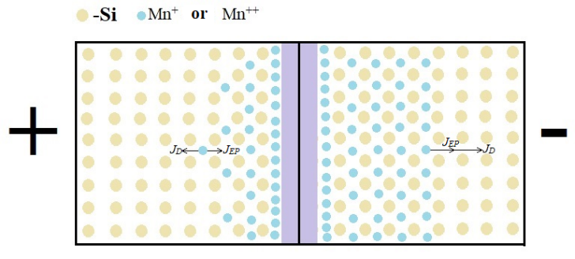
FIGURE 4. The mechanism of diffusion of manganese element into silicon by electrodiffusion at temperatures between 800÷900 ⁰C

2. In the temperature range of 950÷1000 ⁰C, since most of the manganese atoms are located mainly at the nodes of the silicon crystal lattice and form negative ions, the directions of the diffusion current (J_{D}) and the electric field current (J_{EP}) acting on the negative ions of manganese in the sample placed on the positive pole of the electrodiffusion device are the same (see Figure 5).

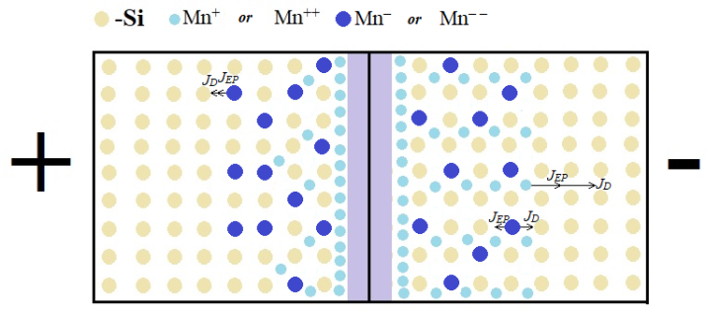
FIGURE 5. The mechanism of diffusion of manganese element into silicon by electrodiffusion at temperatures between 950÷1000 ⁰C
The directions of the diffusion current (J_{D}) and the electric field current (J_{EP}) acting on the negative ions of manganese in the sample placed on the negative pole of the electrodiffusion device are opposite to each other (see Figure 5).
3. Compared to traditional diffusion, the diffusion coefficient of Mn ions under the influence of an electric field in the electrodiffusion method was found to be on average ~4 times greater at temperatures T=800÷900 ⁰C and on average 2.5÷3.5 times greater at temperatures T=950÷1000 ⁰C.
4. The new electrodiffusion method of alloying is very promising because it requires less energy compared to the traditional diffusion method [33,34].
REFERENCES
- G Müller, J Friedrich. Crystal Growth, Bulk: Methods // Encyclopedia of Condensed Matter Physics, 2005, Elsevier Ltd. PP. 262–274. Doi:10.1016/B0-12-369401-9/00416-2.
- M. Schieber, R.B. James, and T.E. Schlesinge. Summary and Remaining Issues for Room Temperature Radiation Spectrometers // Semiconductors and semimetals, vol. 43. 1995, pp. 561-581.
- N.F. Zikrillaev, G.H. Mavlonov, L. Trabzon, S.B. Isamov, Y.A. Abduganiev, Sh.N. Ibodullaev, G.A. Kushiev. Magnetic Properties of Silicon Doped with Impurity Atoms of Europium. Journal of Nano- and Electronic Physics. (2023), 15, 6, 06001. DOI:10.21272/jnep.15(6).06001
- Kh.M. Iliev, S.V. Koveshnikov, B.O. Isakov, E.Zh. Kosbergenov, G.A. Kushiev, Z.B. Khudoynazarov. The Elemental Composition Investigation of Silicon Doped with Gallium and Antimony Atoms. Surface Engineering and Applied Electrochemistry, (2024), 60, 4, pp. 633 – 639. DOI: 10.3103/S106837552470025X
- G.A. Kushiev, B.O. Isakov, U.X. Mukhammadjonov. The Prospects of Obtaining a New Material with a Hetero-Baric Structure Ge_{x}Si_{1–x}-Si Based on Silicon for Photo Energy Applications. Journal of Nano- and Electronic Physics. (2024), 16, 3, 03003. DOI: 10.21272/jnep.16(3).03003
- N.F. Zikrillaev, F.E. Urakova, A.R. Toshev, G.A. Kushiev, T.B. Ismailov, Y.A. Abduganiev, N. Norkulov. Physical and magnetic properties of silicon doped with impurity germanium atoms. East European Journal of Physics. (2025), 1, pp. 184 – 189. DOI:10.26565/2312-4334-2025-1-18
- N.F. Zikrillaev, Kh.M. Iliev, G.A. Kushiev, S.B. Isamov, S.V. Koveshnikov, B.A. Abdurakhmanov, B.O. Isakov. Study Of Photocells Based On Ge_{x}Si_{1−x} Stuctures. Journal of Applied Science and Engineering. (2026), 29, 3, pp. 685 – 691. DOI:10.6180/jase.202603_29(3).0019
- I. Braceras, J.I. Alava, L. Goikoetxea, M.A. de Maeztu, J.I. Onate. Interaction of engineered surfaces with the living world: Ion implantation vs. osseointegration // Surface & Coatings Technology. 2007, 201, pp. 8091–8098.
- P.K. Chu, G.S. Wu. Surface design of biodegradable magnesium alloys for biomedical applications // Surface Modification of Magnesium and its Alloys for Biomedical Applications. 2015, pp. 89-119. http://dx.doi.org/10.1016/B978-1-78242-077-4.00003-6
- Jingjie Dai, Jiyun Zhu, Chuanzhong Chen, Fei Weng. High temperature oxidation behavior and research status of modifications on improving high temperature oxidation resistance of titanium alloys and titanium aluminides: A review // Journal of Alloys and Compounds. 2016, pp. 29. doi: 10.1016/j.jallcom.2016.06.212.
- Siwen Gu, Ling Yuan, Kaiyuan Guo, Wei Huang, LvZhou Li, Ya Yang, Xiulin Jiang, Ningyi Yuan, Qinqin Wang, Jianning Ding. Laser damage and post oxidation repair performance of n-TOPCon solar cells with laser assisted doping boron selective emitter // Solar Energy Materials and Solar Cells, 2024, Volume 274, pp.112988. https://doi.org/10.1016/j.solmat.2024.112988
- Finlay Colville. Laser-assisted selective emitters and the role of laser doping // Photovoltaics International, 2010, pp. 84-91. www.pv-tech.org
- Michelle Vaqueiro-Contreras, Brett Hallam, and Catherine Chan. Review of Laser Doping and its Applications in Silicon Solar Cells // IEEE Journal of Photovoltaics, 2023, vol. 13, NO. 3. pp. 373-383. https://doi.org/10.1109/JPHOTOV.2023.3244367
- N.F. Zikrillaev, M.K. Khakkulov, B.O. Isakov. The mechanism of the formation of binary compounds between Zn and S impurity atoms in Si crystal lattice. East European Journal of Physics. (2023), 4, pp. 177 – 181. DOI: 10.26565/2312-4334-2023-4-20
- N.F. Zikrillayev, S.B. Isamov, B.O. Isakov, T. Wumaier, Liang, Li wen, J.X. Zhan, T. Xiayimulati. New Technological Solution for the Tailoring of Multilayer Silicon-based Systems with Binary Nanoclusters Involving Elements of Groups III and V. Journal of Nano- and Electronic Physics. (2023), 16, 6, 06024. DOI:10.21272/jnep.15(6).06024
- Kh.M. Iliev, N.F. Zikrillaev, K.S. Ayupov, B.O. Isakov, B.A. Abdurakhmanov, Z.N. Umarkhodjaeva, L.I. Isamiddinova. Effect of GaSb Compound on Silicon Bandgap Energy. Journal of Nano- and Electronic Physics. (2024), 16, 2, 02004. DOI: 10.21272/jnep.16(2).02004
- X.M. Iliyev, Z.B. Khudoynazarov, B.O. Isakov, M.X. Madjitov, A.A. Ganiyev. Electrodifusion of manganese atoms in silicon. East European Journal of Physics. (2024), 2, pp. 384 – 387. DOI: 10.26565/2312-4334-2024-2-48
- B.O. Isakov, X.M. Iliyev, Z.B. Khudoynazarov, G.A. Kushiev. Effective charge of Mn and Ni impurity atoms in silicon under the influence of an external electric field. East European Journal of Physics. (2025), 2, pp. 215 – 219. DOI: 10.26565/2312-4334-2025-2-23
- G.H. Mavlonov, Kh.Kh. Uralbaev, B.O. Isakov, Z.N. Umarkhodjaeva, Sh.I. Hamrokulov. Diffusion distribution of Cr and Mn impurity atoms in silicon. East European Journal of Physics. (2025), 2, pp. 237 – 241. DOI:10.26565/2312-4334-2025-2-27
- X.M. Iliyev, S.B. Isamov, B.O. Isakov, U.X. Qurbonova, S.A. Abduraxmonov. A surface study of Si doped simultaneously with Ga and Sb. East European Journal of Physics, (2023), 3, pp. 303-307. DOI:10.26565/2312-4334-2023-3-29
- X.M. Iliyev, V.B. Odzhaev, S.B. Isamov, B.O. Isakov, B.K. Ismaylov, K.S. Ayupov, Sh. I. Hamrokulov, S.O. Khasanbaeva. X-ray diffraction and Raman spectroscopy analyses of GaSb-enriched Si surface formed by applying diffusion doping technique. East European Journal of Physics, (2023), 3, pp. 363-369. DOI: 10.26565/2312-4334-2023-3-38
- B.A. Abdurakhmanov, A.Sh. Movlyanov, U.Kh. Sodikov, N. Norkulov. New materials for solar elements on the basis of silicon with CdS and ZnS quantum dots. Elektronnaya Obrabotka Materialov, (2005), 4, pp. 89-92.
- B.A. Abdurakhmanov, M.K. Bakhadyrkhanov, Kh.M. Iliev, S.A. Tachilin, A.R. Toshev. Effect of stress on the Si solar cell parameters. Applied Solar Energy (English translation of Geliotekhnika), (2005), 41, 2, pp. 65-67.
- B.A. Abdurakhmanov, Kh.M. Iliev, S.A. Tachilin, A.R. Toshev. Silicon solar cells with Si-Ge microheterojunctions. Russian Microelectronics. (2012), 41, 3, pp. 169-171. DOI: 10.1134/S1063739712020023
- B.A. Abdurakhmanov, Kh.M. Iliev, S.A. Tachilin, A.R. Toshev, B.E. Egamberdiev. The effect of silicon-germanium microheterojunctions on the parameters of silicon solar cells. Surface Engineering and Applied Electrochemistry, (2010), 46, 5, pp. 505-507.
- M.K. Bakhadyrkhanov, Kh.M. Iliev, S.A. Tachilin, S.S. Nasriddinov, B.A. Abdurakhmanov. Impurity photovoltaic effect in silicon with multicharge Mn clusters. Applied Solar Energy (English translation of Geliotekhnika), (2008), 44, 2, pp. 132-134. DOI:10.3103/S0003701X08020151
- Zikrillaev, N. F., Urakova, F. E., Toshev, A. R., Kushiev, G. A., Ismailov, T. B., Abduganiev, Y. A., Norkulov, N. (2025). Physical and Magnetic Properties of Silicon Doped with Impurity Germanium Atoms. East European Journal of Physics, (1), 184-189. https://doi.org/10.26565/2312-4334-2025-1-18
- N.F. Zikrillaev, G.A. Kushiev, Sh.I. Hamrokulov, Y.A. Abduganiev. Optical Properties of GexSi1–x Binary Compounds in Silicon. J. Nano- Electron. Phys. 15 No 3, 03024 (2023) https://doi.org/jnep.15(3).03024M.K.
- Bakhadyrkhanov, Kh.M. Iliev, K.S. Ayupov, B.A. Abdurakhmonov, P.Yu. Krivenko, R.L. Kholmukhamedov. Self-organization of nickel atoms in silicon. Inorganic Materials, (2011), 47, 9, pp. 962-964. DOI: 10.1134/S0020168511090020
- N.F. Zikrillaev, G.A. Kushiev, S.B. Isamov, B.A. Abdurakhmanov, O.B. Tursunov. Photovoltaic Properties of Silicon Doped with Manganese and Germanium. Journal of Nano- and Electronic Physics, (2023), 15, 1, 01021. DOI:10.21272/jnep.15(1).01021
- Kh.M. Iliev, K. A. Ismailov, E. Zh. Kosbergenov, V. B. Odzhaev, V. S. Prosolovich, Yu. N. Yankovsky, Z. T. Kenzhaev, B. O. Isakov, and G. A. Kushiev, The Influence of γ-Irradiation on the Electrophysical Parameters of Nickel-Doped Silicon Grown by the Czochralski Method // Surface Engineering and Applied Electrochemistry, 2025, Vol. 61, No. 6, pp. 851–856. https://doi.org/10.3103/S1068375525700942
- Kenzhaev Z.T., Iliev Kh.M., Odzhaev V.B., Mavlonov G.Kh., Prosolovich V.S., Kosbergenov E.Zh., Ismaylov B.K., Isamov S.B., Ollambergenov Sh.Z. The Effect of Gamma Irradiation on the Electrophysical Parameters of Nickel-Doped Silicon Solar Cells//Surface Engineering and Applied Electrochemistry, 2024, Vol. 60, No. 6, pp. 851–856. DOI: 10.3103/S1068375524700467
- Bakhadyrkhanov M.K., Ismailov K.A., Kosbergenov E.Zh. Thermal stability of electrical parameters of silicon crystal doped with nickel during growth // Semiconductor Physics, Quantum Electronics & Optoelectronics, 2022, Vol. 25, No. 1, pp. 6–9. DOI: 10.15407/spqeo25.01.006
- Ismailov K.A., Kenzhaev Z.T., Koveshnikov S.V., Kosbergenov E.Zh., Ismaylov B.K. Radiation stability of nickel-doped solar cells // Physics of the Solid State, 2022, Vol. 64, No. 4, pp. 154–156. DOI: 10.1134/S1063783422040011

