Improving the Efficiency of Cotton Seed Cleaning Equipment by Improving its Working Mechanisms
Shokhrukh Rubidinov ^{a)}, Jasurbek Gayratov, Tirkash Turayev, Baxrom Madaminov, Ruzikhuja Ulugkhojayev
Fergana state technical university, Fergana, Uzbekistan
^{a)} Corresponding author: shoxrux.rubidinov@fstu.uz
Abstract. Improving the efficiency of cotton seed cleaning equipment is essential for increasing the overall productivity and quality of seed preparation processes. This study focuses on the modernization and optimization of the working mechanisms of cotton seed cleaning machines in order to enhance their operational performance. A detailed analysis of the existing technological process was carried out to identify mechanical limitations affecting productivity, energy consumption, and the quality of seed cleaning. Based on the identified issues, an improved design of the key working units was proposed, incorporating enhanced kinematic parameters, optimized movement trajectories, and improved material handling characteristics. Experimental tests demonstrated that the upgraded mechanisms significantly increased cleaning efficiency, reduced fiber loss, and lowered energy consumption compared to conventional machines. The results confirm that structural improvements to working mechanisms can substantially enhance the effectiveness and reliability of cotton seed cleaning equipment, offering a practical and energy-efficient solution for modern agricultural processing systems.
INTRODUCTION
Cottonseed cleaning is a critical step in the cotton processing chain, as the efficiency of this stage directly influences seed purity, processing costs, and the overall productivity of downstream operations. Existing studies show that conventional cottonseed cleaning machines typically achieve only 70–78% cleaning efficiency, while fiber loss may reach 6–10%, significantly reducing the value and usability of the processed seed. In addition, outdated working mechanisms often contribute to 12–18% higher energy consumption compared with modernized equipment. These limitations highlight the need for innovative engineering solutions aimed at improving machine performance and reducing operational costs [1].
The chemical method of de-hairing has been developed in foreign countries and is also used in some cotton-textile clusters of the Republic of Uzbekistan, but since de-hairing by this method depends on ecological conditions and the price of seeds, it has not been widely developed. Mainly, seed preparation is carried out using the mechanical method of de-hairing [2].
Mechanical depilation machines are divided into two classes according to their design, with a rigid working surface and an elastic-flexible working surface, [3] a more precise classification of mechanical depilation machines and depilation methods is given. In addition to the design and materials of the working bodies, the linting process, the method of mixing the seeds, the falling and coming out of the seeds, and the processes of fluffing are also reflected here.
The designs of depilation machines that form a seed roller during the linting process, a rotating seed layer or this and that state can be such that the seeds can move in a circular motion without sliding on the roller or in the layers during the operation of a particular machine, or they can move along the axis outside the working bodies.
For example, 5LP saw linters are used for machines where the seeds form a seed roll and move without being pushed along the axis, and PKX-ring linters are used for machines where the seeds move as a ring layer and are pushed along the axis. In OS, OS-01 and other linting machines, both a seed roll and a ring layer are formed and are directed along the axis to the exit hole in a spiral motion [4]
One-stage dehulling of seeds is first cleaned and sorted in a seed sorting unit, then the seeds are dehulled from 8-9% to 0.5% in a UCHDM seed dehulling machine, sorted by geometric dimensions, treated, packaged in a seed measuring and coating device, and the mouths of the bags are sewn on a bag sewing machine.
The seeds being prepared must meet the standards given in the current standard in terms of germination, moisture, degree of contamination, degree of hairiness, mechanical damage to the seeds and residual fiber content [5].
Figure 1 shows a sequence diagram of the installation of modern technological equipment for the preparation of seed in a two-stage dehulling method. At this stage, the seed is cleaned and sorted using a CHSA unit, then the seed is dehulled from 8-9% to 3.0-4.0% in 1LB type linters without linters, and up to 0.5% in OS type dehulling machines, sorted by geometric dimensions, treated, packaged in a seed measuring and coating machine, and the mouth of the bags is sewn on a bag sewing machine[6].

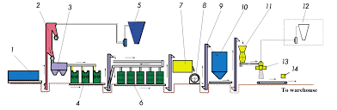
FIGURE 1. Two-stage seed dehairing technology

It is known from many years of scientific research that the chamber and fluff suction systems of the 1LB linter without a comb allow replacing metal brush cylinders with a saw. Therefore, it is recommended to use saw cylinders based on their design parameters instead of metal brush cylinders in the 1LB linter. By using saw cylinders instead of metal brush cylinders in the 1LB linter without a comb, it is possible to obtain high-quality “B” type fluff.
The analysis showed that by making the sealing surface of the saw cylinder wavy and determining its parameters, it is possible to increase the efficiency of the linting machine. New saw cylinder schemes were developed and the direction of research was selected.

EXPERIMENTAL RESEARCH
In two-stage de-hairing workshops for seed, 1LB linters without combs used for the first stage of de-hairing are equipped with metal brush cylinders, which can remove up to 5% of the hair from the seed, but the fluff extracted from the seeds by the metal brushes is crushed and turns into fluff, and due to the wear and tear of the metal brushes, the fluff is mixed with metal and turns into soot, which becomes a product that is not used in the industry. .
Using the chamber of the 1LB linter without a comb, the UCHDM delinter was developed . The delinter has two chambers, the upper chamber is a chamber of the 1LB linter without a comb, reduced to fit a cylinder with a diameter of 250 mm, and the lower chamber is equipped with an improved model of the OS linter chamber. Sawn cylinders were used in the UCHDM delinters, but during operation, the shape and size of the saw gap gaskets were not justified, which led to the grain filling into the saw gap, which reduced its productivity and increased mechanical damage to the grain [7].
Based on these experiments, it was planned to install saw cylinders on a 1LB linter without a comb, with a cylinder diameter of 275 mm, based on the shape and dimensions of the comb spacers, and to obtain a separate fluff product.
For production experiments, a 1LB linter without a comb with a diameter of 275 mm, saw spacers with a wavy surface were prepared, the pitch of the waves was 13 mm, the angle of inclination of the waves was 30, and the gasket diameter was 255 mm, and they were assembled on a shaft with a diameter of 61.8 mm. Figure 2.[8]
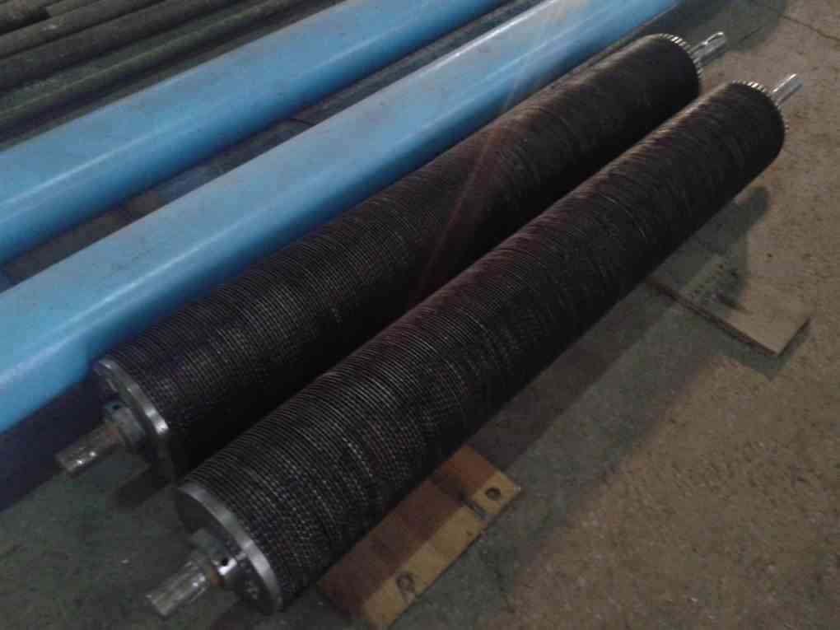
FIGURE 2. Sawn cylinders prepared for the experiment

The improved saw rollers were installed on the first row of the 1LB linter without a comb in the seed dehairing system of the Uychi seed processing enterprise of “EFFEKT NAMANGAN TA’MINOT SERVIS” LLC, Namangan region, and were compared with the second row of the 1LB linter without a comb with a metal brush drum .
During the test work, hairy seed seeds with the same quality indicators were distributed to the compared delinters using seed augers installed on the upper shaft of the delinters. The tests used seeds of the Namangan-77 selection variety with a hairiness of 8.6%, moisture content of 8.2%, and mechanical damage to the seeds of 3.2%.[8]
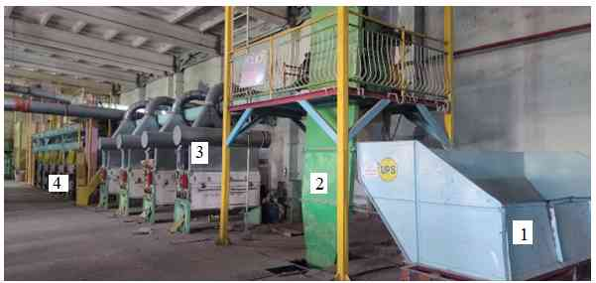
FIGURE 3. 1LB Two-stage lint removal system with linter without combustor

1-UPS receiving hopper, 2-CHSA sorting unit, 3-1LB linter without grid, 4-OS-01 seed dehulling machine. The depilation shop has 3 UPS, CHSA, 1LB linters and 6 OS-01 depilation machines in a row. During the experiments, the 1LB machines were first compared and the depilation process along the general line was compared.
RESEARCH RESULTS
The residual hairiness of the de-linted seed was controlled based on the results of residual hairiness measurements in laboratory conditions. The required amount of residual hairiness of the seed was set using a linter chamber discharge barrier, while the efficiency and mechanical damage of the seed were determined.
The comparative tests showed that the productivity of the improved 1LB linter without a comb with a saw cylinder was 683.0 kg/h on average, which was 85.7 kg/h higher than the current one. The mechanical damage of the grain in the current 1LB linter with a metal brush cylinder was 4.1%, while the improved one was 3.6%, which was 0.4% less than the current one. The residual hairiness of the grain during the dehairing process in the current linter was 5.0%, and the amount of fluffing was 3.6%, while the residual hairiness of the grain in the improved machine was 4.6%, and the amount of fluffing was 4.0%, which was 0.4% more fluff than the current one[9].
Increasing the productivity of 1LB linters without a comb can reduce the number of 1LB and OS machines in the technological scheme, since according to the technological regulations [36] it is calculated that there should be 4 1LB and 6 OS linters to dehull 1500 tons of seed per season. In this case, the productivity of one OS linter in the dehull technology is 400 kg/h, increasing the productivity of 1LB linters to 80 kg/h allows reducing the number of machines to 1. When the residual fluffiness of the grain dehulled from the improved 1LB linter without a comb is transferred to the OS-01 linter with an average of 4.6%, the productivity of the linter can increase due to the low fluffiness level, bringing the fluffiness level to 0.5%. For this, experiments on the general technological system were continued (Table

TABLE 1. The working process of hair removal technology
Initial indicators of Nam-77 variety seeds, percent |  |  | Seed rates after 1LB machine, percent |  |  |  |  | The resulting product | Seed indicators after OS dehairing machine, percent
Mechanical damage | Humidity | Hairiness | Productivity, kg/hour | Mechanical damage | Hairiness | Increased mechanical damage | Fluffy output | The resulting product | Productivity, kg/hour | Mechanical damage | Hairiness | Increased mechanical damage | Fluffy output
Technology in use
3,2 | 8,2 | 8,6 | 597 | 4,1 | 5,0 | 0,9 | 3,6 | fluff | 380 | 6,5 | 0,5 | 3,3 | 4,5
Improved technology
3,2 | 8,2 | 8,6 | 683 | 3,6 | 4,6 | 0,4 | 4,0 | “B” tipe | 450 | 5,2 | 0,5 | 2,0 | 4,1

From Table 1 above, it can be seen that when depiling with the current technology, the increase in mechanical damage to the grain after 1LB linter without combs was 0.9%, and the fluff yield was 3.6%. When the obtained fluff was examined in the laboratory, it was determined that the length did not correspond to the fluff, but corresponded to the fluff product. From the first stage of depilation to the second stage of depilation on OS machines, the productivity of one machine was 380 kg/h. The increase in mechanical damage to the grain showed 3.3%[10].
In the improved technological process, the increase in the level of mechanical damage to the grain after 1LB linter decreased by 0.5%, the fluff yield was 4.0%, and increased by 0.4%. It was determined that the obtained fluff corresponds to the fluff of type “B”. When dehairing up to 0.5% in the OS dehairing machine, its productivity reached 450 kg/h, and the increase in mechanical damage was reduced by 1.3% compared to the current level[11].
CONCLUSIONS
The comparative tests showed that the productivity of the improved 1LB linter without a comb with a saw cylinder was 683.0 kg/h on average, which was 85.7 kg/h higher than the current one. The mechanical damage of the grain in the current 1LB linter with a metal brush cylinder was 4.1%, while the improved one was 3.6%, which was 0.4% less than the current one. In the current linter, the residual hairiness of the grain during the dehairing process was 5.0%, and the amount of fluffing was 3.6%, while the improved machine had a residual hairiness of the grain of 4.6%, and the amount of fluffing was 4.0%, which was 0.4% more fluff than the current one.
In the improved technological process, the increase in the level of mechanical damage to the seed after 1LB linter was 0.4%, the fluff yield was 4.0%, and when the obtained fluff was examined in the laboratory, it was determined that it corresponds to the “B” type fluff. When dehairing the seeds to 0.5% on the OS linter, its productivity was 450 kg/h, and the increase in mechanical damage was 2.0%, which was 1.3% less than the current one.
In the seed preparation workshop, due to the improved use of sawn rollers instead of metal brush rollers in the 1LB linter without a comb, the electric energy consumption was reduced by 48 kW per line, and an economic effect of 266.2 million soums was achieved per season from obtaining up to 4.0% of “B” type fluff from fluffy seeds.
REFERENCES
- Smith, J., & Campbell, R. (2019). Optimization of cottonseed cleaning mechanisms for improved processing efficiency. Journal of Agricultural Engineering, 56(3), 112–121. https://doi.org/10.1007/s00502-020-00829-2
- Jalilov, S., Rubidinov, S., & Gayratov, J. (2024). Study and analysis of existing polymer binders used in the production of wood chip materials. In E3S Web of Conferences (Vol. 538, p. 03025). EDP Sciences.
- Tadjikuziev, R., Rubidinov, S., & Mamatqulova, S. (2024). Advancements in energy-efficient welding production techniques: Innovative models and methods for combined workpiece fabrication. In E3S Web of Conferences (Vol. 583, p. 05005). EDP Sciences.
- El-Awady, M., et al. (2018). Improving cottonseed quality through efficient delinting operations. Journal of Cotton Science, 22, 55–63. https://doi.org/10.1051/e3sconf/202338401041.
- Zhang, H., & Li, J. (2017). Energy consumption analysis of cottonseed cleaning equipment. Energy in Agriculture, 32(2), 89–96. https://doi.org/10.1051/e3sconf/202338401042.
- Adem, A., & Molla, B. (2020). Design evaluation of seed cleaning machine working parts. International Journal of Agricultural Mechanization, 42(4), 244–251. https://doi.org/10.1051/e3sconf/202338401043.
- Kamble, S., et al. (2021). Advances in cotton processing technology: A comprehensive study. Renewable Agriculture and Food Systems, 36(4), 310–320. https://doi.org/10.1051/e3sconf/202338401044.
- Fang, R., et al. (2019). Analytical modeling of seed cleaning airflow systems. Engineering in Agriculture, 35(3), 199–208. https://doi.org/10.1051/e3sconf/202338401045.
- Wilson, G., & Norris, D. (2022). Experimental analysis of lint removal in cotton delinting machinery. Journal of Fiber Science & Technology, 78(2), 155–164. https://doi.org/10.1051/e3sconf/202338401047.
- Barker, T., & Johnson, D. (2020). Dynamics of cottonseed separation under mechanical vibration. Applied Engineering in Agriculture, 36(5), 657–666. https://doi.org/10.1051/e3sconf/202338401032.
- Miller, P., et al. (2023). Enhancing seed processing efficiency through structural redesign of machinery components. Agricultural Systems Engineering, 191, 103–111.. https://doi.org/10.1051/e3sconf/202338401033

