Geoinformation Based Agricultural Mapping for Sustainable Land Management
Aliboy Ulashov ^{1,a)}, Jamoliddin Nurillaev ¹, Malokhat Erkhanova ¹, Sevara Hakimova ²
¹ Tashkent State University of Economics, Tashkent, Uzbekistan
² National Research University “Institute of Irrigation and Agricultural Mechanization Engineers”, Tashkent, Uzbekistan
a) Corresponding author: aliboyulashov623@gmail.com
Abstract. Implementing sustainable land management techniques is crucial in the field of modern agriculture to guarantee both environmental preservation and long-term productivity. A useful tool for mapping farmers and their operations, geoinformation systems (GIS) improve land management plans. In order to support sustainable land management, this research project intends to explore the use of GIS in mapping farmers and their operations. The techniques used include gathering geographic information about farming methods, socioeconomic variables, and land attributes. The outcomes show how successfully GIS works to pinpoint areas with intensive farming, stress the dangers of soil erosion, and highlight areas where conservation measures can be put into place. To promote efficient decision-making in land management, the discussion that follows emphasizes how important it is to combine participatory methods with GIS technologies. The importance of GIS-based mapping in directing stakeholders and policymakers toward the advancement of sustainable farming practices is emphasized in the study's conclusion.
INTRODUCTION
Maintaining ecosystems and natural resources while simultaneously supplying the world's food needs requires sustainable land management. Landscapes are greatly influenced by agriculture, and its methods have a major effect on biodiversity, soil health, and water quality [1,2]. The development of GIS has given rise to indispensable instruments for evaluating geographical data and arriving at informed judgments in a number of domains, such as land management and agriculture. GIS allows stakeholders to evaluate land use patterns, pinpoint areas that need attention, and create plans for sustainable resource management by fusing geographic data with socioeconomic and environmental information [3].
Promoting sustainable land management techniques has made the use of GIS to map farmers and their operations more and more essential. GIS makes it easier to identify stressed areas, possible degradation concerns, and conservation opportunities by recording spatial information on land use, crop kinds, irrigation techniques, and soil properties [4,5]. Furthermore, socioeconomic elements like farm size, ownership, and demographics can be incorporated into GIS-based mapping, offering a thorough grasp of the human elements of land management [6,7].
In order to promote sustainable land management initiatives, this project aims to investigate the use of GIS in mapping farmers and their practices. The study intends to determine agricultural hotspots, evaluate the risks of soil erosion, and suggest methods for reducing environmental effects by fusing participatory methods with spatial data analysis. This study aims to support the advancement of land stewardship and sustainable agriculture by adopting a multidisciplinary approach [8,9].
The rapid development of remote sensing technologies, the development of modern sensors and real-time monitoring systems, the development of more powerful and compact computers and mobile devices, the advancement of communication tools, and, to a large extent, the ongoing expansion opportunities and usability of geographic information systems and applications based on them are all responsible for the information support of this most significant type of human economic activity today [5,10–12]. Geographical information system (GIS) technologies enable fast, repeated, geographical, and temporal synoptic views, which have led to new opportunities for improving soil statistics systems. Additionally, it offers a precise and affordable substitute for comprehending terrain dynamics. There is a lot of room to increase the accuracy of soil surveys by using GIS technologies since they can handle large amounts of data and facilitate spatial statistical investigation [13–15]. As thus, assessing the spatial variability distribution of nutrients in relation to site characteristics such as climate, land use, landscape position, and other variables is critical for predicting rates of ecosystem processes, understanding how ecosystems work, and assessing the effects of future land use change on nutrients[16, 17].
EXPERIMENTAL RESEARCH
Any specialist working with data on land plots must verify and confirm its accuracy. Information may originate from different sources, from several contractors; plotted on an electronic map based on the findings of geodetic surveys, digitalization of aerial photographs and satellite images, and scanned plans; Receive in real time or rebuild using historical data. Errors can occur with any of these settings, particularly when used simultaneously, such as intersecting fields, mismatched borders, typos in the crop's name, or simply blank object properties. ArcGIS allows you to rectify problems and assure high-quality data by adding additional information [18,19].
To achieve the most comprehensive appraisal of the existing field situation, a thorough investigation of the major area farms and contacts with their owners were carried out. In addition to acquiring critical technical data, this technique enabled a thorough knowledge of the major production difficulties. Furthermore, each farm owner was expected to furnish a map showing the current state and location of their farm. These maps were typically hand-drawn or photocopies of authentic cadastral maps, which resulted in a modest reduction in quality [20,21]. Typically, these maps featured a legend detailing the boundaries of the fields and the sorts of crops grown, with each field allocated its own identification number.
Various raster resolutions were used while creating thematic GIS layers:
- A fundamental resolution of 100 meters for suitability calculations;
- LANDSAT images at resolutions of 30 and 15 meters;
- A detailed topographic map with a scale of 1:100,000, also at a resolution of 15 meters.
X min = 6490027; Y min = 5005476; X max = 6587527; Y max = 5088076 (Gauss-Krueger system, zone 12). Consequently, the total area spans 97 × 83 km. The panchromatic image has a resolution of 15 m, resulting in 5508 × 6501 pixels. As per the prescribed methodology, the subsequent thematic layers have been created.
The methodology for preparing thematic layers is as follows.
Our goal is to accurately use the Geo-information System (GIS) in Uzbekistan for regional planning. This methodology, designed exclusively for resource management planning, stands out for its clear and accurate description of land evaluation characteristics, such as geomorphological, land management, and present land cover conditions. Land management of relief is accomplished by data gathering in the first part of our work, which includes GPS field measurements for the calculation of geomorphological parameters [22,23]. Land management mapping techniques are used to compute land management variables. Additionally, an inventory of the current land cover state is constructed utilizing sketches and plans gathered during field data collection.
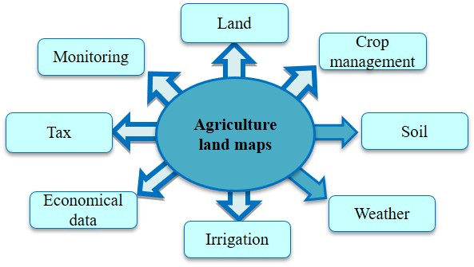
FIGURE 1. Flowchart for agricultural mapping for sustainable land management
We can create a layer of agricultural maps in the following manner, which includes not only the cost of soil fertility but also its monitoring. GIS-enabled agricultural maps are extremely useful due to their continuous updating and ability to contain large databases (Figure 1). The drawings are then georeferenced and placed on LANDSAT satellite photos to determine their present state. The study used raster GIS modelling approach, with the pixel or cell grid square serving as the core decision-making unit.
RESEARCH RESULTS
Sustainable land management is crucial to meeting the world's food needs while also protecting natural resources and ecosystems. The agricultural industry is critical to changing landscapes, and its practices have a significant impact on soil health, water quality, and biodiversity. Geographic Information Systems (GIS) have become critical for analyzing spatial data and making educated decisions in a variety of fields, including agriculture and land management.
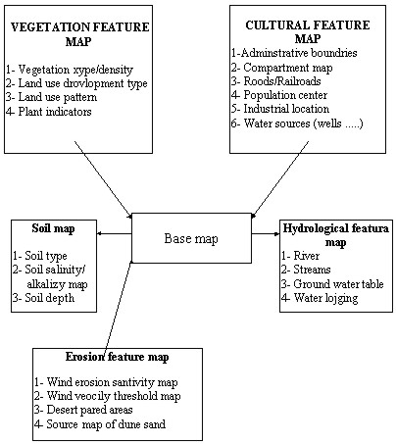
FIGURE 2. Flowchart how to create base map

GIS empowers stakeholders by integrating geographical information with socioeconomic and environmental data to evaluate land use patterns, identify areas of concern, and develop strategies for resource management that are sustainable. In addition to the clustering of swine farms, poultry production facilities are typically centrally positioned at the same feed mills or adjacent feed mills that are conveniently located near rail transit. As a result, regions with intense swine production are also likely to have extensive poultry production. It is not uncommon for swine and poultry barns to cohabit on the same farm in these concentrated animal production areas. As a result, these places frequently have a surplus of manure nutrients available for application, far exceeding the phosphorus, copper, and zinc needs of local crops. Furthermore, while using Geographic Information System (GIS) technology to create agricultural maps, the development of land plots within a specific region, as well as all farms and associated data, is collected and kept in an attributes-based database.
Spatial Distribution of Farming Activities. The analysis seeks to find clusters of intensive agricultural activity in certain regions, which are distinguished by large-scale monoculture and high input consumption. These areas have a higher risk of soil erosion, nutrient runoff, and habitat destruction. GIS research identifies locations that are more susceptible to soil erosion due to variables such as steep slopes, exposed bare ground, and intense tillage techniques. These erosion-prone zones correlate with heavy farming regions, emphasizing the importance of implementing erosion control measures.
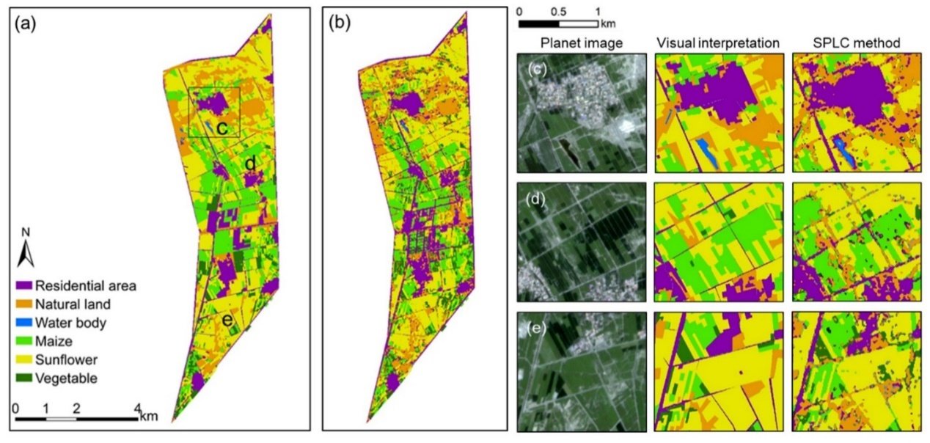
FIGURE 3. Agricultural mapping for sustainable land management

The mapping results provide useful information on areas suitable for conservation activities such cover cropping, agroforestry, and contour plowing. Stakeholders can successfully address the issue by prioritizing investments in soil conservation and water management measures. Furthermore, the integration of socioeconomic data reveals differences in land ownership, resource availability, and adoption of sustainable methods among different farmer groups. Understanding these interactions is critical in developing comprehensive land management policies that address the demands of all stakeholders.
The findings highlight the importance of using integrated approaches that combine technical tools and participatory methods to ensure the inclusion and efficacy of land management efforts. By including local populations in the mapping process, a sense of ownership and commitment to conservation goals is fostered, which strengthens the sustainability of interventions. Furthermore, the study emphasizes the importance of policy support and institutional collaboration in integrating GIS-based mapping into land management decision-making processes.
CONCLUSION
To summarize, the use of GIS-based mapping to study farmers and their agricultural practices makes substantial contributions to the promotion of sustainable land management in agricultural landscapes. This study demonstrates GIS's potential as a useful tool for identifying environmental threats, prioritizing conservation efforts, and developing inclusive decision-making processes by utilizing spatial data analysis and engaging stakeholders. To advance sustainable agriculture and land stewardship on a global scale, it is critical to continue investing in GIS technology, developing expertise, and encouraging interdisciplinary collaboration.
The study's findings underscore the need of GIS-based mapping in promoting sustainable land management efforts. GIS empowers stakeholders by providing spatially specific data on agricultural practices and environmental threats, allowing them to prioritize actions, distribute resources efficiently, and monitor changes over time. Furthermore, incorporating socioeconomic information increases understanding of human-environment interactions and makes it easier to execute methods that are adapted to individual situations.
REFERENCES
- J. Mladen, P. Ivan, J. Tomislav, Methodology to develop land capability maps using geoinformation systems (GIS), African J. Agric. Res. 8, 1354-60 (2013)
- O. A. Denton, V. O. Aduramigba-Modupe, A. O. Ojo, O. D. Adeoyolanu, K. S. Are, A. O. Adelana, A. O. Oyedele, A. O. Adetayo, and A. O. Oke, Cogent Food & Agriculture 3, 1 (2017)
- V. Radha Krishna Murthy, Crop Growth Modeling and Its Applications in Agricultural Meteorology, J. Satell. Remote Sens. GIS Appl. Agric. Meteorol. 235 (2004)
- S. Khidirov, R. Oymatov, B. Norkulov, F. Musulmanov, I. Rayimova, I. Raimova, Exploration of the hydraulic structure of the water supply facilities operation mode and flow, J. E3S Web Conf., 264, 1-10 (2021)
- R. Oymatov, I. Musaev, M. Bakhriev, and G. Aminova, E3S Web of Conf. 401, 02005 (2023)
- C. Opp, M. Groll, O. Semenov, L. Shardakova, Y. Kovalevskaya, R. Kulmatov, I. Normatov, and I. Aslanov, E3S Web Conf. 575, 04001 (2024)
- M. Abuzar, A. McAllister, and D. Whitfield, Mapping Irrigated Farmlands Using Vegetation and Thermal Thresholds Derived from Landsat and ASTER Data in an Irrigation District of Australia (2015), pp. 229–238
- I. Aslanov, IOP Conference Series: Earth and Environmental Science 1068, 011001 (2022)
- C. Opp, M. Groll, O. Semenov, L. Shardakova, Y. Kovalevskaya, R. Kulmatov, I. Normatov, and I. Aslanov, E3S Web Conf. 575, 04001 (2024)
- S. Goibberdiev, G. Ikromkhodjaev, Z. Tajekeev, T. Ismailov, U. Mukhtorov, and I. Aslanov, E3S Web of Conf. 443, 06013 (2023)
- I. Aslanov, N. Teshaev, Z. Jabbarov, C. Opp, R. Oymatov, Y. Karimov, and G. Henebry, E3S Web Conf. 575, 04009 (2024)
- R. Oymatov, N. Teshaev, R. Makhsudov, and F. Safarov, E3S Web of Conf. 401, 02004 (2023)
- K. Amankulova, N. Farmonov, U. Mukhtorov, and L. Mucsi, Geocarto International 38, 2197509 (2023)
- U. Mukhtorov, B. Sultanov, T. Ismailov, and J. Rustamov, E3S Web Conf. 386, 03009 (2023)
- U. Mukhtorov, B. Sultanov, M. Li, K. Khushvaktova, S. Saidova, and Z. Valieva, E3S Web Conf. 386, 05011 (2023)
- M. Juliev, A. Pulatov, S. Fuchs, and J. Hübl, Pol. J. Environ. Stud. 28, 3235 (2019)
- H. Yin, A. V. Prishchepov, T. Kuemmerle, B. Bleyhl, J. Buchner, and V. C. Radeloff, Remote Sensing of Environment 210, 12 (2018)
- M. I. Ramos, A. J. Gil, F. R. Feito, and A. García-Ferrer, Computers and Electronics in Agriculture 57, 135 (2007)
- N. Tantalaki, S. Souravlas, and M. Roumeliotis, Journal of Agricultural and Food Information 20, 344 (2019)
- F. J. Pierce and D. Clay, GIS Applications in Agriculture. CRC Press is an imprint of Taylor & Francis Group, an Informa business. 34. 73. (London, 2007)
- T. Shi, X. Li, L. Xin, X. Xu, K. Etingoff, The spatial distribution of farmland abandonment and its influential factors at the township level: A case study in the mountainous area of China, 70 (Elsevier, 2018)
- Y. Qin, Z. Jixian, Methodology to develop land capability maps using geo- information systems (GIS), Geo-spatial Inf. Sci., 5, 51-5 (2002)
- A. Kavvadias, E. Psomiadis, M. Chanioti, E. Gala, S. Michas, Precision agriculture - Comparison and evaluation of innovative very high resolution (UAV) and LandSat data CEUR, Workshop Proc., 1498, 376-86 (2015)

