Road-Related Flood Risk Disaster Zonification of the Territory of Namangan Region Using the Method of Supplementing Components
Azizjon Namozov^{1, a}, Barno Salimova¹, Rashidbek Hudaykulov¹, Dilshod Aralov¹, Erkinbek Karimov²
¹ Tashkent State Transport University, Tashkent, Uzbekistan
²Osh Technological University named after M.M.Adyshev, Osh, Kyrgyz
a) Corresponding author: azizjonnamozov1239@mail.com
Abstract: This article uses the geomorphological and hydrometeorological characteristics of the Namangan region, as well as archival data on flash floods from Uzgidromet, to zone Namangan region according to flood risk by using the method of interrelated component analysis (overlay) and determine the distribution of the Namangan region's highway network by district and region according to flood risk.
INTRODUCTION
In recent years, due to global climate change, humanity has faced many problems caused by unexpected natural disasters. It is no secret that the natural disaster occurring today in the mountainous and foothill regions of the Republic of Uzbekistan is mudflows. In order to develop measures against such natural disasters, the Resolution of the President of the Republic of Uzbekistan dated November 21, 2022 No. PP-585 "On measures to prevent emergencies related to floods, mudflows, avalanches and landslides, as well as to eliminate their consequences" was adopted. The resolution provides for targeted and systematic measures to ensure the safe passage of flood waters and mudflows, and to reduce the risk of avalanches and landslides. [1,2,3]
As a result of mudflows in various regions of our republic, as well as in the Namangan region, as a result of years of complete or partial damage to roads and other similar artificial structures, many socio-economic problems have arisen in the region [4,5,6]. One of the important tasks is the zoning of the region based on the risk of mudflows in the Namangan region in order to minimize the possible impact of mudflows on roads, bridges, and water-conducting structures, or, if possible, to completely eliminate the risk of impact [7,8,9,10]. Geomorphological features (relief, slope, soil layer, etc.) and hydrometeorological features (annual precipitation, mudflow basins, etc.) of the region were studied as factors influencing the formation of mudflows during regionalization work.

METODOLOGY OF ROAD-RELATED FLOOD DISASTER RISK ZONIFICATION
The superposition of several factors influencing the occurrence of mudflows determines the power of floods and their destructive nature. One of these factors is the orography of the flood-prone area, i.e., the relief and shape of the relief mainly reflect the slopes of the terrain, the degree of relief waviness, as well as the degree of surface erosion and cutting and fragmentation, etc., which directly or indirectly affects the formation of surface runoff, which is one of the necessary conditions for the destruction of mudflows caused by erosion of the earth's surface under the influence of floods and the destruction of roads.
The main part of the territory of the Namangan region is located on the right bank of the Syr Darya River, in the northwestern part of the Fergana Valley. The Earth's surface is mainly flat, surrounded in the north by a series of hills and the Chatkal and Kurama mountains. The relief of the region decreases from north to south and from east to west. This, in turn, means that the flow of small rivers and streams moves along this relief location. As shown in the second figure above, the lowest point of the region's territory is located at an altitude of 358 m above sea level, and the highest part is 3979 m above sea level. Also, the height is 350-800 m. Mountains and hills, narrow valleys, and oases were formed by the activity of large and small rivers and streams of the Quaternary geological period.

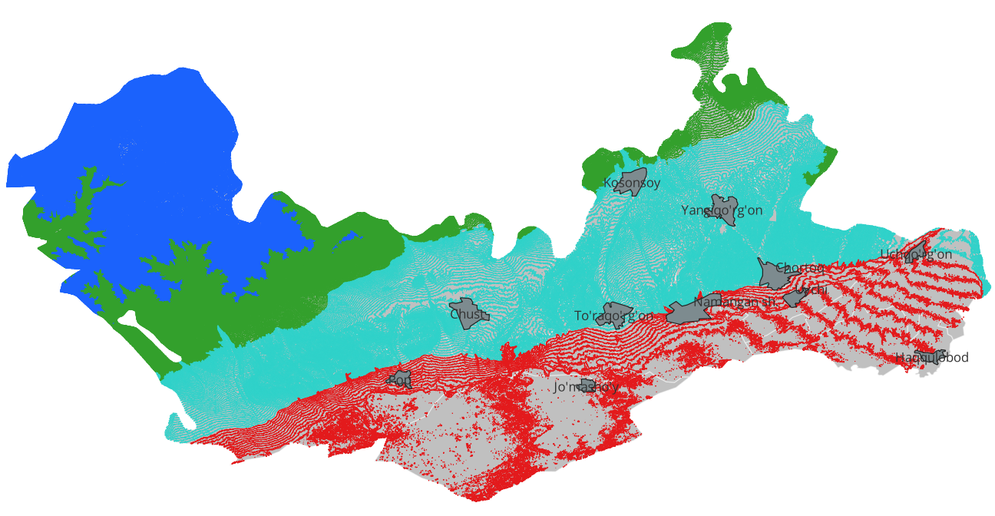  - Contours | 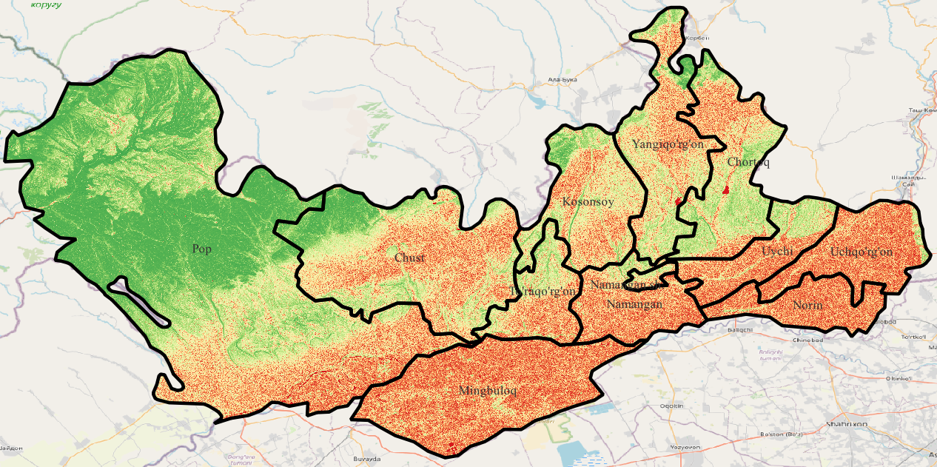  - Slope
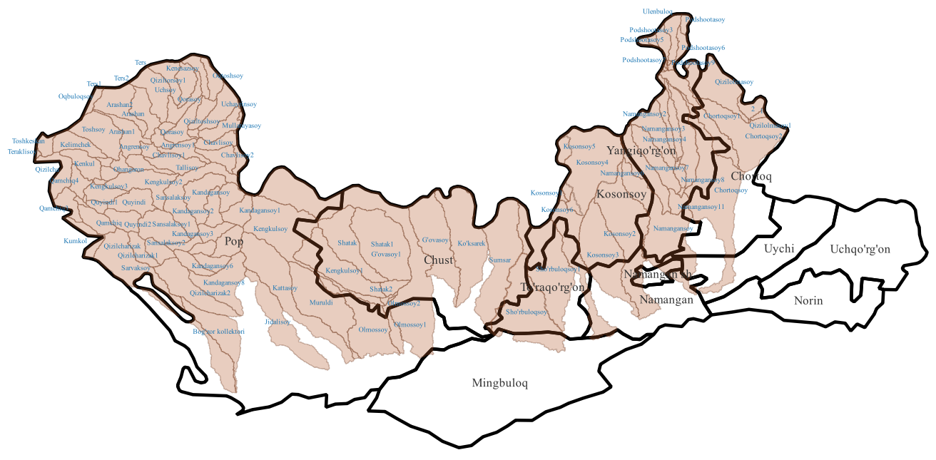  - Watershed areas | 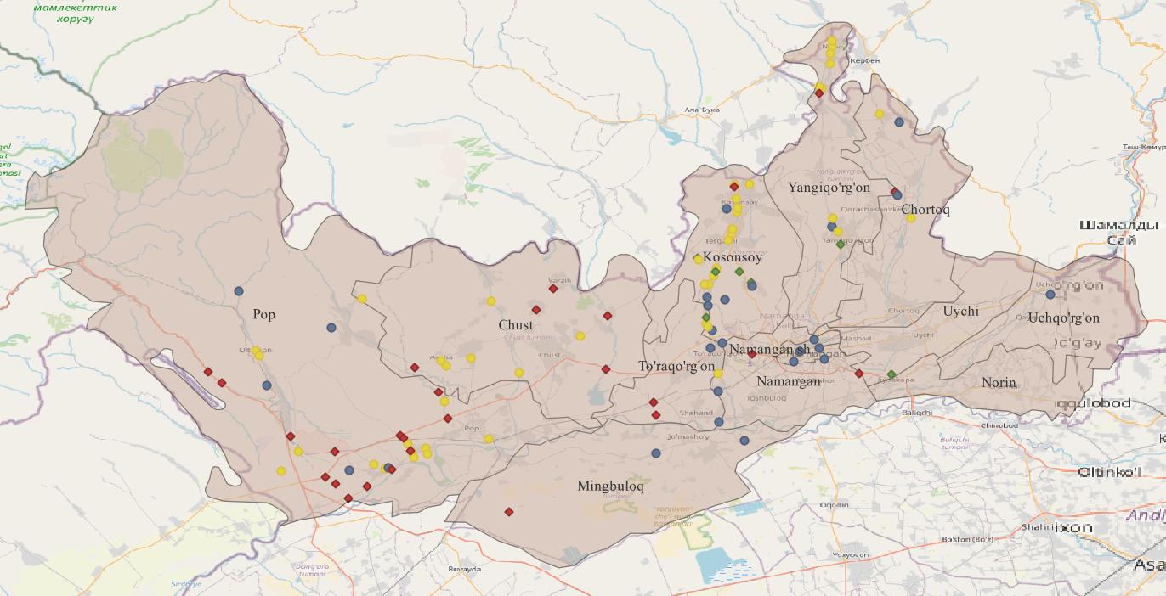  - Observed mudflow areas in 2017-2023

FIGURE 1. Data processing resalts. a) contours, b) slope, c) watershed areas, d) observed mudflow areas.

Using the QGIS-2.28.3 program, based on a layered map of the factors influencing mudflow formation and archival data of Uzhydromet, a map of the location of mudflows observed in the region in 2017-2023 was developed, and using the method of component analysis, a zoning map of the mudflow hazard of the Namangan region was developed.
Due to the increase in the vertical relief of the Namangan region, the amount of precipitation in the highlands will also increase. We can see that the amount of precipitation recorded in 2017-2023 in the Namangan region, shown in Figure 2, is clearly higher at the Kamchik observation station located on the Kamchik pass than at other observation stations of the region in Pap and Namangan.

FIGURE 2. Amount of precipitation observed in Namangan region in 2017-2023 (in months, mm)
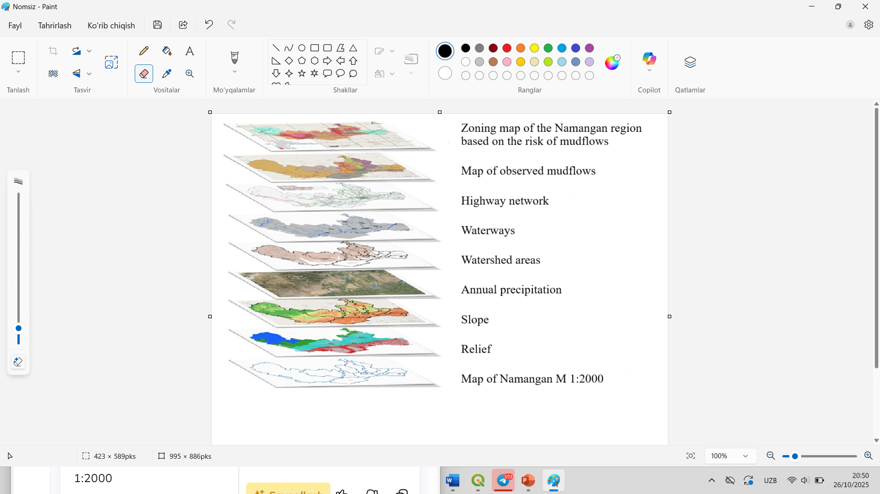

FIGURE 3. Map of mudflow hazard zoning of the Namangan region using the method of component analysis(superimposition)
RESEARCH RESULTS
Topographic and geomorphological factors are factors influencing the occurrence of mudflows and their impact on roads and other civilian facilities. It is necessary to take into account the geographical location of the regionalized territory, its relief and slope, mudflow basins, their area and slope, and the stability and infiltration properties of the soil and the amount of water lost in them. The topographic and geomorphological features of the area where mudflows may occur provide dynamic energy for mudflows, i.e., the speed of the mudflow, the type of solid phase in its composition, and the proportion of its composition.
As a result of studying and analyzing the above-mentioned geomorphological and hydrometeorological features of the Namangan region, maps were developed using the QGIS 2.28.3 program, and a zoning map of the Namangan region for mudflow hazard was developed using the method of component analysis for the effective design and operation of roads and artificial structures for the impact of mudflows on highways.

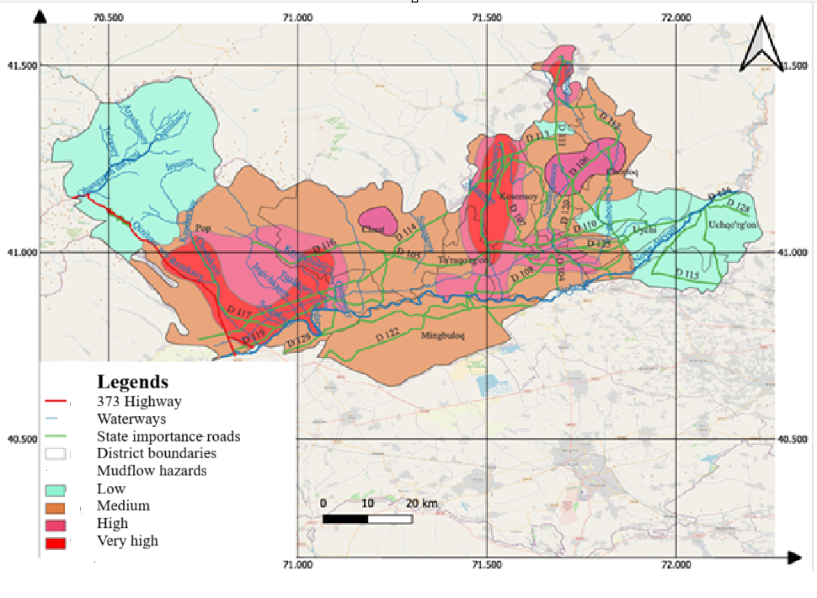
FIGURE 4. Zoning map of the Namangan region based on the risk of mudflows

Figure is divided into four groups according to the danger of the impact of mudflows on highways;
1) low-risk areas - areas where the probability of mudflows occurring is rare, where mudflows do not pose a threat to transport communications, traffic intensity, and human life and health;
2) hazardous areas - areas where mudflows can pose a threat to the operational indicators of transport communications, as well as to human life and health;
3) medium-risk - areas where there is a possibility of mudflows and which can cause serious damage to the operational indicators of transport communications, as well as areas where there is a threat to human life and health;
4) high-risk - areas with a high probability of frequent mudflows and serious damage to transport communications, as well as a high risk to human life and health.

FIGURE 5. Distribution of motorways in areas zoned Namangan region by mudflow hazard

In the histogram of the distribution of roads by the territory of the region by the danger of mudflows, the largest share of roads passing through the territory of the region is located in mudflow-prone areas. There is a high probability that destructive damage from mudflows will be expected on the highways located in the region in the next 10-20 years. Considering that this causes significant economic and social problems, it is recommended to implement measures to protect highways and artificial structures from the effects of mudflows using the zoning map of the Namangan region for the risk of mudflows.
CONCLUSIONS
In this study, the 12.5 m resolution DEM data were used in the QGIS-2.28.3 to identify the regional debris flow susceptibility. The results were first validated using the actual disaster point data combined with remote sensing images, and then the regional disaster risk was further evaluated. The main conclusions reached are follows:
The formation of mudflows and their orographic features were determined. At the same time, it was established that 60% of the region's territory is up to 1000 m above sea level, 18% up to 2000 m, and 22% above 2000 m;
It was established that the amount of precipitation observed in the northwestern regions of the region is 1.5-3 times higher than in other regions;
From the northern regions of the large and high-water flood basins of the region, the confluence of the Syr Darya River into the south was observed;
It was established that destructive mudflows are observed in the southwestern part of the region and in the Kasansay mudflow basin;
It was established that in terms of the scale of damage and the level of danger of mudflows to transport communications, they are most often observed in the Pap district;
During the study, areas with a high impact of mudflows on highways in the Namangan region were identified;
A regionalization map of the Namangan region has been developed according to the degree of danger of mudflows to highways. The distribution of the road network by districts has been determined.

REFERENCES
- R. Hudaykulov, D. Makhmudova, D. Kayumov and O. Zafarov Filter leaching of salt soils of automobile roads, E3S Web of Conferences 264, 02032 (2021) https://doi.org/10.1051/e3sconf/202126402032
- A. Kayumov, B. Salimova, R. Khakimova and A. Kayumov Strengthening the roadbed of highways using soil stabilizers, E3S Web of Conferences 264, 02012 (2021) https://doi.org/10.1051/e3sconf/202126402012
- B. Salimova, A. Tulyaganov, R. Khakimova and P. Muslimova Methods of determination of morphological indicators in hydrological calculations in the design of roads and road structures, E3S Web of Conferences 264, 02014 (2021) https://doi.org/10.1051/e3sconf/202126402014
- A. Kayumov, R. Hudaykulov, B. Salimova, A. Kayumov Influence of saline soils on smoothness of road surfaces, AIP Conf. Proc. 2432, 030020 (2022) https://doi.org/10.1063/5.0090257
- B.D. Salimova, R.M. Hudaykulov, D.A. Mahmudova, Kh.D. Abdullaev and X.X. Xayitov Methods of stabilization of mountain slopes near highways against landslides, E3S Web of Conferences 525, 01004 (2024) https://doi.org/10.1051/e3sconf/202452501004
- R. Hudaykulov, B. Salimova, D. Aralov, A. Kurbanbaev, and N. Osmonkanov, Review of chemical methods for road pavement stabilization: prospects for application in Uzbekistan, Vibroengineering Procedia, Vol. 58, pp. 340–346, May 2025, https://doi.org/10.21595/vp.2025.24997
- R. Hudaykulov, B. Salimova, D. Maxmudova, D. Aralov Effect of modifier on reinforced soil of subgrade, AIP Conf. Proc. 3256, 030002 (2025) https://doi.org/10.1063/5.0266800
- S. Djabbarov, Kh. Abdullaev, R. Hudaykulov, M. Muhammadjonov Modeling of sand transport through vertical protective barriers protecting roads from moving sands, AIP Conf. Proc. 3256, 030020 (2025) https://doi.org/10.1063/5.0266807
- A. Kayumov, R. Hudaykulov, D. Kayumov Methods for preserving soil moisture when constructing the Earth weave, AIP Conf. Proc. 2612, 040010 (2023) https://doi.org/10.1063/5.0113376

