Development of a pole-changing winding for three-speed motors
Dauletbek Rismukhamedov¹, Furkat Tuychiev¹, Khusniddin Shamsutdinov^{1,a)}, Akhror Eshtemirov², Hayotullo Magdiev ²
¹ Tashkent state technical university named after Islam Karimov, Tashkent, Uzbekistan
² Shakhrisabz State Pedagogical Institute, Shakhrisabz, Uzbekistan
^{a)} Corresponding author: shamsutdinovh83@gmail.com
Abstract. This article discusses the development of a pole-changing winding for multi-speed motors used in ventilation systems. Also, using the discrete spatial function method, it was analyzed that the induction ratio and the winding coefficient can be increased compared to the existing three-speed motor by developing a pole-changing winding with high electromagnetic properties with a pole ratio of 4:2 based on the basic "additional branch Y/YY" scheme.
INTRODUCTION
In the current "Y/YY" and "Δ/YY" basic circuits with pole changing windings, the ratio of magnetic inductions in the air gap (B2/B1) is significantly different from 1, which does not allow the full use of the active part of the electric motor. For example, elevators and lifting transport mechanisms use pulleys with a large pole ratio (1/4, 1/5, 1/6, etc.). To improve the air-gap magnetic induction matching of these motors, the “extra-branch Y/YY” basic winding scheme is used, and the extra branches are placed on the large pole side, i.e. on the 2p₁ pole side [1, 2]. It is known that the power consumed by the electric drive of a fan varies cubically with the number of revolutions. Therefore, it is advisable to fully utilize the active part of the electric motor, especially the small pole. In these electric motors, it is advisable to introduce additional windings on the side of the small pole in order to equalize the magnetic induction distribution in the air gap and to increase the coercive force on the minor pole side. As a result, the ratio of magnetic inductions in the air gap (B₂/B₁) changes significantly and approaches unity, leading to a 20–30% increase in the output power corresponding to the small pole [3, 4]. We consider the development process of an electric motor of the rotating part of axial fans of the VO-06-300 type with a stator number of 36 slots. For this electric motor, the pole ratio 2p₁/2p₂=8/4 (rotational speed 1500/750 rpm) and the existing one with a variable number of poles 2p₁=6 (rotational speed 1000 rpm) are used.

EXPERIMENTAL RESEARCH
Building a pole-changing winding. Pole-changing winding schemes that are close to traditional circuits in terms of electromagnetic and technological properties can be obtained using the Discrete Specified Spatial Functions (DSSF) method [1, 5]. It differs from other methods in that the direction of the currents in some coils is reversed on one pole side [6]. This method is based on a new principle, and two simple double-layered surface-mounted coils with the number of pairs of poles p₁. and p₂, and the phases m₁. and m₂ are taken and used in the design of a two-speed coil at the same time. In this case, the winding connection scheme is not taken ready-made, but is formed during its construction process or is selected from previously known basic schemes, taking into account the distribution of phase currents along the motor's phases for each pole and the combination of the winding phases that are compatible with each other [6, 7].
The discrete elements of a conventional winding are the basic state of the electrical conductors in the stator slots of an electric motor and are divided into phases and supplied with a single conditional electrical conductor designated the same as this phase. For example, if the 2p₁ pole winding (a, b and c) is a conditional conductor of positive unit current in the stator slots belonging to phases A, B and C, respectively, then the 2p₂ pole winding (-d, -e and -f) is a conditional conductor of negative unit current belonging to phases D, E and F [8].
A switch with a variable number of poles is built not on simple circuits, but on special basic schemes (BS), which have several group outputs and are connected to the source in a certain sequence (Figure 1).

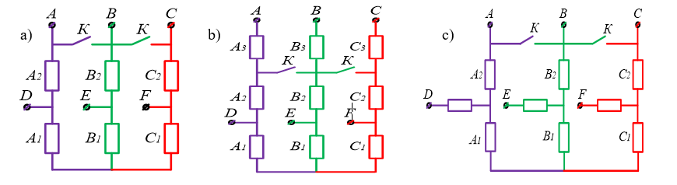
FIGURE 1. Basic schemes of a pole-changing winding: a) Y/YY; b) and c) Y/YY with additional branch.

After determining the required number of standard slots and the ratio of poles, the basic scheme is adopted and the construction of the PChW is carried out in the following order [9]:
1. The first row contains the DSSF of the first layer of the m-zone or 2m-zone circuit (initial circuit) corresponding to the large pole, that is, the ratio of the poles;
2. The second line is written as the DSSF of the first layer of the 2m-zoned grid (base grid) corresponding to the small pole, that is, the ratio of the poles;
3. If there are additional branches, their number is determined and the corresponding wedges in the third row are written with a zero value;
4. The position of the phase conductors of the first and second rows is compared, and the conductors corresponding to the minor pole of the modulated coil of the third row are written to the corresponding wedges.
Winding coupling. Therefore, the procedure for constructing the 2p₁ pole part of a pole-changing winding is to sequentially consider the current states in each wedge, based on the rules given above, and write down the DSSF of the synthesized circuit (Table 1).

TABLE 1. Synthesis of a 2p1=8-pole winding
1 | 2 | 3 | 4 | 5 | 6 | 7 | 8 | 9 | 10 | 11 | 12 | 13 | 14 | 15 | 16 | 17 | 18 | 19 | 20 | 21 | 22 | 23 | 24 | 25 | 26 | 27 | 28 | 29 | 30 | 31 | 32 | 33 | 34 | 35 | 36 | Slot
x | a | a | x | b | b | x | c | c | x | a | a | x | b | b | x | c | c | x | a | a | x | b | b | x | c | c | x | a | a | x | b | b | x | c | c | p1=4
d | d | d | -e | -e | -e | f | f | f | -d | -d | -d | e | e | e | -f | -f | -f | d | d | d | -e | -e | -e | f | f | f | -d | -d | -d | e | e | e | -f | -f | -f | p2=2
x | a | a | x | b | b | x | c | c | x | a | a | x | b | b | x | c | c | x | a | a | x | b | b | x | c | c | x | a | a | x | b | b | x | c | c | p1=4

The above synthesised winding is adapted to the basic scheme of the “extra branch Y/YY” winding [9] and the removed windings with the extra branch are replaced with (x). After that, the synthesized winding and the low pole side windings are combined (Table 2).

TABLE 2. DSSF of the lower layers, taking into account the exit of the windings to additional branches
1 | 2 | 3 | 4 | 5 | 6 | 7 | 8 | 9 | 10 | 11 | 12 | 13 | 14 | 15 | 16 | 17 | 18 | 19 | 20 | 21 | 22 | 23 | 24 | 25 | 26 | 27 | 28 | 29 | 30 | 31 | 32 | 33 | 34 | 35 | 36 | Slot
x | a | a | x | b | b | x | c | c | x | a | a | x | b | b | x | c | c | x | a | a | x | b | b | x | c | c | x | a | a | x | b | b | x | c | c | p1=4
d | d | d | -e | -e | -e | f | f | f | -d | -d | -d | e | e | e | -f | -f | -f | d | d | d | -e | -e | -e | f | f | f | -d | -d | -d | e | e | e | -f | -f | -f | p2=2

It is worth noting that by correctly choosing the step at the 2p₁=8 pole side, that is, at the main speed, it is possible to achieve very successful mutual matching of the layers and a shape close to a sinusoid of the magnetizing force lines. This Table 3 shows the DSSF of the upper and lower layers at a step of y=5 for a variable number of poles 2p₁=8 poles [9, 10, 11].

TABLE 3. DSSF for 2p₁=8 pole side
1 | 2 | 3 | 4 | 5 | 6 | 7 | 8 | 9 | 10 | 11 | 12 | 13 | 14 | 15 | 16 | 17 | 18 | 19 | 20 | 21 | 22 | 23 | 24 | 25 | 26 | 27 | 28 | 29 | 30 | 31 | 32 | 33 | 34 | 35 | 36 | Slot
x | a | a | x | b | b | x | c | c | x | a | a | x | b | b | x | c | c | x | a | a | x | b | b | x | c | c | x | a | a | x | b | b | x | c | c | p1=4
-b | -b | x | -c | -c | x | -a | -a | x | -b | -b | x | -c | -c | x | -a | -a | x | -b | -b | x | -c | -c | x | -a | -a | x | -b | -b | x | -c | -c | x | -a | -a | x | p2=2

This Table 4 shows the upper and lower layer DSSF for a pole-changing winding 2p₂=4 pole side with a pole pitch of y=5.

TABLE 4. DSSF for 2p₂=4 pole side
1 | 2 | 3 | 4 | 5 | 6 | 7 | 8 | 9 | 10 | 11 | 12 | 13 | 14 | 15 | 16 | 17 | 18 | 19 | 20 | 21 | 22 | 23 | 24 | 25 | 26 | 27 | 28 | 29 | 30 | 31 | 32 | 33 | 34 | 35 | 36 | Slot
d | d | d | -e | -e | -e | f | f | f | -d | -d | -d | e | e | e | -f | -f | -f | d | d | d | -e | -e | -e | f | f | f | -d | -d | -d | e | e | e | -f | -f | -f | p1=4
-e | -e | f | f | f | -d | -d | -d | x | -b | -b | x | -c | -c | x | -a | -a | x | -b | -b | x | -c | -c | x | -a | -a | x | -b | -b | x | -c | -c | x | -a | -a | x | p2=2

Using the phase combination table (Table 5) according to the obtained DSSF, it is possible to obtain a distribution table of windings along the branch and draw up a connection diagram for a pole-changing winding. A1, A2, A3 for the first phase, B1, B2, B3 for the second phase, C1, C2, C3 for the third phase. Table 2.8 shows the distribution of windings with a pole-changing windings along the branches of the switching circuit [12].

TABLE 5. Winding branches in the "Y/YY" scheme with additional branches
Neme of branch | Nomer of coil | Neme of branch | Nomer of coil | Neme of branch | Nomer of coil
А1 | 11, 12, 29, 30 | B1 | 5, 6, 23, 24 | C1 | 17, 18, 35, 36
А2 | 1, -10, 19, -28 | B2 | 13, -4, 31, -22 | C2 | 7, -16, 25, -34
А3 | 2, 3, 20, 21 | B3 | 14, 15, 32, 33 | C3 | 8, 9, 26, 27

Figure 2 shows an expanded electrical diagram of a three-phase pole-changing winding with a pole ratio of 8/4, in which the coil coils are grouped in an "additional branch star - double star" scheme. In this case, in part A1, the coils numbered 11-, 12-, 29-, 30- are connected in series, part A2 is divided into two, and in part A2.1, the coils numbered 1-, 10-, and in part A2.2, the coils numbered 19-, 28- are connected in parallel to each other, in part A3, the coils numbered 2-, 3-, 20-, 21- are connected in series, in part B1, the coils numbered 5-, 6-, 23-, 24- are connected in series, in part B2 is divided into two, and in part B2.1, the coils numbered 13-, 4-, and in part B2.2, the coils numbered 31-, 22- are connected in parallel to each other, in part B3, the coils numbered 14-, 15-, 32-, 33- are connected in parallel to each other. connected in series, in part C1, the coils numbered 17-, 18-, 35-, 36-, are connected in series, respectively, part C2 is divided into two parts: part C2.1, the coils numbered 7-, 16-, and part C2.2, the coils numbered 25-, 34-, are connected in parallel to each other, in part C3, the coils numbered 8-, 9-, 26- 27-, are connected in series, respectively [9, 13, 14].
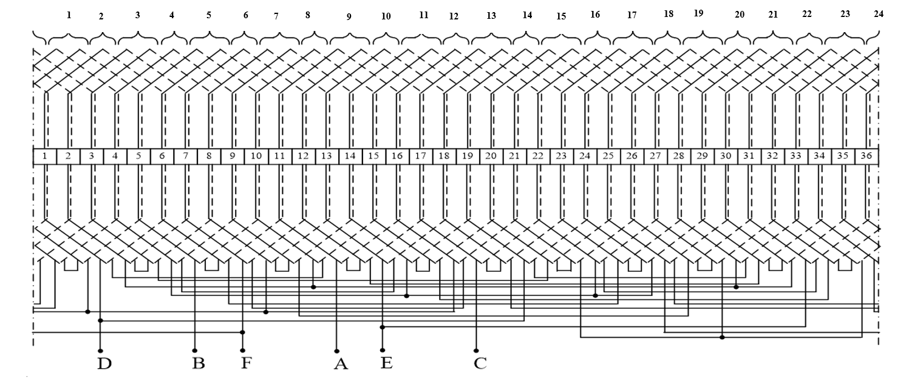
FIGURE 2. Extended electrical diagram of a PCHW with a pole ratio of 8/4

When a three-phase power supply is connected to the outputs A, B, C (in this case, outputs D, E, F are open, and the contactor contacts are disconnected), an eight-pole rotating magnetic wave is generated in the air gap. In the circuit, 24 coils are connected, the EMF vectors of each phase are equal in amplitude and rotated by 120° in phase, that is, they are completely symmetrical with respect to the power supply for the 2p₂=8 pole side of the coil [15, 16].
Here, a proposed and extended electrical circuit based on the additional branched “Y/YY” BS with a stator slot number of 36, a pair pole ratio of 8/4 and a winding pitch of y=5 is presented. Output “A” is taken from the beginning of the 11th coil, output “B” is taken from the beginning of the 5th coil, output “C” is taken from the beginning of the 17th coil [9, 17, 18] and output “D” is taken from the connection point of the end of the 19th coil and the beginning of the 1st coil. The "E" output is removed from the connection point of the end of the 13th coil and the beginning of the 31st coil, and the "F" output is removed from the connection point of the end of the 7th coil and the beginning of the 25th coil. At the same time, the beginnings of the 21st-33rd-27th coils are connected to one common point [17]. To form a double star circuit, the winding must be equipped with a two-pole switch with two left and two right outputs.
First, the exact or multiple matching conditions between the PCHW and the BS branch current conductors developed on the basis of the BS are met, after which the PCHW scheme is obtained by making electrical connections of the current conductors in accordance with the BS branch connections [9].
RESEARCH RESULTS
When determining the electromagnetic properties of a pole-changing winding designed for a three-speed asynchronous motor [19], the optimal winding pitch, i.e., the winding pitch y=5, is used to determine the shape of the magnetic driving force lines for the pole sides with 2p=8, 2p=6, and 2p=4 (Figure 3).

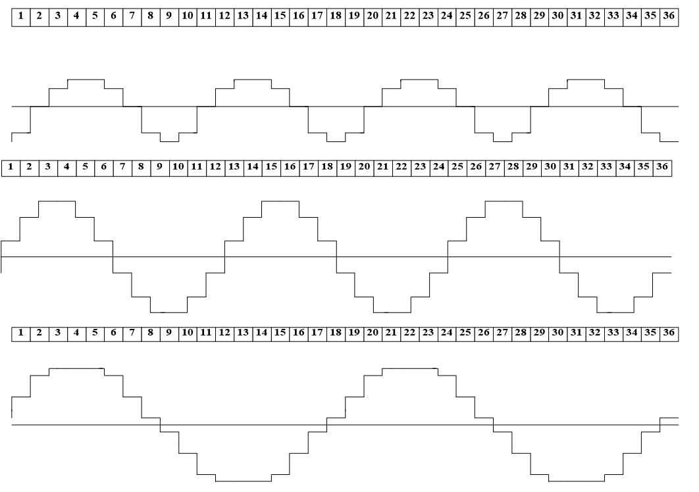
a)
b)
c)
FIGURE 3. The shape of the magnetizing lines of force when the pulley step is y=5: a) 2p=8 direction b) 2p=6 direction c) 2p=4 direction
The results of the amplitude and the coefficient of the winding developed pole-changing winding for all three pole sides are presented in the following tables 6÷8. When the winding step is y=5, the coefficient of the windingl for the pole sides with 2p=8, 2p=6 and 2p=4 is k_{w1}=0.925, k_{w2}=0.933 and k_{w3}=0.735, respectively [9].

TABLE 6. p₁=4 for the pole side (y=5)
 | "Y/YY" basic scheme branch
 | А1 | А2 | А3 | B1 | B2 | B3 | C1 | C2 | C3
А | 14.81 | 14.81 | 14.81 | 14.81 | 14.81 | 14.81 | 14.81 | 14.81 | 14.81
K_{w1} | 0.925 | 0.925 | 0.925 | 0.925 | 0.925 | 0.925 | 0.925 | 0.925 | 0.925
ϕ | 70 | 170 | 50 | 70 | 170 | 50 | 70 | 170 | 50

TABLE 7. p₂=3 for the pole side (y=5)
 | "Y/YY" basic scheme branch
 | А | B | C
А | 22.39 | 22.39 | 22.39
K_{w2} | 0.933 | 0.933 | 0.933
ϕ | 0.00 | 120 | 120

TABLE 8. p₃=2 for the pole side (y=5)
 | “Y/YY” bazaviy sxema shaxobchasi
 | D | E | F
А | 8.82 | 8.82 | 8.82
K_{w3} | 0.735 | 0,735 | 0,735
ϕ | 20 | 140 | 100

When the step of the winding is y=5, the winding coefficient for the pole sides with 2p=8, 2p=6 and 2p=4 is k_{w1}=0.925, k_{w2}=0.933 and k_{w3}=0.735, respectively. As a result, it can be said that the induction ratio of this new pole-changing winding has been improved by 19.1% compared to the closest analogue.
CONCLUSIONS
Applying this newly developed pole-changing winding to electric machines will allow for more efficient use of the machine's active part, saving winding copper, saving insulating materials, and increasing energy performance. It also allows the weight and size of a multi-speed motor to be brought closer to that of a simple single-speed asynchronous motor. Using the Discrete Specified Spatial Functions method, a new pole-changing winding of 4:2 and high electromagnetic properties was developed based on the basic "additional branch Y/YY" scheme. As a result, the induction ratio of the new pole-changing winding has been improved by 19.1% compared to the closest analogue. Also, when determining the electromagnetic properties of this winding, the optimal winding step, i.e., the winding step y=5, the winding coefficient for the polar sides 2p=8, 2p=6, and 2p=4 will be k_{w1}=0.925, k_{w2}=0.933, and k_{w3}=0.735, respectively.
REFERENCES
- D. A. Rismukhamedov, Pole-changing asynchronous motors for turbomechanisms, Ph.D. dissertation, Tashkent, 2006, 225 pp.
- Kh. G. Karimov and Yu. A. Tupoguz, “Method of constructing electrically combined windings of alternating current,” Elektrichestvo, no. 9, pp. 29–38 (1987).
- A. V. Karpenko and I. Yu. Petrova, “Models of indoor microclimate control,” Fundamental Research, no. 7-2, pp. 224–229 (2016). [Online]. Available: https://fundamental-research.ru/ru/article/view?id=40488
- M. K. Bobojanov, D. A. Rismukhamedov, F. N. Tuychiev, Kh. F. Shamsutdinov, and S. T. Ganiev, “Construction methodology and analysis of electromagnetic properties of pole-changing winding,” in AIP Conference Proceedings 2552, 050013 (2025), doi:10.1063/5.0267444.
- G. Kovacs, “A 3Y/3Y pole-changing winding of high-power asynchronous motors,” World Academy of Science, Engineering and Technology, International Journal of Electrical and Computer Engineering 12(1), 1367–1374 (2018).
- M. K. Bobojanov, D. A. Rismukhamedov, Kh. F. Shamsutdinov, S. T. Ganiev, M. B. Peysenov, and S. D. Rismukhamedov, “Development of a pole-changing winding for close pole ratio,” in AIP Conference Proceedings 2764, 020034 (2024), doi:10.1063/5.0219624.
- M. van der Giet, K. Hameyer, and S. Risse, “Induction motor with pole-changing winding for variable supply frequency,” in Proc. IEEE Int. Electric Machines & Drives Conf. (IEMDC) 2, 1484–1489 (2007), doi:10.1109/IEMDC.2007.383647.
- Kh. Shamsutdinov, “Study on improving the asynchronous electric drive of ball mills,” in E3S Web of Conferences 497, 01001 (2024), doi:10.1051/e3sconf/202449701001.
- M. Caruso, A. O. Di Tommaso, F. Marignetti, R. Miceli, and G. R. Galluzzo, “A general procedure for the construction of Gorges polygons for multi-phase windings of electrical machines,” in Proc. 13th Int. Conf. on Ecological Vehicles and Renewable Energies (EVER), pp. 1–7 (Apr. 2018), doi:10.1109/EVER.2018.8362348.
- M. K. Bobojanov, F. N. Tuychiev, D. A. Rismukhamedov, S. D. Rismukhamedov, and Kh. G. Magdiev, “Pole-changing winding with pole pair ratio 8/4,” Patent of the Republic of Uzbekistan, No. IAP 7673.
- V. N. Vanurin, Stator Windings of Asynchronous Electrical Machines, 2nd ed., revised and expanded (Lan Publishing, St. Petersburg, 2016).
- V. N. Vanurin, N. I. Bogatyriev, and O. V. Vronskii, Stator Winding Schemes, Parameters, and Characteristics of Alternating-Current Electrical Machines (Krasnodar Technical University Press, Krasnodar, 2007).
- V. N. Vanurin, Stator Windings of Multi-Speed Electric Motors: A Textbook (Lan Publishing, St. Petersburg, 2022).
- D. Rismukhamedov, Kh. Shamsutdinov, Kh. Magdiev, M. Peysenov, and O. Nurmatov, “Construction of pole-switchable windings for two-speed motors of mechanisms with a stress operating mode,” in AIP Conference Proceedings 3331, 040059 (2025), doi:10.1063/5.0305963
- E. Libbos, E. Krause, A. Banerjee, and P. T. Krein, “Winding layout considerations for variable-pole induction motors in electric vehicles,” IEEE Trans. Transp. Electrification 9(4), 5214–5225 (2023).
- K. S. Chettiar, R. Dhanushkodi, and S. Narayanan, “Electro-thermal co-design of a variable-pole toroidal induction motor,” Applied Thermal Engineering (2024), Article in press.
- D. Rismukhamedov, Kh. Shamsutdinov, Kh. Rozmetov, Sh. Khusanov, and S. Rismukhamedov, “Improvement of electromagnetic properties of pole-changing windings,” in AIP Conference Proceedings 3331, 040058 (2025), doi:10.1063/5.0305959
- E. V. Goremykin, Electrical Equipment of Industry. Part 2: Industrial Electric Drive. A Textbook (Taganrog State Radio Engineering University Press, Taganrog, 2005), 288 pp.
- N. F. Kotelenets, N. A. Akimov, and M. V. Antonov, Testing, Operation, and Maintenance of Electrical Machines (Academy Publishing, Moscow, 2003), 384 pp.

