Intelligent Methods for Measuring and Regulating Gas Flow to Improve the Energy Efficiency of Industrial Furnaces
Yusuf Avazov¹, Shodiev Marufjon¹, Elyor Samadov¹, Elbek Ortikov^{1,a)}, Kamola Abdullaeva¹, Dilmurod Egamberganov²
¹Tashkent state technical university named after Islam Karimov, Tashkent, Uzbekistan
²Urgench State University named after Abu Rayhan Biruni, Urgench, Uzbekistan
^{a)} Corresponding author: ortiqovelbek2018@gmail.com
Abstract. This article examines modern approaches to improving the efficiency of industrial gas furnaces by enhancing natural gas flow measurement and control systems. It is shown that a significant portion of energy losses and temperature regime instability in thermal engineering units are caused by insufficient flow meter accuracy, as well as delayed fuel supply regulation. A comprehensive modernization methodology is proposed, including the application of intelligent signal processing algorithms, digital calibration methods, adaptive control, and mathematical modeling of gas-dynamic processes. The article considers gas-dynamic models, simplified Navier-Stokes equations, PID control with frequency analysis, the use of Kalman filters, soft-sensor models, and neural networks for flow prediction and deviation diagnostics. This designed system seeks to enhance measurement precision, lessen combustion inconsistencies, optimize fuel usage, and lower the output of both nitrogen oxides (NOx) and carbon monoxide (CO). The conducted analysis demonstrates that implementing intelligent gas flow control systems can increase the energy efficiency of industrial furnaces by 8-18%, depending on the type of equipment and its operating conditions.
INTRODUCTION
Modern industry is under strict requirements for energy efficiency, resource conservation, and environmental safety. One of the most energy-intensive technological facilities is gas furnaces, which are widely used in metallurgy, mechanical engineering, construction materials, chemical, and food industries. The efficiency of their operation directly depends on the accuracy of measurement, regulation, and distribution of natural gas consumption, which serves as the main energy source.
Although automation has advanced considerably, many furnaces remain reliant on control systems considered ethically obsolete due to their lack of precision and dependability. This leads to fuel overconsumption, uneven temperature fields, deterioration of product quality, and increased carbon dioxide emissions. According to experts’ estimates, from 5 to 15% of gas in technological processes is consumed inefficiently precisely due to imperfect measurement and regulation systems [1,2].
Increasing the accuracy of gas flow measurement and improving control systems are becoming key factors in energy saving. The accuracy of measurements depends not only on the stability of combustion and the efficiency of the furnace, but also on the safety of the technological process. Even the slightest deviation in fuel consumption can lead to overheating, uneven temperature distribution across the furnace zones, or, conversely, insufficient heating, which negatively affects the final product quality.
Modern trends in the development of energy and technological equipment are aimed at integrating intelligent monitoring and automatic control systems. In this regard, the development and implementation of improved gas flow measurement systems with diagnostic, self-control, and adaptive regulation functions is one of the most important directions in the development of industrial technologies. These devices provide higher accuracy, resistance to disturbances, and enable data transfer to higher-level systems for comprehensive analysis. Despite successes in the development of measurement technologies, their implementation in the real production process is accompanied by a number of problems, such as the lack of automatic calibration and self-checking mechanisms, low noise immunity under changes in gas pressure and temperature, and complexity in integration with existing control systems [3-5]. In addition, the control methods used in most industrial furnaces do not take into account the dynamic characteristics of the combustion process. Often, control is carried out according to the “deviation-reaction” principle, without considering delays and the relationship between the flow rate, temperature, and composition of the gas-air mixture. This leads to increased parameter fluctuations and reduced energy efficiency.

EXPERIMENTAL RESEARCH

Gas furnaces are the main equipment in metallurgy, chemical industry, and energy. Their effectiveness is largely determined by the stability of the combustion process, the accuracy of gas flow regulation, and the quality of the measuring circuits. In the context of Industry 4.0, the application of intelligent control and management systems, which significantly reduce energy costs and increase reliability, is of particular importance. Gas flow rate measurement is a key element in industrial furnace control systems. This work utilizes a comprehensive approach involving the combination of traditional and intelligent measurement methods. The main idea is to create a model that takes into account not only static but also dynamic changes in flow rate during fluctuations in pressure, temperature, and gas composition [6].
The classical dependence for flow rate measurement through the narrowing device is determined by the formula:
, (1)
where: Q – volumetric gas flow rate, m³/s; C – discharge coefficient; ε – expansion coefficient; A – cross-sectional area, m²; ΔP – pressure drop in the constricting device, Pa; ρ – gas density, kg/m³.
However, this formula is valid only for the established regime and does not take into account non-stationary effects. Therefore, the study uses a first-order delayed dynamic model that describes the flow rate behavior over time:
, (2)
where: K – system amplification coefficient, T – time constant, L – delay time.
This model allows for the consideration of inertia and time delays arising from changes in pressure or the position of the regulating valve. To achieve high measurement accuracy, the automatic calibration procedure is applied. Calibration is carried out based on the analysis of deviations between the measured and model flow rate. The regression method based on the minimization of the root mean square error (RMSE) is used:
. (3)
Optimization of the parameters K, T, and L is carried out using the iterative Gauss-Newton algorithm. To increase noise resistance, Kalman filtration and sliding medium are used.
In addition, a sensor self-checking procedure is being implemented. If discrepancies between flow, pressure, and temperature signals exceed the permissible threshold are detected, the system generates a diagnostic message that allows the operator to promptly identify the malfunction.
Gas flow rate regulation is carried out using a PID regulator, which ensures maintaining the required flow rate value during external disturbances. The PID-regulation algorithm is as follows:
, (4)
where: – control action (valve position), – regulation error, ,, – proportional, integral, and differential coefficients, respectively.
Coefficients are adjusted using the Siegler-Nichols method, and to enhance dynamic stability, a modified auto-tuning algorithm is used. To adapt to real conditions, a temperature and pressure correction algorithm was implemented. This allows for consideration of gas density changes and maintains accuracy when external factors change.
The main feature of the proposed approach is the self-adaptation of the measurement and regulation system. When the gas characteristics change or the equipment is worn out, the system automatically reconfigures the model parameters, ensuring stability and accuracy without the operator’s involvement. In addition, an intelligent diagnostic module is provided, which assesses the state of the sensors according to the criteria of signal reliability and the likelihood of failure. When trends in sensor degradation are detected, the system offers a preventive maintenance plan that allows for the transition from reactive to predictive management [7].

RESEARCH RESULTS
During the experimental studies, an assessment of the proposed system for measuring and regulating gas flow rate in an automatically controlled industrial furnace was conducted. The purpose of the experiments was to determine the influence of measurement accuracy and regulation dynamics on the overall efficiency of the furnace and fuel consumption.
The tests were conducted in two stages: 1) Basic mode – operation of the furnace with a traditional differential flow meter and a standard PID regulator without adaptation; 2) Intelligent mode – application of the developed complex with the function of self-calibration, temperature and pressure correction, as well as adaptive regulation.
Figure 1 shows the dynamics of gas flow change in base and intelligent modes. In the first case, pronounced fluctuations of the flow rate with an amplitude up to ±8% are observed, which leads to unevenness of the heat field and overconsumption of fuel [8-9].

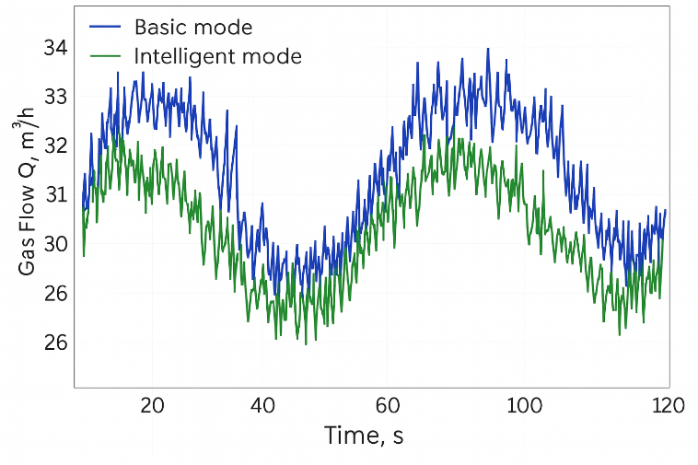
FIGURE 1. Gas flow dynamics: basic and intelligent modes

In the second case (with an intelligent system), the fluctuations are reduced to ±2%, and deviations from the given value are minimal. This phenomenon arises from a self-adjusting algorithm which dynamically modifies a recalculation factor based on fluctuating gas density and pressure levels. Table 1 shows a comparison of flow stability characteristics in two modes.

TABLE 1. Comparison of flow stability characteristics in two modes
Parameter | Basic mode | Intelligent mode | Improvement
Mean square deviation (σ), m³/h | 1,28 | 0,35 | 72 %
Average regulation error, % | 3,9 | 1,2 | 69 %
Temperature fluctuations in the burning zone, °C | ±27 | ±8 | 70 %
Specific gas flow rate, m³/t of product | 14,6 | 12,5 | 14 %

According to the table's findings, implementing the enhanced system leads to a substantial decrease in parameter fluctuations while simultaneously boosting fuel economy.
Temperature analysis showed that the stability of the heat field has a direct impact on energy efficiency. Frequent temperature jumps were observed in the base mode, which is related to the inertia of the valves and the delayed response of the regulator. In intelligent mode, the control system ensures a smooth flow change, which leads to a decrease in thermal fluctuations. The average temperature in the working zone stabilized at 1020 ± 8 °C.
Figure 2 shows the dependence of temperature on gas flow rate. A linear relationship is observed up to a certain limit (Q = 35 m³/h), after which an increase in the flow rate does not lead to a significant increase in temperature, indicating that saturation is achieved by thermal efficiency.

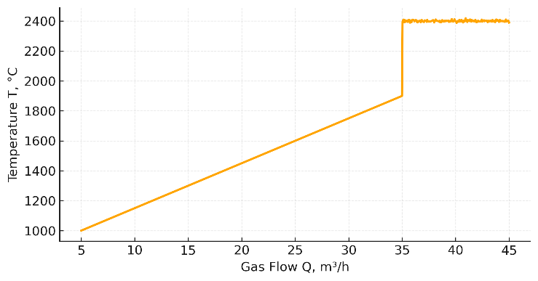
FIGURE 2. Influence of fuel flow rate on combustion zone heat

Assessing the system’s performance hinges primarily on its fuel efficiency, measured by both specific fuel consumption and furnace efficiency. The following relationships were used to evaluate:
(5)
where: – the amount of heat transferred to the processed material, – the thermal energy of the burned gas.
Calculations showed that when using the base system, the efficiency was 78.3%, and when implementing the intelligent system, it was 86.7%. Thus, the increase in efficiency was 8.4 percentage points, which is equivalent to a 12-15% reduction in gas consumption with the same production volume.
Figure 3 shows a comparison of energy efficiency under various loads. At low gas consumption, the differences are insignificant, however, at high power, the effect of intelligent control becomes particularly noticeable. To analyze the accuracy of flow measurement, the following indicators were calculated: average absolute error – 0.18 m³/h; average squared error – 0.27 m³/h; determination coefficient – 0.987; FIT indicator – 96.1%.
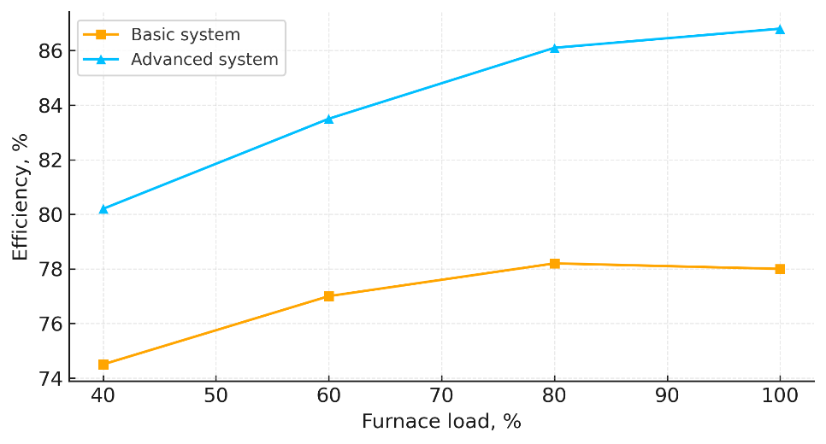
FIGURE 3. Energy efficiency of the furnace under different loads

Thus, the proposed system demonstrates high reliability and stability in measuring flow rate across a wide range of operating conditions. In addition, the system showed resistance to signal noise and short-term failures. Even if data loss occurred within 5 seconds, the adaptive filtering algorithm allowed for the correct restoration of readings without significantly affecting accuracy.
Optimizing gas consumption has had a positive impact on flame stability and reduced emissions of nitrogen oxides (NOx). Analysis of the flue gases showed that the NOx concentration decreased from 135 ppm to 112 ppm, and the CO content decreased from 0.21% to 0.14%. This indicates a more precise regulation of the “fuel-air” ratio and an increase in gas combustion completeness. An additional confirmation of the effectiveness of the developed system was its stable operation under operating conditions: only three short-term deviations of pressure signals were recorded, which were automatically compensated by self-checking algorithms. The diagnostic system promptly flagged the requirement for consumption element calibration, thereby averting recurring inaccuracies and mitigating the risk of critical incidents. During 300 hours of operation, the system did not register any critical failures.
The findings align with contemporary strategies for smart gas flow management, which leverage digital twins, spectral analysis, vibration assessments, machine learning techniques, and Kalman filtering for parameter refinement [10,11]. In particular, the use of the Kalman filter allows for a more reliable assessment of the true gas flow rate under conditions of noise and pressure fluctuations, which enhances the stability of the system’s operation. The recurrent prediction and correction equations used ensure the smoothing of measurements and the detection of hidden deviations. The corresponding graph shows a comparison of actual, noise-induced, and estimated consumption values, which visually demonstrates the effectiveness of the proposed diagnostic and regulatory solution.

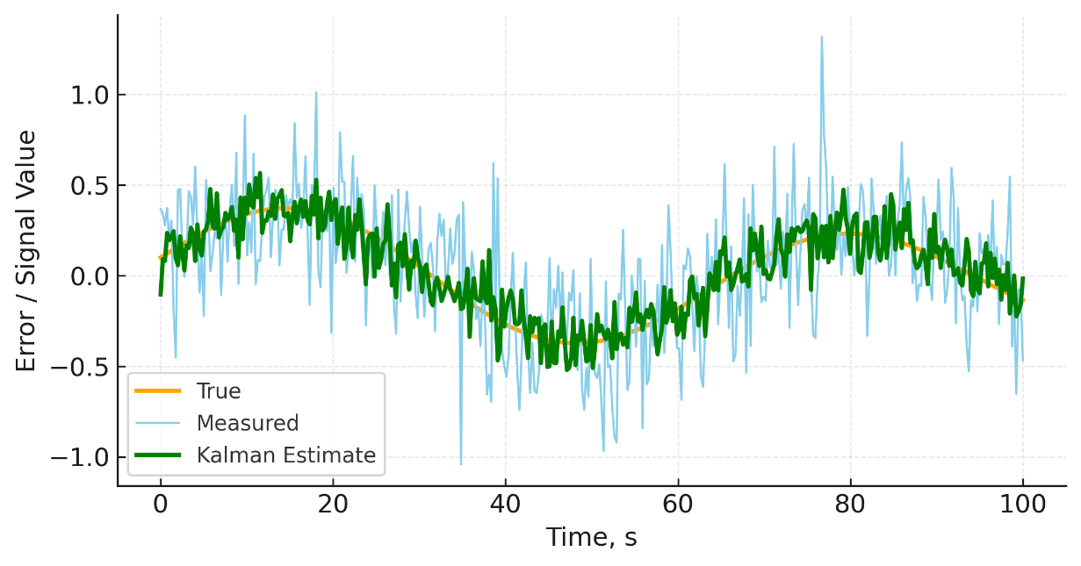
FIGURE 4. Cost estimation using the Kalman method

Thus, the developed system for measuring and regulating gas flow has proven its effectiveness and applicability in industrial conditions. It ensures optimal combustion mode, increases the stability of the technological process, and contributes to achieving energy efficiency goals.
DISCUSSION
The conducted research results showed that the application of an improved gas flow rate measurement and regulation system provides a significant increase in the efficiency of industrial furnaces. The obtained data demonstrate a steady decrease in flow deviations, temperature stabilization, and an increase in equipment efficiency. The main factor determining the effectiveness of the proposed system is its ability to adapt to changing process conditions. Unlike traditional schemes where control parameters are fixed, the new system dynamically adjusts the PID regulator’s recalculation and adjustment coefficients depending on the pressure, temperature, and fuel characteristics. This ensures the smoothness of transient processes and minimizes energy losses [12].
The high accuracy of flow measurement is of particular importance. Increasing the accuracy even by 1% gives a noticeable effect on the scale of industrial production. For example, for a furnace consuming 1000 m³ of gas per hour, a 1% error leads to an overconsumption of 10 m³ per hour, which is equivalent to more than 80000 m³ of fuel per year. Thus, the implementation of accurate and sustainable measurement systems directly affects the cost of production and the overall energy efficiency of the enterprise.
In classical control systems, the combustion process is maintained using simple proportional regulators focused on static characteristics. Such systems are unable to account for dynamic effects, delays, and relationships between parameters. As a result, management becomes “reactive”, not “predictive” : the regulator reacts to already occurring changes instead of anticipating them.
The study shows that using a combined approach based on dynamic modeling and self-correction significantly reduces delays and increases the accuracy of the system’s response. This increases resistance to accidental disturbances characteristic of industrial conditions, such as changes in pressure in the pipeline, fluctuations in air temperature, and variations in fuel composition.
Increasing the efficiency of industrial furnaces is directly reflected in the overall energy performance of the enterprise. According to calculations, the implementation of the proposed system allows for a 12-15% reduction in natural gas consumption without changing the technological operating mode. Over time, this strategy yields not just financial gains, but also enhances the company’s ability to compete by reducing its carbon impact and boosting its environmentally friendly production practices.

Despite the achieved results, there is potential for further development of the proposed system [13,14]. In particular, the following are promising areas: implementation of machine learning elements for gas consumption forecasting and adaptation of regulator parameters depending on the history of the data; development of multi-level control systems that combine local and centralized controllers; integration with the enterprise’s energy management systems to comprehensively optimize fuel and electricity consumption; using the Internet of Things (IoT) for remote monitoring and analysis of equipment operation.

These directions correspond to modern trends in the digitalization of industry and can serve as a basis for further applied research.
CONCLUSIONS
Research conducted on improving gas flow rate measurement and regulation systems in industrial furnaces has shown that intelligent methods of analysis, diagnostics, and automatic control allow for significant improvements in the efficiency, accuracy, and reliability of technological processes. The developed system combines measurement, self-control, calibration, regulation, and diagnostics functions into a single complex, which corresponds to the modern principles of digital production and the Industry 4.0 concept.
Summarizing, we can conclude that the proposed gas flow measurement and regulation system represents an effective and technologically advanced solution for increasing the energy efficiency of industrial furnaces. It combines implementation simplicity, high accuracy, and adaptability while ensuring significant reduction in fuel consumption and harmful emissions.
The research results confirm that the integrated use of intelligent control, automatic diagnostics, and self-correction algorithms allows for a qualitatively new level of heat treatment systems. The developed system can become the basis for the widespread introduction of intelligent measurement and regulation technologies in industry and serve as an important step towards building sustainable, energy-efficient, and environmentally safe production processes.
REFERENCES
- Belyayev, L. M. Gas and Furnace Units: Theory, Calculation, and Operation. - Moscow: Teplotechizdat, 2019. - 384 p.
- Soqolov, E. Ya., Zyablov, A. V. Heat Engineering Systems of Industrial Furnaces. - St. Petersburg: Professional, 2020. - 296 p.
- Fedorov, I. N. Methods for Measuring Gas Flow in Industrial Conditions // Measuring Technology. - 2021. No4. - P. 12-19.
- ISO 5167-2:2019 Measurement of fluid flow by means of pressure differential devices inserted in circular cross-section conduits running full. International Organization for Standardization, 2019. – 60 p.
- Khurmi, R. S., Gupta, J. K. Gas Flow Measurement and Control for Industrial Furnaces // Journal of Thermal Engineering. –2020. Vol. 6(2). P. 115-128.
- Ogata, K. Modern Control Engineering. 5th ed. – New Jersey: Prentice Hall, 2019. – 992 p.
- Rao, S. S. Mechanical Vibrations and Diagnostics in Gas-Fired Furnaces // ASME Journal of Energy Resources Technology. 2021, Vol. 143. - P. 052103.
- E.E. Ortikov. Improving gas flow control systems in industrial furnaces to increase their energy efficiency // TECHSCIENCE.UZ, Topical Issues of Technical Sciences. 2025 | Volume 3 | Issue 9, ISSN (online): 3030-3702. - P. 31-36.
- E.E. Ortikov. Modern methods of self-monitoring, diagnostics, and fault tolerance in flow measurement systems // International scientific and technical journal “Chemical Technology. Control and Management”: 2025, №4 (124) pp. 50-55
- Ljung, L. System Identification: Theory for the User. 2nd ed. New York: Springer, 2020. – 612 p.
- Simon, D. Optimal State Estimation: Kalman, H Infinity, and Nonlinear Approaches. New York: Wiley, 2021. – 552 p.
- Goodfellow, I., Bengio, Y., Courville, A. Deep Learning. Cambridge: MIT Press, 2016. – 775 p.
- Zhou, Y., Han, M. Neural Network Soft-Sensor Development for Gas Flow Monitoring // IEEE Transactions on Industrial Electronics. 2022, Vol. 69(4). – P. 3458-3470.
- Lee, J., Bagheri, B., Kao, H.-A. A Cyber-Physical Systems Architecture for Industrial Furnace Optimization // Manufacturing Letters. 2020, Vol. 26. – P. 45-52.

