Methods for monitoring the radio transparency of composite materials used in the aviation industry
Bekhzod Jumamuratov Akramjonovich^{a)}, Eshmuradov Dilshod Elmuradovich, Raxmonova Gulnora Sadirovna,
Tashkent University of Information Technologies named after Muhammad al-Khwarizmi, Tashkent, Uzbekistan
^{a)} Corresponding author: bexzodjumamuratov3@gmail.com
Abstract. The use of composite materials in the aviation industry has increased significantly in recent decades. Composite materials are materials that are made up of a combi-nation of two or more structural elements, with high strength, lightness and aero-dynamic properties. They have advantages over traditional metallic materials such as light weight, corrosion resistance and good radiolucency. This article analyzes the monitoring of the radiopacity level of composite materials and their metrologi-cal support.
INTRODUCTION
Radio transparency of composite materials is an important property, since the effi-ciency of antennas and other electronic systems located inside the nose of aircraft depends on this indicator. In particular, the effect of materials used on electromag-netic signals in the nose or other parts of aircraft where antennas and various radar systems are located plays a significant role.
If the radio transparency of the material is not high enough, the signal may be ab-sorbed or reflected, which will negatively affect the operation of communication systems, navigation and radar equipment. Therefore, composite materials used in aviation equipment must meet the following requirements:
-have low electromagnetic absorption and scattering properties;
-must have high mechanical strength;
-it is important to be lightweight and aerodynamically friendly;
There are several legal provisions on metrological support for methods for monitor-ing the quality of radiopacity of the nose of an aircraft. Metrological support for methods for monitoring the quality of radiopacity includes a set of measures aimed at ensuring the accuracy, reliability and repeatability of measurement results, as well as the compliance of the methods and control tools used with the established requirements. The results of my analysis of the main aspects of metrological support show that we need to see how accurate the equipment is and what the level of meas-urement accuracy is, as follows, and check the results of the analysis.
Calibration is the process of adjusting measuring instruments to ensure that they conform to standards. Regular calibration helps maintain high measurement accu-racy [1,2].
Materials and Methods: Radio transparency measurement and evaluation uses ra-dar testing methods to determine the degree of transparency of a material to radio waves of different frequencies. This allows for control over the measurement of the permeability of radio waves through the material.
Flaw detection inspection systems help identify internal defects in composite mate-rials, such as flaws, porosity, delamination, or foreign matter, which can negatively affect radiolucency.
Operational stability monitoring During aircraft operation, it is necessary to regu-larly check that the aircraft's nose remains at the specified level of radio transpar-ency.
Modern control systems often incorporate automated data processing tools that allow not only diagnostics but also the prediction of potential material property failures based on trend analysis. Such systems are an important part of the overall aircraft maintenance and safety program.
Measuring and evaluating the radiopacity of composite aircraft components is ac-complished using various methods and instruments that assess how well a material transmits radio waves at certain frequencies. Examples of such methods include:
Transmission method: This method is the most common method for assessing radio-pacity. Its essence is to measure the intensity of radio waves before and after passing through the material. For this purpose, radio wave generators and receivers are used [3,4,5].
The measurement process consists of:
- radio waves generate a certain amount of power at a certain frequency;
- these waves are directed at a sample of composite material;
- the receiver records the strength of the wave after it passes through the material;
- radio transparency is defined as the ratio of the transmitted wave power to the initial power;
In the aviation industry, such measurements and errors are carried out in special laboratories equipped with shielded cameras to eliminate external electromagnetic interference.

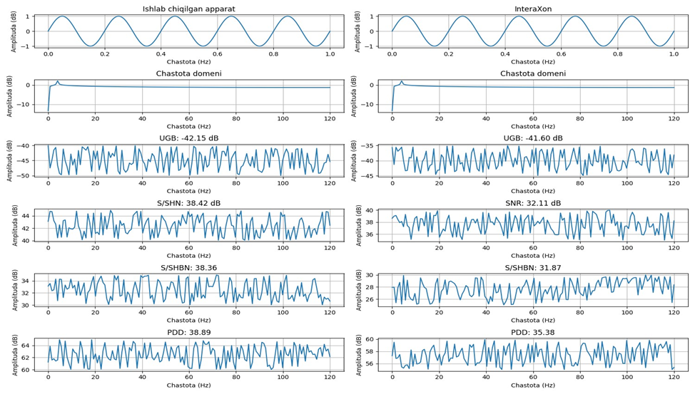
FIGURE 1. Comparison of the device signal quality for the input sinusoidal signal with a frequency of 9-12 GHz.
Signal/noise ratio (S/SHN), signal/noise and distortion ratio (S/SHBN), parasitic-free dynamic range (PDD), and total signal absorption (USY).

Sample Heading (Third Level). Transmittance (T) is defined as the ratio of the transmitted wave power (Pt) to the incident wave power (P0 ) and is found by the following formula:

$T=\frac{P_{t}}{P_{0}},$ (1)
here: P0 - the power of the electromagnetic wave before passing through the material;
Pt is the wave power after passing through the material.
Signal attenuation occurs when a wave passes through a material, some of the energy is absorbed and some is reflected from the surface. The signal attenuation can be described by an exponential law:

$P_{t}=P_{0}e^{-ad},$ (2)
here: $a$the attenuation (transparency) coefficient of the material, which depends on the wave frequency and the properties of the material;
d is the material thickness.
The attenuation coefficient $a$can be determined by the complex value of the extinction coefficient $\dot{N=n-ik}$, where n is the real part that determines the wave propagation speed and, k, the random part to which the absorption is therefore related:

$α=\frac{2πk}{λ},$ (3)
where: $λ$is the wavelength in vacuum.
Conductivity through attenuation coefficient: Substituting the expression Pt into the conductivity equation T, we obtain:

$T=e^{-αd}.$ (4)
By taking the logarithm of both sides of the equation, we can express the attenuation coefficient in terms of the transmittance:

(5)
The process of wave propagation through a material is often described in terms of the complex amplitude of the electric field. If we consider a plane wave propagating in a material, the electric field E(z) can be written as follows, depending on the z coordinate in the direction of its propagation: [6,7,8,9]

(6)
The complex wave number is here, ; $λ$0 is the wavelength in vacuum.
Expression for absolute conductivity: By including reflection at material boundaries, a more accurate expression for conductivity can be obtained:

(7)
here: n₁ and n₂ are the refractive indices of rays at boundaries (for example, when encountering obstacles in the air and in composite radiolucent materials).
Suppose it is necessary to determine the radiopacity of a material with a thickness of d=0.01m for a wave with a length of l=0.1m, and it is known that the measured transmittance is T=0.8.
We calculate the first attenuation coefficient and it is found as follows:

(8)
Based on the attenuation coefficient, it is possible to determine the losses at a given thickness of a material and evaluate its effectiveness as a radiopaque material.
Identifying defects in radiolucent materials used in the nose section of an aircraft is an important step in ensuring the safe operation of aircraft equipment. Defects in radiolucent composite materials used for these purposes include holes, delaminations, cracks, or foreign inclusions. Therefore, defects can significantly degrade the radiolucent properties of the material, which leads to a decrease in the quality of radio signal transmission and reception.
The main methods for flaw detection are ultrasonic waves generated and directed into the material. The waves travel through the material and reflect off the boundaries of layers or defects. The reflected signals are analyzed to determine the presence of defects and identify the defects.
It is used to analyze complex composite materials, even to detect small defects that may affect radiolucency.
Terahertz waves passing through a material are used to make highly sensitive sensors for structural changes, such as holes or delaminations. These waves lie in the spectral range between infrared and microwaves, allowing them to penetrate many dielectric materials [10,11,12].

EXPERIMENTAL RESEARCH
High accuracy, surface and therefore the ability to scan without direct contact.
Cracks or foreign inclusions are therefore suitable for detecting both surface-level and internal defects within the material.
Defects in the material cause signal distortion, which leads to acoustic waves (sound pulses). These pulses are recorded by sensors located on the surface of the material, allowing for real-time monitoring and detection of active defects.
The condition of the materials in the nose section of the aircraft is constantly monitored before flight.
Electromagnetic induction and stray current detection are therefore methods based on changing the electromagnetic field passing through the material. Defects change the field distribution detected by the sensors [13,14], improved method based on high-precision processing of radio transparency indicators of composite materials in digital format, allowing to assess the compliance of the metrological properties of composites with current regulatory requirements through the use of algorithms for continuous digitization of measured electromagnetic parameters and statistical signal processing in order to reduce uncertainties in the propagation of radio waves when taking radio frequency measurements from multilayer and multi-directionally arranged fibrous composite materials, the method for assessing uncertainty has been improved based on the identification of the dielectric, attenuation, and dispersion properties of the material, which change over time based on the application of algorithmic control, minimizing the measurement uncertainty of instruments, a structural-regime calibration scheme has been developed for radio-measuring systems, which allows for a significant improvement in the measurement frequency indicator and an increase in the metrological stability of devices based on the criterion for assessing the uncertainty of radio transparency indicators in the process of measuring radio waves, a minimization algorithm has been developed that allows reducing the relative error of devices operating in the range of 9...12 GHz by 1.1÷1.5 times.
RESEARCH RESULTS
The properties of composite materials can be highlighted using several methods, such as time analysis and statistical and spectral analysis.
Several types of natural raw materials based on iron-titan composition were used to obtain radioprospective materials. Chemical composition of raw materials:

TABLE 1. Influence of temperature on the completeness of the composite material
Required temperature in °C for preparing material to a ready state. | Order of formal kinetic equations |  |  |  |  |  | Critical coefficient of determination
 | V=1 |  | V=2 |  | V=3 |  | Critical coefficient of determination
 | (∑S_{E}) | (R²) | (∑S_{E}) | (R²) | (∑S_{E}) | (R²) | Critical coefficient of determination
+50 | 48 890 | 0.78 | 42 896 | 0.87 | 41 258 | 0.79 | R² _{0.04}=(47:339)=0.18
+10 | 38 780 | 0.80 | 41582 | 0.84 | 39 247 | 0.71 | R² _{0.04}=(37:846)=0.04
-25 | 48 400 | 0.79 | 43 201 | 0.84 | 44 369 | 0.84 | R² _{0.04}=(42:229)=0.18
∑ (S_{E}) | 136 070 |  | 127 679 |  | 124 874

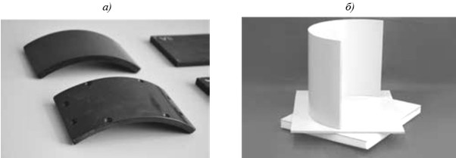
FIGURE 2. KMKS series polymer leather all (a) and polymer foam (b)
This article analyzes data on the creation of antenna aircraft nose parts made of KMKS series polymer materials and copics.

Conclusion, a composite material radiopacity measurement system includes several interconnected components: a signal generator, measurement antennas, a test sample, receiving equipment, amplifiers, analog-to-digital converters, and a central computer. Each of these elements has its own importance and requires metrological sup-port to ensure the accuracy and reliability of the measurement results.
Waveguide-based methods provide high-precision characterization at specific bands by measuring the attenuation and phase shift introduced by the sample. Time-domain reflectometry is also used to detect inhomogeneities, delamination, and regions with altered permittivity that may affect radio transparency. In addition, numerical modeling techniques such as finite-element and finite-difference time-domain simulations support experimental results by predicting electromagnetic wave propagation through layered composites.
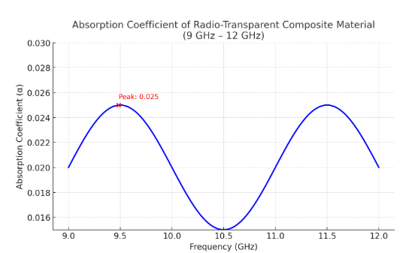
FIGURE 3. Radiolucency absorption indicator of composite material type KMKS-120.

Monitoring the radio transparency of composite materials is crucial in modern aviation, where radar-absorbing structures, dielectric radomes, and communication antennas are increasingly integrated into composite airframes. Several measurement approaches are applied to evaluate the electromagnetic performance of these materials. Free-space measurement techniques, using horn antennas and vector network analyzers, enable non-contact evaluation of transmission and reflection coefficients across wide frequency ranges. Waveguide-based methods provide high-precision characterization at specific bands by measuring the attenuation and phase shift introduced by the sample. Time-domain reflectometry is also used to detect inhomogeneities, delamination, and regions with altered permittivity that may affect radio transparency. In addition, numerical modeling techniques such as finite-element and finite-difference time-domain simulations support experimental results by predicting electromagnetic wave propagation through layered composites. These monitoring methods ensure that composite components meet the stringent requirements for communication reliability, radar performance, and electromagnetic compatibility in aviation applications.
CONCLUSIONS
Composite material radiopacity measurement system includes several interconnected components: a signal generator, measurement antennas, a test sample, receiving equipment, amplifiers, analog-to-digital converters, and a central computer. Each of these elements has its own importance and requires metrological support to ensure the accuracy and reliability of the measurement results.
The development and implementation of effective methods for controlling and monitoring the radiopacity of composite materials will allow aviation enterprises to maintain high standards of flight safety, reduce operational risks, and increase the overall reliability of aircraft. Thus, improv-ing radiopacity measurement technologies and ensuring their metrological accuracy remain im-portant tasks in the field of aviation materials science and engineering.
REFERENCES
1. B. A. Jumamuratov, A. A. Abdukayumov, and D. E. Eshmuradov, Metrological support of a means for controlling the radioscopicity of composite materials, Natl. Stand. J., no. 3, 1–5 (2024).
2. A. V. Savelyev and L. A. Savelyeva, Metrological support for composite materials used in aviation, Meas. Tech. 62(5), 475–480 (2019).
3. B. A. Jumamuratov, N. S. Amangeldiyev, and S. R. Perdebayev, Issues of diagnostics in the certification of radio equipment of aircraft, Sci. Innov. Int. J. 1(8), 86–89 (2022).
4. B. A. Jumamuratov, T. A. Aytbayev, and N. M. Rakhimova, Metrological supply of the repair and testing of the aircraft radome, Proc. Smart Cities & Sustainable Development Conf., 522–526 (2024).
5. A. Rezaei, F. Nikfar, and S. Mahzan, Terahertz imaging for non-destructive testing of composite structures, J. Compos. Mater. 52(12), 1565–1584 (2018).
6. B. A. Jumamuratov, Metrological support of repair and testing of aircraft nose parameters, Sci. Educ. Karakalpakstan, no. 2/1, 123–130 (2024).
7. B. Tribovane and R. Caldeirinha, Radio transparency control of road electromagnetic barriers for C‑V2X communications, IEEE Conf. Proc., 1–4 (2022).
8. Future of aeronautical processing: Opportunities and challenges of automation, Sci. Innov. Int. J. 2(4), 231–236 (2023).
9. B. A. Zhumamuratov, D. E. Eshmuradov, and N. M. Turaeva, Development of a model for restoring navigation equipment, Aviakosmos Instrum. J., 18–27 (2023).
10. B. A. Jumamuratov, P. M. Matyakubova, and T. A. Aytbayev, Qualimetric analysis of satellite navigation systems, Electron. J. Mod. Sci., 54–61 (2022).
11. Physical properties of semiconductor materials in engineering, Sci. Innov. Int. J. 2(10), 162–168 (2023).
12. B. A. Zhumamuratov, D. E. Eshmuradov, and A. D. Nabikhanova, Modern systems for monitoring radio transparency of composites, Sci. Innov. Spec. Issue, 438–441 (2024).
13. B. A. Jumamuratov, G. N. Sharipov, and J. A. Urolov, Metrological support for repair and testing of aircraft radome, Sci. Innov. Spec. Issue, 49–53 (2024).
14. B. A. Zhumamuratov, Signal absorption and metrological support of multilayer composites KMKS‑120, Proc. Digitech Electromech. Conf., 246–250 (2024).
15. B. A. Jumamuratov and D. E. Eshmuradov, Mathematical model for engine blade reaction to bird strike, Proc. OshTU Conf., 199–207 (2023).
16. B. A. Zhumamuratov and P. M. Matyakubova, Analysis of technical characteristics of aerospace systems, LaPlaz‑2022 Conf. Proc., 427–430 (2022).
17. B. A. Zhumamuratov, Metrological foundations for measuring radio transparency of composites, Proc. Digitech Electromech. Conf., 250–256 (2024).
18. B. A. Zhumamuratov, P. M. Matyakubova, and I. K. Gaipov, Quality and reliability management of aviation services, Proc. Digitech Conf., 414–418 (2023).
19. B. A. Jumamuratov and P. M. Matyakubova, Improvement of measurement and testing procedures in aviation industry, Youth Sci. Technol. Conf., 133–136 (2022).
20. B. A. Jumamuratov, D. E. Eshmuradov, and N. M. Turaeva, Prospects for development of aeronautical systems, Digital Tech. Implementation Conf., 1095–1100 (2023).
21. B. A. Zhumamuratov, P. M. Matyakubova, and N. P. Embergenova, Qualimetric analysis of satellite navigation characteristics, Tech. Regulation Conf., 400–406 (2022).
22. B. A. Zhumamuratov and D. E. Eshmuradov, Program for calculating radio transparency of composites, Software Certificate DGU 26270 (2023).
23. B. A. Zhumamuratov, D. E. Eshmuradov, N. M. Turaeva, and S. S. Parsiyev, Simulation program for multi‑agent monitoring of aeronautical networks, Software Certificate DGU 42345 (2024).
24. B. A. Zhumamuratov, D. E. Eshmuradov, Y. A. Borisova, and N. M. Turaeva, Program for controlling sensors of digital tracking range meter (DSID), Software Certificate DGU 32302 (2024).

