Highly Sensitive Magnetic Sensor Modules for Smart Energy Systems Based on Manganese-Doped Silicon
Olmas Sattarov ^{a)}, Giyosiddin Mavlonov, Bakhromjon Abdurakhmanov, Shahboz Ibodullaev, Tachilin Stanislav
Tashkent State Technical University named after Islam Karimov, Tashkent, Uzbekistan
^{a)} Corresponding author: sattorov_ol@mail.ru
Abstract. This paper presents the results of a comprehensive study of the magnetoelectric characteristics of single-crystal silicon doped with manganese (Si<Mn>) for the purpose of creating highly sensitive sensor modules for intelligent power supply systems. It has been established that the presence of manganese in atomic and cluster form leads to significant changes in the magnitude and sign of magnetoresistance, enabling its electrical and temperature modulation. An analysis of the influence of a constant electric field, temperature, and magnetic induction on the sensitivity and linearity of the output signal is conducted. It is shown that the optimal operating mode is a supply voltage range of approximately 9 V, which achieves maximum stability and high sensitivity without thermal degradation of the structure. Long-term tests confirm the absence of parameter degradation in the operating ranges of the magnetic field, making the material promising for use in highly dynamic energy monitoring. The limiting factor is the operating temperature range (−70…+100 °C), associated with the decomposition of manganese clusters at higher temperatures. The results of the study demonstrate the potential of Si<Mn> structures as the basis for a new generation of silicon-compatible sensor modules that have advantages over ferrite and metal analogs in terms of stability, miniaturization, and power consumption.
INTRODUCTION
The development of intelligent energy systems requires the use of new generations of highly sensitive magnetic field sensors capable of stable operation under thermal, electrical, and mechanical disturbances. Traditional ferrite and metal transducers, despite a long history of use, have a number of critical limitations. These include instability of magnetic characteristics upon heating, relaxation processes in the domain structure, corrosion degradation, and a narrow operating magnetic field range. These factors lead to reduced accuracy and limit the integration of such devices into modern power plant monitoring systems [1-3].
Again, semiconductor materials exhibiting pronounced galvanomagnetic effects are attracting increasing interest [4-6]. Manganese-doped silicon (Si<Mn>) structures occupy a special place among these, characterized by a combination of high temperature stability, chemical inertness, and pronounced magnetoresistive properties. The presence of manganese in atomic and cluster form results in unique magnetoelectric properties, opening up broad prospects for the development of compact sensor elements with electrical and optical tuning capabilities [7-11].
This work aims to investigate the physical mechanisms of magnetoresistance in Si<Mn> structures, analyze the influence of electric and magnetic fields on sensitivity, and assess the applicability of the material in creating highly stable sensors for energy systems.
The key advantages of galvanomagnetic devices, which have ensured their widespread use, are:
• the absence of electrical coupling between the input and output circuits;
• the ability to directly convert mechanical movements into an electrical signal;
• simplicity of circuit designs and high manufacturability;
• compact size and low power consumption;
• high stability of characteristics during long-term operation.
Historically, the main problem with such devices was their limited output signal. The advent of magnetodiodes and magnetotransistors, as well as improved magnetoresistors, significantly expanded the functionality of galvanomagnetic sensors, eliminating the need for intermediate amplifiers and reducing the cost of sensor systems [12-16].
Magnetic sensors are typically classified based on their operating principle, which is based on the physical or chemical properties of the materials. The key feature of magnetic sensors is their ability to detect magnetic fields contactlessly, with a high response speed and low sensitivity to environmental interference. Integrated Hall sensors, implemented on a silicon substrate, are the most widely used.
The Hall effect is the generation of a transverse voltage in a current-carrying conductor when exposed to an external magnetic field. In semiconductor structures, the magnitude of the Hall EMF is significantly higher than in metals, making them preferable for sensors of low magnetic fields. Magnetoresistive sensors using ferromagnetic films exhibit high sensitivity, but are characterized by a narrow dynamic range and temperature instability. The anisotropic magnetoresistive effect coefficient in permalloy at room temperature is only 1,5–2%, which limits their use in precision sensing [17].

EXPERIMENTAL RESEARCH
The study utilized p-type manganese-doped silicon samples with a resistivity of ρ=6.3⸱10³ Ω·cm. This group of samples was chosen due to their highest magnetoresistance sensitivity, as confirmed by preliminary tests.
To form ohmic contacts, chemical deposition of nickel from an aqueous electrolyte was used. This method ensures low contact resistance and high reproducibility of results under a variety of external influences. After contact deposition, the leads were soldered and mounted in a protective plexiglass housing, which reduces the influence of external mechanical and magnetic disturbances [18,19].
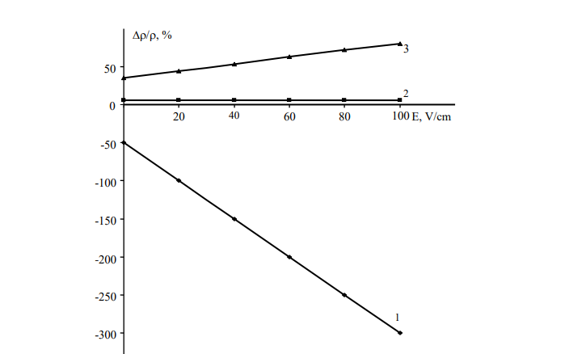

FIGURE 1. Dependence of magnetoresistance on the electric field strength in the dark at a temperature of T=235 K and a magnetic field of H=2 T, where: 1 — compensated sample; 2 — overcompensated sample;
3 — n-type sample doped with manganese.

Figure 1 shows the dependence of magnetoresistance (Δρ/ρ) on the electric field strength (E) for three types of semiconductor samples. Measurements were performed in the dark at a temperature of T=235 K and a magnetic field of H=2 T.
The graph contains three curves, each corresponding to a specific doping state of the material:
1. Compensated sample (curve 1).
As the electric field increases, the magnetoresistance decreases sharply.
The Δρ/ρ value reaches approximately –300% at E≈100 V/cm.
Such a strong negative magnetoresistance indicates the material's high sensitivity to magnetic fields.
This is due to the balance between electrons and holes: in the compensated state, even a small external influence leads to a significant change in the transport properties.
2. Overcompensated sample (curve 2).
In this case, the magnetoresistance remains virtually unchanged with increasing electric field.
The curve remains near zero.
This means that the sample is insensitive to the magnetic field under the conditions studied.
Overcompensation results in an excess of one type of charge carrier, which reduces their response to external fields.
3. N-type sample doped with manganese (curve 3)
The magnetoresistance remains virtually unchanged with increasing electric field, indicating a positive magnetoresistive effect.
This behavior is typical for materials dominated by hole carriers, which are sensitive to magnetic fields and electrical heating.
The figure demonstrates that the nature of the magnetoresistance change is determined by:
the conductivity type of the material,
the degree of impurity compensation,
the interaction of charge carriers with the magnetic and electric fields.
The compensated sample is most sensitive to the magnetic field, while the overcompensated sample shows almost no response, and n-type Mn exhibits moderate positive sensitivity.
Of particular interest was the study of the surface of manganese-doped silicon samples with a resistivity of ρ=6.3⸱10³ Ω·cm using atomic force microscopy (AFM). This method allowed for detailed visualization of local surface changes and identification of the distribution of defective regions on the material's surface. The resulting three-dimensional topographic maps provide a clear representation of microstructural features, which is key to understanding the effect of doping on the electrical and mechanical properties of silicon.

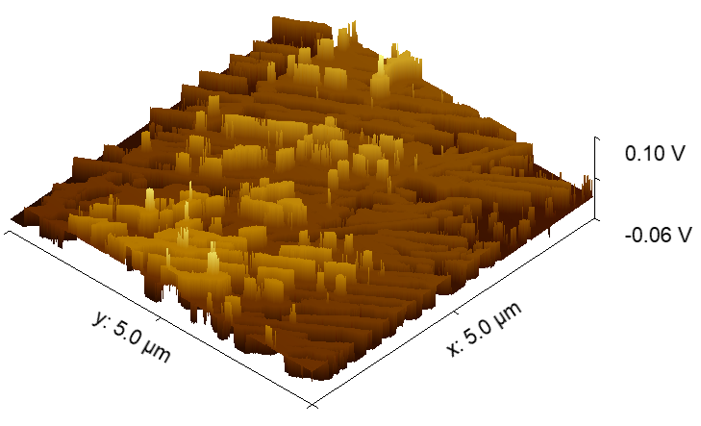
FIGURE 2. Three-dimensional topographic map of the surface of manganese-doped silicon samples with a resistivity of ρ=6.3⸱10³ Ω·cm obtained by atomic force microscopy (AFM) in a region of 5.0 × 5.0 μm².

Figure 2 shows a three-dimensional topographic map of the surface of manganese-doped silicon samples with a resistivity of ρ=6.3⸱10³ Ω·cm, obtained by atomic force microscopy (AFM) in a 5.0 x 5.0 μm² region. The vertical axis shows potential variations in the range from –0.06 to 0.10 V, allowing one to track local surface topography changes and the distribution of defective regions.
As can be seen from the image, the surface has a pronounced nanostructured morphology with alternating peaks and valleys, which is associated with manganese diffusion into the silicon crystal lattice. The formation of this topography indicates uneven penetration of manganese atoms and their tendency to cluster. The presence of nanoscale fluctuations indicates the creation of localized regions with varying electron density, which can affect the electrophysical and magnetic properties of the system. The measured potential range of –0.06 to 0.10 V allowed us to detect the smallest surface variations and precisely identify zones containing defects, providing a highly informative analysis of the sample morphology. Thus, the AFM results confirm that the surface morphological features are directly related to the mechanisms of Mn cluster formation and the subsequent manifestation of ferromagnetic properties caused by hole-mediated exchange interactions.
When recording the output of a single sensor element, the amplitude of the useful signal is significantly smaller than the voltage across the sample's intrinsic resistance. Therefore, the measurement circuit was implemented using a bridge configuration, which allowed for effective compensation of the DC component and isolation of the magnetoresistive signal. The measurement voltage was output via a high-precision digital tester, ensuring high resolution and stability under operating conditions.
RESEARCH RESULTS
Figure 3 shows the dependence of the output voltage on the magnetic field strength at different constant voltages applied to the Si<B,Mn> sample (ρ=6.3⸱10³ Ω·cm).

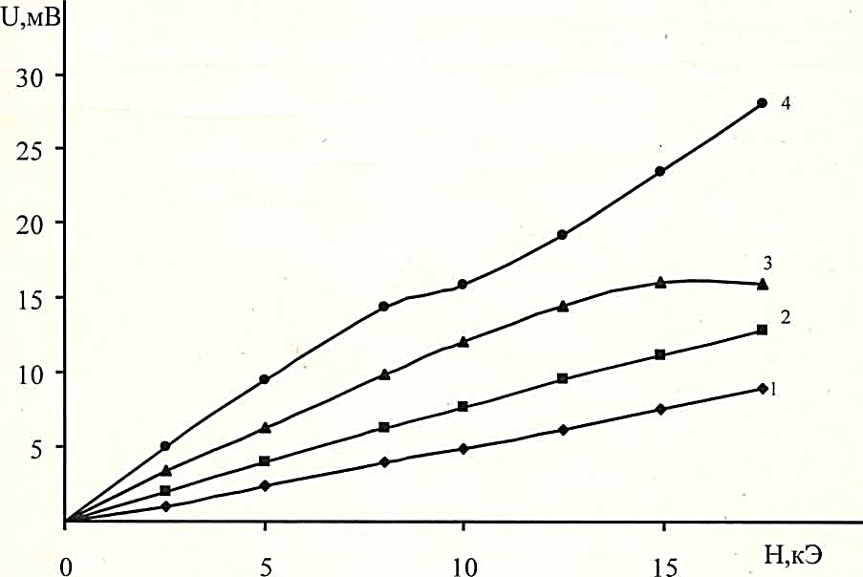

FIGURE 3. Dependence of the output voltage on the magnetic field at different constant voltage of the electric field, in a Si<B,Mn> sample with a specific resistance of ρ=6.3⸱10³ Ω·cm: 1 - 1.5 V; 2 - 3 V; 3 - 4.5 V; 4 - 9 V.

An analysis of the curves shows that increasing the supply voltage leads to increased sensitivity and improved linearity of the sensor response. The optimal value was 9 V, at which the voltage drop across the sample is approximately 4.5 V. Further increases in voltage lead to thermal overheating and instability of the parameters.
Long-term testing (2 years) demonstrated no degradation of the samples under the influence of magnetic fields in the operating ranges. The obtained characteristics were fully reproducible throughout the entire experimental period.
However, the operating temperature range of Si<Mn> structures is limited to -70 to +100 °C. As the temperature rises above 100 °C, the manganese clusters begin to disintegrate, leading to a drop in the concentration of active centers and the disappearance of negative magnetoresistance.
CONCLUSIONS
The conducted studies demonstrate that manganese-doped silicon is a promising material for creating highly sensitive magnetoresistive sensors designed for intelligent energy monitoring systems. The material combines:
• stability during long-term operation,
• high sensitivity,
• electrical control capability,
• resistance to external mechanical stress,
• compatibility with silicon-based microelectronics technology.
The results confirm the very high potential of Si<Mn> structures as a basis for developing new sensor modules that can replace traditional ferrite and metal analogs in energy and related fields.
REFERENCES
- Tumanski, S. Handbook of Magnetic Measurements. Boca Raton: CRC Press, 2011, p. 404.
- Goldman, A. Modern Ferrite Technology, 2nd ed. New York: Springer, 2006, p. 435.
- Manish Naagar, Sonia Chalia, Fayu Wan, Larissa Panina, Preeti Thakur, P.B. Sharma, Atul Thakur Investigations on temperature-dependent magnetic properties and magnetic thermal stability of magnesium ferrite (MgFe₂O₄) nanoparticles, Journal of Magnetism and Magnetic Materials, Volume 592, 15 February 2024, 171798, DOI: https://doi.org/10.1016/j.jmmm.2024.171798
- Utamuradova, Sh.B., Mavlyanov, A. Sh., Sobirova, Sh. A., Sattarov O.E., Hybrid Secondary Structure of Manganese and Sulfur in Silicon, Surface Engineering and Applied Electrochemistry, 2025, Vol.61, p. 633. DOI: 10.3103/S1068375525700681
- Saparniyazova, Z.M., Bakhadyrkhanov, M.K., Sattarov, Norkulov, N., Asanov, D.Zh. Interaction between multiply charged manganese nanoclusters and sulfur atoms in silicon. Inorganic Materials, 48(4), p. 325–328. 2012. DOI: 10.1134/S0020168512030144.
- Iliev, K.M., Saparniyazova, Z.M., Ismailov, K.A., Sattarov, O.E., Nigmonkhadzhaev, S. Interaction of radiation defects with nickel atom clusters in silicon. Surface Engineering and Applied Electrochemistry, (2011). 47(5), p. 385–387. DOI: 10.3103/S1068375511050103.
- Sattarov, O., Abdurakhmanov, B., Yakubov D., Sabirov, E., Normamatov, A., Formation of electroneutral Ni–Mn complexes in silicon and their effect on material properties. Optical and Computational Technologies for Measurements and Industrial Applications (OptiComp 2025). Vol. 13803. pp. 465-470. 2025.
- Bakhadyrkhanov, M.K., Iliev, K.M., Mavlonov, G.K., Ibodullaev, S.N., Tachilin, S.A., The Effect of Negative Magnetoresistance in Silicon to Create Multifunctional Sensors, Technical Physics Letters, 2022, 48(1), p. 1. DOI: 10.1134/S1063785022010023
- Pearton, S.J., Norton, D.P., Ivill, M., Hebard, A.F., Zavada, J.M., Thaler, G.T., Diluted magnetic semiconducting oxides, Semicond. Sci. Technol., 2004, 19(10), p.59. https://doi.org/10.1088/0268-1242/19/10/R01
- Bakhadyrkhanov, M.K., Iliev, K.M., Mavlonov, G.K., Isamov, S.B., Tachilin, S.A., Silicon with Magnetic Nanoclusters of Manganese Atoms as a New Ferromagnetic Material, Technical Physics, 2019, 64(3), p. 385. DOI: 10.1134/S1063784219030046
- Sattarov, O.E., Mavlyan, A.S., An, A. Effect of manganese atoms on the magnetic properties of silicon, Surface Engineering and Applied Electrochemistry, 2023, 59(2), p. 216. DOI: 10.3103/S106837552302014X
- Bakhadyrkhanov, M.K., Mavlonov, G.K., Isamov, S.B., Tachilin, S.A., Photoconductivity of silicon with multicharged clusters of manganese atoms [Mn]₄, Surface Engineering and Applied Electrochemistry, 2010, 46(3), p. 276. DOI: 10.3103/S1068375510030154
- Bakhadyrkhanov, M.K., Iliev, K.M., Ayupov, K.S., Sattorov, O.E., Magnetic Field Sensor Based on Compensated Silicon, Technical Physics Letters, 2003, 29(9), p. 705. DOI: 10.1134/1.1615541
- Bakhadyrkhanov, M.K., Ayupov, K.S., Iliev, K.M., Mavlonov, G.K., Tachilin, S.A., Effect of electric field, illumination, and temperature on negative magnetoresistance of low-temperature-diffusion-doped silicon, Technical Physics Letters, 2010, 36(8), p. 741. DOI: 10.1134/S1063785010080195
- Bakhadirkhanov, M.K., Mavlonov, G.H., Iliev, K.M., Tachilin, S.A., Specific features of magnetoresistance in overcompensated manganese-doped silicon, Semiconductors, 2014, 48(8), p. 986. DOI:10.1134/S106378261408003X
- Bakhadirkhanov, M.K., Iliev, K.M., Ayupov, K.S., Qurbonova, U.Kh., Mavlonov, A.Sh. Magneto-sensors on the basis of negative magnetic resistance. Conference Proceedings International Conference on Actual Problems of Electron Devices Engineering., 2004, p. 305.
- Tumanski, S. Thin Film Magnetoresistive Sensors. CRC Press, 2001, p. 576. doi: 10.1201/9781420033243
- Egamberdiev, B.E., Utamurodova, S.B., Tachilin, S.A., Saidov, D.S., Turopova, S.U. Influence of Doping with Rare Earth Elements on the Parameters of Silicon Photocells, Applied Solar Energy, 2022, 58(4), p.490. DOI: 10.3103/S0003701X22040065
- Bakhadyrkhanov, M.K., Isamov, S.B., Iliev, K.M., Tachilin, S.A., Kamalov, K.U. Silicon-based photocells of enhanced spectral sensitivity with nano-sized graded band gap structures, Applied Solar Energy, 2014, 50(2), p. 61. DOI: 10.3103/S0003701X14020054

