Dependence of vehicle flow speed on exhaust emissions: A Case Study of Tashkent
Maxira Usmanova, Rasuljon Khamraqulov, Shokirkho‘ja Utkirov ^{a)}, Mashkhura Nazarova
Tashkent State Transport University, Tashkent, Uzbekistan
^{a)} Corresponding author: shokirxuja8687@gmail.com
Abstract: In this study, the relationship between the average speed of traffic flow and its environmental impact is analyzed. The research focuses on determining the quantity of exhaust gases, fuel consumption, and time losses associated with different traffic speeds. Various harmful emissions, including carbon monoxide (CO), nitrogen oxides (NOx), and hydrocarbons (HC), are assessed based on speed variations. The study uses the intersection of a public highway and University Street with Bogishamol in Tashkent as a case study. By evaluating the movement of vehicles at this location, the research identifies optimal speed ranges that minimize emissions and fuel consumption. The findings contribute to developing sustainable urban traffic management strategies that reduce environmental pollution and improve air quality. Additionally, the study highlights the importance of optimizing traffic flow to enhance fuel efficiency and reduce harmful emissions. The results can aid policymakers in implementing measures to improve urban mobility while ensuring environmental sustainability. The study emphasizes the need for intelligent transportation systems to regulate vehicle speeds and minimize environmental harm.
INTRODUCTION
Today, global environmental problems pose a great threat to sustainable development, and the reason for this is that the modern transportation system is slowing down due to traffic congestion, which leads to an increase in the amount of exhaust gases and harms the economy and society of our country. One of the reasons for this is that the number of vehicles is increasing day by day, and the most important thing is that the organization and optimization of traffic hardly meets the conditions of modern transport development. In addition, the current problems Traffic congestion at signalized intersections, Traffic collisions between vehicles and pedestrian crossings, Traffic collisions between vehicles, Bus congestion near bus stops,resulting in the combined effects of ambient and household air pollution being linked to 6.7 million premature deaths annually. [1-5].
Also, today there are more than 500 large intersections in our capital, 200 of which have a low level of traffic. It is known that, according to calculations, the amount of toxic substances released from one car is 537 kg per year. If there is one (50,000) car for every four city residents, this amount is 2,685,000 kg. As it can be seen from these indicators, the biggest impact on atmospheric air and the environment is the amount of exhaust gases emitted by vehicles [5-12].
EXPERIMENTAL RESEARCH
Measurement of vehicle traffic intensity (TC) should be carried out for three types of objects:
- in the part of the road section;
- when approaching with dimensions of the vehicle at intersections and intersections (there / behind);
- taking into account the distribution of vehicle traffic at intersections by directions, traffic intensity is measured at each permitted maneuver from each traffic approach.
The measurement of the traffic intensity of the vehicle can be done visually or with the help of video surveillance cameras. At the same time, the quality of photography and viewing angles should provide visibility not only of the intersection itself, but also of pedestrian crossings located on the borders of the intersection in question. When counting vehicles, they are divided into the following types, which allows you to fully study the composition of traffic [13-16].
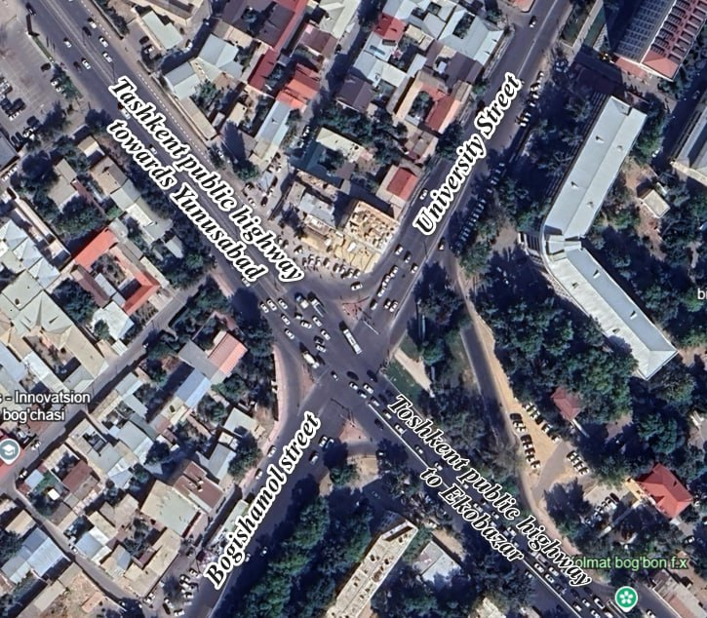
The amount of traffic of pedestrians and vehicles at the intersection we selected was studied as follows. We counted and got the result in the table. Below is information about the traffic flow of the intersection during the morning rush hour, i.e. from 8⁰⁰ to 10⁰⁰. As a result of research, we obtained data on the intensity of traffic and pedestrian flow (distributed by traffic types, taking into account daily disturbances and weekly fluctuations) . It should be noted that the weight of traffic, in particular, observed in the studied part of the road network, with field observation, it is possible to assess the permeability of the considered modeling object only. It is not possible to assess the need for population movement through this area with field observations [16-31].
FIGURE 1. Aerial view of the crossroad of Tashkent public highway, University Street and Bogishamol Street (Google Earth program).
The crossroad of University Street, Bogishamol and Tashkent public highway was chosen as the research object. The general information of the intersection is given below. The total number of lanes of University Street is 5, each street is equipped with dividing lanes, equipped with a pedestrian crossing, the total width of the street is 21 meters, the total number of lanes of Bogishamol Street is 6. equipped with a dividing lane, there is a surface pedestrian crossing, the total width of the street is 25 meters, the total number of lanes of the Tashkent public road is 5, it is equipped with a dividing lane, the width of this road from the eco-market side is its length is 22 meters and it is 27 meters from the Yunusabad side. The traffic light installed at the intersection is 2-phase, cycle duration is 98 seconds. This intersection is one of the most problematic intersections. Below is a top view of this intersection.
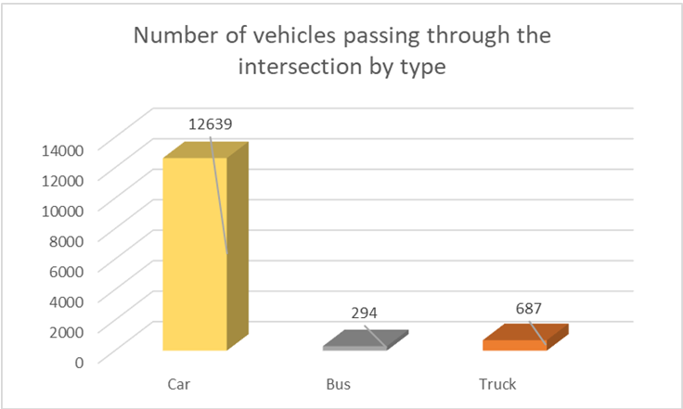
FIGURE 2. The amount of vehicles passing by the types of vehicles in 2 hours from the intersection of Bogishamol Street with TXAY in Tashkent

The intersection of University Street, Bogishamol, and the Tashkent public highway was selected as the study site. Detailed information about the intersection is provided below.. (Table 1)

TABLE 1. A computer model of the current state of the intersection
№ | Indicators or parametrs | Current status
 | Level of Service (LOS) | F
 | Average Latency (sec) | 107,37
 | Traffic Length (M) | 510,21
 | Number of vehicles | 5317
 | Fuel consumption (L) | 1067,959
 | SO exhaust gases (grams) | 19720,533
 | NOx nitrogen oxides (grams) | 3836,899
 | VOC organic compounds (grams) | 4570,424

FIGURE 3. Graphical illustration of the findings obtained for the initial state of the intersection
RESEARCH RESULTS
The management and regulation of urban traffic flow are recognized as pressing issues. During peak hours, specifically from 7:00 to 9:30 in the morning and 16:30 to 19:30 in the evening, the substantial increase in vehicular volume compared to other periods poses serious challenges, including:
- Time wasted by road users;
- excessive nervousness caused by waiting;
- economic losses of transport;
- idle operation of vehicles;
-causes an increase in harmful substances released into the atmosphere due to its stagnation.
Cycle length is defined as the total duration of a traffic signal cycle, encompassing all phases, including green time and change intervals. Although longer cycle lengths enhance the capacity to accommodate a greater number of vehicles per hour, they also lead to increased average delays.
The optimal approach for traffic signal control is to implement the shortest feasible cycle length that efficiently accommodates traffic demand. At signalized intersections, vehicles do not enter the intersection immediately upon receiving a green signal. According to Greenshields' preliminary research, the first vehicle experiences an average entry delay of 3.7 seconds, while subsequent vehicles require approximately 2.1 seconds each. Typically, vehicles passing the proximity detector take between 2 and 2.5 seconds to traverse the intersection. For computational and signal timing estimation purposes, a conservative average entry time of 2.6 seconds per vehicle is recommended. This value serves as a reference for scheduling and optimizing signal phase durations.
Cycle length is defined as the total duration of a signal cycle, incorporating green time and change intervals for each phase, encompassing all signal phases. Several methodologies have been developed for determining optimal cycle lengths, as documented in the Highway Traffic Capacity Manual, the ITE Traffic Signal Design Manual, and the ITE Traffic and Traffic Engineering Manual. Webster introduced a fundamental empirical formula for optimizing cycle length to minimize intersection delay.:
$$C=\frac{1.5*L+5}{1-\sum{Y}} (1)$$
C - total optimal cycle length (sec)
L - total loss time in one period (sec)
$$\sum{Y}-\frac{q}{s} (2)$$

Q - current moving during the phase.
S - saturation current
∑Y - The unusable time in seconds per cycle is usually taken as the sum of the vehicle signal change intervals.
To determine the length of the cycle, it should be the shortest time or fifteen minute period. Once the cycle length is determined, the vehicle's signal changes are removed, giving the total green time of the cycle, which can be proportional to the number of critical lines per signal phase.
The capacity for each green space should be checked to ensure that the significant volume of the road is adequately serviced. Let us be given the following intersection information. Intersection number of phases, 1 hour traffic flow. Using Webster's formula, the optimal signal time parameters, the effective time for the green light, are found depending on the traffic flow.
We calculate the optimal cycle length for the crossroad of Tashkent public highway, University street and Bogishamol street as follows.

TABLE 2. Traffic light phase and cycle duration graph
 | Phase A | Phase B
q | 648/3=216 | 1246/2=623
s | 1400 | 1400
q/s | 0.28 | 0.41

L=N*Yi=216/1400+623/1400=0.59 (3)

L=3*2=6 sek

$C=\frac{1.5*L+5}{1-\sum{Y}}$= $\frac{1.5*6+5}{1-0.59}=22 (sek)$ (4)
Utilizing the acquired data, a computational model of the traffic signal phases and cycle durations at the intersection will be constructed. The resulting simulations will be analyzed and compared to assess their effectiveness and operational efficiency. Figure 4

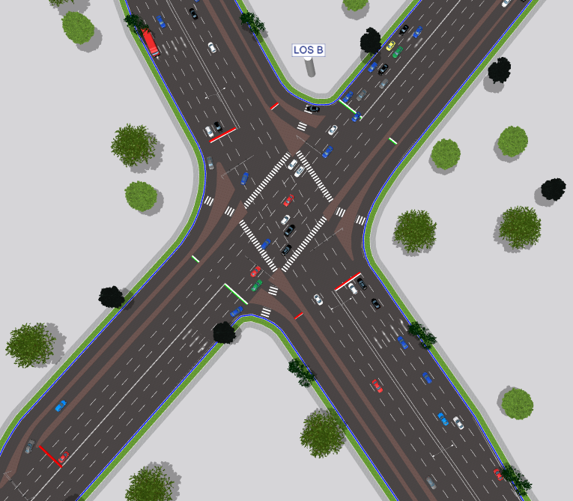
FIGURE 4. Computer model of the proposed intersection of Tashkent public highway, University Street and Bagishamol Street

We can see from Table 3.5 that after optimizing the phase and cycle of the traffic light installed at the intersection and on it, the throughput of the intersection has improved several times.
Geometric modifications at this intersection enable the optimization of traffic signal phases, the reduction of conflict points, and the minimization of vehicle dwell time at the intersection.

TABLE 3. The results of the computer model of the proposed crossroad of Tashkent public highway, University Street and Bogishamol Street
№ | Indicators | Proposed condition
1. | Level of Service (LOS) | B
2. | Average Latency (sec) | 19,8
3. | Traffic Length (M) | 113,31
4. | Number of vehicles | 7598
5. | Fuel consumption (L) | 608,773
6. | SO exhaust gases (grams) | 11241,364
7. | NOx nitrogen oxides (grams) | 2187,161
8. | VOC organic compounds (grams) | 2605,295
FIGURE 5. A diagram of the results obtained for the proposed condition of the intersection

The best effective solution for street traffic management was determined using the PTV vissim software complex. Generally, it is considered sufficient to evaluate the average observed measurement values per vehicle for a fifteen-minute analysis period. After simulating the traffic flow situation using the PTV visim program, the following indicators were determined at the existing intersections, the carrying capacity of the intersection in one hour during rush hours, the maximum length of the traffic jam formed at the intersection, and the number of vehicles. average delay, vehicle fuel consumption, intersection level of service (LOS), and vehicle emissions were determined. (Table 4).

TABLE 4. The results of the computer model of the current and proposed state of the intersection of Tashkent public highway, University Street and Bogishamol Street
№ | Indicators | Current status | Proposed condition
1 | Level of Service (LOS) | F | B
2 | Average Latency (sec) | 107,37 | 19,8
3 | Traffic Length (M) | 510,21 | 113,31
4 | Number of vehicles | 5317 | 7598
5 | Fuel consumption (L) | 1067,843 | 608,773
6 | SO exhaust gases (grams) | 19720,533 | 11241,364
7 | NOx nitrogen oxides (grams) | 3836,899 | 2187,161
8 | VOC organic compounds (grams) | 4570,424 | 2605,295
As a result of the observations conducted at the intersection of Tashkent National Highway, University Street, and Bogishamol Street in Tashkent, traffic congestion at the intersection has been analyzed in terms of the total delay time experienced by each vehicle..
T= t₁ +t₂+…..+t_{n} (3)
Here, t1 is the delay time of vehicle i.
If, t1= t2=..…..tn, then T=n
Observations show that the average delay time of one vehicle under the current and proposed conditions is as follows Figure-6
FIGURE 6. The graph of the change of the time of the average delay of cars according to the computer model of the current and proposed state of the intersection of the Tashkent public highway, University Street and Bogishamol Street

Vehicles were stuck at intersections for an average of 107.37 seconds, the changes to the intersection have resulted in 19.80 seconds of being stuck at intersections, and the average number of vehicles stuck at intersections per traffic light period is 120 from the current proposed scenario. made up 50.
Traffic congestion and road traffic accidents are two critical externalities associated with road usage. The increase in travel time caused by congestion leads to substantial economic losses for road users and generates social costs by negatively impacting mobility and overall quality of life.
T₁ _{current status} = 107.37*120=12884,4 second or 214 minute;
T_{1proposed condition} = 19.80*50=990 second or 16,5 minute;
1 minute of a vehicle being caught at an intersection is 85.2 soums. Detention costs of vehicles in each period are as follows
T_{1current status} k*=107.37*85.2=9147.924 =9148 soum;
T_{1proposed condition} k*=19.80*85.2 = 1692.9= 1693 soum;
The cycle length of the traffic signals at the intersection of Tashkent Public Highway, University Street, and Bogishamol Street is currently 98 seconds. Under the proposed optimization, this duration is reduced to 51 seconds. As a result, the traffic signal cycle repeats approximately 37 times per hour in the existing condition, whereas in the proposed scenario, it increases to 70 cycles per hour. Furthermore, the current estimated hourly cost at the intersection is approximately 338,476 soums, while under the proposed conditions, this cost is reduced to 118,510 soums, indicating a significant improvement in operational efficiency.
1 In the 1-hour rush hour in the morning, a total of 338,476 soums are currently being lost. 338,476*3=1 million 015 thousand 428 soums causing economic damage, in the case of the offer, these indicators are a little better, reducing to 118,510 soums if the number of drivers and passengers in each car is if we consider the average of 3 people, it was 118,510*3= 355 thousand 53 soums. In comparison, the average loss is 981 thousand 875 soums every hour.
Cars currently consume 1,067,959 liters of fuel per hour, which means 1,067,959*6,500=6,941,733 soums. In the proposed situation, 608,773 liters of fuel will be consumed, and in 1 hour, cars will make 608,773*6500=3957,024 soums, if we compare, the economic loss will be 2,984,708 soums. 19,720,533 grams of CO2, 3,836,899 grams of NOx, 4,570,424 grams of VOC exhaust gases are released into the environment in 1 hour. being expelled.
FIGURE 7. The graph of the amount of toxic gases released into the atmosphere from cars at the intersection

The traffic carrying capacity of an urban roadway is primarily influenced by its geometric characteristics, the cycle length of signalized intersections, and the composition of vehicular traffic. Although traffic composition may vary throughout the day, the intersection's capacity remains relatively stable and can only be enhanced through geometric modifications or the optimal distribution of signal timing to maximize vehicle throughput. In principle, intersection efficiency can be further improved by strategically allocating green time for conflicting traffic movements utilizing the same intersection space. The optimal distribution of signal phases plays a crucial role in enhancing intersection performance and overall traffic flow efficiency. Exhaust contains various harmful substances, the amount of which changes depending on the speed of the car. The main harmful substances in the exhaust are:- carbon monoxide or carbon monoxide (CO). Disrupts the supply of oxygen to the body. It is especially dangerous for people with heart and respiratory diseases. Symptoms of poisoning include blurred vision, headaches, and decreased performance. - Hydrocarbon (HC). It has a toxic effect on the body, causes cancer and other diseases. - nitrogen oxide (NOx). They are crucial in influencing health. When precipitation occurs in the area of ​​​​nitrogen distribution, water interacts with nitrogen and forms sulfate and nitric acid, which are called "acid rain" - solid particles. They settle in the lungs and cause asthma, chronic bronchitis and disorders of the respiratory system. The particulates emitted from diesel engines are highly toxic and can cause lung cancer. Emissions vary greatly depending on the speed and technology of the engine system. The graph shows the dependence of the amount of harmful substances emitted depending on the speed of the car. Nitrogen oxides are mainly produced at high operating temperatures of engines, which corresponds to constant high speed. Reducing driving speed significantly reduces the emission of this substance. Hydrocarbon emissions decrease with reduced speed. The lowest levels of carbon monoxide and particulate emissions correspond to moderate driving speeds. Carbon dioxide is produced in proportion to fuel consumption. Each type of harmful substance has its own optimal speed. In modern cars, emissions are reduced at a speed of 40-90 km/h. It should also be noted that at sustained low speeds (15 km/h or less) CO and CO2 emissions are greatest in g/km. Driving style is the most important factor affecting emissions. With sharp acceleration, fuel consumption increases and, as a result, emissions increase. Cold start also increases emissions, since the engine and catalytic filter have not reached operating temperature. Effect of speed on fuel consumption In general, fuel consumption (and , as a result, resource cost) increases with increasing speed. In this sense, lowering the speed limit reduces fuel consumption and helps to reduce the rate of depletion of non-renewable resources. For example, at a constant speed of 90 km/h, 23% less fuel is consumed than at a speed of 110 km/h. However, it should be noted that lowering the speed below 20 km/h often leads to an increase in fuel consumption.
The graph and table of dependence of the average speed of the traffic flow on the exhaust gases emitted by the vehicles in the current state at our designated intersection.

TABLE 5. Indicators in the current state
№ | Indicators in the current state
№ | Average speed km/h | CO gramm | Nox gramm | VOC gramm | Fuel consumption in liters
1 | 25 | 15531,33 | 3021,831 | 3599,556 | 840
2 | 30 | 16339,03 | 3178,787 | 3786,49 | 883,5
3 | 40 | 18329,37 | 3566,23 | 4208,009 | 987
4 | 50 | 21208,91 | 4126,484 | 4915,371 | 1134
5 | 60 | 24226,01 | 4713,501 | 5614,611 | 1310
6 | 70 | 27667,48 | 5383,086 | 6412,206 | 1496

FIGURE 8. Dependence of the average speed of the current traffic flow of the intersection on the amount of exhaust gases and fuel consumption

TABLE 6. Indicators in the offer state
№ | Indicators in the offer state
№ | Average speed km/h | CO gramm | Nox gramm | VOC gramm | Fuel consumption in liters
1 | 25 | 11855,15 | 2297,586 | 2748,721 | 640
2 | 30 | 11643,98 | 2265,495 | 2698,604 | 630
3 | 40 | 10875,58 | 2115,992 | 2520,52 | 588
4 | 50 | 11239,79 | 2186,854 | 2604,929 | 608
5 | 60 | 11872,51 | 2309,959 | 2751,568 | 642
6 | 70 | 12937,89 | 2517,244 | 2998,481 | 700

FIGURE. 9. Dependence of the average speed of the traffic flow of the proposed intersection on the amount of exhaust gases and fuel consumption

Effect of Speed on Ozone Ozone is not produced directly by engines. It occurs as a result of a chemical reaction between hydrocarbons, nitrogen oxides and sunlight. Ozone seriously affects the health of people, especially the elderly and children, and causes acute diseases of the respiratory system. Especially high concentrations of ozone occur in cities in summer at high temperatures. Effect of speed on noise Speed has a strong influence on the generation of noise. At lower speeds, the noise level is always lower. However, other factors should be taken into account - the frequency and intensity of acceleration can greatly affect the appearance of noise. The effect of increased noise due to acceleration is usually not noticeable at speeds above 50 km / h. Noise comes from two sources: the car's engine and the interaction between the wheels and the road. For new cars, wheel noise begins to dominate at a speed of 20-40 km / h, for new trucks this value is 30-60 km / h. For old cars, this limit increases to about 10 km/h. When calculating the impact of noise, it should be considered that Decibel is a logarithmic value in which growth is calculated. An increase in noise of 1 decibel represents a real increase of 30 percent, and an increase of 3 decibels represents a 2-fold increase. That is, according to the table, increasing the speed from 50 to 70 km / h leads to 2.5 times increase in noise. In conclusion, in addition to reducing injuries, setting reasonable speed limits can reduce pollutant emissions, fuel consumption and noise levels

CONCLUSIONS
The cycle length of the traffic signals at the intersection of Tashkent Public Highway, University Street, and Bogishamol Street is currently 98 seconds. Under the proposed optimization, this duration is reduced to 51 seconds. Consequently, the traffic signal cycle repeats approximately 37 times per hour in the existing condition, whereas in the proposed scenario, it increases to 70 cycles per hour. Additionally, the current estimated hourly cost at this intersection is approximately 338,476 soums, while under the proposed conditions, this cost is reduced to 118,510 soums, demonstrating a significant improvement in efficiency and cost reduction.
1 In the 1-hour rush hour in the morning, a total of 338,476 soums are currently being lost. if we consider that from 3 people on average, 338,476*3=1 million 015 thousand 428 soums are causing economic damage, in the case of the offer, these indicators are a little better, reducing to 118,510 soums if the number of drivers and passengers in each car is if we consider the average of 3 people, it was 118,510*3= 355 thousand 53 soums. In comparison, the average loss is 981 thousand 875 soums every hour.
Cars currently consume 1,067,959 liters of fuel per hour, which means 1,067,959*6,500=6,941,733 soums. In the case of the proposal, 608,773 liters of fuel are consumed, and in 1 hour, cars make 608,773*6500=3,957,024 soums. If we compare, the economic loss is 2,984,708 soums. in the current state, a total of 19720.533 grams of CO2, 3836.899 grams of NOx, 4570.424 grams of VOC waste gases are released into the environment in 1 hour. being ejected from cars.

REFERENCES
- Kulmukhamedov, Z., Khikmatov, R., Saidumarov, A., & Kulmukhamedova, Y. (2021). Theoretical research of the external temperature influence on the traction and speed properties and the fuel economy of cargo-carrying vehicles. Journal of Applied Engineering Science, 19(1), 68-76..
- Shvets, O., & Györök, G. (2023). Possible implications for land-use planning mechanisms when considering the results of monitoring and modelling air pollution by industry and transport on the example of Kazakhstan cities. Acta Polytechnica Hungarica, 20(4), 7-26.
- Shvets, O., & Györök, G. (2023). Possible implications for land-use planning mechanisms when considering the results of monitoring and modelling air pollution by industry and transport on the example of Kazakhstan cities. Acta Polytechnica Hungarica, 20(4), 7-26.
- Samatov, R., & Samatov, U. (2022, June). Improvement of methods for assessing the quality of road transport services. In AIP Conference Proceedings (Vol. 2432, No. 1). AIP Publishing.
- Kutlimuratov, K., Khakimov, S., Mukhitdinov, A., & Samatov, R. (2021). Modelling traffic flow emissions at signalized intersection with PTV vissim. In E3S Web of Conferences (Vol. 264, p. 02051). EDP Sciences.
- Jereb, B., Stopka, O., & Skrúcaný, T. (2021). Methodology for estimating the effect of traffic flow management on fuel consumption and CO2 production: a case study of celje, Slovenia. Energies, 14(6), 1673.
- Filina, O. A., Malozyomov, B. V., & Shchurov, N. I. (2024). Generation of hydrogen fuel on board vehicles with internal combustion engines. International Journal of Hydrogen Energy, 93, 320-327.
- Turdibekov, S., Isoxanov, U., Shermatov, S., Abdusamatov, E., Usmanova, M. (2024). Road traffic incidents involving pedestrians in areas with limited visibility. E3S Web of Conferences 549, 06012 (2024) TransSiberia 2024 https://doi.org/10.1051/e3sconf/202454906012
- Turdibekov, S., Isoxanov, U., Shermatov, S., Abdusamatov, E. (2024). Analysis of the parameters of technological material sprinkling devices of special road vehicles (wδ=const): MAN CLA 18.280 4x2 BB CS45. E3S Web of Conferences 549, 02016 (2024) TransSiberia 2024 https://doi.org/10.1051/e3sconf/202454902016
- Usmanova, M.N., Abdusamatov, E.X., Aliyev, A.A. (2024). The impact of driver turnover on traffic safety. E3S Web of Conferences 549, 06011 (2024) TransSiberia 2024 https://doi.org/10.1051/e3sconf/202454906011
- Fayzullayev, E., Khakimov, S., Rakhmonov, A., Rajapova, S., Rakhimbaev, Z. (2023). Traffic intensity on roads with big longitudinal slope in mountain conditions. E3S Web of Conferences 401, 01073 (2023) CONMECHYDRO - 2023 https://doi.org/10.1051/e3sconf/202340101073.
- Khakimov, S. (2022). Vehicle ride regime as a main factor for GHG emission reduction. AIP Conf. Proc. 2432, 030127 (2022) https://doi.org/10.1063/5.0089563
- Khalilova, G., Rakhmonov, A., Samatov, R., Razhapova, S, Abdusamatov, E., Shermatov, S. Methodology for Calculating the Share of Parking-Searching Vehicles in Traffic Congestion on Multi-Lane Roads. International Conference of Young Specialists on Micro/Nanotechnologies and Electron Devices, EDM. https://doi.org/10.1109/EDM65517.2025.11096677
- Fayzullayev, E., Khakimov, S., Rakhmonov, A., Rajapova, S., Abdurazzakova, D. Correct choice of parameters of runaway truck ramp on the mountain roads is factor in saving people's lives. AIP Conference Proceedings. https://doi.org/10.1063/5.0267594
- Choriev, J.A., Faizullaev, E.Z., Khakimov, S.K., Rakhmanov, A.S. The Impact of the Number of Street Intersections on Traffic Safety in Karshi City. Springer Nature https://doi.org/10.1007/978-3-031-83595-7_37
- Khalilova, G. Kh., Choriyeva, M. Sh., Samatov, R. G., Abdurazzokov, U. A., & Urunov, D. A. (2025). AI Integration in Smart Car Parking Stations (pp. 125–133). https://doi.org/10.1007/978-3-031-88846-5_15
- Khalmukhamedov, A., Samatov, R., Rajapova, S.(2024). Prospects for the use of an automatic system for weight and dimensional control of vehicles in the Republic of Uzbekistan. AIP Conference Proceedings, 2024, 3045(1), 050031. https://doi.org/10.1063/5.0197415
- Samatov, R., Samatov, U. Improvement of Methods for Assessing the Quality of Road Transport Services. AIP Conference Proceedings, 2022, 2432, 030094. https://doi.org/10.1063/5.0091190
- Faizullaev, E.Z., Rakhmonov, A.S., Mukhtorjanov, U.M., Turdibekov, S., Nasirjanov, S.I. Parameters of the access road for disaster situations on the roads in the mountain area. E3S Web of Conferences 401, 03022 (2023) CONMECHYDRO - 2023 https://doi.org/10.1051/e3sconf/202340103022
- Usmanova, M., Rajapova, S., Juraev, Y. Innovative Ways to Train Drivers and Improve Their Skills. AIP Conference Proceedings, 2022, 2432, 030100 https://doi.org/10.1063/5.0090825
- Rustamov, K., Komilov, S., Kudaybergenov, M., Shermatov, S., Xudoyqulov, S. Experimental study of hydraulic equipment operation process. E3S Web of Conferences 264, 02026 (2021) https://doi.org/10.1051/e3sconf/202126402026 CONMECHYDRO – 2021
- Sharifbaeva, K.,Niyazova, G.,Abdurazzakova, D.,Abdurashidov, I.,Alimardonov, R. Formation of Methodical Competence of Special Subjects Teachers in Technical Universities. AIP Conference Proceedings, 2432, art. no. 050043. https://doi.org/10.1063/5.0089618
- Rabat, O., Pirnaev, Sh., Rustamov, K., Usmanov I. Shermatov, Sh., Magdiyev, K. Development of corrosion-resistant material for asphalt concrete cutting part. E3S Web of Conferences 587, 03012 (2024) https://doi.org/10.1051/e3sconf/202458703012
- Korabayev, S., Yuldashev, J., Isokhanov, U., Makhkamova, S., Saparboyeva, N. Overcoming obstacles: solving cutting resistance problems. E3S Web of Conferences 587, 03015 (2024) https://doi.org/10.1051/e3sconf/202458703015
- Isokhanov, U., Turdibekov, S., A method of experimental study of the operation of technological material distributors. E3S Web of Conferences 587, 03013 (2024) https://doi.org/10.1051/e3sconf/202458703013
- Turdibekov, S., Xamraqulov, R., Negmatov, N., Raximbayev, Z. The method of calculating the parameters of the materials delivery mechanism of the technological materials distributor. BIO Web of Conferences 145, 03025 (2024) Forestry Forum 2024 https://doi.org/10.1051/bioconf/202414503025
- Kapski, D., Semchenkov, S., Gamulsky, I., Ikromov, A., Omarov, J., & Abruev, S. (2024). Assessment measures developed to improve quality of route transport Polotsk and Novopolotsk. E3S Web of Conferences, 515, 03003. https://doi.org/10.1051/e3sconf/202451503003
- Kapsky, D., Vokhidov, D., Astapenya, P., Abdurakhimov, L., Abruev, S., Khadiyeva, G.(2025). Using special "pre-signals" to improve quality of traffic in mega cities. AIP Conference Proceedings, https://doi.org/10.1063/5.0266811
- Yusupov, U., & Shavkatov, X. (2024). Development of a standard mileage for large-sized tires under moderately severe quarry conditions. BIO Web of Conferences, 141, 04034. https://doi.org/10.1051/bioconf/202414104034
- Ziyaev, K., Vokhidov, D., Shavkatov, K., Khadiyeva, G., & Yangiyeva, I. (2025). Influence of traffic light management on traffic capacity of Urban highways. 060038. https://doi.org/10.1063/5.0266822
- Khalmukhamedov, A.S., Samatov, R.G., Islamov, E.B. and Narziyev, J.S. (2025) Assessment of the Highway Network of International Importance of the Republic of Uzbekistan. Lecture Notes in Networks and Systems https://doi.org/10.1007/978-3-031-99028-1_21

