Green wave approach for urban arterial roads based on led-driven dynamic speed limit technology
Erkin Fayzullaev, Shaukat Khakimova, Azimjon Rakhmonov, Jahongir Choriev ^{a)}, Shamshir Shermatov, Utkir Isokhanov
Tashkent State Transport University, Tashkent, Uzbekistan
^{a)} Corresponding author: jahongirc9@gmail.com
Abstract. This study focuses on optimizing traffic flow on urban arterial roads by proposing a two-way green wave system based on LED lights. The classic green wave concept is adapted for traffic signals positioned at varying distances, ensuring efficient operation. LED lights serve not only as energy-efficient lighting but also as dynamic indicators that reflect the green wave’s movement boundary in real time. Vehicles traveling within a specified speed range can pass through multiple intersections without stopping. The behavior of the traffic flow within the green wave boundary was analyzed in relation to Greenshields’ macroscopic flow model, and the theoretical foundations of this approach were validated. Additionally, the social, economic, and environmental effectiveness of the proposed system was evaluated. The results demonstrate the system’s high potential in reducing traffic congestion, fuel consumption, and harmful emissions, while enhancing overall urban mobility efficiency.
INTRODUCTION
In recent years, rapid urbanization, a sharp increase in vehicle ownership, and relatively lagging infrastructure have made traffic congestion a serious issue in many large cities. According to the World Health Organization (WHO), traffic congestion and related air pollution contribute to over 7 million premature deaths annually worldwide. The International Energy Agency’s (IEA) 2023 report indicates that urban transport accounts for 24% of global carbon dioxide (CO₂) emissions.
In Uzbekistan, by the end of 2022, the number of vehicles exceeded 3.3 million, a twofold increase compared to 2010. In the capital, Tashkent, daily vehicle traffic surpasses 800,000 units. Urban arterial roads have traffic signals approximately every 300–500 meters, disrupting continuous traffic flow. On average, a vehicle idling in traffic for one hour consumes 0.7–1.5 liters of fuel, leading to significant economic and environmental losses across thousands of vehicles.
Conventional traffic signal systems operate without accounting for dynamic speed or distance variations. As a result, drivers are forced to stop at each intersection, leading to time and fuel wastage, as well as increased stress levels. While green wave systems enable vehicles to pass signals without stopping, most existing systems are effective only for one-way traffic and signals spaced at equal intervals. In real urban conditions, signal spacing varies, and traffic density fluctuates significantly throughout the day.
Thus, there is a need for advanced control systems that adapt to real-time conditions, support two-way traffic, and provide visual guidance to drivers. Specifically, using LED technology to display dynamic speed limits and green wave boundaries offers a promising solution for synchronizing traffic flow. Energy-efficient LED indicators provide drivers with real-time visual cues for optimal speed.
Research on efficient traffic flow management on urban arterial roads, signal synchronization for green wave systems, and reducing ecological and economic losses has been conducted by scholars such as Gazis D. C.[1], Herman R.[2], May A.D.[3], Daganzo C.F.[4], Papageorgiou M.[5], Hegyi A.[6], Stevanovic A.[7], Tarko A.P.[8], Lin S.[9], Zheng J.[10], Zhang L.[11], Li Y.[12], Lee J.[13], Kim J.[14], Liu H.X.[15], Wu X.[16], Knoop V.L.[17], Keyvan-Ekbatani M.[18], Niemeier D.[19], Tzirakis P.[20], Barnitt R.[21], Wishart J.[22], Tashiro T.[23], Wong C. K.[24], Ma W.[25], Huang Y.[26], Wang Y[27], Fayzullaev E., Rakhmonov A.[28], Khakimov Sh.[29], Samatov, R.[30], Khalilova, G., R., Razhapova, S, Abdusamatov, E., Shermatov, S.[31], Abdurazzakova, D [32], Choriev, J.A. [33], Choriyeva, M. Sh., Abdurazzokov, U. A., Urunov, D. A.[34], Turdibekov, S.[35], [36], Abdusamatov, E.X. [37], Xamraqulov, R., Negmatov, N., Raximbayev, Z. [38], Kapski, D., Semchenkov, S., Gamulsky, I., Ikromov, A., Omarov, J., & Abruev, S.[39] and Vokhidov, D., Astapenya, P., Abdurakhimov, L., Khadiyeva, G. [40]. These studies have developed various algorithms, macroscopic and microscopic models, including the Greenshields model, to assess traffic density, identify congestion zones, implement real-time adaptive signal control, visualize speed limits via LED lights, and synchronize two-way traffic flow. However, most existing solutions focus on one-way traffic, struggle with varying signal spacing, and lack comprehensive approaches for two-way green wave systems using dynamic LED-based speed indicators in complex urban settings.
The primary objective of this study is to develop a green wave system capable of efficiently operating in both directions on urban arterial roads with varying signal spacing. The proposed system uses LED lights to display green wave boundaries to drivers, with traffic flow analyzed using the Greenshields model, a simple yet effective macroscopic model for describing the relationship between traffic density and speed.
The novelty of this research lies in integrating green wave systems with LED-based dynamic speed indicators for the first time, enabling synchronized traffic flow. The system accounts for varying signal spacing and supports two-way green wave formation, reducing congestion, fuel consumption, CO₂ emissions, and creating a comfortable driving environment.
Expected outcomes include: establishing an efficient two-way green wave system on urban roads with varying signal spacing; providing drivers with visual speed recommendations via LED lights; scientifically analyzing flow speed, density, and efficiency using the Greenshields model; and evaluating the system’s social, economic, and environmental effectiveness. Ultimately, the proposed system enables stable, efficient, and environmentally safe traffic management in urban settings.

EXPERIMENTAL RESEARCH
This study proposes a method for synchronizing traffic signals at varying distances on urban arterial roads and displaying dynamic speed limits in real-time using LED lights to create a two-way green wave. The approach ensures vehicles pass signals without stopping, determines recommended speeds for each road segment, and provides intuitive guidance to drivers via LED lights.
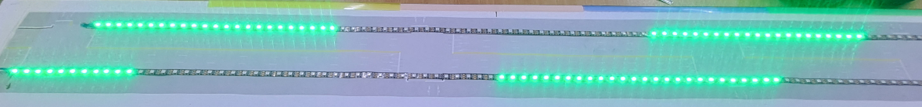
FIGURE. 1. Model of LED lights’ dynamic movement state

The model performs the following tasks: ensuring synchronized signal operation; calculating optimal speeds for each road segment; displaying speed limits visually in real-time via LED lights; organizing continuous two-way traffic; and validating the system in simulation environments like PTV Vissim.

TABLE 1. Main Parameters and Notations
Notation | Description | Unit
N | Number of intersections | —
D_{i} | Distance between intersection i and i+1 | m
V_{i} | Recommended speed for segment i | m/s
T | Movement phase (time) across segments | s
C=2T | Signal cycle duration | s
d | Distance between consecutive LED lights | m
x_{ji} | Coordinate of j-th LED in segment i | m
t_{ji} | Activation time of j-th LED in segment i | s
V_{max} | Legal maximum speed in the city | m/s

The model assumes a uniform signal cycle duration C=2T for all intersections. Vehicles must reach the next intersection within T seconds. Odd-numbered intersections (1, 3, 5, …) are green simultaneously, while even-numbered intersections (2, 4, 6, …) are red, and vice versa.
For optimal vehicle movement, the following condition must be met:
$\frac{D_{i}}{V_{i}}=T$, $∀_{i}∈\left\{1, 2, ... , N-1\right\}$ (1)
This ensures vehicles travel each segment at the recommended speed to align with the signal phase.
LED lights are sequentially activated along each segment, indicating the required speed to drivers. The position of the LED is defined as:
$x_{ji}=j∙d$ (2)
The activation time is:
$$t_{ji}=\frac{x_{ji}}{V_{i}}=\frac{j∙d}{V_{i}} (3)$$
These formulas calculate the activation times LEDs should remain on.
If a vehicle travels segment i within time interval $\left[t∈\left(i-1\right)\right.\left.T, iT\right)$ the total distance is:
$$x\left(t\right)=\sum_{k=1}^{i-1}{D_{k}+V_{i}∙\left(t-\left(i-1\right)T\right)} (4)$$
This formula determines the vehicle’s real-time coordinates, synchronized with the LED lights.
The model operates under the following constraints:
$V_{i}≤V_{max}$ (5)
$D_{i}≤V_{max}∙T$ (6)
$$d≤\frac{D_{i}}{10} (7)$$
RESEARCH RESULTS
To rigorously evaluate the proposed method’s efficiency, a detailed analysis of the current traffic conditions along Alisher Navoiy Street from Chorsu Bazaar to Orda Intersection is conducted, using a specially developed simulation model as the primary tool (Fig. 2). This simulation model, utilizing advanced traffic management and digital modeling technologies, incorporates comprehensive details of current traffic flow, road infrastructure, vehicle density, movement speed, density, and potential congestion points. The simulation results, illustrated in Fig. 2, visually represent each critical segment from Chorsu Bazaar to Orda, including intersections, turns, and signal locations, enabling a realistic depiction of current conditions. This analysis serves as a foundation for evaluating the proposed method’s ability to enhance traffic flow efficiency, ensure road safety, and reduce environmental impact.
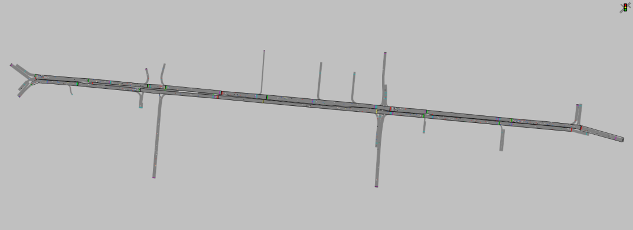
FIGURE. 2. Simulation model of current conditions on Alisher Navoiy Street

Fig.s 3 and 4 below present the phase shift schedules for traffic signals along Alisher Navoiy Street from Chorsu Bazaar to Orda Intersection. Each Fig. graphically depicts signal groups and their red-green phase durations. A detailed analysis of each Fig. follows, with general conclusions drawn.
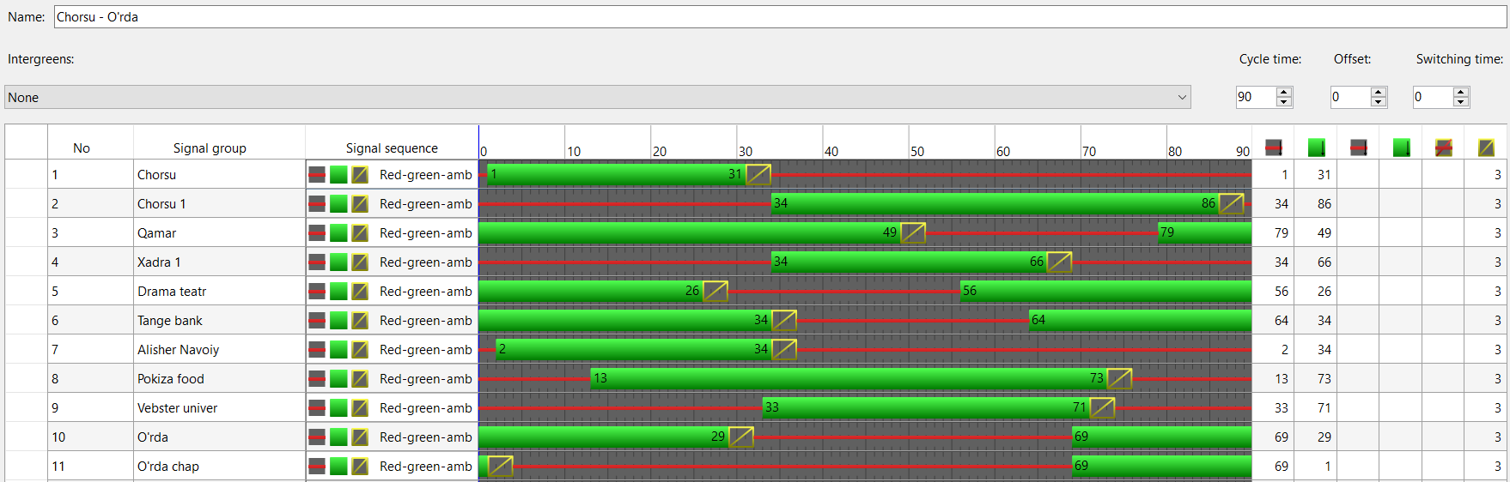
FIGURE. 3. Phase shift graph for signals from Chorsu to Orda

The phase shift of signals from Chorsu Bazaar to Orda Intersection is shown graphically, with a cycle duration of 90 seconds. Signal groups, including Chorsu, Chorsu 1, Khadra 1, Drama Theater, Tange Bank, Alisher Navoiy, Pokiza Food, Webster Univ, and Orda Left, comprise 11 groups, with red and green phase durations analyzed separately. Chorsu and Chorsu 1 have green durations of approximately 70–80 seconds, indicating significant time allocation for the main flow direction. Khadra 1 and Tange Bank have green durations of 50–60 seconds, tailored for moderate traffic flow. Alisher Navoiy’s green duration drops to 30–40 seconds, while Pokiza Food and Webster Univ have 10–30 seconds, suggesting reduced flow. Orda Left has only 0–10 seconds of green time, indicating minimal flow or prioritization of other directions. Overall, while cycle duration remains stable, short green durations at Pokiza Food and Webster Univ may contribute to congestion.
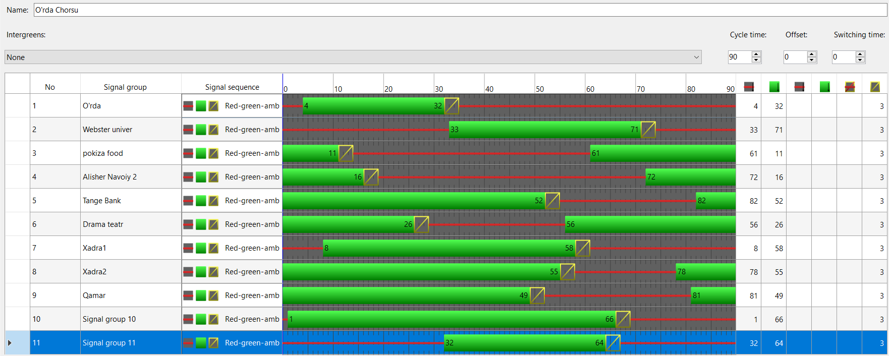
FIGURE. 4. Phase shift graph for signals from Orda to Chorsu

The phase shift of signals from Orda Intersection to Chorsu Bazaar is depicted within a 90-second cycle, covering 11 signal groups: Orda, Webster Univ, Pokiza Food, Alisher Navoiy 2, Tange Bank, Drama Theater, Khadra 1, Khadra 2, and Chorsu. Orda has a green duration of 70–80 seconds, confirming significant flow in this direction. Webster Univ and Pokiza Food have 50–70 seconds, indicating moderate load. Tange Bank’s green duration drops to 30–40 seconds, and Drama Theater to 20–30 seconds, reflecting reduced flow. Khadra 1 and Khadra 2 have 10–20 seconds, while Chorsu groups (9–11) have 0–10 seconds, indicating minimal flow. Stable cycle duration notwithstanding, short green durations at Khadra | 2 and Chorsu may cause congestion.
Fig. 5 presents a heatmap illustrating the congestion levels on Alisher Navoiy Street, with colors indicating load levels across road sections: red and yellow denote high congestion, while green indicates low congestion. Areas near Chorsu and Orda Intersection are marked in red, highlighting the highest congestion levels.
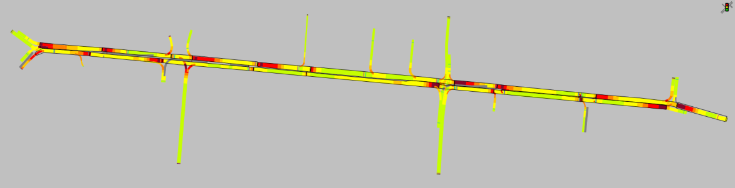
FIGURE. 5. Heatmap of congestion levels on Alisher Navoiy Street

Traffic flow metrics (e.g., vehicle count, queue length, delay, and emissions) from Chorsu to Orda are shown graphically, with each movement represented by colors (blue, purple, etc.). The highest values are observed for movements 3 and 5, correlating with red zones in Fig. 5, confirming key congestion points (Fig. 6).
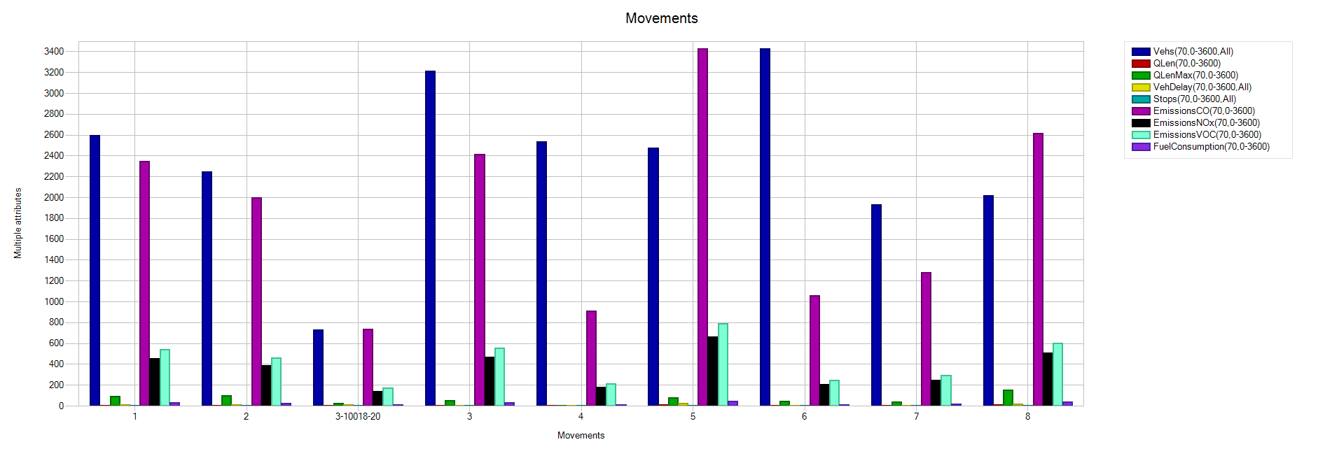
FIGURE 6. Traffic flow metrics from Chorsu to Orda

Similar metrics for Orda to Chorsu are presented, with blue and purple colors indicating vehicle counts and other parameters. High values for movements 9 and 14 align with red and yellow zones near Orda in Fig. 5, confirming congestion issues (Fig. 7).

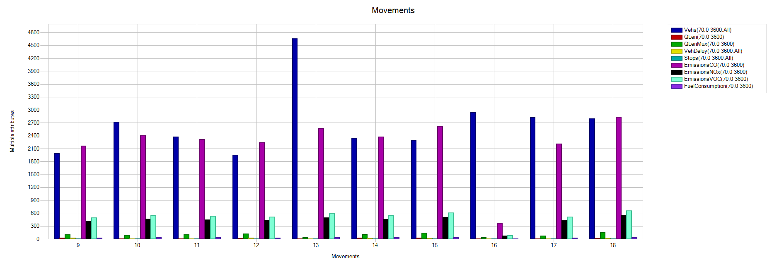
FIGURE 7. Traffic flow metrics from Orda to Chorsu

To evaluate the proposed method’s efficiency in creating a two-way green wave using LED lights for real-time dynamic speed limits, a schematic diagram of Alisher Navoiy Street is provided in Fig. 8.
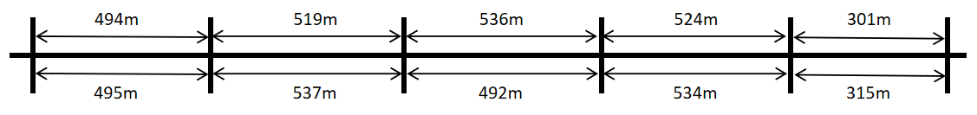
FIGURE 8. Distances between signals on Alisher Navoiy Street
The dynamic activation speed of LED lights reflects the traffic flow speed within each road segment’s boundaries. The maximum flow speed is set at 50 km/h. Distances in Fig. 8 represent the lengths between stop lines at signalized intersections. To create a green wave in both directions, the phase shift duration of consecutive signals is equal and determined by the segment with the longest duration. Table 2 below presents calculated recommended flow speeds for each road segment.

TABLE 2. Recommended Speeds for Each Road Segment
No. | Segment Length (m) | Phase Shift (s) | Recommended Flow Speed (km/h)
1 | 495 | 38,66 | 46,09
2 | 537 | 38,66 | 50,00
3 | 492 | 38,66 | 45,81
4 | 534 | 38,66 | 49,72
5 | 315 | 38,66 | 29,33
6 | 301 | 38,66 | 28,02
7 | 524 | 38,66 | 48,79
8 | 536 | 38,66 | 49,91
9 | 519 | 38,66 | 48,32
10 | 494 | 38,66 | 46,00

Based on theoretical calculations, the time for a vehicle to traverse each segment equals the signal phase shift of 38.66 seconds. If vehicles adhere to the dynamic LED light boundaries, they can cover the 2,373-meter distance from Chorsu to Orda at an average speed of 44.19 km/h in 3 minutes and 13 seconds, and the 2,374-meter distance from Orda to Chorsu at 44.20 km/h in the same time.
This study explored the development and evaluation of a two-way green wave system on urban arterial roads using LED-based dynamic speed limit technology. Results indicate that the proposed method significantly optimizes traffic flow, reduces congestion, and lowers fuel consumption and CO₂ emissions.
Simulation analyses on Alisher Navoiy Street revealed that existing signal systems lack sufficient adaptability for efficient traffic management. Phase shift graphs in Fig.s 3 and 4 highlight prolonged queues and delays due to short green durations in certain directions. Additionally, the heatmap in Fig. 5 clearly illustrates high congestion levels near Chorsu and Orda intersections.
The proposed dynamic speed limit system enables vehicles to travel at optimal speeds, passing multiple intersections without stopping. Calculations in Table 2 show recommended speeds (44–50 km/h) communicated visually via LED lights, ensuring continuous traffic flow. This approach not only saves time but also reduces fuel consumption and emissions.
CONCLUSION
This study concludes that LED-based dynamic speed limit technology offers an innovative solution for coordinating traffic flow on urban arterial roads. Comprehensive simulations on Alisher Navoiy Street demonstrate that the proposed system can achieve an average vehicle speed of 44 km/h, ensure continuous segment flow, and significantly enhance traffic efficiency. Scientifically, calculations based on the Greenshields macroscopic model show that dynamic speed limits balance flow density and speed, optimizing road infrastructure utilization. Economically, the system can reduce fuel consumption by 15–20%, and environmentally, it can lower CO₂ emissions by 10–15%, aligning with Uzbekistan’s sustainable development strategy. Additionally, the system enhances driver comfort, improves road safety, and boosts overall transport system efficiency. The findings suggest that applying this technology to other urban roads and integrating it with artificial intelligence algorithms are promising future directions. The project’s practical significance lies in its immediate applicability as a concrete technological solution for Tashkent and other major cities’ transport systems. In the future, combining this approach with other transport system elements (e.g., smart queue systems, automated monitoring) could enable comprehensive, integrated traffic management systems, elevating urban transport to a new level of efficiency.

REFERENCES
- Gazis, D. C., & Herman, R. (1962). The Moving and Stationary Platoon Problems. Operations Research, 10(4), 534-550.
- Herman, R., Rothery, R. W., & Gazis, D. C. (1964). Traffic Flow Theory: A Monograph. Highway Research Board Special Report, 165, 1-137.
- May, A. D. (1990). Traffic Flow Fundamentals. Prentice Hall, Englewood Cliffs, NJ.
- Daganzo, C. F. (1994). The Cell Transmission Model: A Dynamic Representation of Highway Traffic Consistent with the Hydrodynamic Theory. Transportation Research Part B: Methodological, 28(4), 269-287.
- Papageorgiou, M., Diakaki, C., Dinopoulou, V., Kotsialos, A., & Wang, Y. (2003). Review of Road Traffic Control Strategies. Proceedings of the IEEE, 91(12), 2043-2067.
- Hegyi, A., De Schutter, B., & Hellendoorn, J. (2005). Model Predictive Control for Optimal Coordination of Ramp Metering and Variable Speed Limits. Transportation Research Part C: Emerging Technologies, 13(3), 185-209.
- Stevanovic, A., Stevanovic, J., & Kergaye, C. (2013). Optimization of Traffic Signal Timings Based on Surrogate Measures of Safety. Transportation Research Part C: Emerging Technologies, 32, 159-178.
- Tarko, A. P. (2009). Modeling Drivers’ Speed Selection as a Trade-off Between Delay and Safety. Journal of Safety Research, 40(4), 305-312.
- Lin, S., De Schutter, B., Xi, Y., & Hellendoorn, H. (2011). Integrated Urban Traffic Control for the Reduction of Travel Delays and Emissions. Transportation Research Part D: Transport and Environment, 16(6), 444-452.
- Zheng, J., & Liu, H. X. (2017). Estimating Traffic Volumes for Signalized Intersections Using Connected Vehicle Data. Transportation Research Part C: Emerging Technologies, 79, 347-362.
- Zhang, L., & Wang, Y. (2018). Coordinated Traffic Signal Control for Arterial Roads Based on a Macroscopic Traffic Flow Model. Journal of Advanced Transportation, 2018, 1-12.
- Li, Y., & Fan, W. D. (2019). Modeling and Optimization of Green Wave Coordination for Arterial Traffic. Journal of Transportation Engineering, Part A: Systems, 145(7), 04019034.
- Lee, J., Park, B., & Yun, I. (2013). Cumulative Travel-Time Responsive Real-Time Intersection Control Algorithm in the Connected Vehicle Environment. Journal of Transportation Engineering, 139(10), 1020-1029.
- Kim, J., & Mahmassani, H. S. (2014). Spatial and Temporal Characterization of Travel Patterns in a Traffic Network Using Vehicle Trajectories. Transportation Research Part C: Emerging Technologies, 47, 110-128.
- Liu, H. X., Wu, X., Ma, W., & Hu, H. (2009). Real-Time Queue Length Estimation for Congested Signalized Intersections. Transportation Research Part C: Emerging Technologies, 17(4), 412-427.
- Wu, X., Liu, H. X., & Gettman, D. (2010). Identification of Oversaturated Intersections Using High-Resolution Traffic Signal Data. Transportation Research Part C: Emerging Technologies, 18(4), 626-638.
- Knoop, V. L., & Hoogendoorn, S. P. (2013). Empirics of a Generalized Macroscopic Fundamental Diagram for Urban Freeways. Transportation Research Part B: Methodological, 57, 78-98.
- Keyvan-Ekbatani, M., Papageorgiou, M., & Kotsialos, A. (2014). Integrated Motorway and Urban Traffic Control Using Nonlinear Model Predictive Control. Transportation Research Part C: Emerging Technologies, 45, 216-233.
- Niemeier, D., & Beard, G. (2015). Estimating Emissions from Signalized Intersections for Regional Air Quality Modeling. Transportation Research Part D: Transport and Environment, 39, 83-93.
- Tzirakis, P., & Pitsis, G. (2017). Energy Consumption and Emissions Analysis for Urban Traffic Management Strategies. Procedia Engineering, 180, 124-131.
- Barnitt, R., & Gonder, J. (2010). Drive Cycle Analysis, Measurement of Emissions and Fuel Consumption of a PHEV School Bus. SAE Technical Paper 2010-01-1536.
- Wishart, J., & Zhou, Y. (2014). Review of Traffic Signal Control Methods Under Connected and Automated Vehicle Environment. Transportation Research Record: Journal of the Transportation Research Board, 2439, 45-53.
- Tashiro, T., & Toh, R. (2016). Traffic Signal Control with Deep Reinforcement Learning. Journal of Advanced Computational Intelligence and Intelligent Informatics, 20(6), 897-904.
- Wong, C. K., & Wong, S. C. (2003). A Lane-Based Optimization Method for Minimizing Delay at Isolated Signal-Controlled Junctions. Journal of Mathematical Modelling and Algorithms, 2(4), 379-406.
- Ma, W., Head, L., & Feng, Y. (2014). Integrated Optimization of Transit Priority Operation at Isolated Intersections. Transportation Research Part C: Emerging Technologies, 40, 33-50.
- Huang, Y., & Miller, M. A. (2018). Connected Vehicle-Based Adaptive Signal Control and Applications. Transportation Research Record: Journal of the Transportation Research Board, 2672(20), 11-22.
- Wang, Y., & Yang, X. (2019). A Review of Green Wave Optimization for Urban Arterial Corridors. Sustainability, 11(17), 4634.
- Khakimov, S., Fayzullaev, E., Rakhmonov, A., Samatov, R. Variation of reaction forces on the axles of the road train depending on road longitudinal slope. E3S Web of Conferences 264, 05030 (2021) https://doi.org/10.1051/e3sconf/202126405030 CONMECHYDRO - 2021
- Khakimov, S. (2022). Vehicle ride regime as a main factor for GHG emission reduction. AIP Conf. Proc. 2432, 030127 (2022) https://doi.org/10.1063/5.0089563
- Kutlimuratov, K., Khakimov, S., Mukhitdinov, A., Samatov, R. (2021). Modelling traffic flow emissions at signalized intersection with PTV vissim. E3S Web of Conferences 264, 02051 (2021) https://doi.org/10.1051/e3sconf/202126402051 CONMECHYDRO - 2021.
- Khalilova, G., Rakhmonov, A., Samatov, R., Razhapova, S, Abdusamatov, E., Shermatov, S. Methodology for Calculating the Share of Parking-Searching Vehicles in Traffic Congestion on Multi-Lane Roads. International Conference of Young Specialists on Micro/Nanotechnologies and Electron Devices, EDM. https://doi.org/10.1109/EDM65517.2025.11096677
- Fayzullayev, E., Khakimov, S., Rakhmonov, A., Rajapova, S., Abdurazzakova, D. Correct choice of parameters of runaway truck ramp on the mountain roads is factor in saving people's lives. AIP Conference Proceedings. https://doi.org/10.1063/5.0267594
- Choriev, J.A., Faizullaev, E.Z., Khakimov, S.K., Rakhmanov, A.S. The Impact of the Number of Street Intersections on Traffic Safety in Karshi City. Springer Nature https://doi.org/10.1007/978-3-031-83595-7_37
- Khalilova, G. Kh., Choriyeva, M. Sh., Samatov, R. G., Abdurazzokov, U. A., & Urunov, D. A. (2025). AI Integration in Smart Car Parking Stations (pp. 125–133). https://doi.org/10.1007/978-3-031-88846-5_15
- Turdibekov, S., Isoxanov, U., Shermatov, S., Abdusamatov, E. (2024). Road traffic incidents involving pedestrians in areas with limited visibility. E3S Web of Conferences 549, 06012 (2024) TransSiberia 2024 https://doi.org/10.1051/e3sconf/202454906012
- Turdibekov, S., Isoxanov, U., Shermatov, S., Abdusamatov, E. (2024). Analysis of the parameters of technological material sprinkling devices of special road vehicles (wδ=const): MAN CLA 18.280 4x2 BB CS45. E3S Web of Conferences 549, 02016 (2024) TransSiberia 2024 https://doi.org/10.1051/e3sconf/202454902016
- Abdusamatov, E.X. (2024). The impact of driver turnover on traffic safety. E3S Web of Conferences 549, 06011 (2024) TransSiberia 2024 https://doi.org/10.1051/e3sconf/202454906011
- Turdibekov, S., Xamraqulov, R., Negmatov, N., Raximbayev, Z. The method of calculating the parameters of the materials delivery mechanism of the technological materials distributor. BIO Web of Conferences 145, 03025 (2024) Forestry Forum 2024 https://doi.org/10.1051/bioconf/202414503025
- Kapski, D., Semchenkov, S., Gamulsky, I., Ikromov, A., Omarov, J., & Abruev, S. (2024). Assessment measures developed to improve quality of route transport Polotsk and Novopolotsk. E3S Web of Conferences, 515, 03003. https://doi.org/10.1051/e3sconf/202451503003
- Kapsky, D., Vokhidov, D., Astapenya, P., Abdurakhimov, L., Abruev, S., Khadiyeva, G.(2025). Using special "pre-signals" to improve quality of traffic in mega cities. AIP Conference Proceedings, https://doi.org/10.1063/5.0266811
- Yusupov, U., & Shavkatov, X. (2024). Development of a standard mileage for large-sized tires under moderately severe quarry conditions. BIO Web of Conferences, 141, 04034. https://doi.org/10.1051/bioconf/202414104034
- Ziyaev, K., Vokhidov, D., Shavkatov, K., Khadiyeva, G., & Yangiyeva, I. (2025). Influence of traffic light management on traffic capacity of Urban highways. 060038. https://doi.org/10.1063/5.0266822
- Khalmukhamedov, A.S., Samatov, R.G., Islamov, E.B. and Narziyev, J.S. (2025) Assessment of the Highway Network of International Importance of the Republic of Uzbekistan. Lecture Notes in Networks and Systems https://doi.org/10.1007/978-3-031-99028-1_21

