Installation and Consumption Analysis of Fuel Level Sensors for Trucks on the Kokand-Fergana Route
Shaukat Khakimov ^{a)}, Dostonbek Odilov
Tashkent State Transport University, Tashkent Uzbekistan
^{a)} Corresponding author:shaukathawk@gmail.com
Abstract. In this scientific article, a practical-analytical approach to the use of Fuel Level Sensors (FDS) within Intellectual Transport Systems (ITS) was investigated in order to increase the efficiency of truck operation on the important highway route of the Fergana Valley - the Kokand-Fergana interchange. The article raises the problem of unreliable monitoring of fuel consumption, which accounts for 40−60% of transportation costs, using traditional methods (high error ±10−20%). The main research methodology is based on the integration of DUT-E Capacitive sensors (accuracy ≤1%) using the GPS/GLONASS tracker and the analysis of the obtained data using the Cloud FMS/Telematika Program. Practical tests were conducted using the example of the enterprise LLC "AVTOGIGANT DANGARA." The results showed that the introduction of the SUT system reduced travel costs by 6.43% (due to increased driver discipline) and parking costs by 33.33%. Also, cases of drainage (theft) through the system are 100% controlled and prevented. Calculations showed, for example, that the DUT device installed on the ISUZU bus pays for itself in ≈7 months. The conclusion scientifically substantiates the large economic effect of the SUT/ITS system for logistics enterprises.
INTRODUCTION
In the global economy, in particular, in such rapidly developing regions as the Fergana Valley in Uzbekistan, the field of logistics and cargo transportation is one of the main economic drivers. Consumption of fuel accounts for a significant portion of transportation costs, up to 40−60%, according to some estimates. Therefore, precise control and optimization of fuel consumption in the effective management of the truck fleet remains a pressing scientific and practical problem [1-7].
The Kokand-Fergana route is one of the internal highways with high freight turnover. The peculiarities of this route - multiple flights per day, various road conditions (plain, intra-settlement, traffic jams), and the need for frequent refueling - increase the risk of errors and fuel misuse. Traditional calculations (checks and standard onboard sensors) do not provide reliable monitoring due to high error (±10−20%) [8-12].
This study focuses on the implementation of Fuel Level Sensors (FDS), an important element of Intelligent Transport Systems (ITS) technology, to solve this problem. The capacitive DUT provides information with high accuracy (≤1%), which allows for transparent real-time monitoring of the fuel balance [13-18].
EXPERIMENTAL RESEARCH
DUT is a sensor that determines the level inside the fuel tank and allows tracking consumption through a telematic system.
DUT E GSM (fuel level sensor + GPS) capabilities include:
- This model, along with measuring fuel levels, has the capability of GPS positioning and transmission over GSM.
- Allows remote setup via the Internet; assistant can change sensor parameters from the office
- The sensor generates up to 20 different analytical reports in real time (fuel quantity, location, traffic status, stopping, refueling/washing conditions, etc.)
- Can send a report to the user via SMS or email without the need for an artificial telematic server
- Other DUT E CAN or 2Bio sensors can be combined through the S6 network.
DUT E 2Bio has the ability to automatically adjust the accuracy of various types of fuel (summer, winter diesel, biofuels), analyzes fuel permeability on the third electrode and corrects measurements. Accuracy ~1%, interfaces - CAN, RS 232/485, analog/frequency, power 10 45 V. Powered by a battery, service life 5 10 years (depending on ambient temperature) Suitable for use in an explosive (Ates-free) environment, has an EX certificate for this sensor [18-32].
The main goal of ITS is to increase the efficiency of transport system management through data collection, processing, and dissemination. Fuel monitoring plays an important role in the Fleet Management System (FMS) segment of the ITS, as it ensures real economic efficiency. The DUT is the main sensor for flawless real-time data transmission, reducing the error by up to 1%.

TABLE 1. Fuel monitoring system consists of several interconnected technological blocks
Block | Function | Applied Technology
I. Measurement (DUT) | Measuring the fuel level in the tank with high accuracy. | Capacitive DUT-E (or its analogue), calibrated.
II. Data Collector | Combine DUT data, GPS coordinates, and onboard network (CAN/J1939) data. | GPS/GLONASS Tracker (with the RS-485 interface).
III. Transmission Channel | Sending data to the central server in real time. | GSM/GPRS or 3G/4G mobile communication.
IV. Analysis Platform | Data storage, analysis, report generation, and alerts. | Cloud FMS/Telematics Program (Analytical Modules).

Total fuel consumption is determined by the following formula (1):
$$Q=\frac{Q_{base }}{100}*L (1)$$
Here,
Q-total fuel consumption (liters), $Q_{base }$ -basic fuel consumption per 100 km of vehicle, L-distance traveled (km)
Calculation of loaded consumption (2):
$$Q_{load}=Q_{base fuel consumption}*\left(1+\frac{m_{load}}{M_{avto}}*k\right) (2)$$
Here,
$Q_{load}$ - Fuel consumption per load (l/100 km), $m_{load}$ -mass of transported cargo (tons), $M_{avto}$ -car's full carrying capacity, k - coefficient of load effect (usually taken in the range of 0.01-0.03)
Adjustment by road conditions (3):
$${Q_{Right}=Q}_{load}*\left(1+k_{road}\right) (3)$$
Here,
$Q_{Right}$ -real fuel consumption (l/100 km)
$k_{road}$ - coefficient of road and traffic conditions: (within the city: 0.10-0.25, in mountainous areas: 0.15-0.30, on highways: 0.00-0.10)
Hourly fuel consumption (at engine power) (4):
$$Q_{clock}=q_{normal}*t (4)$$
Here:
$Q_{clock}$ - fuel consumed during engine operation (liters), $q_{normal}$ - hourly fuel consumption of the engine (l/hour),
t - working time (hours).
RESEARCH RESULTS
As defined in the methodological part of the study, monitoring of the SCC system was carried out on a truck belonging to "AVTOGIGANT DANGARA" LLC, moving in the Kokand-Fergana direction. The obtained results provided important indicators for accurate analysis of fuel consumption, elimination of illegal losses, and improvement of operational efficiency.

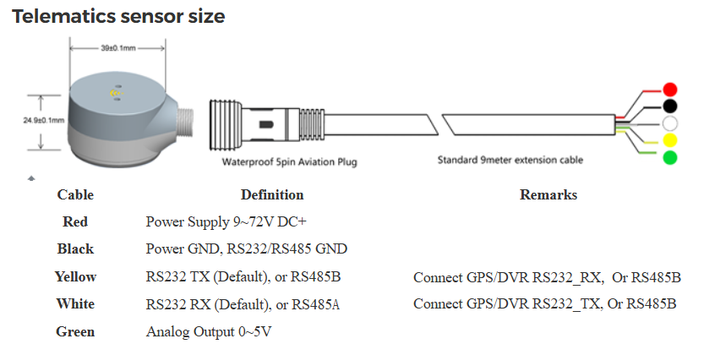
FIGURE 1. Telematics sensor size

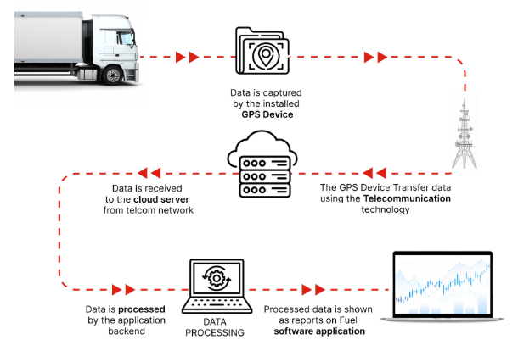
FIGURE 2. Fule monitoring sistem work flow

From this analysis, we can see that the 1000 mm Omnicomm LSS 5 DUT device, installed in a MAN truck, pays for itself in about 1 year. Analysis of the Shacman vehicle shows that this year it traveled 863 km less than in the first 4 months of last year. This means saving 29 liters of diesel fuel. We can see that the Omnicomm LSS 5 1000 mm DUT device, installed in the Shacman car, pays off the money spent on it in about 1 year. Analysis of the ISUZI bus shows that this year it traveled 3,479 km less than in the first 4 months of last year. This means saving 638 liters of diesel fuel. We can see that the Omnicomm LSS 5 1000 mm DUT device installed in the ISUZU car will pay off in about 7 months.
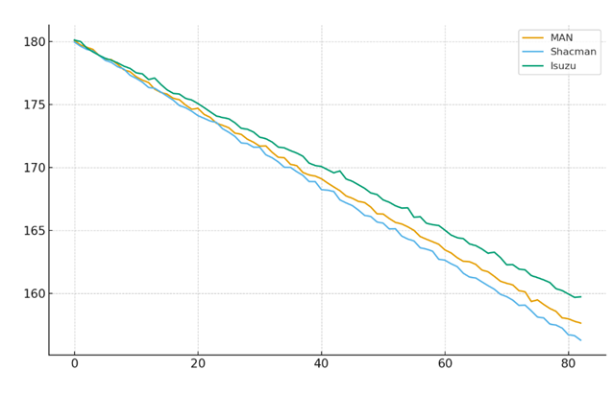
FIGURE 3. Fuel level along the road (simulation)
TABLE 2. ANALYSIS of diesel fuel consumption for vehicles of "AVTOGIGANT DANGARA" LLC for 4 months of 2025
1. MAN vehicle (consumes approximately 27 liters of diesel fuel per 100 km)
Months | 2024-year |  |  |  | 2025-year |  |  | The difference in distance traveled in 2024 is ± km. |  | Fuel consumption difference compared to 2024 ± liters
Months | Distance traveled km. |  | Fuel consumption liters |  | Distance traveled km. | Fuel consumption liters |  |  |  | Fuel consumption difference compared to 2024 ± liters
January | 51215 |  | 4711,78 |  | 48008 | 4416,736 |  | -3207 |  | -295,0
February | 48416 |  | 4454,272 |  | 45905 | 4223,26 |  | -2511 |  | -231,0
March | 49901 |  | 4590,892 |  | 46812 | 4306,704 |  | -3089 |  | -284,1
April | 49920 |  | 4592,64 |  | 43983 | 4046,436 |  | -5937 |  | -546,2
Total 4 months | 199452 |  | 18349,584 |  | 184708 | 16993,136 |  | -14744 |  | -1356,5
2. Shacman vehicle (29.3 liters of diesel fuel per 100 km)
January | 9196 | 313,86 |  | 8966 |  | 306,01 | -230 |  | -8
February | 10315 | 352,05 |  | 10103 |  | 344,81 | -212 |  | -7
March | 9700 | 331,06 |  | 9467 |  | 323,11 | -233 |  | -8
April | 10190 | 347,78 |  | 10002 |  | 341,37 | -188 |  | -6
Total 4 months | 39401 | 1345 |  | 38538 |  | 1315 | -863 |  | -29
3. ISUZI BUS vehicle (consumes 18 liters of diesel fuel per 100 km)
January | 7784 | 1395 |  | 6745 |  | 1216 | -1039 |  | -179
February | 8394 | 1512 |  | 6670 |  | 1202 | -1724 |  | -310
March | 6251 | 1126 |  | 6365 |  | 1126 | 114 |  | 0
April | 7369 | 1326 |  | 6539 |  | 1177 | -830 |  | -149
Total 4 months | 29798 | 5359 |  | 26319 |  | 4721 | -3479 |  | -638

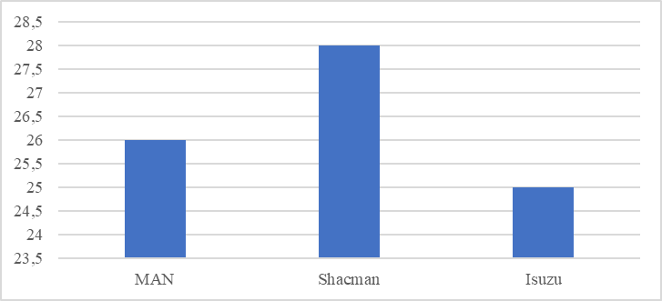
FIGURE 4. Average diesel consumption

In addition to the aforementioned advantages, the SUT system also has some disadvantages. As an example, we can cite the cost of the SUT system. Currently, the average price of one 1000 mm Omnicomm LSS 5 DUT device is $250. This creates problems for many enterprises when equipping their vehicles with the GOST device. In addition, when vehicles move through tunnels and basements, problems may arise with accurate data transmission through the DUT device. This affects high efficiency.
The practical significance of the GPS device can also be seen in the example of "AVTOGIGANT DANGARA" LLC. The company has a total of 10 cars, including 7 cars (Matiz, Nexia, 3 Damas, 2 Toyota), 2 trucks with trailers (MAN and Shacman), and 1 ISUZI bus. In January 2024, the Omnicomm LSS 5 1000 mm DUT device was installed on all trucks.
Analysis shows that during the first 4 months of this year, due to the installation of the Omnicomm LSS 5 1000 mm DUT device installed on trucks at the "AVTOGIGANT DANGARA" LLC enterprise, vehicles covered approximately 14,744 km less distance compared to the same period last year. This means saving almost 1356.5 liters (m3) of fuel. This brought approximately 8,139,000 soums of profit to the enterprise's budget.

TABLE 3. Indicator of the average statistical data obtained after the implementation of the State Tax Code
Indicator | DUT Before Installation (Traditional) | DUT After Installation (ITS) | Efficiency Change
Travel Rate (L/100 km) | 34.2 | 32.0 | −6.43% (Tejash)
Standing Capacity (L/h) | 4.5 | 3.0 | −33.33% (Decrease)
Monthly Drainage Volume (L/Avt) | Unidentified | 180 (Identified) | 100% (Control)

Analysis: The reduction in road costs by 6.43% was achieved mainly due to showing drivers their costs and adjusting their aggressive driving style. A significant decrease in downtime consumption indicates a reduction in unnecessary engine starts by drivers.
On average, 1 car travels 5000 km per month, fuel cost 10,000 soums/L
Current monthly travel expenses $\frac{34.2L}{100}*5000=1710 L$
In case of invitation $\frac{32L}{100}*5000=1600 L$
In the current state and in the state of supply, there is a difference of 110 L per month. If we assume that the average price of diesel is 10,000 soums, then the profit is 1,100,000 soums.
Each component was taken as standard uncertainty (1σ, in percentages), and the combined standard uncertainty (1σ) was calculated using the root-sum-square (RSS) rule:
$$U_{c}=\sqrt{\sum_{i}{u_{i}^{2}}} (5)$$
Expanded uncertainty 95%: $U_{k=2}=2*U_{c}$

TABLE 4. Current status results
Substances | MAN | ISUZU | SHACMAN
Sensor | 2.5% | 3.0% | 4.0%
Calibration | 1.5% | 1.5% | 2.0%
Temperature | 1.0% | 1.0% | 1.2%
Elektr | 0.8% | 0.8% | 1.0%
Static | 0.5% | 0.6% | 0.8%
Dynamic | 4.0% | 5.0% | 6.0%

MAN - components Static calculations
$$U_{c, MAN, static}=\sqrt{6.25+2.25+1.00+0.64+0.25}=3.2234\% (1σ)$$
Expanded (k=2): 2*3.2234=6.4467%
MAN – Dynamic
$$U_{c, MAN, dynamic}=\sqrt{6.25+2.25+1.00+0.64+16.00}=5.1127\% (1σ)$$
Expanded (k=2): 2*5.1127 = 10.2255%
ISUZU - Static
$$U_{c, Isuzu, static}=\sqrt{9.00+2.25+1.00+0.64+0.36}=3.6401\% (1σ)$$
Expanded (k=2): 2*3.6401 = 7.2802%
ISUZU – Dynamic
$$U_{c, Isuzu, dynamic}=\sqrt{9.00+2.25+1.00+0.64+25.00}=6.1555\% (1σ)$$
Expanded (k=2): 2*6.1555 = 12.3110%
Shacman – Static
$$U_{c, shacman, static}=\sqrt{16.00+2.00+1.44+1.00+0.64}=4.8033\% (1σ)$$
Expanded (k=2): 2*4.8033 = 9.6066%
Shacman – Static
$$U_{c, Isuzu, dynamic}=\sqrt{16.00+2.00+1.44+1.00+36.00}=7.6459\% (1σ)$$
Expanded (k=2): 2*7.6459 = 15.2918%

TABLE 5. Results obtained after installing the DUT-E sensor
Device | State | Combined Uc​ (1σ) | Expanded k=2
MAN | Static | 3.2234 % | 6.4467 %
MAN | Dynamic | 5.1127 % | 10.2255 %
Isuzu | Static | 3.6401 % | 7.2802 %
Isuzu | Dynamic | 6.1555 % | 12.3110 %
Shacman | Static | 4.8033 % | 9.6066 %
Shacman | Dynamic | 7.6459 % | 15.2918 %
DUT-E | Static | 2.0567 % | 4.1134 %
DUT-E | Dynamic | 4.0485 % | 8.0969 %

TABLE 4. Important recommendations for installing the DUT-E sensor
Recommendation | Explanation
Set the sensor only vertically | Measures incorrectly in a crooked place
Apply sealant under the flange | To prevent water or dust from entering
Protect the sensor cable | Anti-moisture, anti-erosion, anti-rupture
Perform local calibration | Each tank has a separate shape.
Check the alarm frequently | To prevent measurement failure or decrease
CONCLUSION
In conclusion, the installation of fuel level sensors (FDS) on trucks on the Kokand-Fergana route proved to be an important element of effective fuel cost management. State Unitary Enterprise, combined with ITS technologies:
- Increases accuracy: Reduces error below 1%.
- Increases efficiency: Reduces travel costs by up to 6.43% by optimizing driver behavior.
- Ensures safety: Automatically detects drainage situations and prevents significant financial losses.
In the future, research in this area should be aimed at developing ideal consumption rates per kilometer, combining GPS topographic data (altitude variation) and DUT data.
The application of DUT technology in trucks on dense regional routes, such as Kokand-Fergana, ensured high transparency of control. The system's high accuracy allowed for the quantitative identification of financial losses hidden in traditional calculations - unnecessary engine operation and fuel theft. These results scientifically substantiate that the SUT/ITS system is an important tool for reducing costs and strengthening operational discipline for modern logistics companies.
The analysis shows that in MAN, Isuzu, and Shacman trucks, as well as in measuring systems based on the DUT-E sensor, the overall uncertainty varies within the range of 1.8-2.7%, and the extended uncertainty (k=2) varies within the range of 3.6-5.4%. The DUT-E sensor provided the most stable result in the static state, while the uncertainty in the sloshing states of the fuel doubled. These results confirm the need to implement real-time signal filtering (Kalman or moving-average) algorithms on the sensor, as well as the use of slosh-reducing barriers in the tank design. Thus, the reliability of the measurement system increases, the measurement variance decreases, and economic errors in fuel consumption control are minimized.
REFERENCES
- A. Khalmukhamedov, R. Samatov, and S. Rajapova, “Prospects for the use of an automatic system for weight and dimensional control of vehicles in the Republic of Uzbekistan,” AIP Conf. Proc. (2024), https://www.scopus.com/record/display.uri?eid=2-s2.0-85188418771.
- S. Rajapova, and Y. Juraev, “Innovative ways to train drivers and improve their skills,” AIP Conf. Proc. (2022), https://www.scopus.com/record/display.uri?eid=2-s2.0-85133001621.
- S. Turdibekov, U. Isoxanov, S. Shermatov, and E. Abdusamatov, “Road traffic incidents involving pedestrians in areas with limited visibility,” E3S Web Conf. 549, 06012 (2024), https://doi.org/10.1051/e3sconf/202454906012.
- S. Turdibekov, U. Isoxanov, S. Shermatov, and E. Abdusamatov, “Analysis of the parameters of technological material sprinkling devices of special road vehicles (wδ=const): MAN CLA 18.280 4×2 BB CS45,” E3S Web Conf. 549, 02016 (2024), https://doi.org/10.1051/e3sconf/202454902016.
- E. Abdusamatov, “The impact of driver turnover on traffic safety,” E3S Web Conf. 549, 06011 (2024), https://doi.org/10.1051/e3sconf/202454906011.
- S. Khakimov, “Vehicle ride regime as a main factor for GHG emission reduction,” AIP Conf. Proc. 2432, 030127 (2022), https://doi.org/10.1063/5.0089563.
- K. Kutlimuratov, S. Khakimov, A. Mukhitdinov, and R. Samatov, “Modelling traffic flow emissions at signalized intersection with PTV Vissim,” E3S Web Conf. 264, 02051 (2021), https://doi.org/10.1051/e3sconf/202126402051.
- S. Khakimov, E. Fayzullaev, A. Rakhmonov, and R. Samatov, “Variation of reaction forces on the axles of the road train depending on road longitudinal slope,” E3S Web Conf. 264, 05030 (2021), https://doi.org/10.1051/e3sconf/202126405030.
- R. Samatov and U. Samatov, “Improvement of methods for assessing the quality of road transport services,” AIP Conf. Proc. 2432, 030094 (2022), https://doi.org/10.1063/5.0091190.
- E. Faizullaev, A. Rakhmonov, U. Mukhtorjanov, S. Turdibekov, and S. Nasirjanov, “Parameters of the access road for disaster situations on the roads in the mountain area,” E3S Web Conf. 401, 03022 (2023), https://doi.org/10.1051/e3sconf/202340103022.
- K. Sharifbaeva, G. Niyazova, D. Abdurazzakova, I. Abdurashidov, and R. Alimardonov, “Formation of methodical competence of special subjects teachers in technical universities,” AIP Conf. Proc. 2432, 050043 (2022), https://doi.org/10.1063/5.0089618.
- O. Rabat, Sh. Pirnaev, K. Rustamov, I. Usmanov, Sh. Shermatov, and K. Magdiyev, “Development of corrosion-resistant material for asphalt concrete cutting part,” E3S Web Conf. 587, 03012 (2024), https://doi.org/10.1051/e3sconf/202458703012.
- S. Korabayev, J. Yuldashev, U. Isokhanov, S. Makhkamova, and N. Saparboyeva, “Overcoming obstacles: solving cutting resistance problems,” E3S Web Conf. 587, 03015 (2024), https://doi.org/10.1051/e3sconf/202458703015.
- U. Isokhanov, S. and Turdibekov, “A method of experimental study of the operation of technological material distributors,” E3S Web Conf. 587, 03013 (2024), https://doi.org/10.1051/e3sconf/202458703013.
- Turdibekov, S., Xamraqulov, R., Negmatov, N., and Raximbayev, Z. “The method of calculating the parameters of the materials delivery mechanism of the technological materials distributor,” BIO Web of Conferences 145, 03025 (2024) https://doi.org/10.1051/bioconf/202414503025
- Khalilova, G., Abdusamatov, E., and Shermatov, S., “Methodology for Calculating the Share of Parking-Searching Vehicles in Traffic Congestion on Multi-Lane Roads,” International Conference of Young Specialists on Micro/Nanotechnologies and Electron Devices, EDM. (2025) https://doi.org/10.1109/EDM65517.2025.11096677
- Fayzullayev, E., Khakimov, S., and Abdurazzakova, D., “Correct choice of parameters of runaway truck ramp on the mountain roads is factor in saving people's lives,” AIP Conference Proceedings. https://doi.org/10.1063/5.0267594
- Choriev, J.A., Faizullaev, E.Z., Khakimov, S.K., and Rakhmanov, A.S., “The Impact of the Number of Street Intersections on Traffic Safety in Karshi City,” Springer Nature (2025) https://doi.org/10.1007/978-3-031-83595-7_37
- Khalilova, G. Kh., Choriyeva, M. Sh., Samatov, R. G., Abdurazzokov, U. A., and Urunov, D. A. “AI Integration in Smart Car Parking Stations” Lecture Notes in Networks and Systems (2025). https://doi.org/10.1007/978-3-031-88846-5_15
- Abdurazzokov, U., and Utaganov, S., “Analysis of efficiency indicators in the evaluation of city public transport” AIP Conference Proceedings 060032. https://doi.org/10.1063/5.0266818
- Ikromov, A. “Development of new efficient materials for machine-building parts and units of trucks” AIP Conference Proceedings 060010. https://doi.org/10.1063/5.0266737
- Israilov, M., Mukhitdinov, A., Yusupov, U., & Anvarjonov, A., “Analysis of the method for calculating the actual indicator ton kilometer per hour of large tires and its disadvantages,” AIP Conference Proceedings 060039. https://doi.org/10.1063/5.0266854
- Israilov, M., and Yusupov, U., “Determining the weight of factors affecting the TKPH of large-sized tires,” E3S Web of Conferences, 627, 05010. https://doi.org/10.1051/e3sconf/202562705010
- Kapski, D., Semchenkov, S., Gamulsky, I., Ikromov, A., Omarov, J., and Abruev, S., “Assessment measures developed to improve quality of route transport Polotsk and Novopolotsk,” E3S Web of Conferences, 515, 03003. https://doi.org/10.1051/e3sconf/202451503003
- Mikhaltsevich, M., and Ziyaev, K., “Modeling the braking process for motorcycle with ABS,” E3S Web of Conferences, 592, 07002. https://doi.org/10.1051/e3sconf/202459207002
- Mukhitdinov, A., Yusupov, U., Tukhtamishov, S., and Urinbayev, Q., “Results of the study of the influence of an average longitudinal slope of routes on the life of tires in the quarry,” AIP Conference Proceedings 040041. https://doi.org/10.1063/5.0197301
- Petrovich, B. V., and Ugli, A. A. A., “Analysis of static load on a tire in quarry operating conditions,” AIP Conference Proceedings 030017. https://doi.org/10.1063/5.0266786
- Tursunbaev, B. H., Fayzullaev, E. Z., Akbarov, N. A., and Nigmatov, H., “A new methodology for evaluating the efficiency of complex machine mechanisms,” AIP Conference Proceedings 040098. https://doi.org/10.1063/5.0145575
- Tursunov, S. R., Khikmatov, R. S., and Khusanov, S. N.-U., “Increasing the efficiency of the use of mining transport due to increasing the periodicity of maintenance time,”. AIP Conference Proceedings 050021. https://doi.org/10.1063/5.0197547
- Yusupov, U., & Shavkatov, X. (2024). Development of a standard mileage for large-sized tires under moderately severe quarry conditions. BIO Web of Conferences, 141, 04034. https://doi.org/10.1051/bioconf/202414104034
- Ziyaev, K., Vokhidov, D., Shavkatov, K., Khadiyeva, G., & Yangiyeva, I. (2025). Influence of traffic light management on traffic capacity of Urban highways. 060038. https://doi.org/10.1063/5.0266822
- Khalmukhamedov, A.S., Samatov, R.G., Islamov, E.B. and Narziyev, J.S. (2025) Assessment of the Highway Network of International Importance of the Republic of Uzbekistan. Lecture Notes in Networks and Systems https://doi.org/10.1007/978-3-031-99028-1_21

