Calculation of the Motion Velocity of Particles Ejected from the Spreading Disc of a Special Road Maintenance Machine
Salokhiddin Turdibekov^{1, a)}, Shavkat Alimuxamedov¹ Khudoyar Buranov²
¹ Tashkent State Transport University, Tashkent, Uzbekistan
²Samarkand State University named after Sharof Rashidov, Samarkand, Uzbekistan
^{a)} Corresponding author: saloxiddinturdibekov987@gmail.com

Abstract. This article analyzes the motion velocity and trajectory of technological material particles (sand–salt mixture) ejected from the spreading disc of a special road maintenance machine, aimed at reducing the risk of road surface icing during the winter season. The study presents theoretical and experimental calculations for determining the particle’s ejection velocity from the disc, rebound velocity after collision with an obstacle, and lifting (bouncing) height after impact on the road surface. It has been established that the disc’s rotational speed, radius, restitution coefficient of materials, and the physical condition of the pavement have a significant effect on the motion parameters of the particles. The results show that an increase in the restitution coefficient of metal and rubber barriers, as well as the asphalt surface, linearly increases the particle’s rebound height. The developed mathematical model has practical importance for optimizing the spreading process and improving road safety under winter operating conditions.
INTRODUCTION
Ensuring the operational safety of motor roads, especially during the winter season, is one of the crucial tasks of transport infrastructure management. Snowfall, ice formation, and road surface icing significantly increase the risk of accidents, reduce traffic speed, and lower overall traffic efficiency. In winter, the risk of road icing and the need to maintain the road surface's adhesion coefficient are addressed by spreading a sand-salt mixture on the roads. This mixture is used to melt the ice and treat the road surface's ice layer, thereby improving safety conditions for vehicle movement and pedestrians [1-10].
The efficiency of the spreading process is directly related to minimizing the economic consumption of the mixture and its environmental impact, as well as ensuring road traffic safety. To ensure effective spreading, the particles must be evenly distributed over the road surface. When particles are ejected correctly from the spreading disc and travel a distance of 10–15 meters, this poses a hazard to road users and causes the wasteful and excessive consumption of technological materials (the salt-sand mixture).
The main element of spreading is the spreading disc installed on a specialized road vehicle, which possesses a high-speed rotational motion. The sand-salt mixture, fed to the disc from the center, is ejected through radial fins as a result of the disc's rotation and is distributed over the road surface with a specific velocity and trajectory [11-18].
The initial velocity of the particles at the moment they leave the edge of the disc has a decisive impact on the quality of the particle distribution. This velocity depends on the rotational speed of the disc, its radius, the geometry of the vanes (fins), and the physicomechanical properties of the material.
Differences in the physical properties (e.g., density, moisture content, granulometric composition) of the constituent components (sand and salt) in the sand-salt mixture affect the particles' movement on the disc and, consequently, their ejection velocity. Furthermore, the presence of low temperatures and moisture in winter conditions can lead to the stickiness and agglomeration of the materials, which has an additional negative effect on the spreading efficiency.
Relevance of the Topic lies in ensuring traffic safety during the process of spreading salt-sand mixtures with specialized road vehicles in practice. Excessive uneven spreading of salt-sand mixtures can lead to low quality and environmental problems (e.g., salt runoff to the sides of the fields). Therefore, it is necessary to develop an accurate mathematical model that accounts for the physicomechanical laws governing the movement of sand-salt mixture particles on the disc and to propose a method for calculating the ejection velocity based on this model [19-28].
EXPERIMENTAL RESEARCH

Calculation of the ejection velocity VA of a technological material particle (sand–salt mixture) from the disc.
V_{A} = $\sqrt{V_{r}^{2 }+V_{a}^{2 }}$ = $\sqrt{r^{2}(n-f)^{2}ω^{2}+r^{2 }ω^{2 } }$= r$ω \sqrt{(n-f)^{2}+1 }$ , m/sek. (1)
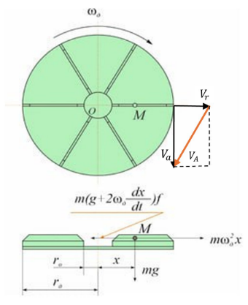
V_{А1} – The rebound velocity of a technological material particle (sand–salt mixture) after colliding with an obstacle., m/sek .
FIGURE 1. Spreading disc and the diagram of forces acting during its rotation.

α_{А} - The impact angle of a technological material particle (sand–salt mixture)., grad
α_{А}$={90}^{0}-γ ;$ – The collision angle of a technological material particle (sand–salt mixture)., grad.
β_{А} – The rebound angle of a technological material particle (sand–salt mixture) after colliding with an obstacle, grad.
$γ$ – The installation angle of the metal and rubber barrier, grad.
β_{В} – The rebound (departure) angle of a technological material particle (sand–salt mixture) after impacting the road surface., grad.
α_{В} – The impact angle of a technological material particle (sand–salt mixture) upon collision with the road surface, grad.
k – Coefficient of restitution
H_{д} =h = 0.5 - The rebound (lifting) height of a particle after impacting the road surface, m.
$f$ = 0,5; – Coefficient of friction
$n$ = 1,2; – Conversion coefficient
N=$ω_{д}$ – Disc rotational speed, rpm revolutions/minute,
r =0,3 – Disc radius, m.
g = 9.81 - Acceleration due to gravity [m/s²]
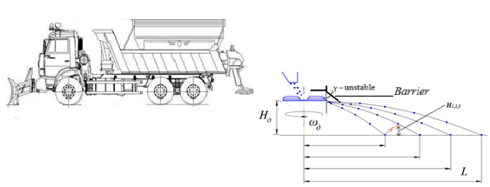
FIGURE 2. Technological material spreader of a special road machine with quick-release equipment

The scraper (paddle) conveyor located at the bottom of the bunker transports the material together with the paddles and transfers it to the spreading disc. From the spreading disc of the improved spreading unit of the special road maintenance machine, positioned at a height h above the road surface, a technological material particle is ejected with an initial velocity V_{A}. The particle then collides with a direction-changing obstacle (rubber or metal), altering its trajectory and continuing its motion with a velocity V_{A1} = V_{B}. It subsequently impacts the road surface at point B, changes its direction again, and rebounds with a velocity U_{B}, reaching a height H as it bounces upward [28-41].
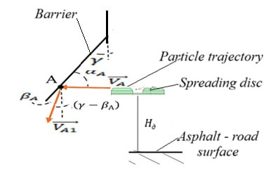
We will calculate the particle velocity after impact at point A (V_{A1} = V_{B}), the velocity after impact with the road surface at point B (U_{B}), and the rebound (bounce) height H. See Fig. 3.
FIGURE 3. Diagram of the particle’s motion direction after colliding with the obstacle at point A.

V_{A} cos α_{A} = V_{A1} cos β_{A} ,
$k_{rez}$= $\frac{V_{A1} sinβ_{ A}}{ V_{A} sinα_{ A}}$ , $k_{met}$= $\frac{V_{A1} sinβ_{ A}}{ V_{A} sinα_{ A}}$ , Coefficients of restitution.
β_{А =}$γ$ It is almost achieved when the particle strikes the asphalt surface nearly vertically, resulting in the maximum rebound height.
V_{A1} = k V_{A} $\frac{sinα_{ A}}{sinβ_{ A}}$ ; (2)
$sinβ_{ A}= \frac{V_{A}}{V_{A1}}$ k sin α_{A ;} (3)
$V_{A}^{2}$ cos² α_{A} = $V_{A1}^{2}$ cos² β_{A} = $V_{A}^{2}$ $\left(1- \frac{{V^{2}}_{ A}}{{V^{2}}_{A1}} k^{2} \sin^{2} α_{A}\right)=V_{A1}^{2}-V_{A}^{2}k^{2}\sin^{2}{α_{A}}$ ; (4)
$V_{A1}^{2}=v_{A}^{2}\cos^{2}{α_{A}}$+$V_{A}^{2}k^{2}\sin^{2}{α_{A}= V_{A}^{2}(\cos^{2}{α_{A}+}} k^{2} \sin^{2} α_{A})$ ; (5)
$V_{A_{1}}=V_{A}\sqrt{\cos^{2}{α_{A}}+k^{2}\sin^{2}{α_{A}}}$ ; (6)
α_{A =}$γ$ Almost equal.
If the particle strikes a suspended rubber surface, the coefficient of restitution is small (k<0,1), and V_{A1} = V_{A} cos α_{A}. However, if the point of impact contains a metal strip, the coefficient of restitution becomes higher.
Calculation of the particle’s velocity as it falls onto the road surface, i.e., at point B, after colliding at point A (see Fig. 4.).
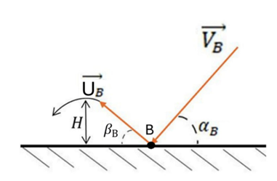
FIGURE 4. Diagram of the particle’s rebound (bounce) height after changing its motion direction upon impact at point B.
$V_{B_{x}}=V_{A_{1}X}$ (7)
${ V}_{By}^{2}=V_{A_{1}y}^{2}+2gh$ (8)
$V_{A_{1}y}=V_{A_{1}}⋅\cos\left(γ-β_{A}\right)$ (9)
$V_{B}=\sqrt{V_{Bx}^{2}+V_{By}^{2}}$ (10)
Calculation of the rebound (bounce) height HHH of the particle after impacting the road surface (asphalt).
$V_{B}\cos{α_{B}}=U_{B}\cos{β_{B} }$ (11)
$k_{asf}=\frac{U_{B}sin{β_{B}}}{V_{B}\sin{α_{B}}}$ ; Coefficients of restitution,
$U_{B}=kV_{B}⋅\frac{\sin{β_{B}}}{\sin{α_{B}}}$ ;$U_{B}^{2}\sin^{2}{β_{B}}=2Hg$ ;H = $\frac{U_{B}^{2}\sin^{2}{β_{B}}}{2g}$ . (12)
RESEARCH RESULTS
To evaluate the reliability of the mathematical model developed on the basis of theoretical and experimental test results, the following variable parameters were selected.
The coefficients of restitution and variable values for rubber, metal, and asphalt were determined based on the results obtained from experimental tests.
$k_{rez}$ = h/H = 6/1000= 0,006-0.008, - Coefficients of restitution of rubber
$k_{met}$ = h/H = 25/1000 = 0,025-0.03-0.5, - Coefficients of restitution of metal
$k_{asf }$=45/1000 = 0.45, - Coefficient of restitution of asphalt
By varying the coefficients of restitution for rubber, metal, and stone, as well as the height of the spreading disc above the ground (road surface), we determine and evaluate the rebound (bounce) height of the technological material particles ejected from the spreading disc upon impact with the road surface.
When the coefficients of restitution for rubber $k_{rez}$=0.006, $k_{met}$=0.025, and asphalt concrete $k_{asf }$=0.45, as well as the height of the spreading disc above the road surface h=0.5 m, and the disc rotational speed N=450 rpm, the dependence of the particle rebound (bounce) height H on the parameters N and γ is analyzed. (See Fig. 5.)
When the coefficients of restitution for rubber $k_{rez}$=0.006, $k_{met}$=0.03, and asphalt concrete $k_{asf }$=0.45, as well as the height of the spreading disc above the road surface h=0.5 m, and the disc rotational speed N=450 rpm, the dependence of the particle rebound (bounce) height H on the parameters N and γ is analyzed. (See Fig. 6.)

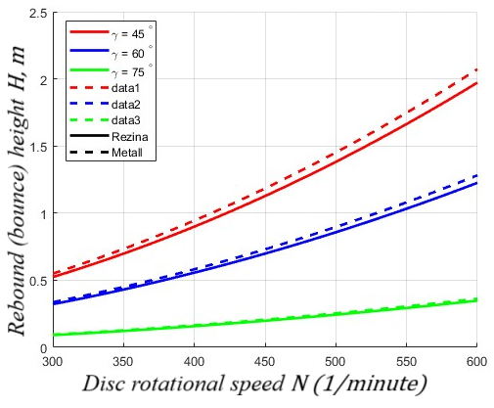 | 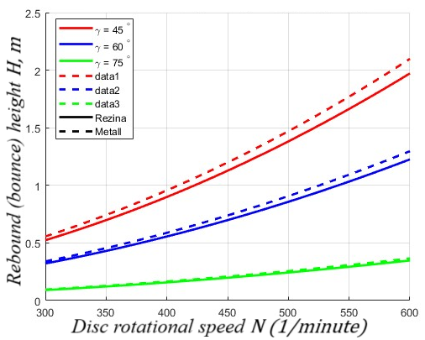
FIGURE 5. Graph of the particle’s rebound (bounce) height. | FIGURE 6. Graph of the particle’s rebound (bouncing) height.

When the disc rotational speed is 450 revolutions/minute , with $k_{rez}$=0.006, $k_{asf }$=0.45, and h=0.5 m, while only the coefficient of restitution for metal $k_{met}$ is variable — taking values $k_{met}$=0.025 - 0.03 - 0,05 — it was determined that the particle’s rebound (bounce) height increases incrementally by approximately 10 mm (0.01 m) with each increase in $k_{met}$.
When the coefficients of restitution for rubber $k_{rez}$=0.008, $k_{met}$=0.05, and asphalt concrete k$k_{asf }$=0.45, as well as the spreading disc height above the road surface h=0.5, and the disc rotational speed 450 revolutions/minute, the dependence of the particle rebound (bounce) height H on the parameters N and γ is determined. (See Fig. 7.)
When the coefficients of restitution for rubber $k_{rez}$=0.01, $k_{met}$=0.05, and asphalt concrete k$k_{asf }$=0.45, as well as the spreading disc height above the road surface h=0.5, and the disc rotational speed 450 revolutions/minute, the dependence of the particle rebound (bounce) height H on the parameters N and γ is determined. (See Fig. 8.)

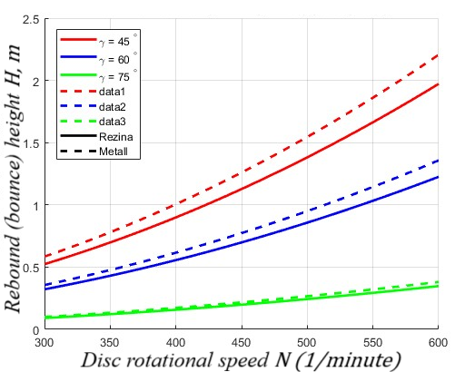 | 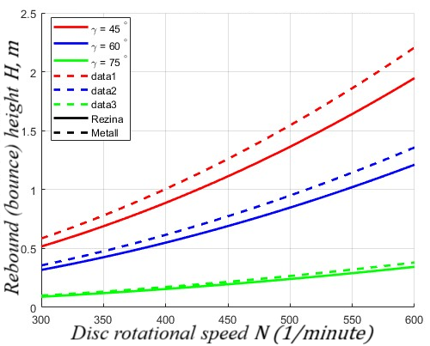
FIGURE 7. Graph of the particle’s rebound (bouncing) height. | FIGURE 8. Graph of the particle’s rebound (bounce) height.

When the disc rotational speed is 450 revolutions/minute, with $k_{met}$=0.05, $k_{asf }$=0.45, and h=0.5m, while only the coefficient of restitution for rubber $k_{rez}$ is variable — taking values $k_{rez}$=0.006, $k_{rez}$=0.008, $k_{rez}$=0.01 — it was determined that the particle’s rebound (bounce) height increases incrementally by approximately 5 mm (0.005 m) with each increase in $k_{rez}$
When the coefficients of restitution for rubber $k_{rez}$=0.01, $k_{met}$=0.05, and asphalt concrete $k_{asf }$=0.45, as well as the spreading disc height above the road surface h=0.5 m, and the disc rotational speed 466 revolutions/minute, the dependence of the particle’s rebound (bounce) height H on the parameters N and γ is determined. (See Fig. 9.)

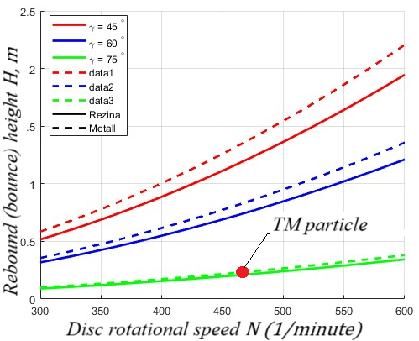
FIGURE 9. Graph of the particle’s rebound (bouncing) height during the experimental process.

TABLE 1. Comparison Table of Current and Proposed States
 | Spreading width along the road is 18 m
m | 9 | 8 | 7 | 6 | 5 |  | 4 | 3 | 2 | 1 | 1 |  | 2 | 3 | 4 | 5 | 6 |  | 7 | 8 | 9
 | 438.48 kg Spreading amount of technological material (sand) per meter, kg.
Kg | 0,001 | 0,002 | 0,003 | 0,005 | 0,1 |  | 0,3 | 1,5 | 14 | 68 | 187 |  | 142 | 22 | 1,2 | 1 | 0,7 |  | 0,4 | 0,25 | 0,1
Targeted spreading in the current and proposed states.
Spreading Width, m |  |  |  |  |  | 3 m |  |  |  |  |  | 5 m |  |  |  |  |  | 7 m
Targeted Spreading in Current State, % |  |  |  |  |  | 95.09 |  |  |  |  |  | 98.73 |  |  |  |  |  | 99.35
Unintentional Spreading in Current State, % (Excessive Consumption/Waste) |  |  |  |  |  | 4.91 |  |  |  |  |  | 1.27 |  |  |  |  |  | 0.65
Targeted Spreading in Proposed State, % |  |  |  |  |  | 100 |  |  |  |  |  | 100 |  |  |  |  |  | 100
Excessive Consumption/Waste in Proposed State, % |  |  |  |  |  | 0 |  |  |  |  |  | 0 |  |  |  |  |  | 0

The practical experimental study was carried out under real weather conditions — cloudy weather following rainfall. The technological material (a salt–sand mixture with particle sizes ranging from 0.5 mm to 5 mm) was in a wet state, and the road surface was moist with a thin layer of water. The results of the theoretical and practical experimental studies showed that the technological material particles ejected from the spreading disc, after colliding with the rubber barrier and the asphalt road surface, reached a rebound (bounce) height H of 0.22 m.
CONCLUSION
The article is focused on increasing the efficiency of the sand-salt mixture spreading process to eliminate the risk of road icing on motor roads during the winter season. Effective spreading of the sand-salt mixture achieves high efficiency in eliminating snow and ice layers on the road surface, which is related to reducing environmental impact and ensuring road traffic safety.
In the research, a theoretical methodology is presented for calculating the velocity (V) of a technological material (or salt-sand mixture) particle ejected from the spreading disc of a specialized road vehicle. Calculations are also provided for determining the particle's velocity after impacting an obstacle (V_{A1} = V_{BX}) and after impacting the road surface (at point B, U_{B}), as well as the rebound height (H). The calculations are based on parameters such as the disc's rotational speed (N), the obstacle installation angle ($α$), the coefficient of friction (f), the drag coefficient (n), and the restitution coefficients (k) for various materials (rubber, metal, asphalt).
The study assessed the rebound height (H) of the particle onto the road surface by varying the restitution coefficients for the technological particles—rubber, metal, and asphalt concrete—and the spreading disc height values on the special road vehicle. The analysis is confirmed by graphs showing the variation of the height H depending on the disc's rotational speed (N) and the obstacle angle ($α$).
Based on experimental test-trial results, the values for k_{rez} (0.006-0.008), k_{met} (0.025-0.03-0.5), and k_{asf} (0.45) were determined. In the analysis conducted with a disc speed of 450 rpm and other specific values, it was found that a change in k_{met} leads to an increase (addition) in the height H by 0.01 m, while a change in k_{rez} leads to an increase by 0.005 m. During practical experimental research under real weather conditions (cloudy, post-rain, wet TMs, wet road surface), the particle's rebound height (H) was recorded to be 0.22 m.
REFERENCES
- A. Khalmukhamedov, R. Samatov, and S. Rajapova, “Prospects for the use of an automatic system for weight and dimensional control of vehicles in the Republic of Uzbekistan,” AIP Conf. Proc. (2024), https://www.scopus.com/record/display.uri?eid=2-s2.0-85188418771.
- S. Rajapova, and Y. Juraev, “Innovative ways to train drivers and improve their skills,” AIP Conf. Proc. (2022), https://www.scopus.com/record/display.uri?eid=2-s2.0-85133001621.
- S. Turdibekov, U. Isoxanov, S. Shermatov, and E. Abdusamatov, “Road traffic incidents involving pedestrians in areas with limited visibility,” E3S Web Conf. 549, 06012 (2024), https://doi.org/10.1051/e3sconf/202454906012.
- S. Turdibekov, U. Isoxanov, S. Shermatov, and E. Abdusamatov, “Analysis of the parameters of technological material sprinkling devices of special road vehicles (wδ=const): MAN CLA 18.280 4×2 BB CS45,” E3S Web Conf. 549, 02016 (2024), https://doi.org/10.1051/e3sconf/202454902016.
- E. Abdusamatov, “The impact of driver turnover on traffic safety,” E3S Web Conf. 549, 06011 (2024), https://doi.org/10.1051/e3sconf/202454906011.
- S. Khakimov, “Vehicle ride regime as a main factor for GHG emission reduction,” AIP Conf. Proc. 2432, 030127 (2022), https://doi.org/10.1063/5.0089563.
- K. Kutlimuratov, S. Khakimov, A. Mukhitdinov, and R. Samatov, “Modelling traffic flow emissions at signalized intersection with PTV Vissim,” E3S Web Conf. 264, 02051 (2021), https://doi.org/10.1051/e3sconf/202126402051.
- S. Khakimov, E. Fayzullaev, A. Rakhmonov, and R. Samatov, “Variation of reaction forces on the axles of the road train depending on road longitudinal slope,” E3S Web Conf. 264, 05030 (2021), https://doi.org/10.1051/e3sconf/202126405030.
- R. Samatov and U. Samatov, “Improvement of methods for assessing the quality of road transport services,” AIP Conf. Proc. 2432, 030094 (2022), https://doi.org/10.1063/5.0091190.
- E. Faizullaev, A. Rakhmonov, U. Mukhtorjanov, S. Turdibekov, and S. Nasirjanov, “Parameters of the access road for disaster situations on the roads in the mountain area,” E3S Web Conf. 401, 03022 (2023), https://doi.org/10.1051/e3sconf/202340103022.
- K. Sharifbaeva, G. Niyazova, D. Abdurazzakova, I. Abdurashidov, and R. Alimardonov, “Formation of methodical competence of special subjects teachers in technical universities,” AIP Conf. Proc. 2432, 050043 (2022), https://doi.org/10.1063/5.0089618.
- O. Rabat, Sh. Pirnaev, K. Rustamov, I. Usmanov, Sh. Shermatov, and K. Magdiyev, “Development of corrosion-resistant material for asphalt concrete cutting part,” E3S Web Conf. 587, 03012 (2024), https://doi.org/10.1051/e3sconf/202458703012.
- S. Korabayev, J. Yuldashev, U. Isokhanov, S. Makhkamova, and N. Saparboyeva, “Overcoming obstacles: solving cutting resistance problems,” E3S Web Conf. 587, 03015 (2024), https://doi.org/10.1051/e3sconf/202458703015.
- U. Isokhanov, S. and Turdibekov, “A method of experimental study of the operation of technological material distributors,” E3S Web Conf. 587, 03013 (2024), https://doi.org/10.1051/e3sconf/202458703013.
- Turdibekov, S., Xamraqulov, R., Negmatov, N., and Raximbayev, Z. “The method of calculating the parameters of the materials delivery mechanism of the technological materials distributor,” BIO Web of Conferences 145, 03025 (2024) https://doi.org/10.1051/bioconf/202414503025
- Khalilova, G., Abdusamatov, E., and Shermatov, S., “Methodology for Calculating the Share of Parking-Searching Vehicles in Traffic Congestion on Multi-Lane Roads,” International Conference of Young Specialists on Micro/Nanotechnologies and Electron Devices, EDM. (2025) https://doi.org/10.1109/EDM65517.2025.11096677
- Fayzullayev, E., Khakimov, S., and Abdurazzakova, D., “Correct choice of parameters of runaway truck ramp on the mountain roads is factor in saving people's lives,” AIP Conference Proceedings. https://doi.org/10.1063/5.0267594
- Choriev, J.A., Faizullaev, E.Z., Khakimov, S.K., and Rakhmanov, A.S., “The Impact of the Number of Street Intersections on Traffic Safety in Karshi City,” Springer Nature (2025) https://doi.org/10.1007/978-3-031-83595-7_37
- Khalilova, G. Kh., Choriyeva, M. Sh., Samatov, R. G., Abdurazzokov, U. A., and Urunov, D. A. “AI Integration in Smart Car Parking Stations” Lecture Notes in Networks and Systems (2025). https://doi.org/10.1007/978-3-031-88846-5_15
- Abdurazzokov, U., and Utaganov, S., “Analysis of efficiency indicators in the evaluation of city public transport” AIP Conference Proceedings 060032. https://doi.org/10.1063/5.0266818
- Ikromov, A. “Development of new efficient materials for machine-building parts and units of trucks” AIP Conference Proceedings 060010. https://doi.org/10.1063/5.0266737
- Israilov, M., Mukhitdinov, A., Yusupov, U., & Anvarjonov, A., “Analysis of the method for calculating the actual indicator ton kilometer per hour of large tires and its disadvantages,” AIP Conference Proceedings 060039. https://doi.org/10.1063/5.0266854
- Israilov, M., and Yusupov, U., “Determining the weight of factors affecting the TKPH of large-sized tires,” E3S Web of Conferences, 627, 05010. https://doi.org/10.1051/e3sconf/202562705010
- Kapski, D., Semchenkov, S., Gamulsky, I., Ikromov, A., Omarov, J., and Abruev, S., “Assessment measures developed to improve quality of route transport Polotsk and Novopolotsk,” E3S Web of Conferences, 515, 03003. https://doi.org/10.1051/e3sconf/202451503003
- Mikhaltsevich, M., and Ziyaev, K., “Modeling the braking process for motorcycle with ABS,” E3S Web of Conferences, 592, 07002. https://doi.org/10.1051/e3sconf/202459207002
- Mukhitdinov, A., Yusupov, U., Tukhtamishov, S., and Urinbayev, Q., “Results of the study of the influence of an average longitudinal slope of routes on the life of tires in the quarry,” AIP Conference Proceedings 040041. https://doi.org/10.1063/5.0197301
- Petrovich, B. V., and Ugli, A. A. A., “Analysis of static load on a tire in quarry operating conditions,” AIP Conference Proceedings 030017. https://doi.org/10.1063/5.0266786
- Tursunbaev, B. H., Fayzullaev, E. Z., Akbarov, N. A., and Nigmatov, H., “A new methodology for evaluating the efficiency of complex machine mechanisms,” AIP Conference Proceedings 040098. https://doi.org/10.1063/5.0145575
- Tursunov, S. R., Khikmatov, R. S., and Khusanov, S. N.-U., “Increasing the efficiency of the use of mining transport due to increasing the periodicity of maintenance time,”. AIP Conference Proceedings 050021. https://doi.org/10.1063/5.0197547
- Abdurazzokov, U., & Utaganov, S. (2025). Analysis of efficiency indicators in the evaluation of city public transport. 060032. https://doi.org/10.1063/5.0266818
- Abdurazzokov, U., Vasylenko, I., Pron, S., Borets, I., Valko, A., & Ozerova, O. (2024). Preconditions for optimizing costs of logistics operator when delivering special categories of cargoes. E3S Web of Conferences, 508, 08003. https://doi.org/10.1051/e3sconf/202450808003
- Abdurazzoqov, U., & Anvarjonov, A. (2024). State of transport system organization in developed cities. 040012. https://doi.org/10.1063/5.0197302
- Alimova, Z., Tursunov, S., Khikmatov, R., & Pulatov, S. (2025). Evaluating motor oil quality in heavily loaded quarry vehicle engines. 030041. https://doi.org/10.1063/5.0269618
- Avdeichik, S. v., Gol’dade, V. A., Struk, V. A., Antonov, A. S., & Ikromov, A. G. (2022). Implementation of the Nanostate Phenomenon in Materials Science of Functional Nanocomposites Based on Industrial Polymers. Surface Engineering and Applied Electrochemistry, 58(3), 211–220. https://doi.org/10.3103/S1068375522030061
- Ikromov, A. (2025). Development of new efficient materials for machine-building parts and units of trucks. 060010. https://doi.org/10.1063/5.0266737
- Israilov, M., Mukhitdinov, A., Yusupov, U., & Anvarjonov, A. (2025). Analysis of the method for calculating the actual indicator ton kilometer per hour of large tires and its disadvantages. 060039. https://doi.org/10.1063/5.0266854
- Israilov, M., & Yusupov, U. (2025). Determining the weight of factors affecting the TKPH of large-sized tires. E3S Web of Conferences, 627, 05010. https://doi.org/10.1051/e3sconf/202562705010
- Kapski, D., Semchenkov, S., Gamulsky, I., Ikromov, A., Omarov, J., & Abruev, S. (2024). Assessment measures developed to improve quality of route transport Polotsk and Novopolotsk. E3S Web of Conferences, 515, 03003. https://doi.org/10.1051/e3sconf/202451503003
- Kamoliddin Ziyaev, Doniyor Vokhidov, Khumoyun Shavkatov, Gulnoza Khadiyeva, Ismigul Yangiyeva; Influence of traffic light management on traffic capacity of Urban highways. AIP Conf. Proc. 15 July 2025; 3256 (1): 060038. https://doi.org/10.1063/5.0266822
- Denis Kapsky, Doniyor Vokhidov, Pavel Astapenya, Lochinbek Abdurakhimov, Shakhbos Abruev, Gulnoza Khadiyeva; Using special “pre-signals” to improve quality of traffic in mega cities. AIP Conf. Proc. 15 July 2025; 3256 (1): 060027. https://doi.org/10.1063/5.0266811
- Khalmukhamedov, A.S., Samatov, R.G., Islamov, E.B. and Narziyev, J.S. (2025) Assessment of the Highway Network of International Importance of the Republic of Uzbekistan. Lecture Notes in Networks and Systems https://doi.org/10.1007/978-3-031-99028-1_21

