Study Of Geospatial Data to Forecast Changes Long-Term Weather and Ecology Pre-Aral Area
Saboxat Abdulxalilova, Zakir Allaberganov, Abdulazizjon Abdulxalilov ^{a)}, Gulshod Avalova
Tashkent State University of Economics, Tashkent, Uzbekistan
^{a)} Corresponding author: surayyo3006@gmail.com
Abstract. Since the 1980s, the Aral Sea region has faced significant environmental challenges because to the illogical use of regional river flows and the exploitation of new lands for agriculture in Central Asia. A significant amount of salt dust from the dry portion of the Aral Sea has formed as a result of the ensuing environmental changes, endangering both human health and the ecology in the 500–600 km Pre-Aral region.Using remote sensing and meteorological data, this study examines the Pre-Aral region's land cover and land change. Using a supported raster data analysis approach, land use and land cover changes over a 30-year period (1991, 2006, and 2021) were examined using long-term Landsat imagery. For 50 years (1971–2021), meteorological data from five stations—Muynak, Kungrad, Chimbay, and Nukus—was examined. The Aral Sea's decline has had a significant effect on the desertification of the region, causing it to become a salt desert and a desolate region and causing the desert to spread. The findings demonstrate that the region's surface cover has changed significantly in the last several years.

INTRODUCTION
Since an arid and semi-arid desert region encircles the region's climate, environmental effects are felt rapidly [1, 2]. Serious environmental changes have resulted from changes in the area of the island sea (lake), groundwater levels, the local climate, and other factors. Consequently, ecological security issues are emerging in the area [3]. The Amudarya River, the region's sole source of water, has seen a major decrease in downstream flow as a result of extensive industrial and agricultural use. As a result, the majority of Central Asian irrigation systems return waste water to the river, contaminating it and causing it to flow into the Pre-Aralia region, where accumulation cases have grown. These waters eventually reached the Aral Sea (lake). The Aral Sea (lake) was the fourth largest sea in the world until 1961, when its total area was 67,000 square kilometers. [4]. Since the 1950s, large-scale hydroelectric plants have been built, mostly for agriculture using water from Central Asia's two main rivers. A substantial amount of water resources flowed into the Aral Sea (Lake) as a result of doubling the area set aside for cotton farming and supplying the water required to irrigate desert regions, which led to the lake's decline [5]. As a result, the lake gradually lost a significant amount of its fresh water supply. The lake level gradually started to drop as evaporation from the lake level greatly outpaced river flow [6]. The Aral Sea (lake) was 53 meters deep in 1960. After 60 years, it dropped to 45 meters. Additionally, the lake's surface area has maintained at just 10%, and its size has shrunk by seven times since 1960. [7] Agriculture and cattle are the main sources of income for the majority of the region's residents. Dry land makes up the majority of Central Asia. Nonetheless, the region's worst water issues are found in some places. Because of its flat topography, the region has a very changeable and severely continental climate. The summer heat reaches 40 to 45 degrees Celsius. We can see that the temperature drops to -35 °C throughout the winter. The area receives only 100 to 80 mm of rain annually [8]. At its highest point, there is little more than 5 mm of snow. The area's temperature has increased by roughly 4 °C in the spring and summer and by 3 °C in the fall and winter due to changes in the regional climate and anthropogenic activity, as well as changes in the ecological situation in the area. Future climate change is predicted to raise temperatures by an additional 1.5–2°C over the next 20 years, which would significantly affect changes in the region's land cover. The region's economy, food security, and human health are all being negatively impacted by the numerous issues brought on by these environmental issues [9].

EXPERIMENTAL RESEARCH
The western region of Central Asia is the location of the region under investigation in this research's continuance. The Amu Darya River's lower stream portion is known as Pre-Aral [19]. For this reason, certain literary works refer to this area as Amu Darya Lower Because of the very continental climate, irrigation is required all year round [21], [22]. Rice, wheat, and cotton are the primary agricultural products. In the area, about 10,4 thousand km2 of land can be irrigated. The Amu Darya and its hierarchically built network of canals, along with a number of smaller rivers, are the only sources of water. (Fig. 1). Where the "Pre Aral region" study area is located.
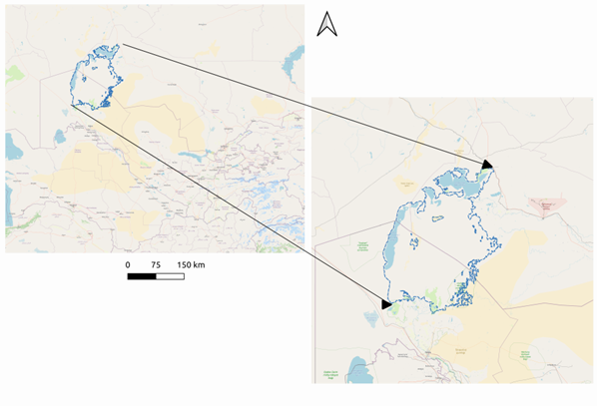
FIGURE 1. Geographic location of study area “Pre Aral region”

The study used different data sets from different sources. The datasets used and their respective sources are listed below. (Figure 2). All data was collected from USDA, USGS, NRCS and ESRI data services. Since their geographic coordinate system is a projection and the date of WGS 1984, all maps are stored in this state [23 - 25]. The projection coordinate system used in this project is the coordinate system, they have been converted into a raster with a cell size of 30 m so that the model can accurately calculate the amount of land cover and use change [26 - 28].

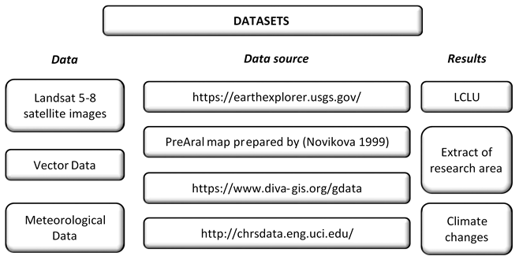
FIGURE 2. Datasets used for the Supervised classification

The Pre-Aral region, which is 29 167 km², was extracted from the 1961 physical map of the Aral Sea (lake) in order to obtain a thorough understanding of how to employ land-cover change analysis in this area. Up till 2019, analyses of the Aral Sea's (lake) coastline were carried out. To extract the Aral Sea's (lake's) border and extent for additional study, the satellite image was digitized. Satellite pictures were downloaded for the purpose of supervised classification analysis. Thus, cloud-free days are ideal for tracking changes in land cover, which is why we use data in July of every year (1991, 2006, and 2021). The information was obtained from the U.S. Geological Survey's open-source datasets. Satellite images were taken using Landsat TM 5 and Landsat 8 OLI sensors. These images have a temporal resolution of 16 days and a spatial resolution of 30 meters, meaning that one pixel covers 30 meters by 30 meters.
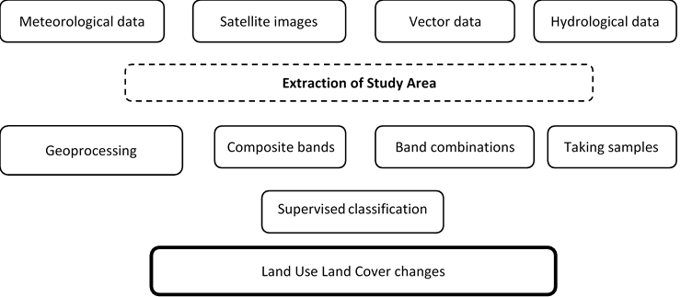
FIGURE 3. Data processing framework for Supervised classification using ArcGIS software

A linear correlation was employed as the SPSS program was utilized to statistically analyze the air temperature in the area.
Temperature correlation is carried out using the following methodology:
• The indices from r -1 to 1 are related to one another and have units of measurement.
• The association's strength rises as r's absolute value gets closer to 1.0.
• The result is 0 if there is no association between the two variables under test.
• A more accurate method of estimating r is often to compute r over treatment means averaged over replicates.
• Independent and dependent variables do not necessarily need to be correlated.
• It is possible to perform correlation when there are two dependent variables.

RESEARCH RESULTS
One of the primary contributors to the development of the Pre-Aral regional climate and its ecosystem was thought to be the Aral Sea (lake). This ecology has been destroyed as a result of the Aral Sea's (lake) shrinkage. It is evident from examining the dynamics of the Aral Sea's formation that the intensity has risen since 1990, and by 2020, a new desert had emerged (Fig. 5). The examination of the space photos makes it evident that the Aral Sea (lake) rapidly dried up between 1990 and 2020, causing a condition of stress and having a significant effect on the ecosystem. First and foremost, these changes had an impact on the local climate (air temperature), animal life, and soil vegetation. Information gathered from four monitoring stations run by the UzHydromet organization in the area shows this. During the study, we used the data of four stations and provided the monitoring of the dynamics of the average annual air temperatures at these stations (fig. 6). Given how far away these stations are from the Aral Sea, the indicator's impact on the local change in air temperature was not uniform.
FIGURE 4. Temperature’s changing last 50 years in Pre-Aral region

Our analysis demonstrates that the Pre-Aral region had a direct influence on the eco-system's climate change by relating changes in air temperature to the distance from the R2 Aral Sea's (lake) water level (Table 1). According to the analysis, the Nukus station has the lowest correlation, while the Muynoq station has the highest correlation. It is evident that climatic change in the examined area has been impacted by the drying of the Aral Sea (lake).

TABLE 2. The relationship between temperature and distance from the ancient Aral Sea
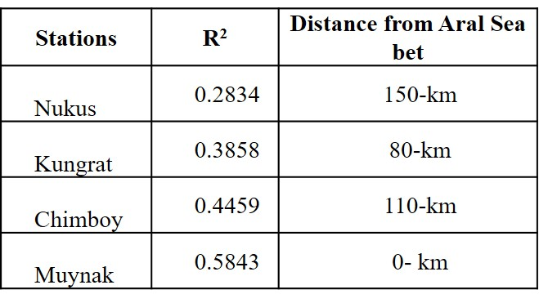

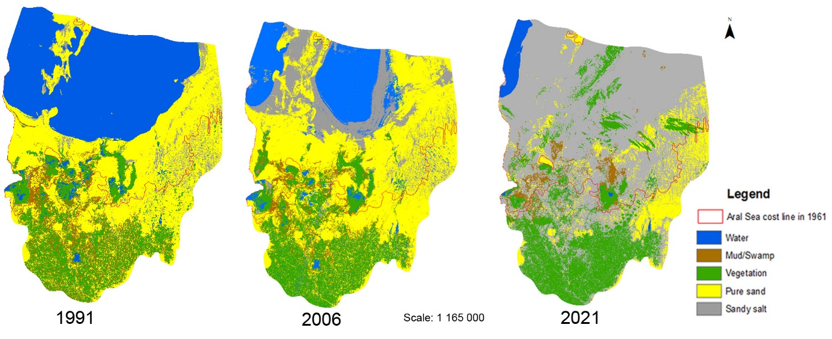
FIGURE 5. The Pre-Aral region's changing land cover.

The Aral Sea (lake) has dried up during the past 30 years, making it the new desert. We can now refer to this desert as the Aralkum desert. (Figure 7). The Pre-Aral region was most affected by the new desert's environmental effects, which included alterations in the region's land cover. The Aral Sea (lake) and its environs both saw ecological changes as a result of it. Five classes were created in order to assess the obtained space images (Table 2). Every class has its own definition. The study area's land-cover changes over the past 30 years are depicted on the updated Pre-Aral region map. The land-cover analysis results (Fig. 7) produced by the supervised classification of the study region show a significant change. Salty sand deserts have drastically expanded to the southern side, which has more agricultural land, while sandy parts have shrunk.
It is evident that the region's interior water bodies have likewise decreased in size. There have also been fewer sandy salt marshes and mud/swamp habitats. The most striking change, however, is that the region's salt marsh area has grown 11 times in 30 years, from 1,180 square kilometers to 13,404 square kilometers (fig.8). The future surface of vegetation cover and population will be severely impacted by the growth of salt deserts.
The average yearly temperature correlation data for the research area from 1971 to 2019 were prepared and shown in Table 1 and Figure 4, respectively. According to the accuracy assessment's findings, the temperature monitoring process's overall accuracy for the year 1971 ranged from a maximum of 0.58 to a minimum of 0.28. An overall R² coefficient in this study is dependent on the distance from “Aralkum's New Desert”.
CONCLUSION
Over the previous three decades (1991–2021), the Pre-Aral region's LULC changes have been monitored with the help of remote sensing data and GIS technologies. The geographical area of the region has changed significantly, according to the study. According to the findings, there has been a minor decline of 0.17 and 0.76 percent in the area covered by water bodies, respectively. During this time, the desert with only sand has also drastically reduced and transformed into a salty desert. The amount covered by vegetation hasn't changed much, though. However, in 2021, the area covered by mud/swamp lands dropped by over 50%, and it appears that a salty desert area has taken its place. Consequently, with an overall accuracy of 90%, the LULC change analysis was determined to be quite effective. Monitoring LULC changes and their possible effects on the environment and society requires this kind of research.
The study concludes by showing how well GIS technologies and remote sensing data can track LULC changes and their effects on the ecosystem in the Pre-Aral region. The findings underline the necessity of sustainable land management techniques and offer insightful information about the ecological state of the area. Researchers can help efficient land use planning and decision-making in the area by using these technologies to deliver timely and accurate information.
REFERENCES
1. I. S. Zonn, M. H. Glantz, A. G. Kostianoy, and A. N. Kosarev, The Aral Sea Encyclopedia (2009)
2. P. P. Micklin and W. D. Williams, The Aral Sea Basin (Routledge, 2019)
3. W. Wang, A. Samat, J. Abuduwaili, Y. Ge, P. De Maeyer, and T. Van de Voorde, Atmospheric Research 275, 106242 (2022)
4. Z. Novitskiy, A. Khamzaev, N. Bakirov, G. Atadjanova, M. Abdukadirova, and U. Tasheva, E3S Web Conf. 377, 03007 (2023)
5. C. Opp, M. Groll, O. Semenov, L. Shardakova, Y. Kovalevskaya, R. Kulmatov, I. Normatov, and I. Aslanov, E3S Web Conf. 575, 04001 (2024)
6. I. Aslanov, N. Teshaev, Z. Jabbarov, C. Opp, R. Oymatov, Y. Karimov, and G. Henebry, E3S Web Conf. 575, 04009 (2024)
7. P. Micklin and N. V. Aladin, The Aral Sea (Scientific American Inc., Berlin, Heidelberg, 2008)
8. G. Issanova, J. Abuduwaili, and K. Tynybayeva, Soil Cover of the Dried Aral Seabed in Kazakhstan (Springer Nature Switzerland, Cham, 2023)
9. X. Wang, J. Zhang, S. Wang, Y. Ge, Z. Duan, L. Sun, M. E. Meadows, Y. Luo, B. Fu, X. Chen, Y. Huang, X. Ma, and J. Abuduwaili, Earth’s Future 11, e2023EF003657 (2023)
10. W. Huang, W. Duan, and Y. Chen, Science of The Total Environment 784, 147193 (2021)
11. T. Wu, S. Sang, S. Wang, Y. Yang, and M. Li, Science of The Total Environment 735, 139562 (2020)
12. A. Khamzina, J. P. A. Lamers, C. Martius, M. Worbes, and P. L. G. Vlek, Agroforestry Systems 68, 151 (2006)
13. I. Forkutsa, R. Sommer, Y. I. Shirokova, J. P. A. Lamers, K. Kienzler, B. Tischbein, C. Martius, and P. L. G. Vlek, Irrigation Science 27, 331 (2009)
14. A. Nuratdinov, K. Bekanov, Z. Allashov, A. Mominov, M. Reimov, and Y. Khudaybergenov, E3S Web of Conf. 590, 01002 (2024)
15. S. Huang, X. Chen, C. Chang, T. Liu, Y. Huang, C. Zan, X. Ma, P. De Maeyer, and T. Van de Voorde, Science of the Total Environment 845, 157203 (2022)
16. P. Ginoux, J. M. Prospero, T. E. Gill, N. C. Hsu, and M. Zhao, Reviews of Geophysics 50, 1 (2012)
17. M. Alexyuk, A. Bogoyavlenskiy, P. Alexyuk, Y. Moldakhanov, V. Berezin, and I. Digel, MicrobiologyOpen 10, (2021)
18. J. Wang, D. Liu, J. Ma, Y. Cheng, and L. Wang, Journal of Arid Land 13, 40 (2021)
19. I. Aslanov, IOP Conference Series: Earth and Environmental Science 1068, 011001 (2022)
20. S. Islomov, I. Aslanov, G. Shamuratova, A. Jumanov, K. Allanazarov, Q. Daljanov, M. Tursinov, and Q. Karimbaev, in XV International Scientific Conference “INTERAGROMASH 2022,” edited by A. Beskopylny, M. Shamtsyan, and V. Artiukh (Springer International Publishing, Cham, 2023), pp. 1908–1914
21. Y. Yu, L. Sun, H. Zhang, I. Malik, M. Wistuba, and R. Yu, 0 (2018)
22. V. I. Kravtsova and T. V. Tarasenko, Water Resour 37, 285 (2010)
23. H. He, R. Hamdi, G. Luo, P. Cai, M. Zhang, H. Shi, C. Li, P. Termonia, P. De Maeyer, and A. Kurban, Atmospheric Research 105977 (2021)

